Table 1 - Patient characteristics and clinical data
Legend.
ª The occurrence of preexisting arterial hypertension was compared between the LMWH (56.1%) and NOAC (82.9%) groups. The confidence intervals for each group were as follows: LMWH 95% CI: 39.9--71.2 and NOAC 95% CI: 65.7--92.8. The comparison yielded a p value of 0.024*, indicating statistical significance. An OR of 0.269 indicated a tendency toward lower preexisting hypertension in the LMWH group, which was supported by a confidence interval that was entirely less than 1.
^{b} CT lung scores were significantly different between the LMWH and NOAC groups (Wilcoxon p=0.0439), with mean scores of 2.32 ± 0.93 and 2.74 ± 0.82, respectively. The Shapiro‒Wilk test indicated a nonnormal distribution for both groups (LMWH, p=0.0018; NOAC, p=0.0006). The odds ratio (OR) was 0.29 (95% CI: 0.10-0.86), indicating that patients in the NOAC group were more likely to have higher lung tomography scores, suggesting a greater degree of pulmonary lesions, than were those in the LMWH group.
^{c} An MFI-5 score greater than 3 indicates that a high level of frailty is associated with significantly increased risks of complications, adverse events, prolonged hospitalization, and mortality. The LMWH and NOAC groups included 12 patients (29%) and 7 patients (20%), respectively, with scores greater than 3 (p = 0.50). While the difference between the groups was not statistically significant, 25% of the patients in this observational study were highly vulnerable to adverse events, extended hospitalization, and increased risk of mortality.
*Significant Fisher’s p value or Wilcoxon’s p value of < 0.05.

Abbreviations: BMI: body mass index; CT: computed tomography; COPD: chronic obstructive pulmonary disease; D1: first day of admission to critical care; IMPROVE-DD: International Medical Prevention Registry on Venous Thromboembolism Risk Assessment Model with D-dimer; LMWH: low-molecular-weight heparin; MFI-5: modified frailty index-5; NOAC: novel oral anticoagulant; OR: odds ratio; SAPS3: simplified acute physiology score 3; SOFA: Sequential Organ Failure Assessment.

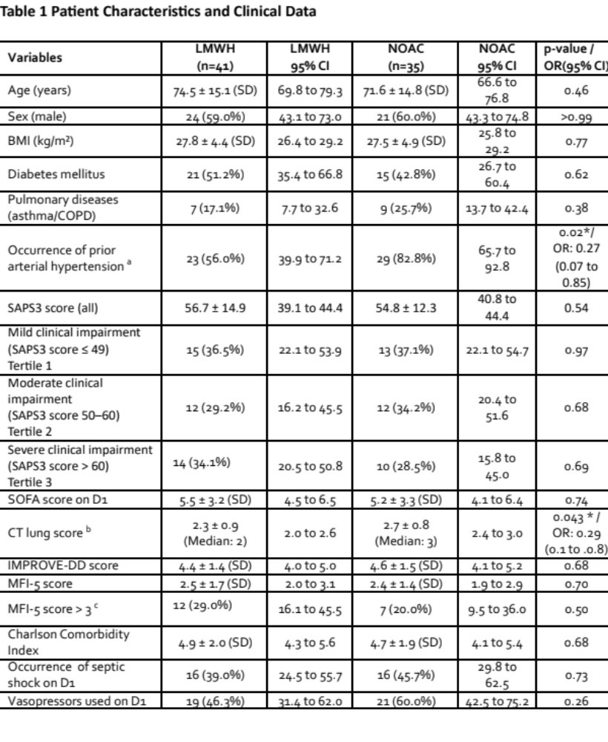Table 2 - Clinical Outcomes and Mortality Data
^{d} In the comparative analysis of the LMWH and NOAC groups, no significant differences were observed in the incidence rates of transfusions, hemorrhagic episodes, or DVT (all p > 0.05). This suggests that adherence to the ICU anticoagulation protocol and vigilant monitoring may be considered safe, as no major adverse events are identified on the basis of these observational parameters.
^{e} Bedside Doppler US showed a nonsignificant trend in the NOAC and LMWH groups (OR = 2.61, p = 0.06). The broad confidence interval and small sample size limit definitive conclusions.
^{f} VFDs are calculated as (28-MV duration) × survival status, where MV duration is the total number of days a patient remains on MV. Survival status was a binary variable (0 or 1, with 1 = patients surviving at least 28 days post-ICU admission and 0 = deceased within this period). If a patient died before 28 days, VFDs were considered to be 0.
^{g} The occurrence of CRRT was 29.3% in the LMWH group (12 patients) and 5.7% in the NOAC group (2 patients), with a p value of 0.02, indicating statistical significance in the univariate analysis. However, in the multivariate analysis, CRRT did not exacerbate mortality in the LMWH group, as shown by the full propensity score analysis (Figure 7). The forest plot of the Cox model indicated a hazard ratio (HR) of 0.16, with a coefficient of -1.86 and a p value of 0.04 (Figure 5). Additionally, the small number of CRRT cases limits the ability to draw definitive conclusions in a retrospective study.
* denotes a significant Fisher’s p value or Wilcoxon’s p value of <0.05.
Abbreviations: CRRT: continuous renal replacement therapy; ICU: intensive care unit; LMWH: low-molecular-weight heparin; MV: mechanical ventilation; NOAC: novel oral anticoagulant; OM: observed mortality; OR: odds ratio; PM: predicted mortality; SAPS3: simplified acute physiology score 3; SD: standard deviation; SMR: standardized mortality ratio; SCCM: Society of Critical Care Medicine; ULN: upper limit of normal; UFD: ventilator-free day.

