Supplementary Materials

Evaluating the Effectiveness of NOAC and LMWHs in Reducing Mortality in Critically Ill Patients with COVID-19

This document contains supplementary materials for the study " Evaluating the Effectiveness of NOACs and LMWHs in Reducing Mortality in Critically Ill Patients with COVID-19." We present detailed statistical analyses, additional figures, and tables that provide a comprehensive view of our methods and results. Included are post hoc power analyses, logistic regression models, survival analyses, and detailed comparisons between treatment groups. We also offer considerations regarding severe acute respiratory syndrome coronavirus 2 (SARS-CoV-2) variants and their potential implications for anticoagulation strategies. These supplementary data are designed to enhance the reader's understanding of our study's methodology and findings, offering deeper insights into the comparative effectiveness of NOACs and LMWH in the context of patients with critical COVID-19. The information herein supports and expands upon the conclusions presented in the main article.

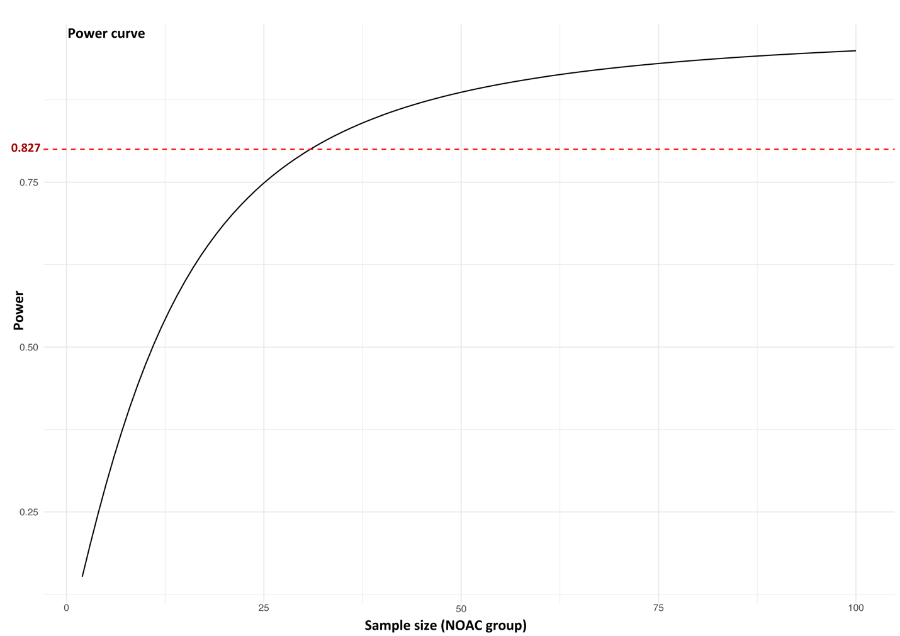

Fig. S1. Post hoc power curve for detecting differences in mortality rates between the LMWH and NOAC groups.
This graph illustrates the study’s power to detect a difference in mortality rates between the LMWH and NOAC groups as a function of the NOAC group’s sample size. The power increases with increasing sample size, reaching approximately 82.7% with the given sample sizes of 41 for LMWH and 35 for NOAC. The red dashed line at 0.8 represents the conventional threshold for acceptable power in clinical studies, indicating a high probability of detecting a significant difference if one exists. LMWH, low-molecular-weight heparin; NOACs, novel oral anticoagulants.

To calculate the post hoc power, we followed these steps:

Effect size Cohen's h:
The observed proportions were 51.2% for the LMWH group and 20% for the NOAC group. Cohen's h was calculated via arcsine transformation:
$$h=2⋅arcsin(\sqrt{0.512}​)-2⋅arcsin(\sqrt{0.200}​)≈0.6675$$

Sample sizes and significance level:
- Sample sizes: 41 for the LMWH group and 35 for the NOAC group.
- Significance level (alpha): 0.05.

Power Analysis
Power analysis determines the sample size needed to detect an effect with a specified confidence level. It helps avoid underpowered studies (risking false negatives) or overpowered studies (wasting resources). Key components include: 1. Effect size: The magnitude of the difference or relationship. 2. Significance level (α): The probability of a Type I error. 3. Power (1 - β): The probability of correctly rejecting the null hypothesis. 4. Sample size: The number of participants or observations needed. Researchers aim for a power of 0.80 or higher, meaning an 80% chance of detecting a true effect. Researchers can conduct power analysis before data collection to plan sample size or post hoc to evaluate a study’s power. Various software and online calculators assist with power analysis for different statistical tests. Researchers must balance practical constraints like budget and time with statistical needs when determining sample size.

- The “pwr.2p2n.test” function from the “pwr” package in R was used
- pwr.2p2n.test (h = 0.6675, n1 = 41, n2 = 35, sig.level = 0.05, alternative = "two.sided")
The calculated power was approximately 0.827, indicating a high probability of detecting a significant difference between the treatment groups if one exists.
Interpretation of the Effect Size h:
Cohen’s h measures the difference between two proportions or probabilities, indicating the practical significance of the effect. The interpretation of h is generally:
h = 0.20: Small effect
h = 0.50: Medium effect
h = 0.80: Large effect
These are rough benchmarks and may vary by field. A small effect might be meaningful in some areas, while a larger effect is needed in others.
When interpreting h, consider:
1. Practical implications
2. Study context and research field
3. Previous findings and norms
4. Sample size and statistical power Report effect sizes alongside statistical significance for a comprehensive understanding and better comparison across studies:
The effect size h of 0.6675 indicates a substantial difference between the mortality rates of the LMWH and NOAC groups. This value was derived via arcsine transformation to stabilize the variance of the proportions. An effect size of this magnitude is considered large, suggesting the observed difference in mortality rates is significant and meaningful in a clinical context.

The significance of the Post Hoc Power Analysis:
The power analysis revealed a power of 82.7%, exceeding the accepted threshold of 80%. This means the study has a high probability of detecting a true difference in mortality rates between the LMWH and NOAC groups, if it exists. The high power reduces the likelihood of a Type II error, where a real effect would go undetected.
The large effect size and high statistical power indicate that the observed difference in mortality rates is statistically significant and clinically important, providing robust support for the findings.

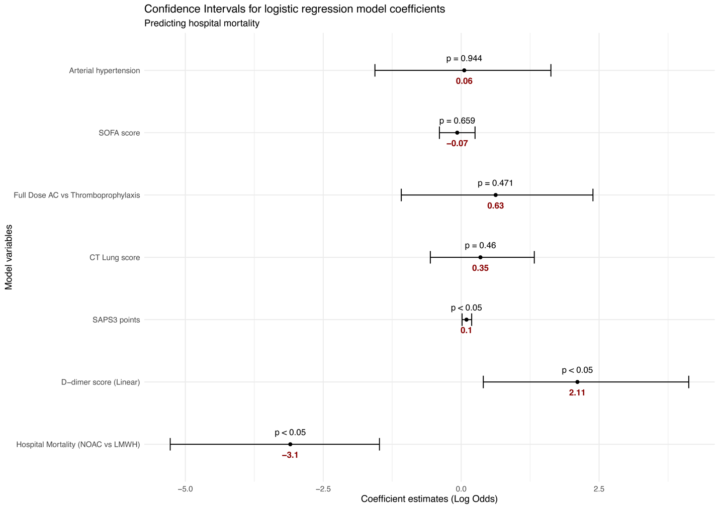
Fig. S2. Logistic regression coefficients for predicting hospital mortality in patients with severe COVID-19: Impact of anticoagulation degree and D-dimer levels.
This figure presents the logistic regression coefficients for predicting hospital mortality in severe cases of COVID-19. The variables include treatment (NOAC vs. LMWH), D-dimer score (linear), full-dose anticoagulation (AC) vs. thromboprophylaxis, arterial hypertension, CT lung score, SAPS 3 points, and SOFA score. Each point shows the estimated log odds ratio for the variable, with vertical lines indicating 95% confidence intervals (CIs). A p-value < 0.05 indicates statistical significance. NOAC treatment significantly reduced hospital mortality compared to LMWH (coefficient: -3.1, 97.5% CI: [-5.2, -1.1], p < 0.05). Higher D-dimer scores significantly increased hospital mortality (coefficient: 2.11, 97.5% CI: [0.28, 3.94], p < 0.05). Higher SAPS 3 points also significantly increased hospital mortality (coefficient: 0.1, 97.5% CI: [0.01, 0.19], p < 0.05). Other variables did not show significant associations with hospital mortality (p > 0.05): arterial hypertension (coefficient: 0.06, 97.5% CI: [-1.50, 1.62], p = 0.944), SOFA score (coefficient: -0.07, 97.5% CI: [-0.39, 0.25], p = 0.659), full-dose AC vs. thromboprophylaxis (coefficient: 0.63, 97.5% CI: [-1.07, 2.33], p = 0.471), and CT lung score (coefficient: 0.35, 97.5% CI: [-0.55, 1.25], p = 0.46).
Abbreviation: AC, anticoagulation; CI, confidence interval; CT, computed tomography; COVID-19, coronavirus disease 2019; LMWH, low-molecular-weight heparin; NOAC, novel oral anticoagulant; SAPS3, Simplified Acute Physiology Score 3; SOFA, Sequential Organ Failure Assessment.
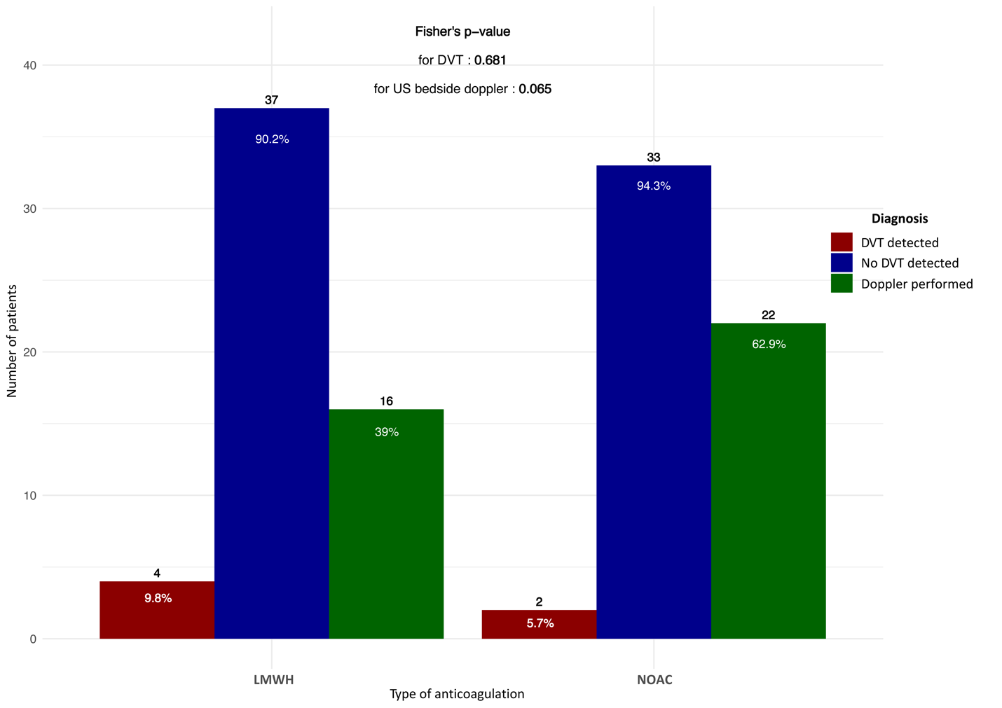
Fig. S3. Comparative incidence of thrombotic adverse events and Doppler ultrasound performance in the LMWH and NOAC treatment groups among ICU-admitted patients with COVID-19.
The bar chart depicts deep vein thrombosis (DVT) presence (9.8%) and absence (90.2%) in patients receiving LMWH, and DVT presence (5.7%) and absence (94.3%) in those receiving NOACs (p = 0.68). Bedside Doppler ultrasound examinations were performed in 39% of the LMWH group and 62.9% of the NOAC group (p = 0.065). These findings underscore the underutilization of these examinations in critically ill patients with hypercoagulability.
Abbreviations: COVID-19, coronavirus disease 2019; DVT, deep venous thrombosis; ICU, intensive care unit; LMWH, low-molecular-weight heparin; NOAC, novel oral anticoagulant; US, ultrasound.

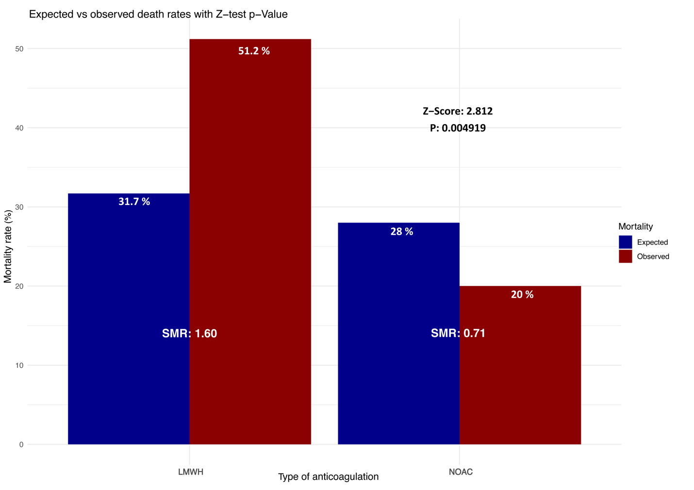
Fig. S4. Comparison of Expected and Observed Mortality in Patients with COVID-19 Receiving Anticoagulation: A Study of Standardized Mortality Ratios and Z-test Results.
This chart contrasts expected and observed mortality rates in patients with COVID-19 under low-molecular-weight heparin (LMWH) and novel oral anticoagulant (NOAC) treatments. Dark blue bars show expected rates, while red bars show actual rates. The standardized mortality ratio (SMR) indicated a 60% excess in observed deaths relative to SAPS3 predictions in the LMWH group. In contrast, the NOAC group showed a 29% reduction in deaths compared to predicted rates. The Z score and p-value highlight the significant difference and demonstrate the impact of treatment choice based on the SAPS3 framework.

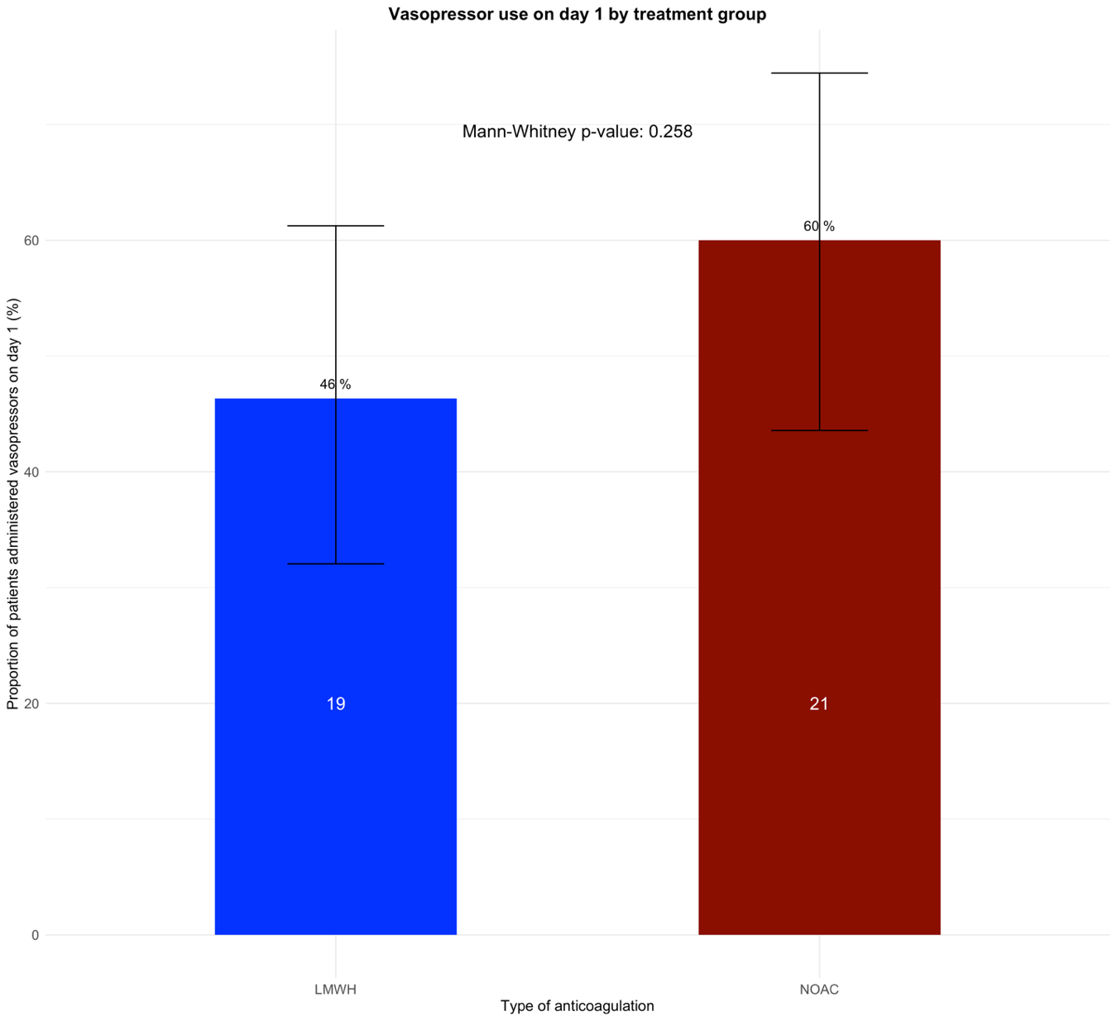
Fig. S5 - Vasopressor use on day 1 of ICU admission in both treatment groups.
This bar chart depicts the percentage of patients who received vasopressors on the first day in the intensive care unit (ICU) between the two groups. Vasopressors were administered to 40 of 76 patients (52.63%). The high usage within 24 hours of ICU admission may indicate challenges in low-molecular-weight heparin (LMWH) bioavailability. The subcutaneous route may hinder therapeutic efficacy in hemodynamic instability or shock. Further study of LMWH pharmacokinetics in acute care and compromised perfusion may elucidate mechanisms affecting its bioavailability.
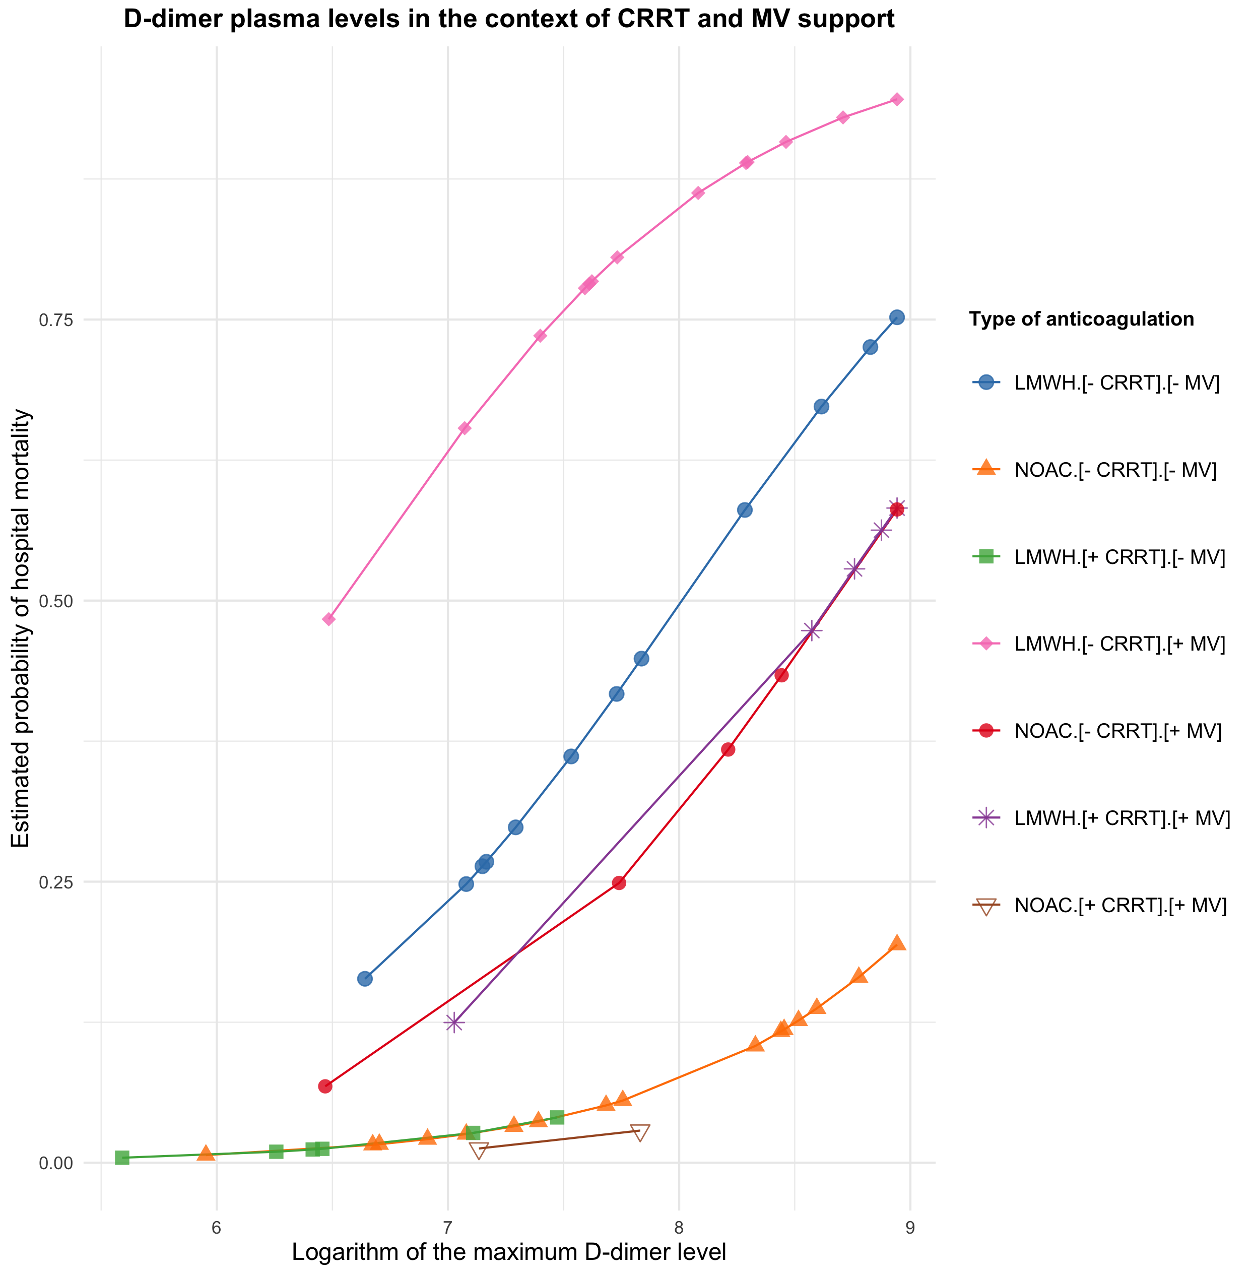

Fig. S6 shows the impact of anticoagulation therapies and supportive treatments on hospital mortality risk in relation to plasma D-dimer levels.
This figure illustrates a logistic regression analysis of low-molecular-weight heparin (LMWH) and novel oral anticoagulant (NOAC) therapies on hospital mortality, focusing on maximum D-dimer levels. Higher D-dimer levels elevate mortality risk in both cohorts, particularly with LMWH. In the LMWH cohort, continuous renal replacement therapy (CRRT) with a diffusive large-pore polysulfone (dlPP) membrane decreases mortality risk. Mechanical ventilation (MV) heightens mortality risk, particularly at higher plasma D-dimer levels.
The dlPP membrane is a hemofiltration membrane that adsorbs endotoxins. It is made of polyacrylonitrile-polyethyleneimine (PAN-PEI).

Variance inflation factor (VIF) analysis and justification for excluding the SAPS3 and SOFA scores
Variance Inflation Factor (VIF) Analysis and Justification for Excluding SAPS3 and SOFA Scores VIF analysis was conducted to assess multicollinearity among predictor variables. The SAPS3 and SOFA scores exhibited high VIF values, indicating substantial collinearity with other predictors. Consequently, these scores were excluded from the final model to enhance its stability and interpretability. This decision aligns with statistical best practices, which recommend removing highly correlated variables to prevent model overfitting and improve the reliability of coefficient estimates. The exclusion of SAPS3 and SOFA scores
Our propensity score and Cox proportional hazards models assessed potential multicollinearity among predictor variables using the variance inflation factor (VIF). High VIF values indicate significant multicollinearity, which can distort coefficient estimation and inflate standard errors.
Initial model incorporating SAPS3 and SOFA scores:
- SAPS3: 52
- SOFA: 8.126
These values indicated substantial multicollinearity, necessitating the removal of these variables. The adjusted model excluded SAPS3 and SOFA scores:
- Highest VIF: DD_SCORE at 2.406
- Most variance inflation factors (VIFs) were below 2.
This reduction in the VIF values indicated that multicollinearity was substantially mitigated, resulting in a more stable and interpretable model.

Table S1. Comparative table of odds ratios and log odds (95% confidence intervals) and their significance across three analytical methods.
Variable (Hospital mortality) | Analysis method | Odds ratio (OR) | Lower CI (95%) | Upper CI (95%) | Log odds (Coef) | Lower CI (95%) | Upper CI (95%) | p value
NOAC vs. LMWH | Contingency table | 0.2455 | 0.0816 | 0.6698 | - | - | - | 0.0055
NOAC vs. LMWH | Logistic regression | 0.045 | 0.0072 | 0.2821 | -3.09671 | -4.936 | -1.264 | 0.00093
D-dimer (linear) | Logistic regression | 8.24 | 1.295 | 52.315 | 2.11 | 0.259 | 3.961 | < 0.05
SAPS3 score | Logistic regression | 1.105 | 1.013 | 1.205 | 0.1 | 0.013 | 0.187 | < 0.05
D-dimer (linear) | Polynomial logistic regression | 2.723 | 1.311 | 5.661 | 12.5916 | 4.0307 | 21.1525 | 0.00178
NOAC vs. LMWH | Polynomial logistic regression | 0.071 | 0.0092 | 0.553 | -26.427 | -45.335 | -0.7519 | 0.00614
Table S1. This table presents a detailed comparative analysis of odds ratios and log odds with their 95% confidence intervals, using three distinct analytical methods—contingency table, logistic regression, and polynomial logistic regression—to assess hospital mortality. NOAC treatment, compared with LMWH, significantly reduced mortality risk, with odds ratios of 0.2455 according to contingency analysis (p = 0.0055) and 0.045 according to logistic regression (p < 0.001), confirming the efficacy of NOACs in lowering mortality. Additionally, D-dimer levels are significantly associated with increased mortality, with odds ratios of 8.24 according to logistic regression and 2.723 according to polynomial logistic regression, emphasizing the importance of monitoring coagulation markers. These findings substantiate the significant role of NOAC treatment in enhancing survival outcomes in patients with severe COVID-19 and establish D-dimer levels as crucial prognostic indicators.
Abbreviations: CI, confidence interval; COVID-19, coronavirus disease 2019; LMWH, low-molecular-weight heparin; MFI, modified frailty index; NOAC, novel oral anticoagulant; SAPS3, Simplified Acute Physiology Score 3
Table S2. Cox proportional hazards model results assessing in-hospital mortality
Variable | coef | Exp (coef) | Se (coef) | z value | Pr(>|z|) | Exp (coef) lower .95 | Exp (coef) upper .95
NOAC × LMWH (Hospital mortality) | -1.602003 | 0.201492 | 0.624694 | -2.564 | 0.0103* | 0.05923 | 0.6855
Septic shock D1 | -0.260546 | 0.77063 | 0.506516 | -0.514 | 0.607 | 0.28556 | 2.0797
MFI points (Frailty) | 0.266042 | 1.30479 | 0.138661 | 1.919 | 0.055 . | 0.99429 | 1.7123
D-dimer score | 0.694557 | 2.002821 | 0.287105 | 2.419 | 0.0156* | 1.14093 | 3.5158
IMPROVE-DD score | -0.059015 | 0.942692 | 0.26677 | -0.221 | 0.8249 | 0.55885 | 1.5902
Deep venous thrombosis | -0.454673 | 0.634655 | 0.990702 | -0.459 | 0.6463 | 0.09104 | 4.4241
Anticoagulation intensity (Full AC × Thromboprophylaxis) | 0.316328 | 1.37208 | 0.61949 | 0.511 | 0.6096 | 0.40744 | 4.6205
Lung CT score | -0.147142 | 0.863172 | 0.3505 | -0.42 | 0.6746 | 0.43426 | 1.7157
BMI | -0.062938 | 0.939002 | 0.070551 | -0.892 | 0.3723 | 0.81774 | 1.0782
Diabetes | -0.686041 | 0.503566 | 0.559517 | -1.226 | 0.2201 | 0.16819 | 1.5077
Charlson comorbidity Index | 0.487221 | 1.627787 | 0.218796 | 2.227 | 0.026* | 1.06013 | 2.4994
Age | -0.009552 | 0.990494 | 0.028241 | -0.338 | 0.7352 | 0.93716 | 1.0469
Transfusion | 1.430992 | 4.182845 | 1.00739 | 1.42 | 0.1555 | 0.58074 | 30.1276
Sex (Female) | 0.525003 | 1.690463 | 0.656295 | 0.8 | 0.4237 | 0.46705 | 6.1185
Bleeding | 0.046402 | 1.047495 | 1.0017 | 0.046 | 0.9631 | 0.14706 | 7.4611
Asthma/COPD | -1.081525 | 0.339078 | 0.761599 | -1.42 | 0.1556 | 0.07621 | 1.5086
Mechanical ventilation | -0.249985 | 0.778812 | 0.620208 | -0.403 | 0.6869 | 0.23095 | 2.6264
Vasopressors 1 h | -0.18179 | 0.833776 | 0.668218 | -0.272 | 0.7856 | 0.22504 | 3.0891
Continuous renal replacement therapy | -1.856401 | 0.156234 | 0.930816 | -1.994 | 0.0461* | 0.0252 | 0.9685
Signif. codes: 0 “***” 0.001 “**” 0.01 “*” 0.05 “.” 0.1 “” 1
- Concordance = 0.823 (se = 0.04)
- Likelihood ratio test = 40.58 on 19 df, p = 0.003
- Wald test = 28.03 on 19 df, p = 0.08
- Score (log-rank) test = 39.32 on 19 df, p = 0.004
- coef: The regression coefficient for each variable, representing the log odds change in the hazard for a one-unit increase in the variable.
- Exp(coef): The exponentiation of the regression coefficient, known as the hazard ratio (HR), indicates how much the hazard increases (HR > 1) or decreases (HR < 1) for a one-unit increase in the variable.
- Se(coef): The standard error of the regression coefficient, indicating the precision of the estimated coefficient.
- z value: The z score from the hypothesis test that the coefficient equals zero; a higher absolute value indicates a stronger effect.
- Pr(>|z|): p value associated with the hypothesis test, reflecting the probability that the observed effect or an effect more extreme occurs under the null hypothesis (no effect).
- Exp(coef) lower .95: The lower bound of the 95% confidence interval for the hazard ratio, providing a range of plausible values for the HR that are consistent with the data.
- Exp(coef) upper .95: The upper bound of the 95% confidence interval for the hazard ratio.
This table presents the results from the Cox proportional hazards model, which evaluates associations between clinical and demographic variables and hospital mortality, as described in Figure 5. The model includes variables such as treatment type (NOACs vs. LMWH), septic shock presence on day 1, MFI points, D-dimer score, improved D-dimer score, DVT presence, anticoagulation intensity (full anticoagulation and thromboprophylaxis), lung tomography score, BMI, diabetes status, Charlson comorbidity index, age, blood transfusion history, sex, bleeding presence, pulmonary conditions (asthma and/or COPD), MV status, vasopressor use within 1 hour, and CRRT. The table provides coefficients, hazard ratios (exp(coef)), standard errors, z values, p values, and 95% confidence intervals for hazard ratios. Model robustness is indicated by a C-index of 0.823, with statistical significance confirmed by likelihood ratio, Wald, and score (log-rank) tests.
Abbreviations: BMI (body mass index), COPD (chronic obstructive pulmonary disease), CT (computed tomography), Full AC (full anticoagulation), LMWH (low-molecular-weight heparin), MFI (modified frailty index), NOAC (novel oral anticoagulant)
Table S3. Effect of D-dimer blood level on in-hospital mortality: polynomial logistic regression model.
Variable | Estimate | Std. Error | z value | Pr(>|z|)
(Intercept) | 0.4081 | 0.4278 | 0.954 | 0.34008
poly(LOG_DD_MAX, 2)1 | 12.5916 | 4.0307 | 3.124 | 0.00178**
poly(LOG_DD_MAX, 2)2 | 0.3879 | 4.0099 | 0.097 | 0.92294
HEPARINASNOAC | -2.6427 | 0.9644 | -2.74 | 0.00614**
poly(LOG_DD_MAX, 2)1:HEPARINASNOAC | -7.0625 | 6.4304 | -1.098 | 0.27208
poly(LOG_DD_MAX, 2)2:HEPARINASNOAC | 15.3577 | 8.208 | 1.871 | 0.06134
This table presents the results of the best-fit logistic regression model examining the effect of the maximum plasma D-dimer level (LOG_DD_MAX) on hospital mortality, including interaction terms with anticoagulant therapies (HEPARINAS). The model incorporates polynomial terms for LOG_DD_MAX and their interactions with HEPARINAS, as illustrated in Figure 6. Coefficients (Estimates) and their standard errors (Std. Error) are reported along with the z values and corresponding p values for testing the null hypothesis that the coefficient equals zero. The significance codes indicate the level of statistical significance: p < 0.001***, p < 0.01**, p < 0.05*, p < 0.1, and p ≥ 0.1.
- Intercept: The baseline log odds of hospital mortality.
- poly(LOG_DD_MAX, 2)1: The linear term for the maximum plasma D-dimer level.
- poly(LOG_DD_MAX, 2)2: The quadratic term for the maximum plasma D-dimer level.
- HEPARINASNOAC: Indicator variable for patients receiving NOAC therapy compared with those receiving LMWH therapy.
- poly(LOG_DD_MAX, 2)1: Interaction term between the linear D-dimer level and NOAC therapy.
- poly(LOG_DD_MAX, 2)2: Interaction term between the quadratic D-dimer level and NOAC therapy.
The deviance residuals summarize the model fit. The null deviance indicates the model's fit without predictors, while the residual deviance indicates the fit with predictors. The Akaike Information Criterion (AIC) measures the model's relative quality. The number of Fisher scoring iterations indicates the iterations required for model convergence.

Table S4. Logistic regression model coefficients for predicting hospital mortality.
Variable | Estimate | Std. Error | z value | Pr(>|z|)
Intercept | -5.66649 | 2.52464 | -2.244 | 0.024802 *
TREATMENT | -3.09671 | 0.93547 | -3.310 | 0.000932***
DD_BYSCORE.L | 2.10710 | 2.10710 | 2.259 | 0.023869 *
DD_BYSCORE.Q | 1.80124 | 0.99276 | 1.814 | 0.069622
DD_BYSCORE.C | -0.62290 | 0.86487 | -0.720 | 0.471388
DD_BYSCORE^4 | 1.09152 | 0.80140 | 1.362 | 0.173194
CODE_BYTREATMENT2 | 0.62522 | 0.86783 | 0.720 | 0.471251
ARTERIAL_HYPERTENSION1 | 0.05599 | 0.80009 | 0.070 | 0.944208
Lung_Tomography_Score | 0.34945 | 0.34945 | 0.739 | 0.459611
SAPS3Points | 0.09654 | 0.04395 | 2.196 | 0.028061 *
SOFA_Score | -0.07145 | 0.16208 | -0.441 | 0.659337
p < 0.001***, p < 0.01**, p < 0.05*, p < 0.1, and p ≥ 0.1.
This table presents coefficients from a logistic regression model predicting hospital mortality. The model includes treatment type NOAC vs. LMWH (TREATMENT1), D-dimer score components (DD_BYSCORE. L, DD_BYSCORE. Q, DD_BYSCORE. C, DD_BYSCORE^4), treatment code (CODE_BYTREATMENT2) representing full anticoagulation vs. thromboprophylaxis, arterial hypertension (ARTERIAL_HYPERTENSION1), lung tomography score (Lung_Tomography_Score), SAPS3 points (SAPS3Points), and SOFA score (SOFA_Score). The coefficients represent the change in log odds of hospital mortality associated with a one-unit change in the predictor variable. Significant predictors (p < 0.05) included treatment type (NOACs vs. LMWH), linear D-dimer score, and SAPS3 score. Variables with p > 0.05 were not significant predictors in this model. The log-odds coefficient of D-dimer levels is 2.10710, indicating that for each unit increase in the D-dimer score, the log-odds of mortality increase by 2.10710. This translates to a significant increase in the probability of mortality for each unit increase in the D-dimer score. For example, if the baseline probability of mortality is 10%, a one-unit increase in the D-dimer score raises this probability to approximately 47.8%. This change applies to both NOAC and LMWH treatments.
Abbreviations: LMWH, low-molecular-weight heparin; NOAC, novel oral anticoagulant; SAPS3, Simplified Acute Physiology Score 3; SOFA, Sequential Organ Failure Assessment

Table S5. Contingency table for mortality risk comparison between LMWH and NOAC treatments.
Treatment | Alive (0) | Deceased (1) | Total
LMWH | 20 | 21 | 41
NOAC | 28 | 7 | 35
Total | 48 | 28 | 76
- Odds ratios with 95% CIs
Treatment | Estimate | Lower | Upper
LMWH | 1.000 | NA | NA
NOAC | 0.2455 | 0.0816 | 0.6698
- Fisher’s test results
LMWH | NA | NA | NA
NOAC | 0.0055 | 0.0082 | 0.0049

This table presents a comparative mortality risk analysis of patients with severe COVID-19 treated with either LMWH or NOACs. The data are categorized by treatment outcome, distinguishing between patients who survived (0) and those who died (1). In the LMWH group, 20 patients survived, and 21 died (total: 41). In the NOACs group, 28 patients survived, and 7 died (total: 35). Overall, 48 patients survived, and 28 died (total: 76). The odds ratio with 95% confidence interval (CI) for LMWH is set as the reference value (1.000), whereas for NOACs, it is 0.2455 (95% CI, 0.0816-0.6698), indicating a significantly lower mortality risk compared to LMWH. Fisher’s test for NOACs revealed a p-value of 0.0055, reinforcing the statistical significance of the lower mortality odds observed with NOAC treatment.
Abbreviations: CI, confidence interval; COVID-19, coronavirus disease 2019; LMWH, low-molecular-weight heparin; NA, not applicable; NOAC, novel oral anticoagulant.
Table S6. Variance inflation factor (VIF) analysis and covariate balance.
Variable | VIF | VIF (without SAPS3/SOFA)
Septic shock D1 | 4.1478 | 1.6700
MFI points (Frailty) | 1.7827 | 1.6316
D-dimer score | 2.3884 | 2.4059
IMPROVE-DD score | 2.2594 | 1.9797
Deep venous thrombosis | 1.4530 | 1.4319
Lung tomography score | 1.6604 | 1.5595
BMI | 2.0331 | 1.8340
Diabetes | 1.7278 | 1.6574
Charlson comorbidity index | 1.6970 | 1.7124
Age | 2.6191 | 1.8855
Transfusion | 1.8433 | 1.8432
Sex | 1.3351 | 1.2660
Bleeding | 1.3182 | 1.2800
Asthma/COPD | 1.7303 | 1.6057
Mechanical ventilation | 1.7510 | 1.7367
Vasopressors 1 h | 1.6952 | 1.5740
CRRT | 1.6666 | 1.645
*SAPS3 points | 5.2057 | Removed
*SOFA score | 8.1258 | Removed
Justification for variable exclusion: The exclusion of the SAPS3 and SOFA scores was further justified by their lack of statistical significance in the univariate analysis. Despite these variables being balanced between treatment groups, their high Variance Inflation Factor (VIF) values were detrimental to the model's performance. By excluding these variables, we achieved a better-balanced and more robust model suitable for accurately assessing treatment effects. This approach ensures that the propensity score model is well-balanced and that the subsequent Cox model is reliable for analyzing mortality outcomes between the NOAC and LMWH groups in our retrospective observational study of patients with COVID-19 in critical care.
Abbreviations: BMI, body mass index; COPD, chronic obstructive pulmonary disease; COVID-19, coronavirus disease 2019; CRRT, continuous renal replacement therapy; LMWH, low-molecular-weight heparin; MFI, modified frailty index; NOAC, novel oral anticoagulant; SAPS3, Simplified Acute Physiology Score 3; SOFA, Sequential Organ Failure Assessment.

Table S7. Balance table for the propensity score via the “full” matching method.
Variable | Means NOAC | Means LMWH | Std. Mean Diff. | Var. Ratio | eCDF Mean | eCDF Max
Distance | 0.6444 | 0.3036 | 1.4849 | 0.846 | 0.3376 | 0.6049
Septic shock D1 | 0.4571 | 0.3902 | 0.1343 |  | 0.0669 | 0.0669
MFI points (Frailty) | 2.3714 | 2.5122 | -0.0966 | 0.7061 | 0.0329 | 0.0927
D-dimer score | 3.6286 | 3.0244 | 0.4147 | 1.1325 | 0.1208 | 0.2098
IMPROVE-DD score | 4.6286 | 4.4878 | 0.0905 | 1.0955 | 0.0507 | 0.1115
Deep venous thrombosis | 0.0571 | 0.0976 | -0.1741 |  | 0.0404 | 0.0404
Lung CT score | 2.7429 | 2.3171 | 0.5213 | 0.7652 | 0.0852 | 0.2139
BMI | 27.5171 | 27.822 | -0.0621 | 1.2289 | 0.0657 | 0.2091
Diabetes | 0.4286 | 0.5122 | -0.169 |  | 0.0836 | 0.0836
Charlson comorbidity index | 4.7429 | 4.9268 | -0.0953 | 0.927 | 0.0244 | 0.0913
Anticoagulation intensity (Full AC or Thromboprophylaxis) | 1.2286 | 1.3171 | -0.2077 | 0.8178 | 0.0443 | 0.0885
Age | 71.6857 | 74.5366 | -0.1922 | 0.963 | 0.054 | 0.1498
Transfusion | 0.0571 | 0.2195 | -0.6995 |  | 0.1624 | 0.1624
Sex (Female) | 1.4 | 1.4146 | -0.0294 | 0.9931 | 0.0073 | 0.0146
Bleeding | 0.0571 | 0.0488 | 0.036 |  | 0.0084 | 0.0084
Asthma/COPD | 0.2571 | 0.1707 | 0.1977 |  | 0.0864 | 0.0864
Mechanical ventilation | 0.4 | 0.5122 | -0.229 |  | 0.1122 | 0.1122
Vasopressors 1 h | 0.6 | 0.4634 | 0.2788 |  | 0.1366 | 0.1366
Continuous renal replacement therapy | 0.0571 | 0.2927 | -1.0148 |  | 0.2355 | 0.2355
Table S7 Legend - Means for NOACs and LMWH indicate the average values of variables in the NOAC and LMWH groups, respectively. Std. Mean Diff. represents the standardized mean difference between the groups. The var. ratio denotes the variance ratio between the groups. eCDF Mean and eCDF Max represent the differences in the empirical cumulative distribution function (eCDF) mean and maximum, respectively.
Abbreviations: BMI, body mass index; COPD, chronic obstructive pulmonary disease; CT, computed tomography; Full AC, full anticoagulation; LMWH, low-molecular-weight heparin; MFI, modified frailty index; NOACs, novel oral anticoagulants.

Table S8. Summary of balance for matched data.
Variable | Means NOAC | Means LMWH | Std. Mean Diff. | Var. Ratio | eCDF Mean | eCDF Max | Std. Pair Dist.
Distance | 0.6444 | 0.6272 | 0.0749 | 0.9863 | 0.0259 | 0.1429 | 0.1797
Septic shock D1 | 0.4571 | 0.3613 | 0.1924 | . | 0.0958 | 0.0958 | 1.0888
MFI points (Frailty) | 2.3714 | 2.5649 | -0.1328 | 0.9325 | 0.0371 | 0.1958 | 1.2797
D-dimer score | 3.6286 | 3.472 | 0.1074 | 1.1237 | 0.0596 | 0.1006 | 0.9423
IMPROVE-DD score | 4.6286 | 4.619 | 0.0061 | 1.8222 | 0.0716 | 0.1506 | 0.894
Deep venous thrombosis | 0.0571 | 0.0423 | 0.0641 | . | 0.0149 | 0.0149 | 1.3874
Lung CT score | 2.7429 | 2.7351 | 0.0095 | 0.7723 | 0.017 | 0.0446 | 1.1827
BMI | 27.5171 | 27.0563 | 0.0938 | 2.0213 | 0.1088 | 0.2375 | 0.9045
Diabetes | 0.4286 | 0.5845 | -0.3151 | . | 0.156 | 0.156 | 1.0275
Charlson comorbidity index | 4.7429 | 5.6774 | -0.4841 | 0.9818 | 0.0949 | 0.1857 | 1.1766
Anticoagulation intensity (Full AC or Thromboprophylaxis) | 1.2286 | 1.322 | -0.2193 | 0.7567 | 0.0467 | 0.0935 | 1.0344
Age | 71.6857 | 77.4226 | -0.3867 | 1.5162 | 0.0975 | 0.25 | 1.0466
Transfusion | 0.0571 | 0.0488 | 0.0359 | . | 0.0083 | 0.0083 | 0.8762
Sex (Female) | 1.4 | 1.4036 | -0.0072 | 0.9343 | 0.0018 | 0.0036 | 0.9548
Bleeding | 0.0571 | 0.0875 | -0.1308 | . | 0.0304 | 0.0304 | 0.4381
Asthma/COPD | 0.2571 | 0.3827 | -0.2874 | . | 0.1256 | 0.1256 | 0.6593
Mechanical ventilation | 0.4 | 0.4857 | -0.175 | . | 0.0857 | 0.0857 | 1.1763
Vasopressors 1 h | 0.6 | 0.6655 | -0.1337 | . | 0.0655 | 0.0655 | 1.2801
Continuous renal replacement therapy | 0.0571 | 0.0357 | 0.0923 | . | 0.0214 | 0.0214 | 1.0223

Table S8 Legend: Means NOAC: The mean values of variables in the NOACs group.
Means LMWH: The mean values of variables in the LMWH group.
Std. Mean Diff: The standardized mean difference between the NOACs and LMWH groups.
Var. Ratio: The variance ratio between the NOACs and LMWH groups.
eCDF Mean: The mean difference in the empirical cumulative distribution function (eCDF) between the NOACs and LMWH groups.
eCDF Max: The maximum difference in the eCDF between the NOACs and LMWH groups.
Std. Pair Dist. : The standardized pairwise distance between the treated and control groups after matching.
Abbreviations: BMI, body mass index; COPD, chronic obstructive pulmonary disease; CT, computed tomography; Full AC, full anticoagulation; LMWH, low-molecular-weight heparin; MFI, modified frailty index; NOAC, novel oral anticoagulant.

Table S9. Sample sizes.
All | LMWH | NOAC
 | 41 | 35
Matched (ESS) | 11.14 | 35
Matched | 41. | 35
Unmatched | 0. | 0
Discarded | 0. | 0
Table S9 legend: LMWH: Number of patients in the dataset NOACs: Number of patients in the dataset All: Total number of patients in both groups before matching Matched (ESS): Effective sample size of matched LMWH after matching, accounting for weights applied in the matching process Matched: Actual number of patients with LMWH and NOACs matched Unmatched: Number of patients with LMWH and NOACs not matched Discarded: Number of patients with LMWH and NOACs excluded during the matching process
This table provides a detailed summary of the balance achieved between the NOACs and LMWH groups after matching via the full propensity score matching method. The listed variables are potential confounders, and their balance is crucial for the validity of the propensity score analysis. The reported metrics help assess the quality of the matching process and ensure that the NOACs and LMWH groups are comparable.
The odds ratio (OR) of 0.045 indicates that the odds of mortality for patients treated with Novel Oral Anticoagulants (NOACs) are 4.5% of those for patients treated with Low Molecular Weight Heparin (LMWH). This signifies a substantial reduction in mortality risk with NOACs. An OR of 0.045 translates to a 95.5% lower risk of mortality with NOACs compared to LMWH. This calculation is derived by subtracting the OR from 1 (1 - 0.045 = 0.955), resulting in a 95.5% reduction. Additionally, inverting the OR provides an approximate factor by which the mortality risk is greater with LMWH than with NOACs. Specifically, the inverse of 0.045 is approximately 22.22, meaning that the odds of mortality for patients on LMWH are about 22 times greater than those for patients on NOACs. For a detailed explanation of this calculation, please refer to the supplementary material.
Our study offers a unique historical perspective on anticoagulation therapy in critically ill patients with COVID-19, conducted during the first wave of the pandemic. This research provides valuable insights into managing severe cases, carried out in the pre-vaccination era. While the pandemic landscape has evolved significantly since then, the emergence of new SARS-CoV-2 variants underscores the ongoing relevance of our findings. As we continue to face the possibility of severe cases requiring intensive care, particularly those induced by new variants, the potential advantages of NOACs demonstrated in our study remain pertinent to current and future treatment strategies.
Table S10 focuses on key SARS-CoV-2 variants recognized for their substantial impact on global public health. These variants are highlighted due to their enhanced transmissibility, potential to evade immune responses, and association with more severe clinical presentations. The table excludes variants with lesser or localized impacts to concentrate on those that have significantly influenced pandemic trends and shaped international health policies.
Table S10 Legends: Abbreviations: DVT, deep vein thrombosis; NOACs, novel oral anticoagulants; PE, pulmonary embolism; VTE, venous thromboembolism:
The scientific nomenclature identifies the specific strain of SARS-CoV-2.
Date of Discovery: The variant was first identified
Key Characteristics: Distinctive features of the variant include mutations in the spike protein that influence its behavior. These mutations affect transmissibility, ability to evade immune responses, and potential impacts on vaccine efficacy.
Transmissibility: Increased ease of spread compared to previous variants.
Impact on Immunity: This section describes the variant’s interactions with the immune system, including its ability to evade immune protection conferred by previous infections or vaccinations.
Notable Outcomes: Epidemiological Impact and Clinical Severity
Classification: VOC (Variant of Concern): Exhibits increased transmissibility, disease severity, or immune escape, significantly impacting public health. VOI (Variant of Interest): Mutations with potential or demonstrated impacts on viral characteristics and transmission that warrant monitoring.
https://www.who.int/activities/tracking-SARS-CoV-2-variants (Accessed August 8, 2024).
European Centre for Disease Prevention and Control (ECDC). COVID-19 variants of concern. Available online: https://www.ecdc.europa.eu/en/covid-19/variants-concern (Accessed [08/08/2024]).
Centers for Disease Control and Prevention (CDC). "SARS-CoV-2 Variant Classifications and Definitions." Available online: https://www.cdc.gov/coronavirus/2019-ncov/variants/variant-classifications.html (Accessed August 8, 2024).
Since our study, the COVID-19 pandemic landscape has changed significantly. Widespread vaccination campaigns and milder variants have altered the disease’s overall clinical picture. However, severe cases requiring ICU admission still occur, especially with new variants that may partially evade immune protection or cause more severe illness in vulnerable populations. Our findings on the efficacy of NOACs in reducing mortality among critically ill COVID-19 patients remain relevant in this context. The potential advantages of NOACs, including their oral administration and predictable pharmacokinetics, could particularly benefit the management of future severe cases. As we continue to navigate the evolving SARS-CoV-2 virus, our study provides a foundation for considering NOACs as a valuable tool in treating severe COVID-19 cases, regardless of the causative variant.

Table S10. Key SARS-CoV-2 Variants: Focus on the Most Impactful Strains

Variant | Date of Discovery | Key Characteristics | Transmissibility | Impact on Immunity | Notable Outcomes | Classification
Alpha (B.1.1.7) | September 2020 | N501Y, D614G, P681H | Increased | Reduced | High initial mortality | VOC
Beta (B.1.351) | May 2020 | K417N, E484K, N501Y | Increased | Reduced | Immune evasion | VOC
Gamma (P.1) | November 2020 | K417T, E484K, N501Y | Increased | Reduced | Immune evasion | VOC
Delta (B.1.617.2) | October 2020 | L452R, T478K, D614G, P681R | Increased | Reduced | Global dominance | VOC
Omicron (BA.1) | November 2021 | Multiple spike mutations | Increased | Reduced | Rapid spread | VOC
Omicron (BA.2) | November 2021 | Similar to BA.1 with slight genetic differences | Increased | Reduced | High transmission | VOC
Omicron (BA.5) | February 2022 | L452R, F486V, R493Q | Increased | Reduced | Dominant in 2022 | VOC
XBB.1.5 | December 2022 | S:Q183E, S:F486P, S:F490S | Increased | Increased | Limited cross-immunity | VOI
KP.3 (FLiRT) | July 2024 | Q493E, F456L | Increased | Increased | Dominant in the U.S. | VOI
LB.1 | June 2024 | S:S31del | Higher than KP.3 | Increased | Rapidly emerging | VOI
Eris (EG.5) | August 2023 | E484A, Q498R, N501Y | Increased | Reduced | Increased spread | VOI

