Shape Recovering Liquids

Anthony Raykh^{1,4}, Joseph D. Paulsen², Alex McGlasson¹, Chaitanya Joshi³, Timothy J. Atherton³, Hima Nagamanasa Kandula⁴, David Hoagland*¹, Thomas P. Russell*^{1,5,6}
¹Department of Polymer Science and Engineering, University of Massachusetts Amherst, Amherst, MA, 01003, Massachusetts United States
²Department of Physics, Syracuse University, Syracuse, New York, 13244, United States
³Department of Physics, Tufts University, Medford, Massachusetts, 02155
⁴Department of Physics, University of Massachusetts Amherst, Amherst, Massachusetts, 01003, United States
⁵Materials Sciences Division, Lawrence Berkeley National Laboratory, Berkeley, CA 94720
⁶Advanced Institute for Materials Research, Tohoku University,2-1-1 Katahira, Aoba, Sendai 980-8577 (Japan)
*Corresponding Authors’ Emails: russell@mail.pse.umass.edu, hoagland@mail.pse.umass.edu

Supporting Information

Interfacial Shape Analysis:
To understand the urn shape of the interface, the Young-Laplace equation was solved assuming a spatially uniform interfacial tension γ_{o/w}, giving this interface a constant capillary length l_{c} equal to (γ_{o/w}/(ρ_{o} -ρ_{w})g)^{1/2}. Describing the interface in terms of a parametric curve [x(s), z(s)], where s is arc length, the Young-Laplace equation can be written in Cartesian coordinates as a system of ordinary differential equations¹:
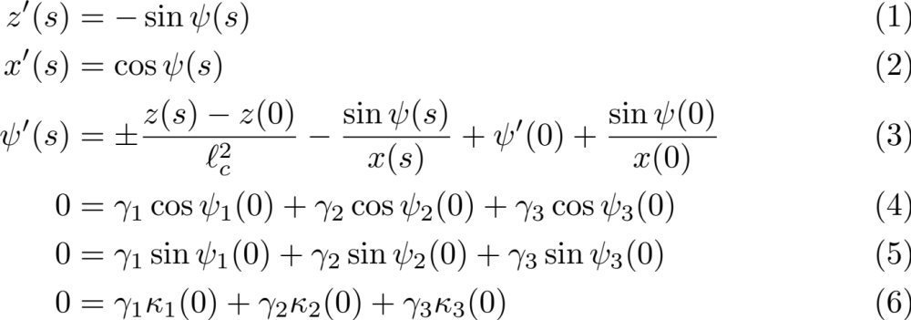

where z is height, x is distance from the axis of symmetry, ψ (s) is the angle of the curve at s, and primes designate derivatives with respect to s. The sign of the first term in the equation for ψ′ (s) is determined by the relative fluid densities and is positive when the denser fluid is encountered to the right of the direction of increasing s. Equations (1-3) may be integrated from an arbitrary starting point [x(0), z(0)] by specifying the local slope ψ (0) and local curvature ψ ′ (0).
The 16.6 mm-diameter vials that hosted the urns could distort their visual appearances due to the refraction of light passing through the curved glass walls. To minimize the distortion in photographs, the vials were immersed in a square water tank to minimize refractive index mismatches. Figure S1 compares photographed and predicted (solid and dashed white curve) interface shapes for γ_{o/w}= 32 mN/m, ρ_{o} = 1.39 g/cm³, and ρ_{w} = 1.00 g/cm³. The shapes agree along most of the urn, although there is obvious deviation near the top, where the predicted curve is dashed.
A three-phase contact line could explain the deviation, and to test this hypothesis, oil/water, oil/air, and water/air interfaces were posited to exist in this region. Sitting [x(0), z(0)] at the putative three-phase contact line, all three interface shapes were integrated from this starting point using eqs. (1-3), with l_{c} set by the appropriate surface tension and density difference for each interface. The integration for each interface required initial values of ψ (0) and ψ´ (0), which were not independent since mechanical equilibrium at the three-phase contact line constrained their values according to:
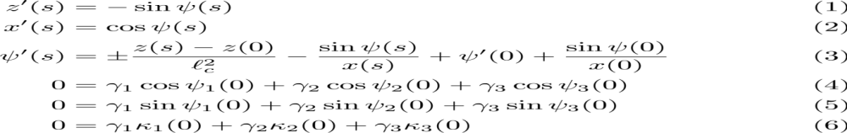
where subscripts distinguish oil/water (γ₁, ψ₁, κ₁), oil/air (γ₂, ψ₂, κ₂), and water/air (γ₃, ψ₃, κ₃) interfaces, and κ_{i}(0) = ψ´_{i}(0) + [sin ψ_{i}(0)]/x(0) capture the axisymmetric interfaces’ double mean curvatures. To obtain possible interface shapes, the triplet of values [γ_{i}, ψ_{i}(0), ψ_{i}´(0)] for only two interfaces were varied, with values for the third obtained from eqs. (4-6).
Figure S1 shows that the curve generated with γ_{o/w} = 32 mN/m, γ_{o} = 34 mN/m, and γ_{w} = 61 mN/m best fits the experimental curve. With these parameters the air/water interface terminated on the vial’s side wall, and the oil/water interface terminated at the vial bottom, which partially supported the oil phase. The new profiles closely match across the entire urn perimeter, and the three fitted surface tensions agree with values from tensiometry experiments. These results also support that the particle-coated oil-water interface was properly described by a spatially homogeneous surface tension. The urn shape thus reflects the liquid densities, interfacial tensions, liquid volumes, contact angles and vial size chosen to study the interfaces decorated by magnetic nanoparticles and does not reflect an unexpected interfacial attribute of magnetic nanoparticles.

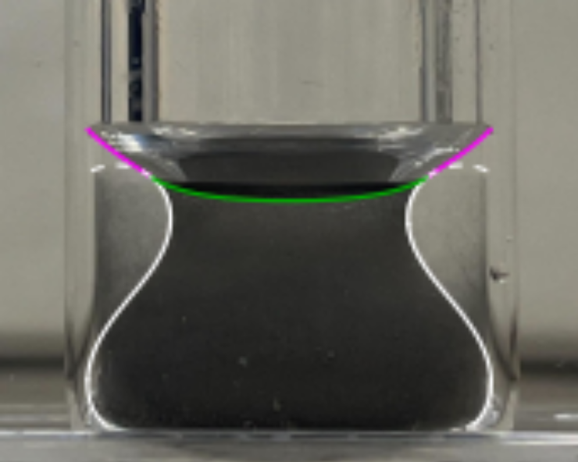

Figure S1. Side view of an urn observed in a submerged glass vial. Thick curves correspond to solutions of the axisymmetric Young-Laplace equation: the white curve traces the oil-water interface, the green curve traces the oil-air interface, and the pink curve traces the water-air interface. The dashed curve in the upper region is a continuation of the predicted oil-water interface in the absence of a three-phase contact line, this curve deviates from the urn outline.

Simulation of Interfacial Assembly

This interfacial assembly of magnetic nanoparticles was simulated in Morpho, an open-source programming environment for shape-optimization problems². In the simulations the interfacial nanoparticles were represented as $N$ dipoles located on the surface of a sphere of radius $R$. Each dipole $i$ possessed dipole moment $μ$ and orientation ${\hat{u}}_{i}$. The distance${\vec{r}}_{ij}$ between dipoles $i$ and $j$ was ${\vec{r}}_{i}-{\vec{r}}_{j}$, and letting $r_{ij}= {|\vec{r}}_{ij}|$, the pairwise dipole-dipole interaction energy ${U^{D}}_{ij}$was given
${U^{D}}_{ij} = \frac{μ^{2}}{4π{r_{ij}}^{3}}[{\hat{u}}_{i}⋅{\hat{u}}_{j} - 3 \frac{\left({\hat{u}}_{i}⋅{\vec{r}}_{ij}\right)\left({\hat{u}}_{j}⋅{\vec{r}}_{ij}\right)}{{r^{2}}_{ij}}$]
The dipoles also experienced a short-ranged hard-core repulsion of the form³,
$${U^{H}}_{ij} = \frac{μ^{2}}{16 π a^{3}}{\left(\frac{a}{r_{ij}}\right)}^{24}$$
where $a$ is the effective dipole radius. The algorithm optimized ${\vec{r}}_{i} for all i$to minimize the total energy E of the dipole assembly
$$E =\sum_{i=0}^{N-1}{\sum_{j=i+1}^{N-1}{\left(U_{ij}^{D}+U_{ij}^{H}\right)}}$$
In Morpho dipoles of unit magnitude and random orientation were initially placed at R as vertices of a point-cloud mesh. Minimization of E was achieved by optimizing dipole configuration, running until the relative energy difference $ΔE/E$ between successive simulated configurations was <$10^{-8}$. At each step dipole orientations were kept fixed while their positions were allowed to vary, a simplification justified by the much smaller times needed for translation rearrangement than for orientational rearrangement. This procedure does not necessarily find the minimized configuration since the last configuration simulated was likely to be trapped in a local energy minimum; however, the physical system was likely to be trapped in much the same way. The full code for this simulation is available on request.
Data from Literature:
Particle Diameter ($μm)$ | Droplet Diameter ($μm)$
0.5 | 45
1 | 55
1.5 | 60
2.7 | 61
Table S1. Average droplet diameters of Pickering emulsions as a function of particle diameter.⁴

Video S1 Agitating a DCM-water mixture containing nickel particles to form DCM droplets dispersed in water that coalesce into container-sized liquid phases separated by an interface shaped like a Grecian urn.
Video S2 Grecian Urn under high frequency magnetic field (~50Hz). It visibly rotates under effects of the applied field. Underneath the Urn, a shadow of a cluster of particles can be seen moving, showing clear evidence of rotation.

References:
1. Marchuk, I. V., V. V. Cheverda, P. A. Strizhak, and O. A. Kabov. "Determination of surface tension and contact angle by the axisymmetric bubble and droplet shape analysis." Thermophysics and Aeromechanics 22 (2015): 297-303.
2. Joshi, C. et al. Morpho -- A programmable environment for shape optimization and shapeshifting problems. Preprint at https://doi.org/10.48550/arXiv.2208.07859 (2022).
3. Kaiser, A., Snezhko, A. & Aranson, I. S. Flocking ferromagnetic colloids. Science Advances 3, e1601469 (2017).
4. Binks, B. P. & Lumsdon, S. O. Pickering Emulsions Stabilized by Monodisperse Latex Particles: Effects of Particle Size. Langmuir 17, 4540–4547 (2001).

