Supplementary Information

Multi-Project Wafer Runs for Electronic Graphene Devices in the European Project “2D-Experimental Pilot Line”
Bárbara Canto,¹ Martin Otto,¹ Arantxa Maestre,^{2, &} Alba Centeno,² Amaia Zurutuza,² Bianca Robertz,¹ Eros Reato,³ Bartos Chmielak,¹ Stefanie L. Stoll,¹ Andreas Hemmetter,^{1,3} Florian Schlachter,¹ Lisa Ehlert,¹ Sha Li,^{1,§} Daniel Neumaier,^{1,4} Gordon Rinke,¹ Zhenxing Wang,^{1,*} Max C. Lemme^{1,3*}

¹ AMO GmbH, Otto-Blumenthal-Str. 25, 52074 Aachen, Germany
² Graphenea S.A., Paseo Mikeletegi 83, 20009 San Sebastián, Spain
³ RWTH Aachen University, Chair of Electronic Devices, Otto-Blumenthal-Str. 2, 52074 Aachen, Germany
⁴ University of Wuppertal, Chair of Smart Sensor Systems, Lise-Meitner-Str. 13, 42119 Wuppertal, Germany
* Correspondence: wang@amo.de, lemme@amo.de

S1 Raman Analysis
Raman maps were measured at the center and the edge of the wafer (see Methods in main paper). Typical Raman spectra, i.e., spectra with the median value of intensity ratio of the D and G peaks (I_{D}/I_{G}) for each respective map (after transfer and after fabrication), measured at the center of each wafer, are shown in Figure S1.1 for the two runs. For MPW run 1, the spectra after fabrication were measured on devices without encapsulation because it was not practical to measure the encapsulated graphene. The encapsulation was 200 nm thick for the MPW run 1 and severely decreased the intensity of the Raman signal. For MPW run 1, the D peak at around 1350 cm^{–1} is very small, indicating high graphene quality.¹ More importantly, there is no noticeable change in the D peak intensity before and after fabrication. For MPW run 3, on the other hand, there is an emergence of additional peaks and an increase of the D peak after the encapsulation. Typical spectra for all the fabrication steps are shown in Figure S1.2a for the MPW run 3. It is evident that only the encapsulation by ALD causes a significant increase in the D peak and additional Raman peaks in the vicinity of the D and G peaks. These peaks can be associated with amorphous carbon (a-C peak).^{2,3} However, when fitting the overlapping peaks in this region of the spectrum, it is difficult to differentiate between the D peak of graphene and the peaks attributed to the amorphous carbon. Because of this, it is quite possible that we are overestimating the amplitude of the D peak. The main cause for these additional peaks in MPW run 3 is the deposition method of the encapsulation in conjunction with the presence of photoresist residue on the graphene. For MPW run 1, the encapsulation was deposited by e-beam evaporation and the wafer remained at a temperature of less than 50 °C. For MPW run 3, the encapsulation was deposited by ALD at a chuck temperature of 300 °C, which corresponds to a wafer temperature of around 200 °C. This is hot enough to burn the resist residue from the graphene patterning step. The reason we believe this is related to burned resist and not to the ALD process itself, will be discussed here. The encapsulation process that was used (more details in the Methods section of the main paper) is a combination of the thermal ALD and PEALD process at 300 °C. However, these peaks only appear if the graphene has been subjected to lithography and RIE prior to ALD, i.e. there is resist residue present on the graphene. For example, Figure S1.2b shows spectra for three different scenarios before and after encapsulation: first, the encapsulation by e-beam evaporation at less than 50 °C from MPW run 1, second, the encapsulation by ALD at 300 °C and third, the encapsulation of graphene by ALD at 300 °C on a test wafer without prior lithography and RIE on the graphene. It is clear in the spectra from Figure S1.2b that the a-C peaks only appear for the combination of higher temperatures and prior lithography, leading us to believe that burning of resist residue is responsible for the appearance of these peaks. We were also able to repeat these results by simply heating samples of graphene with and without photolithography in vacuum, i.e. without deposition by ALD for temperatures between 100 and 300 °C (not shown here), confirming that ALD itself is not responsible for these peaks.
The statistics of I_{D}/I_{G} and the full width at half maximum of the 2D peaks, FWHM(2D), of the Raman maps are shown as box plots for the two runs in Figure S1.3a and S1.3b, respectively, after transfer and after fabrication for MPW run 1 and for MPW run 3. Each box contains the values of both maps for each displayed fabrication step and wafer: the map from the center of the wafer and the one from the edge (details in Methods). I_{D}/I_{G} increases from 0.04 to 0.07 after fabrication for MPW run 1 and from 0.02 to 0.35 for MPW run 3. The stronger increase of this value for the MPW run 3 probably occurred due to the presence of resist residue.

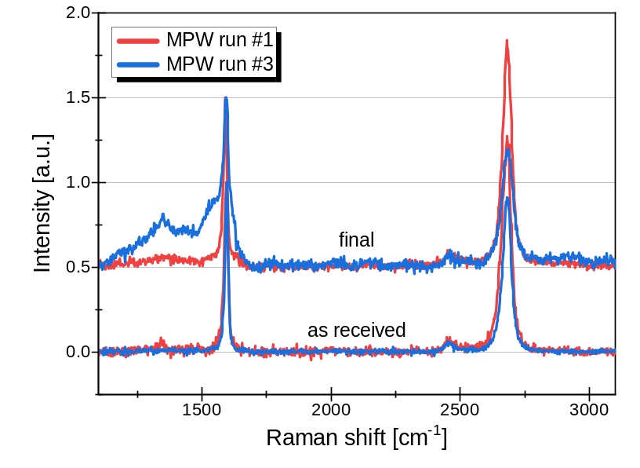
Figure S1.1 | Typical Spectra for the MPW run1 and MPW run 3 wafers, as received and after fabrication.
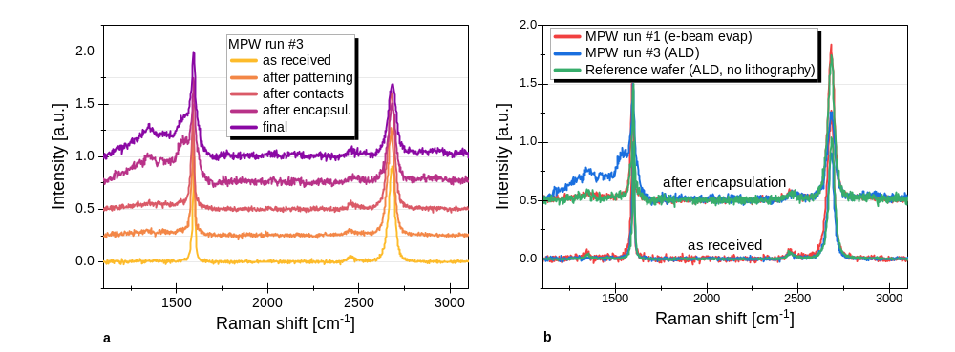

Figure S1.2 | Raman spectra for a-C analysis, comparison tests. a Raman typical spectra for the wafer fabricated in the MPW run 3 in every step of fabrication. b Comparison between one reference wafer without lithography and RIE etching on graphene and the wafers from MPW run 1 and MPW run 3 as received and after ALD deposition.
The box plots for FWHM(2D) also show that the main increase in value occurs after encapsulating the graphene (reminder: MPW run 1 was measured without encapsulation). The FWHM(2D) is a measure for nanoscale strain variations. The FWHM(2D) depends not only on the quality of the graphene but also on the smoothness of the substrate and the interactions of the graphene with the substrate and the dielectric environment encapsulation.^{4,5} A low FWHM(2D) corresponds to small strain variations and ultimately enables high carrier mobilities.^{4,6–8} The values obtained here are higher than what is usually reported in literature.^{4,7,9,10} The main reason for this is that FWHM(2D) values are usually reported for graphene transferred to clean, thermally grown SiO₂, which is smoother and cleaner than our surfaces, i.e. Al₂O₃ deposited by ALD that has already been subjected to three lithography steps.⁴ We also used a Voigt profile to fit the 2D peak, which is a better fit than a Lorentzian profile but also leads to slightly larger peak widths compared to the more commonly used Lorentzian profile.¹¹ There is a significant increase in peak width after encapsulation. This can be attributed to the higher degree of conformality of the graphene to the rough substrate and the confinement of the graphene between two solid interfaces.⁴ The median values of FWHM(2D) after transfer for MPW run 1 are around 45 cm⁻², much higher than expected and, more significantly, higher even than the values after device fabrication. This aspect needs further investigation. The other process steps have no direct effect on the D-peak of the FWHM(2D) but they do slightly affect the peak positions of the G and 2D peaks, which are related to strain and doping of the graphene.⁷ The Figure S1.3c shows the frequency of 2D peak position as a function of the position of the G-peak for the two runs. It is possible to notice that the doping has slightly changed during the fabrication process and the strain is higher for the MPW run 3 than for the MPW run 1. The black line represents the shifts in position due to doping of the graphene.¹²

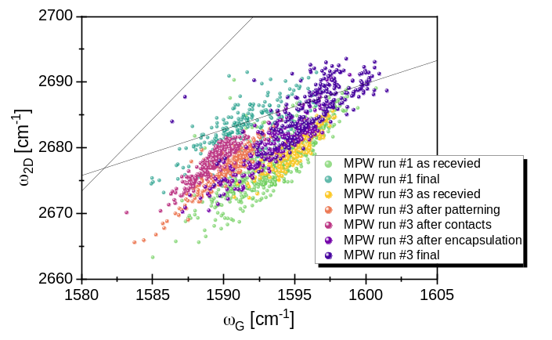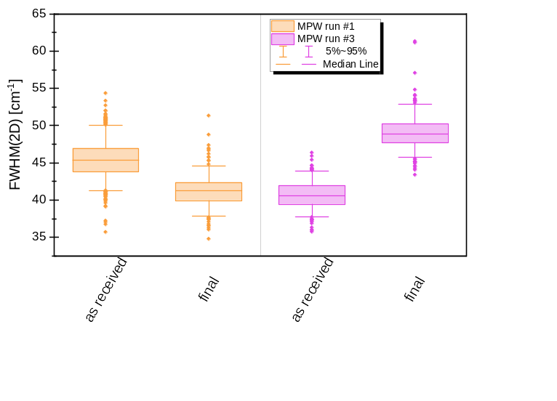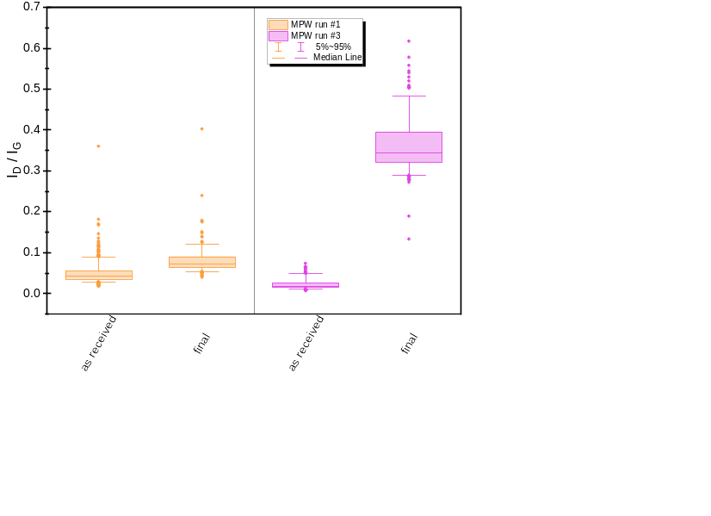
a
b
c
Figure S1.3 | Raman analysis of the wafers from MPW run 1 and 3. a Statistical analysis of the I_{D}/I_{G} and b full width at half maximum (FWHM) of the 2D peak. c Scatter plot of the 2D peak position as a function of the position of the G-peak.

S2 Dielectric constant of the Al₂O₃ used as the back gate oxide
To characterize the dielectric properties of the Al₂O₃ used as a back gate dielectric for both MPW runs, we fabricated metal-oxide-semiconductor capacitors on separate samples. We removed the native oxide on a p-doped silicon substrate in buffered oxide etchant. The oxide removal was verified using an ellipsometer thin film measurement before and after the etching process. A 21.4 nm thick layer of Al₂O₃ was then deposited onto the bare silicon substrate using a PEALD process at 300 °C with a TMA precursor. We used negative photolithography to define circular structures with two different areas, 0.32 and 1.28 mm². Al/Ti (35/15 nm) contacts were deposited by e-beam evaporation, followed by lift-off. A schematic cross-section of the material stack is shown in Fig S2.1a. Electrical measurements were performed in ambient conditions in a Cascade probe station. An AC signal with 25 mV amplitude was applied between the top circular electrode and the p-doped substrate with a frequency sweep between 100 Hz and 1 MHz. We used a Cp-G model consisting of parallel connected resistor with conductance of G (representing the losses in the material) and capacitor with capacitance of C (Fig S2.1b)¹³ to characterize the frequency response of the devices under test. The measurement is repeated on five different devices for each device area (Fig S2.1c). From the capacitance and conductance data we calculated the complex relative permittivity, resulting in a dielectric constant of 7.3 with a deviation of 0.72 for the low frequency regime. This is the value we used for the mobility calculation in the MPW runs.

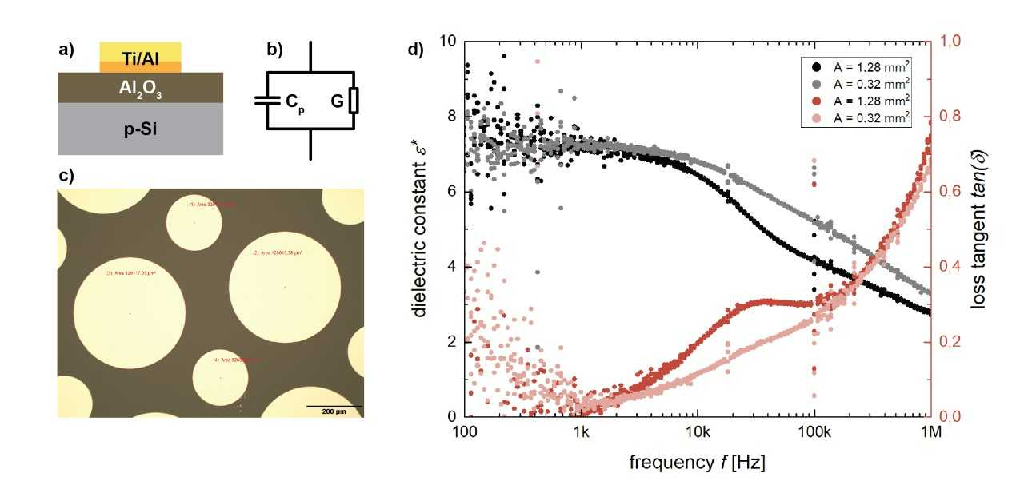Figure S2.1 | Dielectric constant calculation by basic capacitors. a Optical microscopy of the capacitors and b Schematic drawing of the devices. c Graphic of the dielectric constant and loss tangent for two different capacitor areas.

S3 Cracks in the encapsulation layer (MPW run 1)
The cracks that are mentioned in the main text were observed in the Al₂O₃ encapsulation layer and only in the regions on top of large areas of graphene, whenever the covered graphene area was hundreds of µm² large. Therefore, there were no cracks in the devices we measured during the MPW runs. Figure S3.1a shows an optical microscopy of one example of the cracks. Figure S3.1b shows an AFM image of a crack, allowing us to measure the depth of the crack. The crack extends into the graphene layer destroying this as well. In some cases, part of the dielectric layer was also removed as can be seen in the Figure S3.1c. The crack is 220 nm deep and the Al₂O₃ encapsulation layer is 200 nm thick (Figure S3.1d).
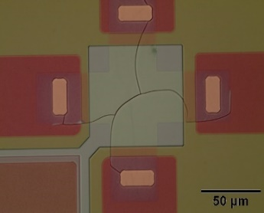
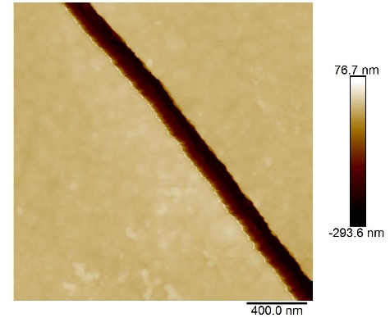
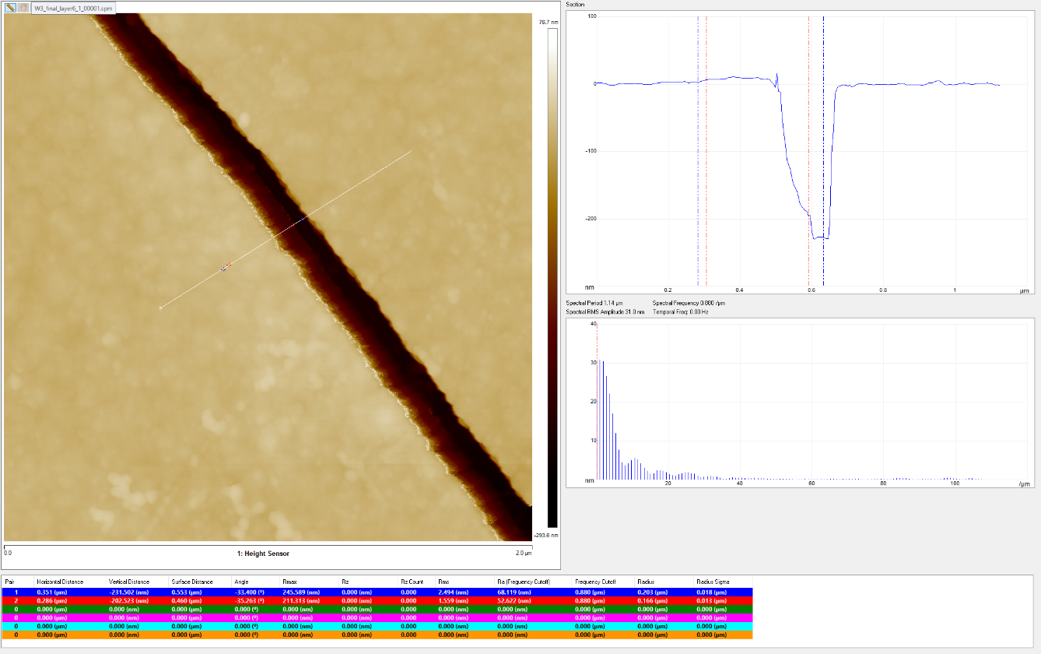
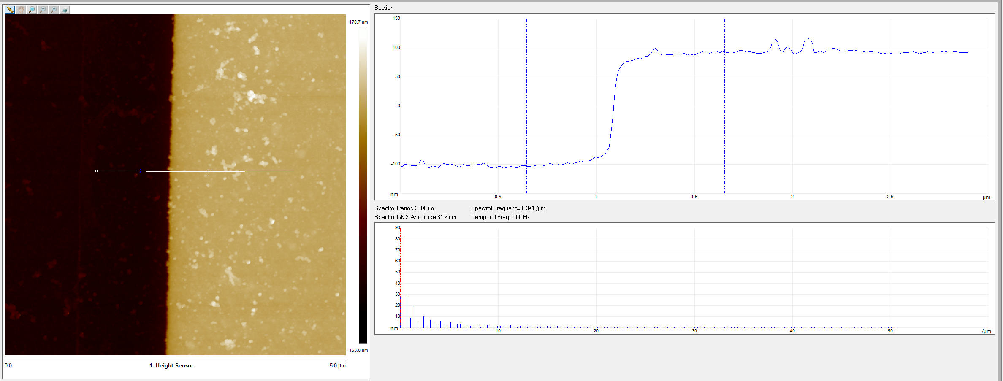
(a)
(b)
(c)
(d)

Figure S3.1 | Cracks in the encapsulation layer of the MPW run 1. a Optical microscopy showing one device with cracks. b AFM image showing a crack. c Measurement of the depth of the crack, red lines have 200 nm (thickness of the encapsulation layer). Blue lines are 220 nm. (d) thickness measurement of the encapsulation layer thickness.
References
1. Malard, L. M., Pimenta, M. A., Dresselhaus, G. & Dresselhaus, M. S. Raman spectroscopy in graphene. Physics Reports 473, 51–87 (2009).
2. Hong, J. et al. Origin of New Broad Raman D and G Peaks in Annealed Graphene. Sci Rep 3, 2700 (2013).
3. Gong, C. et al. Rapid Selective Etching of PMMA Residues from Transferred Graphene by Carbon Dioxide. J. Phys. Chem. C 117, 23000–23008 (2013).
4. Banszerus, L. et al. Ultrahigh-mobility graphene devices from chemical vapor deposition on reusable copper. Sci. Adv. 1, e1500222 (2015).
5. Finney, N. R. et al. Tunable crystal symmetry in graphene–boron nitride heterostructures with coexisting moiré superlattices. Nat. Nanotechnol. 14, 1029–1034 (2019).
6. Couto, N. J. G. et al. Random Strain Fluctuations as Dominant Disorder Source for High-Quality On-Substrate Graphene Devices. Phys. Rev. X 4, 041019 (2014).
7. Canto, B. et al. Plasma‐Enhanced Atomic Layer Deposition of Al ₂ O ₃ on Graphene Using Monolayer hBN as Interfacial Layer. Adv Materials Technologies 6, 2100489 (2021).
8. Neumann, C. et al. Raman spectroscopy as probe of nanometre-scale strain variations in graphene. Nat Commun 6, 8429 (2015).
9. Li, M. et al. Wafer-Scale Graphene Growth on Si/SiO2 Substrates via Metal-Free Chemical Vapor Deposition. ACS Applied Nano Materials 6, 10817.
10. Lee, J. E., Ahn, G., Shim, J., Lee, Y. S. & Ryu, S. Optical separation of mechanical strain from charge doping in graphene. Nature Communications 3, 1024 (2022).
11. Bradley, M. S. Lineshapes in IR and Raman Spectroscopy: A Primer. Spectroscopy 30, 42–46 (2015).
12. Gao, L. et al. Repeated growth and bubbling transfer of graphene with millimetre-size single-crystal grains using platinum. Nature Communications 3, 699 (2012).
13. Basics of Measuring the Dielectric Properties of Materials. https://www.keysight.com/us/en/assets/7018-01284/application-notes/5989-2589.pdf.

