Genome-wide association studies for seed thermoinhibition in lettuce reveal the interplay of seed age, color, and germination under high temperatures

Sookyung Oh¹, Ezekiel Ahn¹, Ainong Shi², Beiquan Mou^{3*} and Sunchung Park^{1*}
¹U.S. Department of Agriculture, Agricultural Research Service, Beltsville, MD 20705, USA
²Horticulture Dept., University of Arkansas, Fayetteville, AR 72701, USA
³U.S. Department of Agriculture, Agricultural Research Service, Salinas, CA 93905, USA

Supplementary information
Supplementary Figure S1
Supplementary Figure S2
Supplementary Table S1-9

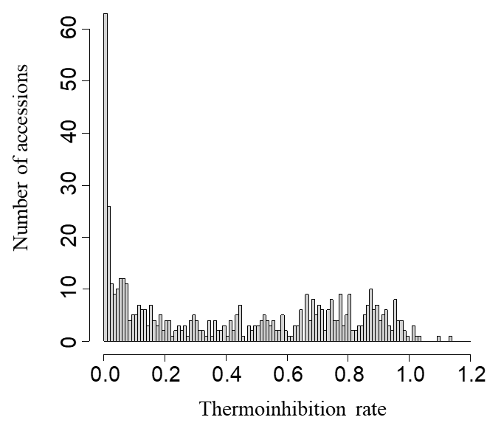
Figure S1. Distribution of accessions by thermoinhibition rate. This histogram illustrates the thermoinhibition rate represented by a ratio of seeds germinated under high-temperature conditions (34°C) to those germinated under control conditions (21°C), highlighting the variance in thermoinhibition among assessed accessions.

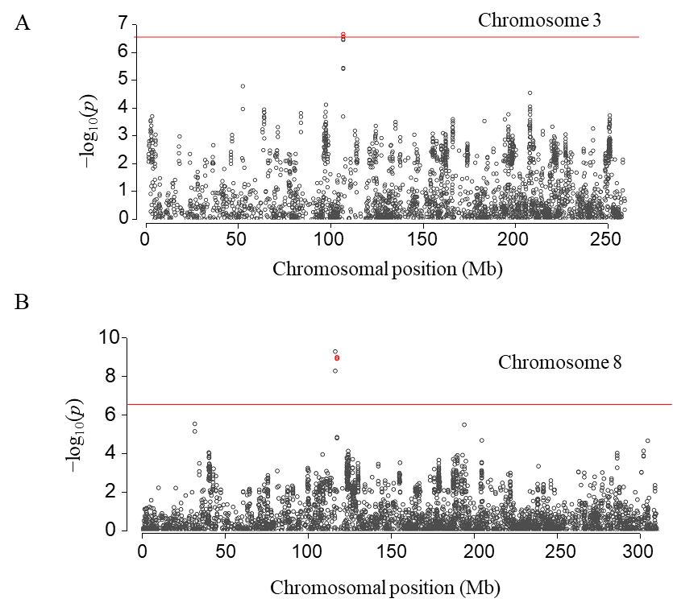
Figure S2. Manhattan plots of chromosome 3 (A) and 8 (B) showing significant SNPs for seed color and thermoinhibition. Manhattan plots display significant SNPs for seed color (red circles) and thermoinhibition (black circles). The red lines represent the genome-wide significance threshold (P-value <2.7E-7, −log10(p) = 6.57)

Supplementary Tables
Table S1. Lactuca accessions and germination phenotypes for GWAS
Table S2. ANOVA test of heat germination across seven harvest year groups
Table S3 ANOVA test of horticultural type effects on seed thermoinhibition
Table S4. ANOVA of seed color effects on seed thermoinhibition
Table S5. Significant SNP associated with thermoinhibition rate in lettuce
Table S6. GWAS LD blocks and Causal genes previously identified for Thermoinhibtion or Seed color
Table S7. Candidate genes associated with thermoinhibition and their GO annotations
Table S8. Significant SNP associated with seed color
Table S9. Candidate genes associated with Seed Color and their GO annotations

