Supplementary Information

Enabling the Multiscale Interfacial Stabilization for Ah-level Anode-free Lithium Metal Battery via a Prelithiation Separator strategy
Ahu Shao ª, Helin Wang ª, Min Zhang ª, Jiacheng Lin ª, Lu Chen ª, Yongsong Li ª, Yuxiang Guo ª, Zhiqiao Wang ª, Qiurong Jia ^{a, b}, Xin Wang ^{c}, Xiaoyu Tang ª, Xiaodong Zhao ^{d}, and Yue Ma ª*

ª State Key Laboratory of Solidification Processing, Center for Nano Energy Materials, School of Materials Science and Engineering, Northwestern Polytechnical University, Xi’an 710072, P. R. China.
^{b} Zhengzhou BAK Battery Co., Ltd., Zhengzhou 451450, China
^{c} Shaanxi Raisight Energy Tech Co., Ltd., Xi’an 710086, China
^{d} Fujian Blue Ocean&Black Stone Technology Co., Ltd., Zhangzhou 363000, China
Corresponding author: mayue04@nwpu.edu.cn (Y. Ma)

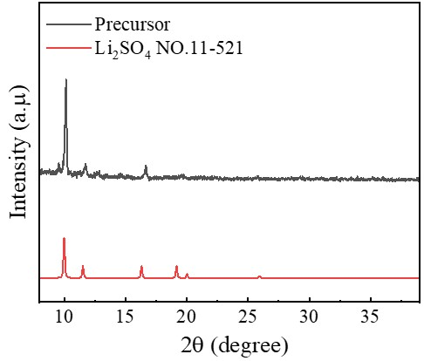
Supplementary Fig. 1 XRD patterns of mixed precursor.

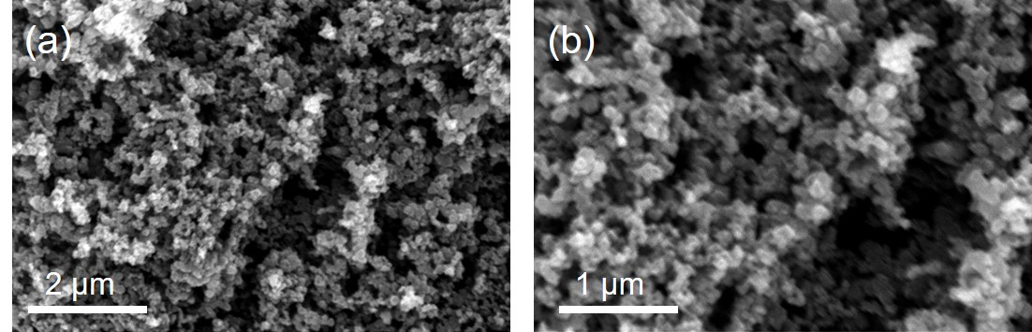
Supplementary Fig. 2 (a-b) The SEM image of Li₂S@C materials. Content.

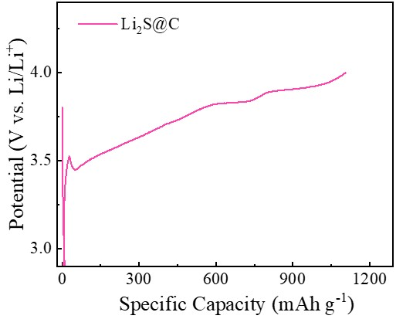
Supplementary Fig. 3 Galvanostatic charge-discharge profiles of Li₂S@C|PE at 0.1 C

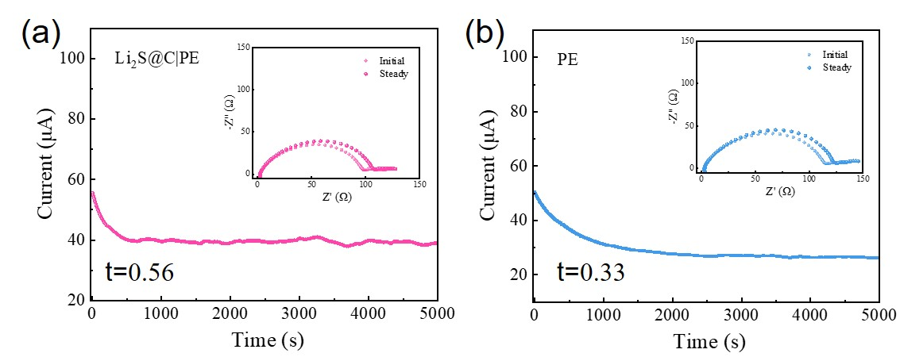
Supplementary Fig. 4 DC polarization curves of (a) the Li|PE|Li symmetric cell, and (b) the Li|Li₂S@C|PE|Li symmetric cell. The insets show the EIS curves before and after polarization.

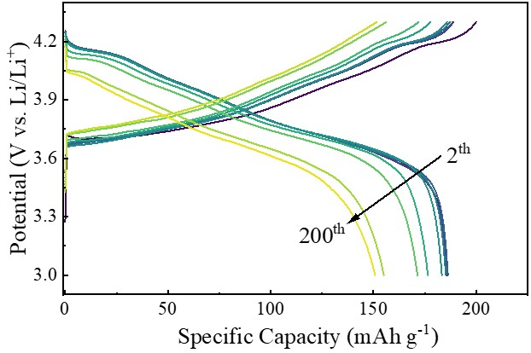
Supplementary Fig. 5 The voltage curve of NCN811||Li with the PE separator cells at 0.5 C in the potential range of 3.0-4.3 V (vs. Li⁺/Li).
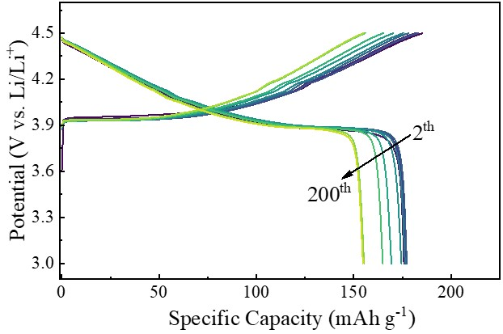
Supplementary Fig. 6 The voltage curve of LCO||Li with the PE separator cells at 0.5 C in the potential range of 3.0-4.5 V (vs. Li⁺/Li).

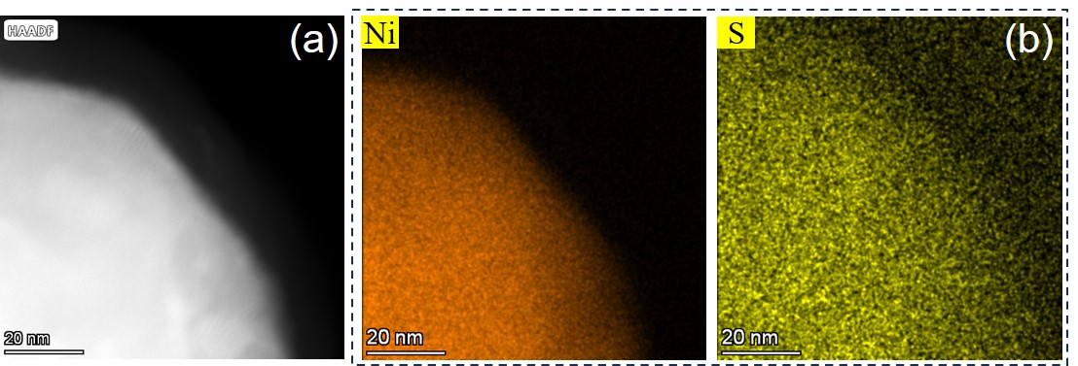
Supplementary Fig. 7 (a-b) The high-angle annular dark-field image and Ni, S elemental mappings of the cycled NCM811 cathode particle in the NCM811||Li paired with Li₂S@C|PE.

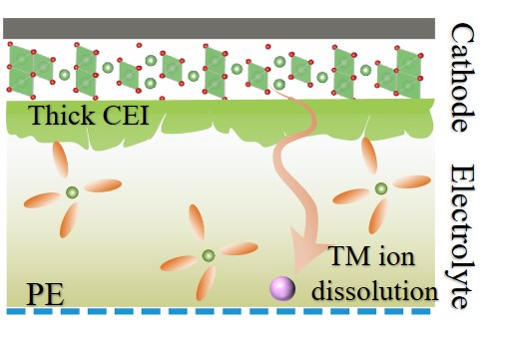
Supplementary Fig. 8 Schematic illustration of cell prototypes under high-voltage conditions.

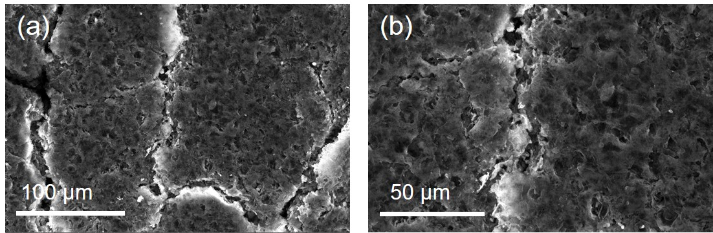
Supplementary Fig. 9 (a-b) The top-view SEM image of cycled Li metal anode with PE separator.

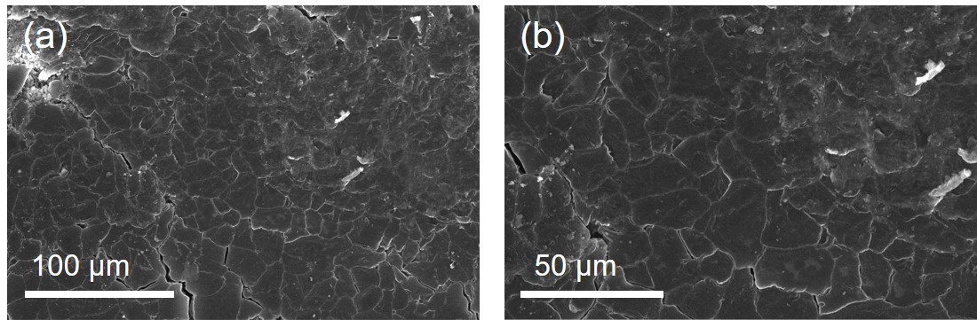
Supplementary Fig. 10 (a-b) The top-view SEM image of cycled Li metal anode with Li₂S@C|PE separator.

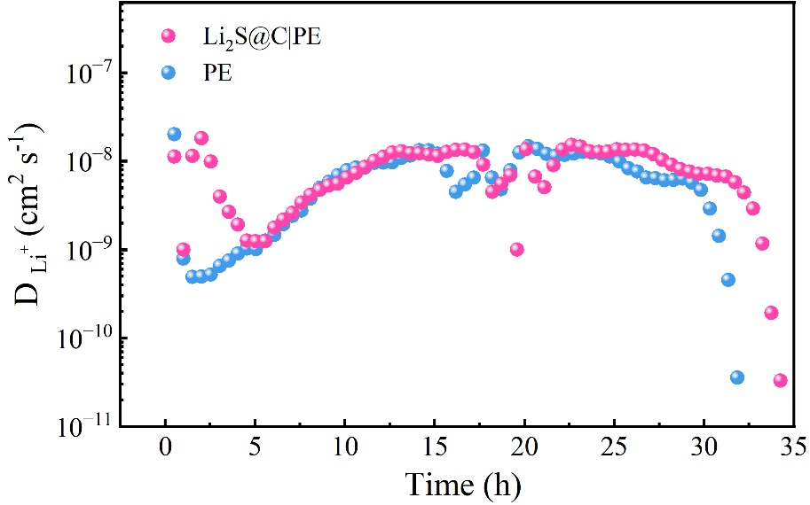
Supplementary Fig. 11 Li⁺ diffusion coefficients were calculated from the GITT profiles of NCM811||Li cell with PE and Li₂S@C|PE, respectively.

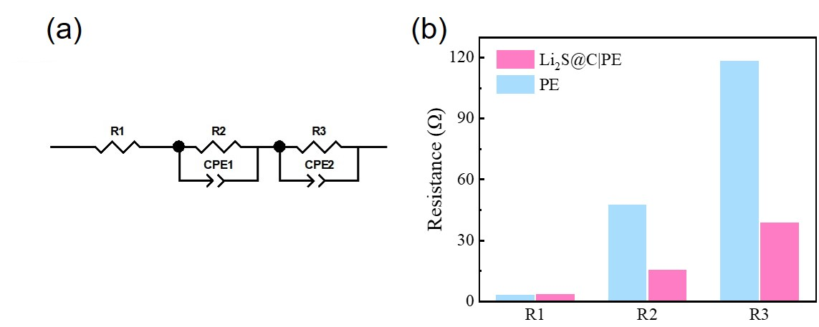
Supplementary Fig. 12 (a) The equivalent circuits for EIS fitting. (b) The fitted resistance for NCM811| |Li with PE and Li₂S@C|PE.

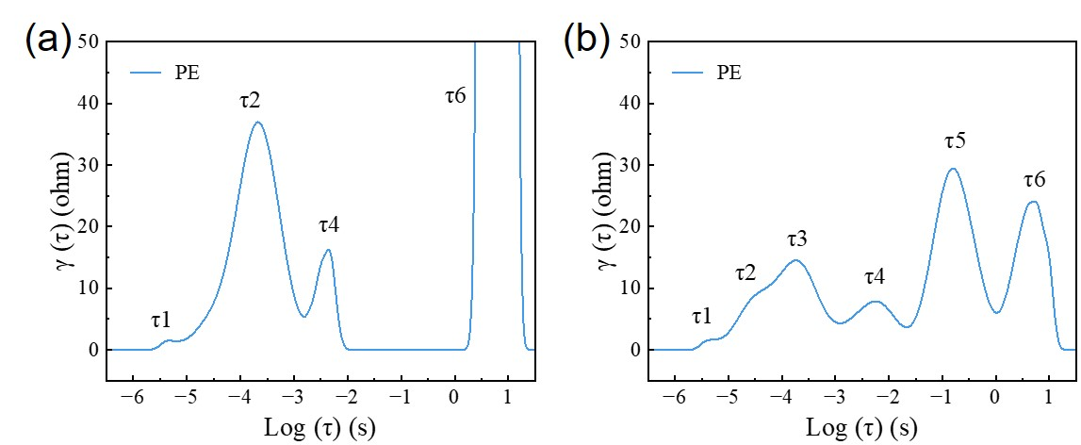
Supplementary Fig. 13 DRT curves calculated form EIS measurements in the NCM811||Li with PE separator cell, (a) before and (b) after cycled.

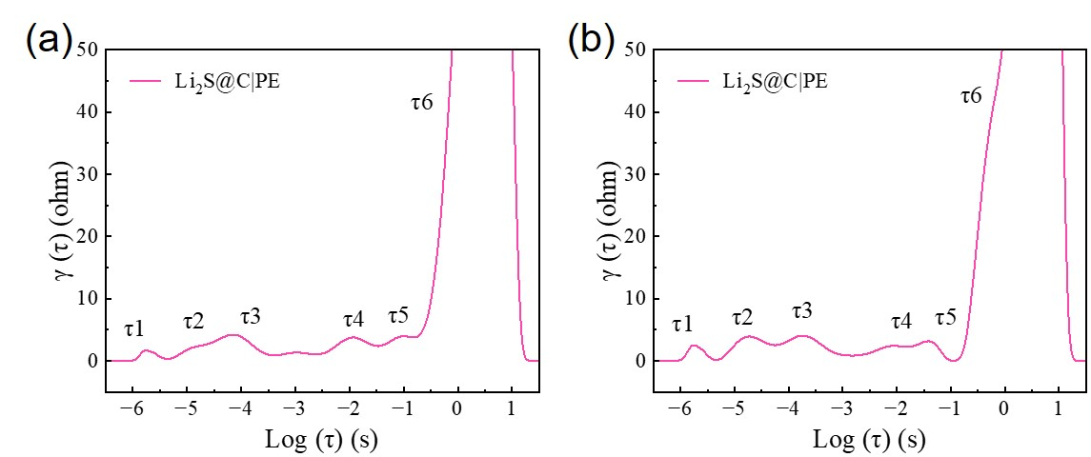
Supplementary Fig. 14 DRT curves calculated form EIS measurements in the NCM811||Li with Li₂S@|PE separator cell, (a) before and (b) after cycled.

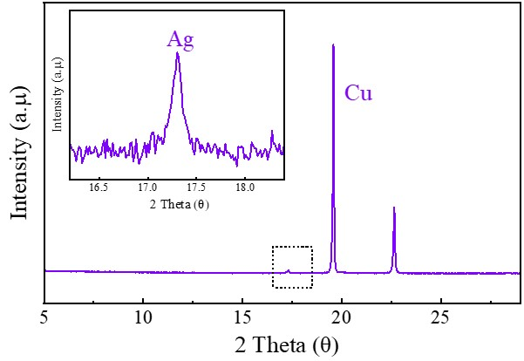
Supplementary Fig. 15 The XRD curve of the Ag-Cu anode. The inset graph shows the characteristic peak of cubic phase Ag.

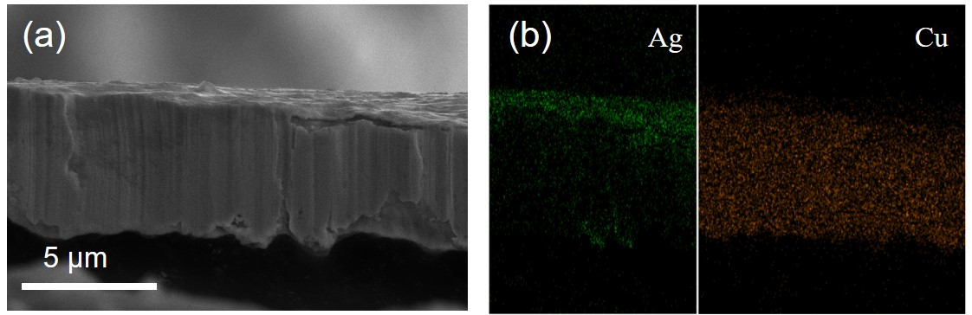
Supplementary Fig. 16 (a) The cross-sectional SEM image of the Ag-Cu anode. (b) The corresponding EDS mapping of Ag and Cu signals.

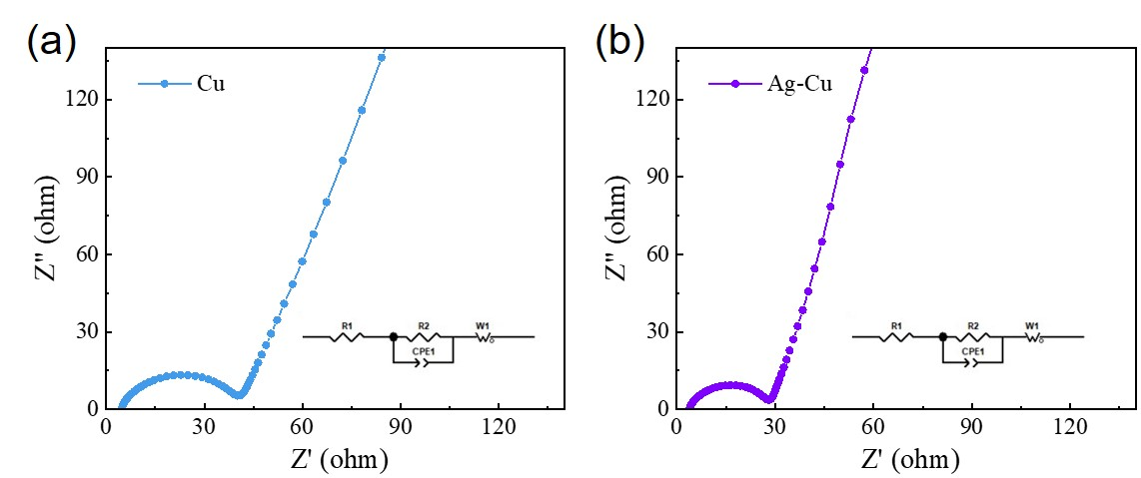
Supplementary Fig. 17 Nyquist plot of (a) Li||Cu half-cell and (b) Li||Ag-Cu half-cell before cycling, the inset graph shows equivalent circuits.

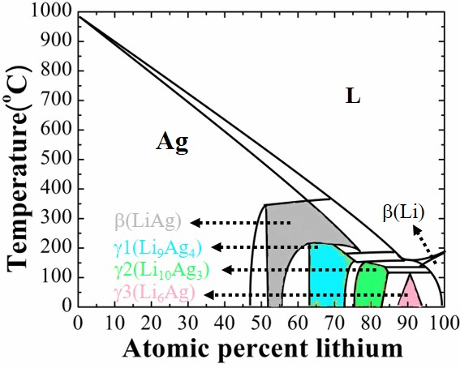
Supplementary Fig. 18 The Ag-Li binary phase diagram.

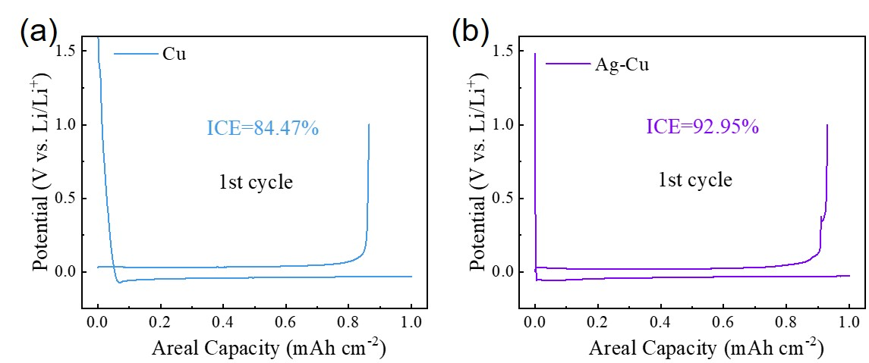
Supplementary Fig. 19 The ICE of half-cell cycling with capacities of 1 mAh cm⁻² under 0.5 mA cm⁻² (a) Li||Cu half-cell, (b) Li||Ag-Cu half-cell.

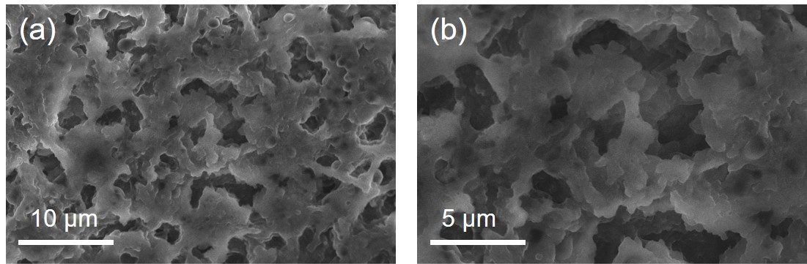
Supplementary Fig. 20 The top-view of SEM image of cycled Li metal anode with Li||Cu half-cell.

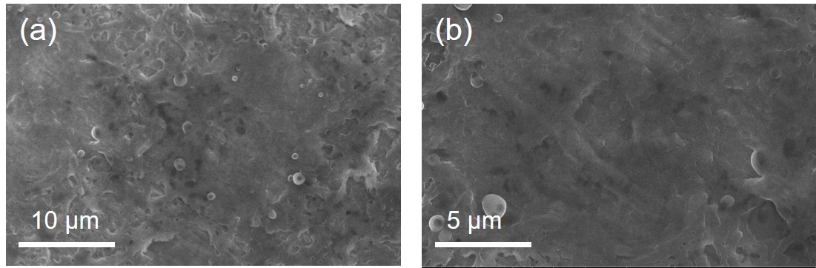
Supplementary Fig. 21 The top-view of SEM image of cycled Li metal anode with Li||Ag-Cu half-cell.

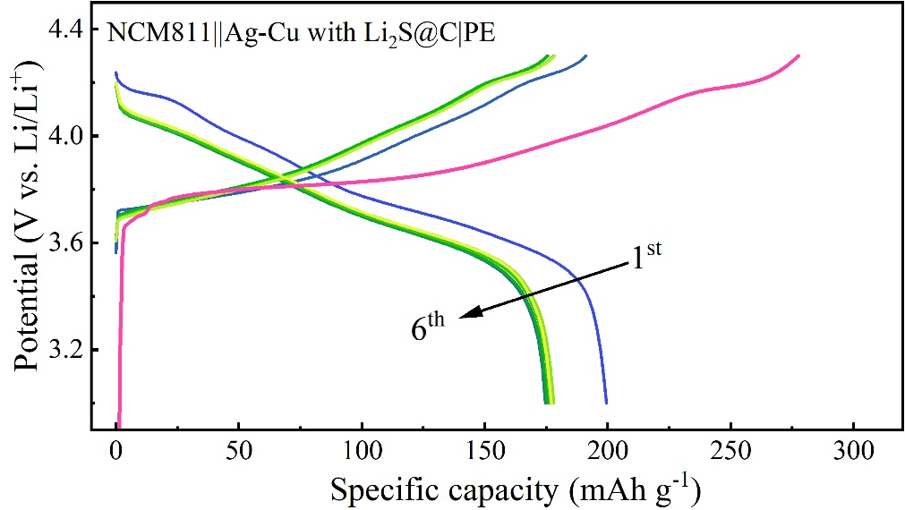
Supplementary Fig. 22 Voltage profiles of NCM811||Ag-Cu model paired with Li₂S@C|PE separator for the initial 6 cycles.

Table S1. The comparisons of typical physical properties for different separators.
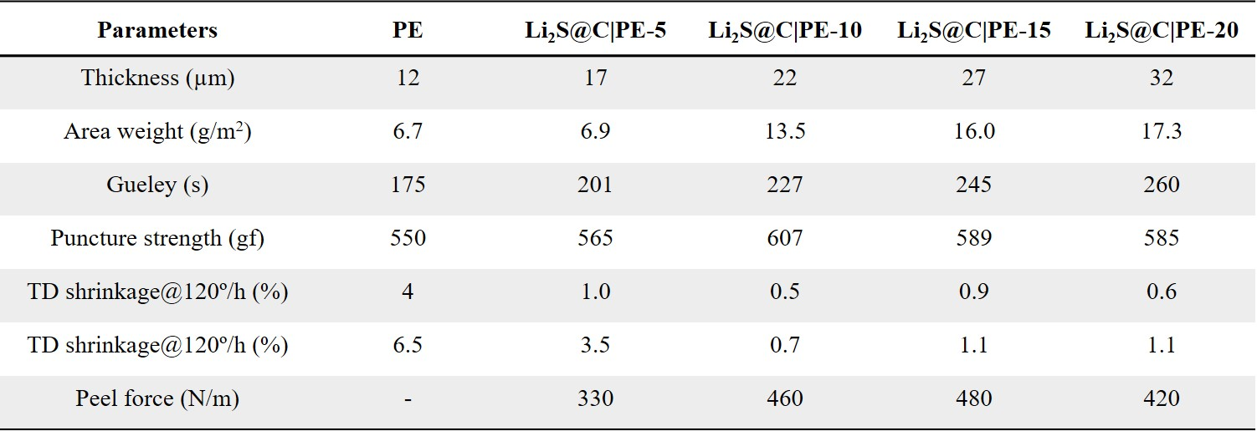

Table S2. The detailed parameters of a high-energy NCM811||Ag-Cu cell with Li₂S@C|PE AFLMBs pouch cell.
