Scheme1S. The outline synthesis of ligand (H₂L)

Scheme 2S. The Equipment's used in the structural characterization

Scheme 3S. Antimicrobial activity screening assay

Scheme 4S. Antioxidant activity screening assay via ABTS method

Scheme 5S. Colorimetric DNA-binding assay for investigated compounds

Scheme 6S.The cytotoxicity using the MTT assay

Scheme 7S. The Antioxidant via erythrocyte haemolysis method

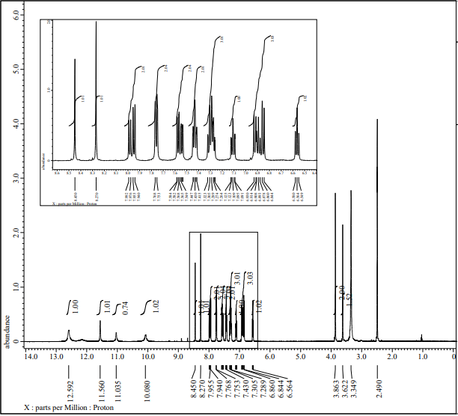(A)
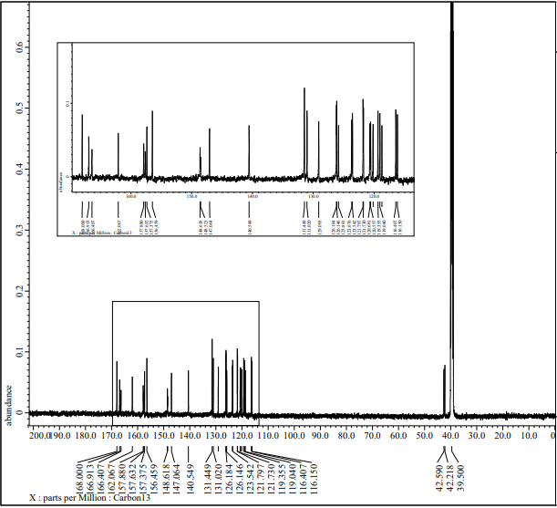(B)
Figure 1S. (A)¹H NMR and (B) ¹³C NMR of H₂L

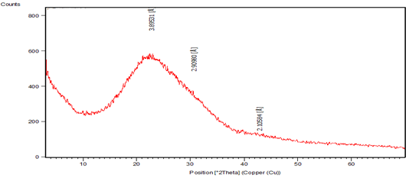(A)
Figure 3S. XRD of (A)[Cu(L)(H₂O)₂].2H₂O complex

(A) 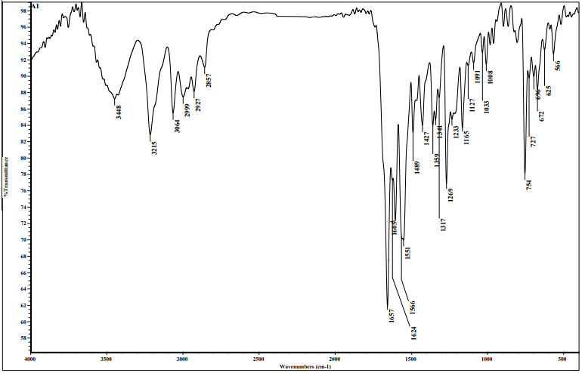
(B) 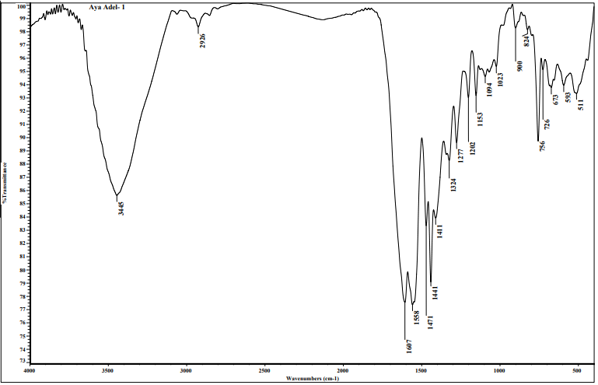
(C) 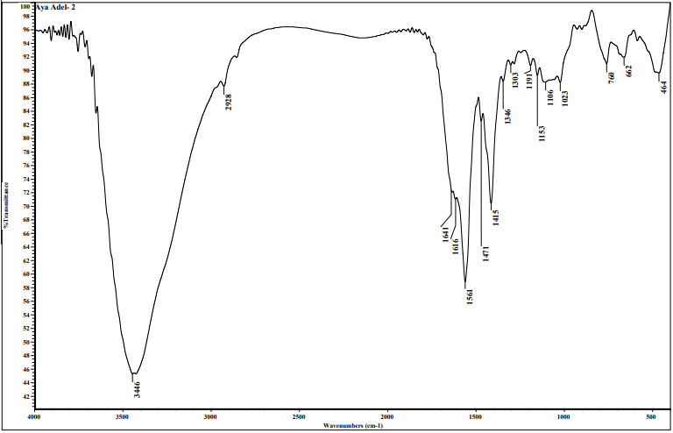
(D) 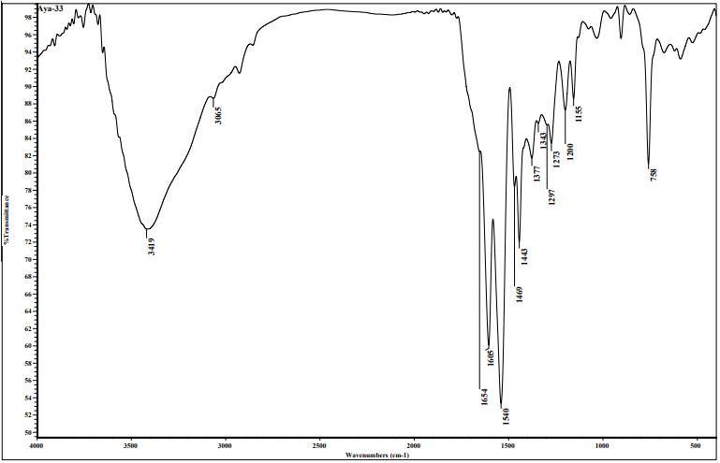
Figure 2S: IR of )A)H₂L ligand, (B) [Cu (L)(H₂O)₂].2H₂O, (C) [Co(HL)(H₂O)(OAc)].2H₂O, and (D) [Ni(HL)(H₂O)(OAc)].3H₂O

(A)
(B)
(C)
Figure 3S. UV of )A) [Cu (L)(H₂O)₂].2H₂O, (B) [Co(HL)(H₂O)(OAc)].2H₂O, and (C) [Ni(HL)(H₂O)(OAc)].3H₂O
(A)
(B)

Scheme 8S. Mass spectra of (A) H₂L and (B) [Cu(L)(H₂O)₂].2H₂O compounds

Figure 4S. ESR of Cu-Complex

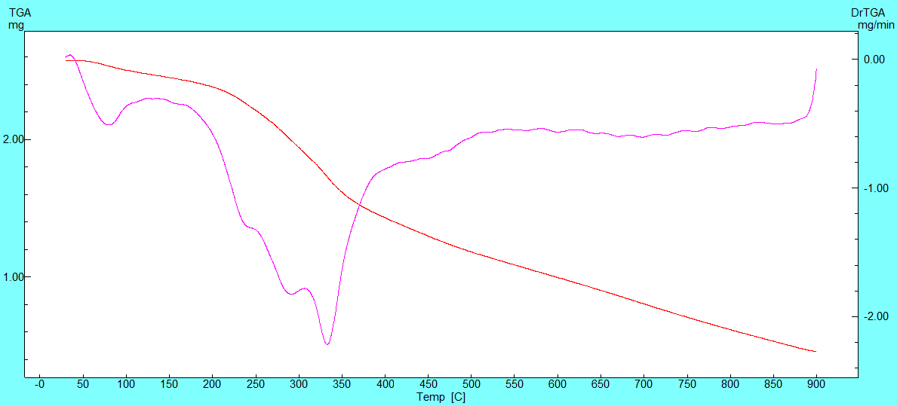
(A)
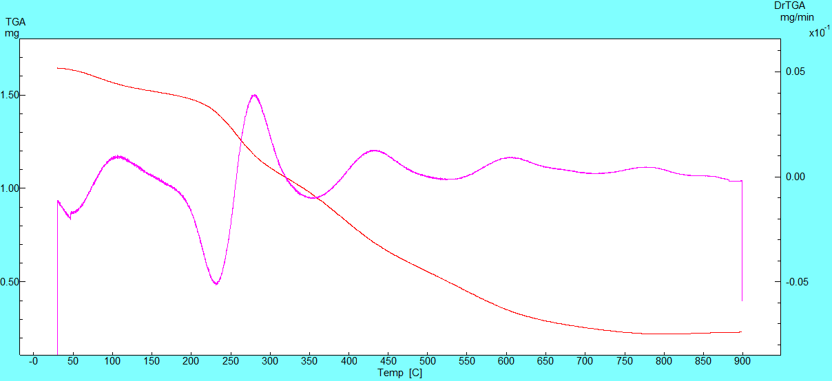
(B)
Figure 5S. TGA of (A) [Cu(L)(H₂O)₂].2H₂O, (B) [Co(HL)(H₂O)(OAc)].2H₂O

(A)
(B)
(C)
(D)
Figure 7S. Selected bond lengths of )A) H₂L ligand, (B) [Cu (L)(H₂O)₂].2H₂O, (C) [Co(HL)(H₂O)(OAc)].2H₂O, and (D) [Ni(HL)(H₂O)(OAc)].3H₂O

(A)
(B)
(C)
(D)
Figure 8S. Selected bond angles of )A) H₂L ligand, (B) [Cu (L)(H₂O)₂].2H₂O, (C) [Co(HL)(H₂O)(OAc)].2H₂O, and (D) [Ni(HL)(H₂O)(OAc)].3H₂O

Table 1S
Physical properties and elemental analyses for H₂L and its complexes
No. | Compounds | Empirical formula  F.W. Found (Calculate) | Yield % | Physical properties |  | Elemental analyses %  Found (Calcd.)
 |  |  |  | Color | M.P. (ºC) | %C | %H | %N | %S | %M
1 | H₂L | C₁₇H₁₄N₄O₃S  354.13 (354.38) | 78 | Yellowish-white | 234 | 57.62  (57.66) | 4.03  (3.98) | 15.94  (15.81) | 9.11  (9.05) | -
2 | [Cu(L)(H₂O)₂].2H₂O | CuC₁₇H₂₀N₄O₇S  487.36 | 98 | Green | > 300 | 41.45  (41.84) | 3.86  (4.13) | 11.92  (11.48) | 6.82  (6.56) | 13.52  (13.02)
3 | [Co(HL)(H₂O)(OAc)].2H₂O | CoC₁₉H₂₂N₄O₈S  (525.06) | 98 | Brown | > 300 | 43.35  (43.31) | 4.2  (4.17) | 10.64  (10.67) | 6.09  (6.12) | 11.19  (11.15)
4 | [Ni(HL)(H₂O)(OAc)].3H₂O | NiC₁₉H₂₄N₄O₉S  (543.175) | 96 | Brown | > 300 | 41.93  (41.88) | 44.45  (44.48) | 10.29  (10.22) | 5.89  (5.91) | 10.78  (10.72)

Table 2S
The IR bands of H₂L and its complexes
Compound | (NH)₁ | (NH)₂ | (C=O)₁ | (C=O)₂ | (C=N)_{thiazole} | (C=N)_{azo} | (C=N*)₁ | (C=N*)₂ | (C-O)₁ | (C-O)₂ | (M-O) | (M-N)
1 | 3214 | 3187 | 1690 | 1657 | 1624 | 1605 | -- | -- | -- | -- | -- | --
2 | -- | -- | -- | -- | 1606 | 1598 | 1637 | 1632 | 1202 | 1153 | 511 | 485
3 | 3222 | -- | 1641 | -- | 1622 | 1589 | -- | 1635 | -- | 1153 | 505 | 464
4 | 3186 | -- | 1654 | -- | 1624 | 1595 | -- | 1605 | -- | 1155 | 580 | 476

Table 3S
Magnetic moment, electronic spectra and ligand field parameters of metal complexes of H₂L
Compound | Μeff  (BM) | Band position  (cm⁻¹) | Dq  (cm⁻¹) | B  (cm⁻¹) | β | υ₂ / υ₁ | Transition
2 | 2.03 | 16129  14388 | - | - | - | - | ²B_{1g}→²E_{g}  ²B_{1g} → ²A_{1g}
3 | 5.12 | 14815  19802 | 793.16 | 933.129 | 0.961 | 2.155 | ⁴T_{1g}→ ⁴A_{2g}(F)  ⁴T_{1g}→ ⁴T_{1g}(P)
4 | 3.12 | 17241  27027 | 1104.64 | 736.43 | 0.758 | 1.553 | ³A_{2g} → ³T_{1g} (F)  ³A_{2g}→ ³T_{1g} (P)

Table 4S
Thermal behavior of H₂L complexes
Complex (Mol.wt.) | Temp.range ( °C) | Decom.prod. (formula wt.) | Wt. loss (%)  Found Calcd.
[Cu(L)(H₂O)₂].2H₂O | 30-119  119-235  235-587  587-850  > 850 | H₂O (18.016)  2H₂O (36.032)  C₆H₆O+ C₇H₆NS (230.301)  C₄N₃O (106.064)  CuO (79.54) | 3.57 3.83  8.04 7.66  48.8848.73  22.59 22.55  16.92 17.23
[Co(HL)(H₂O)(OAc)].2H₂O | 30-124  124-257  257-447  447-800  >800 | 2H₂O (36.032)  H₂O+ CH₃COOH (78.07)  C₆H₆O +C₄N₃O (200.178)  C₇H₆NS (136.187)  CoO (74.93) | 6.26 6.86  15.37 14.87  37.48 38.07  26.61 25.93  14.28 14.27

Table 5S: Bond Lengths of H₂L and its complexes
No. | Ligand H₂L |  | Co-complex |  | Cu-complex |  | Ni-complex
No. | Bond name | Bond length (A°) | Bond name | Bond length (A°) | Bond name | Bond length (A°) | Bond name | Bond length (A°)
1 | C(20)-O(25) | 1.382 | O(31)-H(49) | 0.978 | O(28)-H(44) | 0.977 | O(29)-C(30) | 1.291
2 | C(20)-C(21) | 1.404 | O(31)-H(48) | 0.977 | O(28)-H(43) | 0.977 | O(28)-H(46) | 0.977
3 | C(19)-C(20) | 1.422 | O(28)-C(29) | 1.296 | O(27)-H(42) | 0.975 | O(28)-H(45) | 0.977
4 | C(18)-H(34) | 1.088 | O(27)-C(29) | 1.286 | O(27)-H(41) | 0.976 | O(27)-C(30) | 1.290
5 | C(18)-C(19) | 1.465 | Co(26)-O(31) | 2.201 | O(28)-Cu(26) | 2.083 | O(29)-Ni(26) | 2.092
6 | N(16)-C(18) | 1.303 | Co(26)-O(28) | 2.024 | O(27)-Cu(26) | 2.300 | O(28)-Ni(26) | 2.135
7 | N(15)-H(33) | 1.016 | Co(26)-O(27) | 2.072 | O(25)-Cu(26) | 2.071 | O(27)-Ni(26) | 2.122
8 | N(15)-N(16) | 1.391 | O(25)-Co(26) | 2.122 | O(24)-Cu(26) | 5.090 | O(25)-Ni(26) | 2.005
9 | C(14)-O(17) | 1.247 | O(24)-Co(26) | 2.011 | O(23)-H(40) | 0.977 | O(23)-H(44) | 0.977
10 | C(14)-N(15) | 1.380 | C(18)-O(23) | 1.381 | C(18)-O(23) | 1.376 | C(16)-H(39) | 1.094
11 | C(12)-H(32) | 1.096 | N(15)-Co(26) | 2.044 | C(16)-H(35) | 1.093 | C(16)-C(17) | 1.452
12 | C(12)-H(31) | 1.102 | N(15)-C(16) | 1.319 | N(15)-Cu(26) | 1.970 | N(15)-Ni(26) | 2.054
13 | C(12)-C(14) | 1.530 | N(14)-N(15) | 1.396 | N(15)-C(16) | 1.316 | N(15)-C(16) | 1.316
14 | C(11)-O(13) | 1.225 | C(13)-O(24) | 1.307 | N(14)-N(15) | 1.398 | N(14)-N(15) | 1.412
15 | C(11)-C(12) | 1.555 | C(13)-N(14) | 1.341 | C(13)-O(25) | 1.295 | C(13)-O(25) | 1.299
16 | N(10)-H(30) | 1.029 | C(11)-O(25) | 1.256 | C(13)-N(14) | 1.339 | C(13)-N(14) | 1.331
17 | N(10)-C(11) | 1.394 | N(10)-C(11) | 1.378 | N(10)-C(11) | 1.389 | C(11)-O(24) | 1.240
18 | C(8)-N(10) | 1.392 | C(8)-N(10) | 1.401 | N(9)-Cu(26) | 4.984 | N(10)-H(36) | 1.032
19 | C(8)-N(9) | 1.303 | C(8)-N(9) | 1.306 | C(8)-N(10) | 1.315 | N(10)-C(11) | 1.384
20 | C(8)-S(7) | 1.795 | C(5)-N(9) | 1.389 | C(8)-N(9) | 1.353 | C(8)-N(10) | 1.387

Table 6S: Bond angles of H₂L and its complexes
No. | Ligand H₂L |  | Co-complex |  | Cu-complex |  | Ni-complex
No. | Bond angle name | Bond angle (°) | Bond angle name | Bond angle(°) | Bond angle name | Bond angle (°) | Bond angle name | Bond angle(°)
1 | C(24)-C(19)-C(18) | 122.634 | H(49)-O(31)-Co(26) | 100.890 | H(44)-O(28)-Cu(26) | 110.668 | C(30)-O(29)-Ni(26) | 89.877
2 | C(20)-C(19)-C(18) | 119.425 | H(48)-O(31)-Co(26) | 106.664 | H(43)-O(28)-Cu(26) | 111.941 | H(46)-O(28)-H(45) | 104.094
3 | H(34)-C(18)-C(19) | 117.400 | C(29)-O(28)-Co(26) | 90.074 | H(42)-O(27)-Cu(26) | 111.502 | H(46)-O(28)-Ni(26) | 111.954
4 | H(34)-C(18)-N(16) | 122.635 | C(29)-O(27)-Co(26) | 88.241 | H(41)-O(27)-Cu(26) | 115.191 | H(45)-O(28)-Ni(26) | 111.855
5 | C(19)-C(18)-N(16) | 119.962 | O(31)-Co(26)-O(28) | 89.525 | O(28)-Cu(26)-O(27) | 89.336 | C(30)-O(27)-Ni(26) | 88.544
6 | C(18)-N(16)-N(15) | 118.178 | O(31)-Co(26)-O(27) | 85.756 | O(28)-Cu(26)-O(25) | 109.881 | O(29)-Ni(26)-O(28) | 94.598
7 | H(33)-N(15)-N(16) | 110.926 | O(31)-Co(26)-O(25) | 84.488 | O(28)-Cu(26)-O(24) | 123.397 | O(29)-Ni(26)-O(27) | 63.399
8 | H(33)-N(15)-C(14) | 116.658 | O(31)-Co(26)-O(24) | 86.337 | O(28)-Cu(26)-N(15) | 150.638 | O(29)-Ni(26)-O(25) | 96.071
9 | N(16)-N(15)-C(14) | 130.118 | O(31)-Co(26)-N(15) | 165.748 | O(28)-Cu(26)-N(9) | 152.254 | O(29)-Ni(26)-O(24) | 100.296
10 | O(17)-C(14)-N(15) | 123.868 | O(28)-Co(26)-O(27) | 64.923 | O(27)-Cu(26)-O(25) | 105.436 | O(29)-Ni(26)-N(15) | 165.428
11 | O(17)-C(14)-C(12) | 121.893 | O(28)-Co(26)-O(25) | 165.614 | O(27)-Cu(26)-O(24) | 82.985 | O(28)-Ni(26)-O(27) | 97.520
12 | N(15)-C(14)-C(12) | 114.229 | O(28)-Co(26)-O(24) | 108.174 | O(27)-Cu(26)-N(15) | 113.799 | O(28)-Ni(26)-O(25) | 99.305
13 | H(32)-C(12)-H(31) | 107.166 | O(28)-Co(26)-N(15) | 96.262 | O(27)-Cu(26)-N(9) | 69.454 | O(28)-Ni(26)-O(24) | 128.433
14 | H(32)-C(12)-C(14) | 113.457 | O(27)-Co(26)-O(25) | 101.507 | O(25)-Cu(26)-O(24) | 26.043 | O(28)-Ni(26)-N(15) | 99.975
15 | H(32)-C(12)-C(11) | 105.954 | O(27)-Co(26)-O(24) | 169.530 | O(25)-Cu(26)-N(15) | 82.224 | O(27)-Ni(26)-O(25) | 154.427
16 | H(31)-C(12)-C(14) | 106.191 | O(27)-Co(26)-N(15) | 108.494 | O(25)-Cu(26)-N(9) | 61.871 | O(27)-Ni(26)-O(24) | 133.249
17 | H(31)-C(12)-C(11) | 106.252 | O(25)-Co(26)-O(24) | 84.537 | O(24)-Cu(26)-N(15) | 79.176 | O(27)-Ni(26)-N(15) | 114.234
18 | C(14)-C(12)-C(11) | 117.212 | O(25)-Co(26)-N(15) | 92.624 | O(24)-Cu(26)-N(9) | 39.119 | O(25)-Ni(26)-O(24) | 30.505
19 | O(13)-C(11)-C(12) | 120.358 | O(24)-Co(26)-N(15) | 79.490 | N(15)-Cu(26)-N(9) | 57.093 | O(25)-Ni(26)-N(15) | 81.577
20 | O(13)-C(11)-N(10) | 126.370 | Co(26)-O(25)-C(11) | 128.625 | Cu(26)-O(25)-C(13) | 105.867 | O(24)-Ni(26)-N(15) | 70.464
21 | C(12)-C(11)-N(10) | 113.212 | Co(26)-O(24)-C(13) | 96.580 | Cu(26)-O(24)-C(11) | 71.041 | Ni(26)-O(25)-C(13) | 109.230
22 | H(30)-N(10)-C(11) | 113.904 | Co(26)-N(15)-C(16) | 137.810 | Cu(26)-N(15)-C(16) | 133.646 | Ni(26)-O(24)-C(11) | 40.599
23 | H(30)-N(10)-C(8) | 118.087 | Co(26)-N(15)-N(14) | 104.818 | Cu(26)-N(15)-N(14) | 112.707 | Ni(26)-N(15)-C(16) | 137.639
24 | C(11)-N(10)-C(8) | 127.996 | C(16)-N(15)-N(14) | 116.890 | Cu(26)-N(9)-C(8) | 114.897 | Ni(26)-N(15)-N(14) | 110.256
25 | C(8)-N(9)-C(5) | 110.186 | N(15)-N(14)-C(13) | 109.458 | Cu(26)-N(9)-C(5) | 123.460 | C(16)-N(15)-N(14) | 111.343

Table 7S: Thermodynamic and kinetic parameters of CuCl₂in absence of H₂L at 291.15K and 0.1 scan rate for wave A
M x10⁻⁶  (Mol/cm³) | Ep,a  (Volt) | Ep,c  (volt) | ∆Ep  (volt) | (-)Ip,a x10⁵  (Amp) | Ip,c x10⁻⁵  (Amp) | Ip,a/Ip,c  (Amp) | E˚ | Da x10⁶  (Cm²/s) | Dc x10⁷  (Cm²/s) | α_{na} | ks x10³  (Cm/s) | Γc x10⁻⁹  (Mol/cm²) | (+) Qc X10⁻⁶ | Γa x10⁻⁹  (Mol/cm) | (-)Qa  x10⁻⁶
0.82 | -0.074 | -0.78 | 0.704 | 1.78 | 0.511 | 3.475 | -0.42 | 8.229 | 6.81 | 0.95 | 3.09 | 0.433 | 2.63 | 1.506 | 9.13
1.61 | -0.051 | -0.73 | 0.68 | 3.30 | 0.90 | 3.664 | -0.39 | 7.329 | 5.46 | 0.96 | 1.84 | 0.763 | 4.63 | 2.797 | 17.0
2.38 | 0.014 | -0.74 | 0.76 | 4.25 | 1.28 | 3.318 | -0.36 | 5.589 | 5.08 | 0.82 | 7.82 | 1.087 | 6.58 | 3.606 | 21.9
3.13 | 0.063 | -0.77 | 0.84 | 5.18 | 1.71 | 3.018 | -0.35 | 4.805 | 5.27 | 0.72 | 33.4 | 1.454 | 8.81 | 4.388 | 26.6

Table 8S: Kinetic and solvation parameters of CuCl₂ in presence of H₂L at 291.15K and 0.1 scan rate for wave A
M x10⁻⁶  (mol/cm³) | L x10⁻⁶  (mol/cm³) | Ep,a  (volt) | Ep,c  (volt) | ∆Ep  (volt) | (-)Ip,a x10⁻⁶  (Amp) | Ip,c x10⁻⁶  (Amp) | Ip,a/Ip,c  (Amp) | (-)E˚ | Da x10⁻⁷  (cm²/s) | Dc x10⁻⁹  (cm²/s) | α_{na} | ks x10³  (Cm/sec) | Γc x10⁻⁹  (mol/cm²) | (+) Qc x10⁻⁶ | Γa x10⁻⁹  (mol/cm²) | (-)Qa x10⁻⁶
2.94 | 2.94 | 0.001 | -0.99 | 0.995 | 24.3 | 12.0 | 2.023 | 0.496 | 11.94 | 29.2 | 0.59 | 458.0 | 1.017 | 6.16 | 2.06 | 12.5
2.78 | 5.56 | -0.09 | -1.03 | 0.941 | 13.5 | 8.37 | 1.617 | 0.559 | 4.16 | 15.9 | 0.55 | 114.0 | 0.709 | 4.30 | 1.15 | 6.96
2.63 | 7.89 | -0.08 | -0.68 | 0.604 | 19.3 | 2.52 | 7.65 | 0.377 | 9.377 | 16.0 | 0.57 | 0.052 | 0.213 | 1.29 | 1.63 | 9.89
2.50 | 10.0 | -0.07 | -0.72 | 0.65 | 16.1 | 0.514 | 31.259 | 0.394 | 7.224 | 0.74 | 2.81 | 0.061 | 0.043 | 0.264 | 1.36 | 8.25
2.38 | 11.9 | -0.06 | -0.75 | 0.683 | 14.9 | 1.63 | 9.143 | 0.408 | 6.855 | 8.20 | 0.88 | 0.217 | 0.138 | 0.837 | 1.26 | 7.65
2.13 | 16.0 | -0.09 | -0.79 | 0.703 | 9.96 | 1.22 | 8.15 | 0.441 | 3.84 | 5.78 | 1.44 | 0.344 | 0.104 | 0.628 | 0.84 | 5.12
1.92 | 19.2 | -0.11 | -0.84 | 0.734 | 4.97 | 1.95 | 2.556 | 0.474 | 1.172 | 17.9 | 0.58 | 0.707 | 0.165 | 1.00 | 0.42 | 2.56

Table 9S:Anti-microbial assay of H₂L ligand and its metal complexes
Compound | E. coli |  | B. subtilis |  | C. Albicans
Compound | Diameter of inhibition zone  (mm) | % Activity index | Diameter of inhibition zone  (mm) | % Activity index | Diameter of  inhibition zone  (mm) | % Activity index
1 | 14 | 53.8 | 16 | 69.6 | 21 | 77.8
2 | 5 | 19.2 | 7 | 30.4 | 11 | 40.7
3 | 3 | 11.5 | 5 | 21.7 | 8 | 29.6
4 | 9 | 34.6 | 10 | 43.5 | 15 | 55.5
Ampicillin | 26 | 100 | 23 | 100 | NA | ----
Colitrimazole | NA | ---- | NA | ---- | 27 | 100

Table 10S: Antioxidant results [(A) ABTS, (B) Erythrocyte hemolysis]
 | B |  | A |  | Method
 | Erythrocyte hemolysis  A/B x 100 |  | ABTS  Abs(control)-Abs(test)/Abs(control)X100
% Hemolysis |  | Absorbance of samples (A) |  |  | Compounds
-- |  | 0.862 | % inhibition | Absorbance of samples | Control of ABTS
3.6% |  | 0.031 | 88.5% | 0.059 | Ascorbic-acid
6.0% |  | 0.052 | 85.7% | 0.073 | 1
21.6% |  | 0.186 | 27.7% | 0.370 | 2
26.1% |  | 0.225 | 24.0% | 0.389 | 3
15.9% |  | 0.137 | 40.6% | 0.304 | 4

Table 11S: The interactions of the H₂L ligand, its complexes and DRO ligand with 2w3l target
Compound | ∆G_{bind}  (kcal/mol) | Interaction(s) |  |  |  | Distance (Å)
Compound | ∆G_{bind}  (kcal/mol) | From | To | Category | Type | Distance (Å)
H₂L ligand | -4.08 | 6-ring | PHE63 | Hydrophobic | Pi-Pi T-shaped | 4.968
H₂L ligand | -4.08 | 6-ring | MET74 | Hydrophobic | Pi-Alkyl | 5.44
H₂L ligand | -4.08 | 6-ring | MET74 | Hydrophobic | Pi-Alkyl | 4.59
H₂L ligand | -4.08 | 6-ring | ARG105 | Hydrophobic | Pi-Alkyl | 4.96
H₂L ligand | -4.08 | 6-ring | ALA108 | Hydrophobic | Pi-Alkyl | 4.55
Co²⁺ complex | -4.11 | NH | ASP70 | H-Bond | Conventional H-Bond | 2.32
Co²⁺ complex | -4.11 | 6-ring | VAL92 | Hydrophobic | Pi-Alkyl | 5.40
Co²⁺ complex | -4.11 | 6-ring | LEU96 | Hydrophobic | Pi-Alkyl | 4.59
Co²⁺ complex | -4.11 | 6-ring | ALA108 | Hydrophobic | Pi-Alkyl | 4.30
Ni²⁺ complex | -5.51 | MET74 | 5-ring | Hydrophobic | Pi-Sigma | 3.62
Ni²⁺ complex | -5.51 | MET74 | 6-ring | Hydrophobic | Pi-Sigma | 3.45
Ni²⁺ complex | -5.51 | 6-ring | ALA108 | Hydrophobic | Pi-Alkyl | 4.33
Ni²⁺ complex | -5.51 | GLU73 | 6-ring | Hydrophobic | Amide-Pi Stacked | 4.64
Cu²⁺ complex | -6.89 | OH | PHE71 | H-Bond | Pi-Donor H- Bond | 2.52
Cu²⁺ complex | -6.89 | MET74 | 6-ring | Hydrophobic | Pi-Sigma | 3.73
Cu²⁺ complex | -6.89 | GLU73 | 6-ring | Hydrophobic | Amide-Pi Stacked | 4.72
Cu²⁺ complex | -6.89 | 6-ring | ALA108 | Hydrophobic | Pi-Alkyl | 4.08
DRO ligand | -5.32 | MET74 | 6-ring | Hydrophobic | Pi-Sigma | 2.93
DRO ligand | -5.32 | LEU96 | 5-ring | Hydrophobic | Pi-Sigma | 3.73
DRO ligand | -5.32 | 6-ring | PHE71 | Hydrophobic | Pi-Pi T-Shaped | 5.06
DRO ligand | -5.32 | 6-ring | MET74 | Hydrophobic | Pi-Alkyl | 5.16
DRO ligand | -5.32 | 6-ring | ALA108 | Hydrophobic | Pi-Alkyl | 5.01
DRO ligand | -5.32 | 6-ring | VAL92 | Hydrophobic | Pi-Alkyl | 5.11
DRO ligand | -5.32 | 6-ring | ARG105 | Hydrophobic | Pi-Alkyl | 5.43
DRO ligand | -5.32 | 6-ring | ALA108 | Hydrophobic | Pi-Alkyl | 3.95
DRO ligand | -5.32 | 6-ring | MET74 | Hydrophobic | Pi-Alkyl | 5.13

