Supporting information
Improving the solar harvest of plasmonic organic
solar cells utilizing dielectric coatings
Simenew A. Mulat¹, Fekadu G. Hone¹, Nika Bekri^{2,} ^{3, 4,} Newayemedhin A. Tegegne¹
- Department of Physics, Addis Ababa University, P.O. Box 1176, Addis Ababa,
Ethiopia
- Department of Mathematics, Physics and Statistics, Addis Ababa Science and
Technology University, P.O. Box 16417, Addis Ababa, Ethiopia
- Sustainable energy Center of Excellence, Addis Ababa Science and Technology
University, P.O. Box 16417, Addis Ababa , Ethiopia
- Nanotechnology Center of Excellence, Addis Ababa Science and Technology
University, P.O. Box 16417, Addis Ababa, Ethiopia
*Corresponding author(s). E-mail(s): newaye.medhin@aau.edu.et;

Fig. S 1: Absorption, scattering and extinction cross section area of the Ag NSs with diameter of 10, 20, 30, 50, 80 and 100 nm.

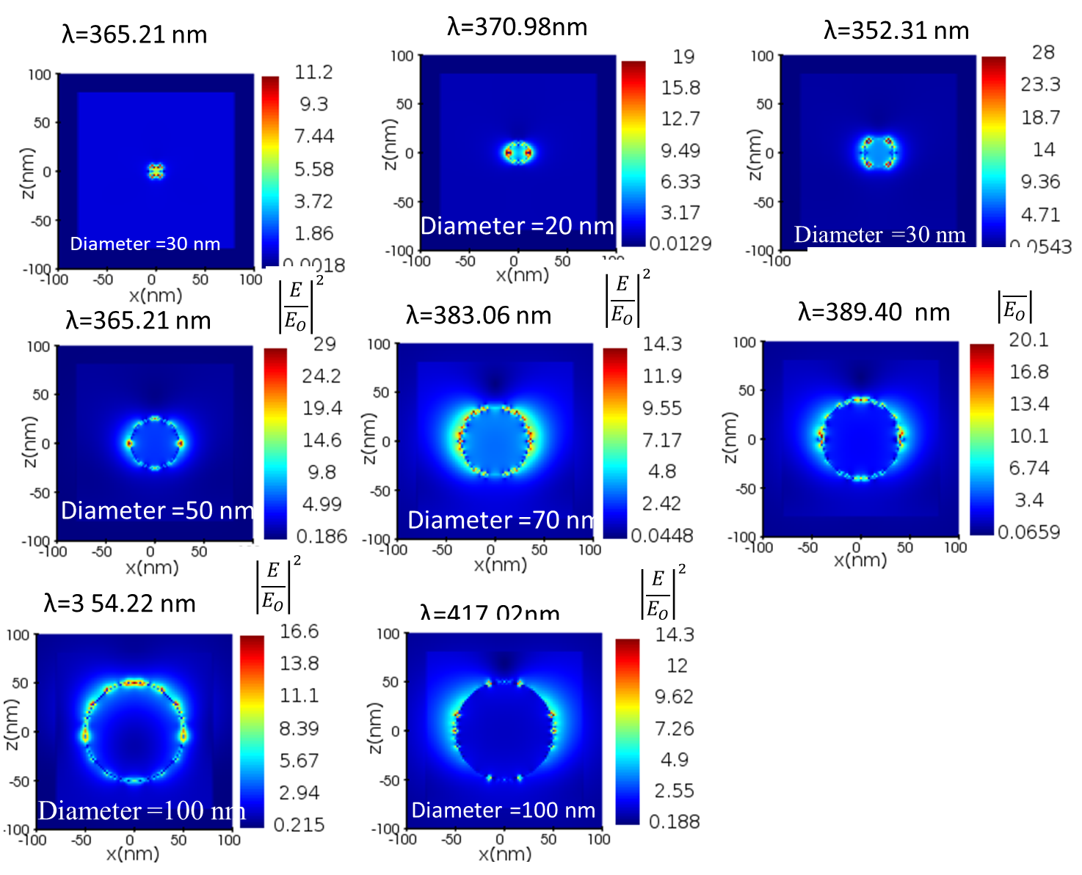

Fig. S 2: Electric field intensity calculated from frequency domain field around Ag NS at the LSPR mode for 10, 20, 30, 50, 80 and 100 nm diameters of Ag NSs.

Fig. S 3: Absorption cross section spectra of Ag NS with 70nm diameter coated by dielectric materials (a) Ag@TiO2, (b) Ag@SnO2, (c)Ag@ZnO and Ag@SiO2 with coating thickness of (0, 2, 5, 10, 35, 40 and 70 nm).
Fig. S 4: Scattering cross section spectra of Ag NS with 70 nm diameter coated by dielectric materials (a) Ag@TiO₂, (b) Ag@SnO₂, (c)Ag@ZnO and Ag@SiO₂ with coating thickness of (0, 2, 5, 10, 35, 40 and 70 nm).

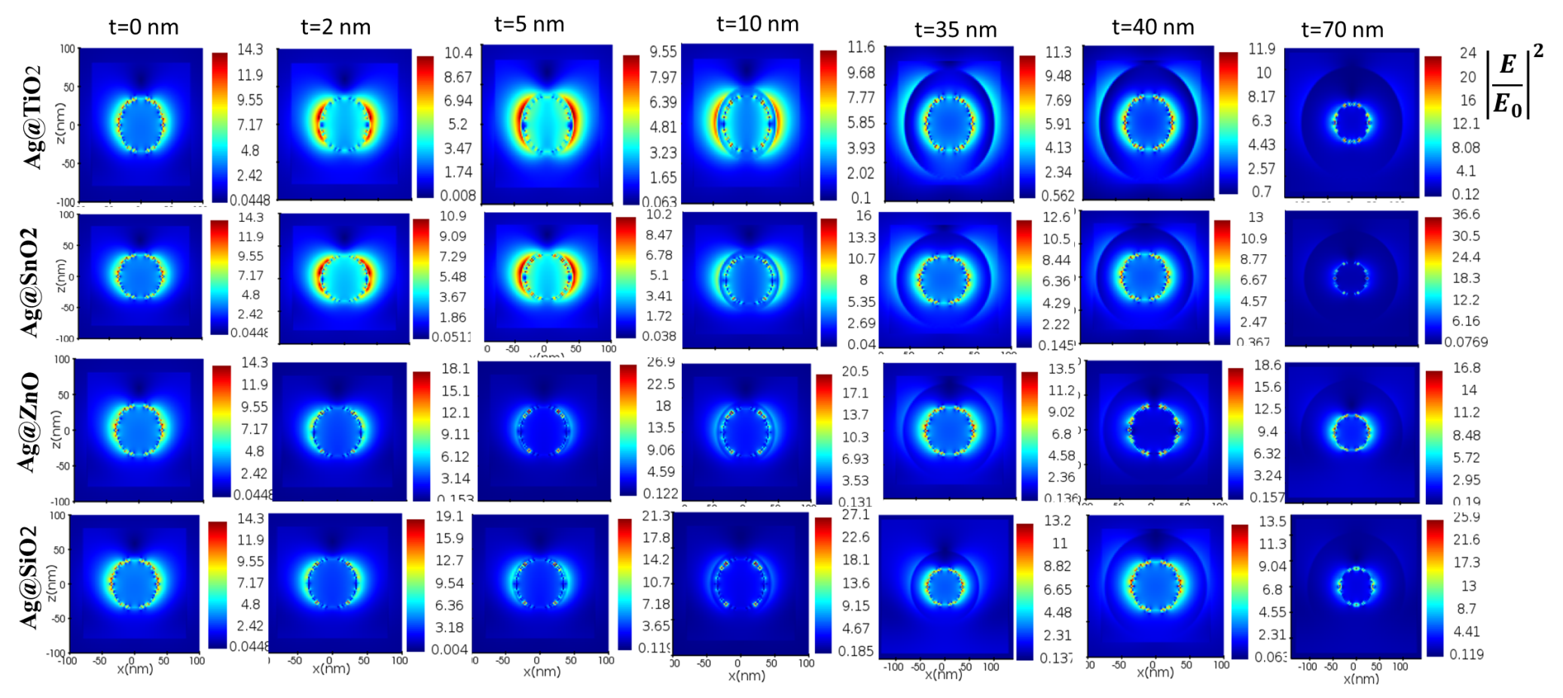
Fig. S 5: Electric filed intensity distribution measured from the frequency domain field monitor at the largest scattering wavelength for all proposed coating thickness.

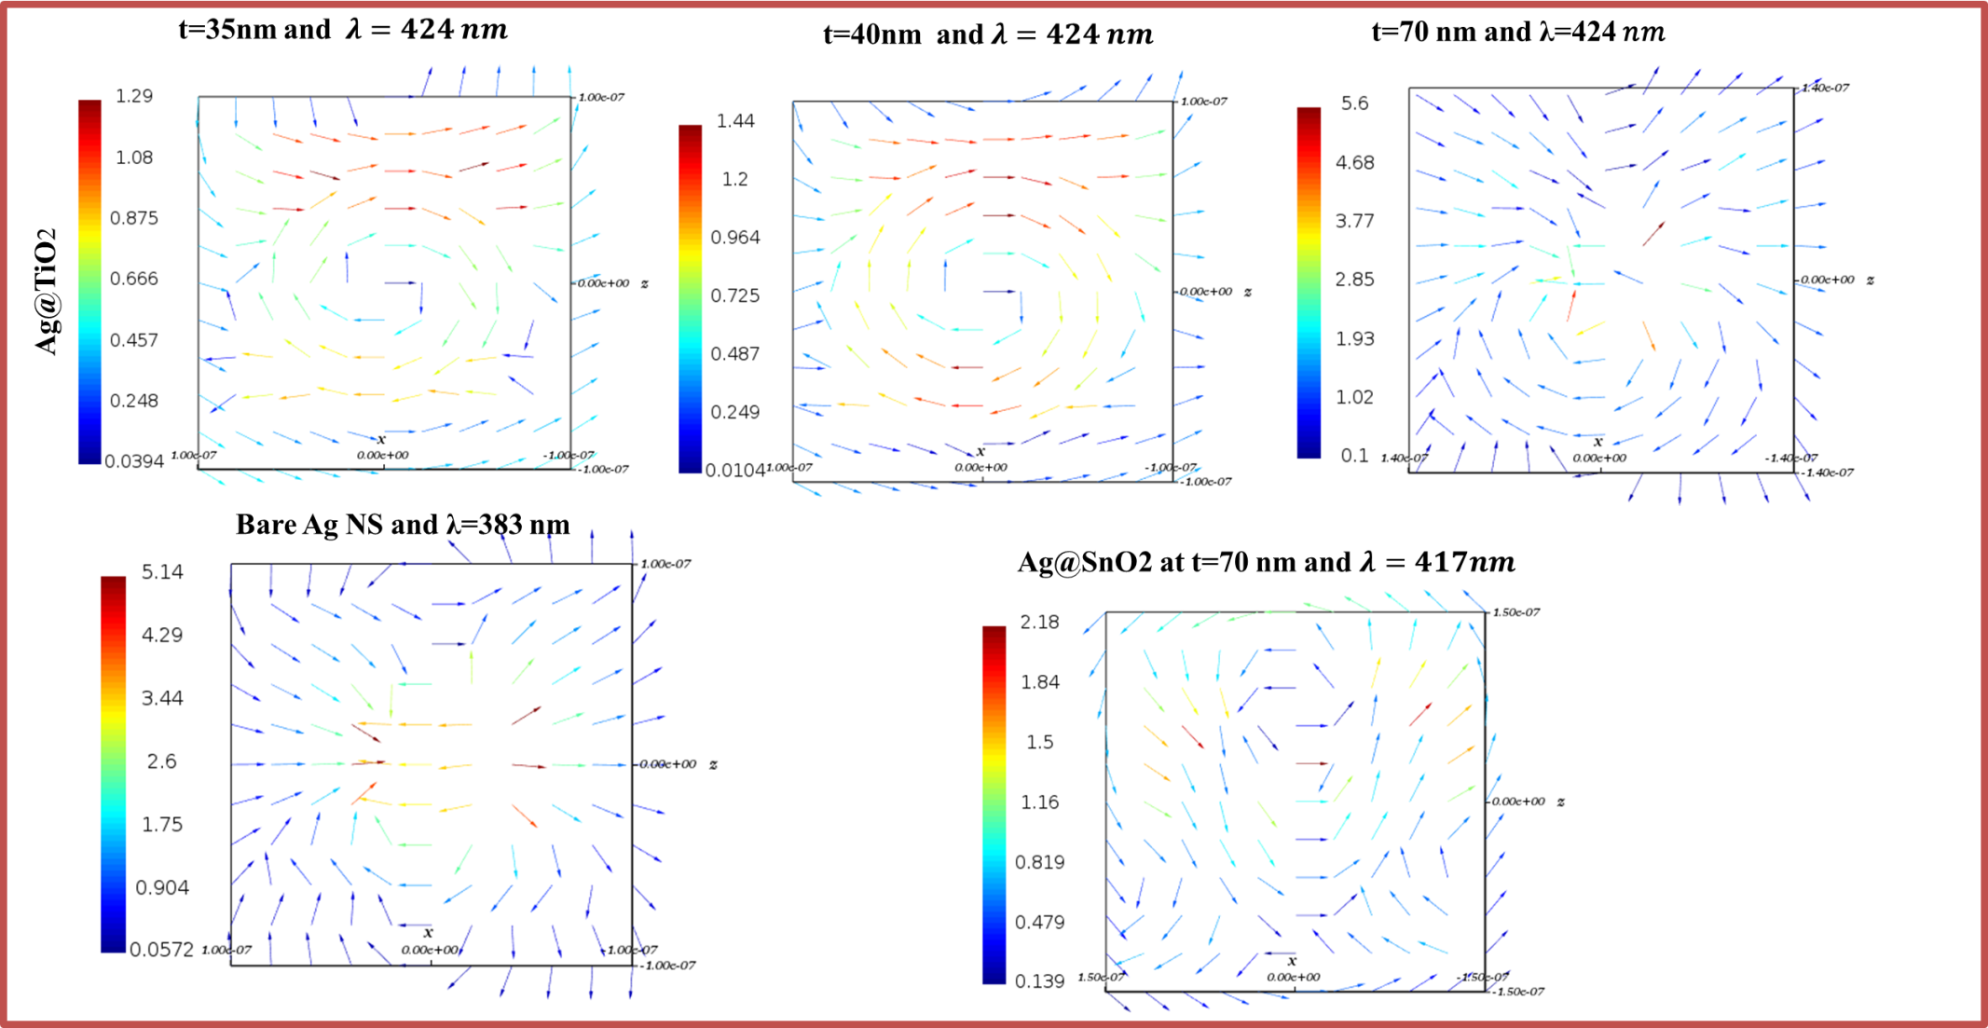
Fig. S 6: Electric field distribution intensity as vector for quadrupole LSPR mode for Ag NS coated by TiO₂ and SnO₂ and for bare Ag NS at the dipole mode for comparison.

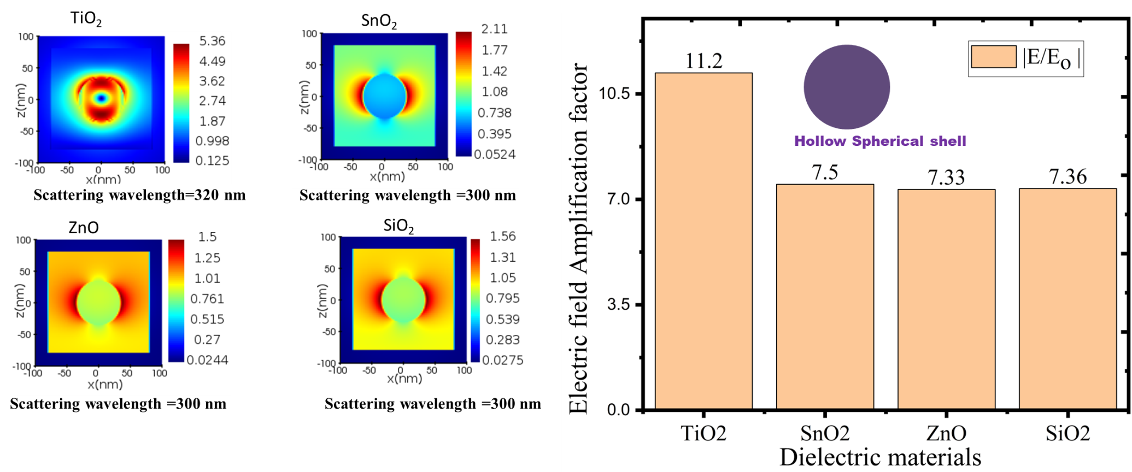
Scattering wavelength =320 nm
Fig. S 7: Represents (a) Electric field distribution intensity in spherical shape of dielectric material at the maximum scattering wavelength, (b) electric field amplification and (c) scattering of dielectric materials (TiO₂, SnO₂, ZnO and SiO₂

Fig. S 8 :Ag@dielectric coating materials placed at the middle of the active layer (P3HT: PCBM)

Fig. S 9: Ag@dielectric coating materials placed at the interfacial layers of HTL and AL

Fig. S 10 Ag@dielectric coating materials placed at the interfacial layers of AL and ETL.

Fig. S 11: Ag@dielectric coating materials placed at the interfacial layers of ETL and ITO

Fig. S 12: PCE of Ag coated by different materials and positioned in different layers of OSC.

