Supplementary Information

Chiroferromagnetic Quantum Dots for Chiroptical Synapse (ChiropS)

Junyoung Kwon^{1,2}†, Jae Bum Jeon¹†, Walber Gonçalves Guimarães Júnior³, Min Gu Lee¹, Changhyeon Lee⁴, Geunyoung Kim¹, Hanchan Song¹, Woon Hyung Cheong¹, Sung Gap Im ⁴, André F. de Moura³, Kyung Min Kim¹*‬‬‬‬‬, and Jihyeon Yeom^{1, 5, 6}*‬‬‬‬‬‬‬‬‬‬‬‬‬‬‬‬‬‬‬‬‬‬‬‬‬‬‬‬‬‬‬‬‬‬‬‬‬‬‬‬‬‬‬‬‬‬‬‬‬‬‬‬‬‬‬‬‬‬‬‬‬‬‬‬‬‬‬‬‬‬‬‬‬‬‬‬‬‬‬‬‬‬‬‬‬‬‬‬‬‬‬‬‬‬‬‬‬‬‬‬‬‬‬‬‬‬‬‬‬‬‬‬‬‬‬‬‬‬‬‬‬‬‬‬‬‬‬‬‬‬‬‬‬‬‬‬‬‬‬‬‬‬‬‬‬‬‬‬‬‬‬‬‬‬‬‬‬‬‬‬‬‬‬‬‬‬‬‬‬‬‬‬‬‬‬‬‬‬‬‬‬‬‬‬‬‬‬‬‬‬‬‬‬‬‬‬‬‬‬‬‬‬‬‬‬‬‬‬‬‬‬‬‬‬‬‬‬‬‬‬‬‬‬‬‬‬‬‬‬‬‬‬‬

Corresponding author: km.kim@kaist.ac.kr, jhyeom@kaist.ac.kr

The file includes:

Supplementary Text
Figs. S1 to S15
References

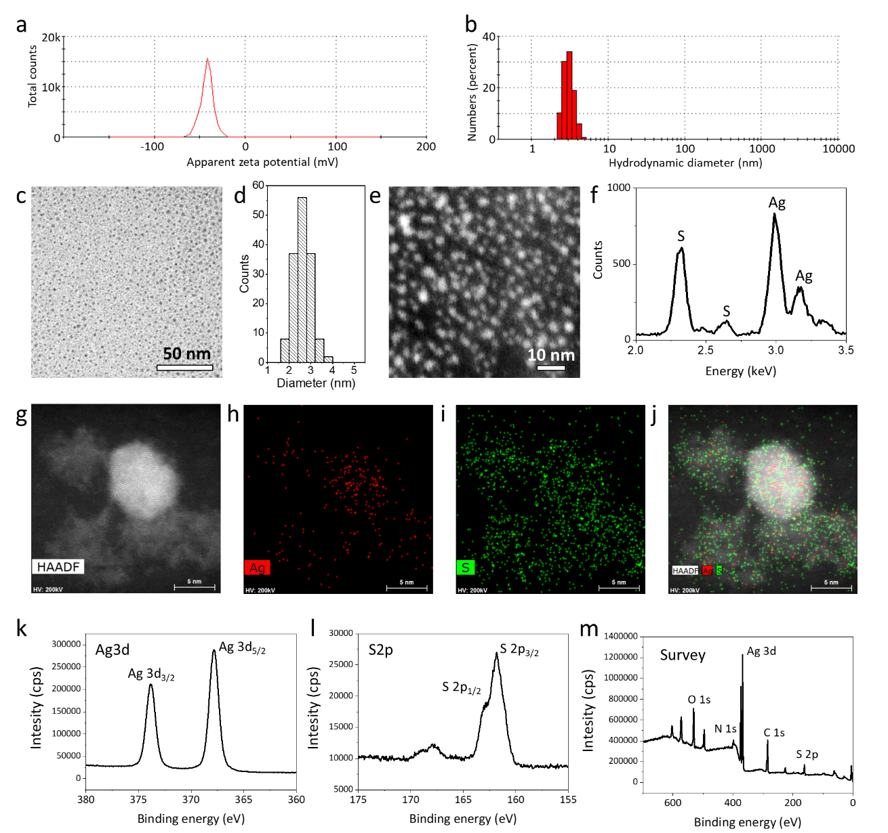

Fig. S1.
(a, b) Dynamic light scattering analysis. (a) Zeta potential: -36.5 mV, (b) hydrodynamic diameter: 3.08 nm (PDI: 0.682) (c) TEM image, (d) size distribution (2.62 ± 0.4 nm), (e) scanning TEM image, (f) energy dispersive spectroscopy (EDS) spectrum of L-Cys-Ag₂S CFQDs (Ag : S = 1.04 : 1.00). (g) High-angle annular dark field (HAADF)-STEM image and EDS mapping image of (h) Ag (i) S (j) Merged image. (k-m) X-ray photoelectron spectra of L-Cys-Ag2S CFQDs. (k) Ag3d, (l) S2p, (m) survey (Ag : S = 1.64 : 1)

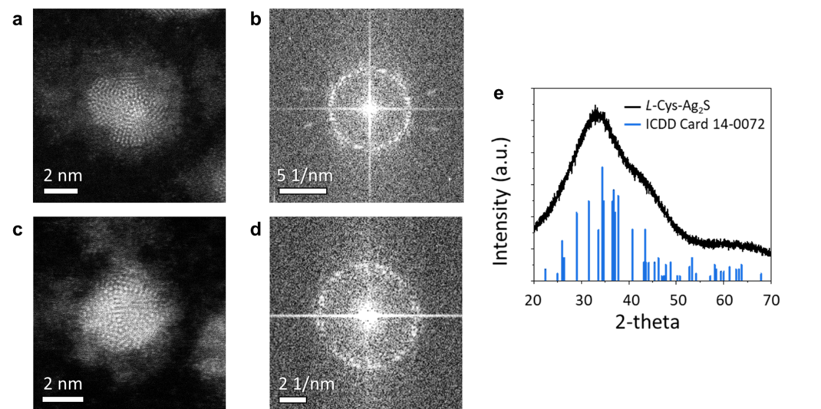

Fig. S2.
(a) STEM images, (b) their FFT images, (e) XRD pattern of L-Cys-Ag₂S CFQDs

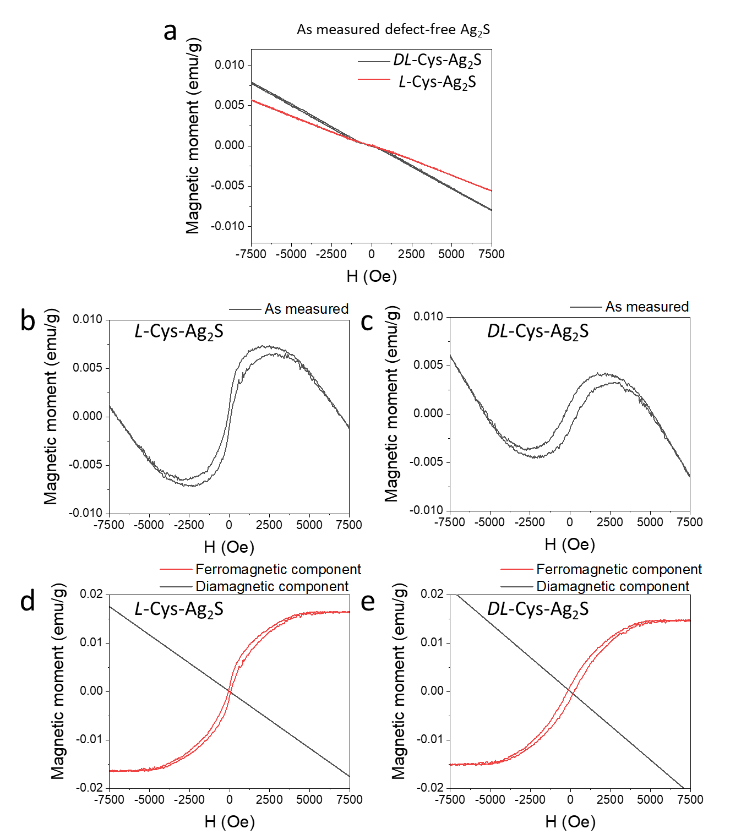

Fig. S3.
Magnetic hysteresis curve of measured (a) defect-free Ag₂S, defective (b) L-, (c) DL-Cys-Ag₂S, (d) L-, (e) DL-Cys-Ag₂S CFQDs showing ferromagnetic (red solid line) and diamagnetic (black solid line) components. The diamagnetism of the organic ligand molecules was subtracted from the measured hysteresis curve to represent the susceptibility of the inorganic cores¹.

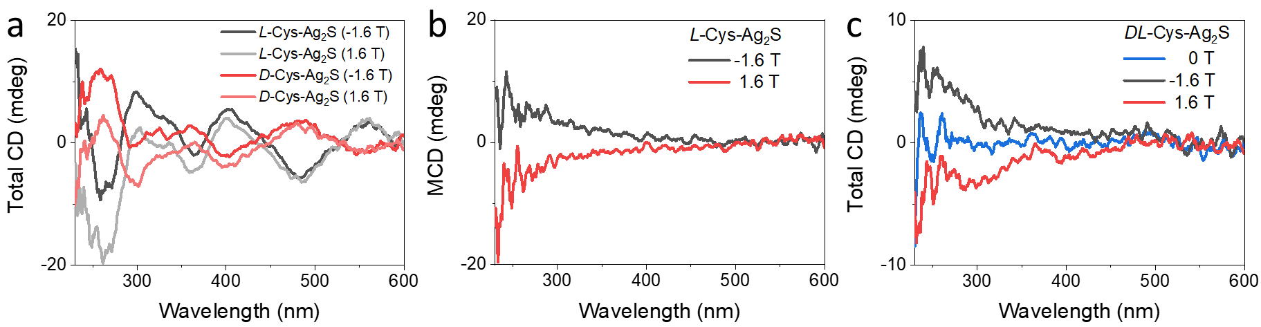
Fig. S4.
Circular dichroism (CD) spectra of Ag₂S CFQDs under external magnetic field. (a) Total CD spectra of L-, D-Cys-Ag₂S, (b) correct magnetic CD (MCD) spectra of L-Cys-Ag₂S which were obtained by subtracting the pure CD signal (external magnetic field: 0 T) from the total CD signal ($±$1.6 T), (c) total CD spectra of DL-Cys-Ag₂S. Applied magnetic fields are −1.6 T (black curve, S-N) and +1.6 T (red curve, N-S). Quartz cuvettes with a beam pathlength of 5 mm were used for the MCD measurements.

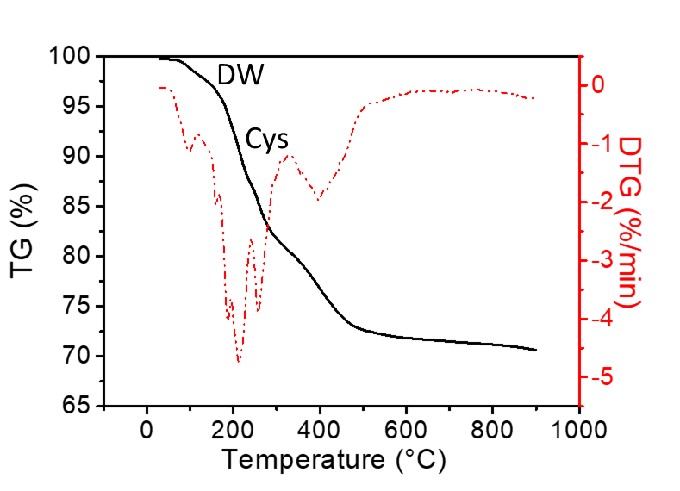
Fig. S5.
The thermogravimetric (TG)/derivative thermogravimetry (DTG) curves of L-Cys-Ag₂S CFQDs.

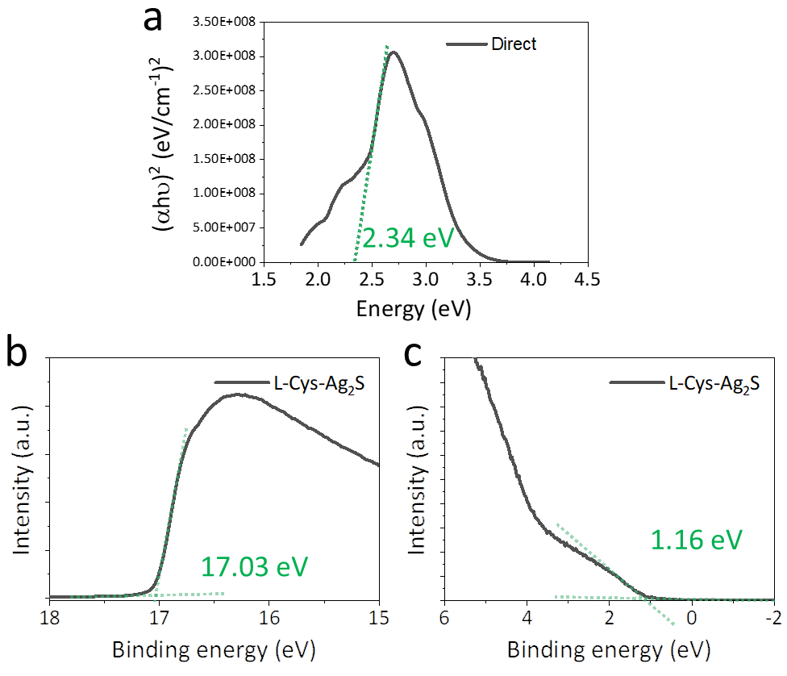
Fig. S6.
(a) Tauc plot from PLE spectrum showing a direct band gap, (b) secondary electron cut-off, (c) valence band region spectra of L-Cys-Ag₂S CFQD film on Si substrate obtained by ultraviolet photoelectron spectroscopy (UPS) spectra. The UPS spectra were measured with a photon energy of 21.2 eV.

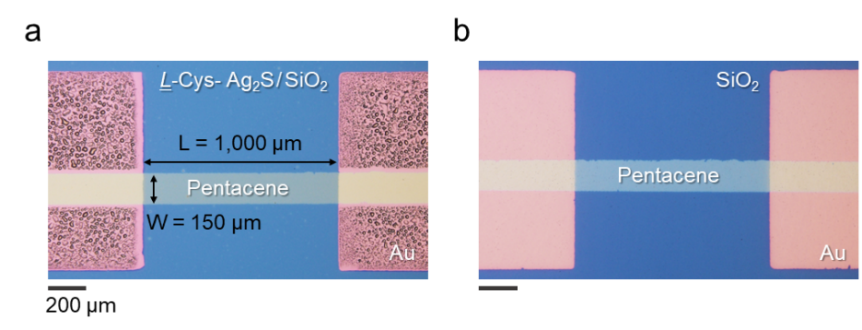
Fig. S7.
Optical microscope images of the top view. (a) the pentacene (50 nm)/Ag₂S(50 nm)/SiO₂(100 nm)/Si devices, (b) the pentacene (50 nm)/SiO₂(100 nm)/Si devices

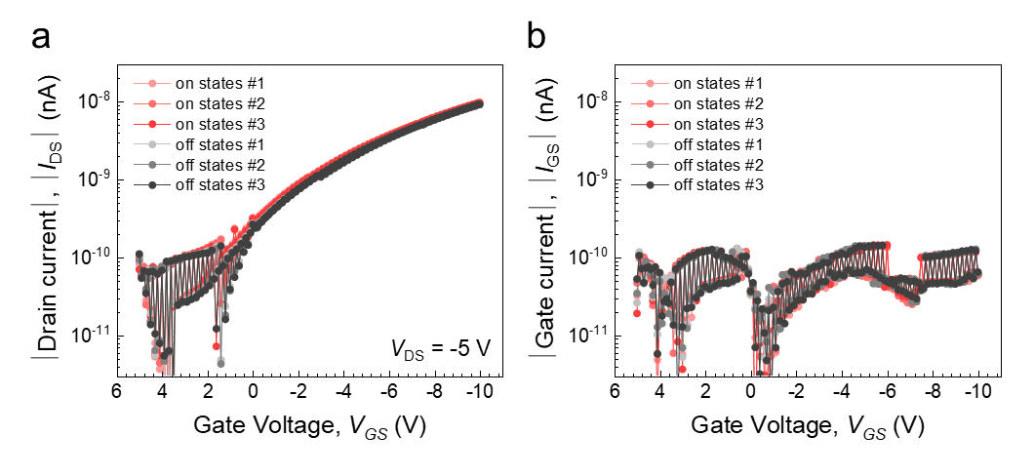
Fig. S8.
The transfer curve of the pentacene (50 nm)/SiO₂(100 nm)/Si devices. (a) drain current, (b) gate current

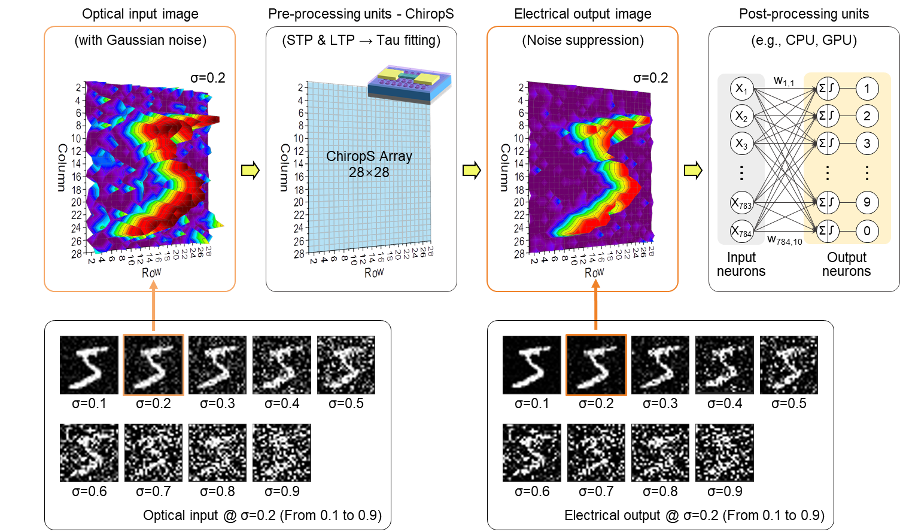
Fig. S9.
Schematic diagram of pre-processing techniques of optical noise suppression in simulation. Image noise from the sensor is undesirable since it obscures desired information and prevents the post-processing units such as the CPU and GPU from recognizing the image when the optical input transmits the data to the post-processing units.

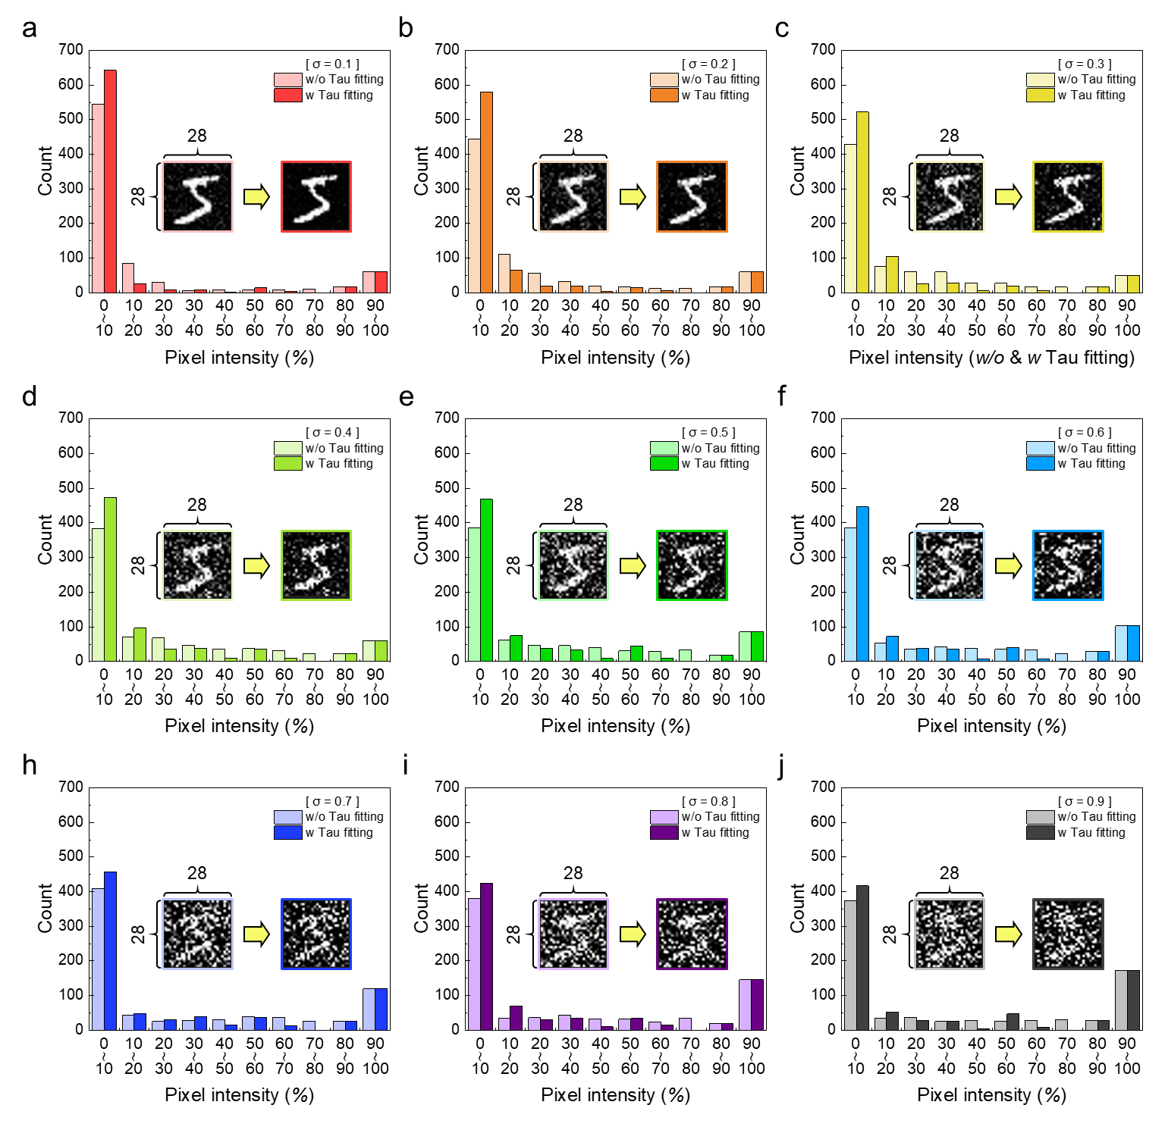
Fig. S10.
Histogram of the 28 × 28 pixel intensity from MNIST dataset into Gaussian random noisy (σ) from 0.1 to 0.9 to the input dataset. The time is 10 s and the tau value was extracted by the linear fittings which were reassembled by an exponential decay function.

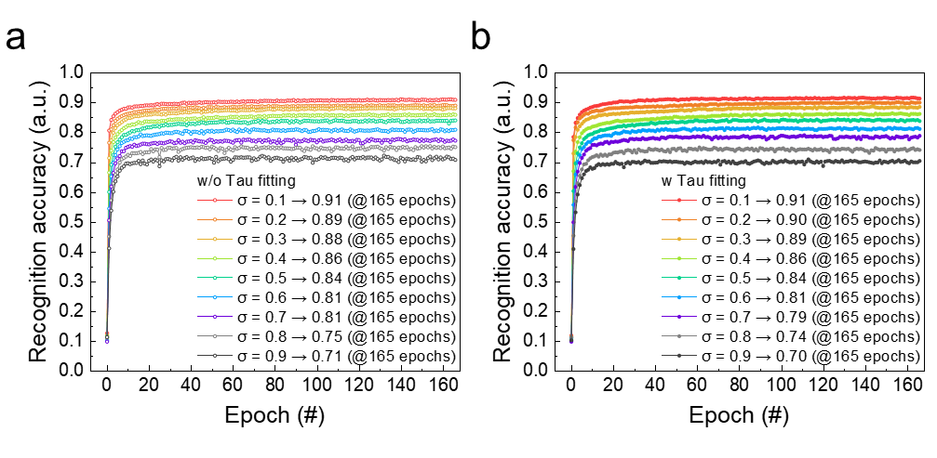
Fig. S11.
a) and b) Accuracy on the MNIST dataset with the different random noise levels from σ = 0.1 to σ = 0.9 in the absence of pre-processing units and pre-processing units (QDs-based chiroptical synapse).

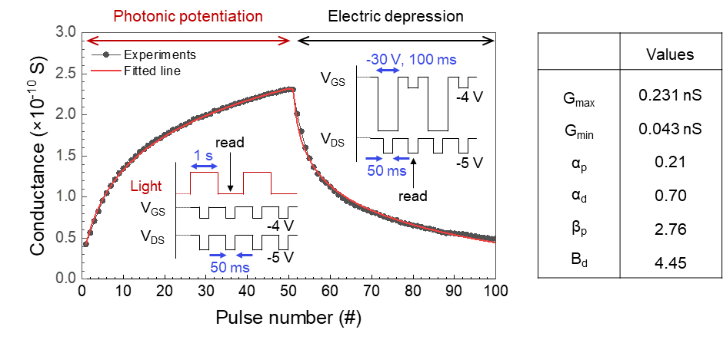
Fig. S12.
Photonic potentiation and electric depression characteristic of Chiroptical Synapse (ChiropS).
It shows a photonic potentiation with 1 s duration (2 mW/cm²) and electrical depression behavior at -30 V of the V_{GS} with 1 ms pulse. The conductance values increased from 0.043 nS ($G_{min}$) to 0.231 nS ($G_{max}$) and the fitting coefficients for the potentiation of $α_{p}$ and $β_{p}$ are matched by 0.21 and 2.76 (The fitting coefficients for the depression of $α_{d}$ and $β_{d}$ are matched by 0.70 and 4.45). Then, the $n$ is the number of potentiation and depression pulses. The value of conductance of our devices (black circle) can be fitted well by an exponential function (red line) as follows².
$$G_{n+1} =G_{n}+ {ΔG}_{P}=G_{n} + α_{p}∙e^{{-β}_{p} \frac{G_{n}-G_{min}}{G_{max}-G_{min}}}$$ | (1)
$$G_{n+1} =G_{n}- {ΔG}_{d}=G_{n}- α_{d}∙e^{{-β}_{d} \frac{G_{max}-G_{n}}{G_{max}-G_{min}}}$$ | (2)

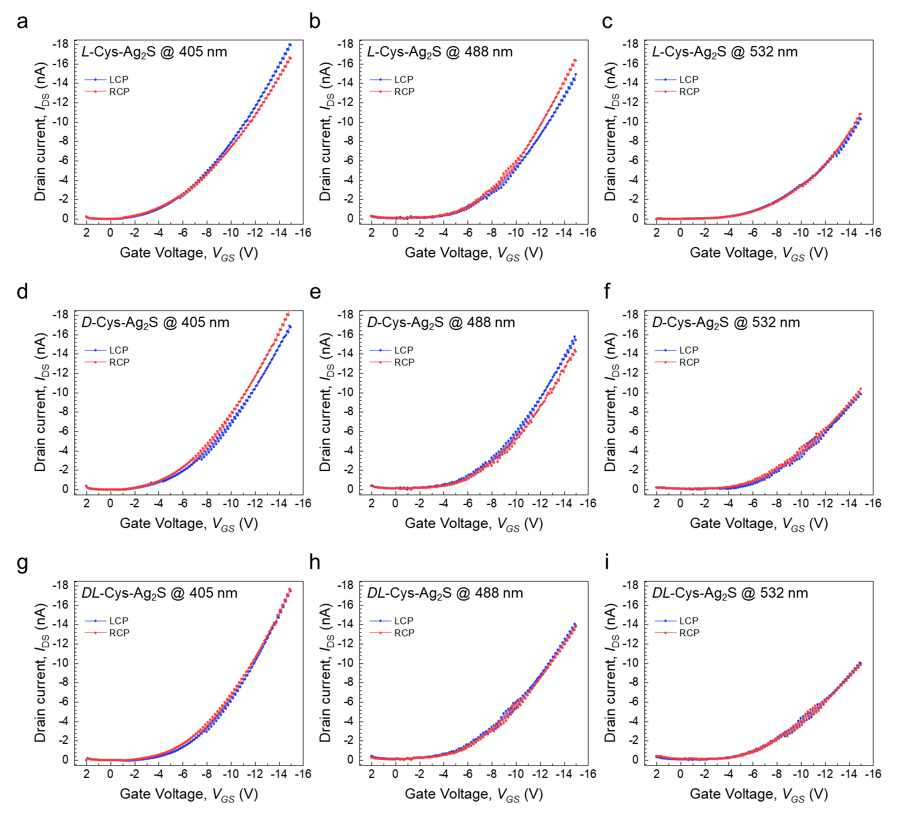
Fig. S13.
Transfer characteristics in a linear scale of the L-Cys, D-Cys, and DL-Cys Ag₂S-based ChiropS under various LCP and RCP light illumination wavelengths of 405 nm, 488 nm, and 532 nm.

Supplementary Text

Model nanoparticle
The model nanoparticle was built based on the Ag₂S acanthite structure³ by the replication of the crystallographic unit cell in the a, b, and c directions, cutting the supercell to expose faces (103), (121), and ($\overline{\text{1}}$23), which were observed in the TEM images (Fig. S14). The resulting nanoparticle had a diameter of 2.0 nm and a composition of Ag₆₀S₃₀, which was stable even without ligands (Fig. S15). The model nanoparticle was functionalized with 22 L-cysteine molecules, whose thiol sulfur atom replaced the surface sulfur sites (inset of Fig. 2a). The Ag₂S structure belongs to the achiral P2₁/n group (space group number 14), but using the Miller indices observed experimentally rendered a model for the bare nanoparticle which belongs to the low symmetry and chiral C₁ point group, so the placement of L-cysteine followed the chiral pattern of sulfur atoms along the surface. Thus, we must acknowledge that the actual physical system must also have this kind of hierarchical chirality, mixing the chirality information from the ceramic core, the ligands, and the surface decoration patterns. L-Cysteine molecules were in their negative state to yield an overall negatively charged structure, consistent with the experimental zeta potential. The enantiomeric pair functionalized with D-cysteine was obtained by mirroring the Cartesian coordinates of all atoms after the L-cysteine structure was fully optimized.

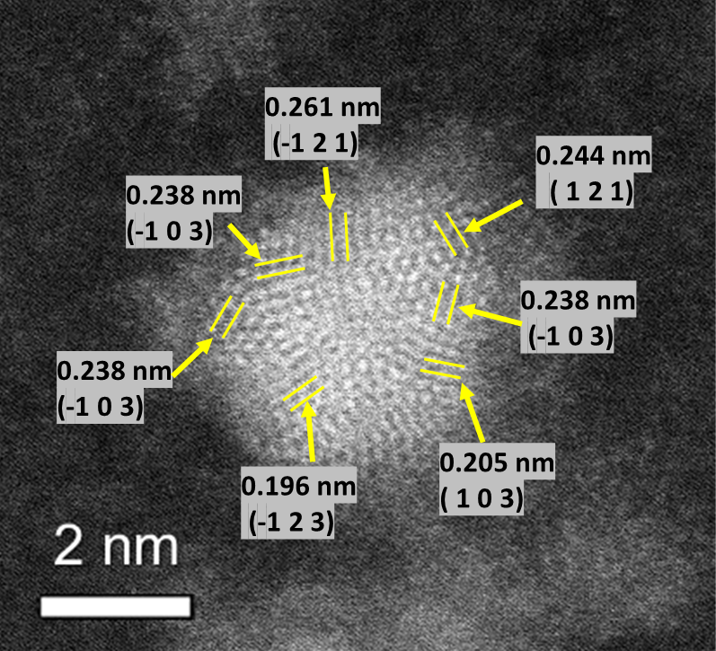
Fig. S14.
Experimental determination of Miller indices to build model nanoparticle.

Fig. S15.
Relative energy (Top) and energy ratio (Bottom) per (Ag₂S)_{n} unit formula. Red points in the gas phase and blue points in the water-implicit solvent.

References
- Chen, S.-Y., Tseng, E., Lai, Y.-T., Lee, W. & Gloter, A. Interface interactions and enhanced room temperature ferromagnetism of Ag@ CeO2 nanostructures. Nanoscale 9, 10764–10772 (2017).
- Querlioz, D., Dollfus, P., Bichler, O. & Gamrat, C. In IEEE/ACM International Symposium on Nanoscale Architectures (IEEE, 2011), pp. 150–156.
- Frueh, A. J. The crystallography of silver sulfide, Ag2S. Z. Kristallogr. 110, 136–144 (1958).

