Supplementary information

Table S1. Characteristics of patients with NSCLC.
Variable | Number of patients |  | p
Variable | High (n=67) | Low（n=15） | p
Gender  Male  Female | 51  16 | 14  1 | 0.137
Age  60≤  <60 | 38  29 | 9  6 | 0.816
Smoking  no  yes | 20  47 | 5  10 | 0.975
Histology  Adenocarcinoma  Squamous cell carcinoma  Other | 33  31  3 | 7  7  1 | 0.933

Table S2. The sequences of primers or probes used in this study
Gene | Sequences
EMSA probe (WT) | TTCCTGGCCACCCACCTGGGCACT  AAGGACCGGTGGGTGGACCCGTGA
EMSA probe (MT) | TTCCTGGCCACCTATCTAGGCACT  AAGGACCGGTGGATAGATCCGTGA
miR-23a (ISH) | TAGTGTAACGGTCCCTAAAGG-DIG
miR-27a (ISH) | AAGTGTCACCGATTCAAGGCG-DIG
miR-24-2 (ISH) | ACCGAGTCAAGTCGTCCTTGTC-DIG
MITF | CGAAAGTTGCAACGRGAACAGCA  GAGCCTGCATTTCAAGTTCCTGTA
CBLB | CACCCTTCTCCCAAGCATAA  AGACCGAACAGGAGCTTTGA
Actin | AAACTGGAACGGTGAAGGTG  GTGGCTTTTAGGATGGCAAG

Supplementary Figure legends
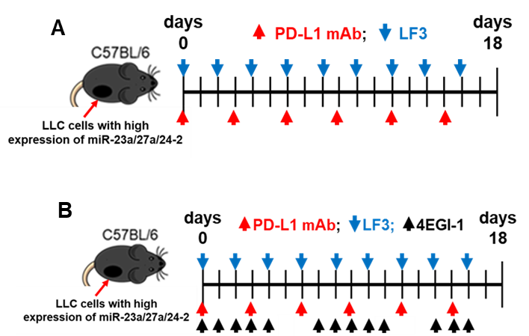
Fig. S1. Drug treatment schedule. A. Drug treatment schedule for LF3 and PD-L1 mAb combination treatment. B. Drug treatment schedule for compare the enhancing effects of LF3 and 4EGI-1 on the PD-L1 mAb therapeutic efficacy. Xenograft models were generated using C57BL/6J mice by subcutaneously injection Lewis lung cancer cells with high expressing miR-23a/27a/24-2 cluster. Drug treatment was started when tumor volumes were reached about 100mm³.

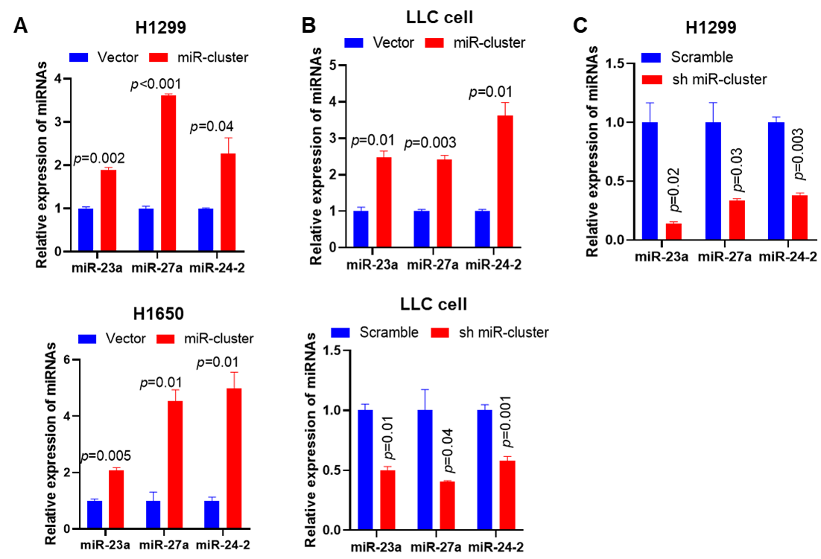
Fig. S2. The expression level of miR-23a/27a/24-2 cluster. A. H1299 and H1650 cells were transfected with empty vector or miR-23a/27a/24-2 cluster expressing construct (miR-cluster) and measured indicated miRNAs expression. B. LLC cells were transfected with empty vector or scramble plasmid or miR-23a/27a/24-2 cluster expressing construct or construct that expressing miR-23a/27a/24-2 cluster shRNA (sh miR-cluster) and measured indicated miRNAs expression. C. H1299 cells were transfected with scramble plasmid or construct that expressing miR-23a/27a/24-2 cluster shRNA and measured indicated miRNAs expression. miRNAs expression was measured by qRT-PCR after 72 hours of transfection.
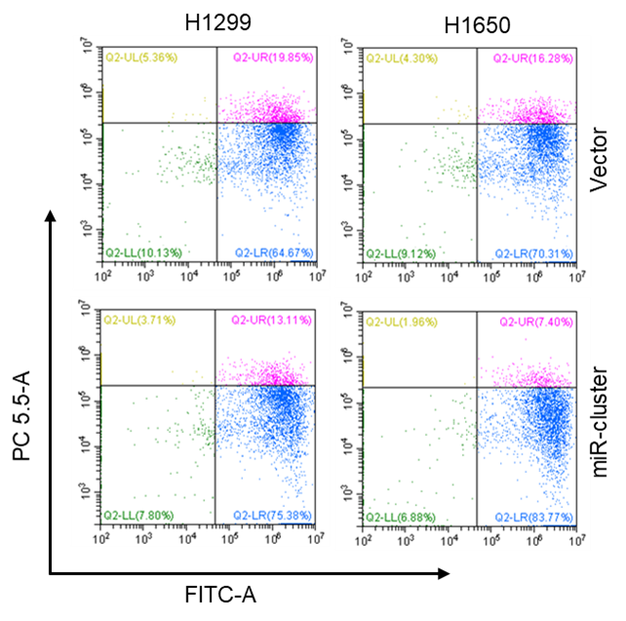
Fig. S3. Histograms for cell death of H1650 and H1299 cells. Indicated cells were transfected with empty vector or miR-23a/27a/24-2 cluster expressing construct. After 48 hours of transfection, tumor cells were co-cultured with activated T cells for 6 hours. Then, tumor cell death was measured by flow cytometry.

