Supplementary information of “Whole Genome Sequence Analysis of Pulmonary Function and COPD in 44,287 Multi-ancestry Participants”

Supplementary Text

Cohort Descriptions
Population- and Family-based Cohorts
The Atherosclerosis Risk in Communities Study (ARIC)
ARIC study is a prospective cohort study designed to evaluate the etiology of atherosclerosis and its clinical sequelae in a general population based sample of adults (1) . Men and women, aged 45–64 years, were recruited and enrolled from four U.S. communities: Forsyth County, North Carolina; Jackson, Mississippi; suburbs of Minneapolis, Minnesota; and Washington County, Maryland. Initial examination of the cohort took place in 1987–1989 (visit 1), when participants responded to health-related questionnaires and completed a clinical examination. Cohort members completed three additional triennial follow-up examinations, a fifth exam in 2011-2013, a sixth exam in 2016-2017, a seventh exam in 2018-2019, and an eighth exam in 2020.
At each visit, spirometry testing protocols were standardized across the four ARIC field centers, calibration checks were performed daily, and the standardization of data collection and management was coordinated across field centers by a single pulmonary function reading center. Each participant's best FEV₁ and FVC of three acceptable maneuvers, based on the centralized expert review, was used for analysis (2). For the current cross-sectional WGS analysis, data from the most recent spirometry exam were utilized for participants having multiple longitudinal measures, as these measures were viewed to be the most consistent with those available for the other more contemporary cohorts.

​​Coronary Artery Risk Development in Young Adults (CARDIA)
During 1985 -1986, CARDIA recruited 5,115 black and white men and women, aged 18 to 30 years, from the general population at Birmingham, Alabama; Chicago, Illinois; and Minneapolis, Minnesota; and from the membership of the Oakland Kaiser-Permanente Health Plan in Oakland, California. The participants were selected so that there would be approximately the same number of people in subgroups of race, gender, education (high school or less and more than high school) and age (18-24 and 25-30) in each of 4 centers. Detailed methods, instruments, and quality control procedures are described at the CARDIA website (http://www.cardia.dopm.uab.edu/ex_mt.htm) and in other published reports (3,4). Spirometric pulmonary function testing was performed using the Collins survey 8-liter water-sealed spirometer and the Eagle II microprocessor (Warren E. Collins, Inc., Braintree, MA) in a sitting position with noseclips, as per the 1979 American Thoracic Society criteria (5). Specifically, each subject performed a minimum of three trials with expirations recorded to the FVC plateau, which occurs after six seconds of expiration in adult males and was maintained for at least one second before terminating the forced expiratory maneuver. If, at the end of the three trials, there were at least three acceptable tracings, and with the maximum FVC and FEV1 reproduced to within 5% or 100 mL, whichever is greater, no more trials were performed. For the current cross-sectional WGS analysis, data from the most recent spirometry exam were utilized for participants having multiple longitudinal measures.

The Cardiovascular Health Study (CHS)
CHS is a population-based cohort study of risk factors for coronary heart disease and stroke in adults ≥65 years conducted across four field centers (6). The original predominantly European ancestry cohort of 5,201 persons was recruited in 1989-1990 from random samples of the Medicare eligibility lists; subsequently, an additional predominantly African-American cohort of 687 persons was enrolled for a total sample of 5,888. Forty one European ancestry CHS participants that had been selected for inclusion in the second phase of the TOPMed sequencing program were included in our discovery analyses.
Blood samples were drawn from all participants at their baseline examination and DNA was subsequently extracted from available samples. CHS was approved by institutional review committees at each field center and individuals in the present analysis had available DNA and gave informed consent including consent to use of genetic information for the study of cardiovascular disease. In the original cohort, pulmonary function testing was conducted at the baseline visit and follow-up visits in years four and seven (7,8). Spirometry technicians were centrally trained and certified prior to recruitment of participants. A standard spirometry system, including a Collins Survey I water-seal spirometer (Collins Medical, Inc., Braintree, Massachusetts) and software from S&M Instruments (Doylestown, Pennsylvania), was used by technicians at all four recruitment centers. Stringent quality assurance procedures for spirometry testing exceeded ATS recommendations (7). For the current cross-sectional WGS analysis, data from the most recent spirometry exam were utilized for participants having multiple longitudinal measures, as these measures were viewed to be the most consistent with those available for the other more contemporary cohorts.

The Cleveland Family Study (CFS)
CFS is a family-based longitudinal study that includes participants with laboratory diagnosed sleep apnea, their family members and neighborhood control families followed between 1990 and 2006. Four examinations over 16 years provided measurements of sleep apnea with overnight polysomnography, anthropometry, and other related phenotypes (9). At each exam, forced vital capacity (FVC) and forced expiratory volume at one second (FEV₁) were obtained using a calibrated spirometer (Multi-Spiro). While seated, participants were encouraged to perform between 5-8 maneuvers to obtain 3 curves that met ATS standards for acceptability and reproducibility. For the current cross-sectional WGS analysis, data from the most recent spirometry exam were utilized for participants having multiple longitudinal measures, since the most recent exam provided the largest number of participants with non-missing spirometry data.

The Framingham Heart Study (FHS)
The Original Cohort of the Framingham Study was established between 1948 and 1952 as a random sample of 5,209 adult residents of the town of Framingham, Massachusetts. Between 1971 and 1975, the Framingham Study was expanded to include a second generation, the Offspring Cohort, comprising 5,124 adults who were the offspring, or spouses of the offspring, of Original Cohort participants (10). The Offspring Cohort has returned for examinations approximately every 4 years since enrollment, and spirometry data are available for the 3rd, 5th, 6th, 7th, and 8th examinations.
Spirometry for the Offspring Cohort 3rd examination (1983-87) was performed with a Collins Survey II spirometer interfaced with an Eagle II microprocessor (Warren E. Collins, Inc., Braintree, MA). Spirometry for the 5th (1991-95), 6th (1995-98), and 7th (1998-2001) examinations were performed with a Collins Survey II spirometer interfaced with a personal computer equipped with software developed by S & M Instruments (Doylestown, PA) and adapted for use in epidemiologic studies. Spirometry for the 8th (2005-08) and 9th (2011-14) examinations was performed with the Collins Comprehensive Pulmonary Laboratory (CPL) system with Collins 2000 Plus/SQL Software (Nspire Health, Inc., Longmont, CO). Spirometry was performed in accordance with contemporaneous guidelines of the American Thoracic Society. For the current cross-sectional WGS analysis, data from the earliest spirometry exam were utilized for participants having multiple longitudinal measures. We used this strategy to construct a cross-sectional subset because there were changes in the spirometers used in FHS over time, and selecting the earliest available spirometry measures for each participant was a practical way to create an internally consistent data set within this cohort.

The Jackson Heart Study (JHS)
JHS is a large, population-based observational study evaluating the etiology of cardiovascular diseases and related disorders among African Americans residing in the three counties (Hinds, Madison, and Rankin) that make up the Jackson, Mississippi metropolitan area (11). Data and biologic materials have been collected from 5,301 participants, including a nested family cohort of 1,498 members of 264 families. The age at enrollment for the unrelated cohort was 35-84 years; the family cohort included related individuals >21 years old. During a baseline examination (2000-2004) and two follow-up examinations (2005-2008 and 2009-2012), participants provided extensive medical and social history, had an array of physical and biochemical measurements and diagnostic procedures, and provided blood for genomic DNA (12). Annual follow-up interviews and cohort surveillance are ongoing. For the current cross-sectional WGS effort, only baseline spirometry data were available and utilized for analyses.

The Multi-Ethnic Study of Atherosclerosis (MESA)
MESA is a longitudinal study of subclinical cardiovascular disease and risk factors that predict progression to clinically overt cardiovascular disease or progression of the subclinical disease (13). Between 2000 and 2002, MESA recruited 6,814 men and women 45 to 84 years of age from Forsyth County, North Carolina; New York City; Baltimore; St. Paul, Minnesota; Chicago; and Los Angeles. Exclusion criteria were clinical cardiovascular disease, weight exceeding 136 kg (300 lb.), pregnancy, and impediment to long-term participation. The MESA Lung Study performed spirometry at Exams 3, 4 and 5 following the 2005 ATS/ERS guidelines in a subset of the MESA Study (14). All participants provided informed consent and the protocols of MESA were approved by the IRBs of collaborating institutions and the National Heart, Lung and Blood Institute. For the current cross-sectional WGS analysis, data from the earliest spirometry exam were utilized for participants having multiple longitudinal measures, as the measures from Exams 3 and 4 were viewed to be more internally consistent with each other, and only a smaller subset of participants had measures available at Exam 5.

Hispanic Community Health Study / Study of Latinos (HCHS/SOL)
HCHS/SOL is a community-based cohort study of 16,415 self-identified Hispanic/Latino persons aged 18 to 74 years recruited from and selected from households in predefined census-block groups across four U.S. communities (Chicago, Miami, the Bronx, and San Diego) (15).. The census-block groups were chosen to provide diversity among cohort participants with regard to socioeconomic status and national origin or background. The HCHS/SOL cohort includes participants who self-identified as having a Hispanic/Latino background; the largest groups are Central American (n = 1,730), Cuban (n = 2,348), Dominican (n = 1,460), Mexican (n = 6,471), Puerto Rican (n = 2,728), and South American (n = 1,068). The HCHS/SOL baseline clinical examination occurred between 2008 and 2011 and included comprehensive biological, behavioral, sociodemographic, and lung function assessments. Spirometry was conducted in accordance with American Thoracic Society/European Respiratory Society guidelines using a dry-rolling sealed spirometer. Institutional Review Boards at each field center approved study protocols, and written informed consent was obtained from all participants.

UK Biobank
The UK Biobank project (16) is a prospective cohort study of approximately 500,000 individuals from across the United Kingdom, aged between 40 and 69 at recruitment. Deep phenotypic information, health data, and biological samples have been collected for all participants. These include questionnaires on socio-demographic, lifestyle and health-related factors, physical measurements, blood, urine, and saliva samples at recruitment. Eye measures, electrocardiograph test, arterial stiffness and hearing test were performed during assessment visit. All subjects provided electronic signed consent for follow-up through linkage to their health-related records.
Spirometry phenotypes were cleaned and the resulting data were used to conduct a genome-wide association study in participants from the UK Biobank. Replication of lung function signals was examined using imputation to the Haplotype Reference Consortium (HRC) (17) in the 321,047 UK Biobank European samples and in 4,350 African UK Biobank samples. African ancestry samples were identified in UK Biobank by k-means clustering of the first two principal components of ancestry. Residuals from linear regression of each trait (FEV₁, FVC, FEV₁/FVC) against age, age2, sex, height, smoking status (ever or never) and genotyping array were ranked and inverse-normal transformed, giving normally distributed Z-scores, and genetic association testing was run using an additive genetic model implemented in BOLT-LMM v2.3 (18,19), using a linear mixed model to account for relatedness and fine-scale population structure. Lung function signals were also tested for association with smoking behaviour traits, including smoking initiation (SI), smoking cessation (SC) and heaviness of smoking index (HSI) in up to 447,062 European and 7,702 African UK Biobank samples. Genome-wide association testing of smoking behaviour traits was run under an additive genetic model using BOLT-LMM v2.320. For binary smoking behaviour phenotypes, age, age squared, sex and genotyping array were used as covariates. For the quantitative HSI phenotype, residuals from linear regression against age, age squared, sex and genotyping array were ranked and inverse-normal transformed to obtain adjusted, normally distributed Z-scores. For replication analysis, we filter variants based on imputation R-squared > 0.3 and effective heterozygosity count > 15.

Cohort Descriptions: COPD-enriched studies
Boston Early-Onset COPD (EOCOPD) Study
The Boston Early-Onset COPD (EOCOPD) study was designed to study genetic factors for early-onset and severe COPD (20,21). Probands were selected to be physician-diagnosed COPD cases with FEV₁≤ 40% predicted and age ≤ 53. Subjects with severe alpha-1 antitrypsin deficiency and other chronic lung diseases (except asthma) were excluded. All subjects completed a questionnaire and spirometry testing before and after bronchodilator administration. Blood samples and written informed consent were obtained for each study subject. A subset of the most severe unrelated probands from this study were sent for whole-genome sequencing through the TOPMed project. For the current cross-sectional WGS effort, only baseline spirometry data were available and utilized for analyses.

Genetic Epidemiology of COPD (COPDGene)
COPDGene (22) is a multi-center observational cohort for epidemiologic and genetic study of over 10,000 subjects (2/3 non-Hispanic White and 1/3 African Americans) with at least 10 pack-years of cigarettes smoking with and without COPD. All subjects underwent extensive phenotyping, including lung function, CT phenotypes (including emphysema and expiratory gas trapping). Pre- and post-bronchodilator spirometry measures were obtained using a standardized protocol and spirometer (ndd EasyOne Spirometer, Zurich, Switzerland). All study sites obtained local IRB approval to enroll participants and all subjects provided informed consent. For the current cross-sectional WGS effort, only baseline spirometry data were utilized for analyses, as the baseline data were complete and only a subset of participants had follow-up data.
ECLIPSE
The Evaluation of COPD Longitudinally to Identify Predictive Surrogate End-points (ECLIPSE, SCO104960, NCT00292552, www.eclipse-copd.com): Details of the ECLIPSE study (23) and genome-wide association analysis (24) have been described previously. ECLIPSE was an observational 3-year study of COPD. Both cases and controls were aged 40-75 with at least a 10 pack-year smoking history without other respiratory diseases; cases were defined using pre-bronchodilator % predicted FEV1 < 80% predicted and FEV1/FVC < 0.7, and controls had normal spirometry (% predicted FEV1 > 85%).

Phenotype Harmonization
The NHLBI Pooled Cohorts Study (PCS) harmonized and pooled data from nine large US epidemiologic cohorts that conducted lung function assessments over the last four decades (25). Additionally, data on self-administered questionnaires, with detailed questions regarding tobacco consumption, past medical history, medications, respiratory symptoms, lipids, renal biomarkers, etc., were also harmonized. Data on CLRD events was harmonized using either adjudicated CLRD hospitalizations or ICD data for all hospitalizations occurring over follow-up.
Among the cohorts included in the NHLBI PCS, the follow cohorts were also included in our TOPMed WGS analyses, for which we utilized harmonized data sets from NHLBI PCS: Atherosclerosis Risk in Communities (ARIC) study; Cardiovascular Health Study (CHS); Framingham Offspring Cohort (FHS-O); Jackson Heart Study (JHS), the Multi-Ethnic Study of Atherosclerosis (MESA). For the purpose of phenotype harmonization in TOPMed, harmonized data sets for each of the participating cohorts were provided by the NHLBI Pooled Cohorts Study for analyses in the current WGS analyses. We note that a subset of the ARIC participants were later recruited into JHS. For TOPMed purposes, participants in the ARIC-JHS overlap group were not included as part of Exam 4 in ARIC. For JHS, ARIC recruits were not excluded. For TOPMed studies not included in the NHLBI Pooled Cohorts Study (the Cleveland Family Study [CFS], Genetic Epidemiology of COPD [COPDGene], and Boston Early-Onset COPD Study [EOCOPD]), phenotype harmonization was conducted separately by each of the participating studies, following as closely as possible with the NHLBI Pooled Cohorts Study variable definitions and procedures.
For studies with multiple longitudinal spirometry measures, we worked with investigators from each study to determine the most practical way to construct a cross-sectional subset of data. All spirometry data utilized for this effort were obtained as pre-bronchodilator measures. Details are provided in the cohort descriptions above.

Whole genome sequence data
Genotypes were obtained from Whole Genome Sequence (WGS) data in TOPMed Freeze 8 samples. ~30X Whole genome sequencing was performed at four sequencing centers, Baylor College of Medicine Human Genome Sequencing Center, Broad Institute of MIT and Harvard, University of Washington Northwest Genomics Center and McDonnell Genome Institute at Washington University, and the TOPMed Informatics Research Center (IRC) performed joint genotype calling using all samples in Freeze 8 on the GRCh38 assembly. Details regarding DNA sample extraction, WGS data sequencing method and quality control are available at https://topmed.nhlbi.nih.gov/topmed-whole-genome-sequencing-methods-freeze-8.
Structural variants including deletion, duplication and inversion were called using the Parliament2 pipeline (5) for 138,134 participants in TOPMed structural variant Freeze 1 covering nearly all participants from the TOPMed WGS Freeze 8. After variant quality control, we retained a total of 466,455 structural variant sites consisting of 231,817 deletions, 197,412 duplications and 37,226 inversions.
In addition to the quality control provided by TOPMed, we additionally excluded any participants with a mismatch between our phenotype-reported sex and the estimated sex using X chromosome heterozygosity, and with greater than 10% of genotypes with read depth of less than 10. We also removed duplicates. Within study-reported race, we removed those who were outliers by ancestry principal components. For each combination of cohort and race, groups with fewer than 100 participants were excluded from the analysis. After filtering, we retained 44,287 participants including 30,650 participants from population-based studies and 13,637 participants from COPD-enriched studies (Supplementary Table 1).

Statistical Methods

Fitting the null model for genetic association analysis
Genome-wide association tests were performed using the R Bioconductor package GENESIS (26) on the DNANexus platform (https://www.dnanexus.com). Genetic association testing with GENESIS comprises two steps: (i) fitting the null model under the null hypothesis of no genetic association and (ii) testing genetic variants for association, either individually or in aggregate. For each of the quantitative phenotypes, we fit the null model using a linear mixed model (LMM) adjusting for sex, age, age², height, height², weight (FVC only), pack-years of smoking, current smoking, former smoking, first 10 PC-AiR (principal components analysis in related samples) of ancestry (27), study, race and sequencing center. For each of the dichotomous phenotypes, we fit a generalized linear mixed model (GLMM) adjusting for covariates and case control definitions as in prior case control studies for sex, age, pack-years of smoking, ever vs. never smoking, first 10 PC-AiR PCs of ancestry, study, race and sequencing center. For both quantitative and dichotomous phenotypes, age and height were centered at mean, and a sparse empirical kinship matrix computed with PC-related (28) was included as a random effect to account for genetic relatedness among study participants. The null models were fit allowing for phenotypic heteroskedasticity across studies and ancestry groups.
To control false-positive rate and improve statistical power, we applied a fully-adjusted two-stage approach (29) to the null model as follows:
Stage 1: Using the current null model, we performed a rank-based inverse-normal transformation of the marginal residuals, and subsequently rescaled by their standard deviation. This rescaling restores the original scale of phenotype, providing more meaningful estimates of effect size from subsequent association tests (30).
Stage 2: We fit again LMM and GLMMs using the rank-normalized and re-scaled residuals obtained from the Stage 1 as the outcome, with the same covariates and a sparse empirical kinship matrix of the original null model allowing for phenotypic heteroskedasticity. We used the null model of Stage 2 to perform both single variant and variant set-based analyses for association.

Single variant-based association analysis
The overview of the workflow for the single variant-based association analysis is illustrated in Supplementary Figure 5. We first fit a null model, i.e., a regression model that uses only covariates and not any variant that is later being tested. We next used this null model to perform genome-wide score tests for single variants. For quantitative phenotypes, we tested genetic association for all single variants with minor allele count (MAC)$≥$25 that passed the TOPMed variant quality filters. For dichotomous phenotypes, we instead required (MAC)$≥$25 in the smaller group among cases and controls (Supplementary Table 10). We applied saddle point approximation (SPA test) for dichotomous phenotypes to calibrate the inflation caused by the unbalanced case-control ratios (31). We determined genome-wide significance at a P-value<5$×$10⁻⁹ (32). Significant association regions were constructed by grouping significant variants together within 2Mb (1Mb flanks) and the top variant was defined as the most significant variant in each region.

Conditional association analysis for significant single variants
To identify genetic variants which were independent of previously reported GWAS variants, we systematically performed a conditional association analysis for significant variants of each trait. First, we collected genetic variants known to be associated with each phenotype from two previous studies with the largest sample size and extensive validation (Supplementary Table 3) (33,34). In addition, we included the known alpha-1 deficiency Z allele in SERPINA1 on chromosome 14 (35) and the variant previously described in association with COPD, as well as cigarette smoking, in CYP2A6 on chromosome 19 (36). And then, for the TOPMed significant variants which were not reported yet, we created a linkage disequilibrium pruned subset of previously reported GWAS variants within 1Mb flanks of each significant variant by greedily pruning variants in pairs of variants in each window with an r² greater than 0.2 until no such pairs remain. Pruning variants were performed using PLINK 2.0 (37). Fourth, we performed conditional analyses by including the pruned subset of variants as fixed effect covariates in the null model using the same approach of the discovery analysis described above. Our analysis was completed before the publication of Shrine et al (2023); as a final step, we assessed whether our signals were in LD with these newly reported variants.

Variant set-based association analysis
To assess the contribution of rare variants, we performed variant set-based association analysis as illustrated in Supplementary Figure 6. We aggregated rare variants with MAF$≤$5% that passed the TOPMed variant quality filters based on gene units from GENCODE v28 (48). To enrich variants that are likely to be functional, we selected a subset of rare variants within the genes with the criteria; (a) hcLoF: high-confidence loss-of-function (LoF) variants based on Loss-Of-Function in Transcript Effect Estimator (LOFTEE) (49) and (b) LoF/Missense: LoF or missense variants based on Variant Effect Predictor (VEP) Ensembl Consequence (50). Variant annotation was performed using the WGSA v0.8 (51) and WGSAParsr v6.3.8 (https://github.com/UW-GAC/wgsaparsr) on the BioData Catalyst cloud-based platform powered by Seven Bridges (52). For quantitative phenotypes, we only considered aggregate units with cumulative MAC$≥$25. Similarly, we used the modified cutoff derived from the single variant-based association analysis for dichotomous phenotypes.
The genome-wide score tests were performed for all aggregate units using the Variant-Set Mixed Model Association Test (SMMAT) implemented in GENESIS (53). The SMMAT is a powerful and efficient hybrid test that combines the mixed model burden and SKAT tests (54–57). For each phenotype, study design and aggregation criteria (hcLoF and LoF/missense), we determined statistical significance using a trait-/subgroup-specific Bonferroni threshold adjusting for the number of valid tests.

Conditional association analysis for significant variant sets
In addition to the previously reported GWAS variants used in the conditional analyses for single variants, we included significant variants of the single variant-based analyses to variant sets known to be associated with each phenotype. Variants used in variant set-based analyses were excluded from the variant sets to be conditional. As with the single variant-based analysis, conditional association analyses were performed by including a pruned subset of variants within 2Mb of each gene as fixed effect covariates in the null model.

Association analysis for structural variants
Structural variant analyses were conducted using SAIGE-LMM (58) on Encore cloud analysis platform (https://encore.sph.umich.edu/). For quantitative phenotypes, we utilized residuals of the null models to account for heterogeneous variances across the studies and phenotypes were then constructed by applying rank-based inverse normal transformation to the residuals. The same covariates used in the association analyses above were included as fixed effect covariates. We assessed structural variants with MAF>0.1% and used a genome-wide significance level of 5$×$10⁻⁸.

Replication analysis in the UK Biobank
We examined association with lung function and COPD for novel single variants and genes identified by the discovery WGS analysis in the UK Biobank (35) for 183,485 unrelated multi-ancestry participants (174,893 European ancestry; 3,447 South Asian; 2,861 African ancestry; 795 Chinese; 342 Mixed African and European ancestry; 1,147 Mixed other, as reported by UK Biobank). We conducted replication studies separately for genetic association results based on (1) all participants, or (2) stratified analysis of European ancestry participants only. The same variables in the discovery analysis were included as covariates except for race due to high correlation with the PC corresponding to the largest eigenvalue (Supplementary Figure 7, Supplementary Table 11). Participants with missing values for any of the variables used in the analysis were excluded from the analysis (Supplementary Table 12).
For the novel single variants, we used a linear regression and a generalized linear regression implemented in PLINK 2.0 (37) for quantitative and dichotomous phenotypes, respectively. Variants demonstrating replication were further examined for significance after adjusting for the same conditioned variants in the discovery analysis. For the novel genes, we annotated functional information to each variant using Ensembl REST API (59) (http://rest.ensembl.org/), and SKAT-O test (57) was performed for either sets of hcLoF or LoF/missense variants.
For gene-based rare variant analyses, we used previously published results of gene-based phenome-wide association studies (PheWAS) in the UK Biobank (60,61) using the results from Gene-biobank association summary statistics browsers (Genebass) with the aggregation unit of high confidence loss of function variants (61), and AstraZeneca Centre for Genomics Research PheWAS Portal (AZPheWAS) with the moderately rare protein-truncating variant of high quality and rare damaging non-synonymous variant of high quality (used for the comparison with the aggregation unit of hcLoF and LoF/Missense, respectively (60)). We generated combined values using Fisher’s method (62).

CRISPR knockdown of HMCN1 and measurement of matrix gene expression

Cell culture
HEK 293FT cells, originating from embryonic kidney epithelium, were procured from ATCC (Minnesota, VA). IMR-90 cells, a human fetal lung fibroblast cell line immortalized with human telomerase reverse transcriptase (hTERT), were acquired from Dr. William Hahn’s laboratory at the Dana-Farber Cancer Institute. IMR-90 cells were cultured with Eagle's minimum essential medium (EMEM), while HEK 293FT cells were sustained in Dulbecco’s modified Eagle medium (DMEM) supplemented with Fetal bovine serum (FBS) at 10%, along with 100 units of penicillin and 100 μg/mL streptomycin.

Molecular Cloning
The single guide RNA (sgRNA) targeting the transcription start site (TSS) of human HMCN1 gene was designed via the CRISPOR program (http://crispor.gi.ucsc.edu/) and subsequently cloned into lentiCRISPRv2 vector (Addgene #52961) using the Gibson assembly (NEB, #E2621L) based on a protocol from Dr. Feng Zhang’s lab, followed by sequence confirmation via Sanger sequencing and plasmid extraction by the QIAGEN plasmid midi kit (QIAGEN, #12945).

Lentiviral packaging and infection
The lentiviral packaging was performed using the polyethylenimine (PEI) protocol. Briefly, 293FT cells were plated at 3.0×10⁶ cells per 60-mm plate one day prior to transfection. For transfection, 4 μg of lentiCRISPRv2 containing HMCN1 sgRNA, 3 μg of psPAX2 (a lentiviral packaging plasmid), and 2.5 μg of pMD2.G (a lentiviral envelope plasmid), were transfected into cells using 30ul of PEI (1 μg/mL) (Polysciences, Warrington, PA). Twelve hours after transfection, the medium was replaced with fresh medium and collected after 72 hours. The virus-containing supernatant was collected and filtered through 0.45 μm membrane and added to IMR90 cells seeded in a 6-well plate at 80% confluency, in the presence of 2 μg/mL polybrene (EMD Millipore, TR-1003-G). Twenty four hours after infection, IMR-90 stable cells were selected with 1ug/mL puromycin (InvivoGen, #ant-pr-1) for 2 days to eliminate non-infected cells. Knockout efficiency of HMCN1 was measured by RT-qPCR analysis in two to three independent biological replicates, each with two technical replicates, of stable KO cells.

Measurement of collagen genes after HMCN1 knockdown
The HMCN1 stable knockout IMR-90 cells, alongside with the empty vector-infected control stable cells, were cultured in either 0.1% FBS or 10% FBS. Cells were harvested for RNA extraction using the Zymo Research Quick RNA mini prep kit (Zymo Research, #R2052), followed by reverse transcription using the High-Capacity cDNA Reverse Transcription Kit (4368813, Thermo Fisher Scientific) based on the manufacturer’s protocol. Real-time qPCR was performed to determine expression of collagen genes (Gene probes were listed in Supplementary Table 4) with Applied Biosystems TaqMan Fast Advanced Master Mix (Thermo Fisher Scientific, #4444557) in the Quantstudio (Thermo Fisher). To analyze the effects, we averaged 2–∆∆Ct values using GAPDH controls across technical replicates and performed a T-test using R 4.3.0. We considered a P-value of < 0.05, Bonferroni corrected for multiple comparisons (i.e. P < 0.05/5, statistically significant).

Supplementary Results
Our initial conditional analysis, including publications through 2022, identified nine variants covering four loci that were still significant in conditional analyses. For these four potential novel loci and rs572516809, we further examined independence with recently reported GWAS variants in Shrine et al. (2023) (63). FEV1/FVC-associated variants at 15q25.2 were already reported (rs66990951) or in linkage disequilibrium (LD) with nearby GWAS variants based on the TOPMed in-sample LD (rs899927, maximum r² between nearby variants = 0.93; rs4414460, max r²=0.95) when considering this recent publication.
Among seven previously reported GWAS variants in the region, rs1294417 was the only previously reported variant correlated with TOPMed significant novel variant in this region (r² = 0.53); other variants were in linkage equilibrium (r²<0.07) in the discovery data set (Supplementary Figure 2A).
Secondary analysis of ancestry-specific results identified 691 significant associations across phenotypes only in European-ancestry samples; however, none of the variants were significant after including GWAS variants nearby each variant as a covariates.
Among 49 and 43 credible sets in multi- and European-ancestry participants respectively, 41 credible sets were observed in overlapping regions, and the PIP for variants included in both credible sets were positively correlated (r²=0.8, Figure 1D). We found 16 fine-mapped signals with PIP difference > 0.2 at eight regions (3p24.2, 4q22.1, 4q24, 4q31.21, 5q32, 6p21.33, 14q32.12 and 15q25.1) (Figure 1E and Supplementary Table 8).
In single cell analysis, some genes to be specifically and highly expressed in a single cell type or tissue compartment (e.g. AGER) and others to have specific expression in multiple cell types or low expression across multiple cell types (e.g. GRK7). SERPINA1 was also highly expressed in alveolar type 2 cells but had similarly high expression in alveolar macrophages and monocytes. NPNT had high expression in epithelial (alveolar type 1 cells) as well as stromal cell types. Similarly, THSD4 expression was localized to basal epithelial cells as well as multiple fibroblast cell types. TTC22 had low, broad expression in multiple epithelial cell types. LY86 was expressed in multiple antigen-presenting cells (macrophages, dendritic cells, monocytes), RIN3 and ADAM19 had broad but low expression in multiple immune cell types. PSMA4 had the highest expression in proliferating immune cells suggesting a cell state-specific as opposed to cell type-specific expression. In stromal cells, C4B expression was specifically found in mesothelial cells, whereas HMCN1 expression was noted in multiple fibroblast populations. In endothelial cells, MAGI1 expression was noted across multiple cell types along with more rare epithelial cells such as deuterosomal cells, ionocytes, and neuroendocrine cells. Expression of TNXB and ADGRG6 overlapped both endothelial and stromal cell types.
When comparing gene expression by healthy versus disease states, we observed similar broad expression patterns for most genes across multiple tissue compartments (Supplemental Figure 8) (65). Some genes expressed by multiple cell types (e.g. SERPINA1, TNXB, THSD4, and MAGI1) demonstrated a shift in tissue predominant expression in disease states (e.g. SERPINA1 from control epithelial cells to IPF/COPD myeloid cells).
Results of the effects on five collagen genes (COL13A1, COL1A1, COL1A2, COL4A1, and COL6A3) are shown in Supplementary Table 13 and Supplementary Figure 9. In 0.1% FBS, knockdown led to a decrease in all five genes, of which two were statistically significant. In the 10% FBS, knockdown led to a decrease in three of five, of which only COL1A2 was statistically significant.

Acknowledgements

Whole-Genome Sequencing
Whole genome sequencing (WGS) for the Trans-Omics in Precision Medicine (TOPMed) program was supported by the National Heart, Lung and Blood Institute (NHLBI). WGS for “NHLBI TOPMed: Atherosclerosis Risk in Communities (ARIC)” (phs001211) was performed at the Baylor College of Medicine Human Genome Sequencing Center (HHSN268201500015C and 3U54HG003273-12S2) and the Broad Institute for MIT and Harvard (3R01HL092577-06S1). WGS for “NHLBI TOPMed: Cardiovascular Health Study (CHS)” (phs001368) was performed at the Baylor College of Medicine Human Genome Sequencing Center (HHSN268201500015C). WGS for “NHLBI TOPMed: The Cleveland Family Study” (phs000954) was performed at the University of Washington Northwest Genomics Center (3R01HL098433-05S1). WGS for “NHLBI TOPMed: Whole Genome Sequencing and Related Phenotypes in the Framingham Heart Study” (phs000974) was performed at the Broad Institute of MIT and Harvard (HHSN268201500014C and 3R01HL092577-06S1). WGS for “NHLBI TOPMed: The Jackson Heart Study” (phs000964) was performed at the University of Washington Northwest Genomics Center (HHSN268201100037C). WGS for “NHLBI TOPMed: Multi-Ethnic Study of Atherosclerosis (MESA)” (phs001416) was performed at the Broad Institute of MIT and Harvard (3U54HG003067-13S1 and HHSN268201500014C). WGS for “NHLBI TOPMed: Boston Early-Onset COPD Study in the TOPMed Program” (phs000946) was performed at the University of Washington Northwest Genomics Center (3R01HL089856-08S1). WGS for “NHLBI TOPMed: Genetic Epidemiology of COPD (COPDGene) in the TOPMed Program” (phs000951) was performed at the University of Washington Northwest Genomics Center (3R01 HL089856-08S1) and the Broad Institute of MIT and Harvard (HHSN268201500014C). WGS for "Hispanic Community Health Study/Study of Latinos (HCHS/SOL)" (phs001395) and "Coronary Artery Risk Development in Young Adults (CARDIA)" (phs001612)was performed at the the Baylor College of Medicine Human Genome Sequencing Center (HHSN268201600033I). Centralized read mapping and genotype calling, along with variant quality metrics and filtering were provided by the TOPMed Informatics Research Center (3R01HL-117626-02S1; contract HHSN268201800002I). Phenotype harmonization, data management, sample-identity QC, and general study coordination, were provided by the TOPMed Data Coordinating Center (3R01HL-120393-02S1; contract HHSN268201800001I). The TOPMed MESA Multi-Omics project was conducted by the University of Washington and LABioMed (HHSN2682015000031/HHSN26800004).
We gratefully acknowledge the studies and participants who provided biological samples and data for TOPMed. The views expressed in this manuscript are those of the authors and do not necessarily represent the views of the National Heart, Lung, and Blood Institute; the National Institutes of Health; or the U.S. Department of Health and Human Services. A full list of authors for the NHLBI Trans-Omics for Precision Medicine (TOPMed) Consortium is provided at https://www.nhlbiwgs.org/topmed-banner-authorship

Population- and Family-based Cohorts

The Atherosclerosis Risk in Communities Study
SJL is supported by the Intramural Research Program of the NIH, National Institute of Environmental Health Sciences (ZO1 ES043012). The Genome Sequencing Program (GSP) was funded by the National Human Genome Research Institute (NHGRI), the National Heart, Lung, and Blood Institute (NHLBI), and the National Eye Institute (NEI). The GSP Coordinating Center (U24 HG008956) contributed to cross-program scientific initiatives and provided logistical and general study coordination. The Centers for Common Disease Genomics (CCDG) program was supported by NHGRI and NHLBI, and whole genome sequencing was performed at the Baylor College of Medicine Human Genome Sequencing Center (UM1 HG008898 and R01HL059367).
The Atherosclerosis Risk in Communities study has been funded in whole or in part with Federal funds from the National Heart, Lung, and Blood Institute, National Institutes of Health, Department of Health and Human Services, under Contract nos. (75N92022D00001, 75N92022D00002, 75N92022D00003, 75N92022D00004, 75N92022D00005). The authors thank the staff and participants of the ARIC study for their important contributions.

​​Coronary Artery Risk Development in Young Adults

The Coronary Artery Risk Development in Young Adults study is conducted at the University of Alabama at Birmingham (HHSN268201800005I & HHSN268201800007I), Northwestern University (HHSN268201800003I), University of Minnesota (HHSN268201800006I), and Kaiser Foundation Research Institute (HHSN268201800004I). CARDIA was also partially supported by the Intramural Research Program of the National Institute on Aging (NIA) and an intra‐agency agreement between NIA and NHLBI (AG0005).

The Cardiovascular Health Study
This Cardiovascular Health Study (CHS) research was supported by NHLBI contracts 75N92021D00006, HHSN268201200036C, HHSN268200800007C, HHSN268200960009C, HHSN268201800001C, N01HC55222, N01HC85079, N01HC85080, N01HC85081, N01HC85082, N01HC85083, N01HC85086; and NHLBI grants U01HL080295, U01HL130114, R01HL087652, R01HL105756, R01HL103612, R01HL085251, and R01HL120393 with additional contribution from the National Institute of Neurological Disorders and Stroke (NINDS). Additional support was provided through R01AG023629 from the National Institute on Aging (NIA). A full list of principal CHS investigators and institutions can be found at CHS-NHLBI.org.

The Cleveland Family Study
The Cleveland Family Study and SR were supported by NIH grants HL 046389, HL113338, and 1R35HL135818. BC is supported by the NIH grant K01 HL135405 and an American Thoracic Society Foundation Unrestricted Grant (Sleep) (http://foundation.thoracic.org).

The Framingham Heart Study
The Framingham Heart Study (FHS) acknowledges the support of contracts NO1-HC-25195, HHSN268201500001I and 75N92019D00031 from the National Heart, Lung and Blood Institute and grant supplement R01 HL092577-06S1 for this research. We also acknowledge the dedication of the FHS study participants without whom this research would not be possible. Dr. Vasan is supported in part by the Evans Medical Foundation and the Jay and Louis Coffman Endowment from the Department of Medicine, Boston University School of Medicine.

The Jackson Heart Study
The Jackson Heart Study (JHS) is supported and conducted in collaboration with Jackson State University (HHSN268201800013I), Tougaloo College (HHSN268201800014I), the Mississippi State Department of Health (HHSN268201800015I) and the University of Mississippi Medical Center (HHSN268201800010I, HHSN268201800011I and HHSN268201800012I) contracts from the National Heart, Lung, and Blood Institute (NHLBI) and the National Institute on Minority Health and Health Disparities (NIMHD). The authors also wish to thank the staffs and participants of the JHS.

The Multi-Ethnic Study of Atherosclerosis

The Multi-Ethnic Study of Atherosclerosis (MESA) projects are conducted and supported by the National Heart, Lung, and Blood Institute (NHLBI) in collaboration with MESA investigators. The MESA Lung Study is supported by R01-HL077612 and R01-HL093081. Support for MESA is provided by contracts 75N92020D00001, HHSN268201500003I, N01-HC-95159, 75N92020D00005, N01-HC-95160, 75N92020D00002, N01-HC-95161, 75N92020D00003, N01-HC-95162, 75N92020D00006, N01-HC-95163, 75N92020D00004, N01-HC-95164, 75N92020D00007, N01-HC-95165, N01-HC-95166, N01-HC-95167, N01-HC-95168, N01-HC-95169, UL1-TR-000040, UL1-TR-001079, UL1-TR-001420, UL1TR001881, DK063491, and R01HL105756. The authors thank the other investigators, the staff, and the participants of the MESA study for their valuable contributions. A full list of participating MESA investigators and institutes can be found at http://www.mesa-nhlbi.org.

The Hispanic Community Health Study / Study of Latinos
The authors thank the staff and participants of HCHS/SOL for their important contributions. The Hispanic Community Health Study/Study of Latinos is a collaborative study supported by contracts from the National Heart, Lung, and Blood Institute (NHLBI) to the University of North Carolina (HHSN268201300001I / N01-HC-65233), University of Miami (HHSN268201300004I / N01-HC-65234), Albert Einstein College of Medicine (HHSN268201300002I / N01-HC-65235), University of Illinois at Chicago – HHSN268201300003I / N01-HC-65236 Northwestern Univ), and San Diego State University (HHSN268201300005I / N01-HC-65237). The following Institutes/Centers/Offices have contributed to the HCHS/SOL through a transfer of funds to the NHLBI: National Institute on Minority Health and Health Disparities, National Institute on Deafness and Other Communication Disorders, National Institute of Dental and Craniofacial Research, National Institute of Diabetes and Digestive and Kidney Diseases, National Institute of Neurological Disorders and Stroke, NIH Institution-Office of Dietary Supplements.

The UK Biobank
This research has been conducted using the UK Biobank Resource under application 20915.

COPD-enriched studies

Boston Early-Onset COPD Study
The Boston Early-Onset COPD Study (dbGaP accession number phs000946) was supported by the following NIH grants: R01 HL075478, U01 HL089856, and R01 HL113264.

Genetic Epidemiology of COPD (COPDGene)
The project described was supported by Award Number U01 HL089897 and Award Number U01 HL089856 from the National Heart, Lung, and Blood Institute. The content is solely the responsibility of the authors and does not necessarily represent the official views of the National Heart, Lung, and Blood Institute or the National Institutes of Health.

COPD Foundation Funding
The COPDGene® project is also supported by the COPD Foundation through contributions made to an Industry Advisory Board comprised of AstraZeneca, Boehringer Ingelheim, GlaxoSmithKline, Novartis, Pfizer, Siemens and Sunovion.

COPDGene® Investigators – Core Units
Administrative Center: James D. Crapo, MD (PI); Edwin K. Silverman, MD, PhD (PI); Barry J. Make, MD; Elizabeth A. Regan, MD, PhD
Genetic Analysis Center: Terri Beaty, PhD; Ferdouse Begum, PhD; Peter J. Castaldi, MD, MSc; Michael Cho, MD; Dawn L. DeMeo, MD, MPH; Adel R. Boueiz, MD; Marilyn G. Foreman, MD, MS; Eitan Halper-Stromberg; Lystra P. Hayden, MD, MMSc; Craig P. Hersh, MD, MPH; Jacqueline Hetmanski, MS, MPH; Brian D. Hobbs, MD; John E. Hokanson, MPH, PhD; Nan Laird, PhD; Christoph Lange, PhD; Sharon M. Lutz, PhD; Merry-Lynn McDonald, PhD; Margaret M. Parker, PhD; Dandi Qiao, PhD; Elizabeth A. Regan, MD, PhD; Edwin K. Silverman, MD, PhD; Emily S. Wan, MD; Sungho Won, Ph.D.; Phuwanat Sakornsakolpat, M.D.; Dmitry Prokopenko, Ph.D.
Imaging Center: Mustafa Al Qaisi, MD; Harvey O. Coxson, PhD; Teresa Gray; MeiLan K. Han, MD, MS; Eric A. Hoffman, PhD; Stephen Humphries, PhD; Francine L. Jacobson, MD, MPH; Philip F. Judy, PhD; Ella A. Kazerooni, MD; Alex Kluiber; David A. Lynch, MB; John D. Newell, Jr., MD; Elizabeth A. Regan, MD, PhD; James C. Ross, PhD; Raul San Jose Estepar, PhD; Joyce Schroeder, MD; Jered Sieren; Douglas Stinson; Berend C. Stoel, PhD; Juerg Tschirren, PhD; Edwin Van Beek, MD, PhD; Bram van Ginneken, PhD; Eva van Rikxoort, PhD; George Washko, MD; Carla G. Wilson, MS;
PFT QA Center, Salt Lake City, UT: Robert Jensen, PhD
Data Coordinating Center and Biostatistics, National Jewish Health, Denver, CO: Douglas Everett, PhD; Jim Crooks, PhD; Camille Moore, PhD; Matt Strand, PhD; Carla G. Wilson, MS
Epidemiology Core, University of Colorado Anschutz Medical Campus, Aurora, CO: John E. Hokanson, MPH, PhD; John Hughes, PhD; Gregory Kinney, MPH, PhD; Sharon M. Lutz, PhD; Katherine Pratte, MSPH; Kendra A. Young, PhD
Mortality Adjudication Core: Surya Bhatt, MD; Jessica Bon, MD; MeiLan K. Han, MD, MS; Barry Make, MD; Carlos Martinez, MD, MS; Susan Murray, ScD; Elizabeth Regan, MD; Xavier Soler, MD; Carla G. Wilson, MS
Biomarker Core: Russell P. Bowler, MD, PhD; Katerina Kechris, PhD; Farnoush Banaei-Kashani, Ph.D

COPDGene® Investigators – Clinical Centers
Ann Arbor VA: Jeffrey L. Curtis, MD; Carlos H. Martinez, MD, MPH; Perry G. Pernicano, MD
Baylor College of Medicine, Houston, TX: Nicola Hanania, MD, MS; Philip Alapat, MD; Mustafa Atik, MD; Venkata Bandi, MD; Aladin Boriek, PhD; Kalpatha Guntupalli, MD; Elizabeth Guy, MD; Arun Nachiappan, MD; Amit Parulekar, MD;
Brigham and Women’s Hospital, Boston, MA: Dawn L. DeMeo, MD, MPH; Craig Hersh, MD, MPH; Francine L. Jacobson, MD, MPH; George Washko, MD
Columbia University, New York, NY: R. Graham Barr, MD, DrPH; John Austin, MD; Belinda D’Souza, MD; Gregory D.N. Pearson, MD; Anna Rozenshtein, MD, MPH, FACR; Byron Thomashow, MD
Duke University Medical Center, Durham, NC: Neil MacIntyre, Jr., MD; H. Page McAdams, MD; Lacey Washington, MD
HealthPartners Research Institute, Minneapolis, MN: Charlene McEvoy, MD, MPH; Joseph Tashjian, MD
Johns Hopkins University, Baltimore, MD: Robert Wise, MD; Robert Brown, MD; Nadia N. Hansel, MD, MPH; Karen Horton, MD; Allison Lambert, MD, MHS; Nirupama Putcha, MD, MHS
Los Angeles Biomedical Research Institute at Harbor UCLA Medical Center, Torrance, CA: Richard Casaburi, PhD, MD; Alessandra Adami, PhD; Matthew Budoff, MD; Hans Fischer, MD; Janos Porszasz, MD, PhD; Harry Rossiter, PhD; William Stringer, MD
Michael E. DeBakey VAMC, Houston, TX: Amir Sharafkhaneh, MD, PhD; Charlie Lan, DO
Minneapolis VA: Christine Wendt, MD; Brian Bell, MD
Morehouse School of Medicine, Atlanta, GA: Marilyn G. Foreman, MD, MS; Eugene Berkowitz, MD, PhD; Gloria Westney, MD, MS
National Jewish Health, Denver, CO: Russell Bowler, MD, PhD; David A. Lynch, MB
Reliant Medical Group, Worcester, MA: Richard Rosiello, MD; David Pace, MD
Temple University, Philadelphia, PA: Gerard Criner, MD; David Ciccolella, MD; Francis Cordova, MD; Chandra Dass, MD; Gilbert D’Alonzo, DO; Parag Desai, MD; Michael Jacobs, PharmD; Steven Kelsen, MD, PhD; Victor Kim, MD; A. James Mamary, MD; Nathaniel Marchetti, DO; Aditi Satti, MD; Kartik Shenoy, MD; Robert M. Steiner, MD; Alex Swift, MD; Irene Swift, MD; Maria Elena Vega-Sanchez, MD
University of Alabama, Birmingham, AL: Mark Dransfield, MD; William Bailey, MD; Surya Bhatt, MD; Anand Iyer, MD; Hrudaya Nath, MD; J. Michael Wells, MD
University of California, San Diego, CA: Joe Ramsdell, MD; Paul Friedman, MD; Xavier Soler, MD, PhD; Andrew Yen, MD
University of Iowa, Iowa City, IA: Alejandro P. Comellas, MD; Karin F. Hoth, PhD; John Newell, Jr., MD; Brad Thompson, MD
University of Michigan, Ann Arbor, MI: MeiLan K. Han, MD, MS; Ella Kazerooni, MD; Carlos H. Martinez, MD, MPH
University of Minnesota, Minneapolis, MN: Joanne Billings, MD; Abbie Begnaud, MD; Tadashi Allen, MD
University of Pittsburgh, Pittsburgh, PA: Frank Sciurba, MD; Jessica Bon, MD; Divay Chandra, MD, MSc; Carl Fuhrman, MD; Joel Weissfeld, MD, MPH
University of Texas Health Science Center at San Antonio, San Antonio, TX: Antonio Anzueto, MD; Sandra Adams, MD; Diego Maselli-Caceres, MD; Mario E. Ruiz, MD

The ECLIPSE study (NCT00292552; GSK code SCO104960) was funded by GlaxoSmithKline.
ECLIPSE Investigators — Bulgaria: Y. Ivanov, Pleven; K. Kostov, Sofia. Canada: J. Bourbeau, Montreal; M. Fitzgerald, Vancouver, BC; P. Hernandez, Halifax, NS; K. Killian, Hamilton, ON; R. Levy, Vancouver, BC; F. Maltais, Montreal; D. O'Donnell, Kingston, ON. Czech Republic: J. Krepelka, Prague. Denmark: J. Vestbo, Hvidovre. The Netherlands: E. Wouters, Horn-Maastricht. New Zealand: D. Quinn, Wellington. Norway: P. Bakke, Bergen. Slovenia: M. Kosnik, Golnik. Spain: A. Agusti, J. Sauleda, P. de Mallorca. Ukraine: Y. Feschenko, V. Gavrisyuk, L. Yashina, Kiev; N. Monogarova, Donetsk. United Kingdom: P. Calverley, Liverpool; D. Lomas, Cambridge; W. MacNee, Edinburgh; D. Singh, Manchester; J. Wedzicha, London. United States: A. Anzueto, San Antonio, TX; S. Braman, Providence, RI; R. Casaburi, Torrance CA; B. Celli, Boston; G. Giessel, Richmond, VA; M. Gotfried, Phoenix, AZ; G. Greenwald, Rancho Mirage, CA; N. Hanania, Houston; D. Mahler, Lebanon, NH; B. Make, Denver; S. Rennard, Omaha, NE; C. Rochester, New Haven, CT; P. Scanlon, Rochester, MN; D. Schuller, Omaha, NE; F. Sciurba, Pittsburgh; A. Sharafkhaneh, Houston; T. Siler, St. Charles, MO; E. Silverman, Boston; A. Wanner, Miami; R. Wise, Baltimore; R. ZuWallack, Hartford, CT.
ECLIPSE Steering Committee: H. Coxson (Canada), C. Crim (GlaxoSmithKline, USA), L. Edwards (GlaxoSmithKline, USA), D. Lomas (UK), W. MacNee (UK), E. Silverman (USA), R. Tal Singer (Co-chair, GlaxoSmithKline, USA), J. Vestbo (Co-chair, Denmark), J. Yates (GlaxoSmithKline, USA).
ECLIPSE Scientific Committee: A. Agusti (Spain), P. Calverley (UK), B. Celli (USA), C. Crim (GlaxoSmithKline, USA), B. Miller (GlaxoSmithKline, USA), W. MacNee (Chair, UK), S. Rennard (USA), R. Tal-Singer (GlaxoSmithKline, USA), E. Wouters (The Netherlands), J. Yates (GlaxoSmithKline, USA).

RNA-Seq eQTL
Freeze 1RNA TOPMed cis-eQTL results were generated in a collaboration between the TOPMed Informatics Research Center, TOPMed Multi-Omics working group, and the TOPMed parent studies contributing RNA-seq and distributed to TOPMed investigators.
We acknowledge the contributing cohorts, sequencing centers, and the TOPMed IRC.

Supplementary Figures

Supplementary Figure 1. Forest plots demonstrating study-stratified and ancestry-stratified effects for all significant regions across all phenotypes
For each significant region of the genome grouped together within 1Mb, 95% confidence interval (CI) of effects for the most significant variant in the discovery analysis were displayed. Effect/other alleles were provided. Square dots and their size represent the effect size and 1/standard error, respectively. Genome-wide significant results were highlighted in red.

A) FEV₁ ​​4:105742954-105907638
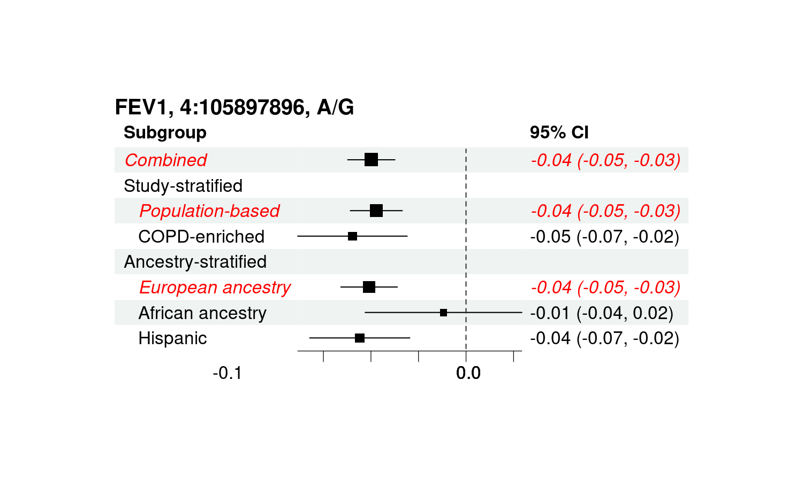

B) FEV₁ 4:144513592-144595585
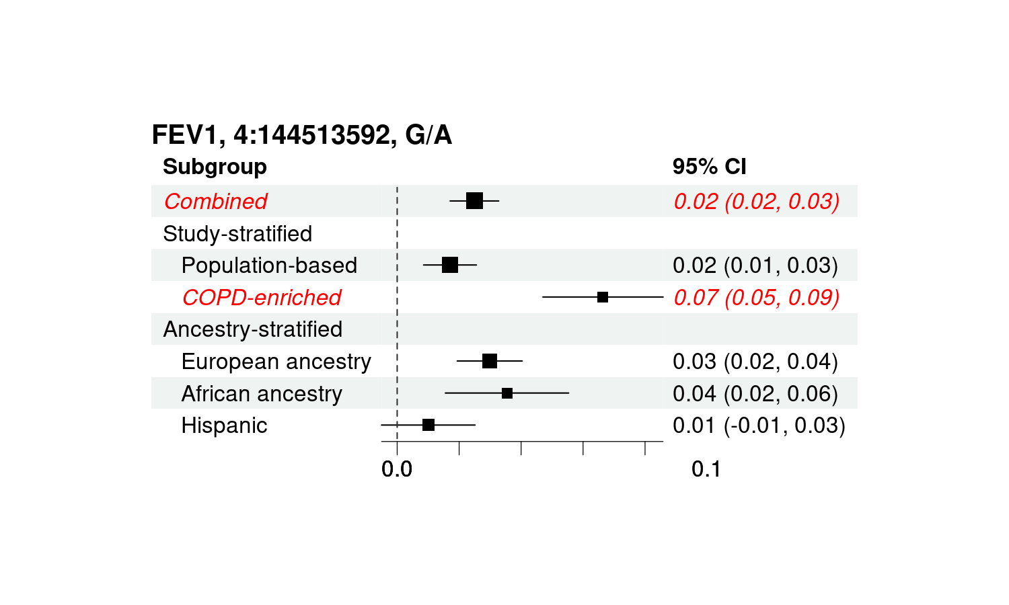
C) FEV₁ 5:148476669-148476669
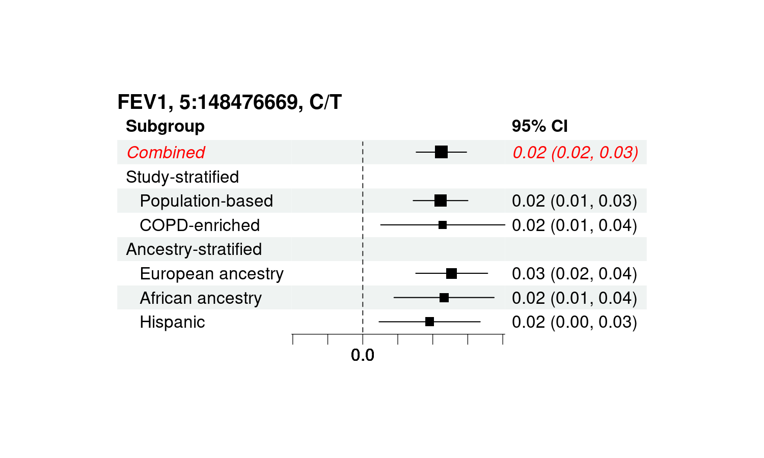
D) FEV₁ 10:12227401-12227401
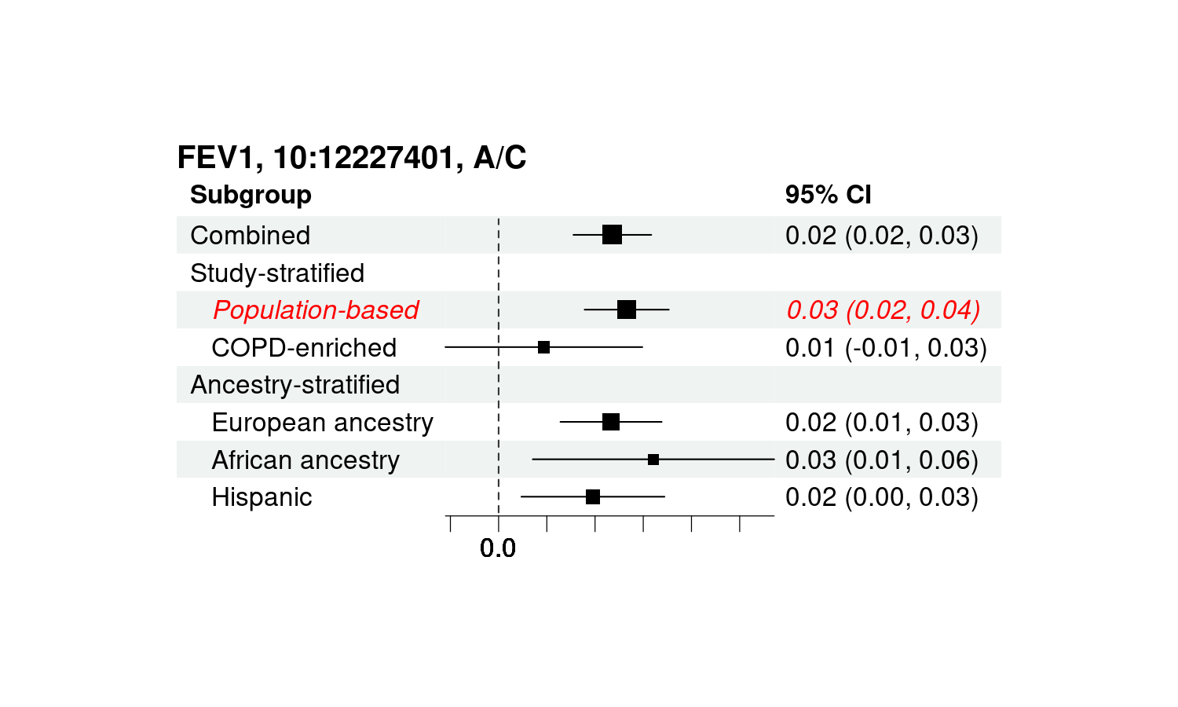
E) FEV₁ 17:45430037-46207176
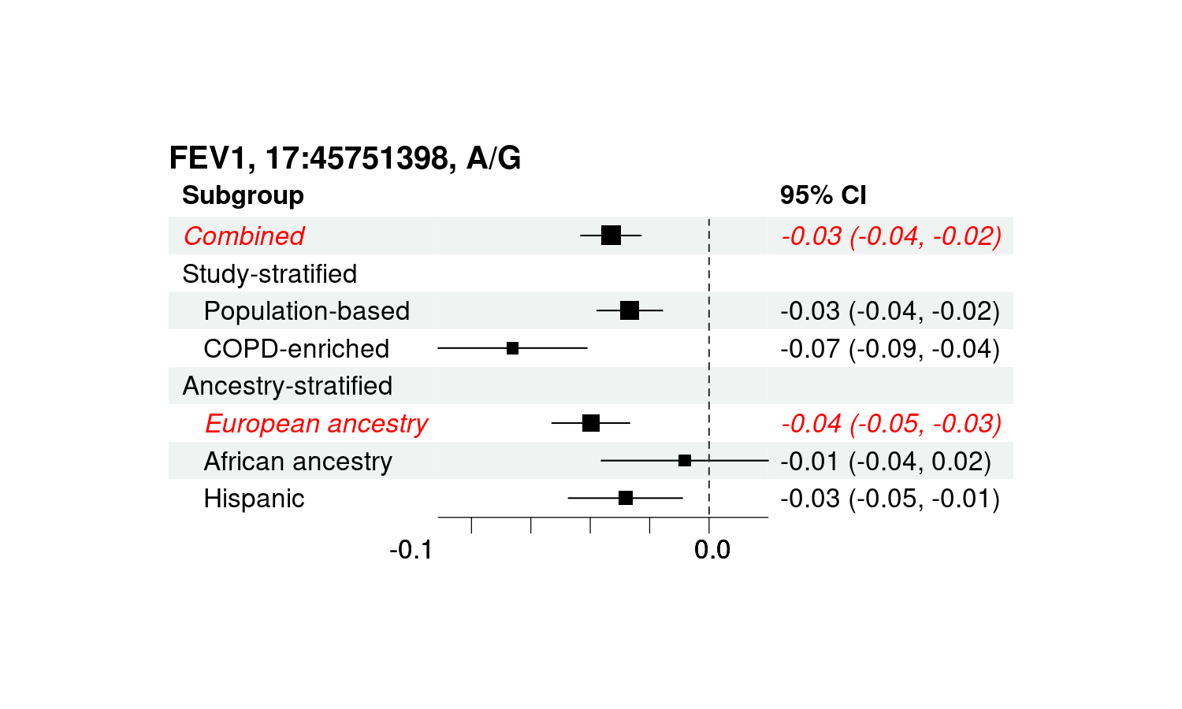
F) FVC 12:28346942-28575800
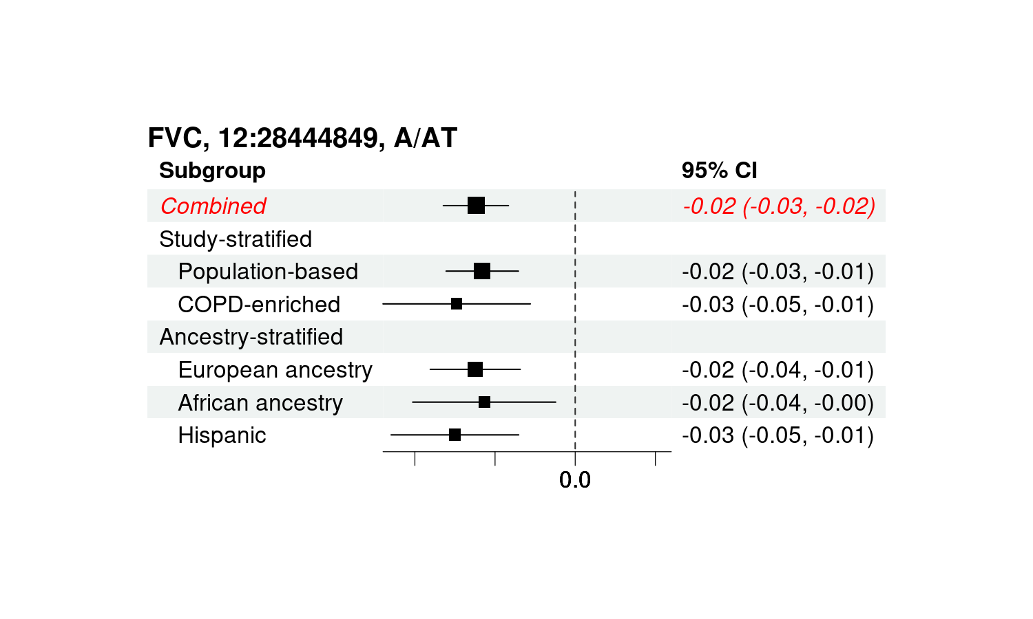
G) FEV₁/FVC 2:228637029-228727699
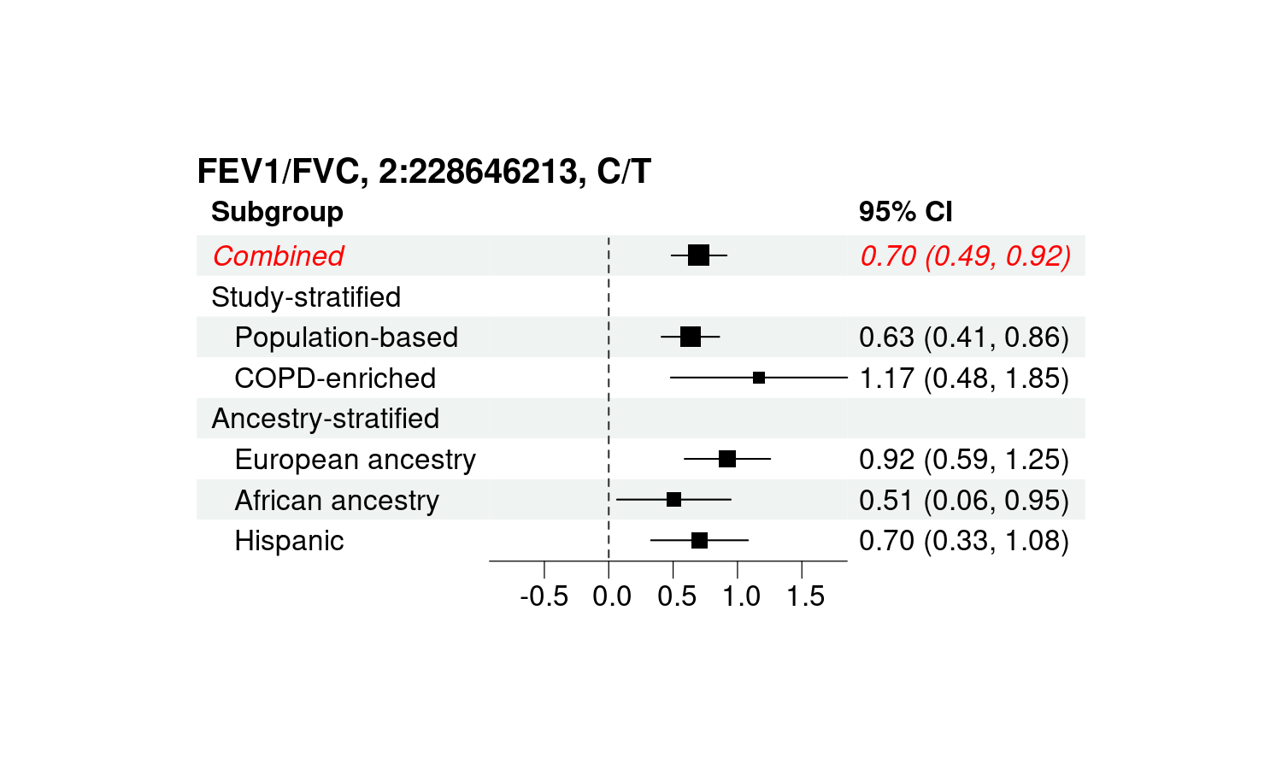
H) FEV₁/FVC 3:25479091-25507083
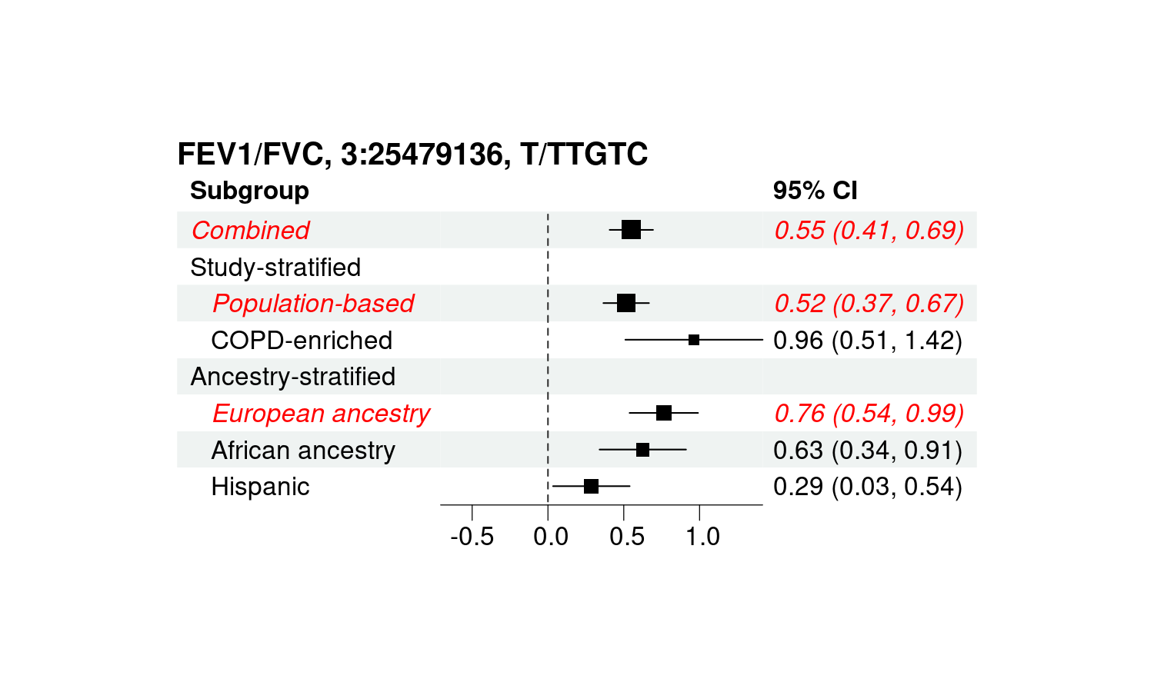
I) FEV₁/FVC 3:65875486-65875486
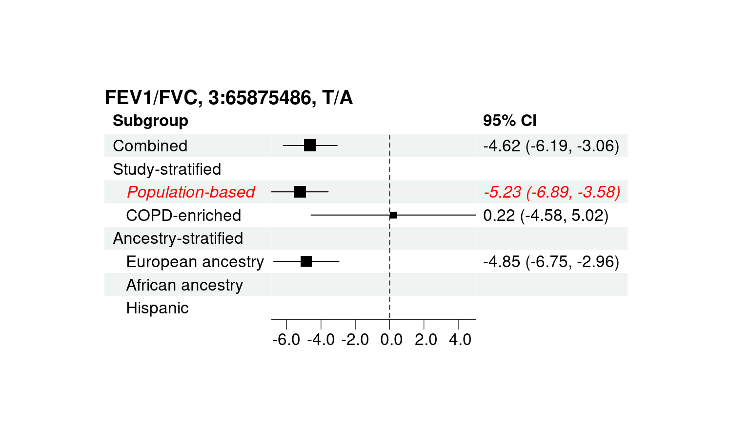
J) FEV₁/FVC 4:88829210-89009241
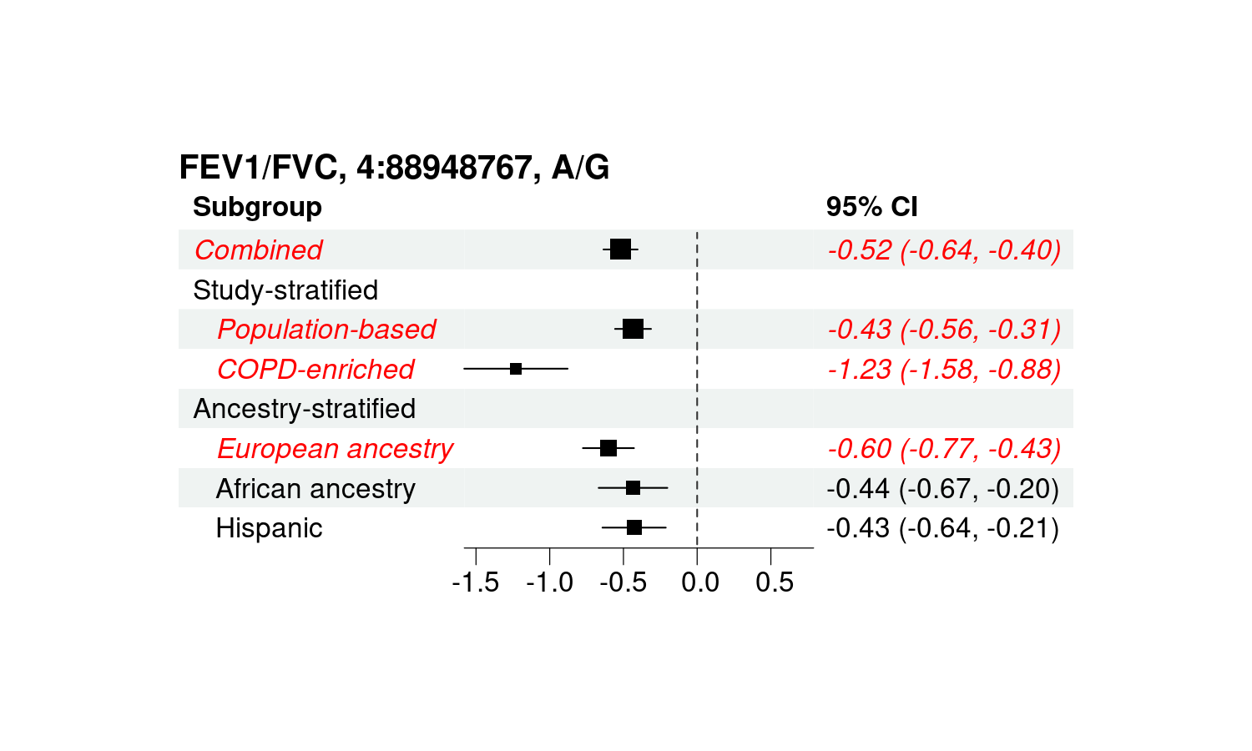
K) FEV₁/FVC 4:105897896-105907638
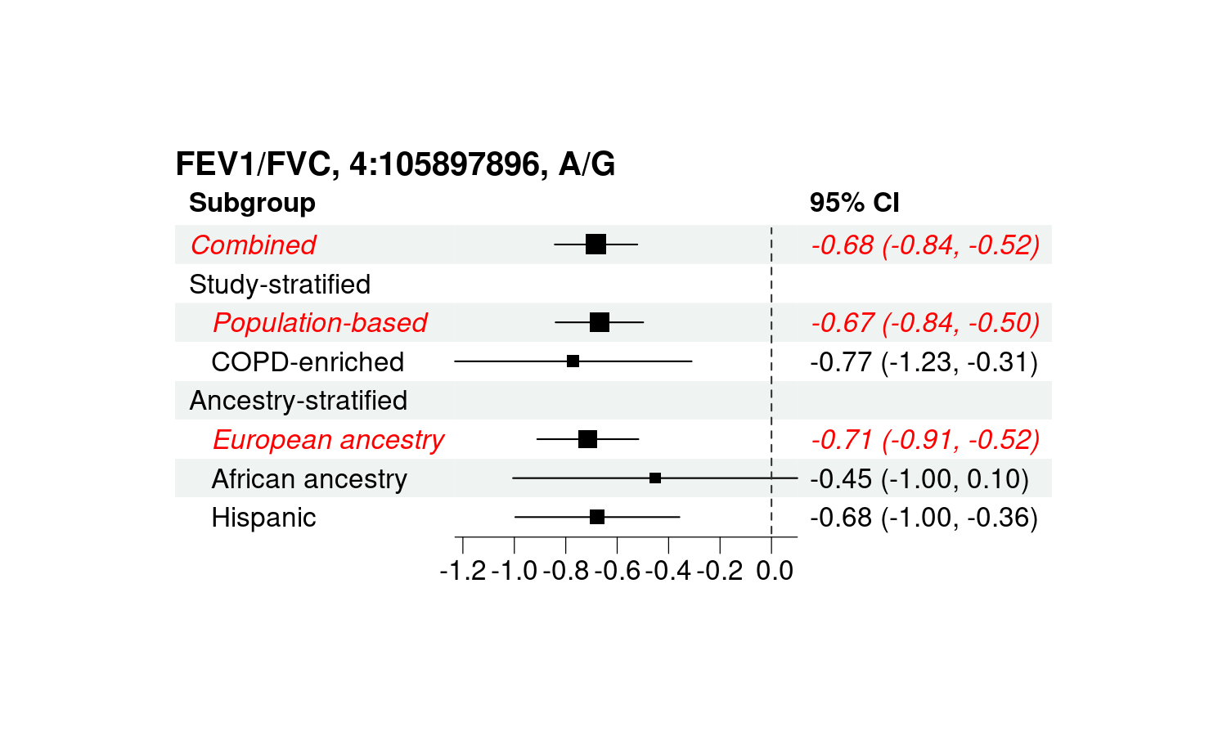
L) FEV₁/FVC 4:144502816-144585304
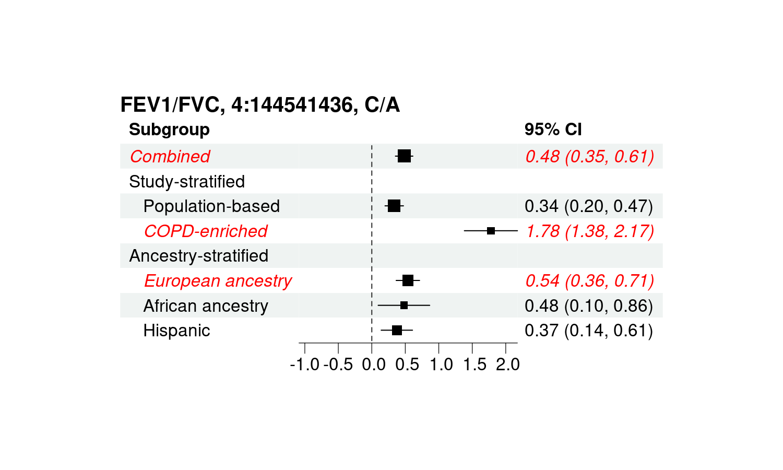
M) FEV₁/FVC 5:148306389-148476959
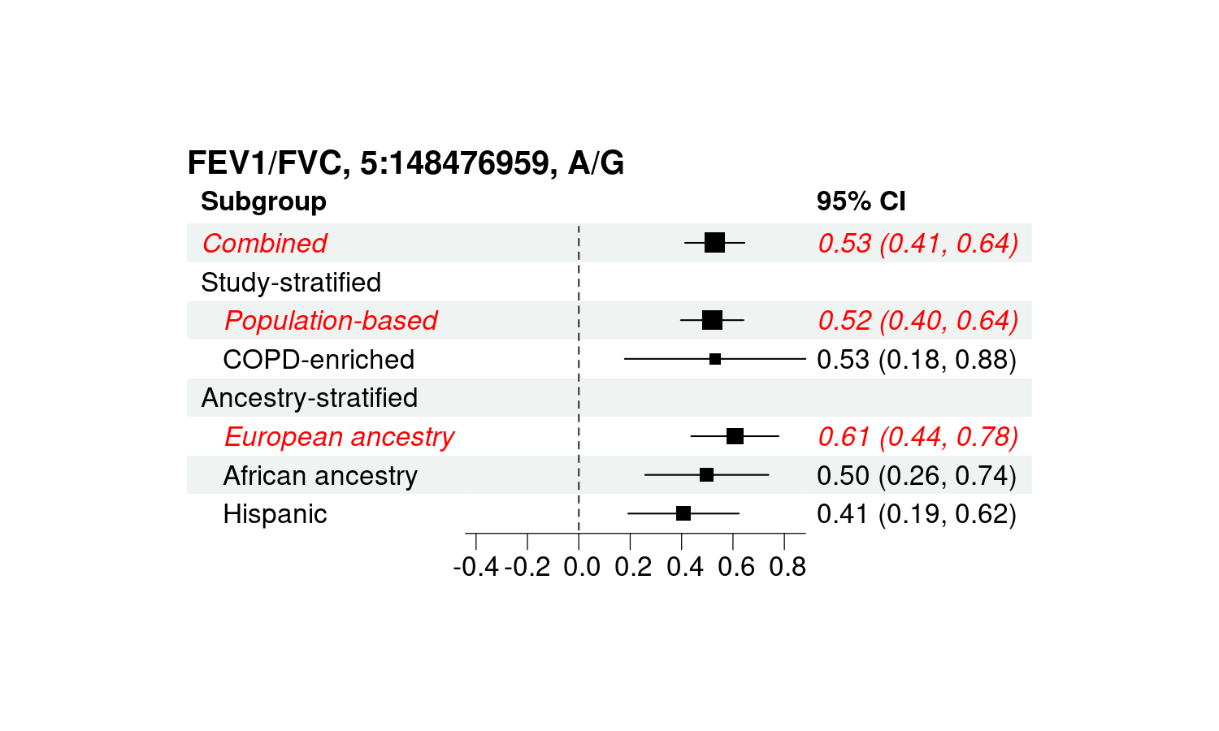
N) FEV₁/FVC 5:157505368-157517467
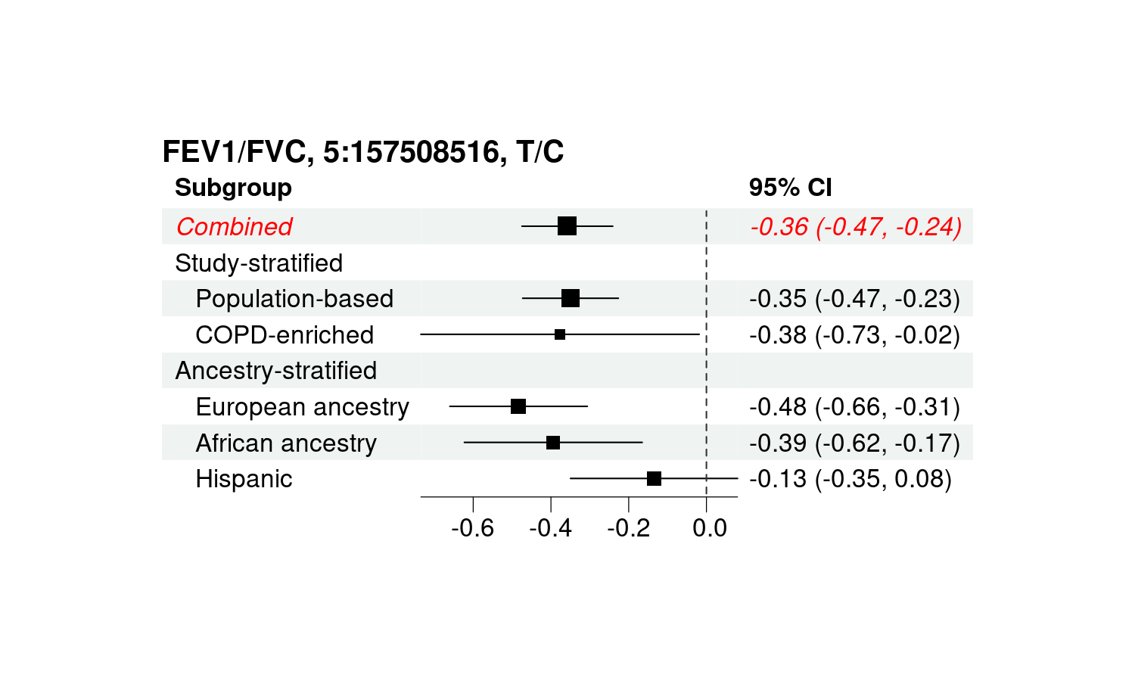
O) FEV₁/FVC 6:6736698-6744465
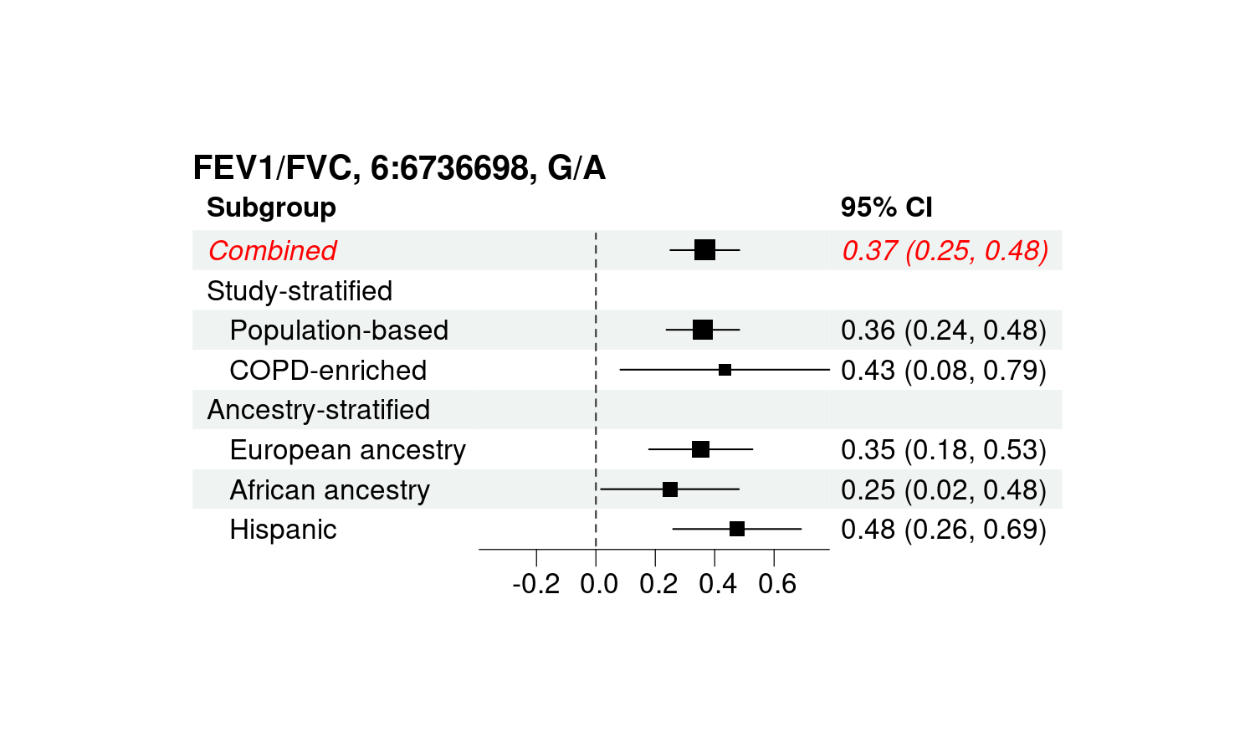
P) FEV₁/FVC 6:31616064-32201368
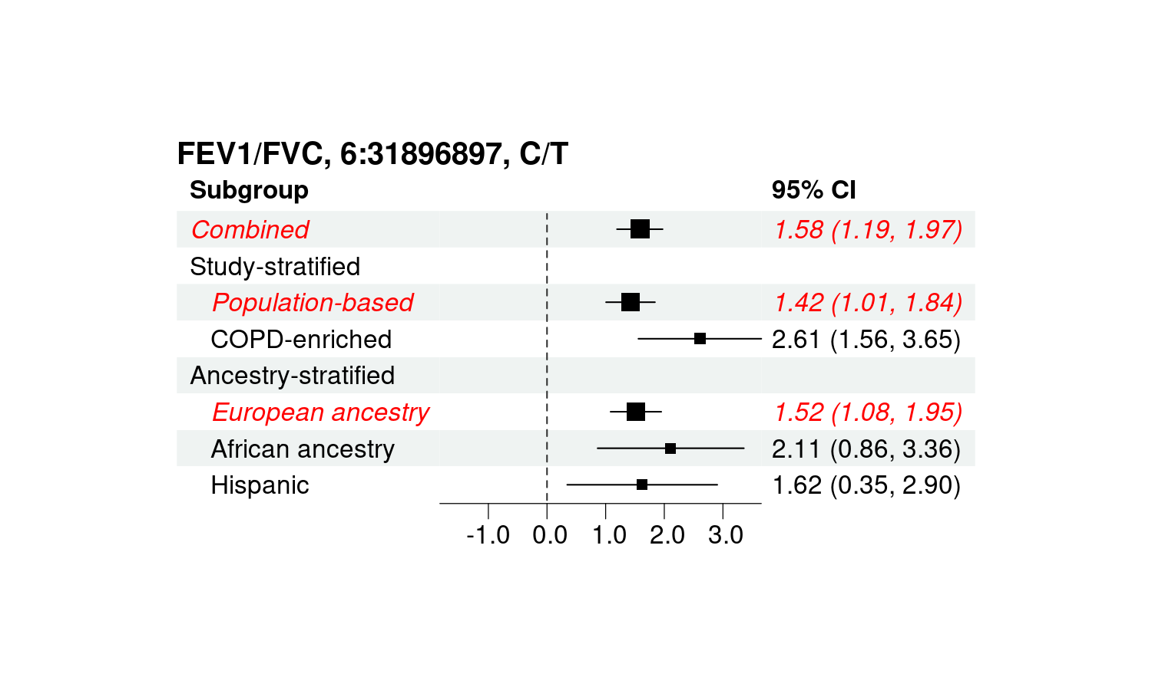
Q) FEV₁/FVC 6:142326919-142545708
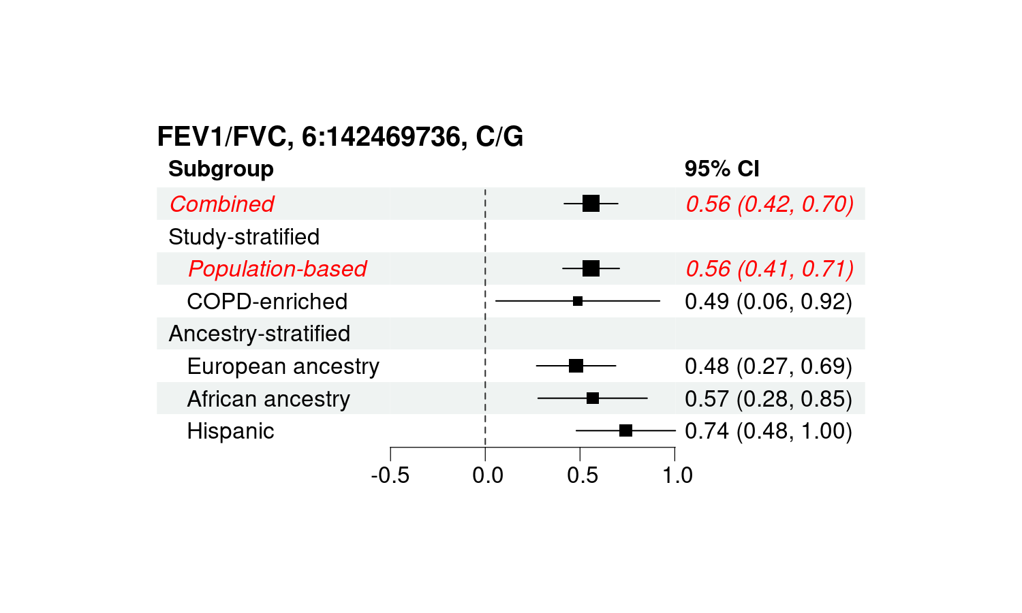
R) FEV₁/FVC 10:3255632-3255632
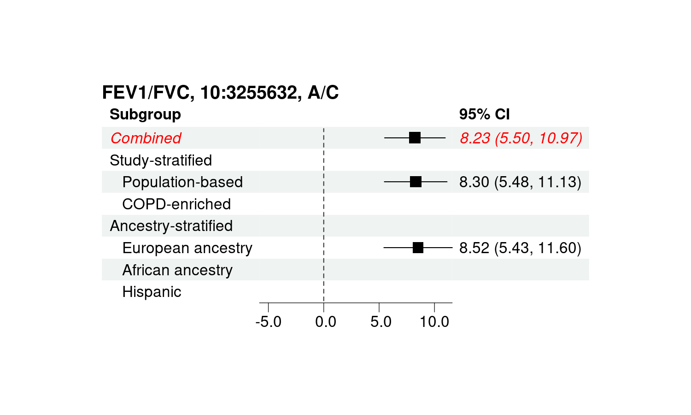
S) FEV₁/FVC 15:71295034-71414285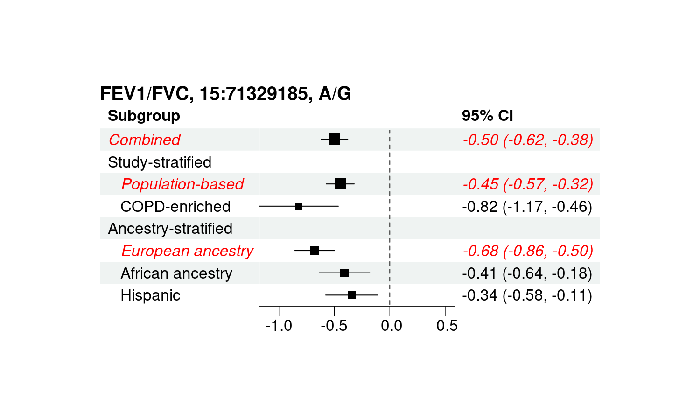
T) FEV₁/FVC 15:83893127-83903704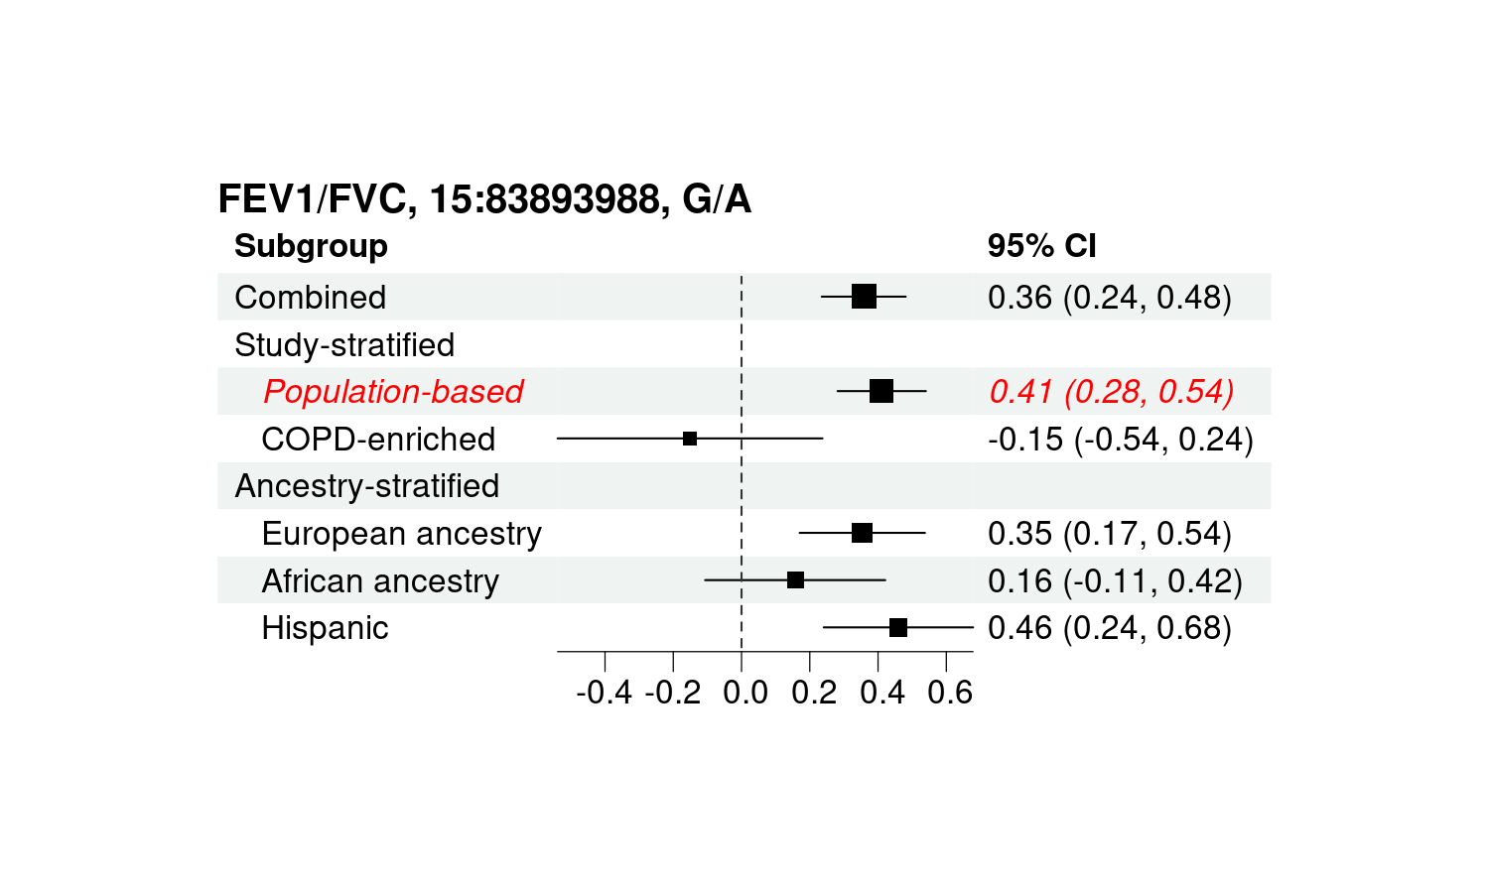
U) Moderate-to-severe COPD 3:141765054-141807348
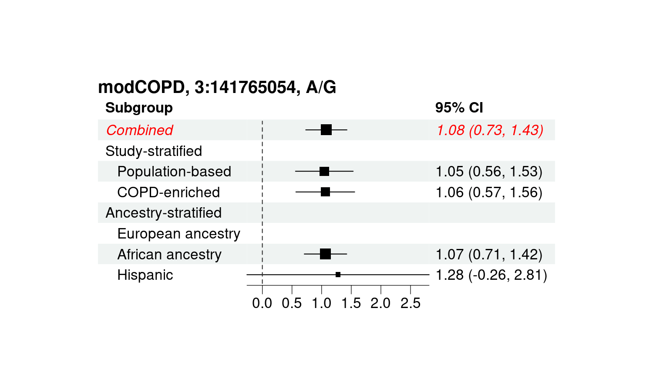
V) Moderate-to-severe COPD 4:88849758-88965146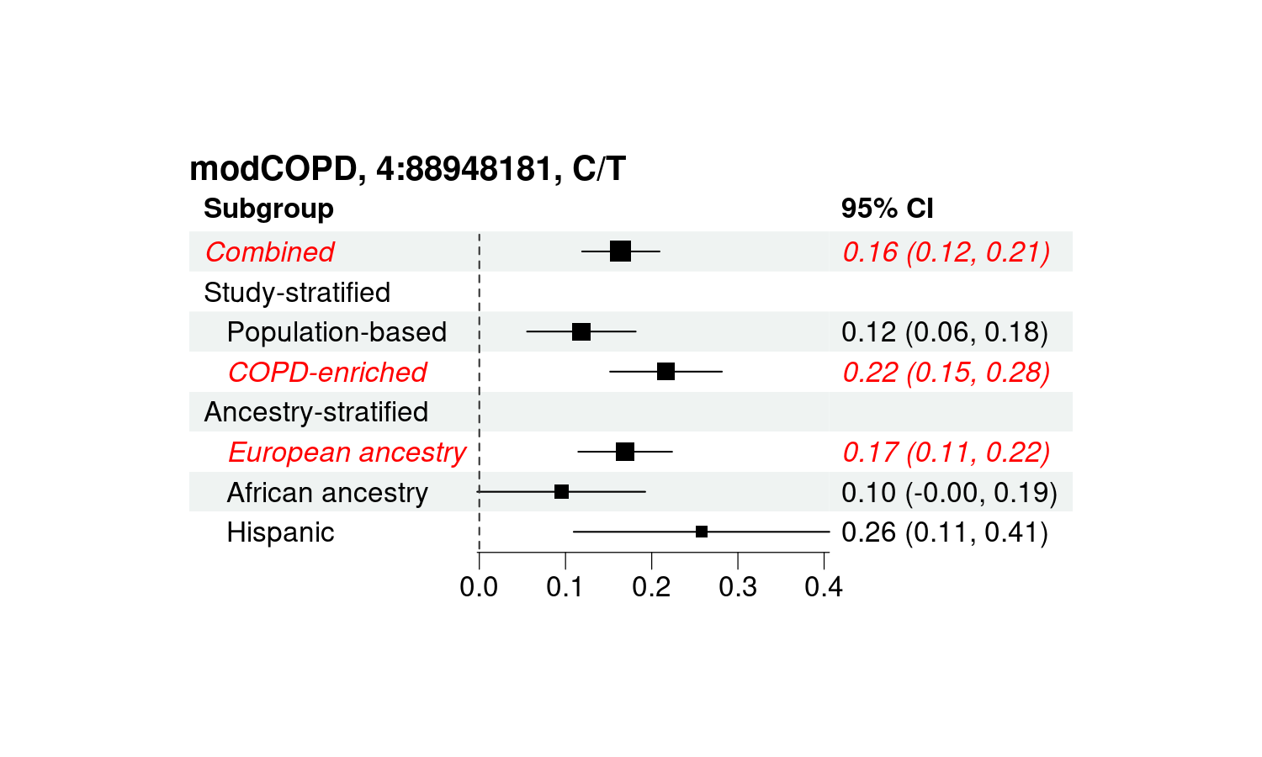
W) Moderate-to-severe COPD 4:105897896-105897896
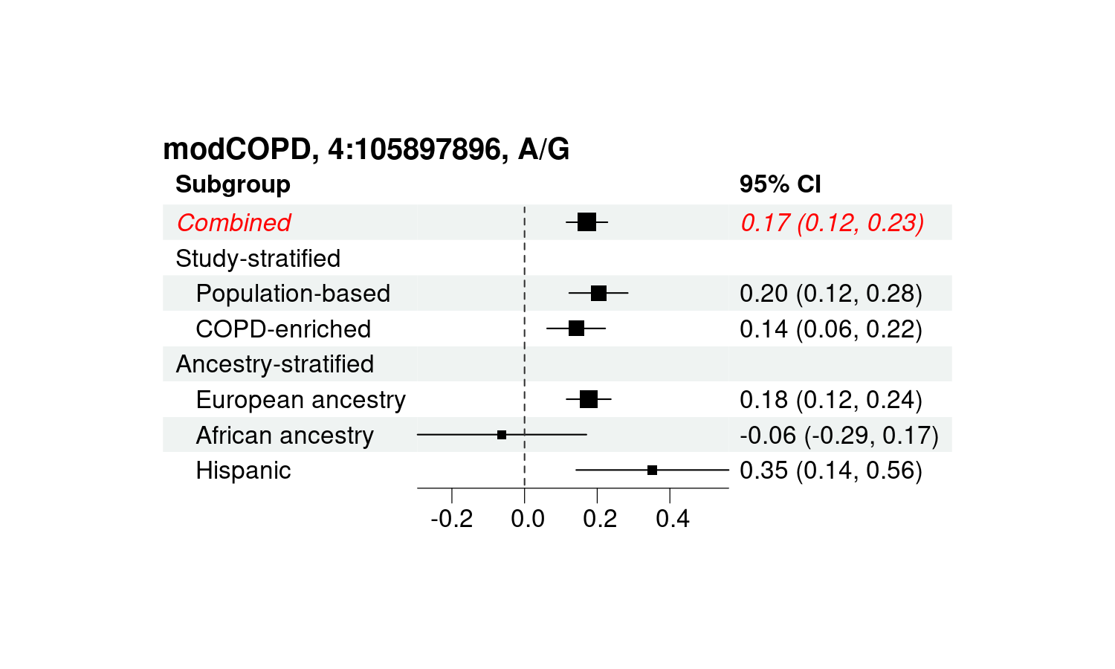
X) Moderate-to-severe COPD 4:144502816-144585304
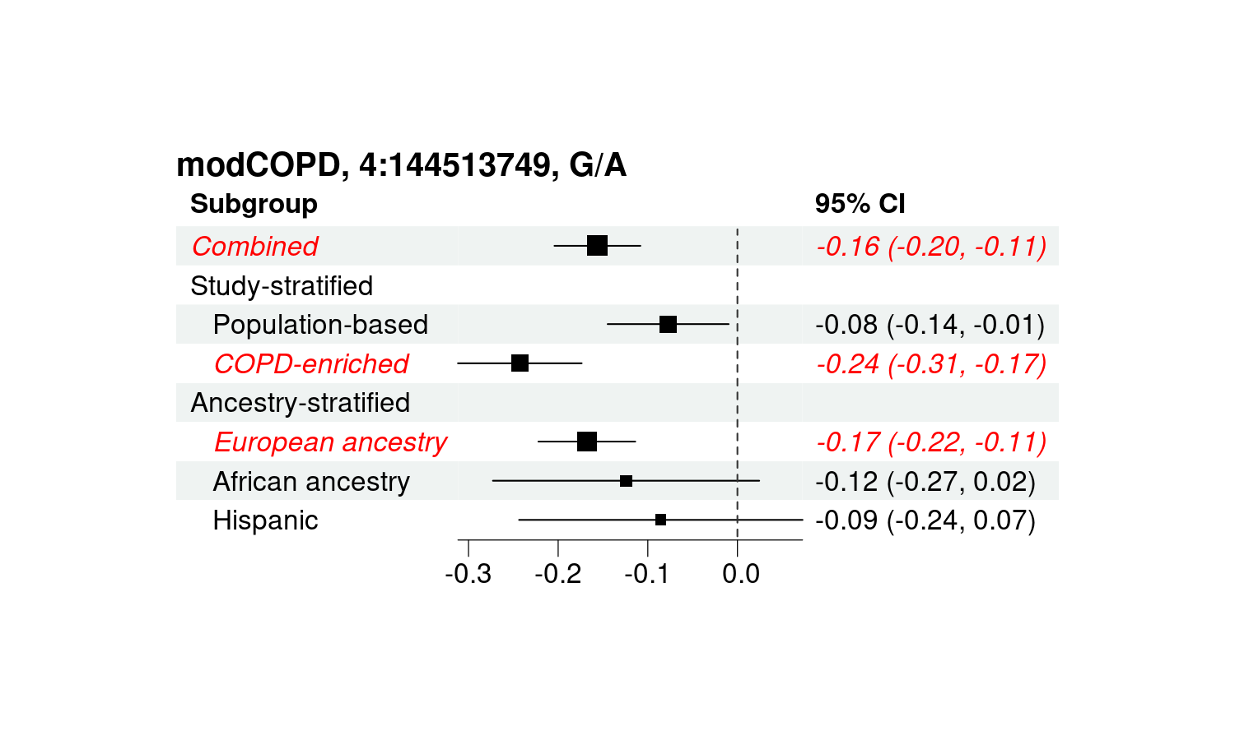
Y) Moderate-to-severe COPD 14:92635906-92637384
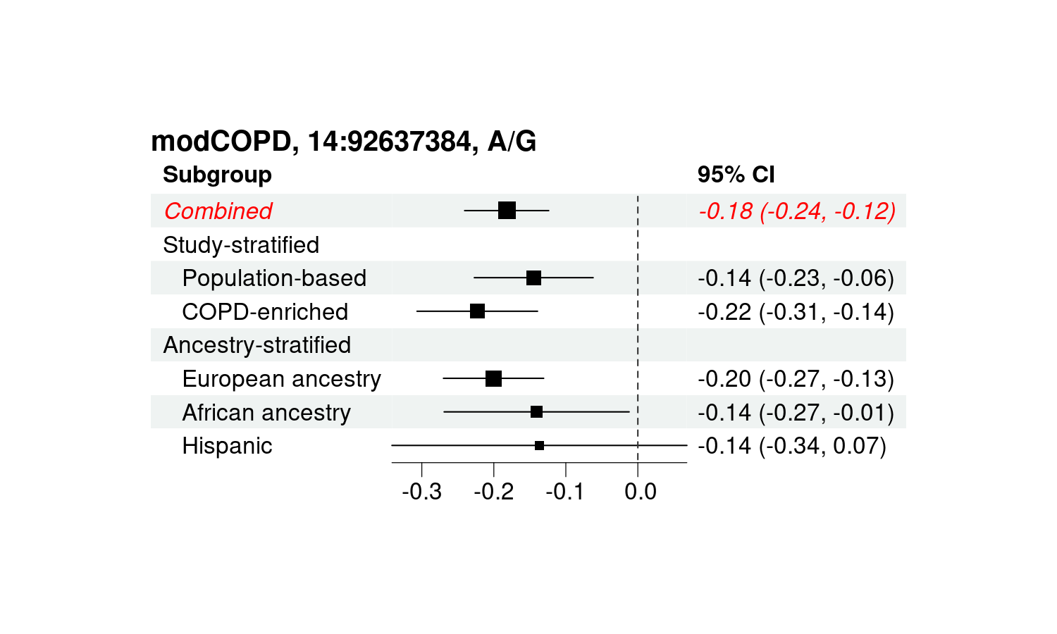
Z) Moderate-to-severe COPD 15:78427490-78643826
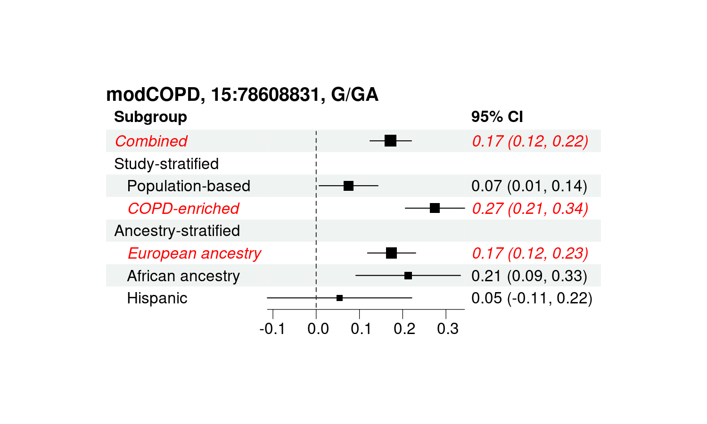
AA) Moderate-to-severe COPD 19:40840084-40847202
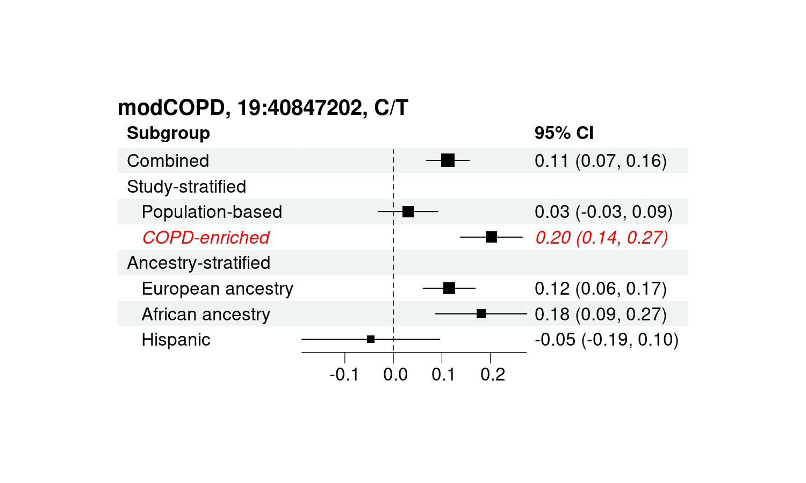
AB) Severe COPD 4:88878055-89009241
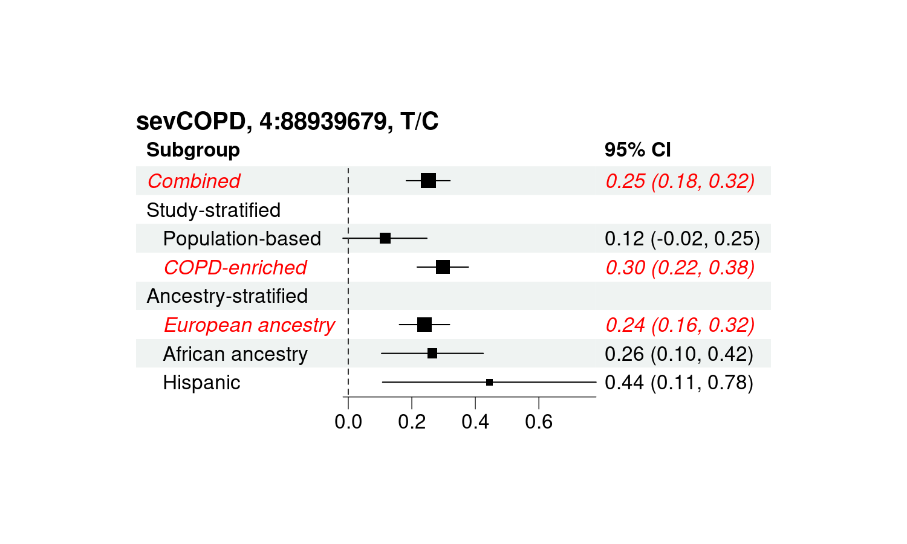AC) Severe COPD 4:144341775-144585304
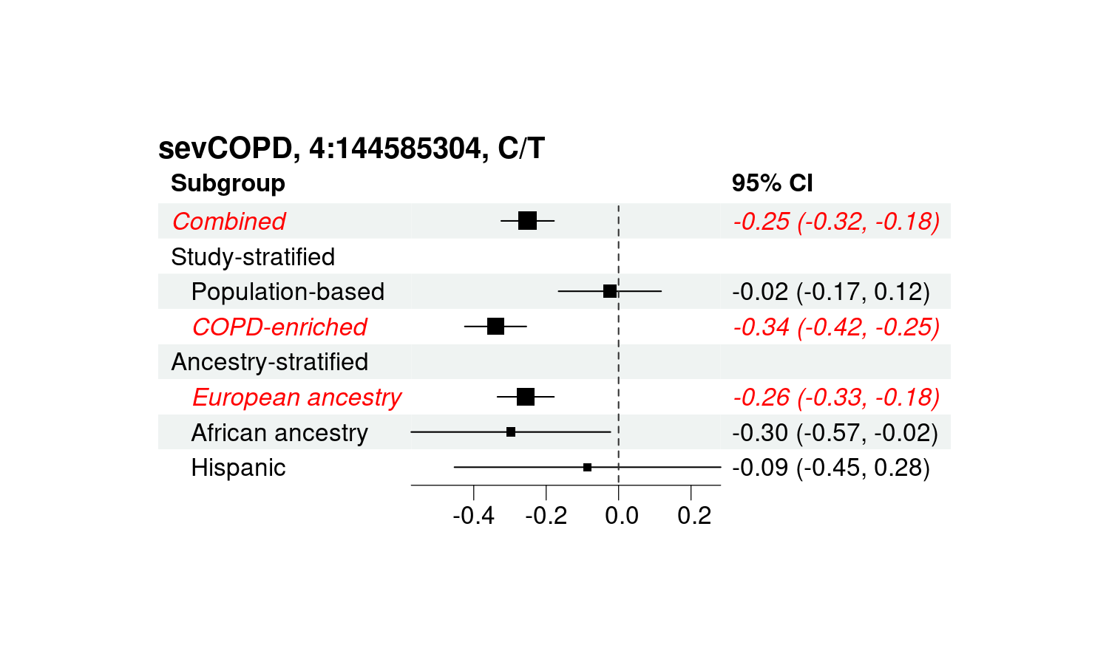
AD) Severe COPD 14:92637384-94378610
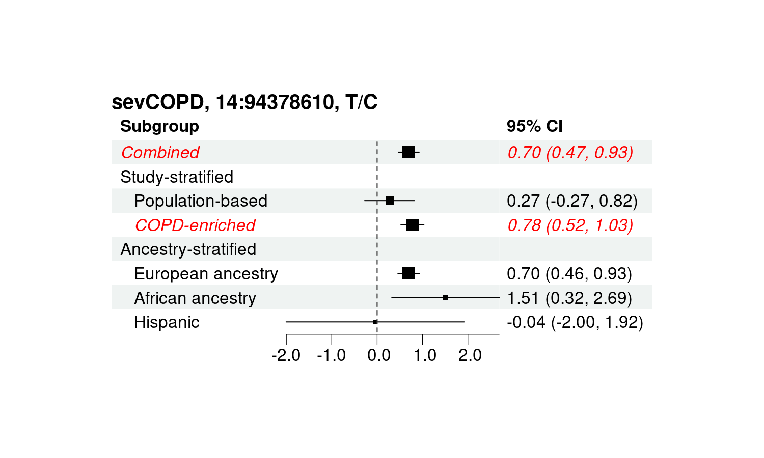
AE) Severe COPD 15:78427159-78634103
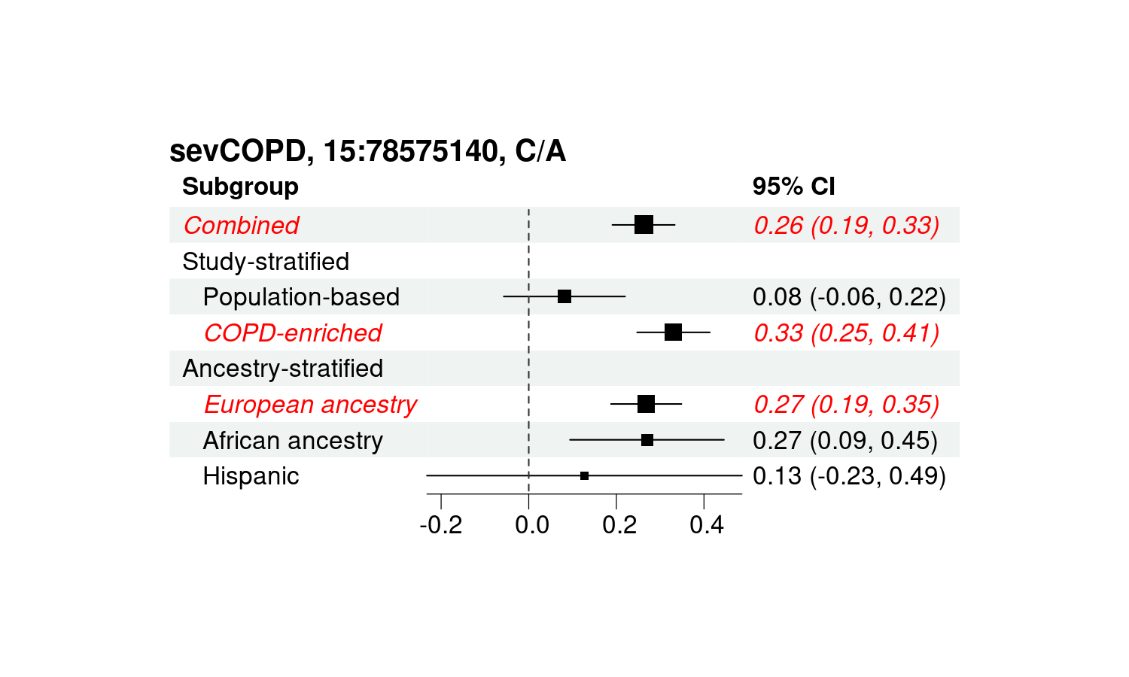
AF) Severe COPD 19:40847202-40847202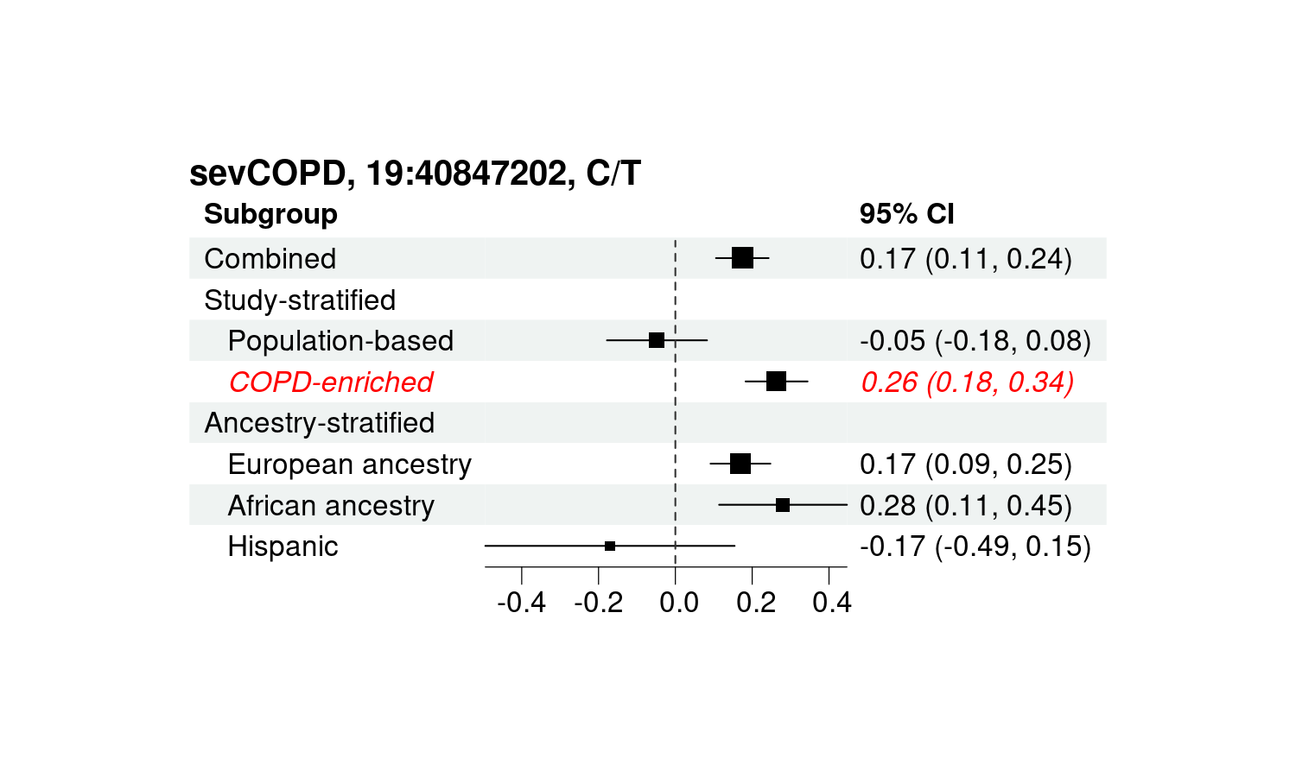

Supplementary Figure 2. Heatmaps of linkage disequilibrium matrix
LD plots for the novel variant, rs912057 (red), and previously reported GWAS variants (black) in this region showed different LD structure between (A) the discovery data set and (B, C) UK Biobank. Only values ​​where r² is greater than 0.2 are displayed.

(A) TOPMed multi-ancestry
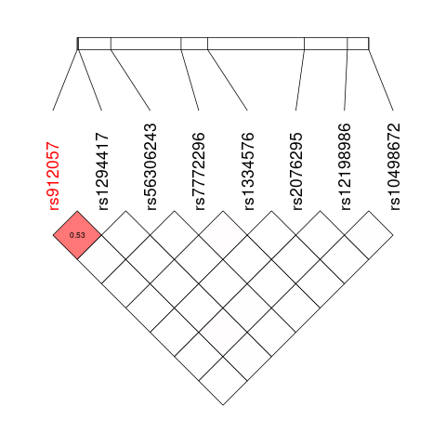

(B) UK Biobank European-ancestry
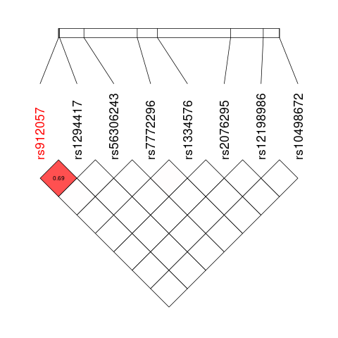

(C) UK Biobank multi-ancestry
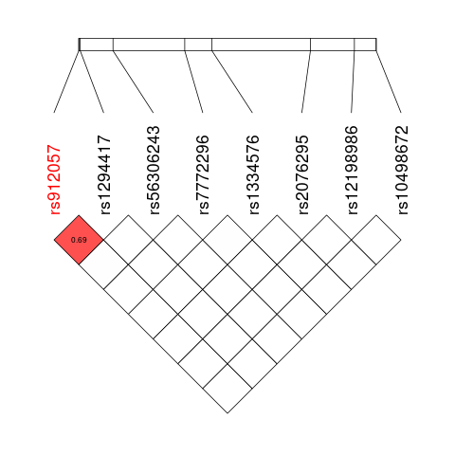

Supplementary Figure 3. Box plots for comparing fine-mapping resolution between Multi- and European-ancestry participants
For better understanding, outliers were removed from the figures.

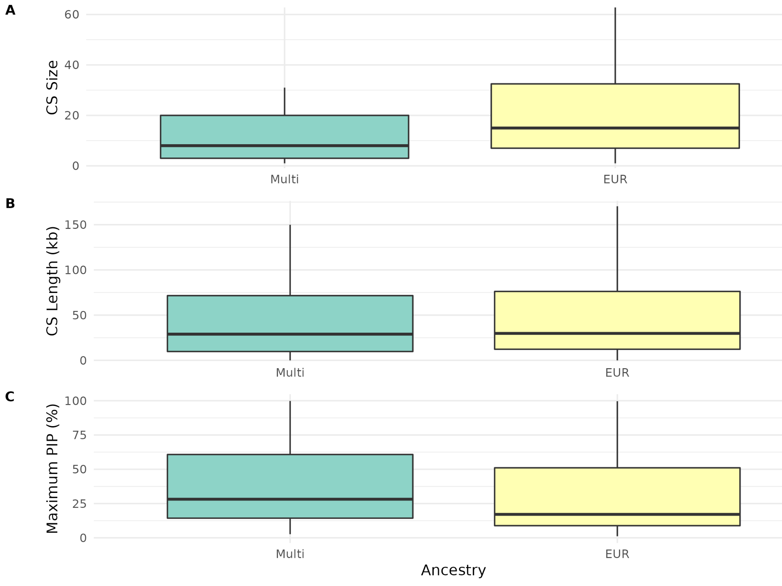

Supplementary Figure 4. Regional plots of pulmonary trait association and LTRC eQTL for all colocalized gene regions. A) C4B; B) HHIP; C) HHIP-AS1; D) NPNT; E) RARB; F) RIN3. Each sub-panel presents the genetic association results for a target region; the left plot visualizes the strength of association with pulmonary trait vs LTRC within the target region; the right top plot shows pulmonary trait association within the target region; and the right bottom plot shows LTRC eQTL association within the target region. The labeled variant is the lead variant identified from the sum of P-values for pulmonary trait association and LTRC eQTL, and other variants are colored according to their LD R2 with the lead variant. The TOPMed Freeze 8 genotype data of 1,360 LTRC samples were used to calculate in-sample LD for LTRC colocalization and for generating plots.

- C4B: population-based analysis of FEV1/FVC ratio.
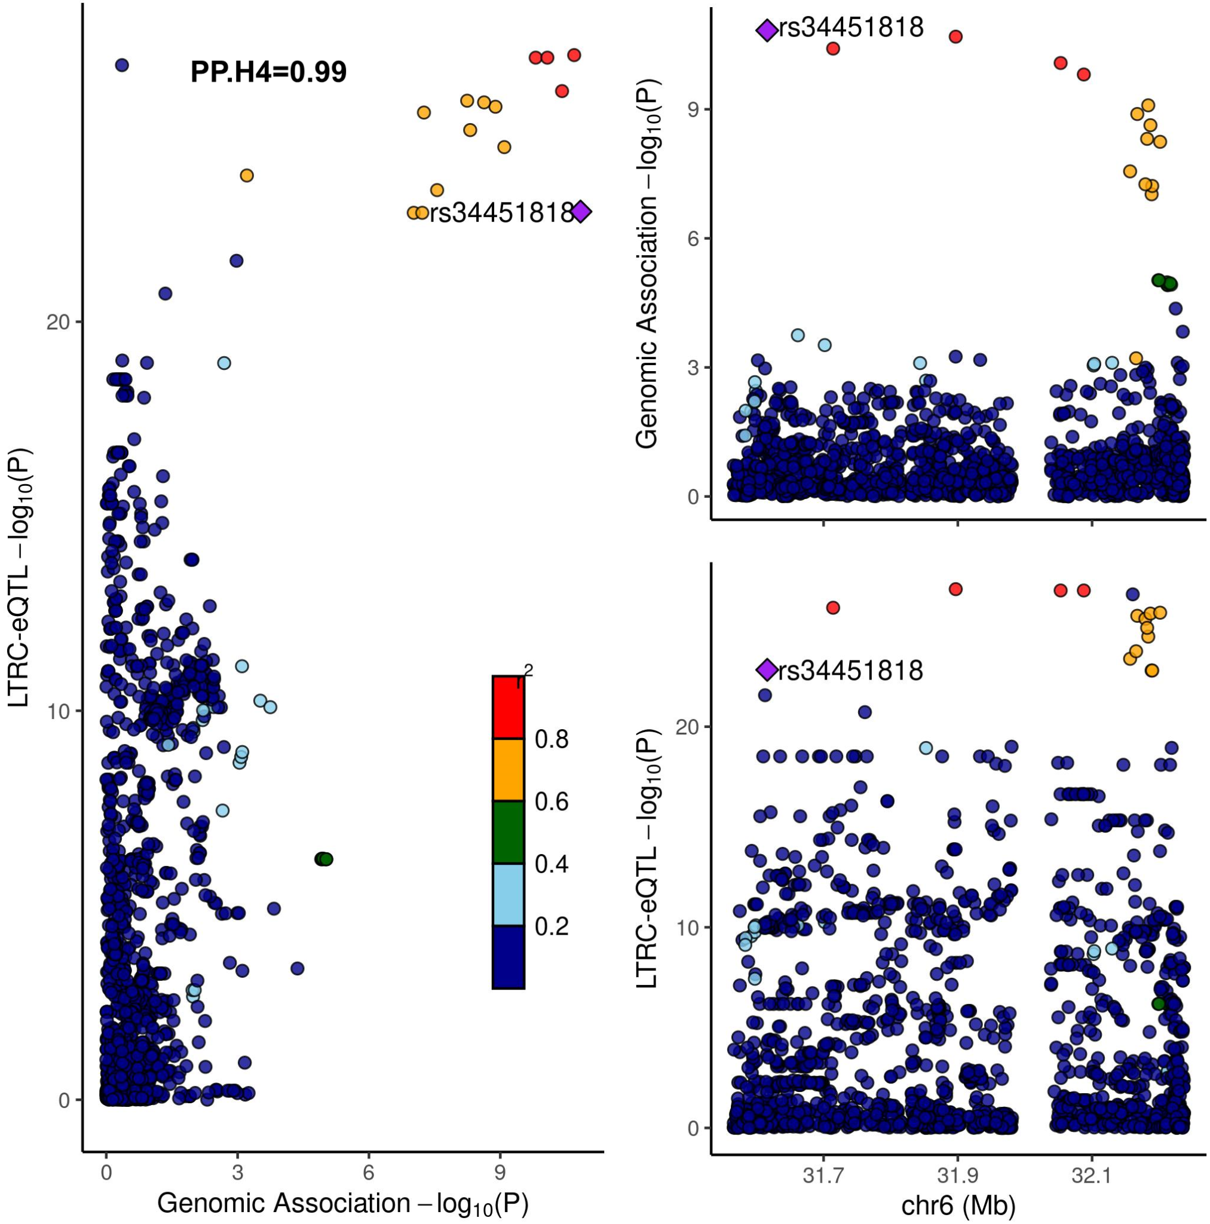

- HHIP: 1) combined analysis of FEV1/FVC ratio; 2) combined analysis of FEV1; 3) COPD-enriched analysis of moderate-to-severe COPD.

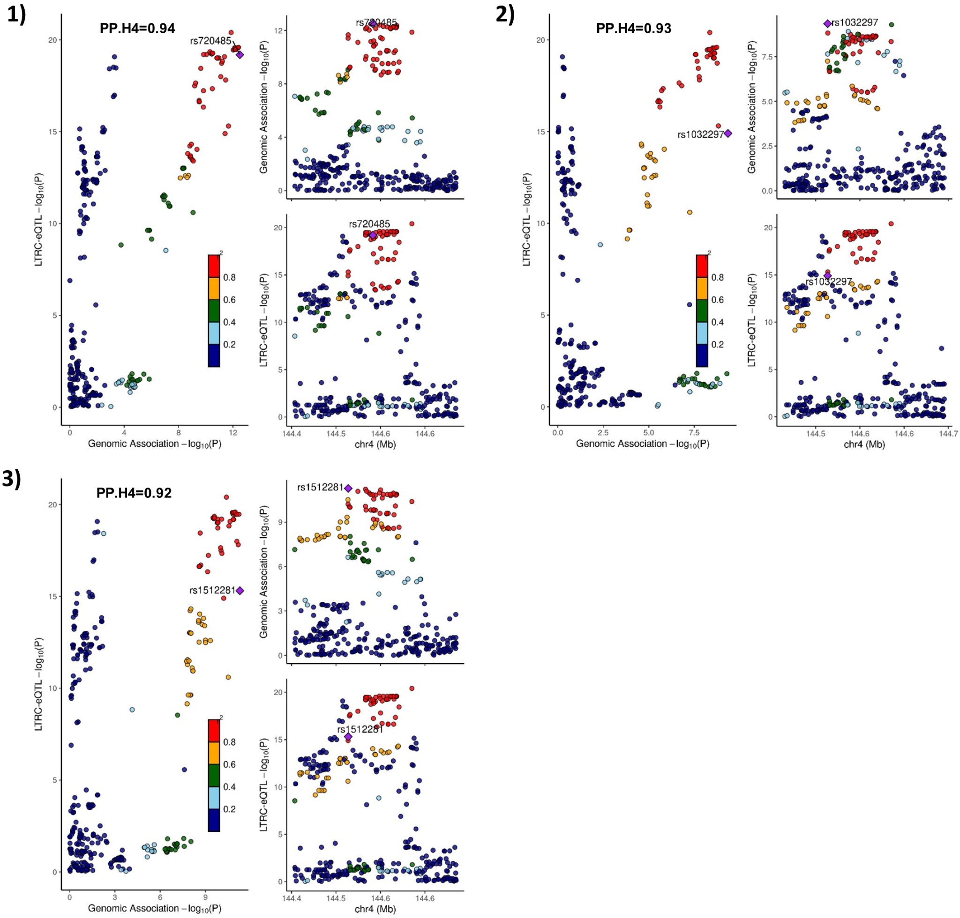

- HHIP-AS1: 1) combined analysis of FEV1/FVC ratio; 2) combined analysis of FEV1; 3) combined analysis of moderate-to-severe COPD; 4) COPD-enriched analysis of moderate-to-severe COPD.

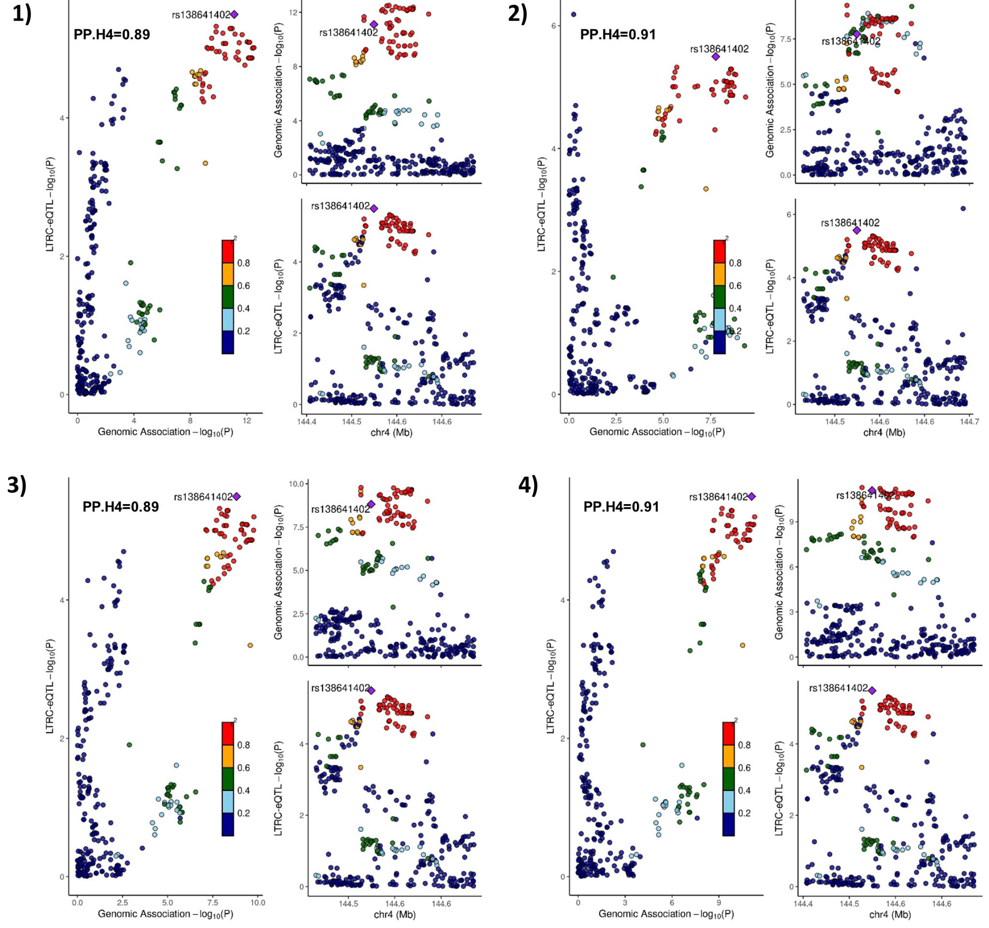

- NPNT: 1) combined analysis of FEV1/FVC ratio; 2) population-based analysis of FEV1/FVC ratio; 3) combined analysis of FEV1; 4) population-based analysis of FEV1.

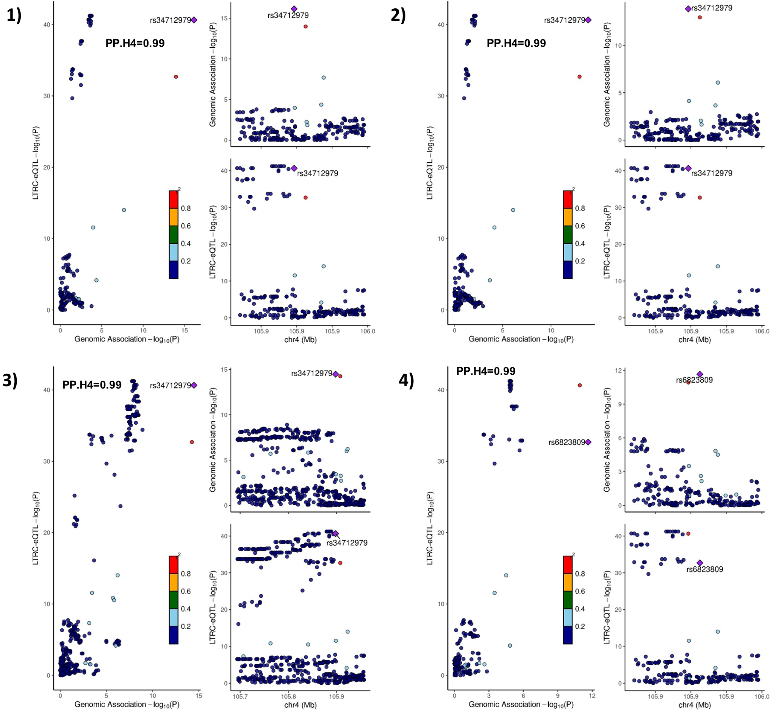

- RARB: 1) combined analysis of FEV1/FVC ratio; 2) population-based analysis of FEV1/FVC ratio.

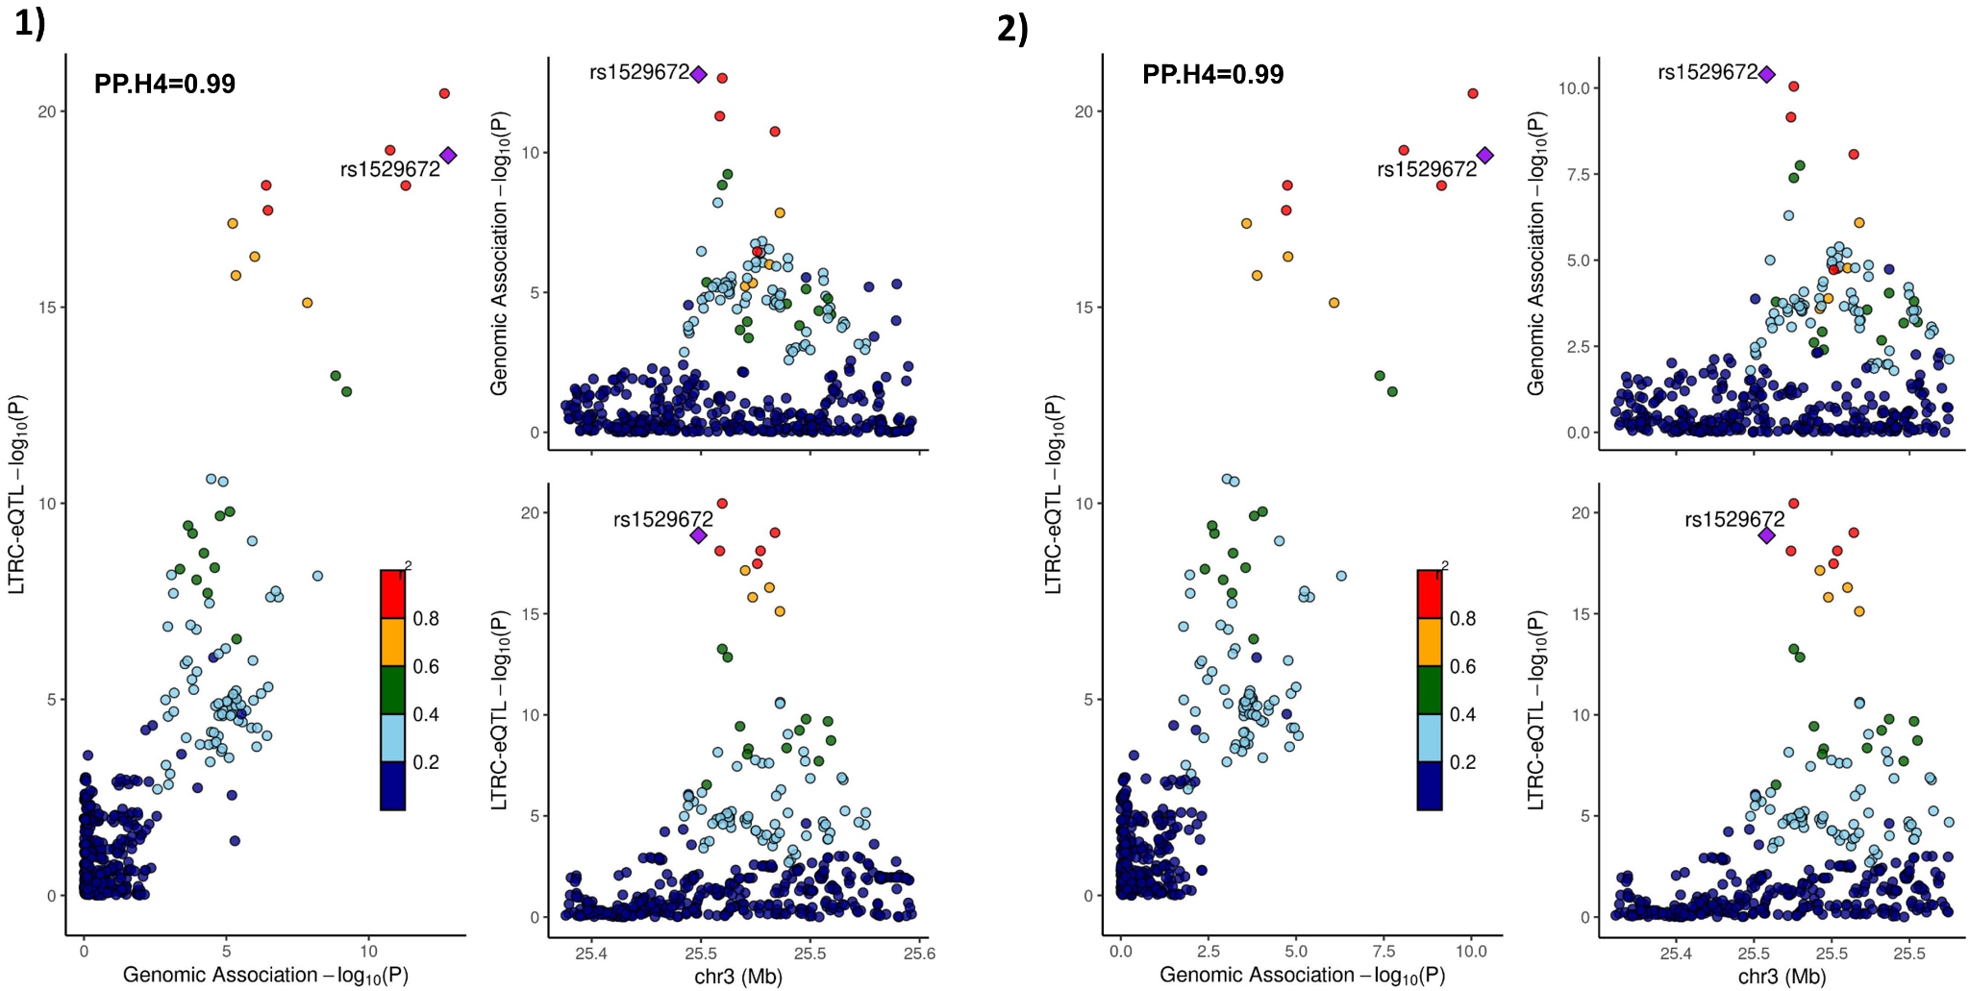

- RIN3: 1) combined analysis of moderate-to-severe COPD; 2) combined analysis of severe COPD.

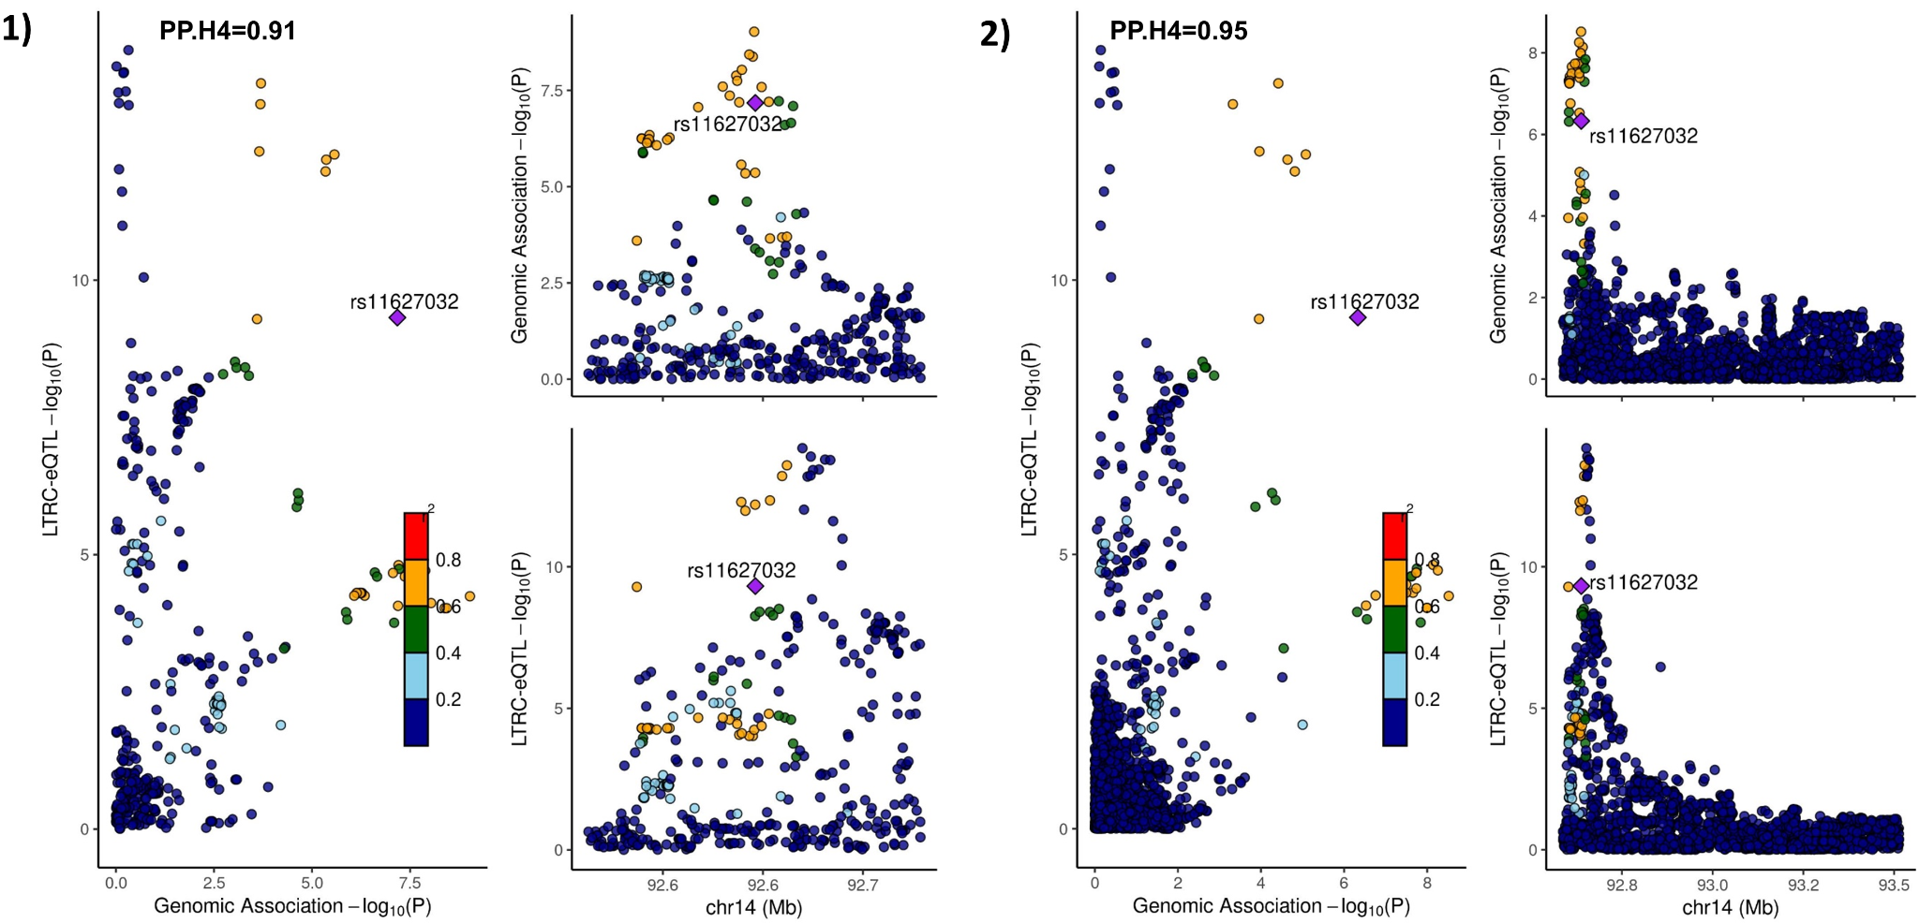

Supplementary Figure 5. Overview of the workflow for the single variant-based association analysis 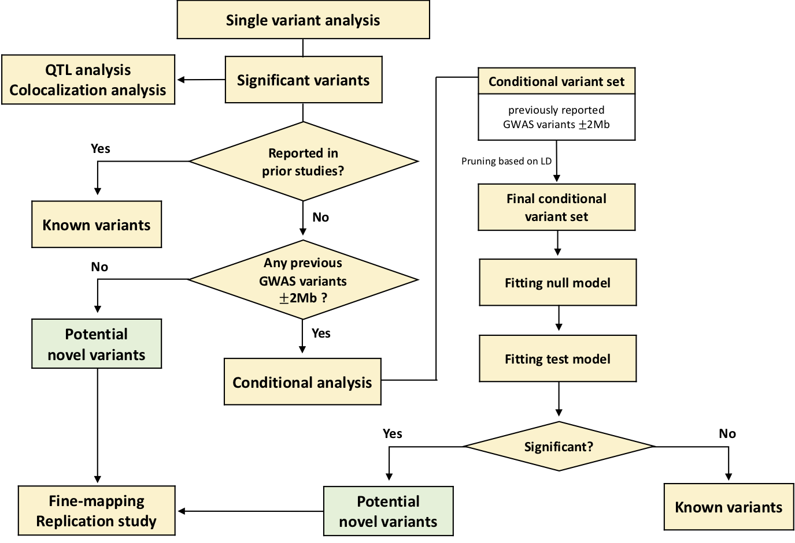

Supplementary Figure 6. Overview of the workflow for the variant set-based association analysis
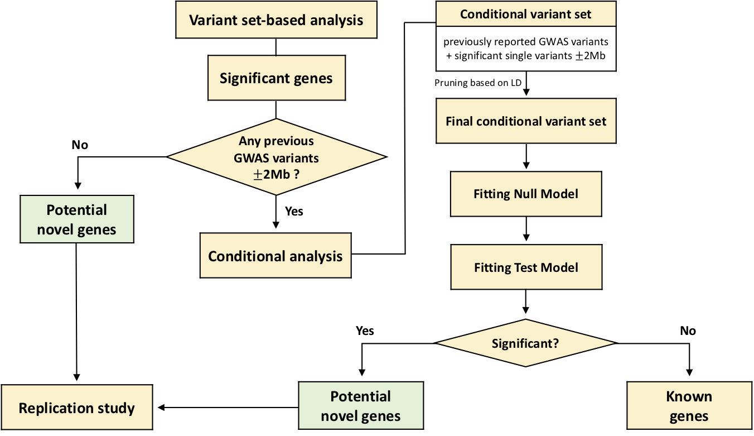

Supplementary Figure 7. MDS plot

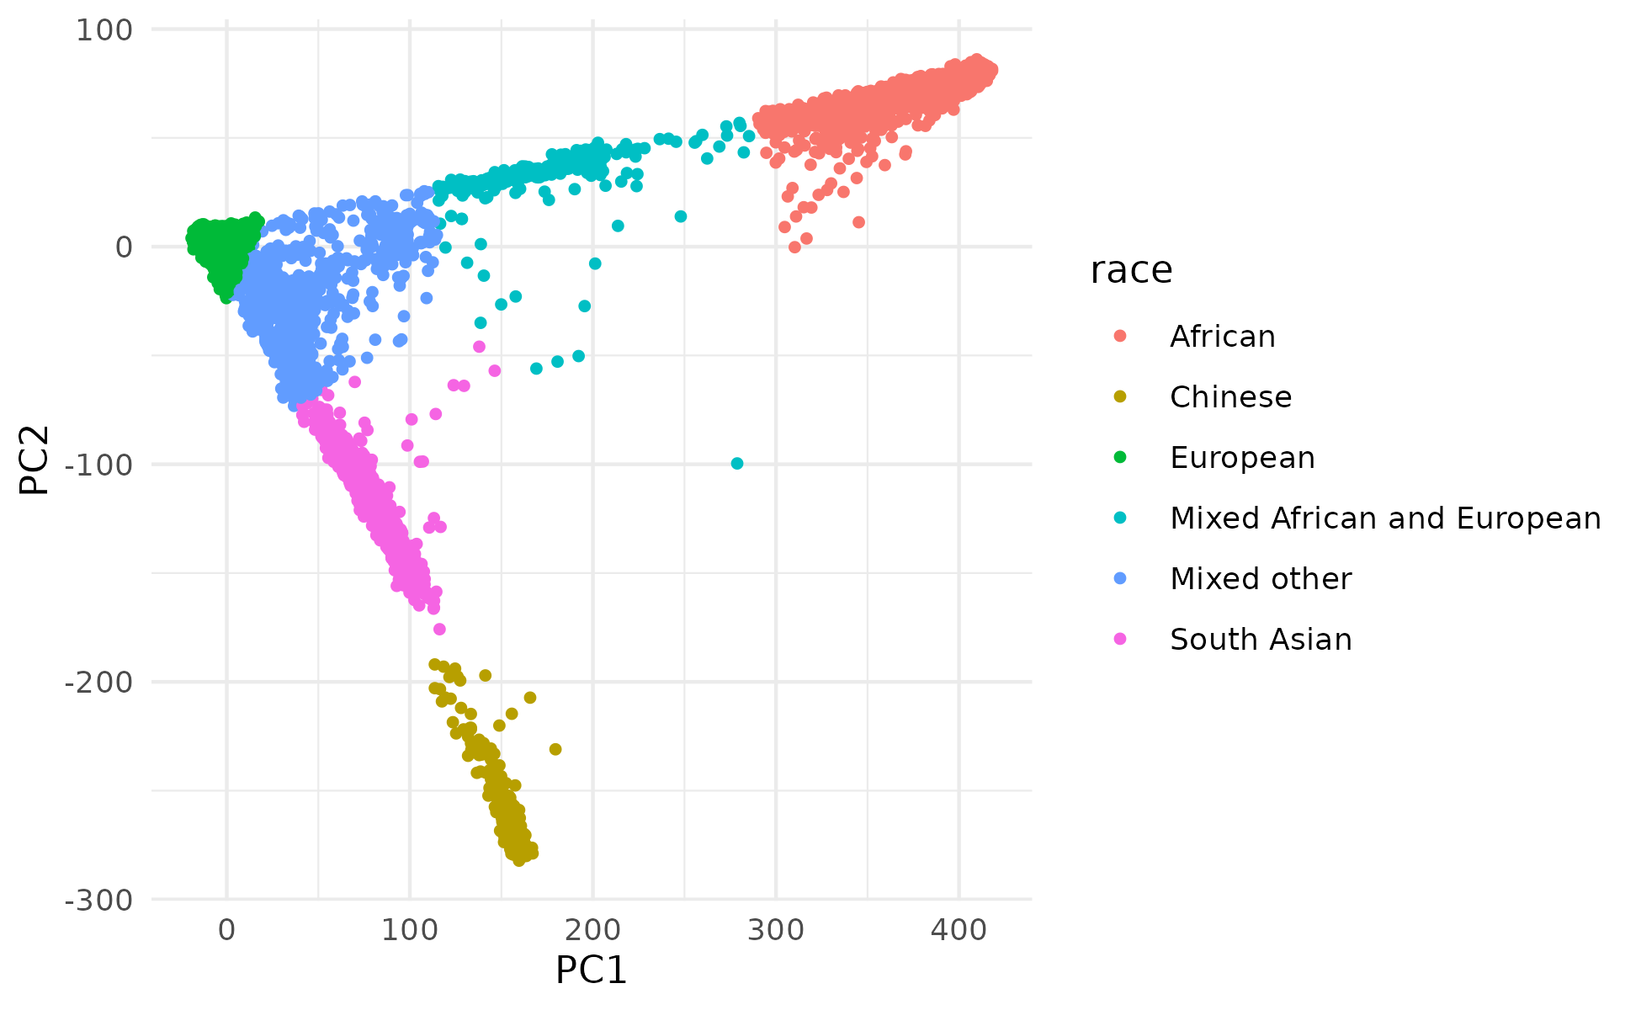

Supplementary Figure 8. Single cell data of prioritized genes by disease state
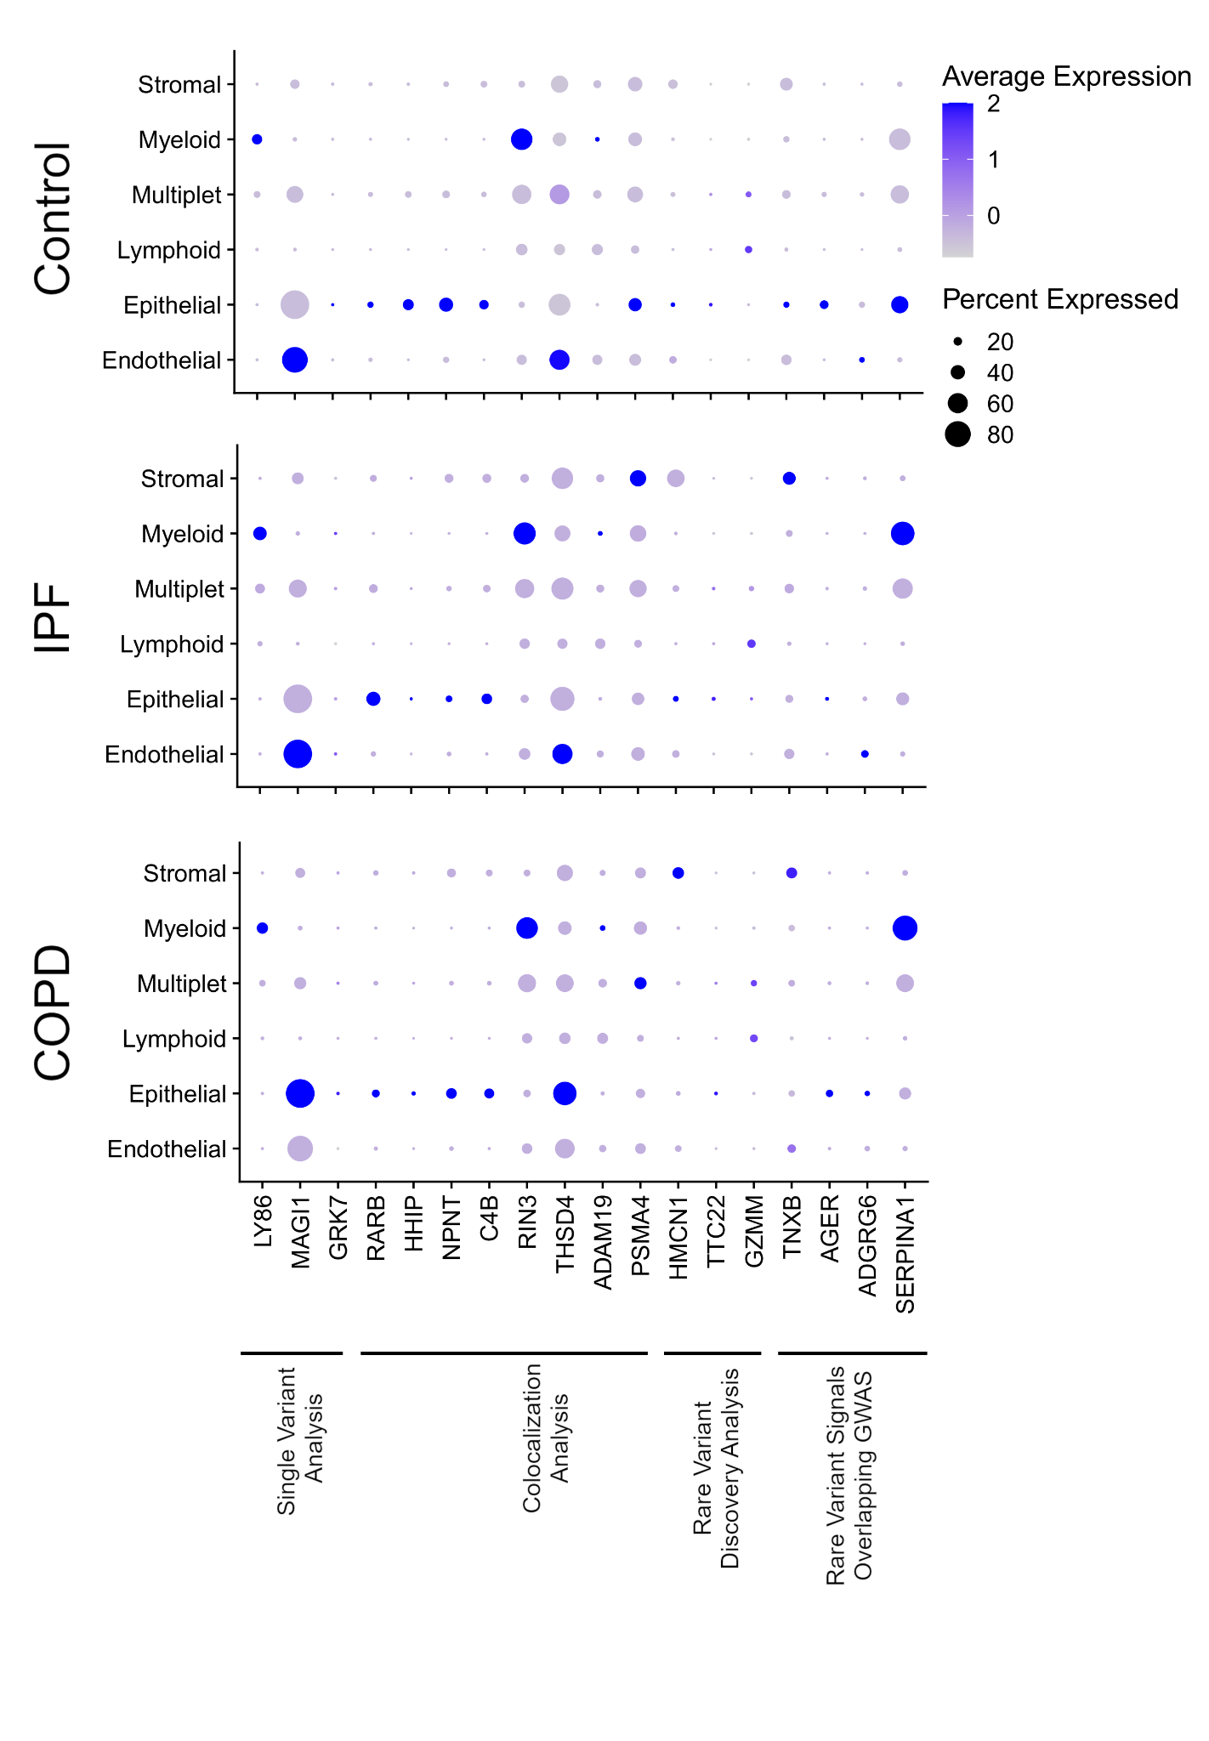

Supplementary Figure 9: HMCN1 knockdown
A
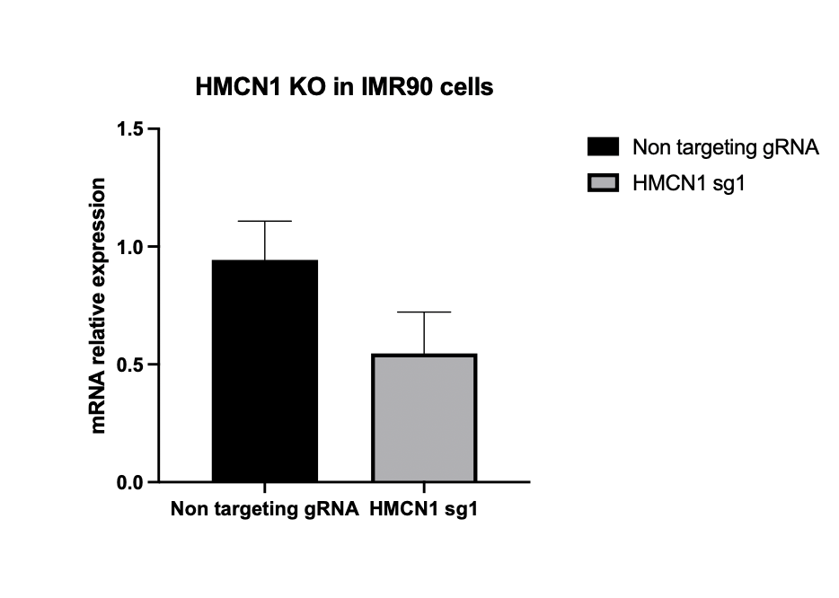
B
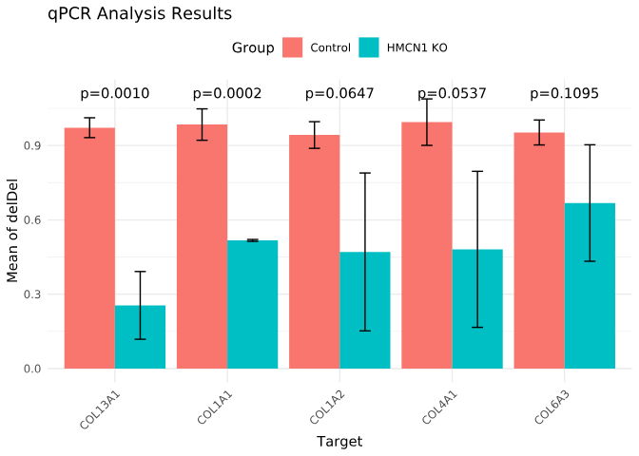
C
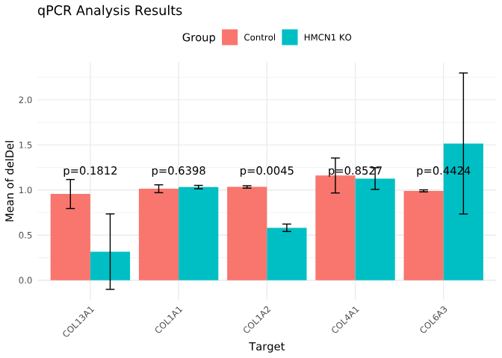

Supplementary Figure 9. knockout of HMCN1 leads to reduced expression of matrix collage genes in human lung fibroblasts. A. Knockout efficiency of HMCN1 in IMR-90-hTERT cells stably infected HMCN1 gRNA in two biological replicates. C,D. Expression of collagen genes in HMCN1 knockout IMR90-hTERT cells cultured with 0.1% (C) and 10% FBS. DeldelCT = 2-∆∆CT, error bars represent standard deviations across biologic replicates.

Supplementary References

1. Wright JD, Folsom AR, Coresh J, Sharrett AR, Couper D, Wagenknecht LE, et al. The Atherosclerosis Risk in Communities (ARIC) study: JACC Focus Seminar 3/8. J Am Coll Cardiol. 2021 Jun 15;77(23):2939–59.
2. Mirabelli MC, Preisser JS, Loehr LR, Agarwal SK, Barr RG, Couper DJ, et al. Lung function decline over 25 years of follow-up among black and white adults in the ARIC study cohort. Respir Med. 2016 Apr;113:57–64.
3. Hughes GH, Cutter G, Donahue R, Friedman GD, Hulley S, Hunkeler E, et al. Recruitment in the Coronary Artery Disease Risk Development in Young Adults (Cardia) Study. Control Clin Trials. 1987 Dec;8(4 Suppl):68S-73S.
4. Friedman GD, Cutter GR, Donahue RP, Hughes GH, Hulley SB, Jacobs DR, et al. CARDIA: study design, recruitment, and some characteristics of the examined subjects. J Clin Epidemiol. 1988;41(11):1105–16.
5. ATS statement--Snowbird workshop on standardization of spirometry. Am Rev Respir Dis. 1979 May;119(5):831–8.
6. Fried LP, Borhani NO, Enright P, Furberg CD, Gardin JM, Kronmal RA, et al. The cardiovascular health study: Design and rationale. Ann Epidemiol. 1991 Feb 1;1(3):263–76.
7. Enright PL, Kronmal RA, Higgins M, Schenker M, Haponik EF. Spirometry Reference Values for Women and Men 65 to 85 Years of Age: Cardiovascular Health Study. Am Rev Respir Dis. 1993 Jan;147(1):125–33.
8. Enright PL, Kronmal RA, Higgins MW, Schenker MB, Haponik EF. Prevalence and Correlates of Respiratory Symptoms and Disease in the Elderly. Chest. 1994 Sep 1;106(3):827–34.
9. Larkin EK, Patel SR, Goodloe RJ, Li Y, Zhu X, Gray-McGuire C, et al. A Candidate Gene Study of Obstructive Sleep Apnea in European Americans and African Americans. Am J Respir Crit Care Med. 2010 Oct;182(7):947–53.
10. KANNEL WB, FEINLEIB M, McNAMARA PM, GARRISON RJ, CASTELLI WP. AN INVESTIGATION OF CORONARY HEART DISEASE IN FAMILIES: THE FRAMINGHAM OFFSPRING STUDY. Am J Epidemiol. 1979 Sep 1;110(3):281–90.
11. Sempos CT, Bild DE, Manolio TA. Overview of the Jackson Heart Study: A Study of Cardiovascular Diseases in African American Men and Women. Am J Med Sci. 1999 Mar 1;317(3):142–6.
12. Wilson JG, Rotimi CN, Ekunwe L, Royal CDM, Crump ME, Wyatt SB, et al. Study Design for Genetic Analysis in the Jackson Heart Study. Ethn Dis. 2005;15:30–7.
13. Bild DE, Bluemke DA, Burke GL, Detrano R, Diez Roux AV, Folsom AR, et al. Multi-Ethnic Study of Atherosclerosis: Objectives and Design. Am J Epidemiol. 2002 Nov 1;156(9):871–81.
14. Hankinson JL, Kawut SM, Shahar E, Smith LJ, Stukovsky KH, Barr RG. Performance of American Thoracic Society-recommended spirometry reference values in a multiethnic sample of adults: the multi-ethnic study of atherosclerosis (MESA) lung study. Chest. 2010;137(1):138–45.
15. LaVange LM, Kalsbeek WD, Sorlie PD, Avilés-Santa LM, Kaplan RC, Barnhart J, et al. Sample Design and Cohort Selection in the Hispanic Community Health Study/Study of Latinos. Ann Epidemiol. 2010 Aug 1;20(8):642–9.
16. Bycroft C, Freeman C, Petkova D, Band G, Elliott LT, Sharp K, et al. The UK Biobank resource with deep phenotyping and genomic data. Nature. 2018 Oct;562(7726):203–9.
17. Loh PR, Danecek P, Palamara PF, Fuchsberger C, A Reshef Y, K Finucane H, et al. Reference-based phasing using the Haplotype Reference Consortium panel. Nat Genet. 2016 Nov;48(11):1443–8.
18. Loh PR, Tucker G, Bulik-Sullivan BK, Vilhjálmsson BJ, Finucane HK, Salem RM, et al. Efficient Bayesian mixed-model analysis increases association power in large cohorts. Nat Genet. 2015 Mar;47(3):284–90.
19. Loh PR, Kichaev G, Gazal S, Schoech AP, Price AL. Mixed-model association for biobank-scale datasets. Nat Genet. 2018 Jul;50(7):906–8.
20. Silverman EK, Chapman HA, Drazen JM, Weiss ST, Rosner B, Campbell EJ, et al. Genetic epidemiology of severe, early-onset chronic obstructive pulmonary disease. Risk to relatives for airflow obstruction and chronic bronchitis. Am J Respir Crit Care Med. 1998 Jun;157(6 Pt 1):1770–8.
21. Silverman EK, Weiss ST, Drazen JM, Chapman HA, Carey V, Campbell EJ, et al. Gender-related differences in severe, early-onset chronic obstructive pulmonary disease. Am J Respir Crit Care Med. 2000 Dec;162(6):2152–8.
22. Kim V, Han MK, Vance GB, Make BJ, Newell JD, Hokanson JE, et al. The Chronic Bronchitic Phenotype of COPD: An Analysis of the COPDGene Study. Chest. 2011 Sep 1;140(3):626–33.
23. Vestbo J, Anderson W, Coxson HO, Crim C, Dawber F, Edwards L, et al. Evaluation of COPD Longitudinally to Identify Predictive Surrogate End-points (ECLIPSE). Eur Respir J. 2008 Apr;31(4):869–73.
24. Cho MH, Boutaoui N, Klanderman BJ, Sylvia JS, Ziniti JP, Hersh CP, et al. Variants in FAM13A are associated with chronic obstructive pulmonary disease. Nat Genet. 2010 Mar;42(3):200–2.
25. Oelsner EC, Balte PP, Cassano PA, Couper D, Enright PL, Folsom AR, et al. Harmonization of respiratory data from 9 US population-based cohorts: the NHLBI Pooled Cohorts Study. Am J Epidemiol. 2018;187(11):2265–78.
26. Gogarten SM, Sofer T, Chen H, Yu C, Brody JA, Thornton TA, et al. Genetic association testing using the GENESIS R/Bioconductor package. Bioinformatics. 2019;35(24):5346–8.
27. Conomos MP, Miller MB, Thornton TA. Robust inference of population structure for ancestry prediction and correction of stratification in the presence of relatedness. Genet Epidemiol. 2015;39(4):276–93.
28. Conomos MP, Reiner AP, Weir BS, Thornton TA. Model-free estimation of recent genetic relatedness. Am J Hum Genet. 2016;98(1):127–48.
29. Sofer T, Zheng X, Gogarten SM, Laurie CA, Grinde K, Shaffer JR, et al. A fully adjusted two‐stage procedure for rank‐normalization in genetic association studies. Genet Epidemiol. 2019;43(3):263–75.
30. Tang ZZ, Lin DY. Meta-analysis for discovering rare-variant associations: statistical methods and software programs. Am J Hum Genet. 2015;97(1):35–53.
31. Dey R, Schmidt EM, Abecasis GR, Lee S. A fast and accurate algorithm to test for binary phenotypes and its application to PheWAS. Am J Hum Genet. 2017;101(1):37–49.
32. Lin DY. A simple and accurate method to determine genomewide significance for association tests in sequencing studies. Genet Epidemiol. 2019 Jun;43(4):365–72.
33. Shrine N, Guyatt AL, Erzurumluoglu AM, Jackson VE, Hobbs BD, Melbourne CA, et al. New genetic signals for lung function highlight pathways and chronic obstructive pulmonary disease associations across multiple ancestries. Nat Genet. 2019;51(3):481–93.
34. Sakornsakolpat P, Prokopenko D, Lamontagne M, Reeve NF, Guyatt AL, Jackson VE, et al. Genetic landscape of chronic obstructive pulmonary disease identifies heterogeneous cell-type and phenotype associations. Nat Genet. 2019;51(3):494–505.
35. Strnad P, McElvaney NG, Lomas DA. Alpha1-antitrypsin deficiency. N Engl J Med. 2020;382(15):1443–55.
36. Cho MH, Castaldi PJ, Wan ES, Siedlinski M, Hersh CP, Demeo DL, et al. A genome-wide association study of COPD identifies a susceptibility locus on chromosome 19q13. Hum Mol Genet. 2012;21(4):947–57.
37. Chang CC, Chow CC, Tellier LC, Vattikuti S, Purcell SM, Lee JJ. Second-generation PLINK: rising to the challenge of larger and richer datasets. Gigascience. 2015;4(1):s13742-015-0047–8.
38. Schaid DJ, Chen W, Larson NB. From genome-wide associations to candidate causal variants by statistical fine-mapping. Nat Rev Genet. 2018;19(8):491–504.
39. Wang G, Sarkar A, Carbonetto P, Stephens M. A simple new approach to variable selection in regression, with application to genetic fine mapping. J R Stat Soc Ser B Stat Methodol. 2020;82(5):1273–300.
40. Zou Y, Carbonetto P, Wang G, Stephens M. Fine-mapping from summary data with the “Sum of Single Effects” model. bioRxiv. 2021;
41. Taylor-Weiner A, Aguet F, Haradhvala NJ, Gosai S, Anand S, Kim J, et al. Scaling computational genomics to millions of individuals with GPUs. Genome Biol. 2019;20(1):1–5.
42. Kasela S, Aguet F, Kim-Hellmuth S, Brown BC, Nachun DC, Tracy RP, et al. Interaction molecular QTL mapping discovers cellular and environmental modifiers of genetic regulatory effects. BioRxiv Prepr Serv Biol. 2023 Jun 29;2023.06.26.546528.
43. Schubert R, Geoffroy E, Gregga I, Mulford AJ, Aguet F, Ardlie K, et al. Protein prediction for trait mapping in diverse populations. PloS One. 2022;17(2):e0264341.
44. Stegle O, Parts L, Durbin R, Winn J. A Bayesian framework to account for complex non-genetic factors in gene expression levels greatly increases power in eQTL studies. PLoS Comput Biol. 2010;6(5):e1000770.
45. GTEx Consortium. The GTEx Consortium atlas of genetic regulatory effects across human tissues. Science. 2020 Sep 11;369(6509):1318–30.
46. Wallace C. A more accurate method for colocalisation analysis allowing for multiple causal variants. PLoS Genet. 2021;17(9):e1009440.
47. Liu B, Gloudemans MJ, Rao AS, Ingelsson E, Montgomery SB. Abundant associations with gene expression complicate GWAS follow-up. Nat Genet. 2019 May;51(5):768–9.
48. Frankish A, Diekhans M, Jungreis I, Lagarde J, Loveland JE, Mudge JM, et al. GENCODE 2021. Nucleic Acids Res. 2021;49(D1):D916–23.
49. Karczewski KJ, Francioli LC, Tiao G, Cummings BB, Alföldi J, Wang Q, et al. The mutational constraint spectrum quantified from variation in 141,456 humans. Nature. 2020;581(7809):434–43.
50. McLaren W, Gil L, Hunt SE, Riat HS, Ritchie GR, Thormann A, et al. The ensembl variant effect predictor. Genome Biol. 2016;17(1):1–14.
51. Liu X, White S, Peng B, Johnson AD, Brody JA, Li AH, et al. WGSA: an annotation pipeline for human genome sequencing studies. J Med Genet. 2016;53(2):111–2.
52. Consortium BC. The NHLBI BioData Catalyst. Zenodo31 August 2020 Date Last Accessed. 2020;
53. Chen H, Huffman JE, Brody JA, Wang C, Lee S, Li Z, et al. Efficient variant set mixed model association tests for continuous and binary traits in large-scale whole-genome sequencing studies. Am J Hum Genet. 2019;104(2):260–74.
54. Morris AP, Zeggini E. An evaluation of statistical approaches to rare variant analysis in genetic association studies. Genet Epidemiol. 2010;34(2):188–93.
55. Madsen BE, Browning SR. A groupwise association test for rare mutations using a weighted sum statistic. PLoS Genet. 2009;5(2):e1000384.
56. Wu MC, Lee S, Cai T, Li Y, Boehnke M, Lin X. Rare-variant association testing for sequencing data with the sequence kernel association test. Am J Hum Genet. 2011;89(1):82–93.
57. Lee S, Emond MJ, Bamshad MJ, Barnes KC, Rieder MJ, Nickerson DA, et al. Optimal unified approach for rare-variant association testing with application to small-sample case-control whole-exome sequencing studies. Am J Hum Genet. 2012;91(2):224–37.
58. Zhou W, Nielsen JB, Fritsche LG, Dey R, Gabrielsen ME, Wolford BN, et al. Efficiently controlling for case-control imbalance and sample relatedness in large-scale genetic association studies. Nat Genet. 2018;50(9):1335–41.
59. Yates A, Beal K, Keenan S, McLaren W, Pignatelli M, Ritchie GR, et al. The Ensembl REST API: Ensembl data for any language. Bioinformatics. 2015;31(1):143–5.
60. Wang Q, Dhindsa RS, Carss K, Harper AR, Nag A, Tachmazidou I, et al. Rare variant contribution to human disease in 281,104 UK Biobank exomes. Nature. 2021 Sep;597(7877):527–32.
61. Karczewski KJ, Solomonson M, Chao KR, Goodrich JK, Tiao G, Lu W, et al. Systematic single-variant and gene-based association testing of thousands of phenotypes in 394,841 UK Biobank exomes. Cell Genomics. 2022 Sep 14;2(9):100168.
62. Fisher RA. Statistical Methods for Research Workers. In: Kotz S, Johnson NL, editors. Breakthroughs in Statistics: Methodology and Distribution [Internet]. New York, NY: Springer; 1992 [cited 2023 Sep 1]. p. 66–70. (Springer Series in Statistics). Available from: https://doi.org/10.1007/978-1-4612-4380-9_6
63. Shrine N, Izquierdo AG, Chen J, Packer R, Hall RJ, Guyatt AL, et al. Multi-ancestry genome-wide association analyses improve resolution of genes and pathways influencing lung function and chronic obstructive pulmonary disease risk. Nat Genet. 2023 Mar;55(3):410–22.
64. Sikkema L, Ramírez-Suástegui C, Strobl DC, Gillett TE, Zappia L, Madissoon E, et al. An integrated cell atlas of the lung in health and disease. Nat Med. 2023 Jun;29(6):1563–77.
65. Adams TS, Schupp JC, Poli S, Ayaub EA, Neumark N, Ahangari F, et al. Single-cell RNA-seq reveals ectopic and aberrant lung-resident cell populations in idiopathic pulmonary fibrosis. Sci Adv. 2020 Jul;6(28):eaba1983.
66. Hao Y, Hao S, Andersen-Nissen E, Mauck WM, Zheng S, Butler A, et al. Integrated analysis of multimodal single-cell data. Cell. 2021 Jun 24;184(13):3573-3587.e29.

