Appendix 1 Pearson’s correlation analysis of the ecological factors
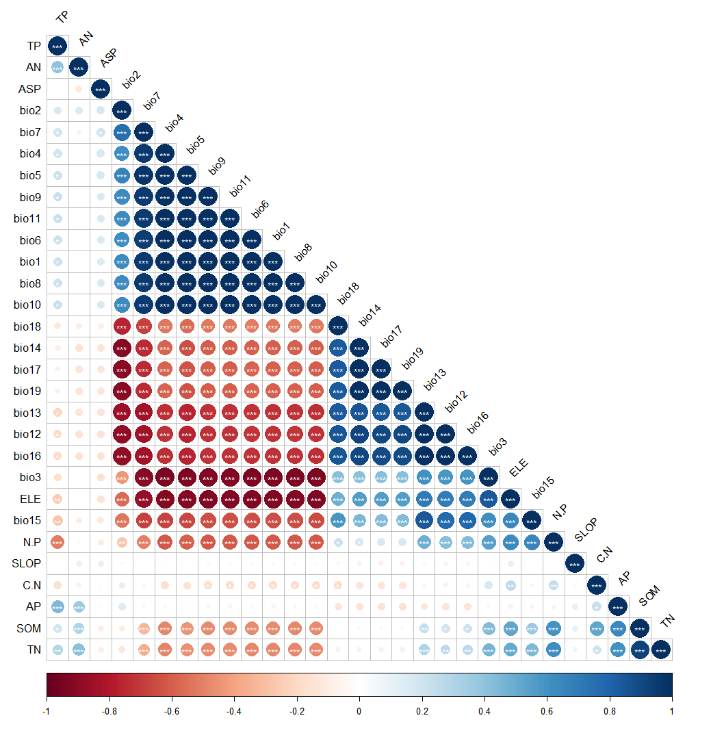
Fig. 7 Correlation analysis of the environmental factors. “*”: P < 0.05, “**”: P < 0.01, “***”: P < 0.001
Appendix 2 Preferred food plants of the Hainan gibbon
Species | Family | Genus
Bridelia balansae | Euphorbiaceae | Bridelia
Canarium album | Burseraceae | Canarium
Gironniera subaequalis | Ulmaceae | Gironniera
Planchonella annamensis | Sapotaceae | Pouteria
Acmena acuminatissima | Myrtaceae | Syzygium
Garcinia oblongifolia | Guttiferae | Garcinia
Acronychia oligophlebia | Rutaceae | Acronychia
Polyalthia laui | Annonaceae | Polyalthia
Elaeocarpus sylvestris | Elaeocarpaceae | Elaeocarpus
Baccaurea ramiflora | Euphorbiaceae | Baccaurea
Artocarpus styracifolius | Moraceae | Artocarpus
Nephelium topengii | Sapindaceae | Nephelium
Litchi chinensis var. | Sapindaceae | Litchi
Dillenia turbinata | Dilleniaceae | Dillenia
Machilus chinensis | Lauraceae | Machilus
Canarium pimela | Burseraceae | Canarium
Dacrycarpus imbricatus | Podocarpaceae | Podocarpus
Garcinia multiflora | Guttiferae | Garcinia
Microcos chungii | Tiliaceae | Microcos
Ficus esquiroliana | Moraceae | Ficus
Alangium salviifolium | Alangiaceae | Alangium
Ficus vasculosa | Moraceae | Ficus
Gnetum montanum | Gnetaceae | Gnetum
Podocarpus neriifolius | Podocarpaceae | Podocarpus
Endospermum chinense | Euphorbiaceae | Endospermum
Ficus auriculata | Moraceae | Ficus
Ficus hederacea | Moraceae | Ficus
Ficus variegata | Moraceae | Ficus
Dacrydium pierrei | Podocarpaceae | Dacrydium
Spondias lakonensis | Anacardiaceae | Spondias
Choerospondias axillaris | Anacardiaceae | Choerospondias
Caryota maxima | Palmae | Caryota
Ficus altissima | Moraceae | Ficus
Appendix 3 Food plants of the Hainan gibbon during the dry season
Species | Family | Genus
Alangium chinense | Alangiaceae | Alangium
Ficus vasculosa | Moraceae | Ficus
Gironniera subaequalis | Ulmaceae | Gironniera
Ficus superba var. | Moraceae | Ficus
Tetrastigma planicaule | Vitaceae | Tetrastigma
Uvaria calamistrata | Annonaceae | Uvaria
Liquidambar formosana | Hamamelidaceae | Liquidambar
Canarium album | Burseraceae | Canarium
Ficus altissima | Moraceae | Ficus
Lindera kwangtungensis | Lauraceae | Lindera
Diospyros susarticulata | Ebenaceae | Diospyros
Polyalthia laui | Annonaceae | Polyalthia
Garcinia oblongifolia | Guttiferae | Garcinia
Nephelium topengii | Sapindaceae | Nephelium
Castanopsis hainanensis | Fagaceae | Castanopsis
Castanopsis hystrix | Fagaceae | Castanopsis
Cryptocarya chinensis | Lauraceae | Cryptocarya
Eurya ciliata | Theaceae | Eurya
Machilus chinensis | Lauraceae | Machilus
Litsea elongata | Lauraceae | Litsea
Endospermum chinense | Euphorbiaceae | Endospermum
Xanthophyllum hainanense | Polygalaceae | Xanthophyllum
Dacrycarpus imbricatus | Podocarpaceae | Podocarpus
Ficus nervosa | Moraceae | Ficus
Psychotria rubra | Rubiaceae | Psychotria
Kadsura oblongifolia | Magnoliaceae | Kadsura
Dacrydium pierrei | Podocarpaceae | Dacrydium
Baccaurea ramiflora | Euphorbiaceae | Baccaurea
Choerospondias axillaris | Anacardiaceae | Choerospondias
Mussaenda erosa | Rubiaceae | Mussaenda
Sarcosperma laurinum | Sapotaceae | Sarcosperma
Melodinus suaveolens | Apocynaceae | Melodinus
Adina pilulifera | Rubiaceae | Adina
Planchonella annamensis | Sapotaceae | Pouteria
Ficus hederacea | Moraceae | Ficus
Trichilia connaroides | Meliaceae | Trichilia
Acmena acuminatissima | Myrtaceae | Acmena
Caryota maxima | Palmae | Caryota
Elaeocarpus sphaericus | Elaeocarpaceae | Elaeocarpus
Cryptocarya metcalfiana | Lauraceae | Cryptocarya

