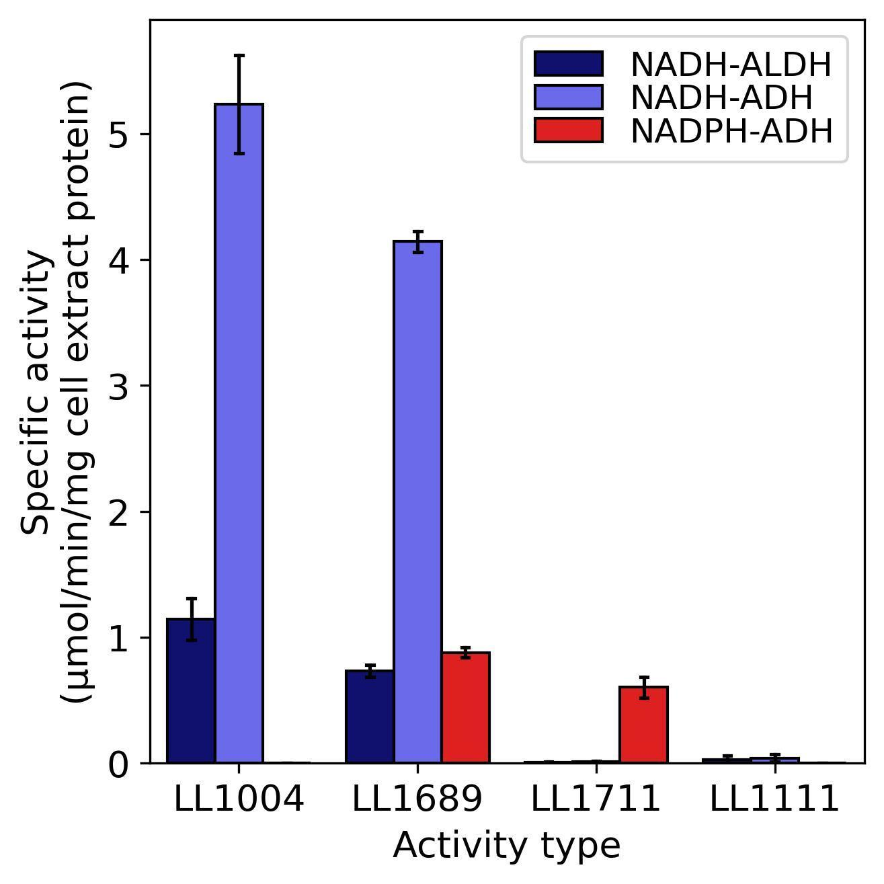
Figure S1: Enzyme activity of C. thermocellum strains for aldehyde dehydrogenase (ALDH, EC 1.2.1.10) and alcohol dehydrogenase (ADH, EC 1.1.1.1 or 1.1.1.2) reactions. Strain LL1004 is wild type C. thermocellum DSM 1313. Strain LL1111 is strain control for adhE deletion that has been described previously (Lo et al., 2015). Strain LL1689 is a strain in the lineage before E784* mutation in C. thermocellum adhE. Strain LL1711 is final PPi-free glycolysis strain with E784* mutation in C. thermocellum adhE. Missing bars indicate the absence of activity (i.e. below the limit of detection, <0.01 μmol/min/mg). Error bars represent 1 standard deviation (n = 2 biological replicates). Complete genotypes of strains LL1689 and LL1711 are shown in Table 1.
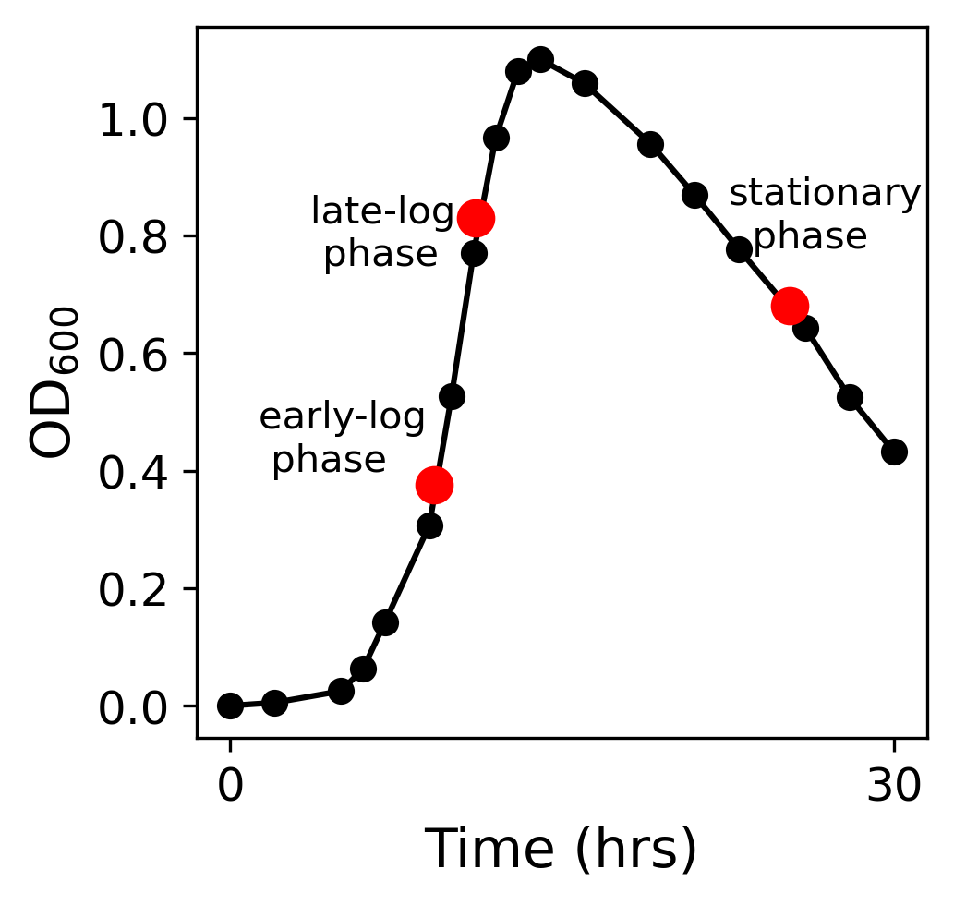
Figure S2: Schematic growth curve of C. thermocellum strains (LL1590, LL1592, LL1711) for ¹³C labeling experiments. Red dot indicates sampling time points.
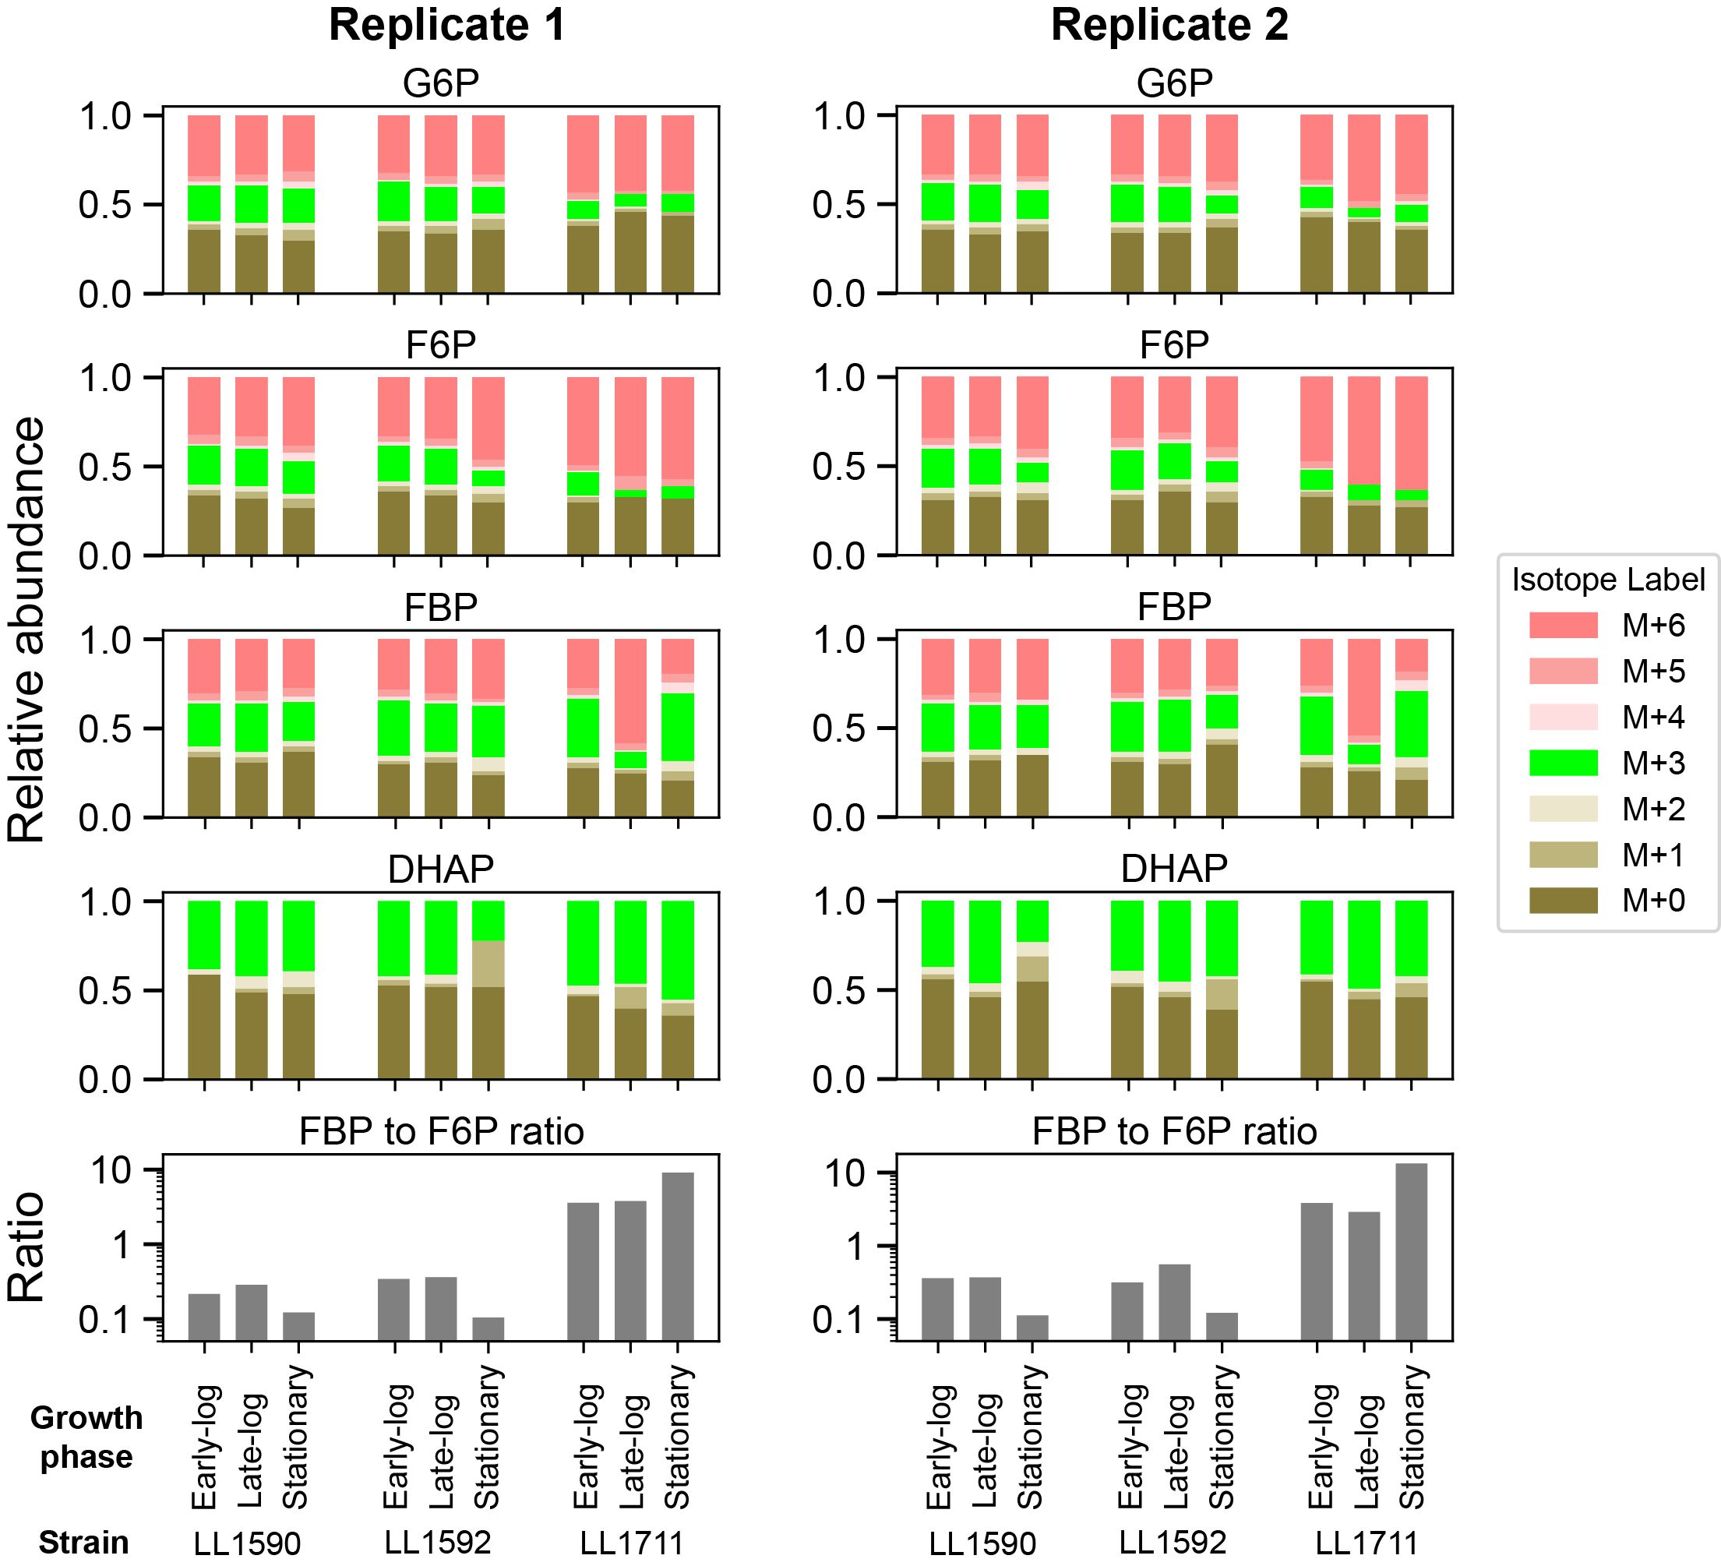
Figure S3: ¹³C-labeling patterns of key glycolysis metabolites near the PFK reaction. The metabolites glucose-6-phosphate (G6P), fructose-6-phosphate (F6P), fructose 1,6-bisphosphate (FBP) and dihydroxyacetone phosphate (DHAP) were measured at different stages of growth for cells grown with a 50:50 mixture of uniformly labeled and naturally labeled cellobiose. ‘M+’ notation indicates the number of ¹³C-labeled carbon atoms. One set of representative data is shown for each strain (n = 2 biological replicates). Strain LL1592 is the parent strain, strain LL1590 is a control for loss of wild type C. thermocellum AdhE activity, strain LL1711 is the PPi-free glycolysis strain. The ratio represents the ratio of absolute abundance of FBP to F6P. Figure 3 shows replicate 1 of this experiment.Raw data used for the analysis is available as Additional File 2.

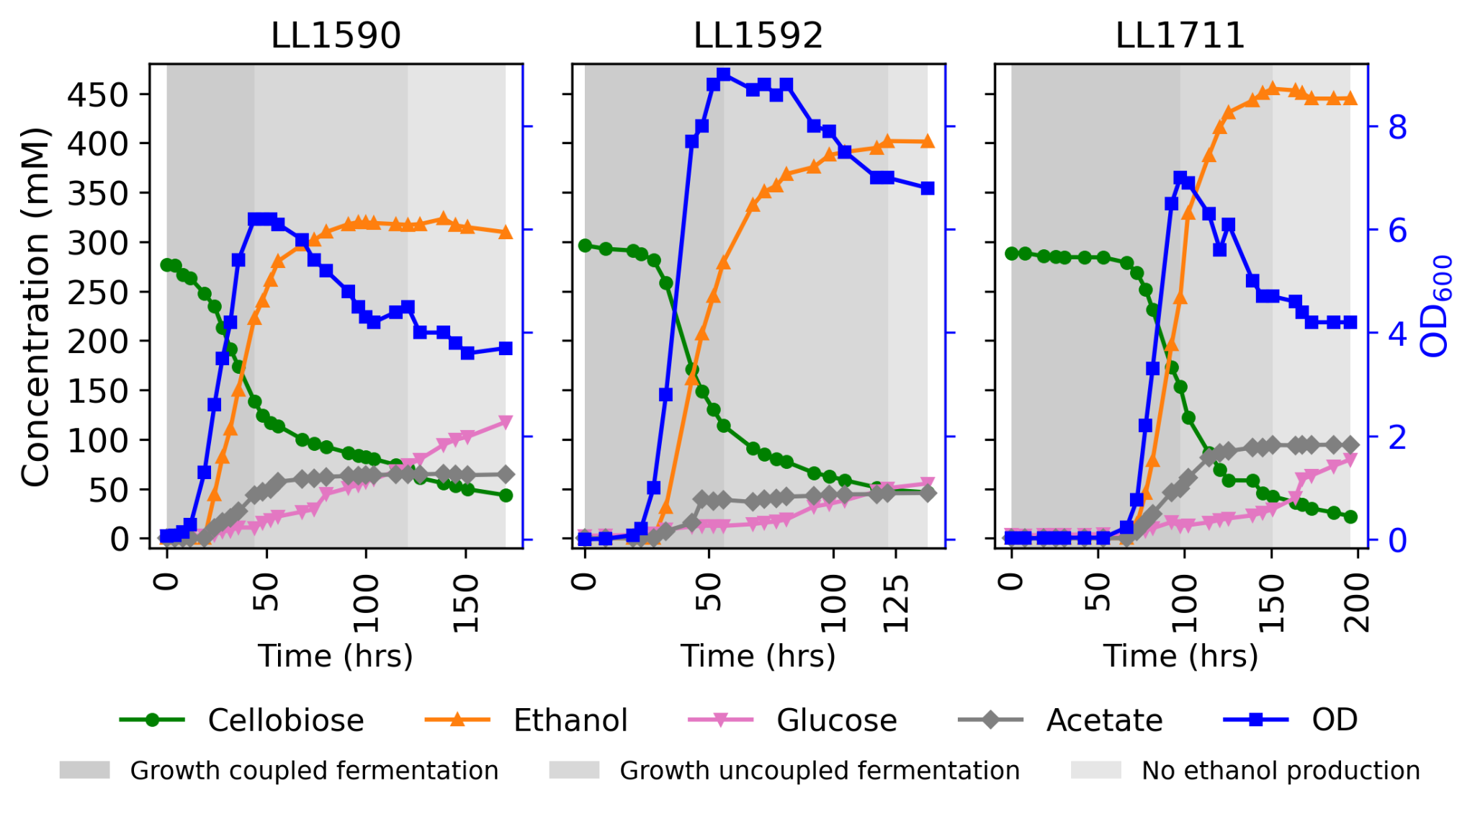
Figure S4: Batch fermentations of C. thermocellum strains with wild type glycolysis (strains LL1590 and LL1592) and PPi-free glycolysis (strain LL1711). Strain LL1592 is the parent strain. Strain LL1590 is a control for loss of wild type C. thermocellum AdhE activity. Strain LL1711 is the PPi-free glycolysis strain. Strain LL1590 (LL1592 with a targeted deletion of C. thermocellum adhE) is included to control for the effects of inactivation of the native adhE gene, to allow the effects of the changes to glycolysis to be seen more clearly. Strains LL1590 and LL1711, the only functional adhE gene is the one heterologously expressed from T. saccharolyticum. Fermentations were performed with 100 g/L cellobiose in MTC-7 chemically defined medium with pH maintained at 7.0 +\- 0.05 by addition of 4 M potassium hydroxide. The shaded background represents different phases of fermentation: dark gray, growth coupled fermentation; medium gray, growth uncoupled fermentation; and light gray, no ethanol production phases. One representative fermentation profile is shown for each strain (n≥2). Figure 5 shows a biological duplicate of this experiment. Additional File 3 (LL1590-2, LL1592-2, LL1711-2) shows additional fermentation product data for this experiment.

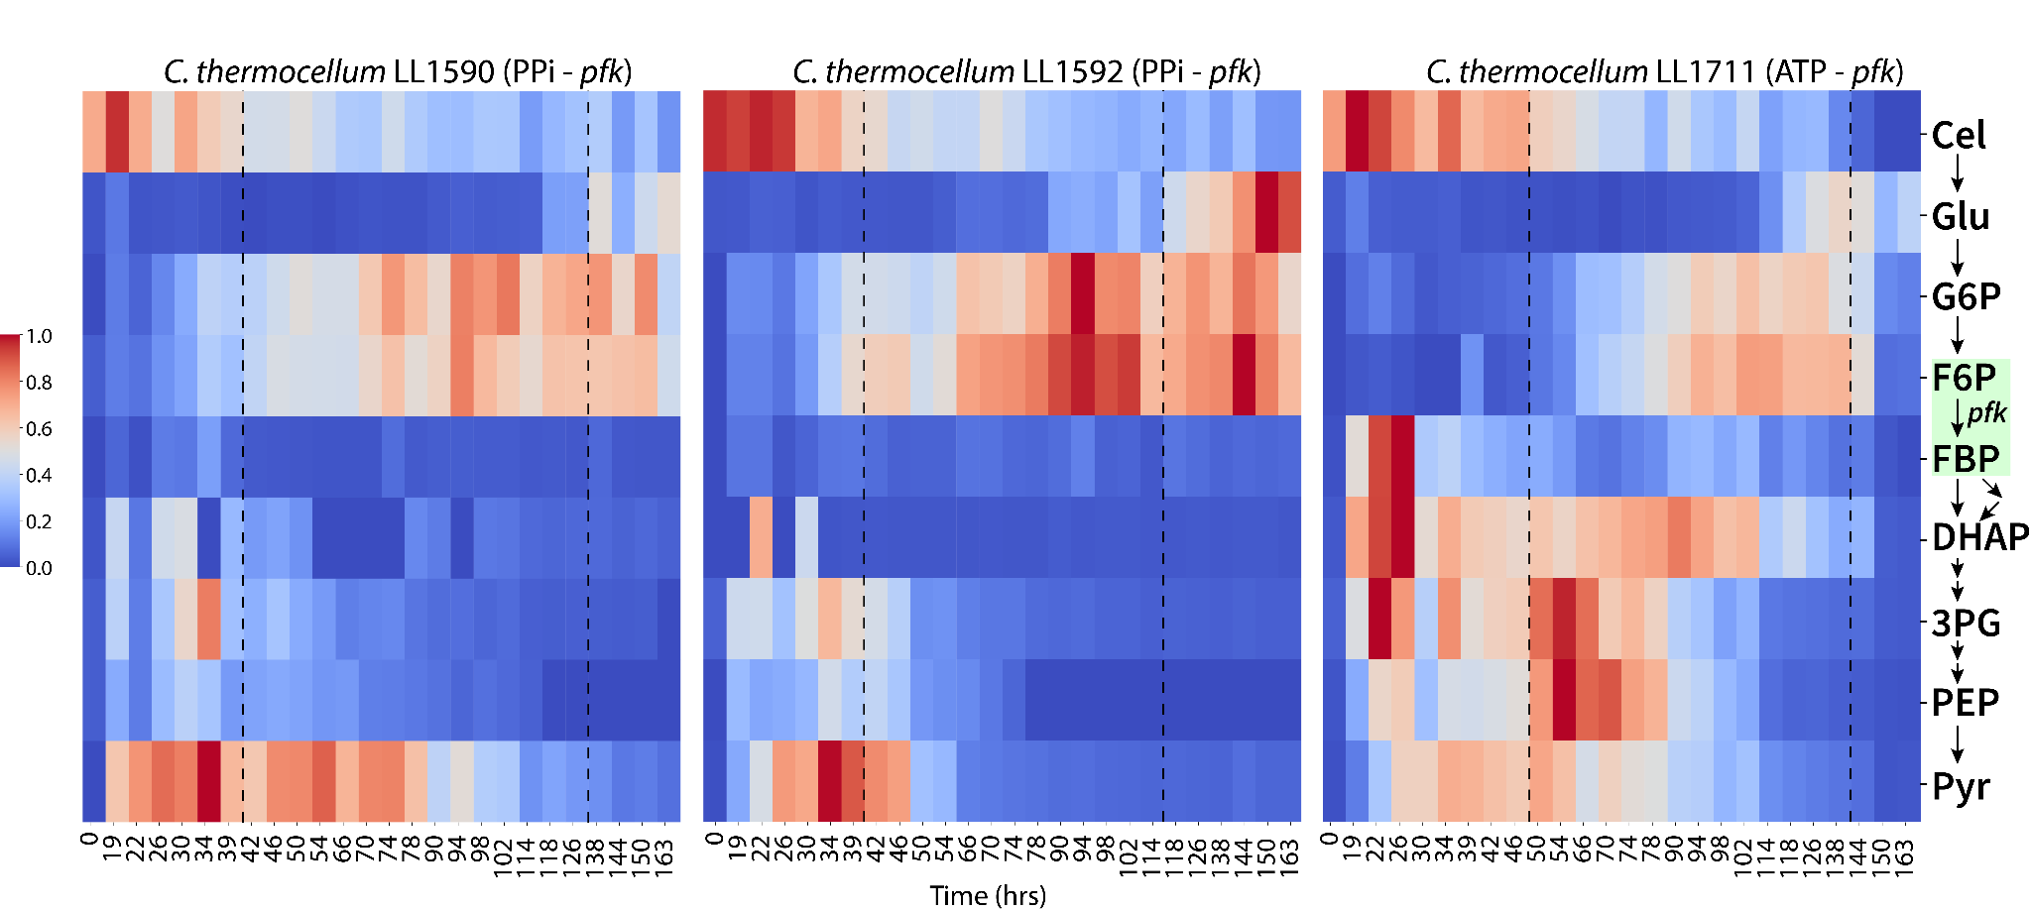
Figure S5: Abundance of glycolytic metabolites in C. thermocellum strains LL1590, LL1592 and LL1711 during the course of fermentation. The dotted lines differentiate different growth phases (from left to right, growth coupled fermentation, growth uncoupled fermentation and no ethanol production respectively). Absolute metabolite concentrations were determined by using external standards. Metabolite concentrations were normalized (per metabolite) from 0 to 1, with 0 being the least and 1 being the highest concentration measured. The green box shows the location of the PFK reaction in glycolysis. Figure 6 shows a biological duplicate of this experiment. Key: cellobiose (Cel); glucose (Glu); glucose 6-phosphate (G6P); fructose 6-phosphate (F6P); fructose 1,6-bisphosphate (FBP); dihydroxyacetone phosphate (DHAP); 3-phosphoglycerate (3PG); phosphoenolpyruvate (PEP); pyruvate (Pyr)

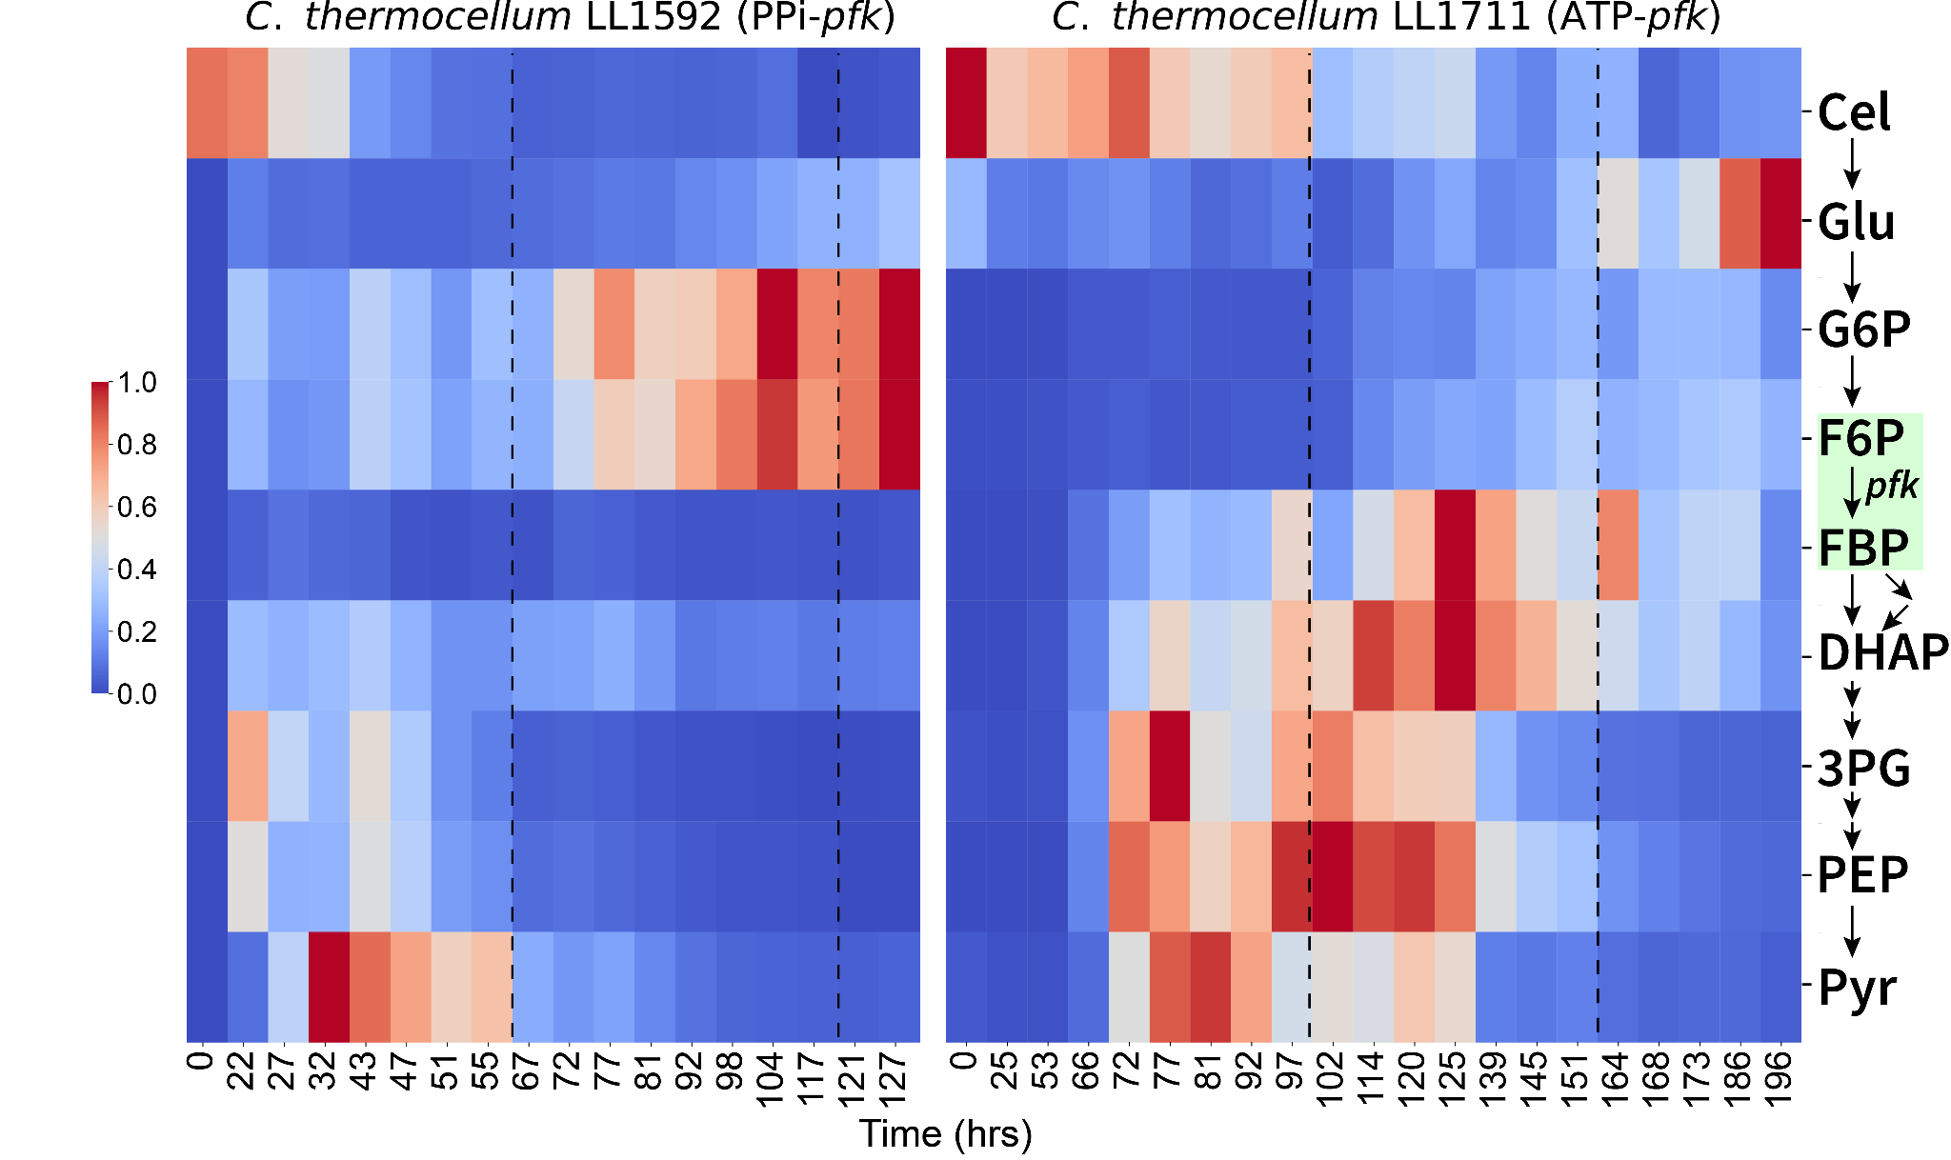
Figure S6: Abundance of glycolytic metabolites in C. thermocellum strains LL1592 and LL1711 during the course of fermentation. The dotted lines differentiate different growth phases (from left to right, growth coupled fermentation, growth uncoupled fermentation and no ethanol production respectively). Absolute metabolite concentrations were determined by using external standards. Metabolite concentrations were normalized (per metabolite) from 0 to 1, with 0 being the least and 1 being the highest concentration measured. The green box shows the location of the PFK reaction in glycolysis. Figure 6 shows a biological duplicate of this experiment. Key: cellobiose (Cel); glucose (Glu); glucose 6-phosphate (G6P); fructose 6-phosphate (F6P); fructose 1,6-bisphosphate (FBP); dihydroxyacetone phosphate (DHAP); 3-phosphoglycerate (3PG); phosphoenolpyruvate (PEP); pyruvate (Pyr)
Additional File 1: Raw enzyme assay data.
Additional File 2: Peak area top values for different isotopes of Glucose 6-phosphate, Fructose 6-phosphate, Fructose 1,6-bisphosphate and Dihydroxyacetone phosphate. Key: M+0 (No carbon ¹³C labeled or fully unlabeled); M+1 (One carbon ¹³C labeled); M+2 (Two carbons ¹³C labeled); M+3 (Three carbons ¹³C labeled); M+4 (Four carbons ¹³C labeled); M+5 (Five carbons ¹³C labeled); M+6 (Six carbons ¹³C labeled or fully labeled)
Additional File 3: Complete fermentation data for the strains LL1590, LL1592 and LL1711. All the strains were grown with 100 g/L cellobiose in MTC-7 medium at pH 7. LL1590-1, LL1592-1, LL1711-1 correspond to Figure 5. LL1590-2, LL1592-2, LL1711-3 correspond to Figure S4. LL1592-3, LL1711-3 are the triplicate fermentation data for respective strains.
Additional File 4: Summary of strain resequencing analyses.

