Table 1. Participant demographics by age-group and health-status
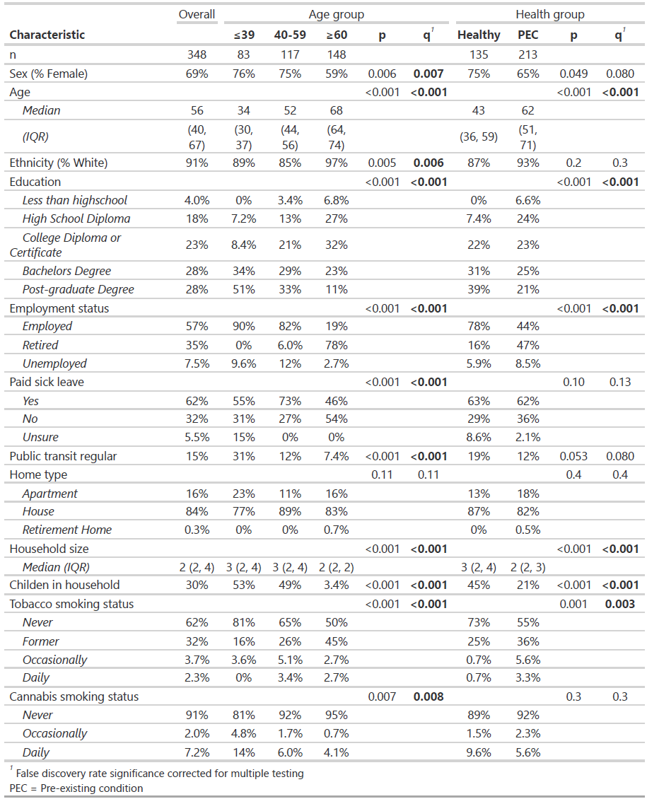

Table 2. Participant comorbidities by age-group and health-status
