Supplementary material

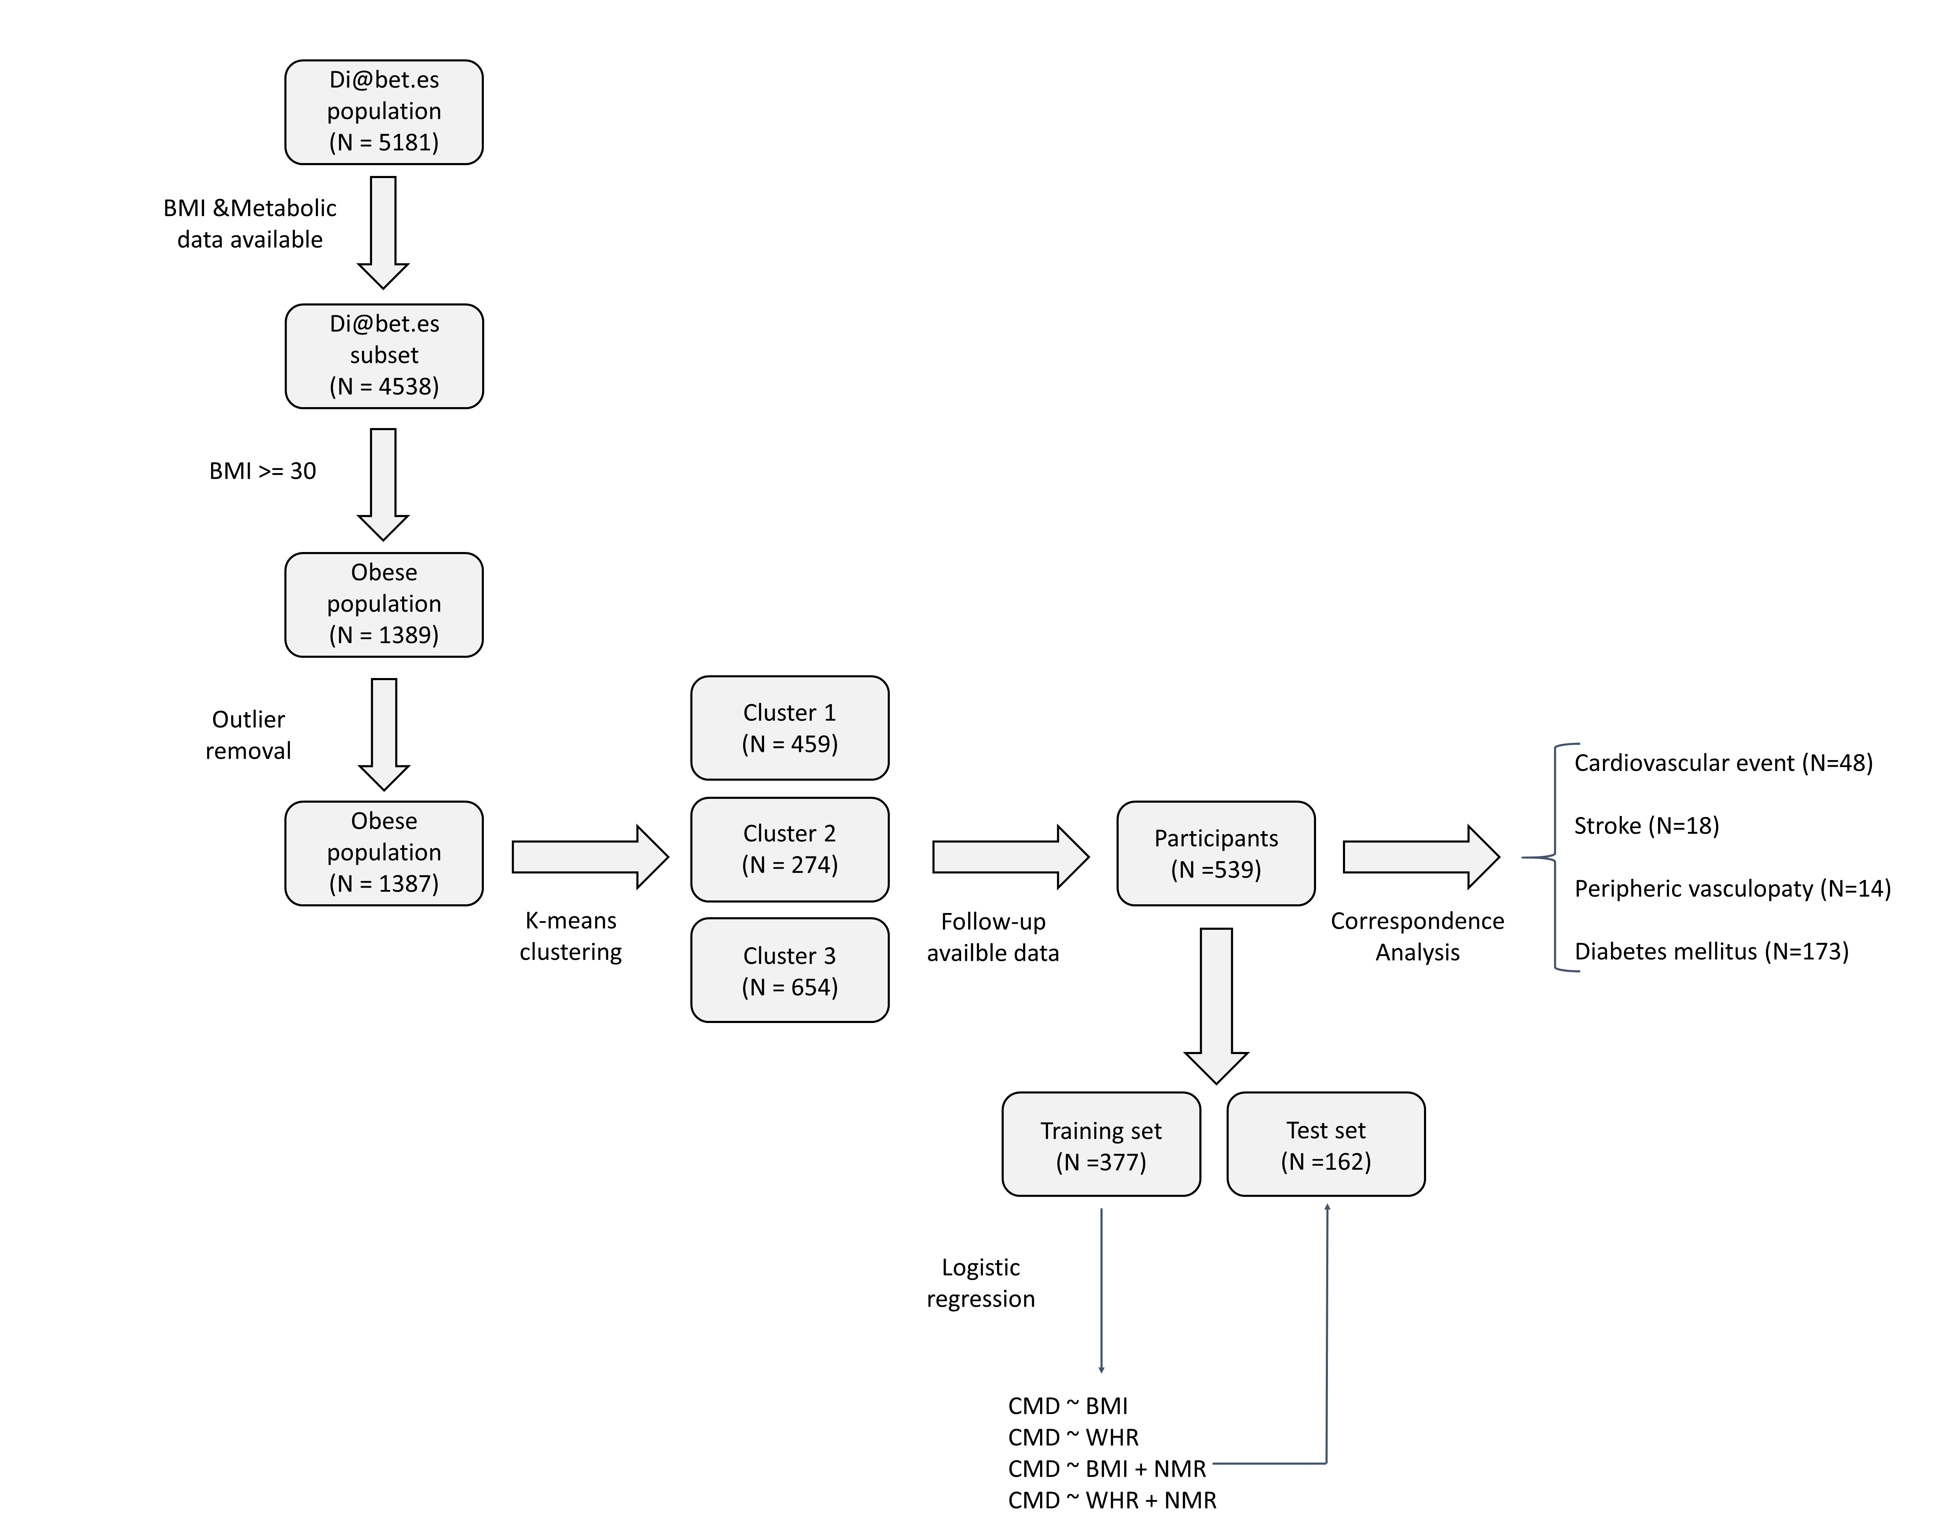

Supplementary figure 1. Flow chart of the study. From the 5181 individuals forming the Di@bet.es cohort, 4,538 had BMI and metabolomic data available. This subset of individuals was filtered by BMI in order to keep just obese individuals for further analysis. Two samples displaying very unusual results were removed on suspicion of being affected by analytical issues. The resulting obese population was clustered in three groups deploying a K-means algorithm. Then, the association of the clusters with future development of cardiometabolic disease was studied. A total of 539 individuals had available follow-up data for all the cardiometabolic conditions considered and were used in the correspondence analysis. This population was divided in a training and a test set containing the 70% and the 30% of the observations, respectively. Four logistic regressions using different predictors were trained using the training set. Their performance in predicting cardiometabolic disease was then evaluated in the independent test set.
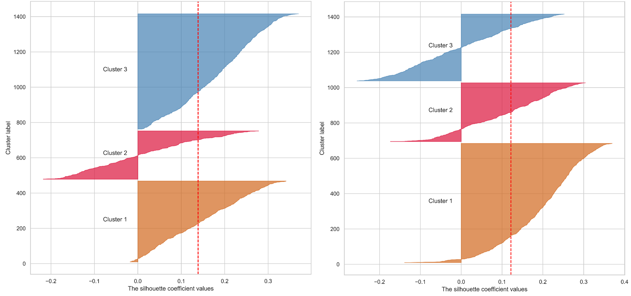
Supplementary figure 2. Comparison of silhouette coefficients between the clusters defined deploying the K-means algorithm (left) and the K-medoids algorithm (right). The silhouette coefficient computed for each sample within each of the three clusters are displayed. The red line indicates the average silhouette coefficient.

Variable | Study population (N=1387)
Age (years) | 56 (16)
Sex (% Women) | 55%
BMI (Kg/m²) | 34 (3.8)
WHR | 0.95 (0.08)
AHT | 66%
Pre-diabetes | 19%
Diabetes Mellitus | 24%
LDL-Cholesterol (mg/dl) | 139 (27.4)
HDL-Cholesterol (mg/dl) | 52 (10.2)
Cholesterol (mg/dl) | 226 (34.7)
Triglycerides (mg/dl) | 136 (65)
Glucose (mg/dl) | 93 (35.5)

Supplementary table 1. Anthropometric and biochemical measures of the study population. For numerical variables (i.e., age, BMI, WHR, lipids and glucose) the mean and standard deviation are displayed.

Variable | Cluster 1 (N=459) | Cluster 2 (N=274) | Cluster 3 (N=654) | Cluster 2 vs. 1 | Cluster 3 vs. 1 | Cluster 3 vs. 2
Age | 55.0 [41.0;67.5] | 57.0 [46.0;67.0] | 59.0 [46.0;69.0] | 0.147 | 0.004 | 0.361
BMI | 32.979 [31.342;35.84] | 32.98 [31.376;35.749] | 32.542 [31.203;35.618] | 0.884 | 0.162 | 0.173
Sex: |  |  |  | 1.19E-05 | 0.939 | 7.50E-06
Male | 189 (41%) | 162 (59%) | 272 (42%)
Female | 270 (59%) | 112 (41%) | 382 (58%)
Glycemia: |  |  |  | 2.52E-18 | 0.197 | 9.46E-16
Normoglycemia | 299 (65%) | 97 (35%) | 389 (60%)
Pre-diabetes | 84 (18%) | 47 (17%) | 133(20%)
Diabetes | 76 (17%) | 130 (48%) | 132 (20%)
AHT: |  |  |  | 1.19E-05 | 0.034 | 0.010
No | 187 (41%) | 65 (24%) | 219 (33%)
Yes | 272 (59%) | 209 (76%) | 435 (67%)
Abdominal obesity: |  |  |  | 0.116 | 0.372 | 0.392
No | 187 (40%) | 90 (33%) | 219 (36%)
Yes | 277 (60%) | 274 (67%) | 435 (64%)
Treatment: |  |  |  | 0.041 | 0.933 | 0.041
No | 274 (60%) | 139 (51%) | 386 (59%)
Yes | 185 (40%) | 135 (49%) | 268 (41%)
GlycA (µmol/L) | 674.215 [612.952;750.178] | 979.071 [864.163;1146.875] | 729.822 [652.095;808.663] | 2.07E-118 | 3.27E-09 | 3.33E-92
GlycB (µmol/L) | 255.528 [222.586;287.849] | 310.129 [263.202;355.983] | 256.777 [227.734;291.346] | 8.08E-25 | 0.635 | 9.92E-26
GlycF (µmol/L) | 270.738 [244.798;300.968] | 358.83 [319.25;399.108] | 285.108 [259.291;313.368] | 1.46E-87 | 7.84E-06 | 6.80E-70
HWGlycA | 15.772 [14.303;17.381] | 19.787 [17.965;21.598] | 16.402 [14.982;18.068] | 1.93E-62 | 2.99E-05 | 5.20E-47
HWGlycB | 4.19 [3.797;4.661] | 4.789 [4.294;5.283] | 4.293 [3.869;4.748] | 2.28E-19 | 0.082 | 1.12E-15
VLDLTG (mg/dL) | 57.59 [41.815;76.516] | 147.547 [116.922;194.591] | 63.844 [48.671;84.196] | 3.25E-161 | 0.003 | 2.03E-155
IDLTG (mg/dL) | 10.841 [9.066;12.658] | 17.096 [14.685;20.267] | 13.521 [11.09;16.068] | 1.69E-81 | 1.10E-25 | 1.24E-34
LDLTG (mg/dL) | 13.678 [11.872;16.063] | 20.526 [17.095;23.971] | 19.86 [17.191;22.867] | 1.08E-64 | 5.17E-76 | 0.019
HDLTG (mg/dL) | 14.999 [12.766;17.904] | 21.567 [18.197;26.56] | 16.083 [13.211;19.737] | 2.76E-46 | 0.068 | 4.46E-42
TG (mg/dL) | 98.178 [79.772;120.058] | 207.383 [173.87;262.896] | 115.221 [96.21;140.569] | 2.82E-159 | 1.47E-10 | 1.77E-130
VLDLC (mg/dL) | 13.303 [8.84;18.64] | 37.81 [31.057;47.937] | 17.815 [12.92;23.385] | 7.85E-147 | 1.08E-10 | 2.28E-117
IDLC (mg/dL) | 9.645 [7.599;11.421] | 17.047 [14.244;20.982] | 14.077 [11.322;16.927] | 7.35E-80 | 6.87E-45 | 4.25E-19
LDLC (mg/dL) | 125.714 [111.896;139.517] | 126.891 [107.184;150.438] | 151.628 [136.212;166.903] | 0.230 | 1.45E-42 | 3.14E-25
HDLC (mg/dL) | 54.664 [48.149;61.927] | 44.427 [39.29;50.032] | 50.682 [45.509;57.258] | 3.35E-34 | 6.59E-11 | 3.28E-14
TC (mg/dL) | 204.904 [187.323;223.703] | 230.999 [206.152;257.292] | 236.349 [219.446;255.746] | 7.88E-22 | 3.79E-41 | 0.196
VLDLp (nmol/L) | 42.495 [30.807;58.289] | 116.64 [93.007;154.691] | 49.196 [37.309;65.489] | 3.93E-169 | 2.23E-04 | 1.03E-158
lVLDLp (nmol/L) | 1.278 [0.922;1.68] | 2.733 [2.242;3.351] | 1.283 [1.035;1.627] | 4.63E-121 | 0.617 | 1.73E-136
mVLDLp (nmol/L) | 3.62 [2.467;4.773] | 7.096 [4.257;11.434] | 4.787 [3.719;6.079] | 1.19E-57 | 3.46E-14 | 4.53E-28
sVLDLp (nmol/L) | 36.76 [26.716;52.25] | 106.534 [84.625;140.084] | 42.921 [32.199;58.617] | 8.69E-172 | 0.001 | 1.36E-164
VLDLZ (nm) | 41.905 [41.658;42.161] | 41.534 [41.256;41.82] | 41.996 [41.778;42.222] | 2.48E-21 | 0.004 | 2.45E-35
LDLp (nmol/L) | 1279.226 [1151.842;1443.52] | 1442.201 [1230.939;1703.595] | 1540.32 [1388.398;1700.333] | 1.48E-10 | 5.91E-40 | 4.12E-06
lLDLp (nmol/L) | 171.267 [155.072;186.822] | 172.568 [142.042;196.245] | 213.417 [194.529;230.175] | 0.367 | 2.73E-72 | 1.48E-47
mLDLp (nmol/L) | 335.974 [278.331;393.118] | 326.847 [262.132;404.014] | 486.56 [419.949;560.787] | 0.949 | 6.61E-74 | 2.56E-54
sLDLp (nmol/L) | 773.295 [692.806;871.23] | 924.572 [770.688;1113.557] | 828.213 [738.885;927.137] | 4.28E-24 | 4.14E-05 | 2.26E-13
LDLZ (nm) | 20.841 [20.665;21.001] | 20.605 [20.273;20.86] | 21.119 [20.979;21.289] | 3.01E-22 | 1.25E-42 | 1.55E-95
HDLp (µmol/L) | 28.916 [25.818;32.162] | 26.497 [23.613;29.465] | 26.719 [23.975;29.665] | 3.39E-10 | 1.01E-15 | 0.848
lHDLp (µmol/L) | 0.254 [0.237;0.273] | 0.282 [0.252;0.323] | 0.294 [0.274;0.319] | 1.59E-18 | 8.37E-45 | 0.005
mHDLp (µmol/L) | 8.775 [7.963;9.669] | 8.03 [7.411;9.168] | 9.184 [8.471;10.07] | 1.11E-07 | 2.26E-04 | 2.57E-18
sHDLp (µmol/L) | 19.99 [17.338;22.6] | 18.014 [15.385;20.396] | 17.218 [15.214;19.562] | 9.30E-08 | 2.38E-25 | 0.001
HDLZ (nm) | 8.215 [8.175;8.257] | 8.232 [8.181;8.29] | 8.29 [8.245;8.34] | 0.008 | 1.69E-41 | 1.49E-18
Glucose (mmol/L) | 4.588 [4.13;5.182] | 5.523 [4.697;6.762] | 4.703 [4.218;5.409] | 2.48E-20 | 0.539 | 4.37E-20
Lactate (mmol/L) | 0.82 [0.65;1.054] | 1.05 [0.841;1.416] | 0.824 [0.659;1.091] | 8.02E-11 | 0.705 | 5.07E-13
Creatine (mmol/L) | 0.057 [0.042;0.073] | 0.054 [0.038;0.07] | 0.056 [0.044;0.072] | 0.674 | 0.272 | 0.607
Creatinine (mmol/L) | 0.042 [0.032;0.054] | 0.051 [0.04;0.064] | 0.042 [0.034;0.055] | 1.91E-06 | 0.226 | 9.05E-05
Alanine (mmol/L) | 0.422 [0.366;0.48] | 0.491 [0.432;0.555] | 0.425 [0.371;0.491] | 6.17E-12 | 0.569 | 4.39E-15
Tyrosine (mmol/L) | 0.06 [0.051;0.068] | 0.064 [0.055;0.075] | 0.061 [0.051;0.071] | 0.002 | 0.496 | 0.011
Valine (mmol/L) | 0.219 [0.196;0.248] | 0.256 [0.225;0.292] | 0.224 [0.195;0.258] | 7.52E-12 | 0.055 | 2.59E-08
Leucine (mmol/L) | 0.121 [0.102;0.146] | 0.154 [0.124;0.186] | 0.123 [0.104;0.15] | 2.04E-21 | 0.087 | 7.87E-18
Isoleucine (mmol/L) | 0.057 [0.045;0.069] | 0.075 [0.061;0.089] | 0.056 [0.045;0.071] | 1.70E-19 | 0.617 | 9.75E-20
Acetone (mmol/L) | 0.016 [0.012;0.023] | 0.021 [0.015;0.028] | 0.016 [0.012;0.024] | 1.33E-11 | 0.958 | 9.32E-13

Supplementary table 2. Univariate comparison between clusters. The median and the interquartile range are displayed for continuous variables and the observed frequency for the categorical variables. The comparisons of all metabolomics features were adjusted by age, sex and treatment. The post-hoc p-values were adjusted for multiple comparisons using Benjamini – Hochberg’s method.

Model | Accuracy (%) | Specificity (%) | Sensitivity (%)
BMI | 64 | 99 | 9
WHR | 65 | 89 | 30
BMI + NMR metabolomics | 68 | 96 | 23
WHR + NMR metabolomics | 69 | 90 | 38

Supplementary table 3. Model metrics. The accuracy, specificity and sensitivity computed for each model.

