Supplementary Materials

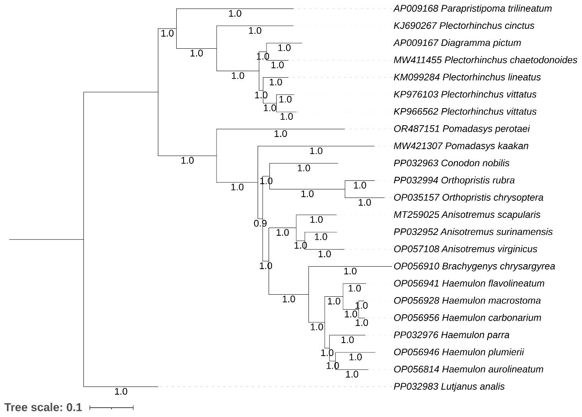

Fig. S1 Bayesian matrilineal phylogeny tree based on the concatenated sequences of 13 PCGs and two rRNAs exhibits the evolutionary pattern among haemulids species. The posterior probability values are indicated at each node.

Table S1. Details of the mitogenomes of Haemulidae species acquired from the GenBank database for phylogenetic analyses.
No. | Subfamily | Valid Species | Accession No. | References
1 | Haemulinae | Pomadasys perotaei | OR487151 | This study
2 | Haemulinae | Orthopristis ruber | PP032994 | Alvarenga et al. 2024
3 | Haemulinae | Haemulon parra | PP032976 | Alvarenga et al. 2024
4 | Haemulinae | Conodon nobilis | PP032963 | Alvarenga et al. 2024
5 | Haemulinae | Anisotremus surinamensis | PP032952 | Alvarenga et al. 2024
6 | Haemulinae | Anisotremus virginicus | OP057108 | Hoban et al. 2022
7 | Haemulinae | Haemulon macrostomum | OP056928 | Hoban et al. 2022
8 | Haemulinae | Brachygenys chrysargyreum | OP056910 | Hoban et al. 2022
9 | Haemulinae | Haemulon flavolineatum | OP056941 | Hoban et al. 2022
10 | Haemulinae | Orthopristis chrysoptera | OP035157 | Hoban et al. 2022
11 | Haemulinae | Haemulon carbonarium | OP056956 | Hoban et al. 2022
12 | Haemulinae | Haemulon plumierii | OP056946 | Hoban et al. 2022
13 | Haemulinae | Haemulon aurolineatum | OP056814 | Hoban et al. 2022
14 | Haemulinae | Anisotremus scapularis | MT259025 | Gomes-dos-Santos et al. 2020
15 | Haemulinae | Pomadasys kaakan | MW421307 | Chen et al. 2022
16 | Plectorhinchinae | Plectorhinchus chaetodonoides | MW411455 | He et al. 2022
17 | Plectorhinchinae | Plectorhinchus vittatus | KP976103 | Liang et al. 2019
18 | Plectorhinchinae | Plectorhinchus vittatus | KP966562 | Liang et al. 2019
19 | Plectorhinchinae | Plectorhinchus lineatus | KM099284 | Liang et al. 2016
20 | Plectorhinchinae | Plectorhinchus cinctus | KJ690267 | Liu et al. 2016
21 | Plectorhinchinae | Parapristipoma trilineatum | AP009168 | Yamanoue et al. 2007
22 | Plectorhinchinae | Diagramma picta | AP009167 | Yamanoue et al. 2007

References:
Alvarenga M, D’Elia AKP, et al (2024) Mitochondrial genome structure and composition in 70 fishes: a key resource for fisheries management in the South Atlantic. BMC Genomics 25: 1–13.
Hoban ML, Whitney J, et al (2022) Skimming for barcodes: rapid production of mitochondrial genome and nuclear ribosomal repeat reference markers through shallow shotgun sequencing. PeerJ 10: 13790.
Gomes-dos-Santos A, Nande M, et al (2020) Constructing the mitochondrial genome of the Peruvian grunt Anisotremus scapularis Tschudi, 1846 (Lutjaniformes: Haemulidae) using RNA-seq data. Mitochondrial DNA B Resour 5: 1921–1923.
Chen M, Yang J, et al (2022) The complete mitochondrial genome of Pomadasys kaakan (Perciformes: Haemulidae). Mitochondrial DNA B Resour 7: 573–574.
He H, Zhang G, et al (2022) The Complete Mitochondrial Genome of Plectorhinchus chaetodonoides (Perciformes: Haemulidae). Mitochondrial DNA B Resour 7: 1334–1336.
Liang R, Zhou M, et al (2019) Complete mitochondrial genomes of two oriental sweetlips, Plectorhinchus orientalis and Plectorhinchus vittatus (Perciformes: Haemulidae) with the molecular analysis on their synonym controversies. Pak J Zool 51: 871–885.
Liang R, Zhou M, et al (2016) Complete mitochondrial genome of the yellow-banded sweetlips Plectorhinchus lineatus (Perciformes: Haemulidae). Mitochondrial DNA 27: 1466–1467.
Liu L, Yang H, et al (2016) The complete mitochondrial genome of the Plectorhinchus cinctus (Teleostei, Haemulidae). Mitochondrial DNA 27: 842–843.
Yamanoue Y, Miya M, et al (2007) Phylogenetic position of tetraodontiform fishes within the higher teleosts: Bayesian inferences based on 44 whole mitochondrial genome sequences. Mol Phylogenet Evol 45: 89–101.
Table S2. Comparison of intergenic nucleotides of two Pomadasys species mitogenomes.
Genes | Pomadasys perotaei | Pomadasys kaakan
tRNA-F | 0 | 0
12S rRNA | 0 | 0
tRNA-V | 0 | 0
16S rRNA | 0 | 0
tRNA-L2 | 0 | 0
ND1 | 4 | 0
tRNA-I | 17 | 17
tRNA-Q | 8 | 8
tRNA-M | 0 | 0
ND2 | 0 | 0
tRNA-W | 1 | 1
tRNA-A | 1 | 0
tRNA-N | 36 | 34
tRNA-C | -1 | 0
tRNA-Y | 1 | 1
COI | 0 | -13
tRNA-S2 | 3 | 2
tRNA-D | 4 | 4
COII | 0 | 0
tRNA-K | 1 | 1
ATP8 | -10 | -10
ATP6 | 0 | 0
COIII | 0 | 0
tRNA-G | 0 | 0
ND3 | 0 | 0
tRNA-R | 0 | 0
ND4L | -7 | -7
ND4 | 0 | 0
tRNA-H | 0 | 0
tRNA-S1 | 4 | 4
tRNA-L1 | 0 | 0
ND5 | -4 | -4
ND6 | 0 | 0
tRNA-E | 4 | 4
Cytb | 0 | 0
tRNA-T | -1 | -1
tRNA-P | 0 | 0
CR | . | .

Table S3. Comparison of the start and stop codons of the PCGs across two Pomadasys species mitogenomes.
Genes | Pomadasys perotaei |  | Pomadasys kaakan
Genes | Start | Stop | Start | Stop
ND1 | ATG | TAA | ATG | TAA
ND2 | ATG | TA- | ATG | TA-
COI | GTG | TAA | GTG | AGG
COII | ATG | T-- | ATG | T--
ATP8 | ATG | TAA | ATG | TAA
ATP6 | ATG | TA- | ATG | TA-
COIII | ATG | TAA | ATG | TA-
ND3 | ATG | T-- | ATG | T--
ND4L | ATG | TAA | ATG | TAA
ND4 | ATG | T-- | ATG | T--
ND5 | ATG | TAG | ATG | TAA
ND6 | ATG | TAG | ATG | TAG
Cytb | ATG | T-- | ATG | T--

Table S4. Comparative pairwise Ka/Ks values of each PCG for two Pomadasys and other haemulids species.
Species | Species | ND1 | ND2 | COI | COII | atp8 | atp6 | COIII | ND3 | ND4L | ND4 | ND5 | ND6 | Cytb
P. perotaei | P. kaakan | 0.069 | 0.047 | 0.008 | 0.013 | 0.066 | 0.049 | 0.015 | 0.000 | 0.034 | 0.041 | 0.041 | 0.167 | 0.029
P. perotaei | P. cinctus | 0.060 | 0.070 | 0.018 | 0.018 | 0.082 | 0.071 | 0.030 | 0.000 | 0.047 | 0.046 | 0.047 | 0.141 | 0.025
P. perotaei | P. lineatus | 0.037 | 0.070 | 0.017 | 0.019 | 0.235 | 0.067 | 0.037 | 0.063 | 0.072 | 0.034 | 0.036 | 0.118 | 0.027
P. perotaei | P. vittatus | 0.033 | 0.072 | 0.019 | 0.024 | 0.175 | 0.063 | 0.037 | 0.000 | 0.063 | 0.038 | 0.044 | 0.156 | 0.022
P. perotaei | P. chaetodonoides | 0.034 | 0.081 | 0.016 | 0.022 | 0.204 | 0.066 | 0.037 | 0.000 | 0.053 | 0.039 | 0.040 | 0.142 | 0.027
P. perotaei | A. scapularis | 0.047 | 0.046 | 0.013 | 0.014 | 0.105 | 0.062 | 0.021 | 0.050 | 0.024 | 0.044 | 0.051 | 0.162 | 0.037
P. perotaei | H. aurolineatum | 0.035 | 0.046 | 0.009 | 0.017 | 0.123 | 0.047 | 0.012 | 0.000 | 0.034 | 0.036 | 0.037 | 0.144 | 0.029
P. perotaei | H. plumierii | 0.062 | 0.048 | 0.009 | 0.020 | 0.114 | 0.057 | 0.013 | 0.042 | 0.026 | 0.035 | 0.041 | 0.132 | 0.025
P. perotaei | H. carbonarium | 0.031 | 0.062 | 0.009 | 0.016 | 0.086 | 0.052 | 0.015 | 0.000 | 0.041 | 0.033 | 0.036 | 0.148 | 0.028
P. perotaei | O. chrysoptera | 0.041 | 0.061 | 0.009 | 0.021 | 0.084 | 0.047 | 0.027 | 0.000 | 0.041 | 0.023 | 0.034 | 0.161 | 0.026
P. perotaei | H. flavolineatum | 0.036 | 0.046 | 0.009 | 0.020 | 0.104 | 0.047 | 0.018 | 0.000 | 0.046 | 0.026 | 0.032 | 0.115 | 0.035
P. perotaei | B. chrysargyrea | 0.032 | 0.051 | 0.008 | 0.014 | 0.086 | 0.040 | 0.016 | 0.000 | 0.032 | 0.036 | 0.045 | 0.137 | 0.025
P. perotaei | H. macrostoma | 0.032 | 0.064 | 0.008 | 0.016 | 0.095 | 0.052 | 0.011 | 0.000 | 0.045 | 0.038 | 0.036 | 0.165 | 0.028
P. perotaei | A. virginicus | 0.055 | 0.050 | 0.009 | 0.011 | 0.084 | 0.045 | 0.010 | 0.052 | 0.022 | 0.031 | 0.038 | 0.142 | 0.031
P. perotaei | A. surinamensis | 0.048 | 0.049 | 0.009 | 0.015 | 0.072 | 0.049 | 0.016 | 0.047 | 0.025 | 0.029 | 0.037 | 0.118 | 0.040
P. perotaei | C. nobilis | 0.034 | 0.069 | 0.010 | 0.014 | 0.065 | 0.046 | 0.018 | 0.041 | 0.031 | 0.030 | 0.050 | 0.134 | 0.036
P. perotaei | H. parra | 0.046 | 0.052 | 0.008 | 0.015 | 0.088 | 0.046 | 0.014 | 0.000 | 0.034 | 0.037 | 0.048 | 0.128 | 0.034
P. perotaei | O. rubra | 0.046 | 0.055 | 0.009 | 0.022 | 0.068 | 0.046 | 0.029 | 0.068 | 0.033 | 0.030 | 0.039 | 0.184 | 0.030
P. perotaei | D. pictum | 0.037 | 0.068 | 0.018 | 0.022 | 0.146 | 0.069 | 0.037 | 0.000 | 0.074 | 0.034 | 0.037 | 0.117 | 0.025
P. perotaei | P. trilineatum | 0.035 | 0.059 | 0.012 | 0.016 | 0.145 | 0.049 | 0.019 | 0.000 | 0.048 | 0.030 | 0.037 | 0.211 | 0.025
Average |  | 0.043 | 0.058 | 0.011 | 0.018 | 0.110 | 0.054 | 0.022 | 0.019 | 0.041 | 0.035 | 0.040 | 0.143 | 0.029
Standard Deviation |  | 0.011 | 0.011 | 0.004 | 0.004 | 0.047 | 0.009 | 0.010 | 0.026 | 0.015 | 0.006 | 0.005 | 0.024 | 0.005

Table S5. The abundance of amino acids and RSCU value of the complete PCGs of two Pomadasys species.
Pomadasys perotaei
Codon | Count | RSCU | Codon | Count | RSCU | Codon | Count | RSCU | Codon | Count | RSCU
UUU(F) | 81 | 0.87 | UCU(S) | 132 | 1.22 | UAU(Y) | 63 | 0.94 | UGU(C) | 46 | 0.81
UUC(F) | 106 | 1.13 | UCC(S) | 176 | 1.63 | UAC(Y) | 71 | 1.06 | UGC(C) | 67 | 1.19
UUA(L) | 118 | 1.01 | UCA(S) | 125 | 1.16 | UAA(*) | 146 | 1.56 | UGA(W) | 68 | 1.13
UUG(L) | 112 | 0.96 | UCG(S) | 65 | 0.6 | UAG(*) | 94 | 1.01 | UGG(W) | 52 | 0.87
CUU(L) | 131 | 1.12 | CCU(P) | 182 | 1.14 | CAU(H) | 113 | 1.01 | CGU(R) | 48 | 1.02
CUC(L) | 125 | 1.07 | CCC(P) | 226 | 1.42 | CAC(H) | 111 | 0.99 | CGC(R) | 53 | 1.13
CUA(L) | 120 | 1.03 | CCA(P) | 149 | 0.93 | CAA(Q) | 146 | 1.19 | CGA(R) | 39 | 0.83
CUG(L) | 93 | 0.8 | CCG(P) | 81 | 0.51 | CAG(Q) | 99 | 0.81 | CGG(R) | 48 | 1.02
AUU(I) | 73 | 1.11 | ACU(T) | 94 | 0.89 | AAU(N) | 85 | 0.91 | AGU(S) | 53 | 0.49
AUC(I) | 59 | 0.89 | ACC(T) | 140 | 1.32 | AAC(N) | 101 | 1.09 | AGC(S) | 96 | 0.89
AUA(M) | 63 | 0.96 | ACA(T) | 130 | 1.23 | AAA(K) | 125 | 1.14 | AGA(*) | 70 | 0.75
AUG(M) | 68 | 1.04 | ACG(T) | 60 | 0.57 | AAG(K) | 95 | 0.86 | AGG(*) | 64 | 0.68
GUU(V) | 35 | 0.97 | GCU(A) | 81 | 1.09 | GAU(D) | 59 | 1.05 | GGU(G) | 38 | 0.81
GUC(V) | 38 | 1.06 | GCC(A) | 118 | 1.59 | GAC(D) | 53 | 0.95 | GGC(G) | 62 | 1.33
GUA(V) | 36 | 1 | GCA(A) | 72 | 0.97 | GAA(E) | 71 | 1.05 | GGA(G) | 37 | 0.79
GUG(V) | 35 | 0.97 | GCG(A) | 26 | 0.35 | GAG(E) | 64 | 0.95 | GGG(G) | 50 | 1.07
Pomadasys kaakan
UUU(F) | 70 | 0.8 | UCU(S) | 136 | 1.22 | UAU(Y) | 64 | 0.78 | UGU(C) | 48 | 0.89
UUC(F) | 104 | 1.2 | UCC(S) | 160 | 1.43 | UAC(Y) | 100 | 1.22 | UGC(C) | 60 | 1.11
UUA(L) | 129 | 1.1 | UCA(S) | 141 | 1.26 | UAA(*) | 139 | 1.5 | UGA(W) | 64 | 1.05
UUG(L) | 90 | 0.76 | UCG(S) | 77 | 0.69 | UAG(*) | 104 | 1.12 | UGG(W) | 58 | 0.95
CUU(L) | 142 | 1.21 | CCU(P) | 193 | 1.21 | CAU(H) | 107 | 0.99 | CGU(R) | 44 | 0.89
CUC(L) | 133 | 1.13 | CCC(P) | 230 | 1.44 | CAC(H) | 109 | 1.01 | CGC(R) | 62 | 1.25
CUA(L) | 137 | 1.16 | CCA(P) | 143 | 0.9 | CAA(Q) | 148 | 1.18 | CGA(R) | 41 | 0.83
CUG(L) | 75 | 0.64 | CCG(P) | 72 | 0.45 | CAG(Q) | 102 | 0.82 | CGG(R) | 51 | 1.03
AUU(I) | 62 | 0.95 | ACU(T) | 104 | 0.92 | AAU(N) | 92 | 0.95 | AGU(S) | 67 | 0.6
AUC(I) | 68 | 1.05 | ACC(T) | 153 | 1.36 | AAC(N) | 101 | 1.05 | AGC(S) | 88 | 0.79
AUA(M) | 81 | 1.18 | ACA(T) | 129 | 1.15 | AAA(K) | 128 | 1.11 | AGA(*) | 66 | 0.71
AUG(M) | 56 | 0.82 | ACG(T) | 64 | 0.57 | AAG(K) | 102 | 0.89 | AGG(*) | 61 | 0.66
GUU(V) | 38 | 1.06 | GCU(A) | 61 | 0.89 | GAU(D) | 48 | 0.91 | GGU(G) | 28 | 0.71
GUC(V) | 34 | 0.95 | GCC(A) | 120 | 1.75 | GAC(D) | 57 | 1.09 | GGC(G) | 52 | 1.32
GUA(V) | 39 | 1.09 | GCA(A) | 71 | 1.04 | GAA(E) | 79 | 1.09 | GGA(G) | 32 | 0.82
GUG(V) | 32 | 0.9 | GCG(A) | 22 | 0.32 | GAG(E) | 66 | 0.91 | GGG(G) | 45 | 1.15

Table S6. Detailed comparison of anticodons found in the transfer RNA genes within the two Pomadasys mitogenomes.
Genes | Pomadasys perotaei | Pomadasys kaakan
tRNA-Phe (F) | GAA | GAA
tRNA-Val (V) | TAC | TAC
tRNA-Leu (L2) | TAA | TAA
tRNA-Ile (I) | GAT | GAT
tRNA-Gln (Q) | TTG | TTG
tRNA-Met (M) | CAT | CAT
tRNA-Trp (W) | TCA | TCA
tRNA-Ala (A) | TGC | TGC
tRNA-Asn (N) | GTT | GTT
tRNA-Cys (C) | GCA | GCA
tRNA-Tyr (Y) | GTA | GTA
tRNA-Ser (S2) | TGA | TGA
tRNA-Asp (D) | GTC | GTC
tRNA-Lys (K) | TTT | TTT
tRNA-Gly (G) | TCC | TCC
tRNA-Arg (R) | TCG | TCG
tRNA-His (H) | GTG | GTG
tRNA-Ser (S1) | GCT | GCT
tRNA-Leu (L1) | TAG | TAG
tRNA-Glu (E) | TTC | TTC
tRNA-Thr (T) | TGT | TGT
tRNA-Pro (P) | TGG | TGG

