Supporting Information for

Heterometallic Ru-Ir hydride carbonyl clusters
Francesca Forti,ª Cristiana Cesari,ª* Marco Bortoluzzi,^{b} Cristina Femoni,ª Tiziana Funaioli,^{c} Maria Carmela Iapalucci,ª and Stefano Zacchiniª
ª Dipartimento di Chimica Industriale "Toso Montanari", Università di Bologna, Via Piero Gobetti 85, 40129 Bologna, Italy. E-mail: cristiana.cesari2@unibo.it
^{b} Dipartimento di Scienze Molecolari e Nanosistemi, Ca’ Foscari University of Venice, Via Torino 155 – 30175 Mestre (Ve), Italy.
^{c} Dipartimento di Chimica e Chimica Industriale, Università di Pisa, Via G. Moruzzi 13 - 56124, Pisa, Italy.

Page/s
IR spectra S2-S5
NMR spectra S6-S7
ESI-MS spectra S8-S11
UV-VIS spectra S12-S13
Cyclic voltammetry S14-S15
X-Ray crystallographic study S16-S24
Computational studies S25-S33
References S34-S34

Figure S1. IR spectrum in the ν_{CO} region of [NEt₄][H₂Ru₃Ir(CO)₁₂] (2) in CH₂Cl₂.

Figure S2. IR spectrum in the ν_{CO} region of [NEt₄][H_{1–x}Ru_{3–x}Ir_{2+x}(CO)₁₂(COD)] (x = 0.11) (3) in CH₃CN.

Figure S3. IR spectrum in the ν_{CO} region of H_{2-x}Ru_{3-x}Ir_{2+x}(CO)₁₀(COD)₂ (4) (x = 0.5) in toluene.

Figure S4. IR spectrum in the ν_{CO} region of [NEt₄]₂[Ru₄Ir₂(CO)₁₇] (5) in nujol mull.

Figure S5. IR spectrum in the ν_{CO} region [NEt₄]₂[Ru₄(O)Cl₄(CO)₁₀] (9) in CH₂Cl₂.

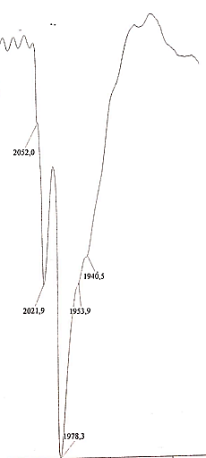

Figure S6. IR spectrum in the ν_{CO} region [NEt₄]₃[HRu₂Ir₂(CO)₁₂]Cl₂ (8) in CH₂Cl₂.

Figure S7. IR spectrum in the ν_{CO} region [NEt₄][H₂Ru₃Ir(CO)₁₀(COD)] (6) in CH₂Cl₂.

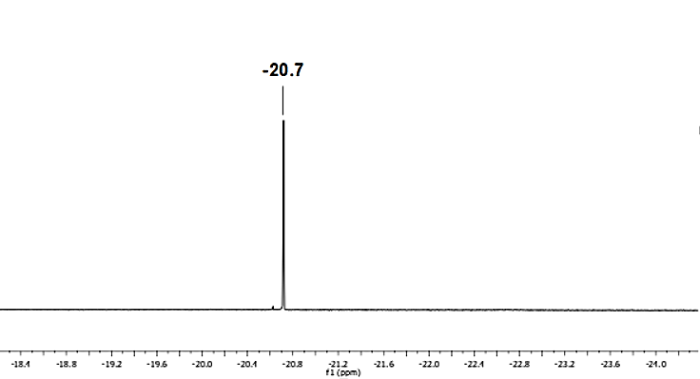
Figure S8. Hydride region of the ¹H NMR spectrum of [NEt₄][H₂Ru₃Ir(CO)₁₂] (2) in CD₂Cl₂.

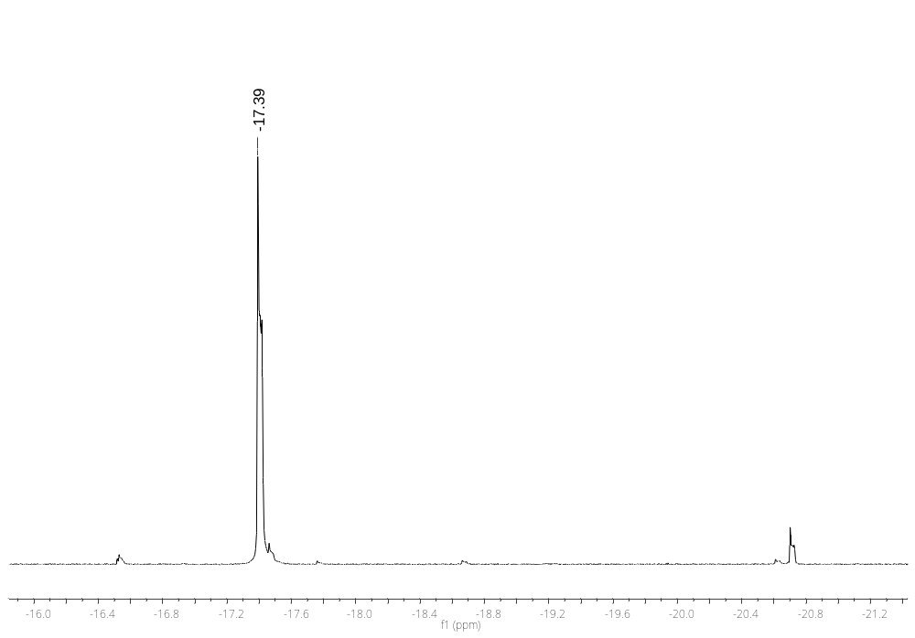
Figure S9. Hydride region of the ¹H NMR spectrum of [NEt₄][H_{1–x}Ru_{3–x}Ir_{2+x}(CO)₁₂(COD)] (x = 0.11) (3) in CD₂Cl₂.
b)
Figure S10. Hydride region of the ¹H NMR spectrum of H_{2-x}Ru_{3-x}Ir_{2+x}(CO)₁₀(COD)₂ (4) (x = 0.5) in CD₂Cl₂.

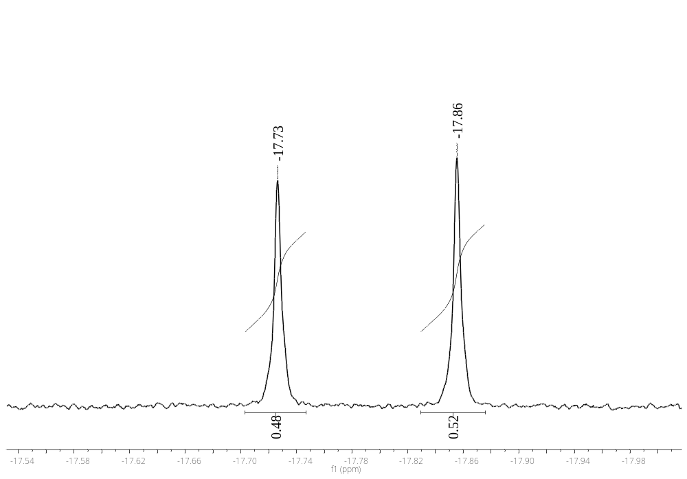a)
Figure S11. Hydride region of the ¹H NMR spectrum of H_{2-x}Ru_{3-x}Ir_{2+x}(CO)₁₀(COD)₂ (4) (x = 0.77) in CD₂Cl₂.

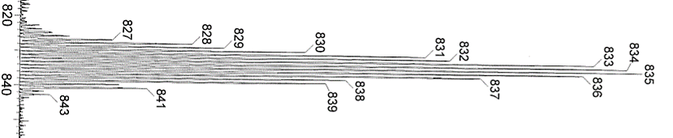
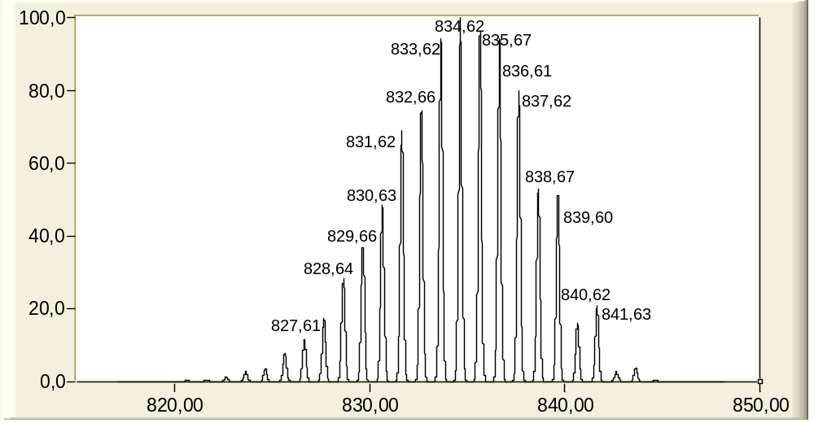(b)

(a)
Figure S12. a) ESI-MS spectrum in CH₃CN (ES–) of [NEt₄][H₂Ru₃Ir(CO)₁₂] (2) and (b) simulated isotope pattern.

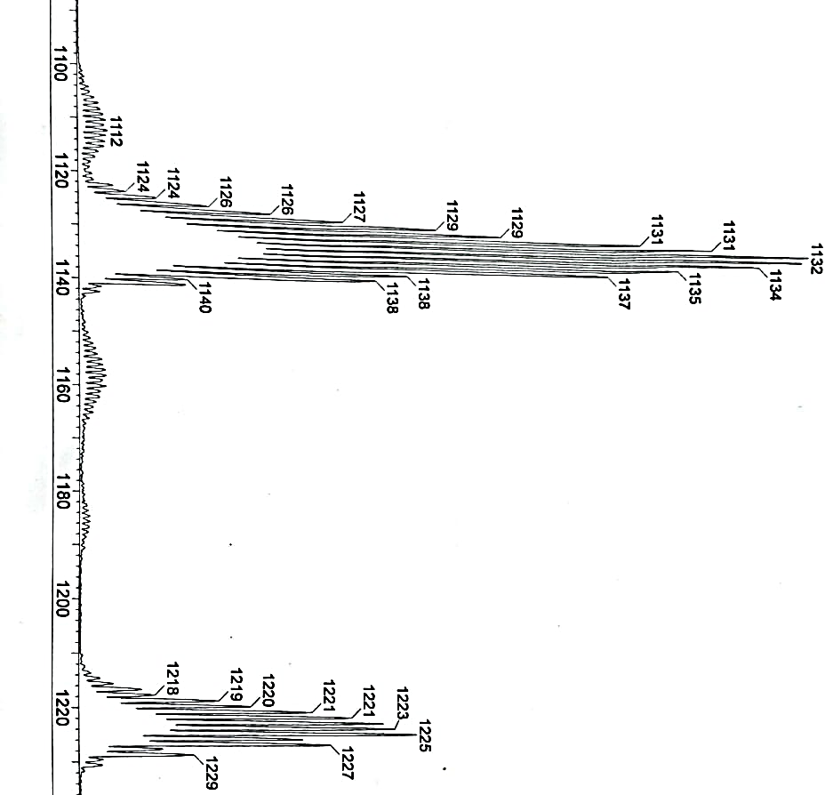
[Ru₂Ir₃(COD)(CO)₁₂]⁻
[HRu₃Ir₂(COD)(CO)₁₂]⁻
a)
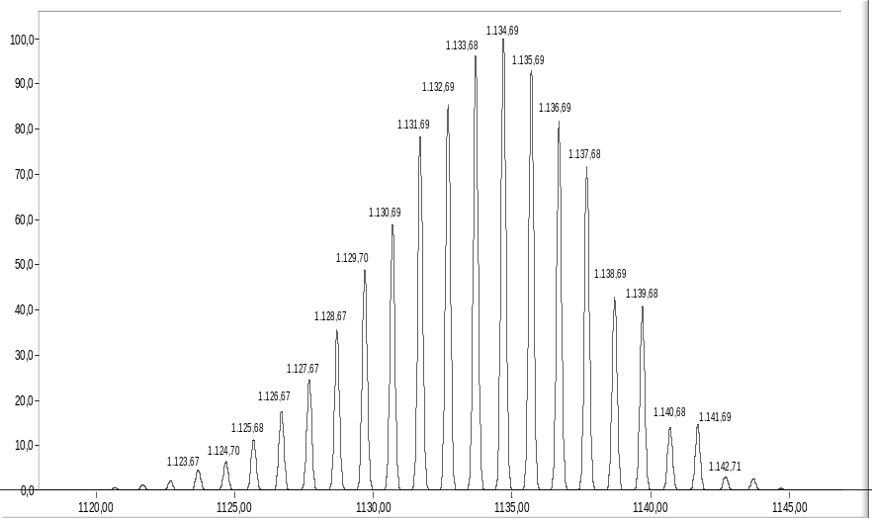
b)
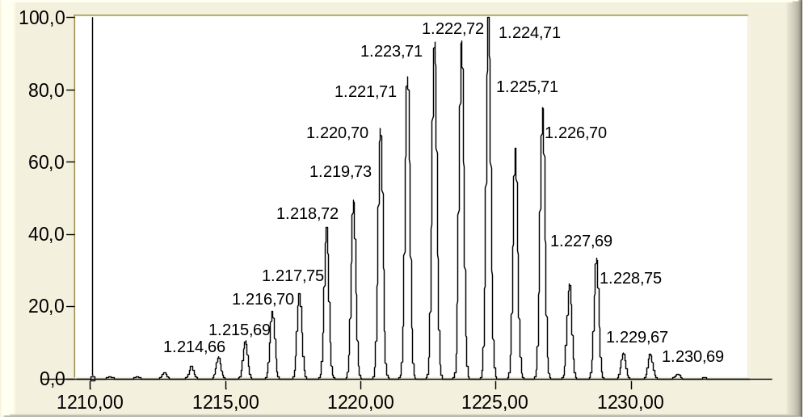
c)

Figure S13. a) ESI-MS spectrum in CH₃CN (ES–) of [NEt₄][H_{1–x}Ru_{3–x}Ir_{2+x}(CO)₁₂(COD)] (x = 0.11) (3), (b) and (c) simulated isotope pattern.

[Ru₄Ir₂(CO)₁₃]²⁻
[Ru₄Ir₂(CO)₁₂]²⁻
[Ru₄Ir₂(CO)₁₆]²⁻
[Ru₄Ir₂(CO)₁₄]²⁻
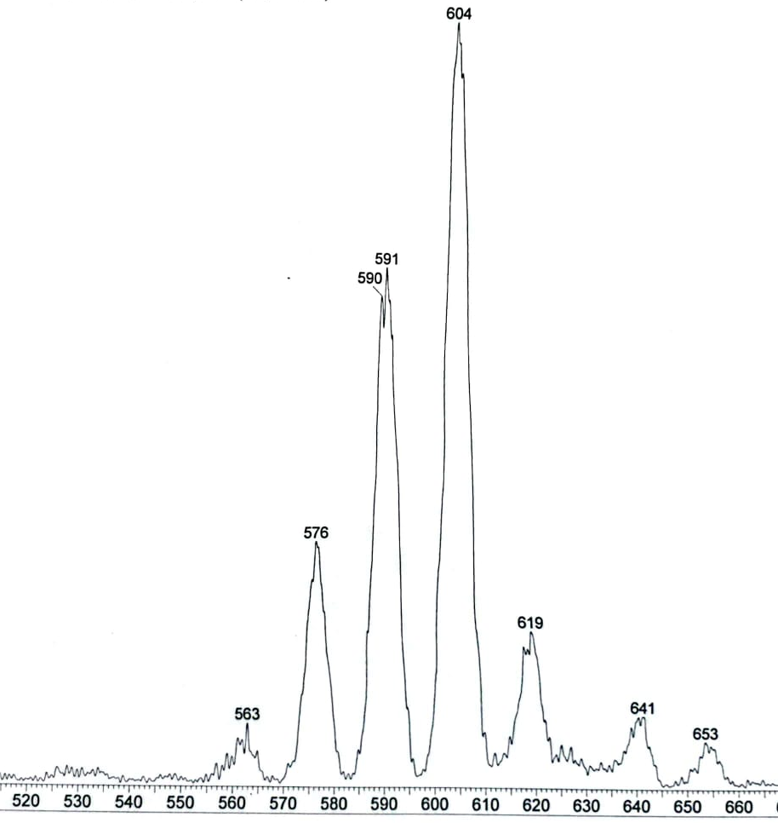
a)
[Ru₄Ir₂(CO)₁₅]²⁻

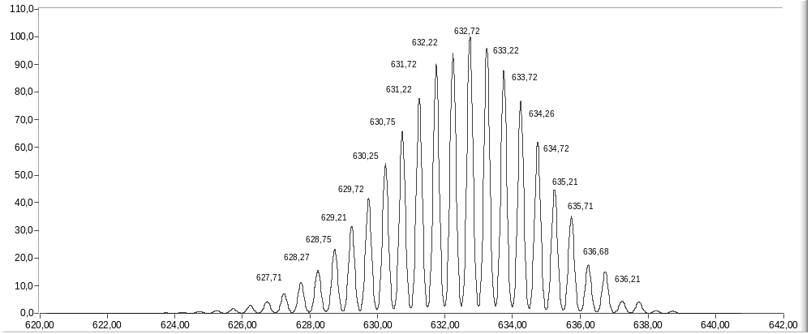
b)
Figure S14. a) ESI-MS spectrum in CH₃CN (ES–) of [NEt₄]₂[Ru₄Ir₂(CO)₁₇] (5) displaying various fragmentation with CO loss and (b) simulated isotope pattern of the molecular ion [Ru₄Ir₂(CO)₁₇]²⁻.

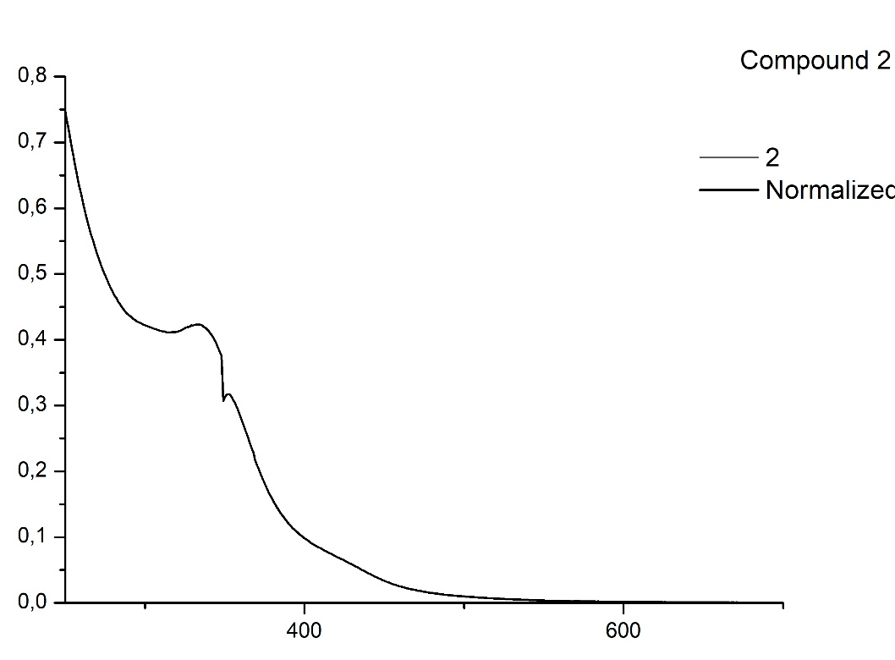
Abs (A.U.)
λ (nm)
Figure S15. Normalized UV-VIS spectrum in CH₃CN of [NEt₄][H₂Ru₃Ir(CO)₁₂] (2).
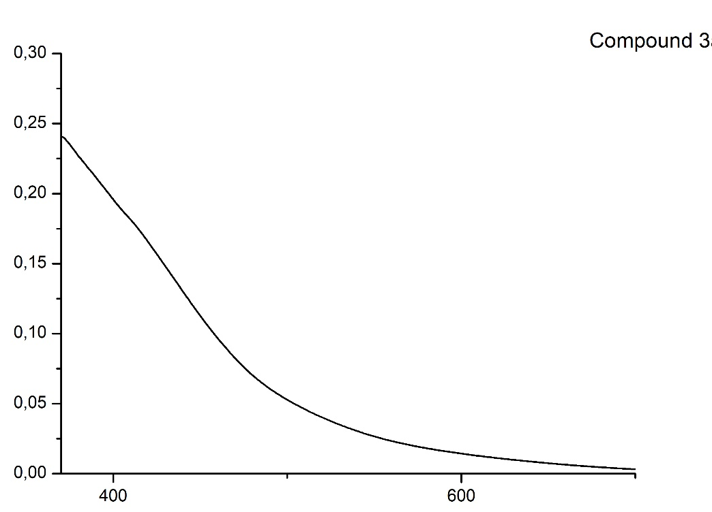
Abs (A.U.)
λ (nm)
Figure S16. Normalized UV-VIS spectrum in CH₃CN of [NEt₄][H_{1–x}Ru_{3–x}Ir_{2+x}(CO)₁₂(COD)] (x = 0.11) (3).

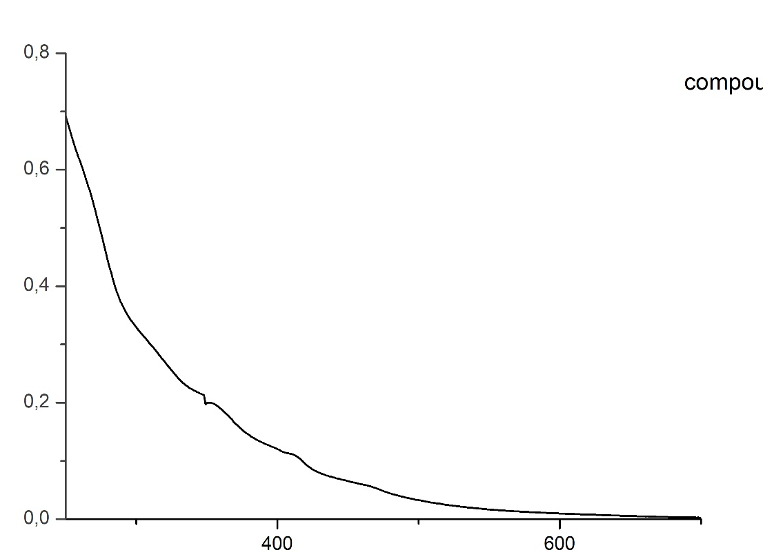
Abs (A.U.)
λ (nm)
Figure S17. Normalized UV-VIS spectrum in CH₃CN of H_{2-x}Ru_{3-x}Ir_{2+x}(CO)₁₀(COD)₂ (4).
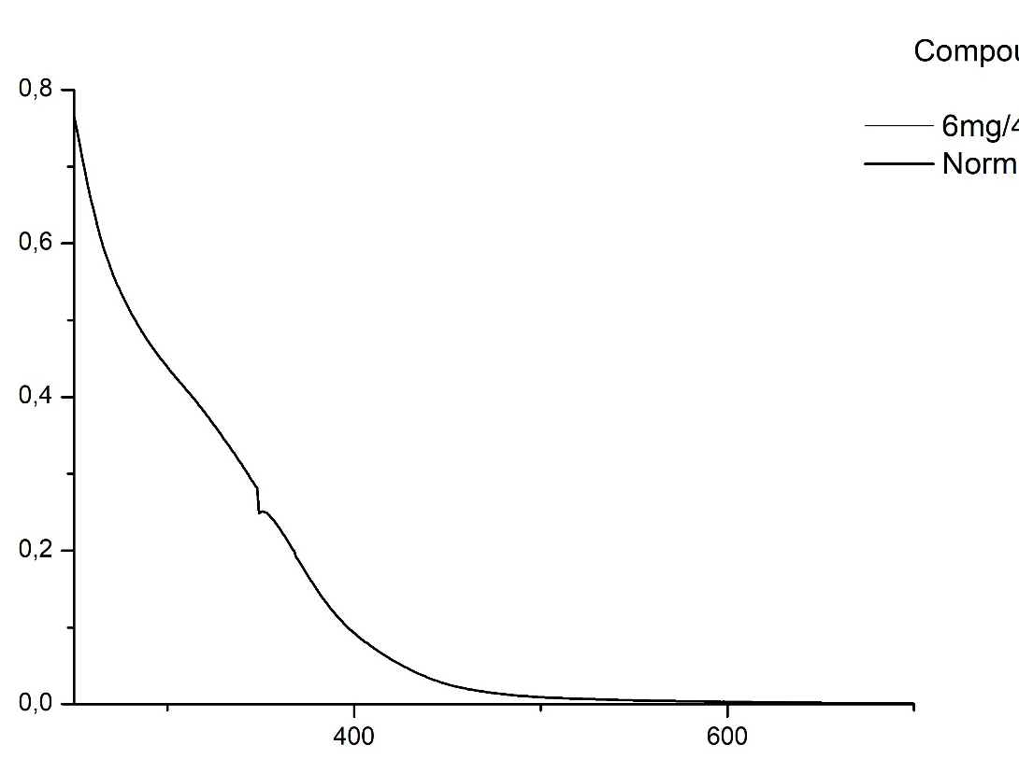
λ (nm)
Abs (A.U.)
Figure S18. Normalized UV-VIS spectrum in CH₃CN of [NEt₄]₂[Ru₄Ir₂(CO)₁₇] (5).

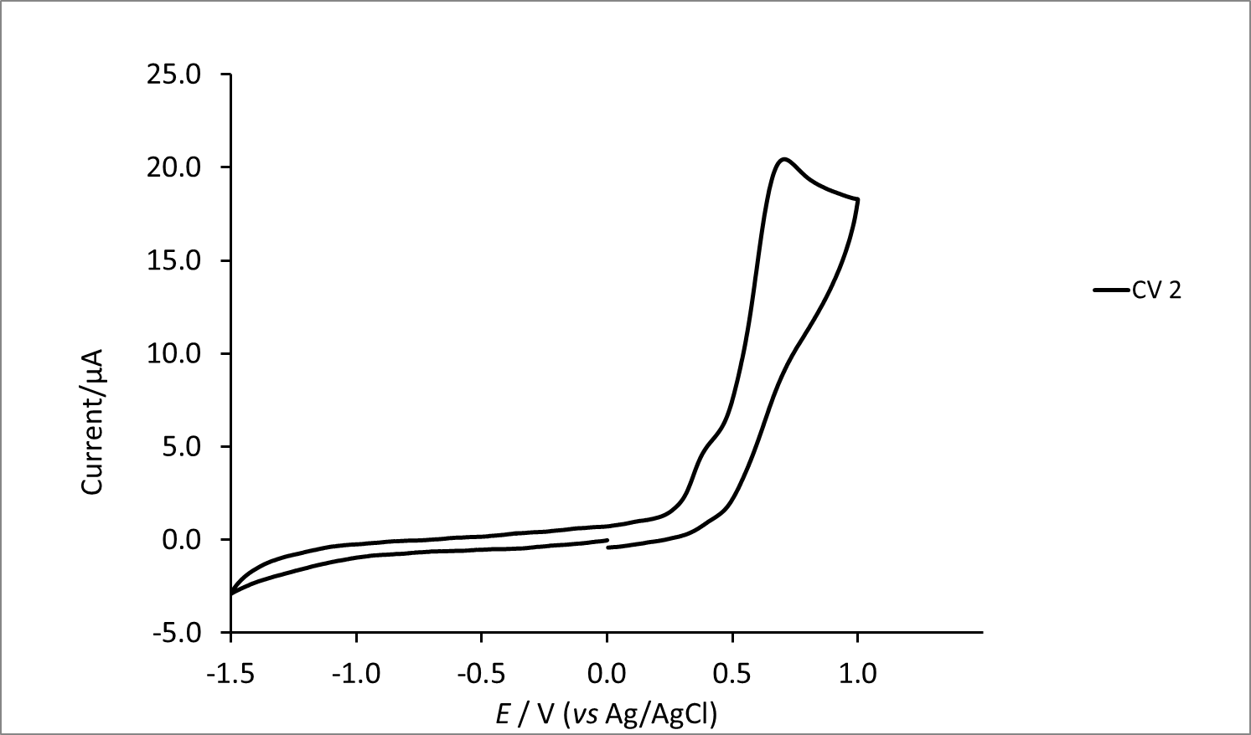
Figure S19. CV response of 2 at a Pt electrode in CH₃CN solution between –1.50 and +1.0V; scan rate: 0.1 V s⁻¹. [N^{n}Bu₄][PF₆] (0.1 mol dm⁻³) supporting electrolyte.

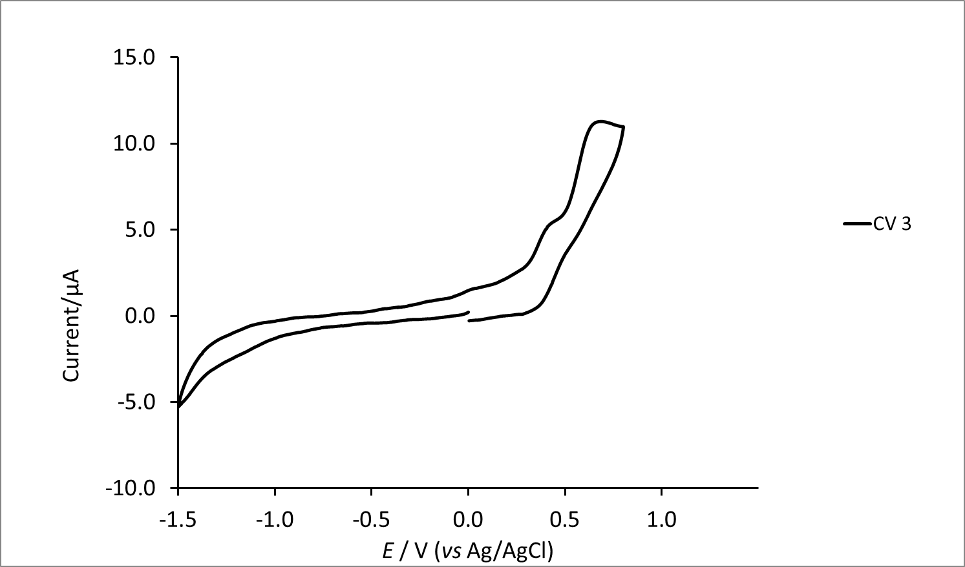
Figure S20. CV response of 3a/3b at a Pt electrode in CH₃CN solution between –1.50 and +0.8V; scan rate: 0.1 V s⁻¹. [N^{n}Bu₄][PF₆] (0.1 mol dm⁻³) supporting electrolyte.

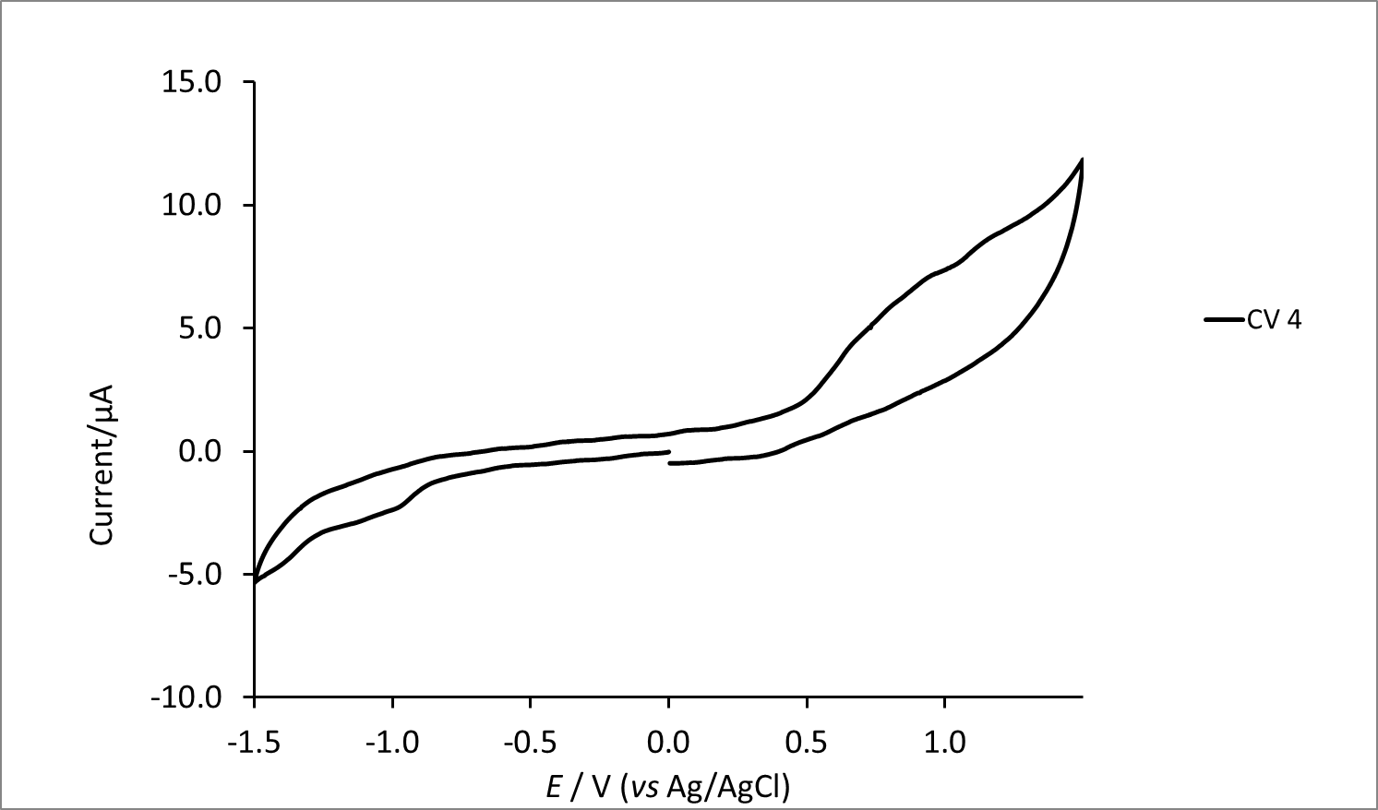
Figure S21. CV response of 4a/4b at a Pt electrode in CH₃CN solution between –1.50 and +1.5V; scan rate: 0.1 V s⁻¹. [N^{n}Bu₄][PF₆] (0.1 mol dm⁻³) supporting electrolyte.

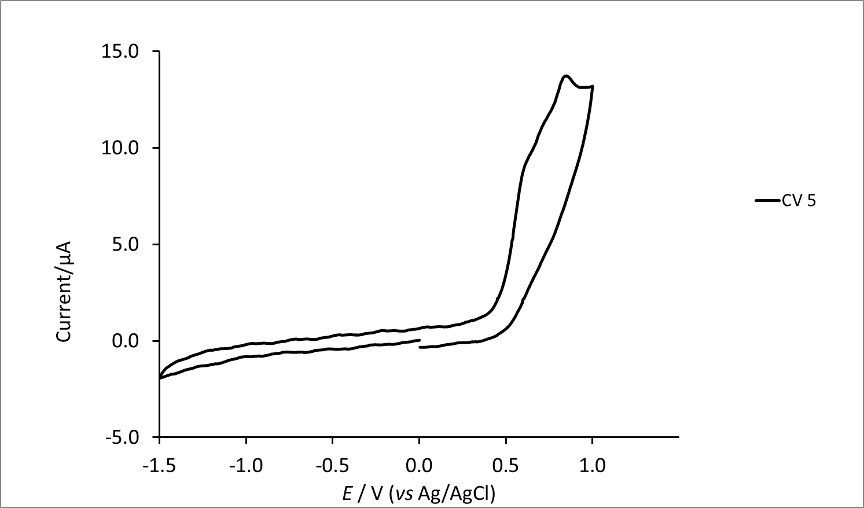
Figure S22. CV response of 5 at a Pt electrode in CH₃CN solution between –1.50 and +1.0V; scan rate: 0.1 V s⁻¹. [N^{n}Bu₄][PF₆] (0.1 mol dm⁻³) supporting electrolyte.

Table S1. Main bond lengths (Å) of H₂Ru₃Ir₂(CO)₁₀(COD)₂ (4a) and HRu₂Ir₃(CO)₁₀(COD)₂ (4b) from H_{2-x}Ru_{3-x}Ir_{2+x}(CO)₁₀(COD)₂ (4) (x = 0.77) (see Scheme S1 for labelling).
 | H₂Ru₃Ir₂(CO)₁₀(COD)₂ | HRu₂Ir₃(CO)₁₀(COD)₂
Ir(1)-M(2) | 2.7988(11) | 2.7988(11)
Ir(1)-Ru(3) | 2.7956(18) | 2.7956(18)
Ir(1)-Ru(4) | 2.7825(15) | 2.7825(15)
M(2)-Ir(5) | 2.7720(11) | 2.7720(11)
Ru(3)-Ir(5) | 2.8187(17) | 2.8187(17)
Ru(4)-Ir(5) | 2.8062(17) | 2.8062(17)
M(2)-Ru(3) | 2.7726(18) | 2.7726(18)
M(2)-Ru(4) | 2.7255(17) | 2.7255(17)
Ru(3)-Ru(4) | 2.914(2) | 2.914(2)
Ir(1)-COD | 2.14(2)-2.17(2) | 2.14(2)-2.17(2)
Ir(1)-CO_{b} | 2.06(2)-2.51(3) | 2.06(2)-2.51(3)
M(2)-CO_{t} | 1.91(3) | 1.91(3)
M(2)-CO_{b} | 2.02(2) | 2.02(2)
Ru(3)-CO_{t} | 1.88(2)-1.90(2) | 1.88(2)-1.90(2)
Ru(3)-CO_{b} | 2.04(2)-2.151(18) | 2.04(2)-2.151(18)
Ru(4)-CO_{t} | 1.88(3)-1.89(2) | 1.88(3)-1.89(2)
Ru(4)-CO_{b} | 1.96(3) | 1.96(3)
Ir(5)-CO_{b} | 2.03(2)-2.24(2) | 2.03(2)-2.24(2)
Ir(5)-COD | 2.13(2)-2.187(19) | 2.13(2)-2.187(19)
Ru(3)-H(1) | 1.69(11) | 1.69(11)
Ru(4)-H(1) | 1.70(11) | 1.70(11)
Ru(3)-H(2) | - | 1.69(12)
M(2)-H(2) | - | 1.69(12)

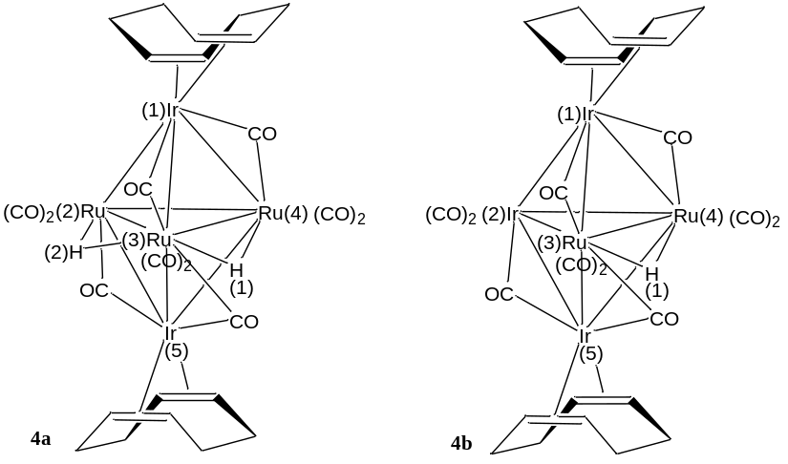
Scheme S1. Labelling of H₂Ru₃Ir₂(CO)₁₀(COD)₂ (4a) and HRu₂Ir₃(CO)₁₀(COD)₂ (4b)

X-ray Crystallographic Study.
Crystal data and collection details for 3, 4 (two crystal structures have been determined on crystals originated form independent syntheses, resulting in x = 0.5 and 0.77), 5, 6, 7, and 8 are reported in Table S2. The diffraction experiments were carried out on a Bruker APEX II diffractometer equipped with a PHOTON2 detector using Mo–Kα radiation. Data were corrected for Lorentz polarization and absorption effects (empirical absorption correction SADABS).¹ Structures were solved by direct methods and refined by full-matrix least-squares based on all data using F².² Hydrogen atoms were fixed at calculated positions and refined by a riding model. The presence of hydrides in 3, 4, 6, 7, and 8 has been determined by ¹H NMR spectroscopy. Hydride ligands have been preliminarily located in the Fourier difference map and, then, their positions further corroborated based on geometrical considerations, that is, elongation of M-M bonds, stereochemistry of the CO ligands, steric requirements. Their positions have been included in the structural model, and refined isotropically using a riding model. Some restraints have been used for hydrides, as listed below. All non-hydrogen atoms were refined with anisotropic displacement parameters, unless otherwise stated.
3: The asymmetric unit of the unit cell contains one cluster anion and one [NEt₄]⁺ cation, all located on general positions. The crystals appear to be racemically twinned with refined batch factor 0.032(5). Two metal positions, Ru(1)/Ir(11) and Ru(2)/Ir(21) display some minor disorder. Indeed, after refinement the occupancy factors of Ru(1) and Ru(2) were 0.931(3) and 0.964(3), respectively. Thus, the occupancy factors of Ir(11) and Ir(21) were 0.069(3) and 0.036(3), respectively. This disorder may be explained that the crystal contains 89% of [HRu₃Ir₂(CO)₁₂(COD)]– and 11% of [Ru₂Ir₃(CO)₁₂(COD)]–. The hydride ligand has been included in the former cluster but not in the latter for electron counting reasons. The Ru(1)/Ir(11) and Ru(2)/Ir(21) atoms have been constrained to have the same x, y, z coordinates, and the same anisotropic displacement parameters (EXYZ and EADP lines in SHELXL).
4 (x = 0.5): The asymmetric unit of the unit cell contains one cluster molecule located on a general position. The crystals appear to be racemically twinned with refined batch factor 0.299(10). The position occupied by M(3) is disordered Ru/Ir, both with occupancy factor 0.5. Thus, the crystal contains a 1:1 mixture of H₂Ru₃Ir₂(CO)₁₀(COD)₂ and HRu₂Ir₃(CO)₁₀(COD)₂. The number of H-ligands has been determined based on electron counting considerations and supported by ¹H NMR spectroscopy. The Ru(3)/Ir(3) atoms have been constrained to have the same x, y, z coordinates, and the same anisotropic displacement parameters (EXYZ and EADP lines in SHELXL). Restraints to bond distances were applied as follow (s.u. 0.02): 1.8 for Ru–H.
4 (x = 0.77): The asymmetric unit of the unit cell contains one cluster molecule located on a general position. The crystals appear to be racemically twinned with refined batch factor 0.146(13). The position occupied by M(3) is disordered Ru/Ir, with refined occupancy factors 0.766(10) for Ru(3) and 0.234(10) for Ir(3). Thus, the crystal contains a mixture of 23% H₂Ru₃Ir₂(CO)₁₀(COD)₂ and 77% of HRu₂Ir₃(CO)₁₀(COD)₂. The number of H-ligands has been determined based on electron counting considerations and supported by ¹H NMR spectroscopy. The Ru(3)/Ir(3) atoms have been constrained to have the same x, y, z coordinates, and the same anisotropic displacement parameters (EXYZ and EADP lines in SHELXL). All Ru-H distances have been restrained to be the same (SADI line in SHELXL, s.u. 0.02).
5: The asymmetric unit of the unit cell contains one cluster anion and two [NEt₄]⁺ cations, all located on mirror planes. The M(1), M(2), M(3), M(4), M(5) and M(6) positions are disordered Ru/Ir with refined occupancy factors 0.255(6) for Ir(1), 0.159(6) for Ir(2), 0.728(8) for Ir(3), 0.040(9) for Ir(4), 0.151(9) for Ir(5), and 0.666(8) for Ir(6). The occupancy factors for Ru(1), Ru(2), Ru(3), Ru(4), Ru(5) and Ru(6) are the compliment to one, that is, 0.745(6), 0.841(6), 0.272(8), 0.960(9), 0.849(9), and 0.334(8), respectively. Overall, the crystal contains two Ir and four Ru atoms, corresponding to one [Ru₄Ir₂(CO)₁₇]^{2–} anion. Thus, it displays positional but not compositional disorder. The Ru(1)/Ir(2), Ru(2)/Ir(2), Ru(3)/Ir(3), Ru(4)/Ir(4), Ru(5)/Ir(5) and Ru(6)/Ir(6) atoms have been constrained to have the same x, y, z coordinates, and the same anisotropic displacement parameters (EXYZ and EADP lines in SHELXL). The C and O atoms of the CO ligands have been restrained to isotropic-like behaviour (ISOR line in SHELXL, s.u. 0.01). Restraints to bond distances were applied as follow (s.u. 0.02): 1.47 Å for C–N and 1.53 Å for C–C in disordered [NEt₄]⁺.
6: The asymmetric unit of the unit cell contains one cluster anion and one [NEt₄]⁺ cation, all located on general positions. All Ru-H distances have been restrained to be the same (SADI line in SHELXL, s.u. 0.02). The [NEt₄]⁺ cation is disordered and, thus, it has been split into two positions and refined anisotropically using one occupancy factor per disordered group. Similar U restraints have been applied to the C and N atoms of the disordered [NEt₄]⁺ cation (SIMU line in SHELXL, s.u. 0.01). Restraints to bond distances were applied as follow (s.u. 0.02): 1.47 Å for C–N and 1.53 Å for C–C in disordered [NEt₄]⁺.
7: The asymmetric unit of the unit cell contains one cluster anion and one [NEt₄]⁺ cation, all located on general positions. All Ru-H distances have been restrained to be the same (SADI line in SHELXL, s.u. 0.02).
8: The asymmetric unit of the unit cell contains one cluster anion, two Cl– anions and three [NEt₄]⁺ cations, all located on general positions. The crystals are pseudo-merohedrally twinned, with twin matrix -1 0 0 0 -1 0 0 0 1, and refined batch factor 0.2604(11). The M(2), M(3) and M(4) positions are disordered Ru/Ir with refined occupancy factors 0.657(5) for Ir(2), 0.217(5) for Ir(3), and 0.135(5) for Ir(4). The occupancy factors for Ru(2), Ru(3) and Ru(4) are the compliment to one, that is, 0.343(5), 0.783(5) and 0.865(5), respectively. Overall, the crystal contains two Ir and two Ru atoms, corresponding to one [HRu₂Ir₂(CO)₁₂]– anion. Thus, it displays positional but not compositional disorder. The Ru(2)/Ir(2), Ru(3)/Ir(3) and Ru(4)/Ir(4) atoms have been constrained to have the same x, y, z coordinates, and the same anisotropic displacement parameters (EXYZ and EADP lines in SHELXL). Restraints to bond distances were applied as follow (s.u. 0.02): 1.80 Å for Ru–H in the cluster anion; 1.47 Å for C–N and 1.53 Å for C–C in disordered [NEt₄]⁺.

Table S2 Crystal data and experimental details for 3, 4 (two crystal structures have been determined on crystals originated form independent syntheses, resulting in x = 0.5 and 0.77), 5, 6, 7, and 8.
 | 3 | 4 (x = 0.5) | 4 (x = 0.77)
Formula | C₂₈H_{32.89}Ir_{2.11}NO₁₂Ru_{2.89} | C₂₆H_{25.5}Ir_{2.5}O₁₀Ru_{2.5} | C₂₆H_{25.23}Ir_{2.77}O₁₀Ru_{2.23}
Fw | 1272.62 | 1231.14 | 1255.47
T, K | 100(2) | 100(2) | 100(2)
λ, Å | 0.71073 | 0.71073 | 0.71073
Crystal system | Orthorhombic | Monoclinic | Monoclinic
Space Group | Pna2₁ | Pn | Pn
a, Å | 17.7814(7) | 8.7873(7) | 8.7967(11)
b, Å | 16.1609(6) | 10.8357(8) | 10.8028(13)
c, Å | 11.4668(4) | 15.2032(12) | 15.2607(19)
α, ° | 90 | 90 | 90
β, ° | 90 | 104.901(2) | 105.796(4)
γ, ° | 90 | 90 | 90
Cell Volume, Å³ | 3295.1(2) | 1398.92(19) | 1395.4(3)
Z | 4 | 2 | 2
D_{c}, g cm⁻³ | 2.565 | 2.923 | 2.988
μ, mm⁻¹ | 9.828 | 13.223 | 14.396
F(000) | 2373 | 1128 | 1145
Crystal size, mm | 0.18×0.16×0.12 | 0.16×0.14×0.11 | 0.19×0.16×0.13
θ limits, ° | 1.703–25.998 | 1.879–25.049 | 2.341–25.090
Index ranges | -21 ≤ h ≤ 21  -19 ≤ k ≤ 19  -14 ≤ l ≤ 14 | -10 ≤ h ≤ 10  -12 ≤ k ≤ 12  -18 ≤ l ≤ 18 | -10 ≤ h ≤ 10  -12 ≤ k ≤ 12  -18 ≤ l ≤ 18
Reflections collected | 61110 | 13553 | 14416
Independent reflections | 6467 [R_{int} = 0.0812] | 4929 [R_{int} = 0.0357] | 4817 [R_{int} = 0.0531]
Completeness to θ max | 100.0% | 99.9% | 99.3%
Data / restraints / parameters | 6467 / 8 / 425 | 4929 / 103 / 378 | 4817 / 27 / 378
Goodness on fit on F² | 1.018 | 1.252 | 1.090
R₁ (I > 2σ(I)) | 0.0208 | 0.0281 | 0.0393
wR₂ (all data) | 0.0391 | 0.0720 | 0.1014
Largest diff. peak and hole, e Å⁻³ | 0.744 / –0.984 | 1.381 / –1.588 | 3.354 / –1.364

 | 5 | 6 | 7
Formula | C₃₃H₄₀Ir₂N₂O₁₇Ru₄ | C₂₆H₃₄IrNO₁₀Ru₃ | C₂₀H₂₁ClIrNO₁₂Ru₃
Fw | 1525.35 | 1015.95 | 998.24
T, K | 296(2) | 100(2) | 100(2)
λ, Å | 0.71073 | 0.71073 | 0.71073
Crystal system | Orthorhombic | Monoclinic | Monoclinic
Space Group | Pnma | P2₁/c | P2₁/c
a, Å | 19.6694(7) | 12.3230(12) | 12.3023(9)
b, Å | 11.6894(4) | 13.5656(13) | 12.8833(10)
c, Å | 19.1292(6) | 18.2036(18) | 18.7996(14)
α, ° | 90 | 90 | 90
β, ° | 90 | 100.729(3) | 108.405(3)
γ, ° | 90 | 90 | 90
Cell Volume, Å³ | 4398.3(3) | 2989.9(5) | 2827.2(4)
Z | 4 | 4 | 4
D_{c}, g cm⁻³ | 2.304 | 2.257 | 2.345
μ, mm⁻¹ | 7.435 | 5.978 | 6.416
F(000) | 2872 | 1944 | 1880
Crystal size, mm | 0.16×0.13×0.12 | 0.13×0.10×0.07 | 0.18×0.16×0.13
θ limits, ° | 2.042–25.994 | 1.682–25.049 | 1.745–27.999
Index ranges | -24 ≤ h ≤ 24  -14 ≤ k ≤ 14  -23 ≤ l ≤ 23 | -14 ≤ h ≤ 14  -16 ≤ k ≤ 16  -21 ≤ l ≤ 21 | -16 ≤ h ≤ 16  -17 ≤ k ≤ 17  -24 ≤ l ≤ 24
Reflections collected | 63149 | 27566 | 54800
Independent reflections | 4547 [R_{int} = 0.0943] | 5260 [R_{int} = 0.1049] | 6781 [R_{int} = 0.1121]
Completeness to θ max | 100.0% | 99.4% | 99.9%
Data / restraints / parameters | 4547 / 176 / 338 | 5260 / 364 / 425 | 6781 / 1 / 350
Goodness on fit on F² | 1.196 | 1.185 | 1.095
R₁ (I > 2σ(I)) | 0.0874 | 0.0835 | 0.0324
wR₂ (all data) | 0.1785 | 0.1590 | 0.0674
Largest diff. peak and hole, e Å⁻³ | 2.152 / –1.897 | 3.022 / –2.720 | 1.728 / –1.264

 | 8
Formula | C₃₆H₆₁Cl₂Ir₂N₃O₁₂Ru₂
Fw | 1385.31
T, K | 100(2)
λ, Å | 0.71073
Crystal system | Monoclinic
Space Group | P2₁/n
a, Å | 16.3023(11)
b, Å | 10.8810(8)
c, Å | 25.8281(18)
α, ° | 90
β, ° | 90.372(2)
γ, ° | 90
Cell Volume, Å³ | 4581.4(6)
Z | 4
D_{c}, g cm⁻³ | 2.008
μ, mm⁻¹ | 6.613
F(000) | 2680
Crystal size, mm | 0.16×0.15×0.13
θ limits, ° | 1.577–25.999
Index ranges | -20 ≤ h ≤ 20  -13 ≤ k ≤ 13  -31 ≤ l ≤ 31
Reflections collected | 61977
Independent reflections | 8996 [R_{int} = 0.0667]
Completeness to θ max | 100.0%
Data / restraints / parameters | 8996 / 70 / 521
Goodness on fit on F² | 1.037
R₁ (I > 2σ(I)) | 0.0541
wR₂ (all data) | 0.1443
Largest diff. peak and hole, e Å⁻³ | 2.299 / –3.026

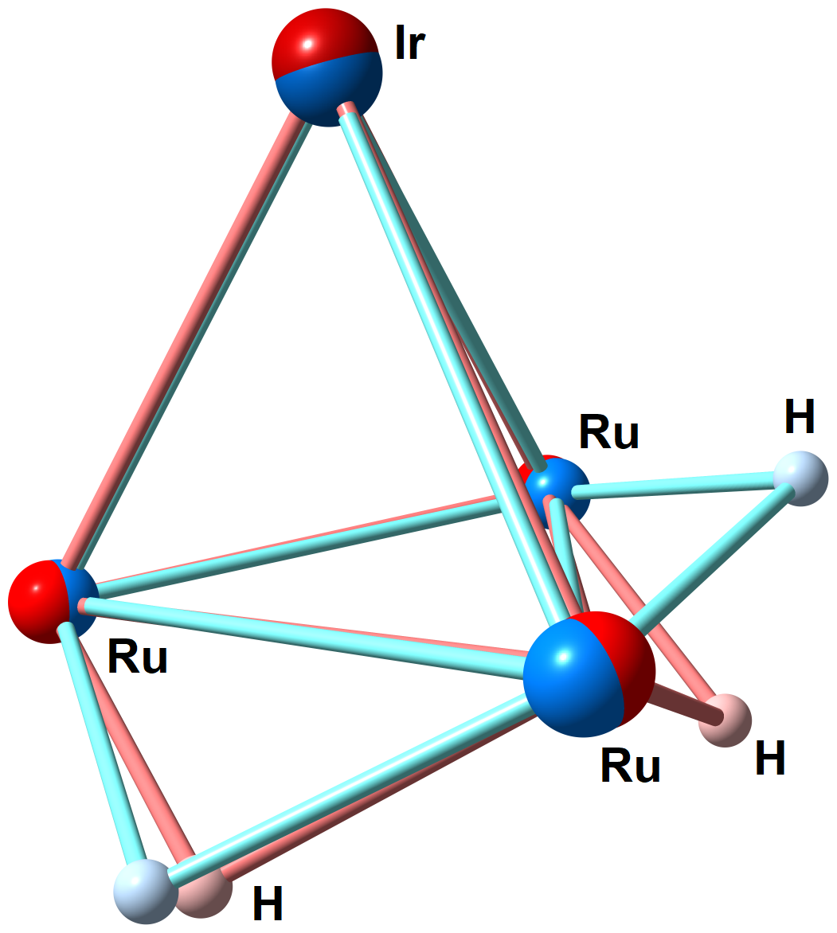
Figure S23. Best superposition of the {H₂Ru₃Ir} fragments in the computed (red tones) and experimental (blue tones) structures of 6.

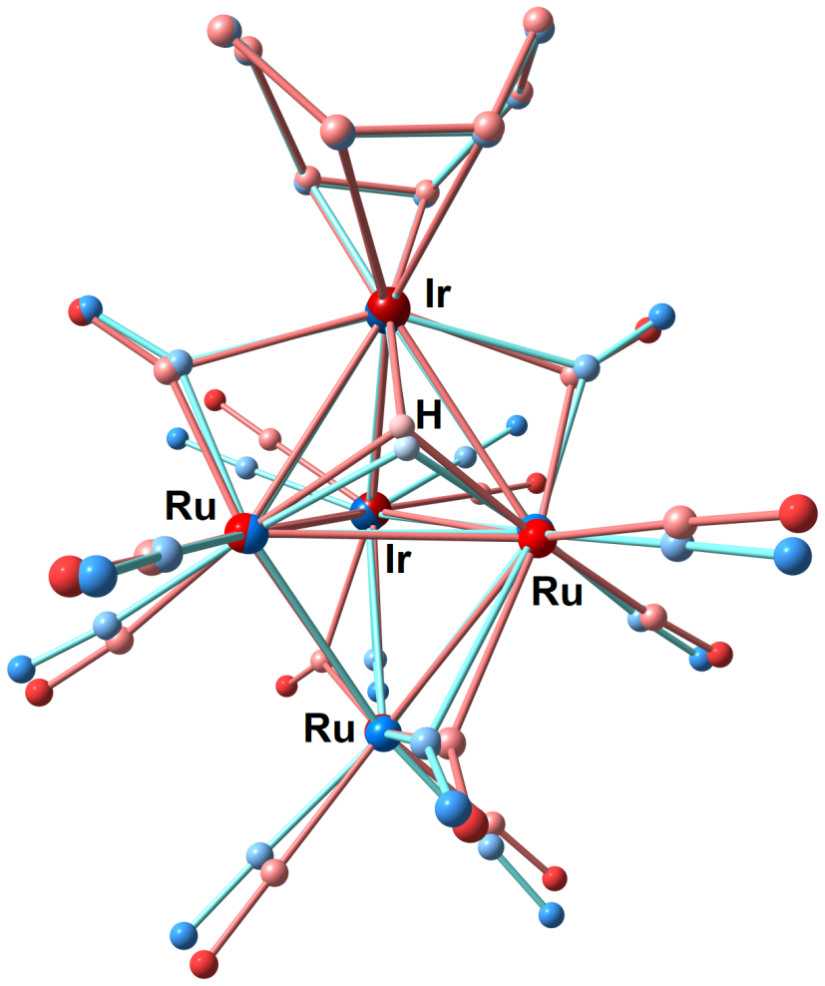
Figure S24. Best superposition of the X-ray structure of 3 (blue tones) and the DFT-optimized structure of 3-is1 (red tones). Hydrogen atoms of the COD ligands are omitted for clarity.

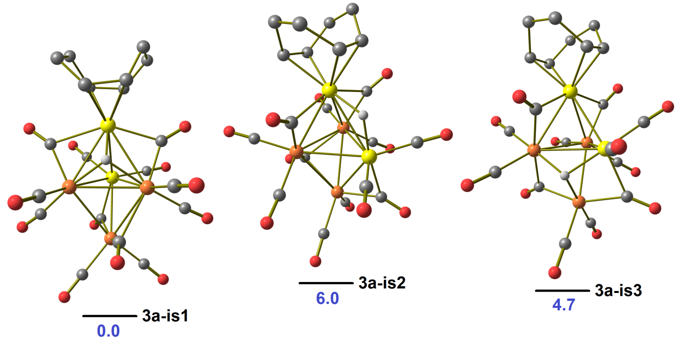
Figure S25. DFT-optimized structures of possible isomers of 3a with relative Gibbs energy values (kcal mol⁻¹). Orange Ru; yellow Ir; red O; grey C; white H. Hydrogen atoms of the COD ligands are omitted for clarity.

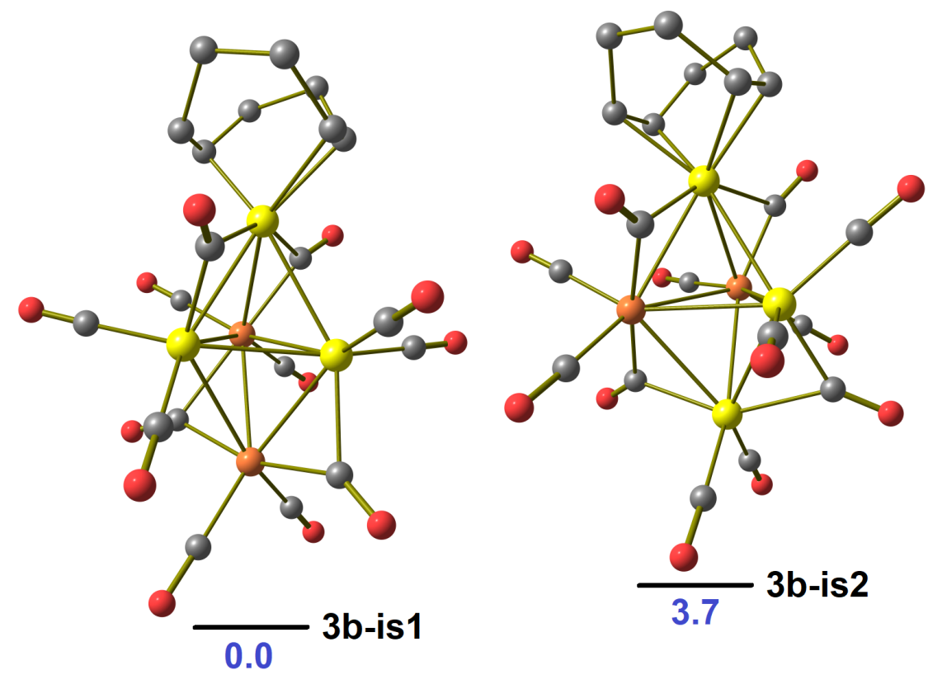
Figure S26. DFT-optimized structures of possible isomers of 3b with relative Gibbs energy values (kcal mol⁻¹). Orange Ru; yellow Ir; red O; grey C; white H. Hydrogen atoms of the COD ligands are omitted for clarity.

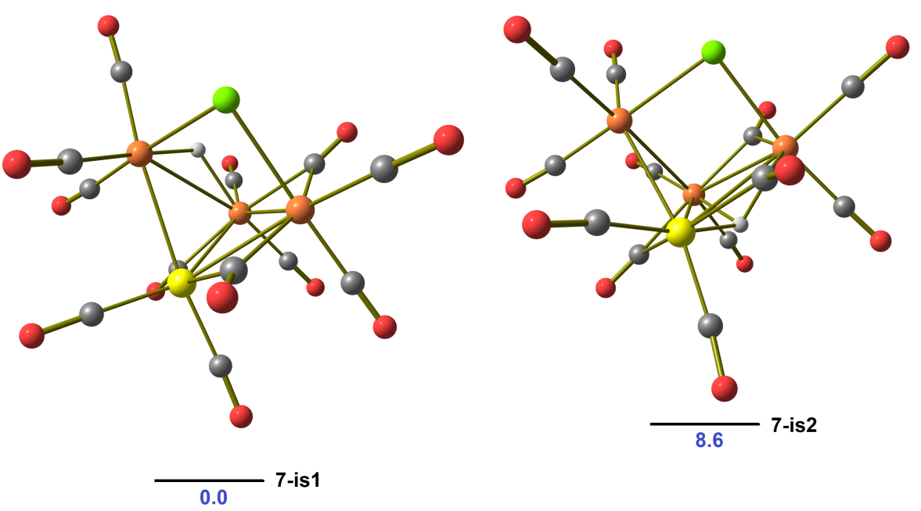
Figure S27. DFT-optimized structures of possible isomers of 7 with relative Gibbs energy values (kcal mol⁻¹). Orange Ru; yellow Ir; red O; grey C; green Cl; white H.

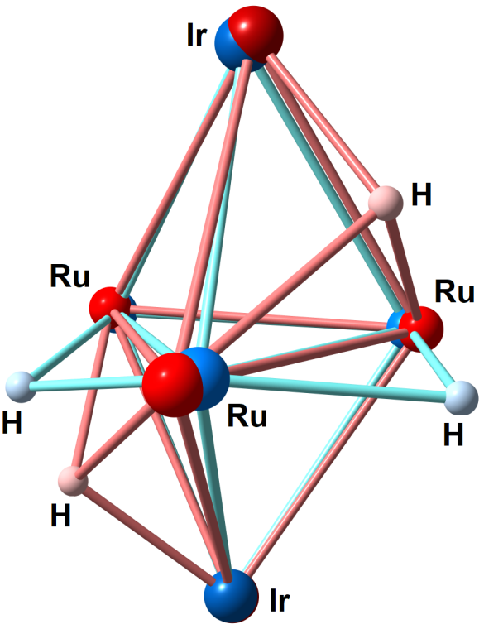
Figure 28. Best superposition of the {H₂Ru₃Ir₂} fragments in the computed 4a-is1 isomer (red tones) and in the experimental structure (blue tones).

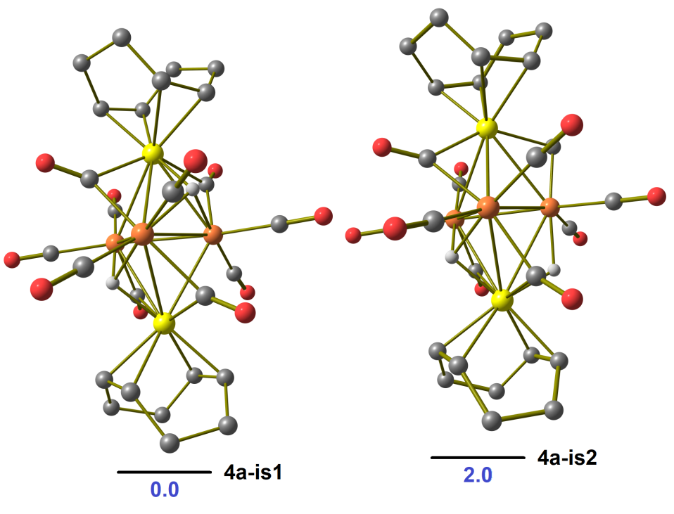
Figure S29. DFT-optimized structures of possible isomers of 4a with relative Gibbs energy values (kcal mol⁻¹). Orange Ru; yellow Ir; red O; grey C; white H. Hydrogen atoms of the COD ligands are omitted for clarity.

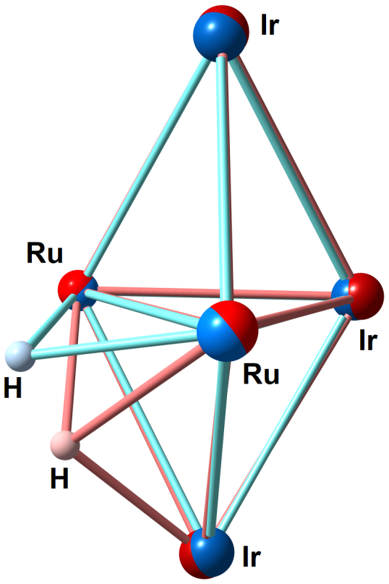
Figure S30. Best superposition of the {HRu₂Ir₃} fragments in the computed 4b-is1 isomer (red tones) and in the experimental structure (blue tones).

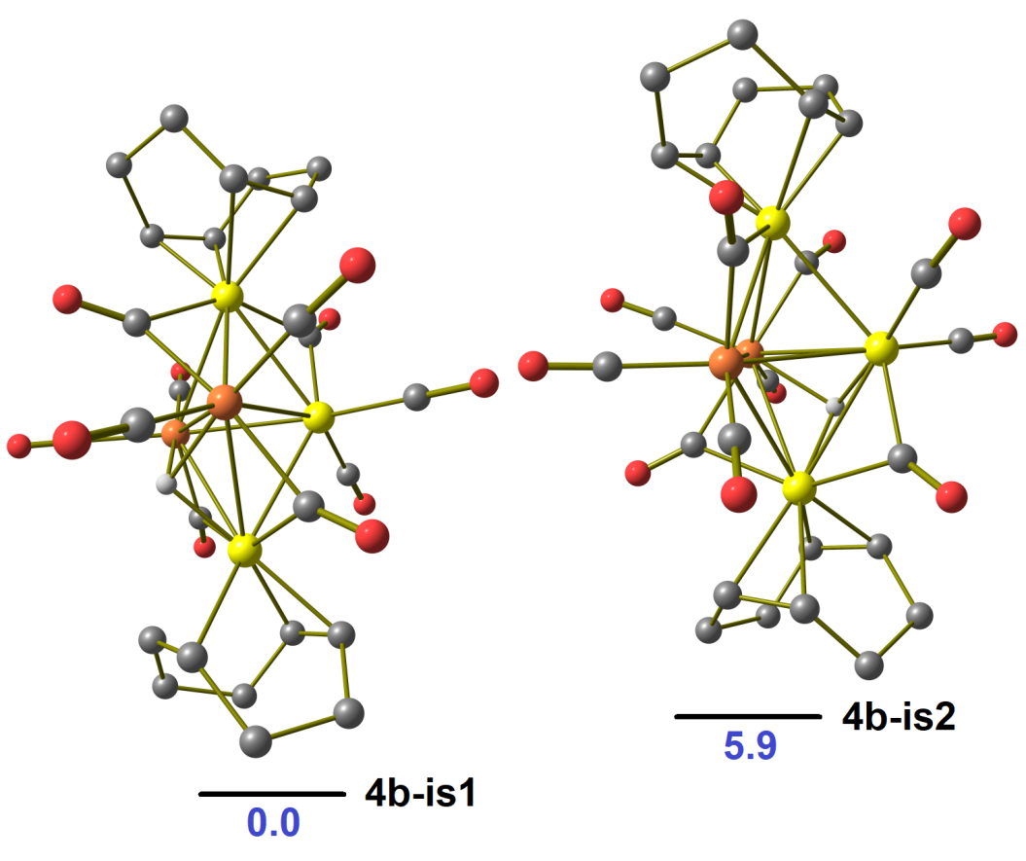
Figure S31. DFT-optimized structures of possible isomers of 4b with relative Gibbs energy values (kcal mol⁻¹). Orange Ru; yellow Ir; red O; grey C; white H. Hydrogen atoms of the COD ligands are omitted for clarity.

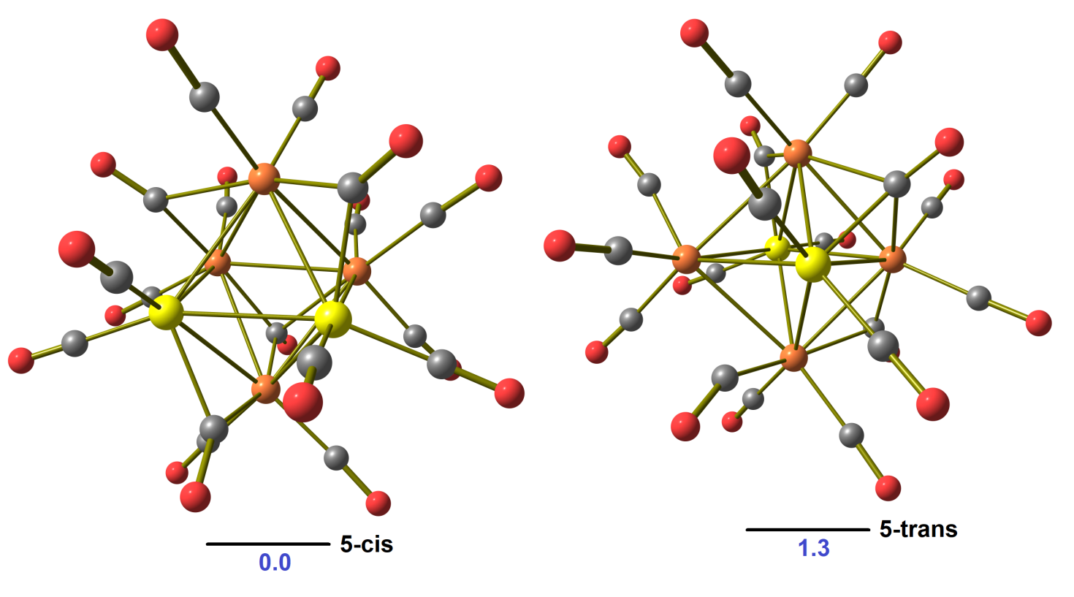Figure S32. DFT-optimized structures of the cis and trans isomers of 5 with relative Gibbs energy values (kcal mol⁻¹). Orange Ru; yellow Ir; red O; grey C; white H.
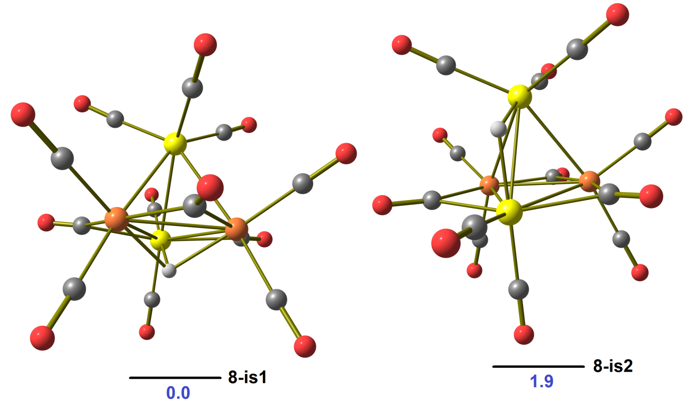
Figure S33. DFT-optimized structures of possible isomers of 8 with relative Gibbs energy values (kcal mol⁻¹). Orange Ru; yellow Ir; red O; grey C; white H.

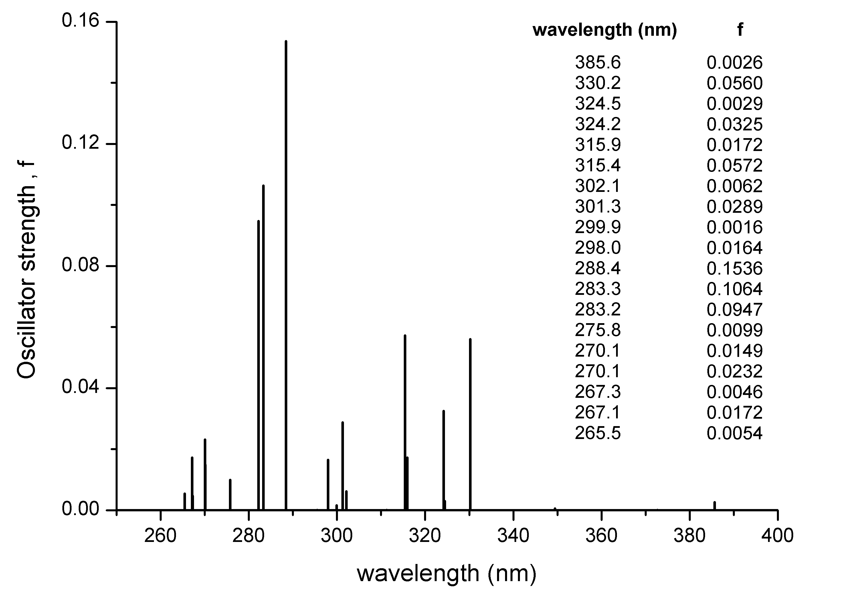
Figure S34. TD-DFT simulated absorption transitions of 2. Transitions with oscillator strengths higher than 10⁻³ are tabulated.

Table S3 Selected absorption transitions predicted for 2 in the 400 - 280 nm range.
385.6 | HOMO → LUMO : 0.830058  HOMO → LUMO+2 :0.137935
330.2 | HOMO-5 → LUMO : 0.011096  HOMO-3 → LUMO : 0.169502  HOMO-2 → LUMO+1 : 0.037878  HOMO-1 → LUMO+1: 0.298500  HOMO → LUMO : 0.063656  HOMO → LUMO+2 : 0.347622
324.5 | HOMO-2 → LUMO : 0.064648  HOMO-2 → LUMO+2 : 0.088034  HOMO-1 → LUMO : 0.070806  HOMO-1 → LUMO+2 : 0.744428
324.2 | HOMO-3 → LUMO : 0.612540  HOMO-3 → LUMO+2 : 0.074181  HOMO-2 → LUMO+1 : 0.055816  HOMO-1 → LUMO+1 : 0.023784  HOMO → LUMO : 0.024856  HOMO → LUMO+2 : 0.138302
315.9 | HOMO-3 → LUMO+1 : 0.068004  HOMO-2 → LUMO : 0.675743  HOMO-2 → LUMO+2 : 0.150140  HOMO-1 → LUMO : 0.027045  HOMO → LUMO+1 : 0.012045
315.4 | HOMO-3 → LUMO : 0.066334  HOMO-3 → LUMO+2 : 0.013376  HOMO-2 → LUMO+1 : 0.342978  HOMO-1 → LUMO+1 : 0.310887  HOMO → LUMO+2 : 0.190020
302.1 | HOMO-4 → LUMO : 0.590945  HOMO-4 → LUMO+2 : 0.071853  HOMO-3 → LUMO+1 : 0.036779  HOMO-2 → LUMO : 0.021369  HOMO-1 → LUMO+3 : 0.192613  HOMO → LUMO+4 : 0.014877
301.3 | HOMO-4 → LUMO+1 : 0.308760  HOMO-3 → LUMO : 0.052128  HOMO-3 → LUMO+2 : 0.492141  HOMO-2 → LUMO+1 : 0.061269  HOMO-1 → LUMO+1 : 0.020349  HOMO → LUMO+2 : 0.020006
299.9 | HOMO-4 → LUMO : 0.087738  HOMO-4 → LUMO+2 : 0.146237  HOMO-3 → LUMO+1 : 0.036700  HOMO-2 → LUMO+2 : 0.045489  HOMO → LUMO+3 : 0.512410  HOMO → LUMO+4 : 0.058221
298.0 | HOMO-5 → LUMO : 0.114419  HOMO-4 → LUMO+1 : 0.365820  HOMO-3 → LUMO : 0.023164  HOMO-3 → LUMO+2 : 0.323840  HOMO-2 → LUMO+1 : 0.036979  HOMO-1 → LUMO+1 : 0.064524
288.4 | HOMO-5 → LUMO : 0.304635  HOMO-4 → LUMO+1 : 0.040164  HOMO-3 → LUMO+2 : 0.025173  HOMO-2 → LUMO+1 : 0.269416  HOMO-1 → LUMO+1 : 0.157906  HOMO → LUMO+2 : 0.015456  HOMO → LUMO+5 : 0.014057
283.3 | HOMO-7 → LUMO+1 : 0.015629  HOMO-6 → LUMO : 0.073327  HOMO-6 → LUMO+2 : 0.016170  HOMO-5 → LUMO : 0.397057  HOMO-4 → LUMO+1 : 0.197732  HOMO-3 → LUMO : 0.015708  HOMO-2 → LUMO+1 : 0.077173  HOMO-1 → LUMO+2 : 0.031067  HOMO → LUMO : 0.017051  HOMO → LUMO+2 : 0.033940
283.2 | HOMO-6 → LUMO+1 : 0.018716  HOMO-4 → LUMO+2 : 0.223356  HOMO-3 → LUMO+1 : 0.015983  HOMO-2 → LUMO : 0.031948  HOMO-2 → LUMO+2 : 0.431625  HOMO-1 → LUMO+2 : 0.049737  HOMO → LUMO+4 : 0.010540  HOMO → LUMO+6 : 0.064287

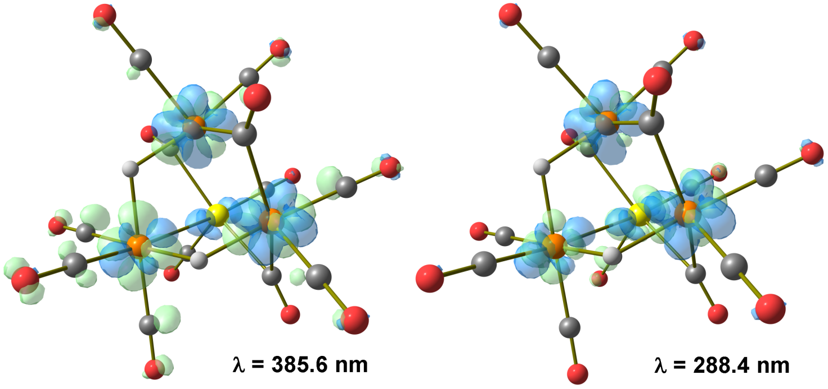
Figure S35. Hole (blue) and electron (green) distributions for the lowest-energy (λ = 385.6 nm) and highest-intensity (λ = 288.4 nm) absorption transitions predicted for 2. Surface isovalue = 0.005 a.u.

REFERENCES
- G. M. Sheldrick, SADABS-2008/1-Bruker AXS Area Detector Scaling and Absorption Correction; Bruker AXS: Madison, WI, 2008.
- G. M. Sheldrick, Crystal Structure Refinement with SCHELXL, Acta Crystallogr., Sect. C: Struct. Chem., 2015, 71, 3-8.

