Supporting information

Acid Deashing Kinetics and Alkali Activation of Carbon Rich Particles in Coal Gasification Fine Slag to Prepare Capacitor Carbon
Nana Yang¹, Shanxin Xiong^{1,2*}, Shuai Zhang¹, Fengyan Lv¹, Yukun Zhang¹, Xiaoqin Wang¹, Jia Chu¹, Zhen Li¹, Jianwei Xu³
¹ College of Chemistry and Chemical Engineering, Xi’an University of Science and Technology, Xi’an 710054, PR China
² Key Laboratory of Coal Resources Exploration and Comprehensive Utilization, Ministry of Land and Resources, Xi’an 710021, PR China
³Institute of sustainability for chemicals, energy and environment, 138634, Singapore
* To whom correspondence should be addressed, e-mail: xiongsx@xust.edu.cn

Table S1. Proximate analysis, ultimate analysis and loss on ignition of CGFS
Proximate analysis (%) |  |  |  |  | Ultimate analysis (%) |  |  |  |  |  | Loss on ignition (%)
M_{ad} | A_{d} | V_{d} | FC_{d}* |  | C_{daf} | O_{daf}* | H_{daf} | N_{daf} | S_{daf} |  | 24.25%
12.31 | 69.28 | 4.36 | 26.35 |  | 85.81 | 11.51 | 1.81 | 0.65 | 0.22 |  | 24.25%
ad: air dry basis, d: dry basis, daf: dry ash free basis, M: moisture, A: ash, V: volatiles, FC: fixed carbon, *: by difference

1-kyanite Al₂SiO₅ 2-albite Na(AlSi₃O₈) 3-quartz SiO₂ 4-anorthite CaAl₂Si₂O₈ 5-diopside Ca(Mg_{0.7}Al_{0.3})(Si_{1.7}Al_{0.3})O₆ 6-hematite Fe₂O₃ 7-mullite Al₆Si₂O₁₃ 8-pyrope (Mg_{0.804}Ca_{0.196})₃Al₂(SiO₄)₃ 9-corundum Al₂O₃
Figure S1. XRD spectra of CRP

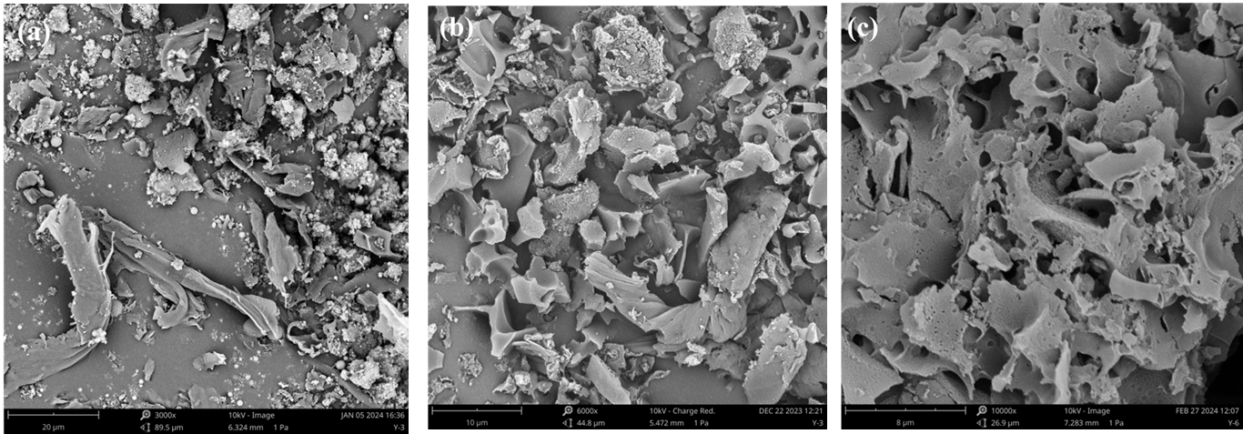
Figure S2. SEM images of CRP (a), D-CRP (b), and CRP-AC (90 min) (c).

Table S2. Parameters of equivalent circuit for CRP-AC
Samples | Rs (Ω) | Rct (Ω) | Zw (Ω)
CRP-AC (60 min) | 1.212 | 0.751 | 1.052
CRP-AC (70 min) | 1.111 | 0.811 | 1.024
CRP-AC (80 min) | 1.012 | 0.879 | 1.012
CRP-AC (90 min) | 0.942 | 1.399 | 0.873
CRP-AC (100 min) | 1.321 | 1.552 | 1.121

