Spatial distribution characteristics and pollution assessment of heavy metals in sediments of typical urban areas in the middle and upper reaches of the Yellow River

Junzhang Wang^{1, 2}, Jun Ren^{1, 2, 3, *}, Ling Tao^{1, 2, 3}, Hanru Ren^{1, 2, 3}, Xiangyu Xue ^{1, 2, 3}, Zhijie Yang^{1, 2, 3}, Yucheng Jiang^{1, 2, 3}

1 School of Environmental and Municipal Engineering. Lanzhou Jiaotong University, Lanzhou 730070, P. R. China
2 Key laboratory of Yellow River Water Environment in Gansu Province, Lanzhou Jiaotong University, Lanzhou 730070
3 Gansu Hanxing Environmental Protection Co. Ltd., Lanzhou 730070, China

Junzhang Wang:
wangjz@mail.lzjtu.cn

Ling Tao:
taoling@mail.lzjtu.cn

Hanru Ren:
renhanru@163.com

Xiangyu Xue:
11220143@stu.lzjtu.edu.cn

Zhijie Yang:
11220065@stu.lzjtu.edu.cn

Yucheng Jiang:
Jiangyc6010@162.com

Correspondence，Jun Ren:
renjun@mail.lzjtu.cn

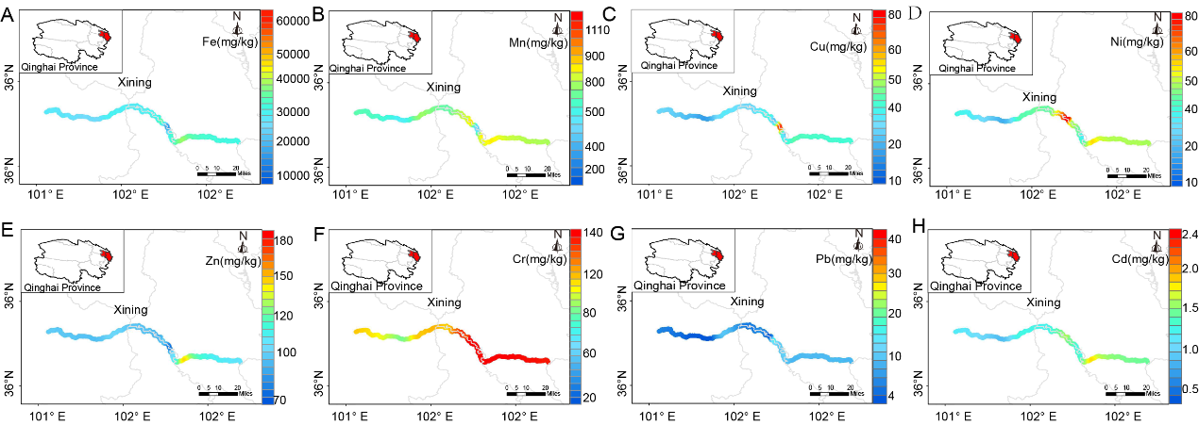
Fig. 1 Spatial distribution of heavy metals in river sediments of Xining City. F(Cr). The spatial distribution is dominated by medium and high values. C(Cu). D(Ni). There is a high value area. A(Fe). B(Mn). E(Zn). H(Cd). The spatial distribution is dominated by low value areas, and some are medium value areas. G(Pb). The spatial distribution is dominated by low value areas.

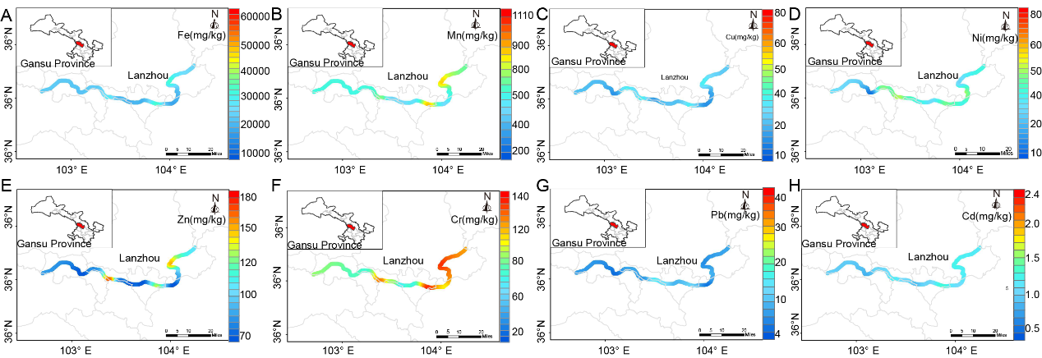
Fig. 2 Spatial distribution of heavy metals in river sediments of Lanzhou City. F(Cr). The lower reaches are dominated by higher value areas distribution. E(Zn). The spatial distribution is dominated by low value areas, and there are two medium—high value areas. B(Mn). D(Ni). The spatial distribution is dominated by medium value areas, with a few medium—high value areas. A(Fe). C(Cu). G(Pb). H(Cd). The spatial distribution is dominated by low value areas.

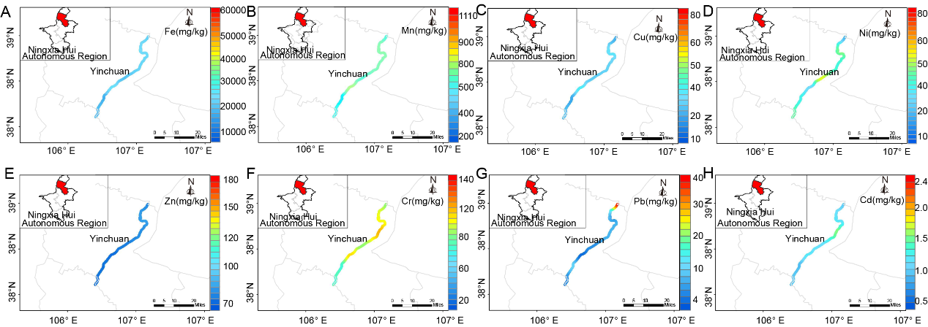
Fig. 3 Spatial distribution of heavy metals in river sediments of Yinchuan City. G(Pb). The spatial distribution is dominated by the low value area, and the content of the end reached the medium and high values. F(Cr). The spatial distribution is dominated by the medium-high value areas. A(Fe). B(Mn). C(Cu). D(Ni). E(Zn). H(Cd). The spatial distribution is dominated by the medium and high value areas.

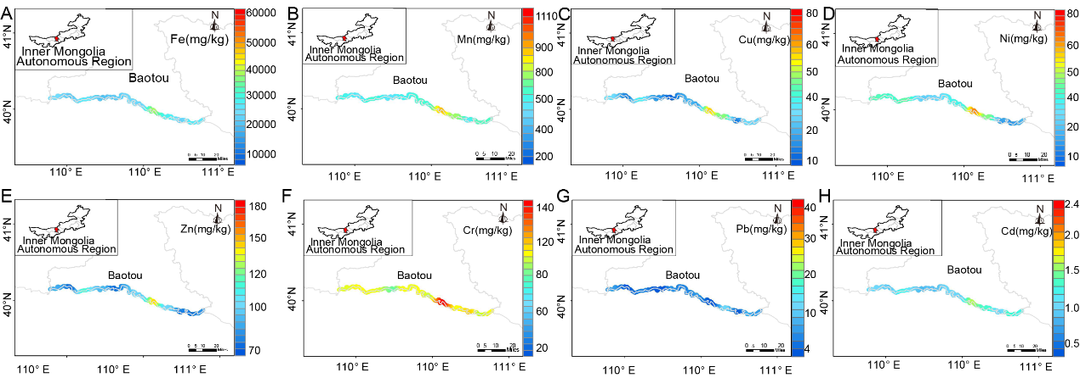
Fig. 4 Spatial distribution of heavy metals in river sediments of Baotou City. F(Cr). The spatial distribution is dominated by the medium-high value areas，and the content in one area reached the high value. B(Mn). C(Cu). D(Ni). E(Zn). The spatial distribution is dominated by low value areas, and the content reached medium-high value in the same area. A(Fe). G(Pb). H(Cd). The spatial distribution is dominated by medium-low value areas

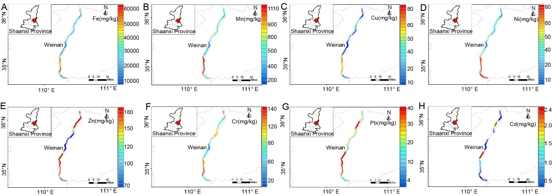
Fig. 5 Spatial distribution of heavy metals in river sediments of Weinan City. A(Fe). B(Mn). C(Cu). D(Ni). F(Cr). The spatial distribution is dominated by the medium-low value areas, and the content reached the high value in some of the same areas. E(Zn). G(Pb). The upper and lower reaches are dominated by high value areas, while the middle reaches are distributed in the middle and low value areas. H(Cd). The spatial distribution is dominated by medium-low value areas, and the content reached medium and high values in some areas.

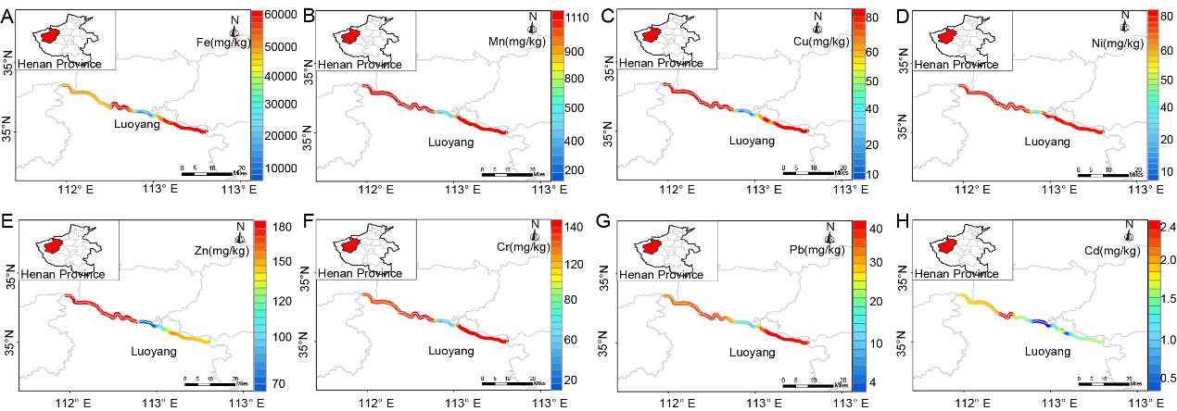
Fig. 6 Spatial distribution of heavy metals in river sediments of Weinan City. B(Mn). C(Cu). D(Ni). F(Cr). G(Pb). The upper and lower reaches are dominated by high values in the same areas, and and the others are medium-low value areas. A(Fe). The upper reaches are dominated by median-high value areas, the lower reaches are dominated by the high value areas, and the others are low value areas. E(Zn). The upper reaches are dominated by high value areas, the lower reaches are dominated by the medium-high value areas, and the others are low value areas. H(Cd). The upper reaches are dominated by medium and high value areas, and others are medium-low value areas.

