Modifying Post-Surgical Immunity: Controlled Release of TLR7/8 Agonist for Immune Mediated Clearance of Glioblastoma
Elizabeth G. Graham-Guryshª, Sean R. Simpsonª, Ryan N. Woodringª, Kathryn M. Moore^{b}, Sophie E. Mendellª, Erik S. Pena^{b}, Nicole Rose Lukeshª, Christopher J. Genito^{c}, Kaitlyn A. Hipp^{d}, Garima Singhª, William C. Zamboni^{d}, Shawn D. Hingtgenª, Peter E. Fecci^{e}, Eric M. Bachelderª, Kristy M. Ainslie^{abc}*

ª Division of Pharmacoengineering and Molecular Pharmaceutics, Eshelman School of Pharmacy, University of North Carolina at Chapel Hill, USA.
^{b} Joint Department of Biomedical Engineering, University of North Carolina at Chapel Hill and North Carolina State University, USA.
^{c} Department of Microbiology and Immunology, UNC School of Medicine, University of North Carolina, Chapel Hill, NC, USA.

^{d} Division of Pharmacotherapy and Experimental Therapeutics, Eshelman School of Pharmacy, University of North Carolina at Chapel Hill and UNC Lineberger Comprehensive Cancer Center, Chapel Hill, NC, USA

^{e} Preston Robert Tisch Brain Tumor Center, Duke University Medical Center, Durham, NC, USA. Department of Neurosurgery, Duke University Medical Center, Durham, NC, USA. Department of Pathology, Duke University Medical Center, Durham, NC, USA

*Corresponding Author
Kristy M. Ainslie
Distinguished Professor
Chair, Division of Pharmacoengineering & Molecular Pharmaceutics
UNC Eshelman School of Pharmacy
4012 Marsico Hall, 125 Mason Farm Road
Chapel Hill, NC 27599, United States
ainsliek@email.unc.edu

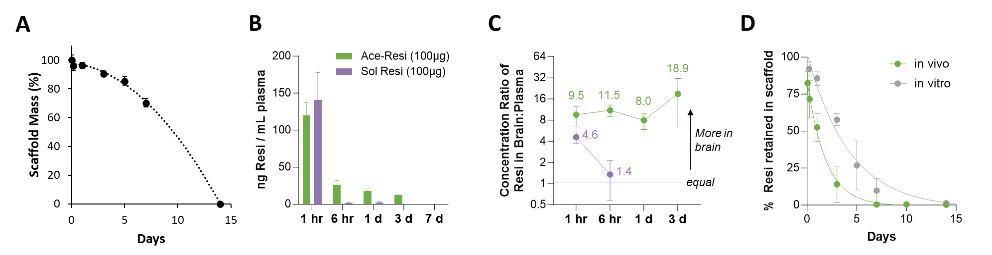
Supplemental Figure 1. Ace-Resi scaffold characterization (A) Ace-Resi scaffold mass over time after incubation at 37 ºC in PBS. B) Concentration versus time profile of resiquimod in plasma (ng/mL) in mice treated with 100 µg of resiquimod via Ace-Resi or bolus injection in PBS (Sol Resi). C) Ratio of the concentration of resiquimod in brain compared to plasma over time. D) Retention of resiquimod in Ace-Resi scaffolds in vivo (removed from resection cavity in healthy mouse brain during the pharmacokinetic study) compared to in vitro (PBS at 37ºC) conditions.

Supplemental Table 1. Comparison of PK properties of Ace-Resi to soluble Resi. The area under the curve (AUC) and half-life (T₅₀) of resiquimod in the brain and plasma of mice treated with 100 µg of resiquimod via Ace-Resi or bolus injection in PBS at 1 hr, 6 hr, 1-, 3-, and 7- days.
 | Ace-Resi (100 µg) | Soluble Resi (100 µg)
AUC brain (average ± standard deviation)  ng resi x days / gram tissue | 1140 ± 324 | 60 ± 40
AUC plasma (average ± standard deviation)  ng resi x days / mL plasma | 85 ± 6 | 19 ± 7
T₅₀ brain (hours) | 3.0 | 1.1
T₅₀ plasma (hours) | 2.5 | 1.5

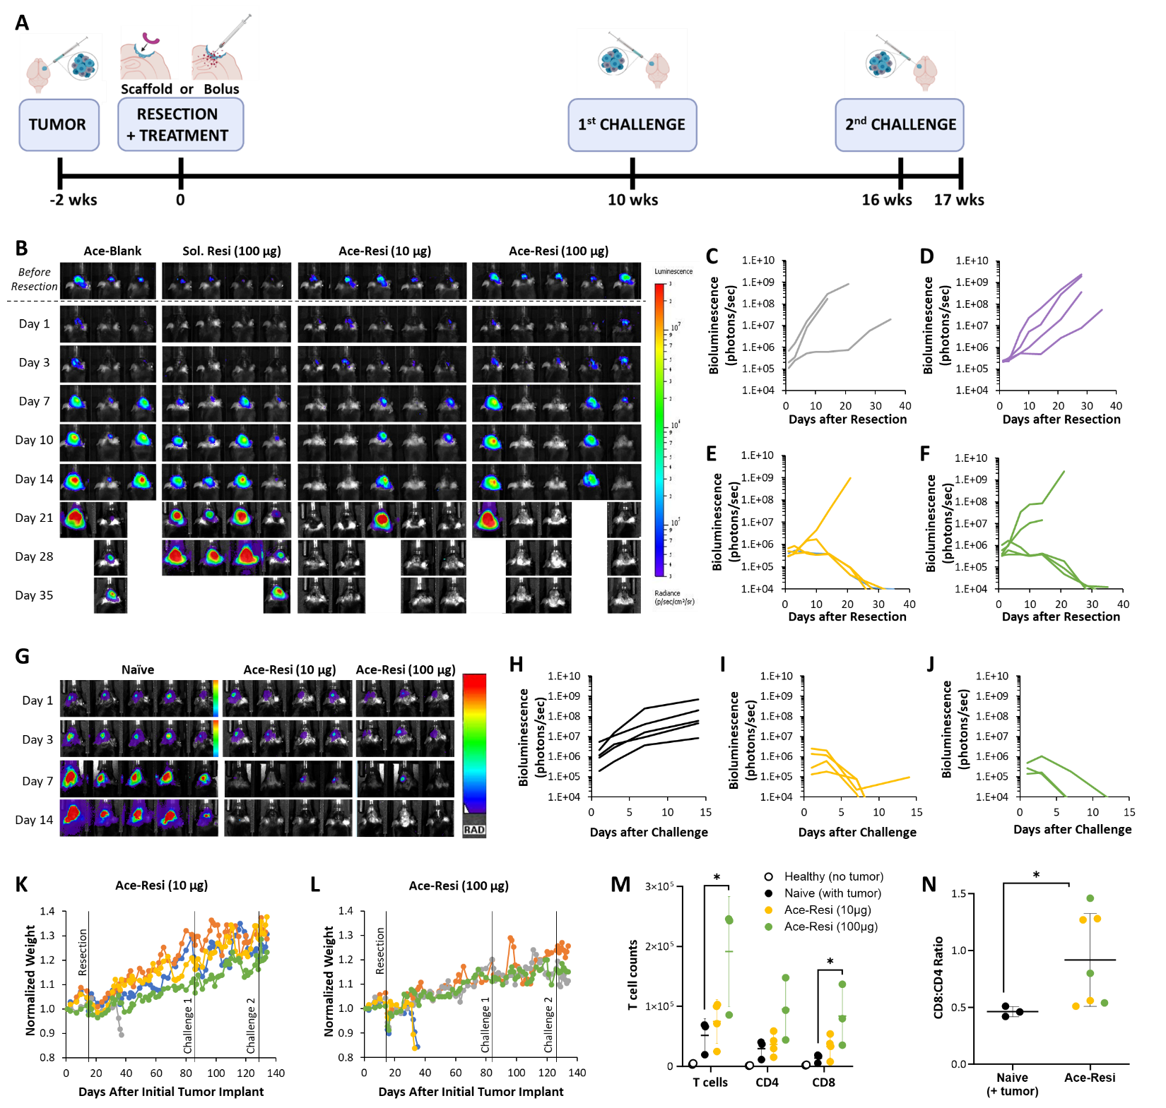

Supplemental Figure 2. GL261 dosing study (A) Timeline of study design. The GL261-mCh-Luc tumor was implanted and resected 2 weeks later (day 0). Ace-Resi or bolus resiquimod (Sol. Resi) treatments applied during resection. Mice that survived were challenged at 10 weeks and then again at 16 weeks. Mice euthanized at 17 weeks for brain leukocyte analysis. B) Bioluminescent images of all mice from each treatment group after tumor resection. Bioluminescent signal from mice treated with C) Ace-Blank, D) soluble resiquimod (100 µg), E) Ace-Resi (10 µg), and F) Ace-Resi (100 µg). G) Bioluminescent images of all mice from each treatment group after tumor challenge. Bioluminescent signal from mice after tumor challenge H) naïve, I) Ace-Resi (10 µg), and J) Ace-Resi (100 µg). Normalized weight for K) Ace-Resi (10 µg) and L) Ace-Resi (100 µg) treated mice throughout the whole study. M) Total number of brain infiltrating T cells. *p < 0.05, with respect to naïve mice bearing tumors by one-way ANOVA with multiple comparisons to the healthy control and Dunnett’s post-hoc test. N) Ratio of CD8⁺ to CD4⁺ T cells among brain infiltrating leukocytes. *p < 0.05 by student’s t-test.

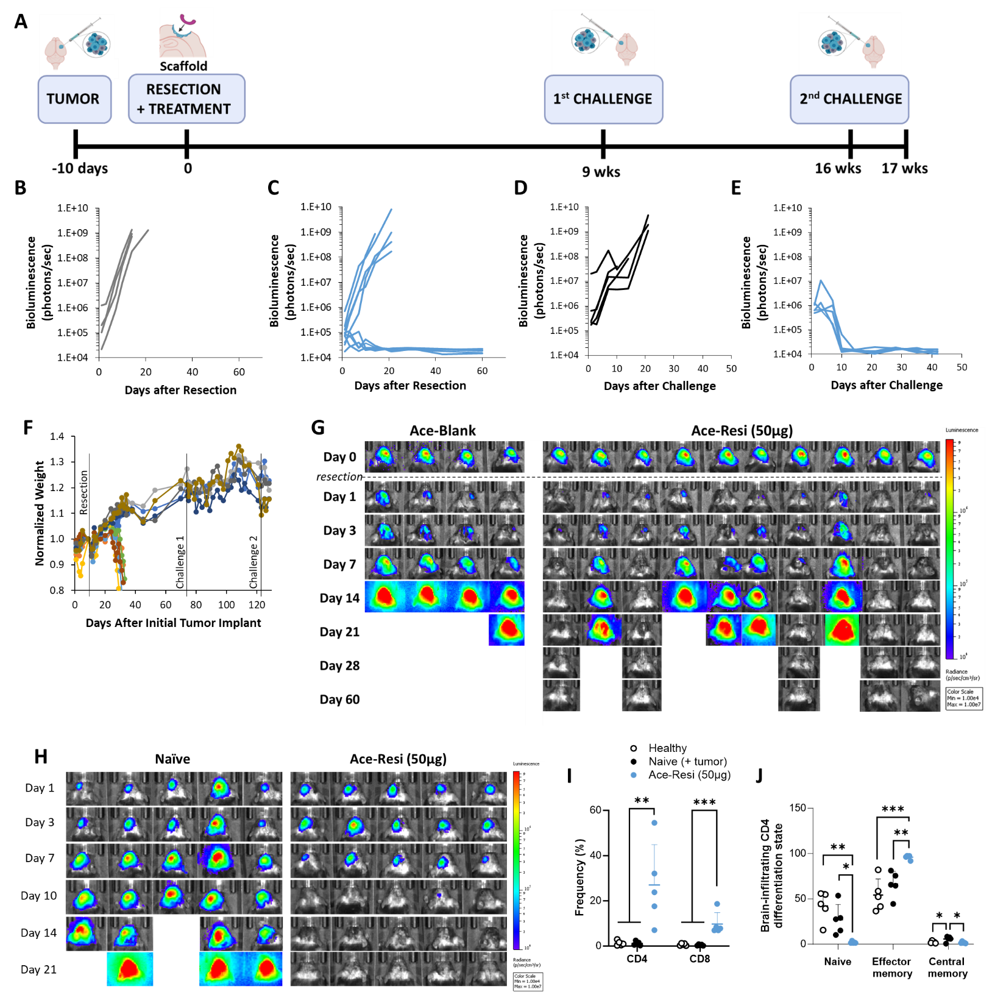

Supplemental Figure 3. GL261 study (A) Timeline of study design. The GL261-mCh-Luc tumor was implanted then resected 10 days later (day 0). Ace-Resi (50µg) or Ace-Blank applied during resection. Surviving mice were challenged at 9 weeks and then again at 16 weeks. Mice euthanized at 17 weeks for brain leukocyte analysis. Bioluminescent signal from mice after resection and treatment with B) Ace-Blank or C) Ace-Resi (50 µg). Bioluminescent signal from D) naïve or E) long term survivors after tumor challenge. F) Normalized weight for Ace-Resi (50 µg) throughout the whole study. G) Bioluminescent images of all mice after treatment with Ace-Blank or Ace-Resi (50 µg). H) Bioluminescent images of all mice from each treatment group after tumor challenge. I) Frequency of CD4⁺ and CD8⁺ T cells in the brain one week after second tumor challenge. J) Differentiation state of CD4⁺ T cells one week after second tumor challenge. **p < 0.01, ***p < 0.001 by one-way ANOVA with multiple comparisons Dunnett’s post-hoc test.

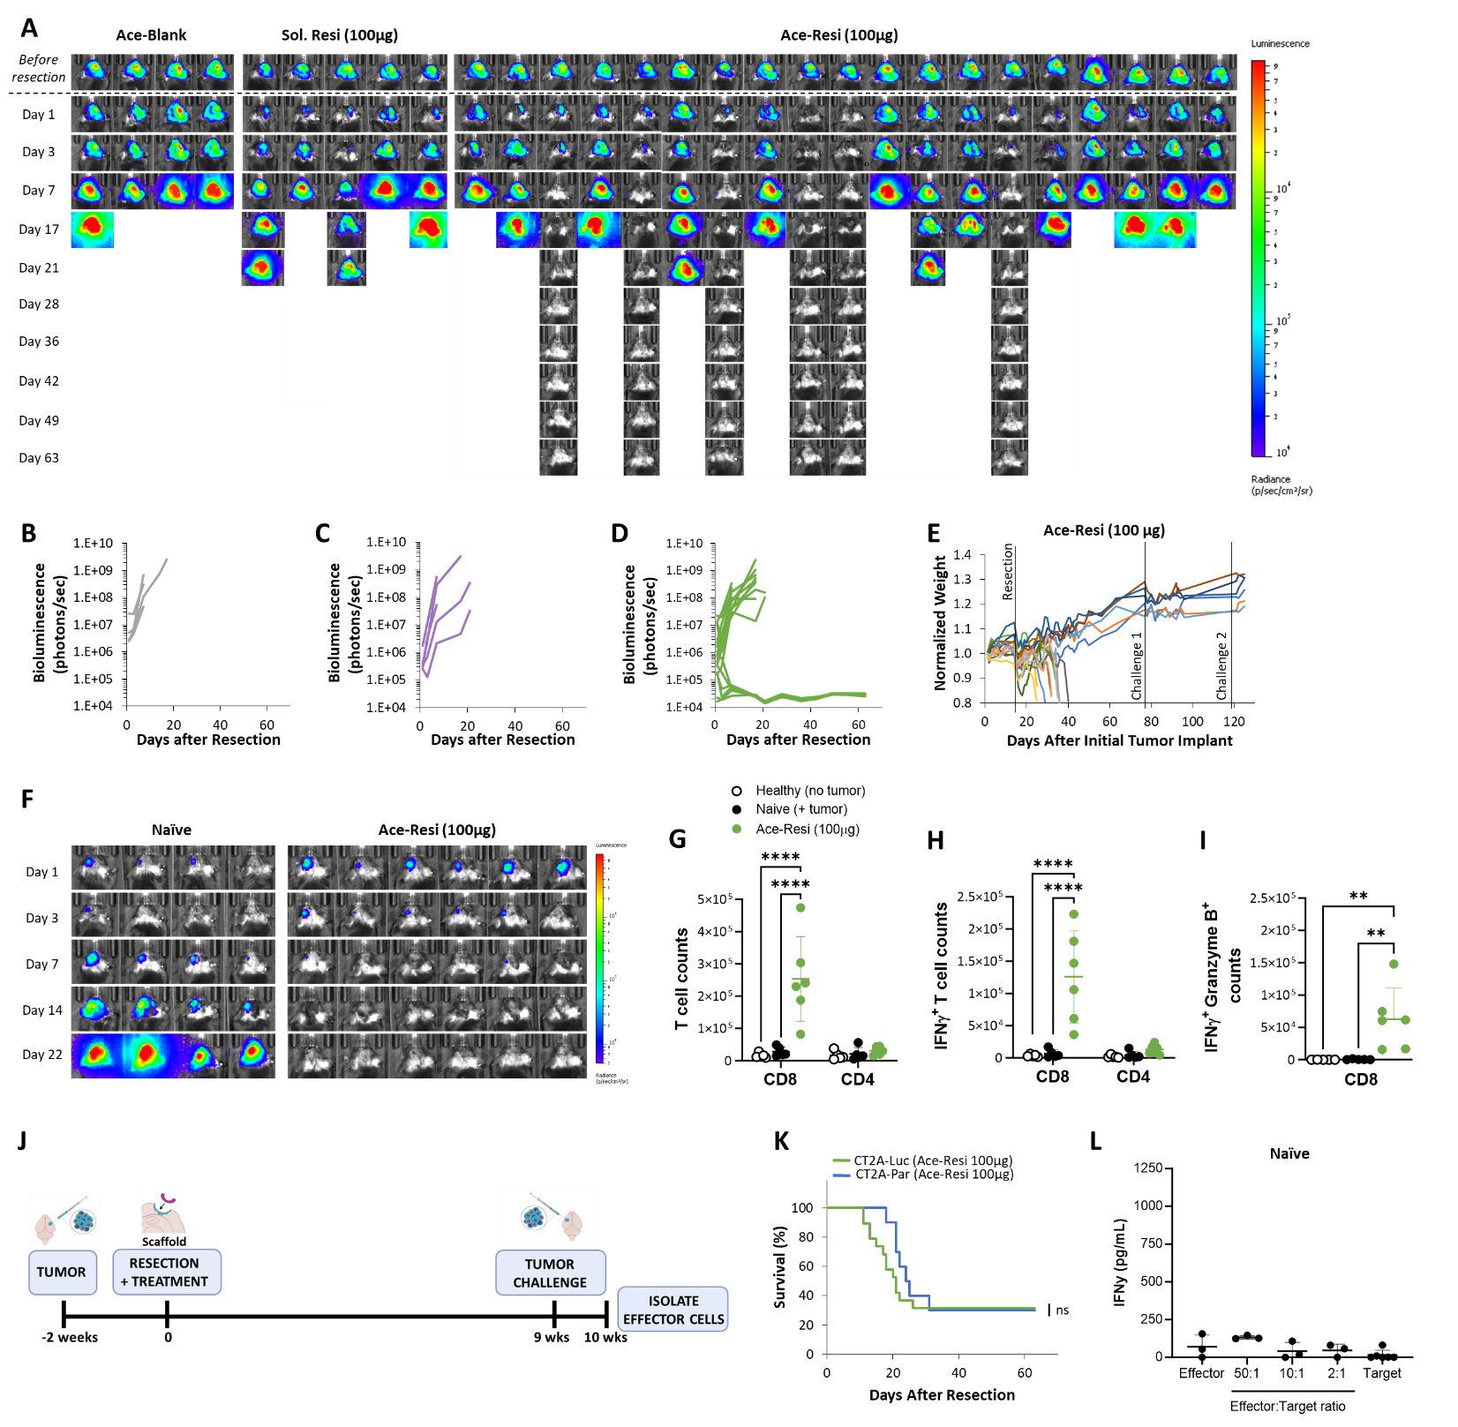
Supplemental Figure 4. CT2A study A) Bioluminescent images of all mice from each treatment group after tumor resection. Bioluminescent signal from mice treated with B) Ace-Blank, C) soluble resiquimod (100 µg), and D) Ace-Resi (100 µg). Normalized weight for E) Ace-Resi (100 µg) treated mice throughout the whole study. F) Bioluminescent images of all mice after tumor challenge. G) Counts of brain-infiltrating CD8⁺ or CD4⁺ T cells. H) Counts of brain-infiltrating T cells that are positive for IFNγ. I) Counts of brain-infiltrating CD8⁺ T cells that are multi-functional (Positive for both IFNγ and granzyme B). ** p < 0.01, ****p < 0.0001 by one-way ANOVA and Dunnett’s multiple comparisons test. J) Timeline of study design. The CT2A-Par tumor was implanted then resected 14 days later. Ace-Resi (100µg) was applied during resection. Surviving mice were challenged 9 weeks after initial resection, then euthanized at 10 weeks. Effector cells were isolated from long-term survivors and naïve ‘healthy’ controls. K) Survival of mice after primary tumor resection and treatment with Ace-Resi (100µg) for CT2A-Par compared to CT2A-Luc. ns= no significance by Log-Rank test. L) IFNγ in supernatant of effector cells from naïve (non-tumor bearing) mice cocultured with CT2A-Par cells (‘target cells’) after 24 hours as measured by ELISA.

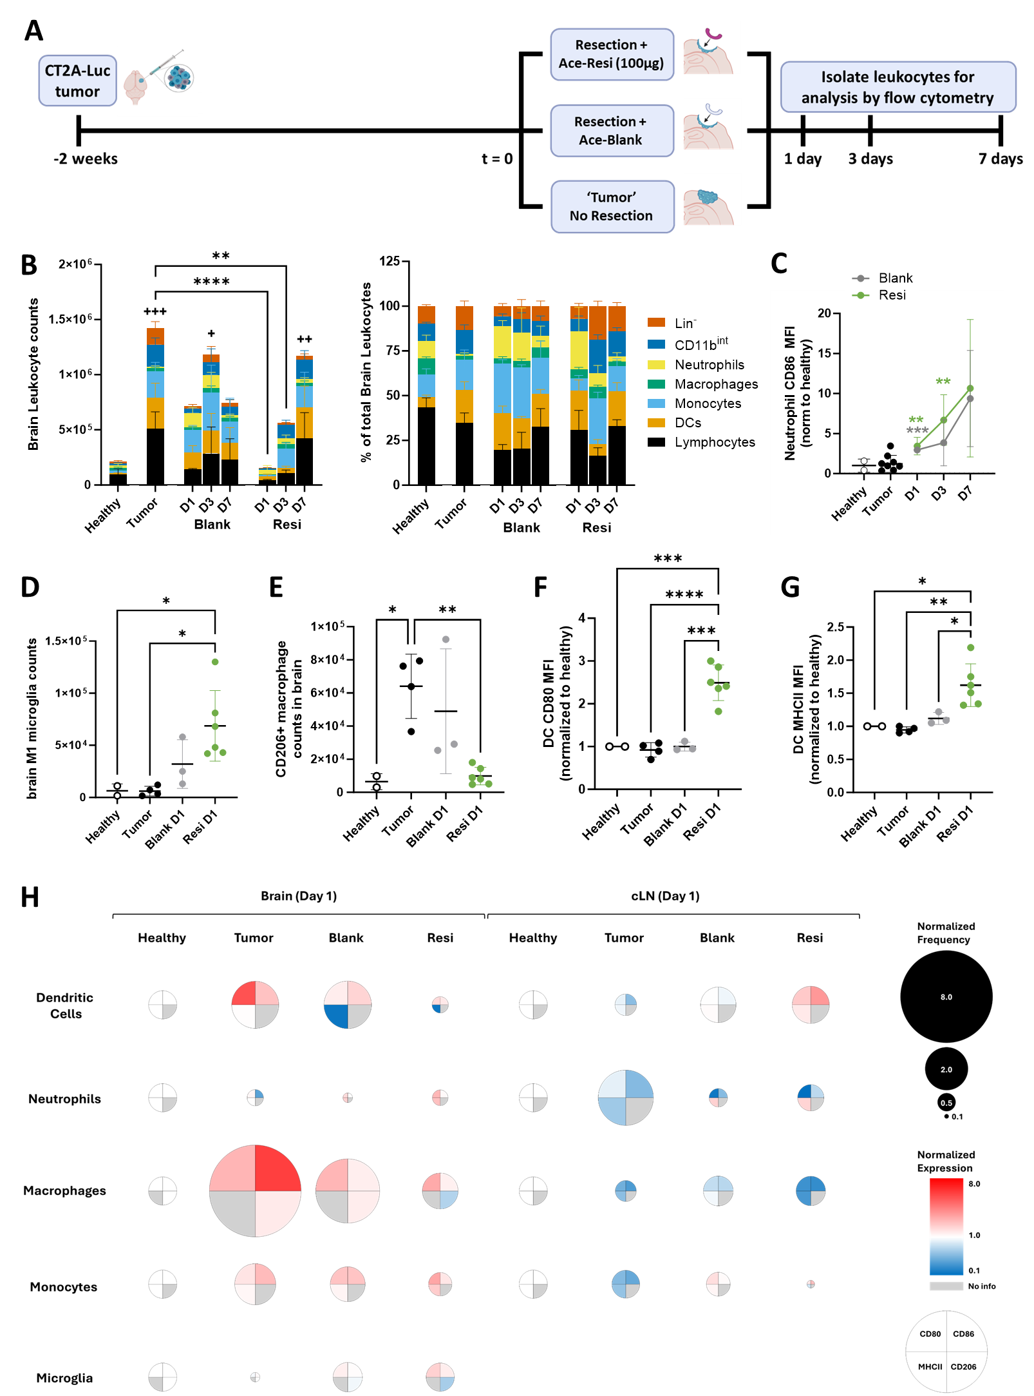
Supplemental Figure 5. Ace-Resi remodels the local innate immune environment. (A) Timeline of study design. CT2A-Luc tumors were implanted 2 weeks prior, mice were randomized to treatment group: resection + Ace-Blank, resection + Ace-Resi, or no resection ‘tumor’. Mice were euthanized days 1, 3, and 7 after treatment and organs harvested for leukocyte analysis. Healthy mice were included as a control. (B) Counts and percentage of total brain infiltrating leukocyte (BIL) by leukocyte population identified by flow cytometry gating (Supp Fig 11). (C) Mean Fluorescence Intensity (MFI) of CD86 of neutrophils normalized to healthy control., ** <0.005, *** <0.0005 by one-way ANOVA with multiple comparisons against the healthy group (+) or tumor (*) group on with Dunnett's post-hoc test. (D) Counts of M1 microglia in the brain. (E) Counts of M2 macrophages in the brain. (F) MFI of CD80 and (G) MHCII on DCs normalized to healthy control * <0.05, ** <0.005, *** <0.0005, **** < 0.0001 by one-way ANOVA with multiple comparisons with Dunnett's post-hoc test. (H) Bubble plot illustrating normalized cell frequencies and CD80, CD86, MHCII, and CD206 expression normalized to healthy controls.

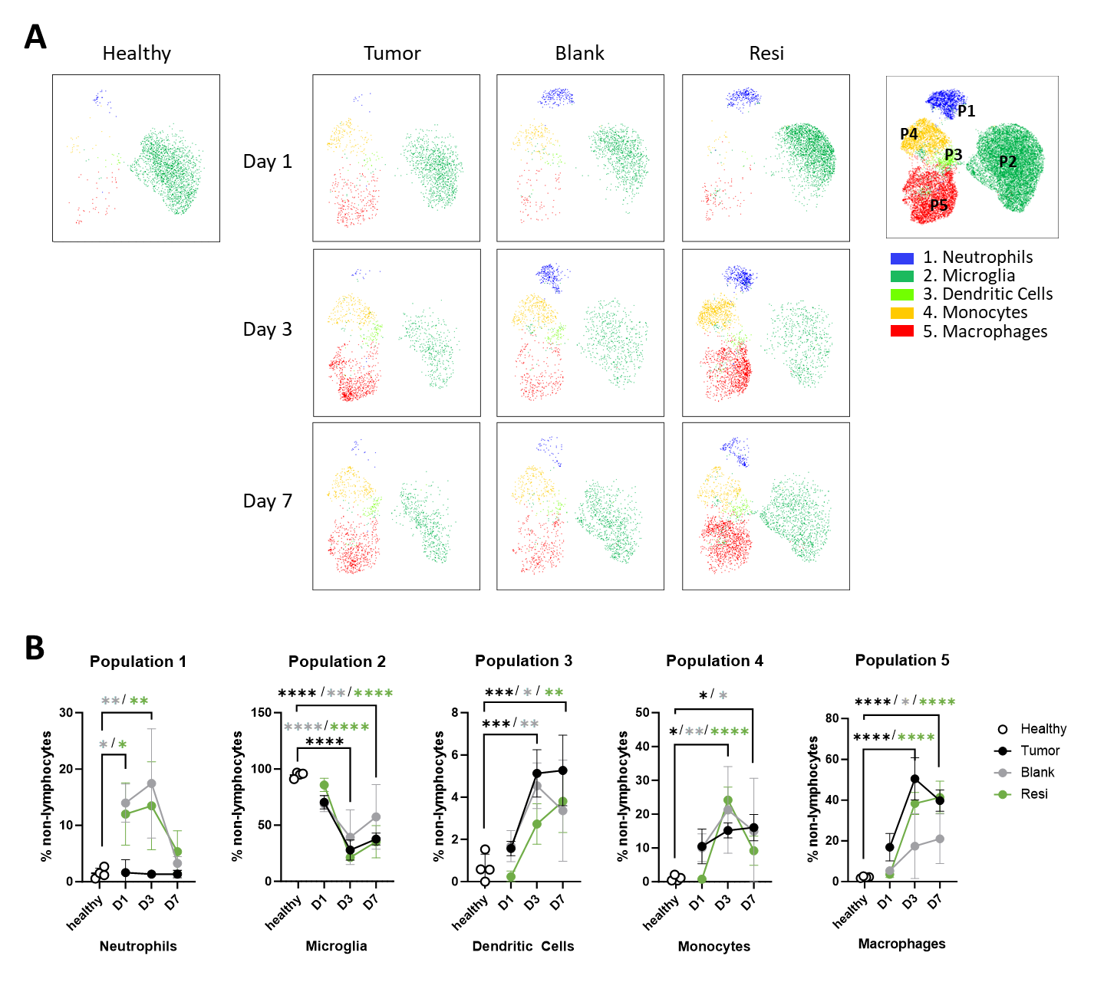

Supplemental Figure 6. FlowSOM UMAP figures from the brain. (A) UMAP showing concatenated FlowSOM plot comparing treatment groups over time (Healthy: no tumor, no resection; Tumor: tumor-bearing, no resection; Blank: tumor resected and Ace-Blank scaffold implanted; Resi: tumor resected and Ace-Resi (100µg) scaffold implanted) showing five immune populations in the brain: neutrophils, microglia, dendritic cells, monocytes, macrophages (defined based on expression analysis of CD45, CD11b, CD11c, Ly6C, Ly6G, MHCII, CD80, and CD86 as detailed in Supp Fig 13). (B) Frequencies of each population across treatment groups and time. *p<0.05, **p<0.005, ***p<0.0005, ****p<0.0001 by one-way ANOVA with multiple comparisons by with Dunnett's post-hoc test.
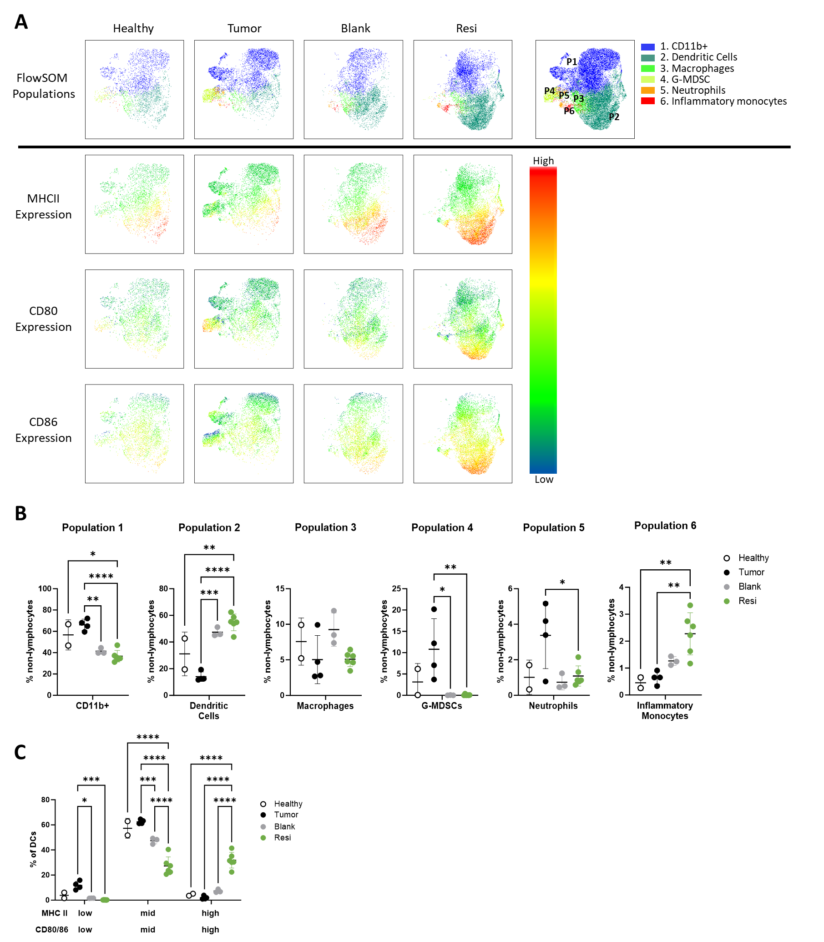

Supplemental Figure 7. FlowSOM UMAP figures from the cLN. (A) UMAP plot comparing treatment groups (Healthy: no tumor, no resection; Tumor: tumor-bearing, no resection; Blank: tumor resected and Ace-Blank scaffold implanted; Resi: tumor resected and Ace-Resi (100µg) scaffold implanted) 1 day after treatment showing six clusters generated by FlowSOM in the cervical lymph nodes (cLN): CD11b+, dendritic cells (DCs), macrophages, granulocytic myeloid-derived suppressor cells (G-MDSC), neutrophils, inflammatory monocytes (as defined based on expression analysis of CD45, CD11b, CD11c, Ly6C, Ly6G, MHCII, CD80, and CD86 as detailed in Supp Fig 13). (B) Frequencies of each population across treatment groups. (C) Dendritic cell co-stimulatory expression across treatment groups. *p<0.05, **p<0.005, ***p<0.0005, ****p<0.0001 by one-way ANOVA with multiple comparisons by with Dunnett's post-hoc test.

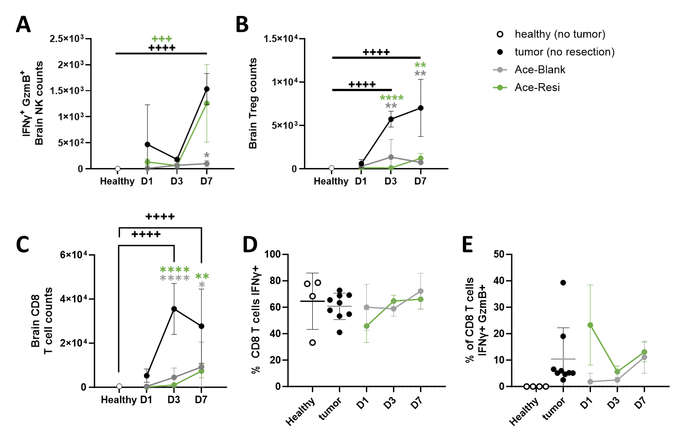
Supplemental Figure 8. Ace-Resi promotes NK activation, depletes T-regs, and reduces CD8⁺ T cell PD-1 expression. (A) Counts of brain-infiltrating natural killer (NK) cells that are positive for both IFNγ and granzyme B (GzmB) over time. (B) Counts of brain-infiltrating CD4⁺ T cells that are positive for T-reg markers (Foxp3⁺ CD25⁺) over time. (C) Counts of brain-infiltrating CD8⁺ T cells over time. (D) Frequency of IFNγ+ and (E) double positive (IFNγ+, GzmB+) CD8⁺ T cells in the brain comparing Ace-Blank and Ace-Resi 1, 3, and 7-days after resection and treatment with healthy and tumor (not resected) controls. *p<0.05, **p<0.005, ***p<0.0005, ****p<0.0001 by one-way ANOVA with multiple comparisons against the healthy group (+) or tumor group (*) with Dunnett's post-hoc test.

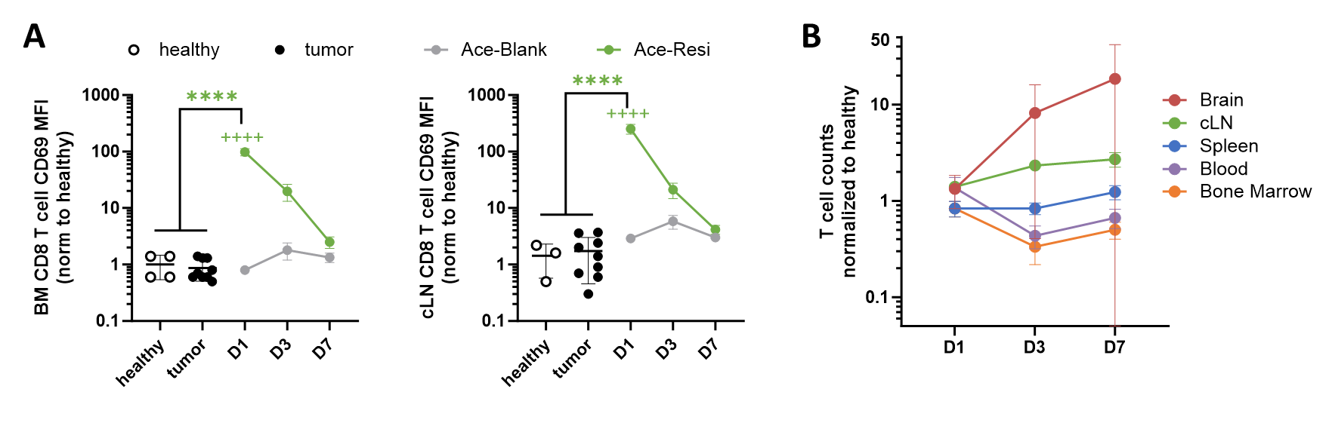
Supplemental Figure 9. Ace-Resi induces systemic signaling and T cell re-localization. (A) Normalized CD69 expression in CD8⁺ T cells in the bone marrow (BM) and cervical lymph node (cLN) 1, 3, and 7-days after resection and treatment with Ace-Resi (100µg) and Ace-Blank compared to unresected tumors ‘tumor’ and ‘healthy’ control. ****p<0.0001 by one-way ANOVA with multiple comparisons with respect to healthy or tumor group (*) or between Ace-Resi and Ace-Blank groups (+) with Tukey’s post-hoc test. (B) T cell counts from mice treated with Ace-Blank in specific organs normalized to ‘healthy’ controls.
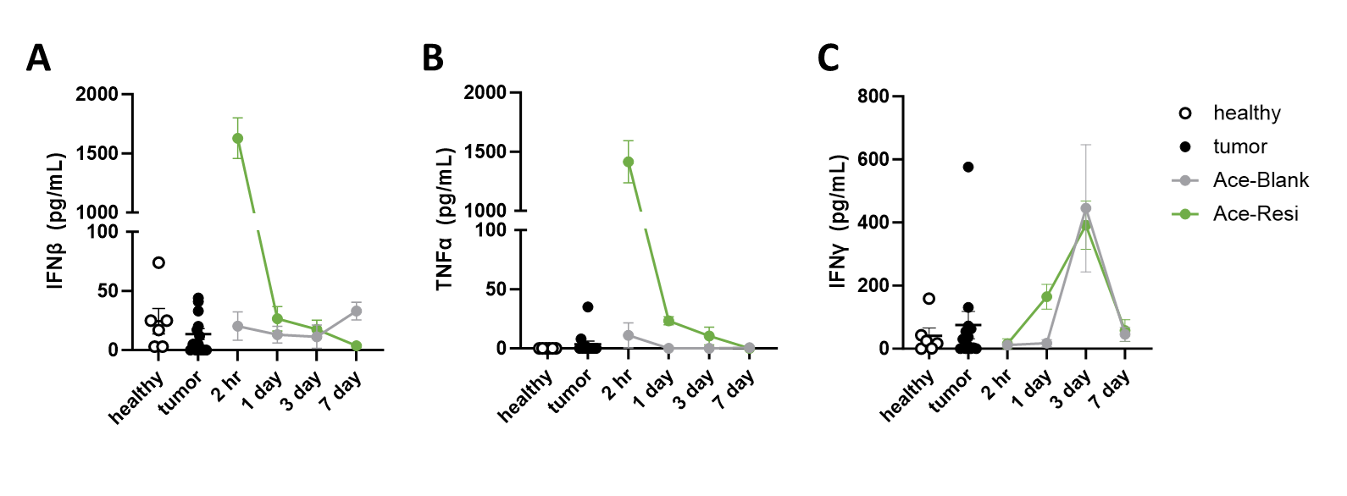
Supplemental Figure 10. Serum cytokine levels after treatment. Serum cytokines (A) IFNβ, (B) TNFα, (C) IFNγ as measured by ELISA 2 hours, 1, 3, and 7-days after resection and treatment with Ace-Resi (100µg) and Ace-Blank compared to unresected tumors ‘tumor’ and non-tumor bearing control ‘healthy’.

Supplemental Equation 1. Scaffold mass loss was calculated according to the following calculation: $Percent of mass loss= \left(1-\left(\frac{Mass at T_{x}}{Mass at T_{0}}\right)\right)x 100$.

Supplemental Equation 2. Resiquimod release was calculated according to the following calculation: $Percent of drug released= \left(1-\left(\frac{Drug Retained at T_{x}}{Drug at T_{0}}\right)\right)x 100$.

Supplemental Table 2. Groups and sample sizes for in vivo studies. Table details sample sizes and treatment groups for each study.

Study | Treatment Group | Sample size | Per timepoint
GL261-mCh-Luc dosing study | Ace-Blank | n=3 | ---
 | Soluble Resi (100 µg) | n=4 | ---
 | Ace-Resi (10 µg) | n=5 | ---
 | Ace-Resi (100 µg) | n=5 | ---
 | naïve (tumor challenge 1) | n=5 | ---
 | naïve (tumor challenge 2) | n=3 | ---
 | Healthy (flow cytometry) | n=2 | ---
GL261-mCh-Luc study | Ace-Blank | n=5 | ---
 | Ace-Resi (50 µg) | n=10 | ---
CT2A-Luc study | Ace-Blank | n=4 | ---
 | Soluble Resi (100 µg) | n=5 | ---
 | Ace-Resi (100 µg) | n=19 | ---
 | naïve (tumor challenge 1) | n=4 | ---
 | naïve (tumor challenge 2) | n=5 | ---
 | Healthy (flow cytometry) | n=5 | ---
CT2A-Par study | Ace-Resi (100 µg) | n=10 | ---
PK study | Soluble Resi | n=12 | n=3
 | Ace-Resi (100 µg) | n=15 | n=3
Early Immunological Effects  Days 1, 3, 7 | Healthy (no resection) control | n=4 | ---
Early Immunological Effects  Days 1, 3, 7 | Tumor (no resection) | n=9 | n=3 or n=9
 | Ace-Blank | n=9 | n=3
 | Ace-Resi (100 µg) | n=18 | n=6

Supplemental Table 3. Flow Cytometry Details. A complete list of antibody clones, fluorochrome conjugates, and dilutions for all flow experiments.
 | Systemic Lymphocyte Panel
 | Antigen | Clone | Vendor | Fluorophore | Dilution
 | live/dead | --- | Fisher | e506 | 1000
 | CD4 | GK1.5 | Biolegend | AF700 | 1000
 | CD8 | 53-6.7 | Biolegend | PerCp/Cy5.5 | 200
 | CD69 | H1.2F3 | Biolegend | PE | 200
 | CD90.2 | 30-H12 | Biolegend | AF488 | 250
 | CD44 | IM7 | Biolegend | BV421 | 400
 | CD62L | MEL-14 | Biolegend | BV785 | 400
 | CD19 | 6D5 | Biolegend | PE/Dazzle594 | 400
 | NK1.1 | S17016D | Biolegend | PE/Dazzle594 | 400
Bone Marrow S1P1 Panel
Antigen |  | Clone | Vendor | Fluorophore | Dilution
S1P1 |  | 713412 | R&D Systems | APC | 20
CD90.2 |  | 30-H12 | Biolegend | AF488 | 250
 | Brain Lymphocyte Panel
 | Antigen | Clone | Vendor | Fluorophore | Dilution
 | live/dead | --- | Fisher | e506 | 1000
 | CD4 | GK1.5 | Biolegend | AF700 | 1000
 | CD8 | 53-6.7 | Biolegend | PerCp/Cy5.5 | 200
 | CD25 | PC61 | Biolegend | APC/F750 | 200
 | IL-10 | JES5-16E3 | Biolegend | PE | 200
 | IFNγ | XMG1.2 | Biolegend | BV605 | 200
 | Granzyme B | GB11 | Biolegend | AF647 | 200
 | CD90.2 | 53-2.1 | BD Biosciences | BUV395 | 250
 | CD44 | IM7 | Biolegend | BV421 | 400
 | CD62L | MEL-14 | Biolegend | BV785 | 400
 | NK1.1 | S17016D | Biolegend | PE/Dazzle594 | 400
 | Foxp3 | MF-14 | Biolegend | AF488 | 400
 | PD-1 | 29F.1A12 | Biolegend | BV711 | 200
 | Myeloid Panel
 | Antigen | Clone | Vendor | Fluorophore | Dilution
 | live/dead | --- | Fisher | e506 | 1000
 | CD45 | 30-F11 | Biolegend | PerCp/Cy5.5 | 200
 | CD11c | N418 | Biolegend | APC | 600
 | CD11b | M1/70 | Biolegend | BV711 | 400
 | MHC II | M5/114.15.2 | Biolegend | FITC | 500
 | CD80 | 16-10A1 | Biolegend | PE/Cy7 | 800
 | CD86 | GL-1 | Biolegend | BV421 | 200
 | Ly6G | 1A8 | Biolegend | APC/Fire750 | 200
 | Ly6C | HK1.4 | Biolegend | BV605 | 400
 | CD19 | 6D5 | Biolegend | PE/Dazzle594 | 400
 | CD3 | 17A2 | Biolegend | PE/Dazzle594 | 200
 | TCRb | H57-597 | Biolegend | PE/Dazzle594 | 200
 | Microglia and Macrophage Panel
 | Antigen | Clone | Vendor | Fluorophore | Dilution
 | live/dead | --- | Fisher | e506 | 1000
 | CD80 | 16-10A1 | Biolegend | PE/Cy7 | 800
 | CD86 | GL-1 | Biolegend | BV421 | 200
 | CD206 | C068C2 | Biolegend | APC | 400
 | CD45 | 30-F11 | Biolegend | PerCp/Cy5.5 | 200
 | CD11c | N418 | Biolegend | FITC | 600
 | CD19 | 6D5 | Biolegend | PE/Dazzle594 | 400
 | CD3 | 17A2 | Biolegend | PE/Dazzle594 | 200
 | TCRb | H57-597 | Biolegend | PE/Dazzle594 | 200

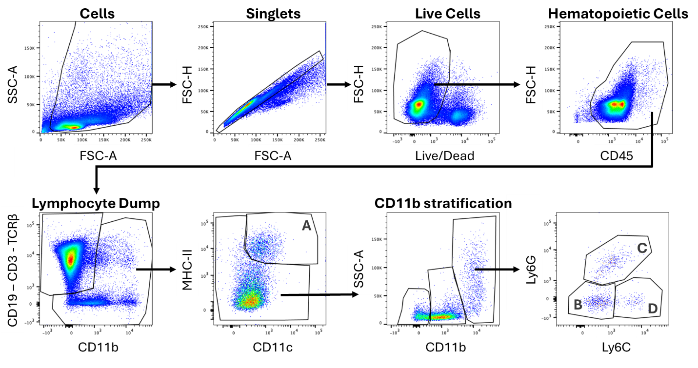
Supplemental Figure 11. Myeloid panel gating strategy. A: activated dendritic cells (MHC-II⁺ CD11c⁺). B: Macrophages (Ly6C⁻ Ly6G⁻), C: Neutrophils (Ly6C⁺ Ly6G⁺). D: Inflammatory monocytes (Ly6C⁺ Ly6G⁻).

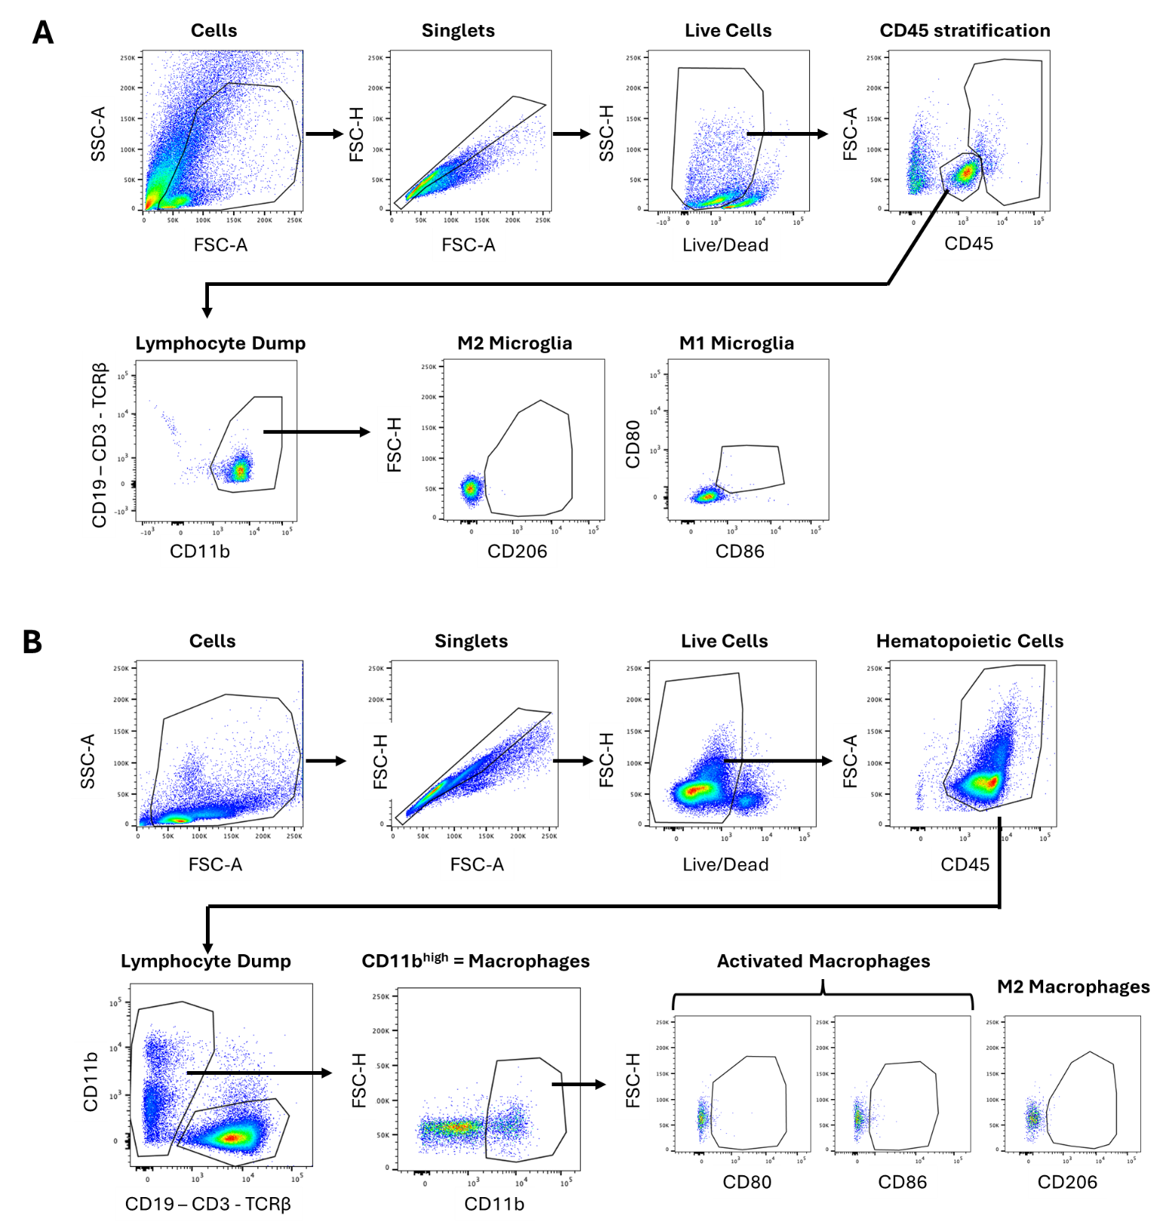
Supplemental Figure 12. A) Microglia and B) macrophage panel gating strategy.

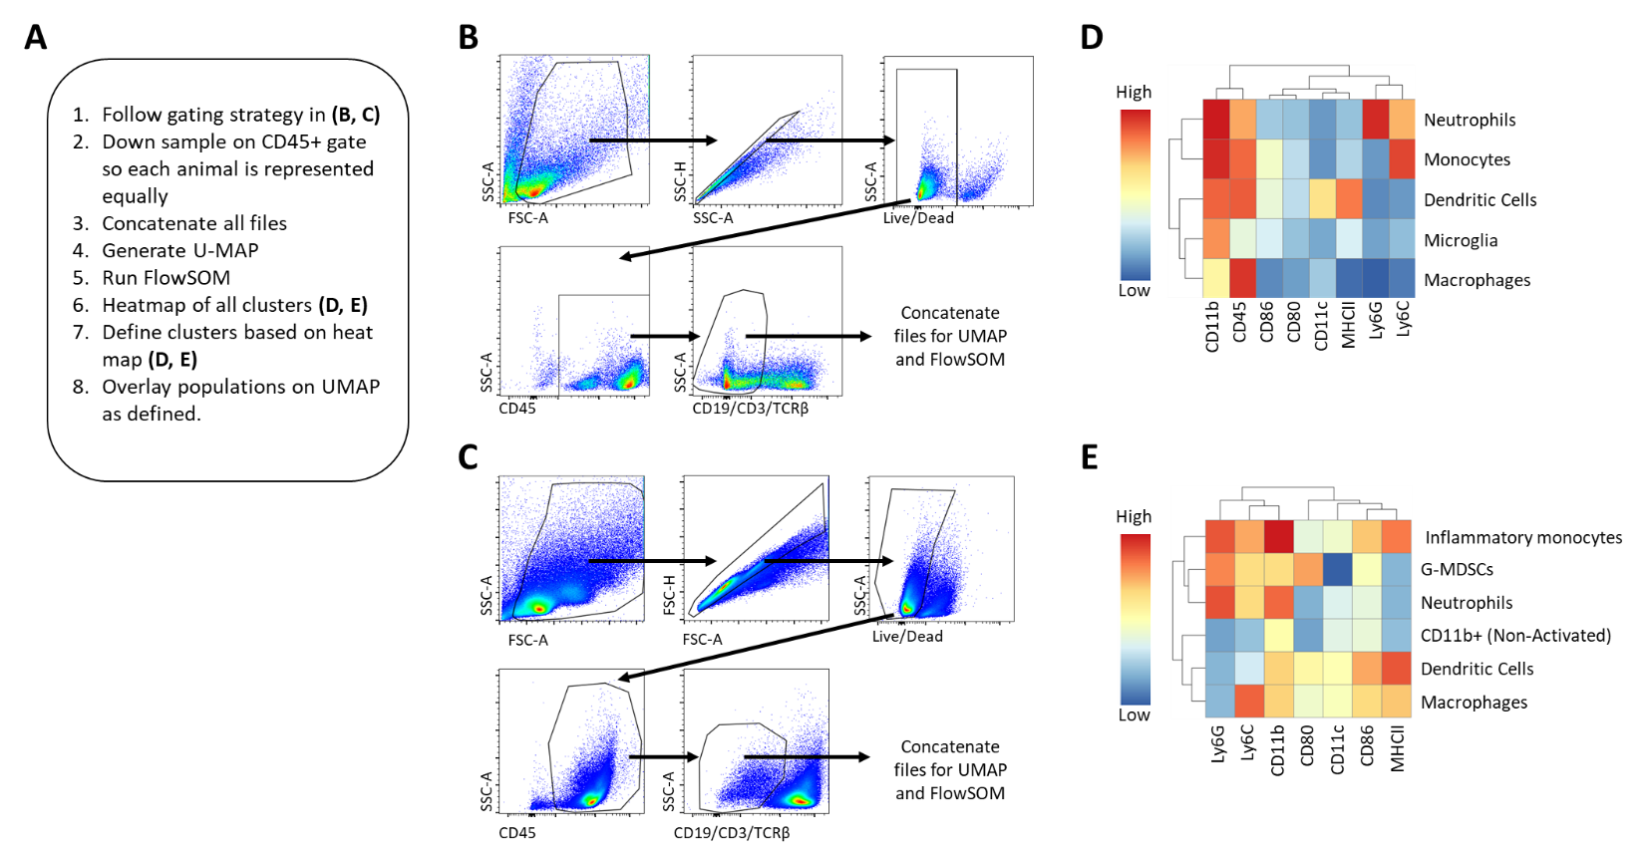

Supplemental Figure 13. FlowSOM UMAP Methodology. (A) Gating strategy for flow cytometry data. (B) Clustering workflow and analysis for brain and (C) cervical lymph node after resi treatment. (D) Heatmap output of clusters ran using FlowSOM and their cluster definitions for brain myeloid cells and (E) cervical lymph node myeloid cells.

