Supplementary information
Breeding water parameters are important determinants of Microsporidia MB prevalence in Anopheles mosquitoes at the aquatic stages

Esinam A. Akorli ^{1$}, Nana Efua Andoh ^{1,2 $}, Richardson K. Egyirifa¹ Christopher Dorcoo ¹, Sampson Otoo ¹, Seraphim N.A. Tetteh ¹, Reuben Mwimson Pul ¹, Derrick B. Sackitey ¹, Stephen K.D Oware ¹, Samuel K. Dadzie ¹, Jewelna Akorli ¹*.

¹ Department of Parasitology, Noguchi Memorial Institute for Medical Research, University of Ghana, P.O. Box LG 581, Legon Accra
² Department of Pathology, University of Cambridge, 10 Tennis Ct Rd, Cambridge CB2 1QP, United Kingdom

* Corresponding author: jakorli@noguchi.ug.edu.gh
$ These authors worked equally and are shared first authors.

Fig S1: Monthly average rainfall information for Ghana in 2021 (blue) and 2022 (green) obtained from ClimateEngine.org (https://www.climateengine.org/). Red horizonal lines are the annual average precipitation recorded for each sampling year.
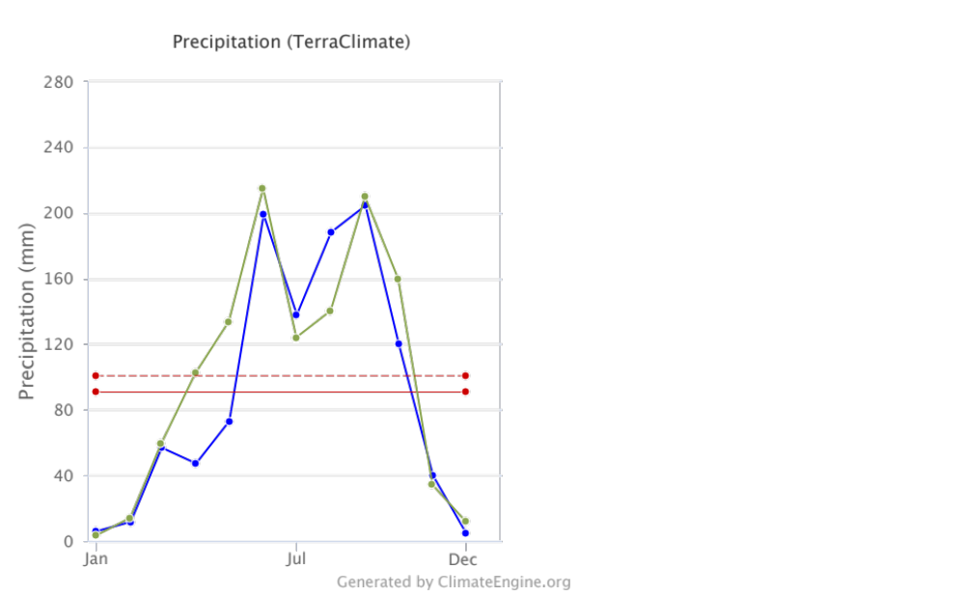
2021
2022

2022
2021

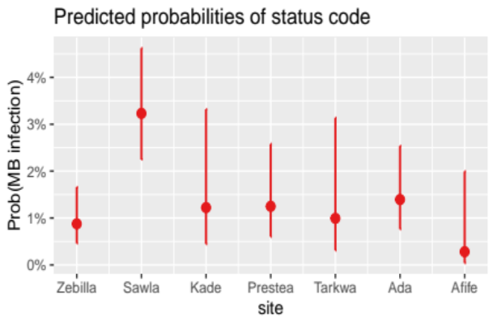
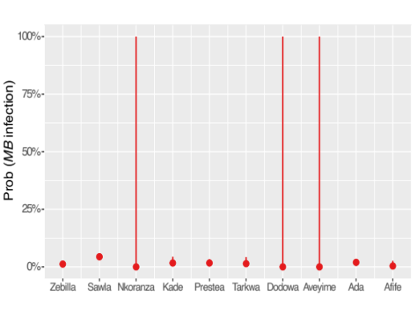
Fig S2: Predicted probabilities of MB infection in study sites according to the selected model status~ site+ sex.

Table S2: Compared logistic regression models fitted to identify significant categorical factors (study site and, mosquito species and sex) correlating with MB positivity.
 | Status |  | Status |  | Status
Predictors | Odds Ratios | P | Odds Ratios | P | Odds Ratios | P
(Intercept) | 0.01 *** | <0.001 | 0.02 *** | <0.001 | 0.01 *** | <0.001
site [Sawla] | 3.75 *** | <0.001 |  |  | 3.78 *** | <0.001
site [Nkoranza] | 0.00 | 0.993 |  |  | 0.00 | 0.993
site [Kade] | 1.40 | 0.570 |  |  | 1.40 | 0.567
site [Prestea] | 1.40 | 0.475 |  |  | 1.43 | 0.443
site [Tarkwa] | 1.16 | 0.819 |  |  | 1.14 | 0.846
site [Dodowa] | 0.00 | 0.994 |  |  | 0.00 | 0.994
site [Aveyime] | 0.00 | 0.983 |  |  | 0.00 | 0.983
site [Ada] | 1.63 | 0.237 |  |  | 1.60 | 0.255
site [Afife] | 0.31 | 0.263 |  |  | 0.32 | 0.275
sex [male] |  |  | 1.85 ** | 0.004 | 1.85 ** | 0.004
Observations | 4255 |  | 4255 |  | 4255
R² Tjur | 0.010 |  | 0.002 |  | 0.013
AIC | 860.451 |  | 883.077 |  | 854.104
* p<0.05 ** p<0.01 *** p<0.001

Table S3: Results for test of statistical relationship between study site, mosquito species and sex as interaction terms for MB occurrence.

Call: anova(modelst_sp_sx, test="Chisq")
Model: binomial, link: logit
Response: status

Terms added sequentially (first to last)

 | Df | Deviance | Residual Df | Residual Deviance | P-value
NULL | 4255 | 5898.70
site | 10 | 5058.20 | 4245 | 840.5 | < 2.20e-16 | ***
species | 11 | 8.90 | 4234 | 831.6 | 0.635216
sex | 1 | 9.90 | 4233 | 821.7 | 0.001695 | **

Table S6: Comparison of outputs for models on water abiotic parameters association with MB prevalence.

 | status code |  | status code |  | status code |  | status code
Predictors | Odds Ratios | p | Odds Ratios | p | Odds Ratios | p | Odds Ratios | p
(Intercept) | 0.00 | 0.377 | 0.83 | 0.843 | 2285.39 | 0.633 | 2.66 | 0.667
TURB | 1.00 | 0.337 | 1.00 | 0.071 | 1.00 | 0.192 | 1.00 | 0.429
SAL | 0.75 | 0.718 |  |  | 0.43 | 0.596
Ca | 1.03 | 0.117 |  |  | 1.02 | 0.296
NO3 N | 0.41 | 0.334 |  |  | 28.30 | 0.249
PO4 P | 1.01 | 0.956 | 0.93 | 0.711 | 23.23 | 0.419 | 1.43 | 0.525
SO4 | 0.99 | 0.114 | 1.00 | 0.160 | 0.99 | 0.258 | 0.99 | 0.183
NH4 N | 0.99 | 0.923 | 0.95 | 0.448 | 0.40 | 0.197 | 0.79 * | 0.048
BOD | 1.04 * | 0.049 | 1.03 * | 0.029 | 1.08 | 0.052 | 1.04 * | 0.016
Mn | 0.32 * | 0.046 | 0.45 | 0.074 | 0.28 | 0.119 | 0.33 | 0.083
Cu | 4.72 | 0.956 | 0.00 | 0.634 | 395.64 | 0.890 | 17661.52 | 0.769
Zn | 0.00 | 0.085 | 0.00 | 0.081 | 0.00 | 0.092 | 0.00 | 0.180
pH | 1.77 | 0.540 |  |  | 0.03 | 0.192
Temp | 1.03 | 0.478 |  |  | 2.02 | 0.131
DO | 1.15 | 0.076 | 1.15 * | 0.043 | 1.05 | 0.840 | 1.16 | 0.231
Site [Afife] |  |  |  |  | 1.59 | 0.915 | 1.42 | 0.858
Site [Aveyime] |  |  |  |  | 0.00 | 0.993 | 0.00 | 0.997
Site [Dodowa] |  |  |  |  | 0.00 | 0.998 | 0.00 | 0.998
Site [Kade] |  |  |  |  | 5607147.73 | 0.999 | 49075008.87 | 0.999
Site [Nkoranza] |  |  |  |  | 0.00 | 0.989 | 0.00 | 0.991
Site [Sawla] |  |  |  |  | 0.89 | 0.969 | 0.30 | 0.610
Site [Zebilla] |  |  |  |  | 0.00 | 0.118 | 0.04 | 0.189
Observations | 60 |  | 60 |  | 60 |  | 60
R² Tjur | 0.476 |  | 0.396 |  | 0.685 |  | 0.577
AIC | 75.498 |  | 71.997 |  | 71.357 |  | 70.474
* p<0.05 ** p<0.01 *** p<0.001

Table S6:

Table S
Call:
glm(formula = status_code ~ (Mn + NH4..N + BOD + Site)^2, family = binomial(link = "logit"),
data = physico)

Coefficients: (6 not defined because of singularities)
Estimate Std. Error z value Pr(>|z|)
(Intercept) 6.896e+15 4.515e+07 152743513 <2e-16 ***
Mn -4.204e+16 1.591e+08 -264235909 <2e-16 ***
NH4..N -8.362e+15 2.027e+07 -412511198 <2e-16 ***
BOD 9.649e+14 2.274e+06 424214281 <2e-16 ***
SiteAfife -4.246e+15 1.935e+08 -21939254 <2e-16 ***
SiteAveyime -4.630e+16 1.356e+08 -341430943 <2e-16 ***
SiteDodowa -2.965e+15 1.040e+08 -28512269 <2e-16 ***
SiteKade 1.796e+15 7.829e+07 22934796 <2e-16 ***
SiteNkoranza -6.891e+15 9.229e+07 -74667386 <2e-16 ***
SiteSawla -8.136e+15 4.850e+07 -167750643 <2e-16 ***
SiteZebilla -8.721e+15 5.056e+07 -172481715 <2e-16 ***
Mn:NH4..N -1.177e+14 3.782e+06 -31115976 <2e-16 ***
Mn:BOD 4.480e+12 1.264e+05 35456545 <2e-16 ***
Mn:SiteAfife 4.227e+16 1.605e+08 263349216 <2e-16 ***
Mn:SiteAveyime 6.843e+16 3.383e+08 202259106 <2e-16 ***
Mn:SiteDodowa -8.939e+16 1.071e+09 -83434005 <2e-16 ***
Mn:SiteKade NA NA NA NA
Mn:SiteNkoranza 3.822e+16 2.088e+08 183054146 <2e-16 ***
Mn:SiteSawla 4.377e+16 1.941e+08 225519241 <2e-16 ***
Mn:SiteZebilla 4.065e+16 1.589e+08 255758856 <2e-16 ***
NH4..N:BOD -1.163e+12 2.705e+04 -43002147 <2e-16 ***
NH4..N:SiteAfife 1.003e+16 3.033e+07 330749035 <2e-16 ***
NH4..N:SiteAveyime 6.939e+15 1.839e+07 377329713 <2e-16 ***
NH4..N:SiteDodowa NA NA NA NA
NH4..N:SiteKade NA NA NA NA
NH4..N:SiteNkoranza 8.174e+15 2.331e+07 350693415 <2e-16 ***
NH4..N:SiteSawla 8.563e+15 2.024e+07 423093579 <2e-16 ***
NH4..N:SiteZebilla 8.737e+15 2.156e+07 405267286 <2e-16 ***
BOD:SiteAfife -1.164e+15 6.675e+06 -174346086 <2e-16 ***
BOD:SiteAveyime NA NA NA NA
BOD:SiteDodowa NA NA NA NA
BOD:SiteKade NA NA NA NA
BOD:SiteNkoranza -9.745e+14 2.322e+06 -419724468 <2e-16 ***
BOD:SiteSawla -9.439e+14 2.269e+06 -415943916 <2e-16 ***
BOD:SiteZebilla -9.241e+14 2.274e+06 -406376653 <2e-16 ***
---
Signif. codes: 0 ‘***’ 0.001 ‘**’ 0.01 ‘*’ 0.05 ‘.’ 0.1 ‘ ’ 1

(Dispersion parameter for binomial family taken to be 1)

Null deviance: 80.761 on 59 degrees of freedom
Residual deviance: 1009.222 on 31 degrees of freedom
AIC: 1067.2

Number of Fisher Scoring iterations: 25

