Identification and structural characterization of novel bacteriocins by genome-wide screening of hypothetical mini-proteins in Staphylococcus aureus.
Anirudha Dutta*, Suman Deb#, Bishista Dasgupta#, Aleya Khatoon#, Arpita Mal#, Taskeen Kauser#

Supplementary data
Supplementary Figure S1: Solvent accessible surface area
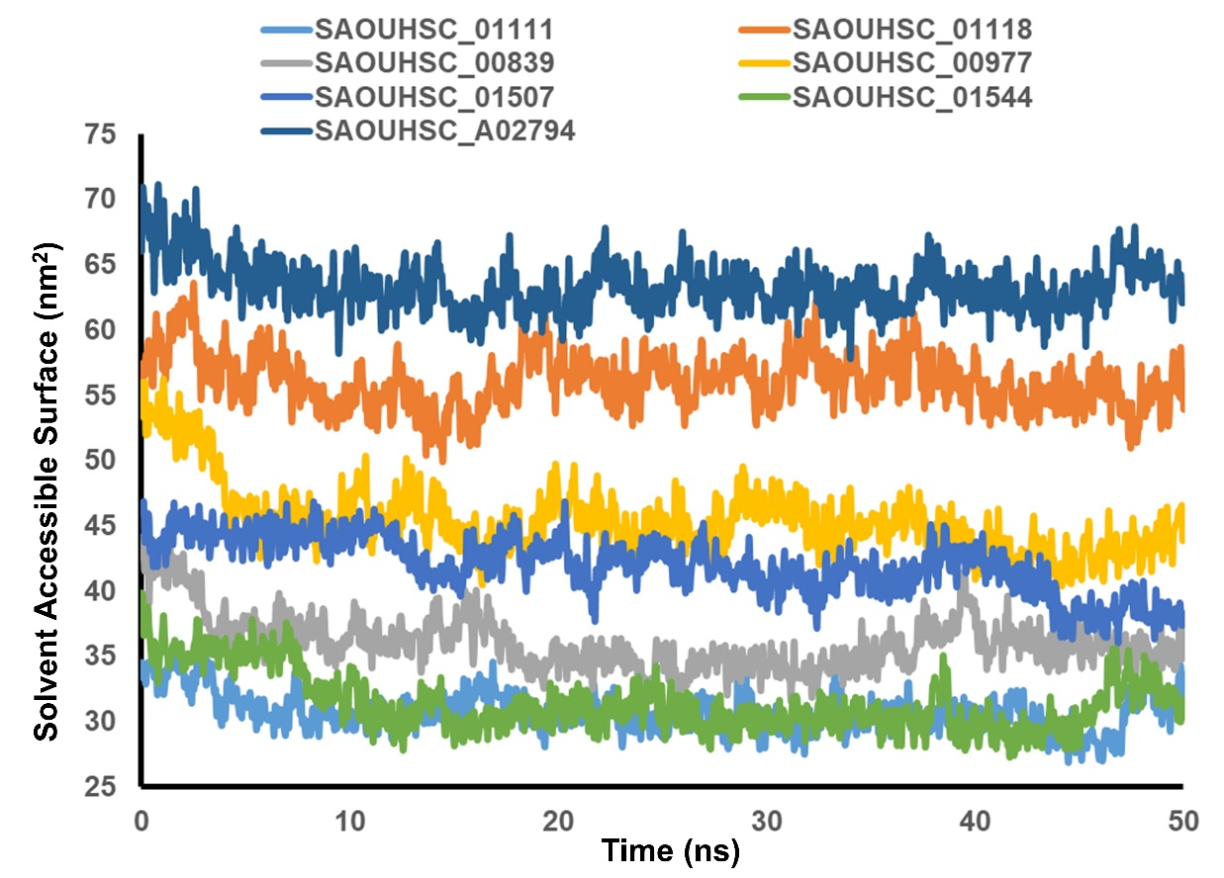

Supplementary Figure S2: overall H-bonding
