Supplementary Figures

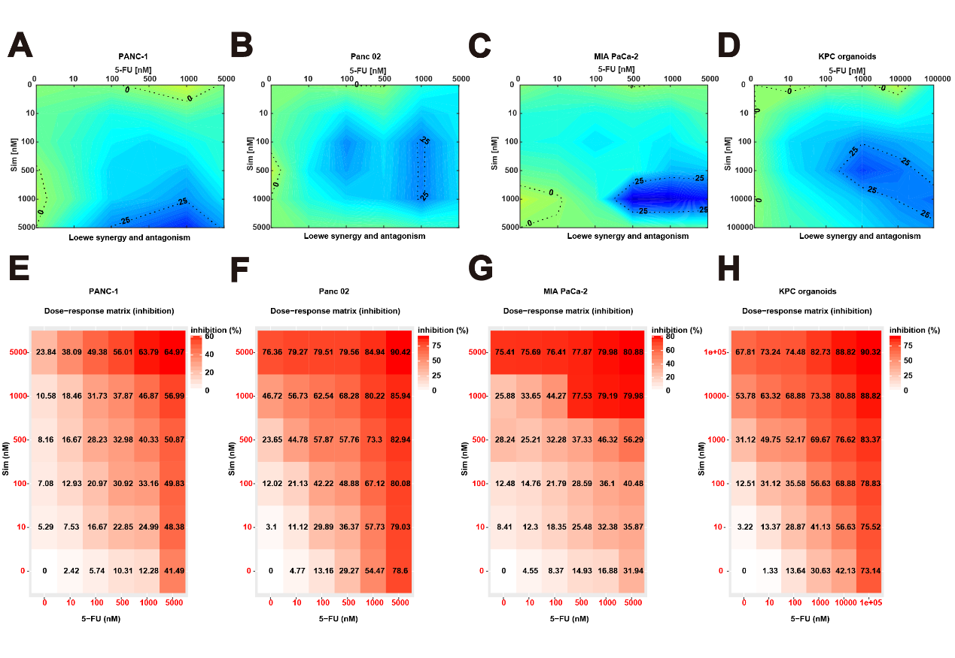
Supplementary Fig.1
(A-H) Synergistic distribution and Dose-response matrix (inhibition) of 5-FU and simvastatin in three PC cell lines and organoids of KPC mice.
Supplementary Tables

Supplementary Table 1. The correlation between HMGCR level and age, sex, AJCC stage, differentiation degree, and CA19-9 value.
 | Variable | High HMGCR  (n=31) | Low HMGCR  (n=25) | P value | t/z | Chi-Square
Age | Mean ± SD | 58.35±7.163 | 57.76±6.009 | 0.742 | -0.332
Sex | Male  Famale | 15  16 | 15  10 | 0.386 |  | 0.750
AJCC stage | I  II  III | 2  22  7 | 19  6  0 | <0.001 |  | 29.602
Differentiation  degree | Poorly  Moderately  Well | 22  7  2 | 10  9  6 | 0.046 |  | 6.178
CA 19-9 value | Median (IQR) | 564.4(516-671) | 350(35.65-572.4) | 0.003 | -2.992

Supplementary Materials and Methods
Cell Viability Assay
Approximately 2000 Panc 02 cells or 4000 PANC-1 and MIA PaCa-2 cells were seeded into 96-well plates. After 24 hours, allowing for cell adhesion, the cells were treated with varying concentrations of 5-FU or simvastatin. After 72 hours, Cell viability was measured by the Cell Counting Kit-8 (Selleck, #B34302).
Cell Count Assay
Approximately 2000 Panc 02 cells or 4000 PANC-1 and MIA PaCa-2 cells were seeded into 96-well plates. After 24 hours, allowing for cell adhesion, the cells were treated with specified concentrations of 5-FU or simvastatin. During the subsequent 72 hours of treatment, images of the 96-well plate were captured every 12 hours using the Operetta CLS™ high-content analysis system (PerkinElmer, USA), and cell counts were analyzed with Harmony software (version 4.9, USA).
Working Concentration and Synergy Analysis of 5-Fluorouracil and Simvastatin
5-FU (HY-9006) and simvastatin (HY-17502) are both sourced from MCE (MedChemExpress) company.For both dose-response curves, the gradient concentrations ranged from 0 to 100 μM.The three-dimensional synergy visualization model (LOEWE) and synergy score for 5-FU and simvastatin in PC cells were generated using Combenefit software and the SynergyFinder web application (version 3.0).
Antibody information
The primary antibodies used in immunofluorescence (IF) staining assay were as follows: rabbit anti-Ki67 (1:200, Abcam, #ab16667), mouse anti-Pan-Keratin (1:200, Cell Signaling Technology, #4545S), rabbit anti-NLRP3 (1:200, Proteintech, #27458-1-AP). And the secondary antibodies were goat anti-rabbit IgG H&L (Alexa Fluor® 488,1:500, Abcam, #ab150077), goat anti-mouse IgG H&L (Alexa Fluor® 594,1:500, Abcam, #ab150116). The primary antibodies used in immunohistochemistry (IHC) staining assay were as follows: rabbit anti-HMGCR (1:100, Proteintech, #13533-1-AP) and rabbit anti-GSDMD (1:100, Proteintech, #20770-1-AP).
Immunoblotting
The detailed methodologies for immunoblotting have been earlier mentioned[1]. The primary antibodies used in immunoblotting assay were as follows: rabbit anti-Caspase 1 (1:2500, Proteintech, #222915-1-AP), rabbit anti-GSDMD (1:1000, Proteintech, #20770-1-AP),rabbit anti-GAPDH (1:1000, Proteintech, #10494-1-AP). The ratio of secondary antibody of goat anti-rabbit IgG (ABclonal, # AS014) was 1:10000.
Immunofluorescence
PC cells were seeded in 10-mm diameter cell culture dishes, permeabilized with 4% paraformaldehyde fixative (Biosharp,#BL539A).Cells or antigen-retrieved sections were blocked with IF blocking solution (Beyotime,#P0260) for 1 hour. The primary antibody was incubated overnight at 4°C after blocking. The following day, the cells or sections were washed with PBST (0.05% Tween-20 in PBS) and incubated with the corresponding fluorescent secondary antibody for 2 hours at room temperature. The staining was then captured using the TISSUE FAXS PLUS system (TissueGnostics, Austria).
Immunohistochemistry
Paraffinembedded tumor tissues were cut into 4-μm-thick sections. The sections were deparaffinized, rehydrated in consecutive ethanol solution, and antigens were retrieved in a pressure pot with citrate repair solution (pH 6.0). Subsequent staining was performed using the UltraSensitiveTM SP (mouse/rabbit) IHC kit (MXB, #KIT-9710) and then the color reaction was performed with diamino hydrazine and hematoxylin. The staining was then captured using the TISSUE FAXS PLUS system (TissueGnostics, Austria). The staining intensity (grade from 0 to 3) and the percentage of positive cells (0-100%) were evaluated by three pathologists at the Second Hospital of Lanzhou University. The IHC score was calculated based on these assessments, with high and low expression levels of HMGCR and GSDMD distinguished by the median IHC score (HMGCR,162.5;GSDMD,165).

Reference

1. Yu Z, Jiang X, Qin L, Deng H, Wang J, Ren W, Li H, Zhao L, Liu H, Yan H et al: A novel UBE2T inhibitor suppresses Wnt/β-catenin signaling hyperactivation and gastric cancer progression by blocking RACK1 ubiquitination. Oncogene 2021, 40(5):1027-1042.

