(A)Centroid transfer of Oceania
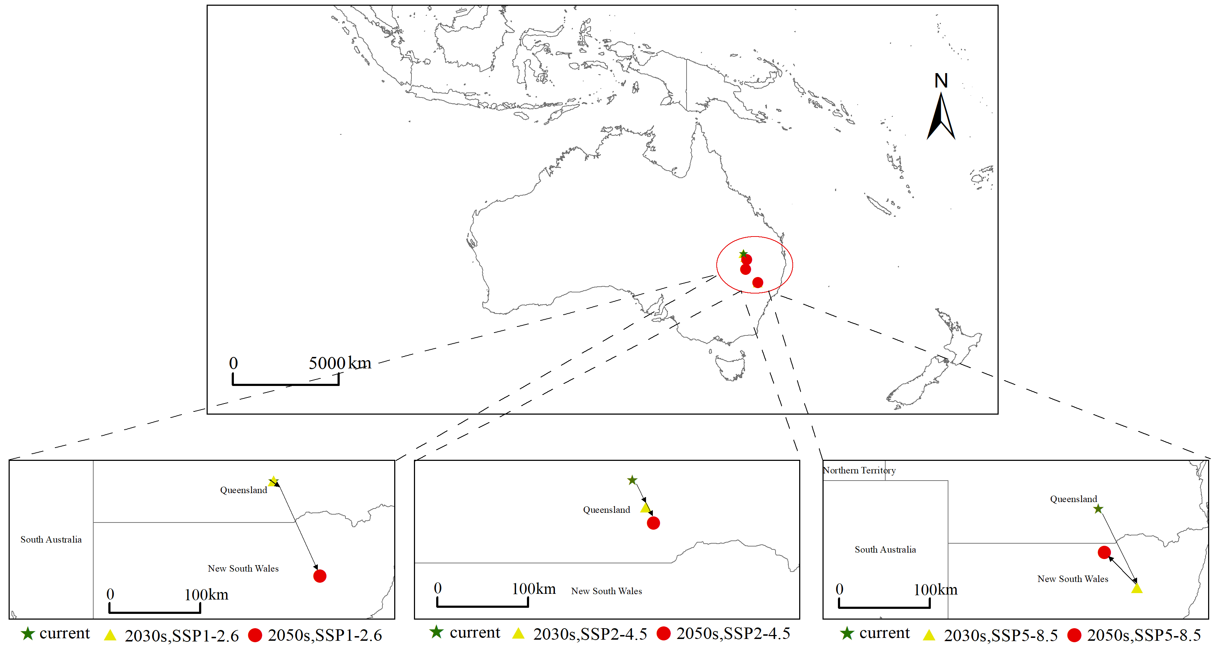
(B)Centroid transfer of Asia
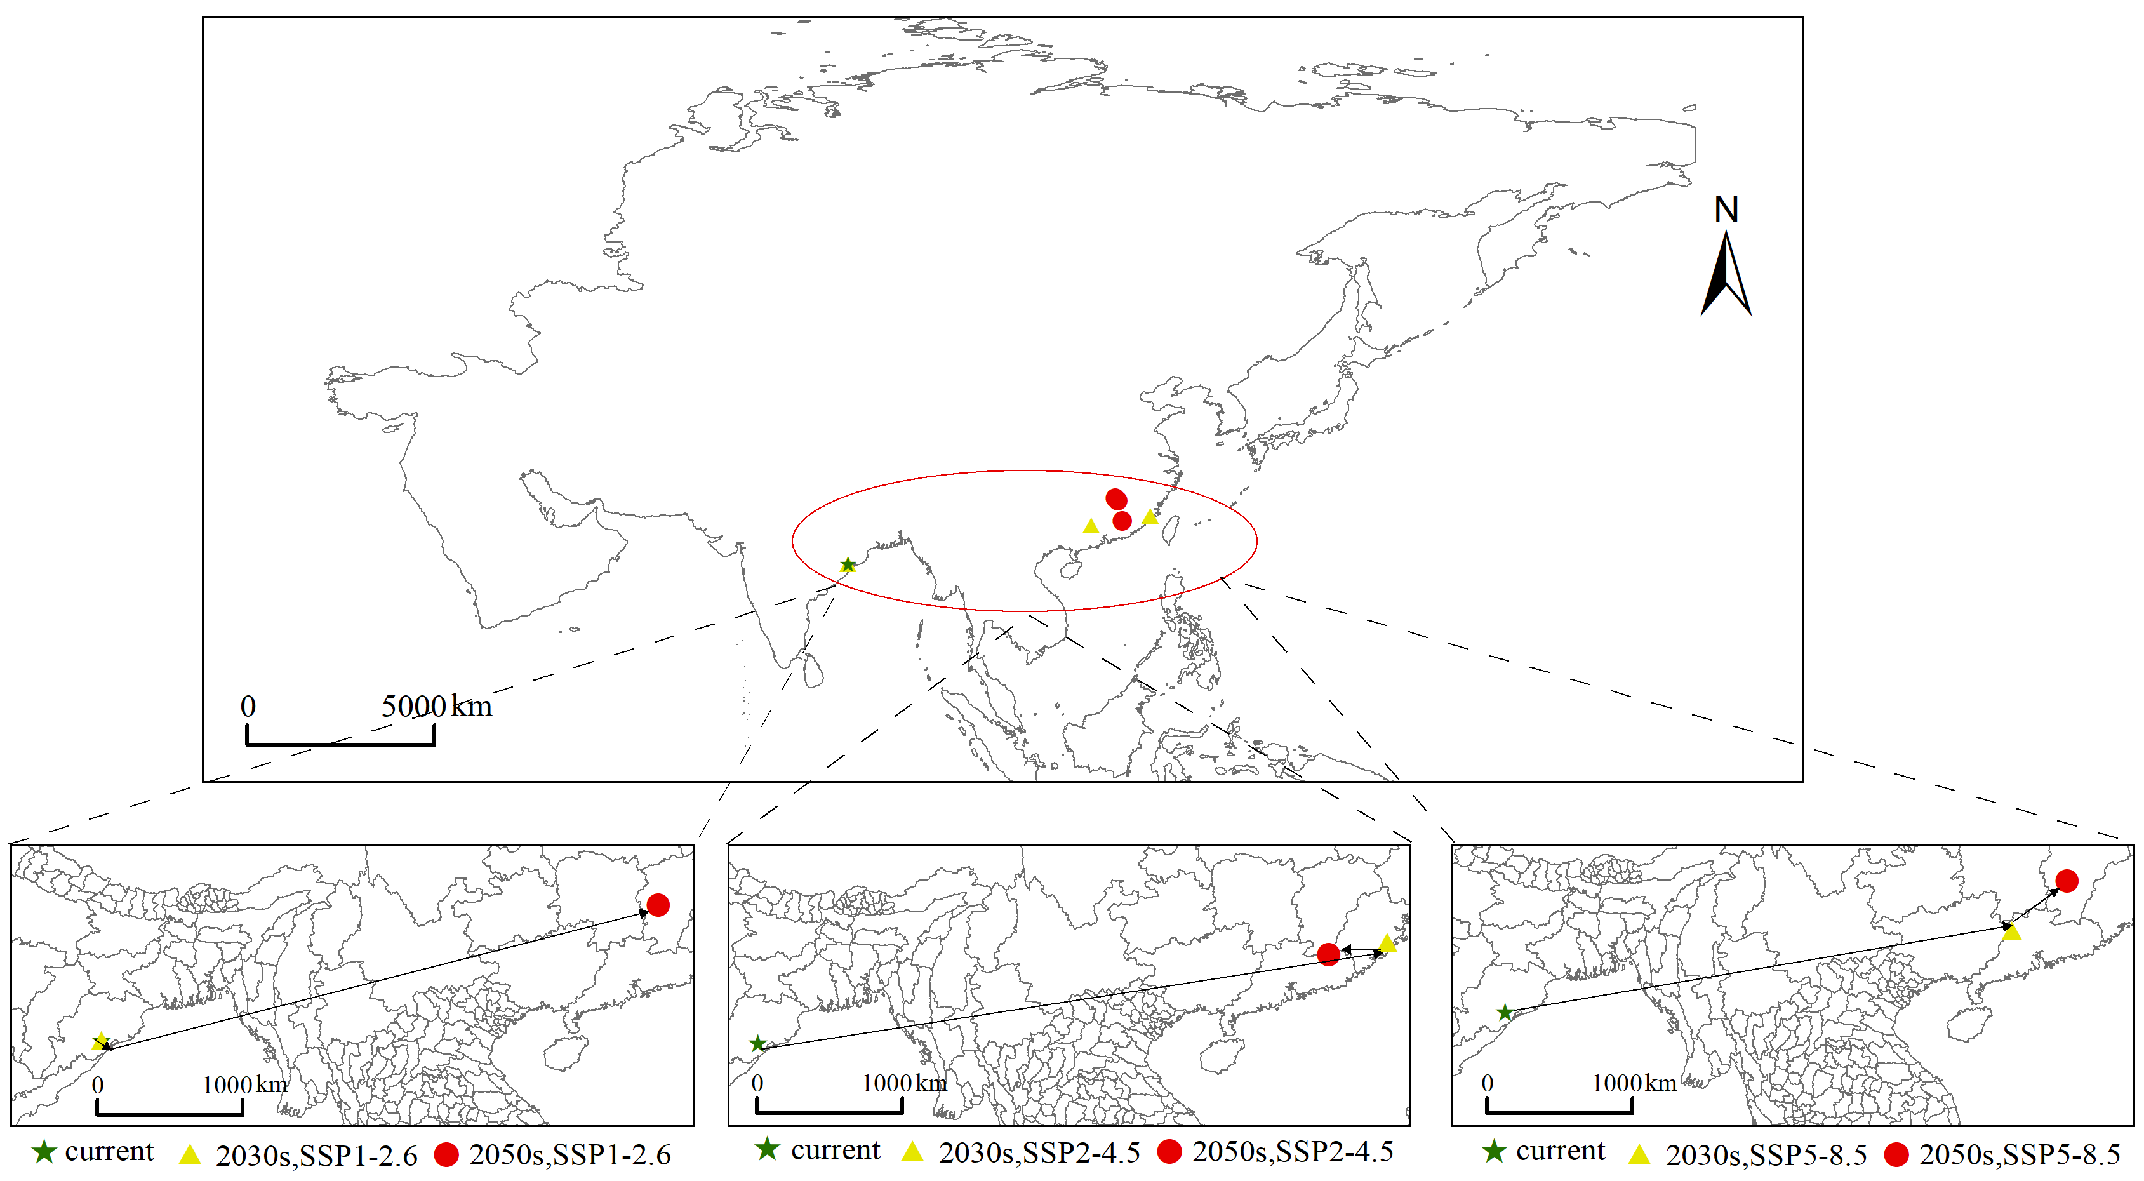
(C)Centroid transfer of South America
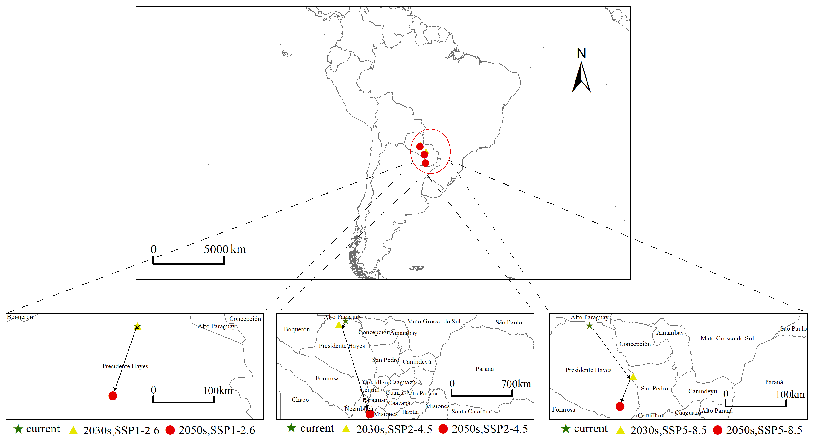
(D)Centroid transfer of Africa
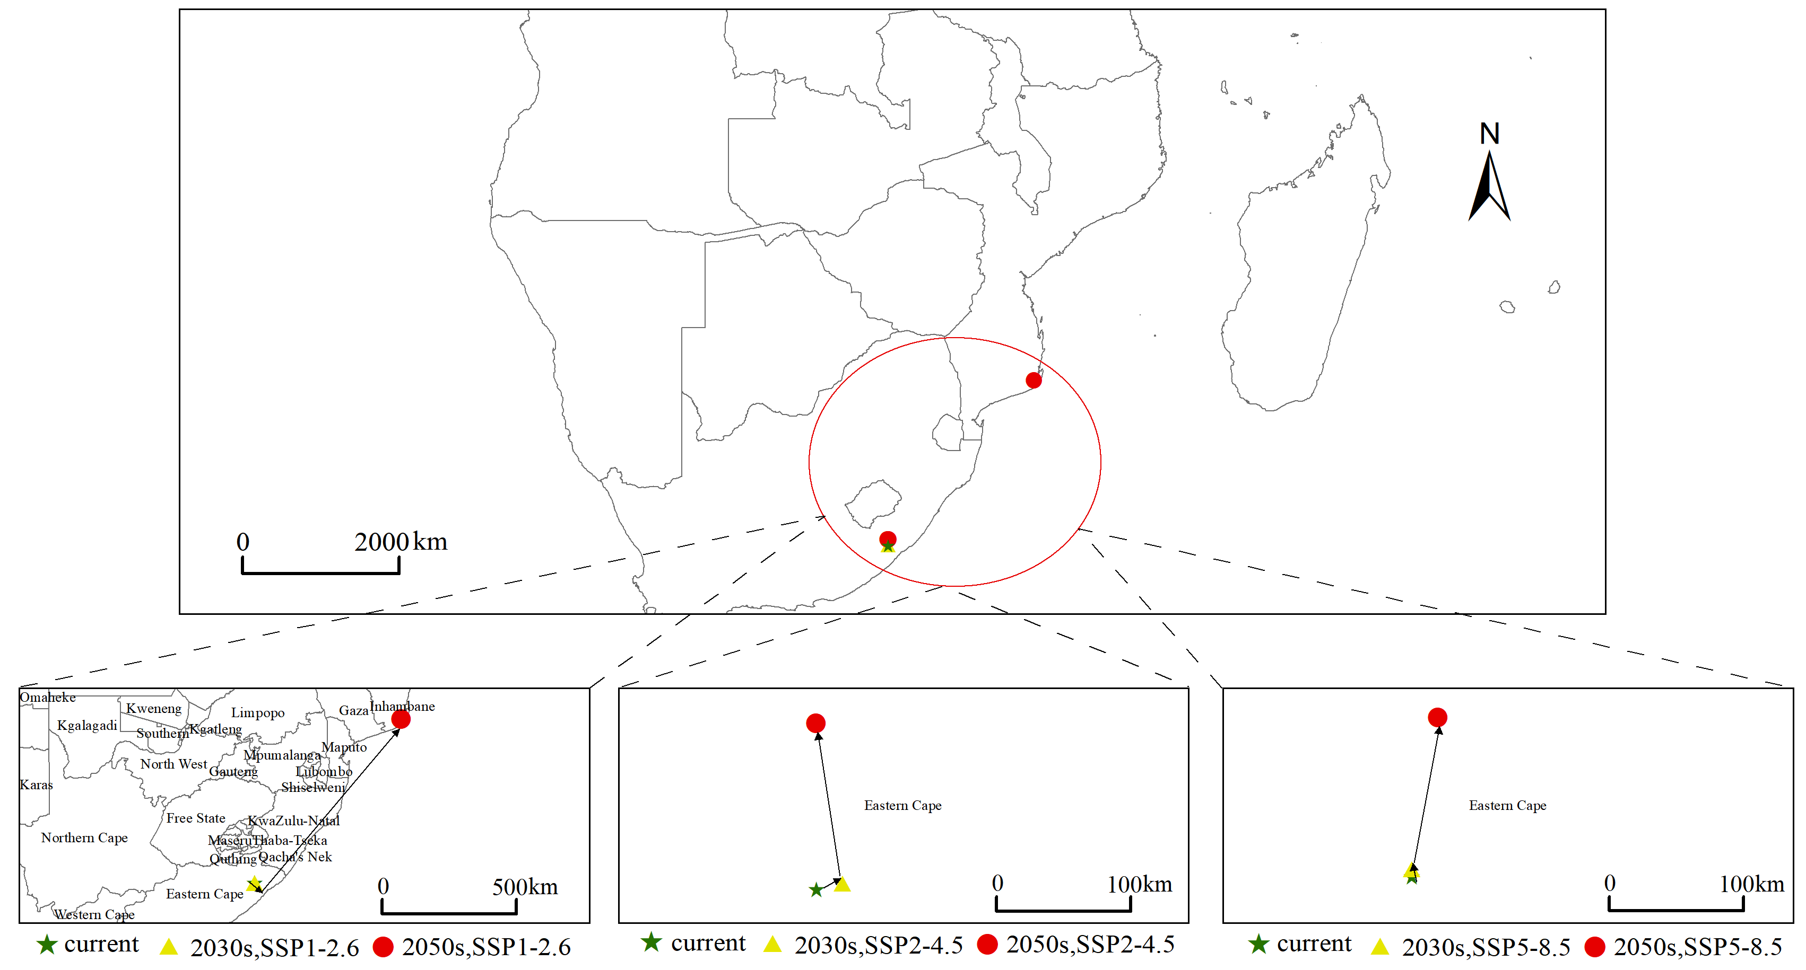
(E)Centroid transfer of Europe
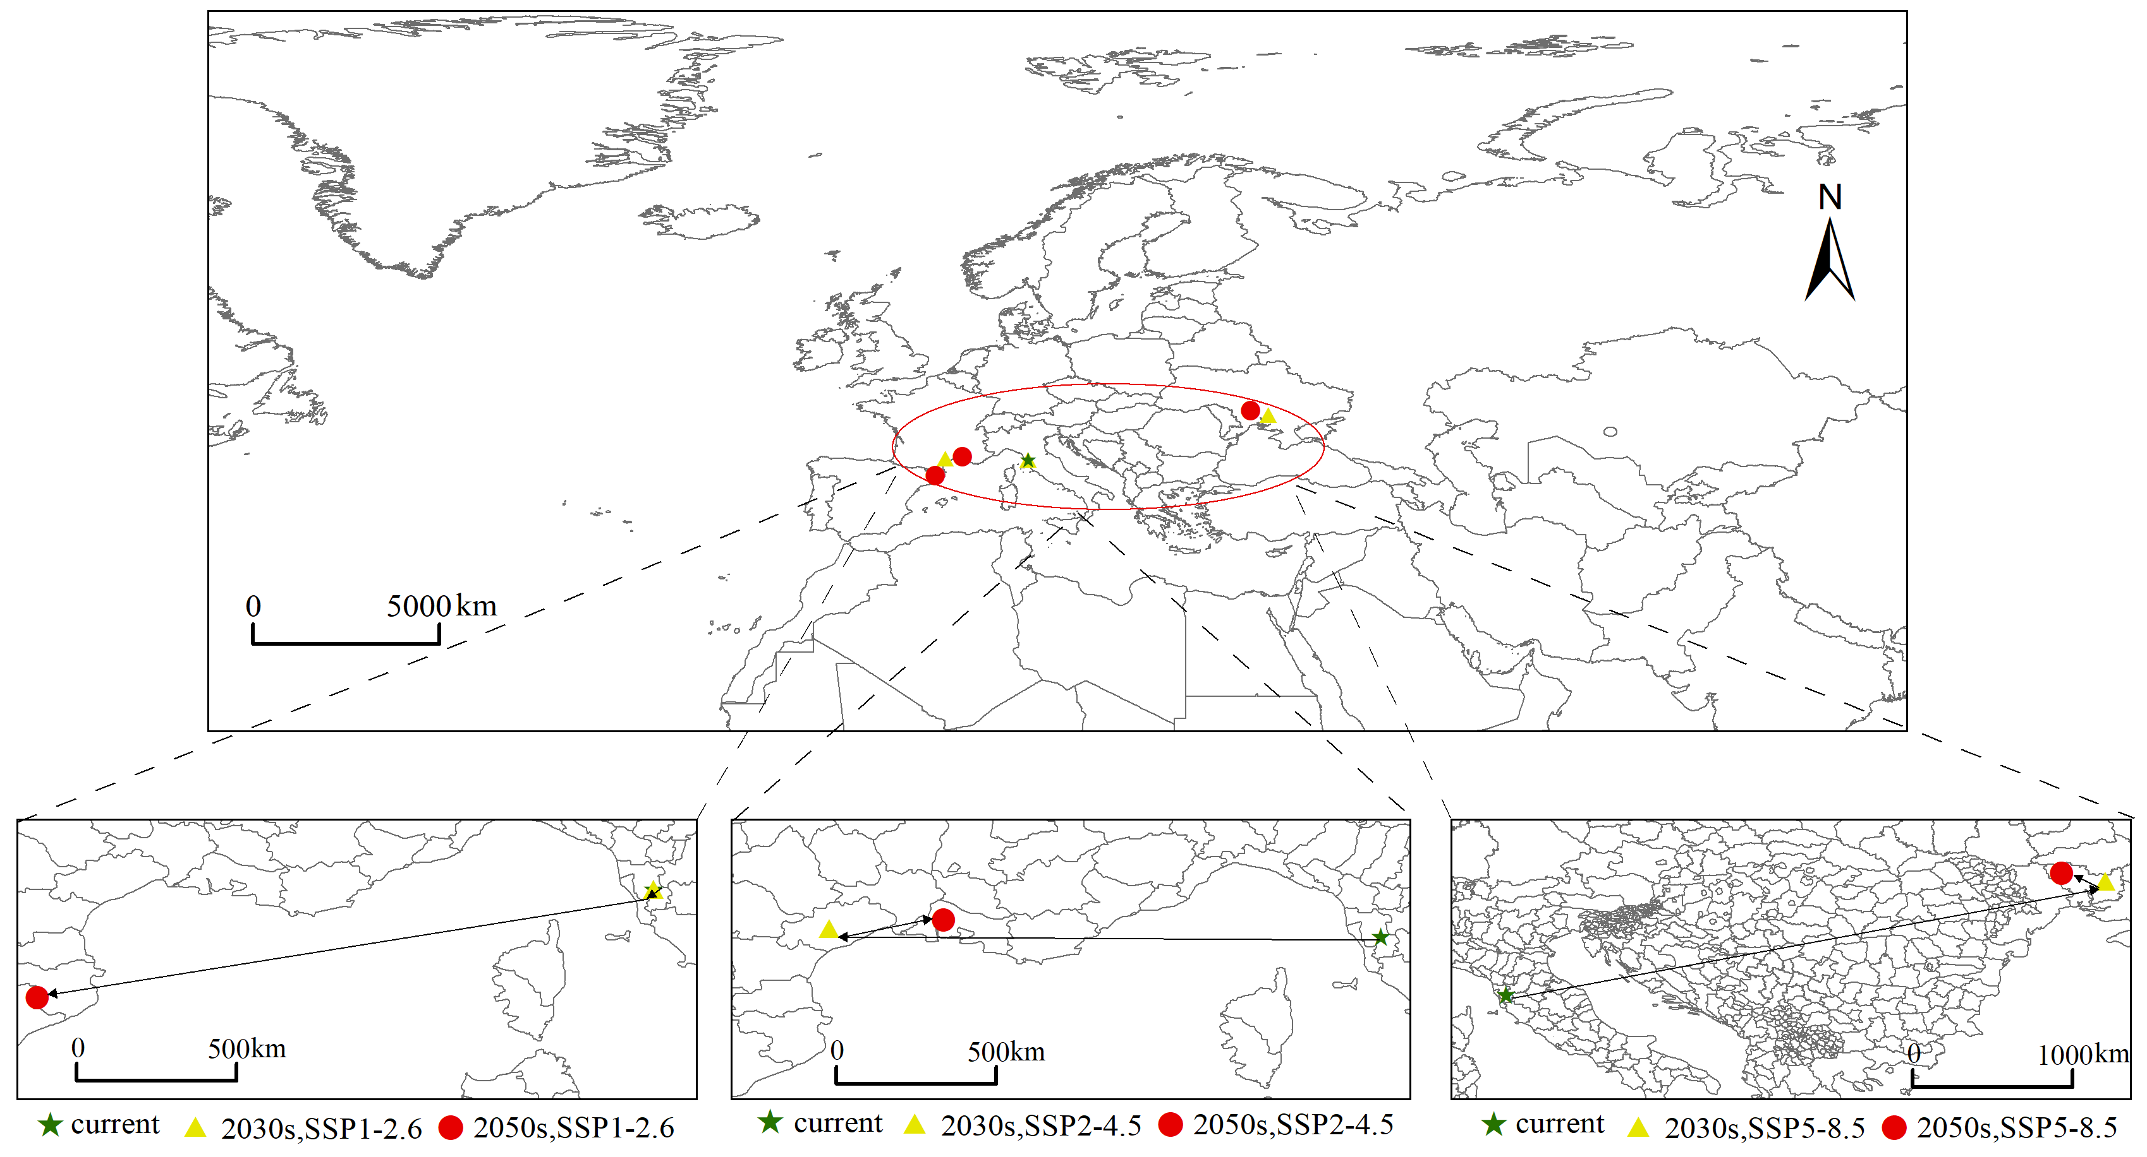

Figure. S2. Centroid shift of Anthonomus eugenii on different continents.

