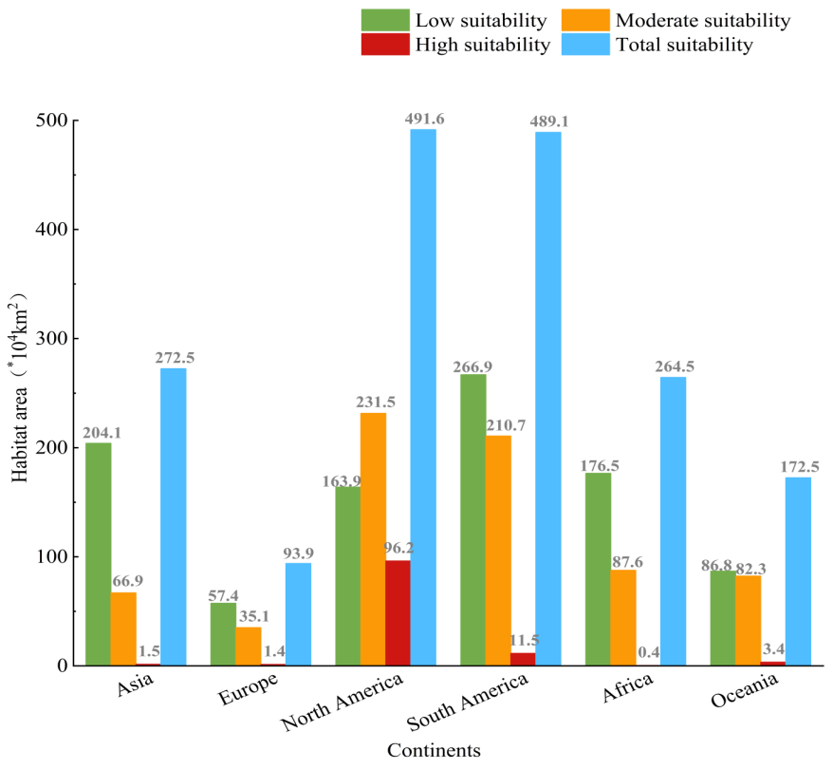
Figure. S1. Area of different types of suitable areas in six continents under current climate scenarios.

