Supplementary Materials:
A  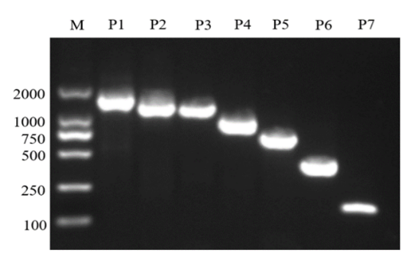 | B  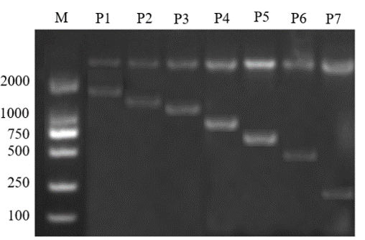

Figure S2. Agarose gel electrophoresis of the original deletion promoter fragment. (A) Different lengths of fragments of CDH11 promoter cloned by RT-PCR. (B) Detection of vectors construction of CDH11 promoter in different lengths fragments. M: marker, P1: PGL-1855/+55, P2: PGL-1629/+55, P3: PGL-1329/+55, P4: PGL-1029/+55, P5: PGL-729/+55, P6: PGL-429/+55 and P7: PGL-129/+55.

