Extended Data Figures

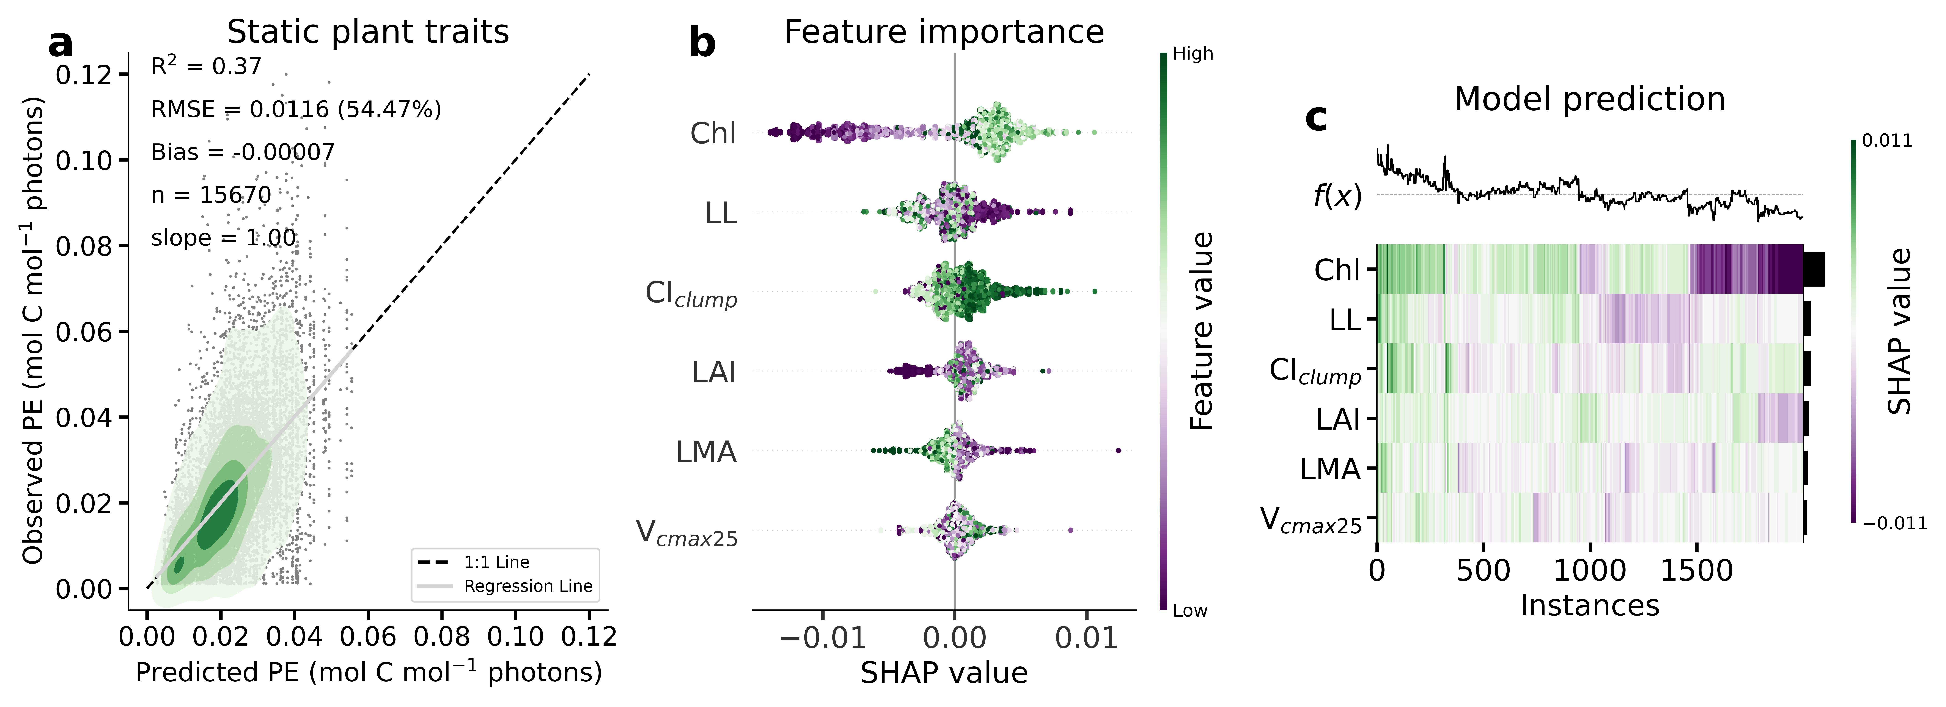
Extended Data Fig. 1 (a) Explanatory power of static leaf traits (representing the growing season mean) only in estimating daily ecosystem-scale PE for C₃ vegetation, shaded area indicates Gaussian kernel density estimation. (b) Contribution (SHAP value) of each feature ranked in descending order of importance, along with their relative feature values. (c) Heatmap showing clustering of 2,000 random instances by their local explanation embedding. Columns represent instances, and rows represent features’ SHAP values for each explanatory variable, where the f(x) denots the model predicted PE for each instance. Chl: leaf chlorophyll content; CI_{clump}: clumping index; LAI: leaf area index; LL: leaf longevity; LMA: leaf mass per area; V_{cmax25}: maximum carboxylation rate at 25 °C.

Extended Data Fig. 2 Explanatory power of various factors in estimating daily variation in ecosystem-scale PE for C₄ vegetation: (a, d, g) climatic factors only, (b, e, h) dynamic leaf traits and canopy structure, and (c, f, i) dynamic leaf traits, climatic factors, and canopy structure; shaded area indicates Gaussian kernel density estimation. (d, e, f) Contribution (SHAP value) of each feature ranked in descending order of importance, along with their relative feature values. (g, h, i) Heatmap showing clustering of 2,000 random instances by their local explanation embedding. Columns represent instances, and rows represent features’ SHAP values for each explanatory variable, where the f(x) denotes the model predicted PE for each instance. ESI: evaporative stress index; Chl: leaf chlorophyll content; CI_{cloud}: cloudiness index; CI_{clump}: clumping index; CO₂: carbon dioxide; LAI: leaf area index; LL: leaf longevity; LMA: leaf mass per area; SWC: soil water content; T_{a}: air temperature; VPD: vapor pressure deficit.
Extended Data Fig. 3 Performance in estimating daily ecosystem-scale PE with additional contributions of climatic variables incorporated into the baseline of plant traits only model (Chl, CI_{clump}, LAI, LL, LMA, V_{cmax25}) for C₃ vegetation. (a) Variation explained. (b) Root mean square error. (c) Slope of the regression lines against Fluxnet2015 inferred PE. (d) Mean absolute percentage error. ESI: evaporative stress index; Chl: leaf chlorophyll content; CI_{cloud}: cloudiness index; CI_{clump}: clumping index; CO₂: carbon dioxide; LAI: leaf area index; LL: leaf longevity; LMA: leaf mass per area; SWC: soil water content; T_{a}: air temperature; VPD: vapor pressure deficit.

Extended Data Fig. 4 (a) Performance of the XGBoost model in estimating daily ecosystem-scale PE by replacing MODIS Chl product with MERIS Chl data for C₃ vegetation. (b) feature importance, (c) interaction between CI_{cloud} and Chl content, (d) interaction between Chl content and LAI. ESI: evaporative stress index; Chl: leaf chlorophyll content; CI_{cloud}: cloudiness index; CI_{clump}: clumping index; CO₂: carbon dioxide; LAI: leaf area index; LL: leaf longevity; LMA: leaf mass per area; SWC: soil water content; T_{a}: air temperature; V_{cmax25}: maximum carboxylation rate at 25 °C; VPD: vapor pressure deficit.

Extended Data Fig. 5 Dominant (top six) features in predicting daily ecosystem PE across global major PFTs, ranked in descending order of importance, along with their relative feature values. ESI: evaporative stress index; Chl: leaf chlorophyll content; CI_{cloud}: cloudiness index; LAI: leaf area index; LL: leaf longevity; LMA: leaf mass per area; SWC: soil water content; T_{a}: air temperature; V_{cmax25}: maximum carboxylation rate at 25 °C; VPD: vapor pressure deficit.

Extended Data Fig. 6 Performance of the XGBoost model (trained and evaluated on a per-PFTs basis) in estimating daily ecosystem-scale PE across global major PFTs. CRO: cropland; CSH: closed shrubland; DBF: deciduous broadleaf forest; EBF: evergreen broadleaf forest; ENF: evergreen needleleaf forest; GRA: grassland; MF: mixed forest; WSA: woody savanna; SAV: savanna; OSH: open shrubland.

Extended Data Fig. 7 List of feature’s main effects and interaction terms on ecosystem PE. ESI: evaporative stress index; Chl: leaf chlorophyll content; CI_{cloud}: cloudiness index; LAI: leaf area index; LL: leaf longevity; LMA: leaf mass per area; SWC: soil water content; T_{a}: air temperature; V_{cmax25}: maximum carboxylation rate at 25 °C; VPD: vapor pressure deficit.

Extended Data Fig. 8 Feature interaction effects on daily ecosystem PE. SHAP interaction plots demonstrate how pairs of features interact to influence predictions. The vertical dispersion of the data points in the interaction figures indicate the presence and magnitude of interaction effects between the variables. Specifically, a greater spread along the vertical axis indicates stronger interactions, while a narrower spread suggests weaker or negligible interaction. CI_{cloud}: cloudiness index, Chl: leaf chlorophyll content; LAI: leaf area index; LL: leaf longevity; LMA: leaf mass per area; V_{cmax25}: maximum carboxylation rate at 25 °C.

