SUPPLEMENTARY INFORMATION

Evaluating interviewers’ reliabilities and compensating for potential shortcomings
Our data is gathered in remote villages in a low-income country. Further, for practical and also for ethical reasons, we relied on locally based assistants in gathering the data from the respondents (i.e. the farmers). In field campaigns of this sort, interviewer reliability can be an issue due to difficulties in accomplishing adequate training that would prepare the interviewers for a range of situations they could encounter in the field. Further, fully comprehending the intention behind the questions we indent to ask the respondents could also be associated with difficulties due to different education and cultural backgrounds of the assistants and the researchers. The same applies when interpreting the answers provided by the respondents. Hence, to ensure that data gathered by the different interviewers were compatible and in accordance with our aims and intentions, we performed some descriptive analyses where we compared the responses gathered by the different interviewers. We focused on two things; number of reported social ties per respondent, and the relative proportions of the reported fertilize uses. The first could differ based on how much prompting the interviewer applies when asking the respondents about their social ties. For example, would the interviewer be satisfied when they got one reported tie from a given respondent, or would they continue to prompt the respondent for more ties? The latter would likely yield more ties. However, our analyses showed there were no clear differences, on average, in how many ties each interviewer reported for their village. Since most of the interviewers were sampling several villages, any village specific biases were thus kept low, and thus we concluded the interviewers did report ties to the same extent.
Furthermore, potential skewedness in regards to the proportion of fertilize uses could stem from different perceptions among the interviewers on how certain uses of fertilizer should be coded when filling in the questionnaires. We identified interviewers that essentially only reported the same fertilize uses across a range of network (i.e. villages) since that indicates there is bias (Fig. S1). All reported fertilizer uses sampled by these identified interviewers where therefore removed (set to N/A). If those removals decreased the rate of farmers that had a valid response in regards to their fertilizer use in a village below 50%, we removed that village in its entirely (equivalent of setting a limit of 50% response rate in regards to fertilizer use).
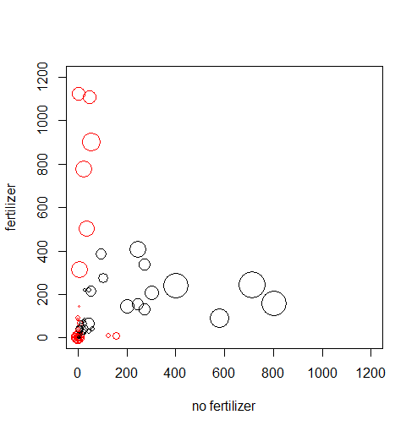
Fig. S1. Plot of interviewers’ reported fertilizer uses by their respondents. If an interviewer had a skewed ratio (>10 in either direction), the interviewer’s data was removed from the sample. The circles correspond to how many villages the interviewer covered, and if the circle is red, their data was removed. Data from interviewers that never reported on fertilizer use were also removed (thus several red circles are at the 0,0).
In addition to the above, we also removed all reported ties sampled before the date of a training event. The training event was set up to elaborate the interviewers’ first experiences in the field, and to jointly sort out different issues being raised. Since this was a crucial step in ensuring cross-interviewer reliability, social data gathered before this event was considered unreliable and therefore removed. If any village had more than 10% of its reported ties removed due to this procedure, the village was removed in its entirely (equivalent to requiring a 90% valid response rate, albeit the true response rate could be lower since there could, in spite of best efforts by the enumerators, exist a few farmers that were never interviewed).
Finally, we excluded villages with less than 10 farmers, and with a mean degree centrality less than 0.1 (essentially no reported ties)
After these measures had been taken, 30 networks remained out of the original 175. Before any data was removed due to potentially unreliable estimations of fertilizer use (but still removing small or very sparsely connected networks, and villages where were data was gathered before the training event), 70 networks remained. Hence, 105 villages were removed due to data being gathered before the training event, or being too small, or to sparsely connected.
We acknowledge that these measures have likely removed certain amounts of perfectly valid data. But nonetheless, in balancing the value of having more data at out disposals for subsequent analyses with the uncertainties that follow from potentially unreliable data, we opted for this rather strict approach. Further, we argue that the measures taken to select the sample of 30 networks used for the present study out of the 70 networks (i.e. before excluding data due to potentially unreliable estimations of fertilizer use – which we argue is the most critical filtering procedure since the other filtering procedures, in practice, only removed villages with incomplete, tiny, or unquestionable erroneous data) did not introduce any substantial biases in terms of favoring villages with networks that differed from the more complete sample (see table S1 – all means in the fully filtered group are well within the standard deviations in the less filtered group as well as the group of excluded villages).
Table S1 – Descriptive network statistics. The table presents descriptive statistics of the fully cleaned dataset, the dataset where no data was removed due to potentially unreliable estimations of fertilizer use, and the excluded data (standard deviations within parenthesis).
Network metric | Filtered data used for all analyses (30 villages) | Unfiltered data (70 villages) | Removed data (40 villages)
Mean network size | 91.1 (65.5) | 73.5 (57.6) | 60.3 (47.6)
Mean degree | 2.29 (0.58) | 2.42 (0.58) | 2.52 (0.57)
Mean centralization | 0.33 (0.20) | 0.38 (0.21) | 0.42 (0.21)
Mean modularity | 0.63 (0.19) | 0.57 (0.20) | 0.52 (0.19)

Multivariate regression with full set of controls
In table S2 we present the regression results where all controls were included (although note that modularity and centralization are strong correlated, the Pearson correlation coefficient is -0.85)
Table S2 - The relation between network structure and fertilizer adoption at the village level
Network structure | Coefficients (SE in parenthesis)
Centralization (Freeman degree, log) | -0.181(0.0754)*
Modularity (Cluster coefficient) | -0.00558 (0.246)
Network size (number of nodes) | 0.0000874 (0.000369)
Network density (mean degree) | 0.0194 (0.0738)
Linear regression with the dependent variable indicating village-level fertilizer adoption rates (0-1). N=30. *Significance at p<0.05. To account for heteroscedasticity, the reported standard errors are based on the White-Huber sandwich estimator of variance (i.e. ‘robust’ standard error). Adjusted R-squared is 0.186.

Simulating social influence mechanisms using Agent Based Modeling (ABM)
As a way to elaborate if a set of social influence mechanisms could have created the observed qualitative differences in fertilizer use between the network above or below the 0.4 centralization threshold, we built a set of simplistic ABMs. Although simplistic, we used the empirical networks, below and above the threshold, when simulating how the farmers’ fertilizer uses change and evolve over time. If a social influence mechanism was able to reproduce networks with similar distributions of fertilize uses as in the empirical networks both above and below the threshold, we deemed is as a potential relevant mechanism. These evaluations were not intendent to single out what mechanisms are explaining the observed data, but rather to evaluate if a given mechanism could have possibly given rise to the observed reality.
All ABMs were built on one basic principle; all farmers could change their uses randomly. In modeling term, at each time unit every farmer (‘agent’) is, at first, potentially changing their uses, albeit the probability for such truly random change was kept low (typically not more than 10%). This is followed by the agent being probed to potentially change its current (or new) fertilize use (actually changing the use is conditional on the social influence mechanism being evaluated, along with some stochastics). Hence, the potential random change in the first step could, conditional on social influence, be changed back. Through these two sequential steps, the total probability for change is made asymmetric. The first truly random change is symmetrical since there is no bias that would favor the potential change in any certain direction. The second step, however, introduces bias since this subsequent potential change is affected by social influence, making it less likely an agent would change it use that would contradict the current social influence mechanism.
We argue these assumptions (i.e. steps) to be context relevant since farmers can and do change their use of fertilizer for reasons that are not solely determined by how they are influenced by their peers. We, however, assume that for whatever reason a farmer deliberates on its use of fertilizer, actually implementing a change is in parts determined by peer-to-peer social influence. The two steps in the modeling procedure aim to capture such a process.
Building from this basic principle, we tested five different social influence mechanisms. These mechanisms are to a varying extent overlapping (both in that they encompass similar characteristics, and that the implementations in the ABMs could be computationally similar). Notwithstanding these overlaps, the mechanisms are derived from different principles of how social influence is exerted.
1. Cognitive dissonance
This mechanism derives from the social tension that emerge when someone’s opinion deviates from its peers’ opinions (1). It is often expressed in group of three taking all social ties among them into account (2), but for simplicity we here focus on all the egos (i.e. the agent being modeled at a given time step) peers, and we do not consider ties among the peers. Further, we also assume that the tension exerted at the ego increases with the number of peers that potentially disagrees with the ego.
We implemented this by assuming that the higher proportion of the egos peers that would use fertilizers in a different way from the ego, the more unlikely the ego will actually change its use. The probability for changing use is in our model proportional to: (1-peerp)^cogdiss. Cogdiss is the number of peers who’s fertilize uses differ from what ego is about to change to, and peerp is a global constant that captures the strength of peer pressure (range: 0-1).
2. Influenced by the majority
This mechanism derives from what has been coined a threshold model (3), i.e. that a person typically changes its preferences only when a certain proportion of the others have changed their preferences.
In this scenario, the ego will potentially change its use, conditional on a fixed global probability, to what the majority of its peers are using.
3. Randomly selected peer influence
This mechanism assumes that social influence is exerted by one peer at a time, analogous to a situation where a person discusses with one of its peers, and then make a decision. At a later stage, the person might engage with another of its peers (or the same), and based on that encounter the person makes a new decision. Although this influence mechanism is based on sequential interactions among peers, over longer time periods social influence will be exerted by all peers.
In this scenario, one of the ego’s peers will be randomly selected, and ego might change (given a fixed global probability) to that peer’s fertilizer use. Over time, this model implies that all the egos’ use of fertilizer will, on average, converge to the average of their peers’ uses (albeit we do not assume that the model will necessarily converge to a stable state).
4. Homogeneity of opinions (“echo-chamber”)
This mechanism assumes that the willingness/likelihood of a person to change its opinion is conditional upon how certain its peers appear to be on what would be the preferred opinion. If all its peers are in agreement, it is less likely the person will change preference to something that differs from its peer than if there is already some level of disagreement. This mechanism is supported by recent findings about associate homogeneity of opinions in dense structures of communications among likeminded people (e.g. 4).
In this scenario, the ego will randomly change its use conditional on a probability that is dependent upon the extent of ego’s current alignment with its peers. If all peers, and the ego itself, are using fertilizer in the same way, the probability for change is small (e.g. 5%). If there is disagreement, the probability for change is significantly higher (e.g. 20%). It is enough with one peer, or the ego itself, to use fertilizers in a different way in relation to the others for disagreement to be present.
5. Social influence conditional on peers being highly connected
This mechanism assumes that people are only being influenced by others that are highly socially connected. It essentially assumed there is a threshold, and if anyone has fewer peers that this threshold, s/he will not exert any influence on its peers. This mechanism is based in numerous studies showing that actors with abundant social ties are perceived as more worthy to connect with simply because they are well connected (this long standing observation of many social networks was generalized to networks of various kinds in the late 90s, see e.g. (5)).
In this scenario, the ego will potentially change, given a fixed probability, its use to what the majority of its highly central peers are using. In the applied model settings, highly central peers were those with degree centralities exceeding the mean degree in their network plus two to four standard deviations.
Results from the ABMs
In evaluating the five different influence mechanisms, we tried out different values, and different combinations of values, for all the parameters associated with all model scenarios. Starting from a set of initial parameter values, we tried to recreate patterns of fertilizer uses that qualitatively resembled the empirical observations in networks both above and below the threshold. We modelled the social influence scenarios on two of the village networks below and above the threshold (Fig. S2).
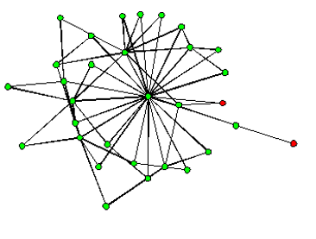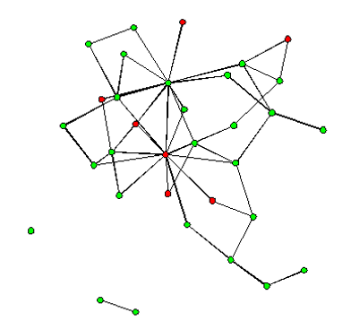
Fig. S2. The two village networks used for ABM explorations. The network to the left has 31 nodes, a degree centralization of 0.69, and only two farmers (6%) that are using fertilizers. To the right, the network has 33 nodes, a degree centralization score of 0.30, and 21% of the farmers are using fertilizer.
It was relatively easy to create patterns that resembled a diversity of fertilizer use across all the networks just by increasing the overall level of randomness. It was, generally, also not difficult to generate outcomes where everyone or nearly every agent used fertilizer in the same way by reducing the level of randomness (thereby indirectly strengthening social influence). The challenge was to, for a given set of parameter values, generate networks where the level of heterogeneity was high in the non-centralized network while also leading to strong homogeneity in the centralized network. In our search for those combinations of values that could lead to that desired outcome, we followed a “non-automated” hill-climbing algorithm in our explorations. To avoid getting stuck only testing parameter values that could only take us to a local minimum, we made sure to restart our high-climbing algorithm at times when our searches led nowhere. Using this approach, we are confident that we have, in practice, exhausted all possibilities that certain un-tested combinations of parameter values could have led to the desired outcome, albeit we acknowledge that we cannot entirely rule out the possibility any such undetected regions in parameter space still exist. But we maintain that if such regions do exist, they would be very small and likely associated with parameter values and combinations thereof that would be rather extreme. Hence, even if these exist in a numerical sense, the likelihood that they could explain the empirical observations would be, as we argue, close to zero.
These explorations demonstrated that simulations of Social influence conditional on peers being highly connected mechanism was clearly closest to the observed reality (Fig. 3). Furthermore, this mechanism was quite robust since a relative broad range of parameter values led to the same qualitative outcome. The Cognitive dissonance, Randomly selected peer influence, and Influenced by the majority mechanisms were, however, also able to generate results that to a limited extent also followed the empirical observations (all these models also required more explorations of the parameter values for any such patterns to be observed). Fig. 4. shows the result from best-fitting ABM building on these mechanisms.
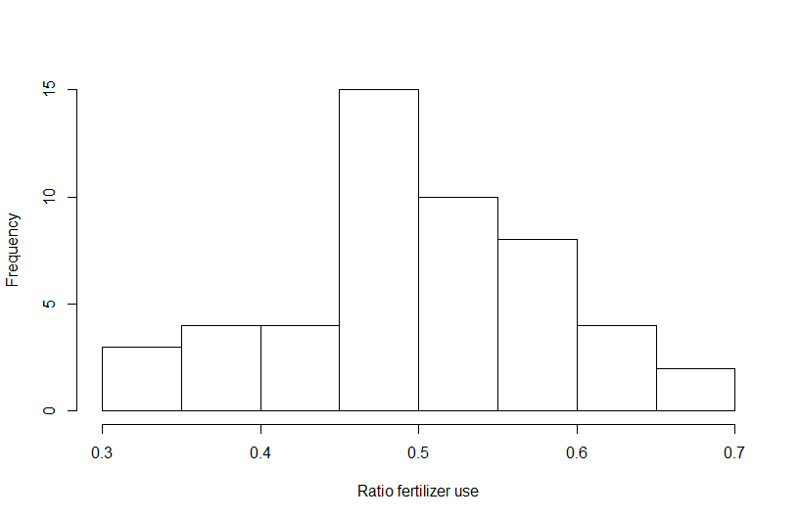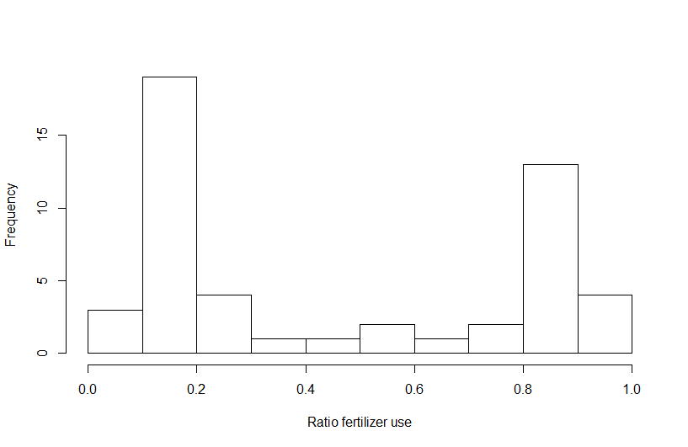
Fig. 3. Histograms drawn from the Social influence conditional of peers being highly connected mechanism. The histogram to left shows the distribution of average fertilizer use for the less centralized network, and the right shows the same for the centralized network. As seen, in the less centralized network, the means are distributed around 0.5, whereas in the centralized network the means are aggregated at the extremes (where most or all of the farmers uses fertilizers in the same way).

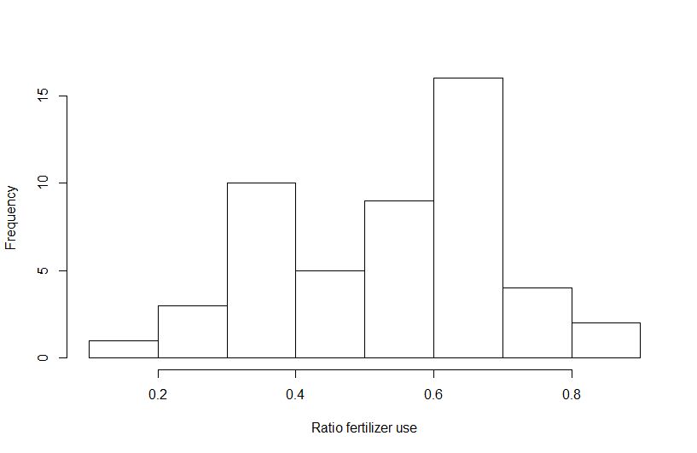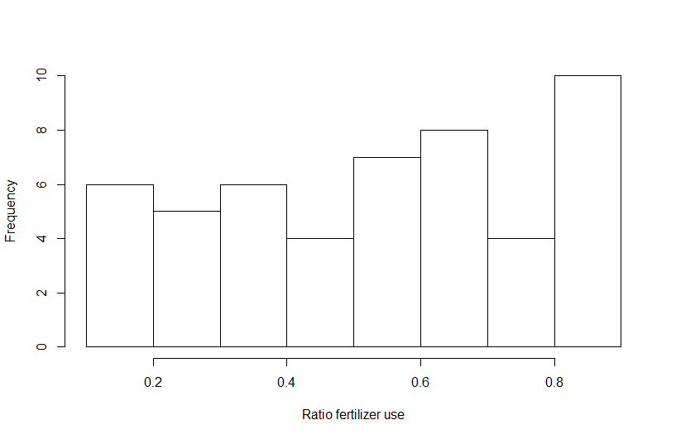
Fig. 4. As in Fig. 3, but drawn from the Cognitive dissonance mechanism. There is a tendency for higher values in the middle in the histogram to the left than to the right. This tendency is, however., far from as clear as in Fig. 3.

Investigating simple (peer-to-peer) social influence using ALAAM
To triangulate and complement the analyses of what (if any) social influence mechanisms could potentially explain the observed empirical observations, we applied a network analytical method called Auto-Logistic Actor Attribute Models (ALAAM) that is devised to explain node attributes based on structures of ties (6). It relates to the Exponential Random Graph Model (ERGM) family of network model, but in contrast to ERGMs, its objective is to explain node attributes and not ties. Hence, ties are seen as fixed, and the model tries to explain node attributes based on the structures of ties.
We were primarily interested in whether if any individual farmer’s use of fertilizer could be influenced by its network peers. Using the SW package MPnet (7), we thus tested if the network configuration “contagion” were significant in any of the village networks (Table S3). All farmers with unknown fertilizer use were removed from the networks. Contagion captures if any two nodes that share a tie tend to have the same attribute value (in this case, use of fertilizer). We also controlled for the presence of skewed distributions of fertilizer use (“Density” in Table 1). Since ALAAM explores variability in node attributes, not all networks could be tested. Essentially, if all or almost all nodes use fertilizer in the same way, there is not enough variability for the model to produce any meaningful results. The same applies if the number of ties is very small, and/or if too many of the nodes have undefined attribute values. Hence, all in all we only got reliable results from 14 networks. None of these network displayed any significant tendency for peer-to-peer social influence.

Table S3. The results from the ALAAM for the networks with applicable variability in fertilizer use. Please observe all coefficient are based on log odds (logit).
Village ID | Degree centralization | Size (after data cleaning) | Density (ratio of fertilize use) | Contagion (i.e. peer-to-peer influence) (Standard error in parenthesis) | Network diagram (farmers with incomplete data on fertilizer use are removed)
7725 | 0.15 | 199 | -0,8837* | 0,2711 (0,155) | 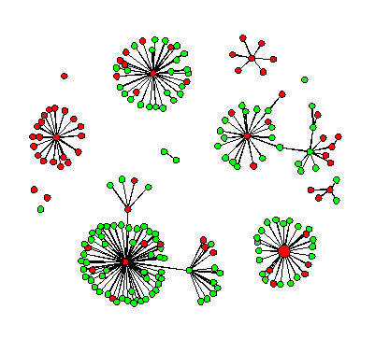
3317 | 0.22 | 85 | 1,1345* | 0,0692 (0,163) | 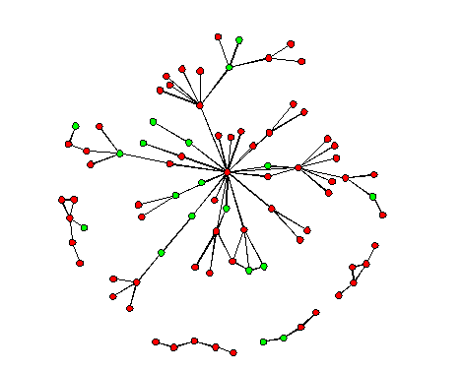
5667 | 0.20 | 52 | -1,5863* | 0,1444 (0.792) | 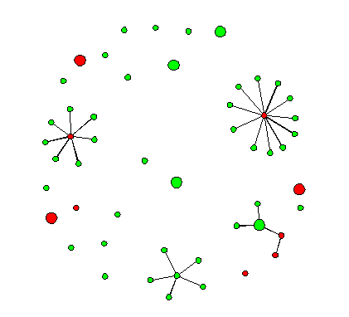
5139 | 0.31 | 59 | -0,7401 | -0,2166 (0.426) | 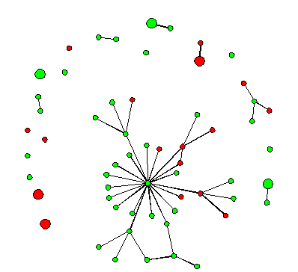
6887 | 0.1 | 120 | -1,2198* | 0,0847 (0,372) | 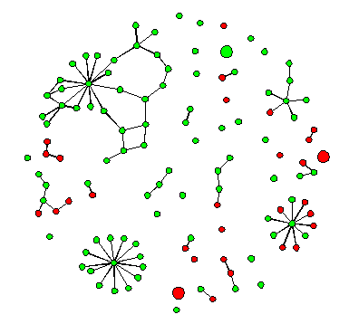
9141 | 0.19 | 25 | -0,1088 | -0,1646 (0,569) | 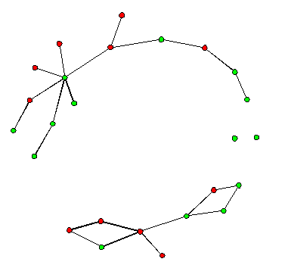
7775 | 0.30 | 33 | -1,4873* | 0,2248 (0.537) | 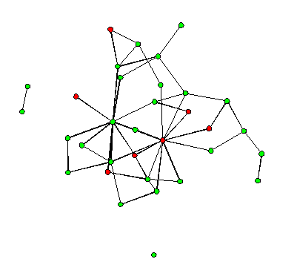
8030 | 0.57 | 65 | -2,4509* | 0,3862 (0,528) | 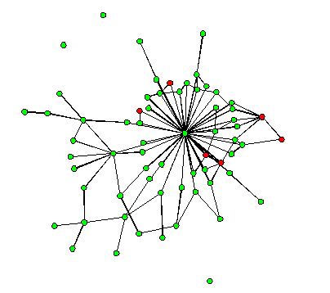
5779 | 0.30 | 55 | -2,8453* | 1,3855 (0,857) | 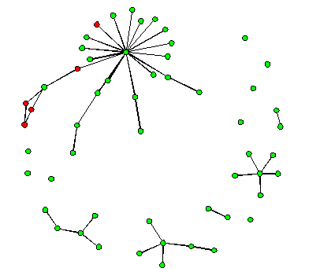
1183 | 0.52 | 102 | -1,6265* | 0,1682 (0,196) | 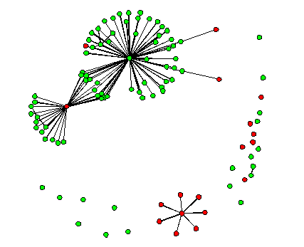
9694 | 0.38 | 32 | -0,3569 | 0,2197 (0,211) | 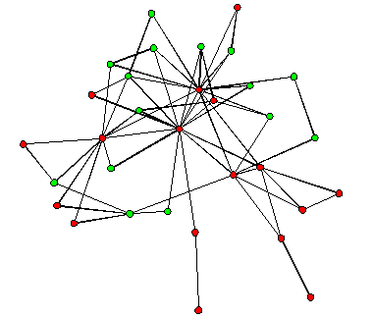
4446 | 0.18 | 57 | -1,6806* | 0,6916 (0,416) | 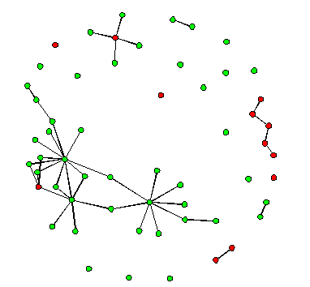
6496 | 0.13 | 85 | -0,3307 | 0,1915 (0,205) | 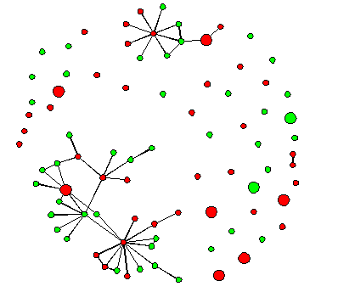
7152 | 0.35 | 25 | -0,6730 | 0,0978 (0,430) | 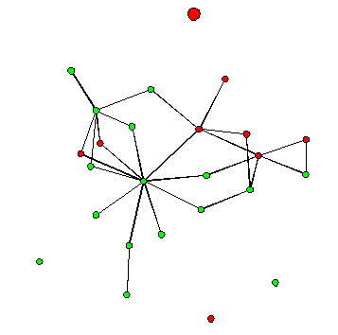

References
1. Heider F (1946) Attitudes and Cognitive Organization. J Psychol 21:107–112.
2. Cartwright D, Harary F (1956) Structural balance: a generalization of Heider’s theory. Psychol Rev 63:277–293.
3. Granovetter M (1978) Threshold models of collective behavior. Am J Sociol 83(6):1420–1443.
4. Jasny L, Waggle J, Fisher DR (2015) An empirical examination of echo chambers in US climate policy networks. Nat Clim Chang (May):1–5.
5. Barabási AL, Albert R (1999) Emergence of scaling in random networks. Science (80- ) 286:509–512.
6. Daraganova G, Robins G (2013) Autologistic actor attribute models. Exponential Random Graph Models for Social Networks: Theory, Methods and Applications, eds Lusher D, Koskinen J, Robins G (Cambridge University Press,), pp 102–108.
7. Wang P, Robins G, Pattison P, Koskinen JH (2014) MPNet: Program for the Simulation and Estimation of (p*) Exponential Random Graph Models for Multilevel Networks Available at: http://sna.unimelb.edu.au/PNet.

