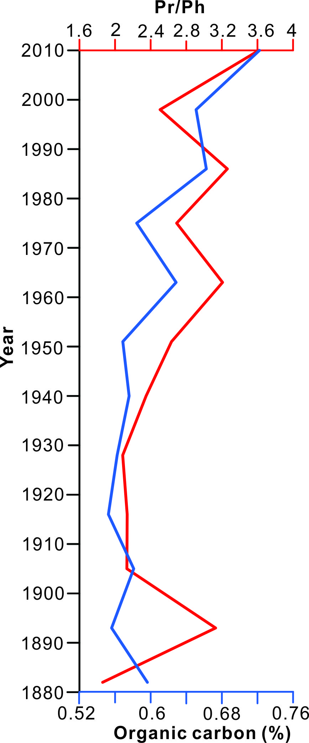
Figure S1 Pr/Ph ratio and organic carbon content in sediment core Sc1. The Pr/Ph in sediment core Sc01 is modified after reference¹⁷. The organic carbon concentration in sediment core Sc01 is modified after reference⁵⁷.
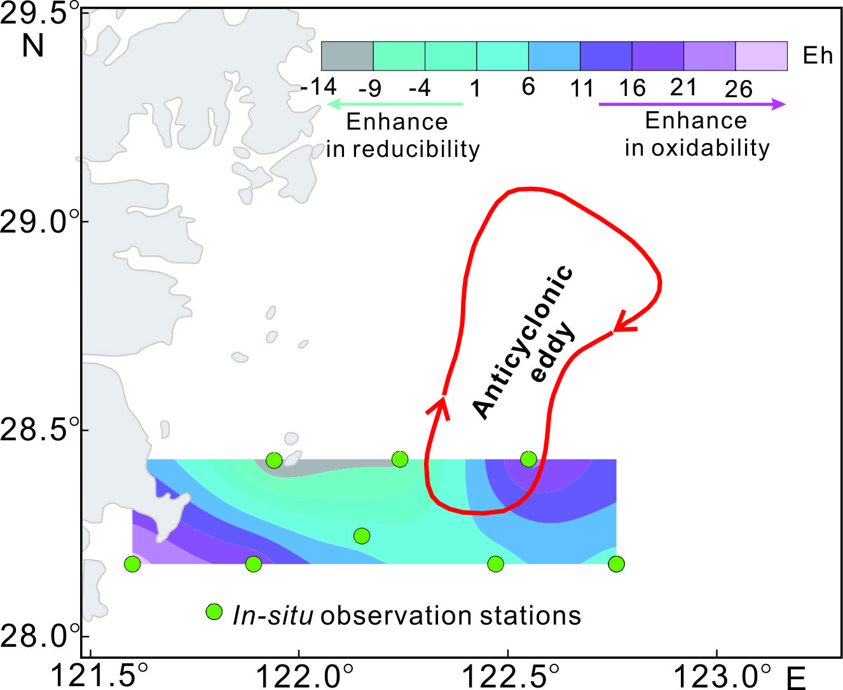
Figure S2 Spatial distribution of redox potential (Eh) values at representative stations in the study area

