Supplementary Information
Exploring the therapeutic potential of Rutin and Morin in Type 2 Diabetes: A transcriptomics and molecular dynamics simulation for proteins
Rout George Kerry^{1,2#*}, Hemangini Naik^{3#}, Soumya Ranjan Mahapatra⁴, Sanghamitra Nayak², Abhishek Behera¹, Kali Prasad Pattanaik⁴, Saumya Ranjan¹, Namrata Misra^{4,5}, Jyoti Ranjan Rout⁶, Gitishree Das⁷, Jayanta Kumar Patra⁷, Sanatan Majhi^{1*}
¹Department of Biotechnology, Utkal University, Vani Vihar, Bhubaneswar, Odisha, 751004, India
²Centre for Biotechnology, Siksha ‘O’ Anusandhan (Deemed to be University), Kalinga Nagar, Bhubaneswar-751003, Odisha, India
³Department of Biotechnology and Bioinformatics, Sambalpur University, Jyoti Vihar, Burla-768019, India
⁴School of Biotechnology, Kalinga Institute of Industrial Technology (KIIT), Deemed to be University, Bhubaneswar 751024, India
⁵KIIT-Technology Business Incubator (KIIT-TBI), Kalinga Institute of Industrial Technology (KIIT), Deemed to be University, Bhubaneswar 751024, India
⁶School of Biological Sciences, AIPH University, Bhubaneswar, Odisha, 752101, India
⁷Research Institute Integrative Life Sciences, Dongguk University-Seoul, Goyangsi, 10326, Republic of Korea
#Equal contribution
*Corresponding author (R.G.K.: routgeorgekerry3@gmail.com; S.M.: sanatanm@gmail.com)

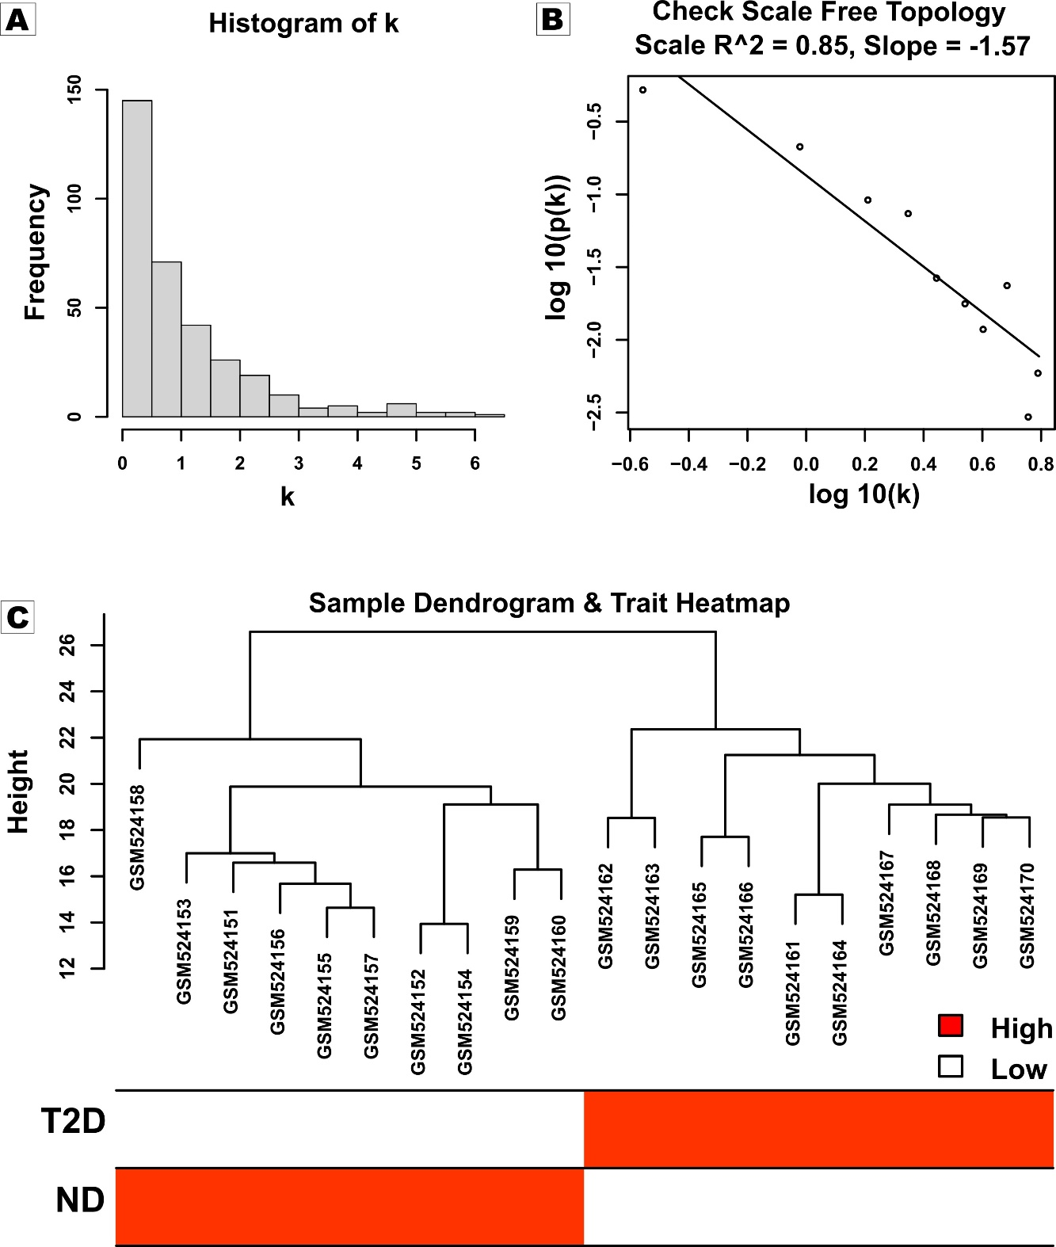
Figure S1. Scale free topology. (A) Histogram of connectivity distribution when β=12. (B) Validation of scale-free topology when β=12.

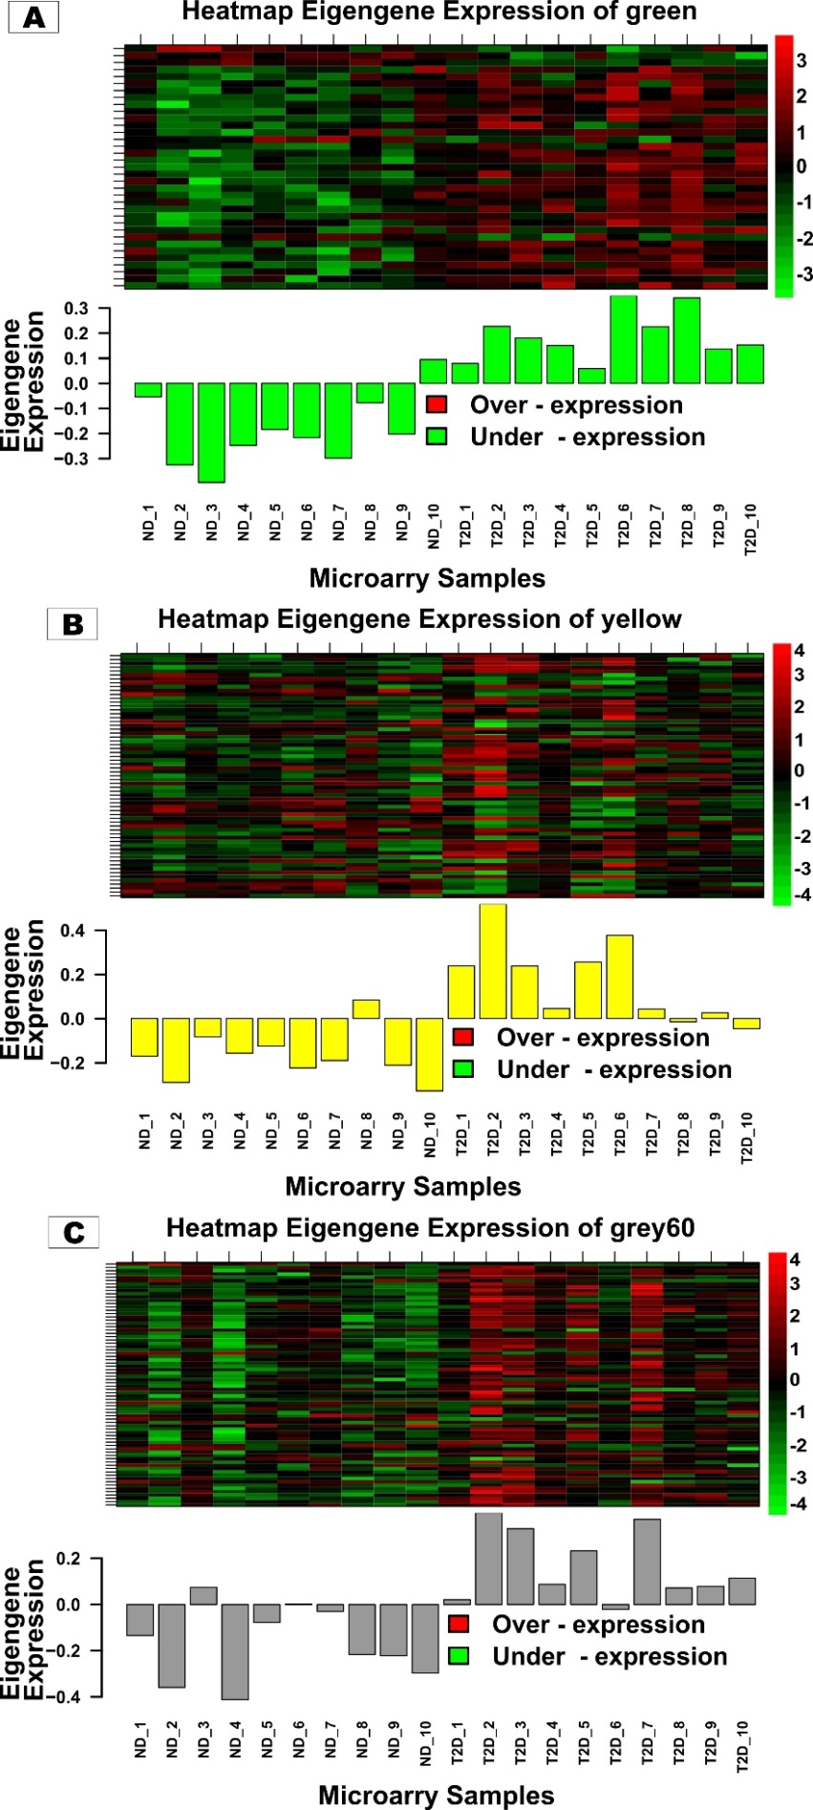
Figure S2.Eigengene expression. (A-C) The histogram represents the eigengene expression of MEgree, MEyellow and MEgrey60 across ND and T2D samples.
Supplementary Table 1.DEGs analysis results (See attached separate excel sheet).

