Discovering Natural Products as Potential Inhibitors of SARS-CoV-2 Spike Protein

Muhammad Alqaaf¹, Ahmad Kamal Nasution¹,
Rumman Mahfujul Islam¹, Mohammad Bozlul Karim¹, Muhammad Hendrick Sedayu^{2†},
Retno Supriyanti^{2†}, Naoaki Ono¹, Md. Altaf-Ul-Amin^{1*},
Shigehiko Kanaya¹

¹Graduate School of Science and Technology, Nara Institute of Science
and Technology, Ikoma, 630-0192, Nara, Japan.
²Department of Electrical Engineering, Jenderal Soedirman University,
Purbalingga, 53371, Central Java, Indonesia.

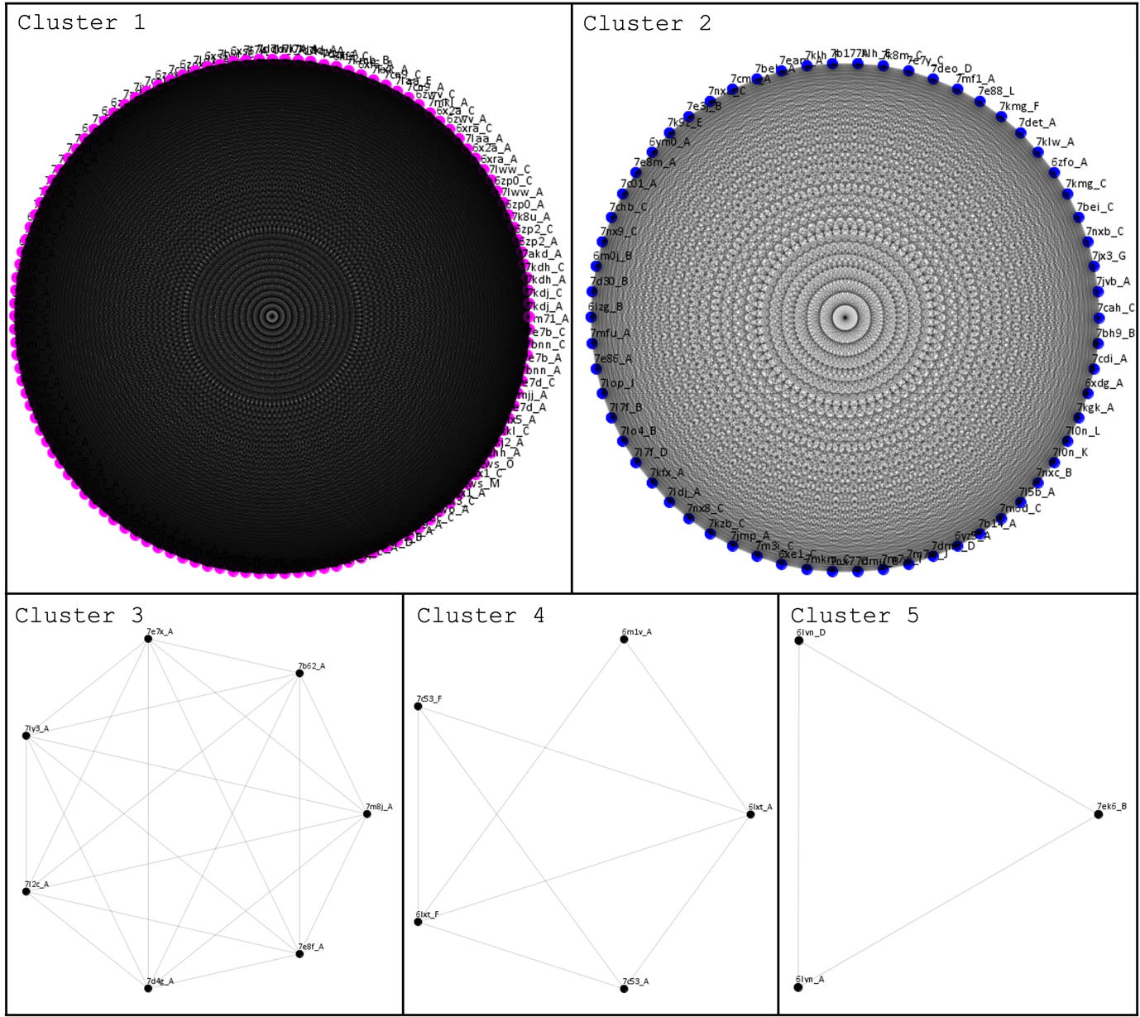
Figure S1. Full network graph of five clusters of spike proteins based on sequence similarity.

TABLE SI
Cluster information.
Cluster | Size | Edge | Density | Cluster Info
C1 | 124 | 7613 | 1.0 | [7dx1_A, 7dx1_C, 7cak_A, 7ddd_A, 7ddd_C, 7k8u_A, 7jwy_A, 7jwy_C, 7k8x_A, 7l58_A, 6zp2_A, 6zp2_C, 7dzw_A, 7dzw_C, 6z97_A, 6z97_C, 6zox_A, 6zox_C, 7d00_A, 7kj2_A, 7ad1_A, 7ad1_C, 7a5r_C, 7jw0_A, 7k90_A, 7l06_A, 7cwo_A, 7kdi_A, 7kdi_C, 6zp1_A, 6zp1_C, 7bno_A, 7bno_C, 7mjj_A, 7dx3_C, 7nt9_A, 7nt9_C, 7kxk_A, 7krs_A, 7krs_C, 6zow_D, 7lwi_A, 7lwi_C, 6xs6_A, 6xs6_C, 6zoy_A, 6zoy_C, 7lyk_A, 7lyk_C, 7mkl_A, 7a94_A, 6zb5_A, 6zb5_C, 7kec_A, 7kec_C, 7m71_A, 7akd_A, 7byr_A, 7e8c_A, 7cac_A, 6vyb_A, 6vyb_C, 7kdj_A, 7kdj_C, 7a93_C, 7jji_A, 7jji_C, 7kj5_C, 7mjk_I, 7chh_A, 7laa_A, 7laa_E, 7cn9_A, 7cn9_C, 7lwv_A, 7lwv_C, 7ld1_A, 6x79_A, 6x79_C, 7cws_M, 7cws_O, 6x6p_C, 7kdh_A, 7kdh_C, 7lww_A, 7lww_C, 6xf6_A, 6xf6_C, 6zwv_A, 6zwv_C, 6xkl_C, 6xra_A, 6xra_C, 7m8k_A, 7m8k_C, 7cab_A, 7cab_C, 7l3n_A, 6vxx_C, 7jwb_D, 7l7k_A, 7l7k_C, 6zp0_A, 6zp0_C, 7dzx_A, 7kl9_A, 7bnn_A, 7bnn_C, 7lqv_A, 7lqw_E, 7e7b_A, 7e7b_C, 7e7d_A, 7e7d_C, 6x2a_A, 6x2a_C, 7m0j_A, 7m0j_C, 6x6p_A, 7kmb_B, 7lx5_A, 6x29_A, 6x29_C, 7a92_B]
C2 | 62 | 1891 | 1.0 | [6lzg_B, 7chb_C, 7c01_A, 7jmp_A, 7kfx_A, 7cm4_A, 7beh_A, 7nx7_C, 7b14_A, 7bei_C, 7e3j_B, 7d30_B, 7bh9_B, 7cdi_A, 7mfu_A, 6zfo_A, 7e86_A, 7l5b_A, 7lo4_B, 7ldj_A, 7cah_C, 7e7y_C, 7nxa_C, 7klw_A, 7det_A, 7k8m_C, 7e8m_A, 7klh_E, 7klh_F, 7jvb_A, 7kgk_A, 7nxc_B, 7kmg_C, 7kmg_F, 7lop_J, 6xe1_C, 7dmu_B, 7dmu_D, 6m0j_B, 7jx3_G, 7mf1_A, 7e88_L, 7eam_A, 7nxb_C, 7deo_D, 7nx8_C, 6ym0_A, 7m3i_C, 7kzb_C, 6xdg_A, 7l0n_K, 7l0n_L, 6yz5_A, 7m7w_I, 7m7w_J, 7k9z_E, 7mkm_C, 7m6d_C, 7nx9_C, 7b17_A, 7l7f_B, 7l7f_D]
C3 | 7 | 21 | 1.0 | [7e8f_A, 7m8j_A, 7e7x_A, 7d4g_A, 7b62_A, 7l2c_A, 7ly3_A]
C4 | 5 | 8 | 0.8 | [6lxt_A, 6lxt_F, 7c53_A, 7c53_F, 6m1v_A]
C5 | 3 | 3 | 1.0 | [6lvn_A, 6lvn_D, 7ek6_B]

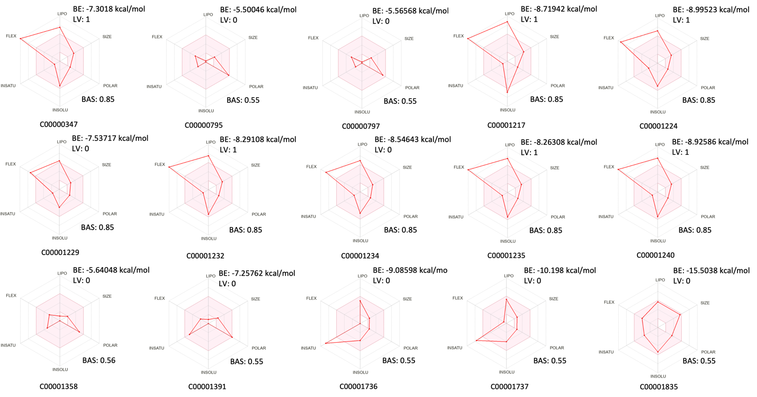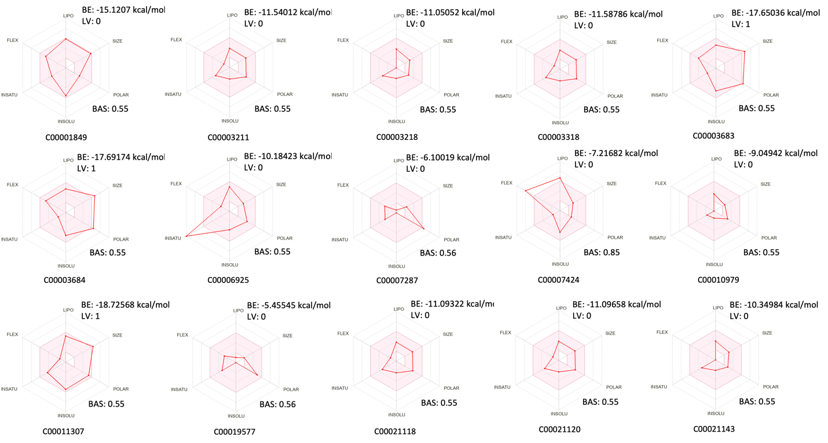
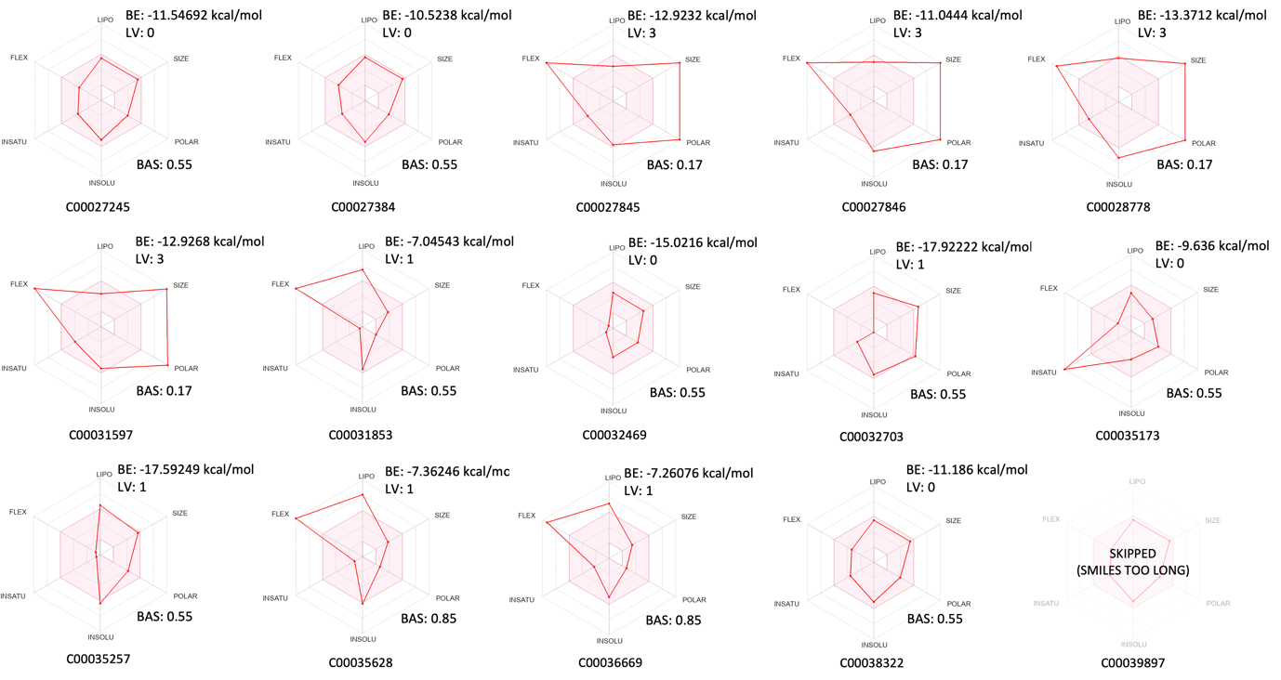
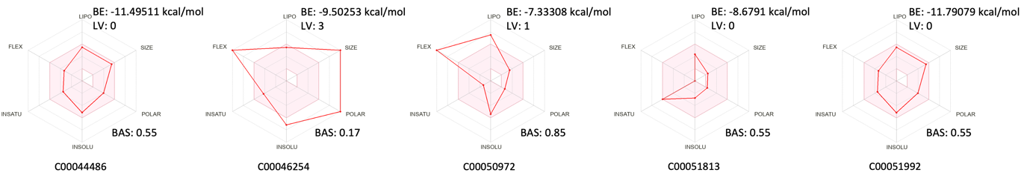
Figure S2. Bioavailability radar of secondary metabolites in cluster 1.

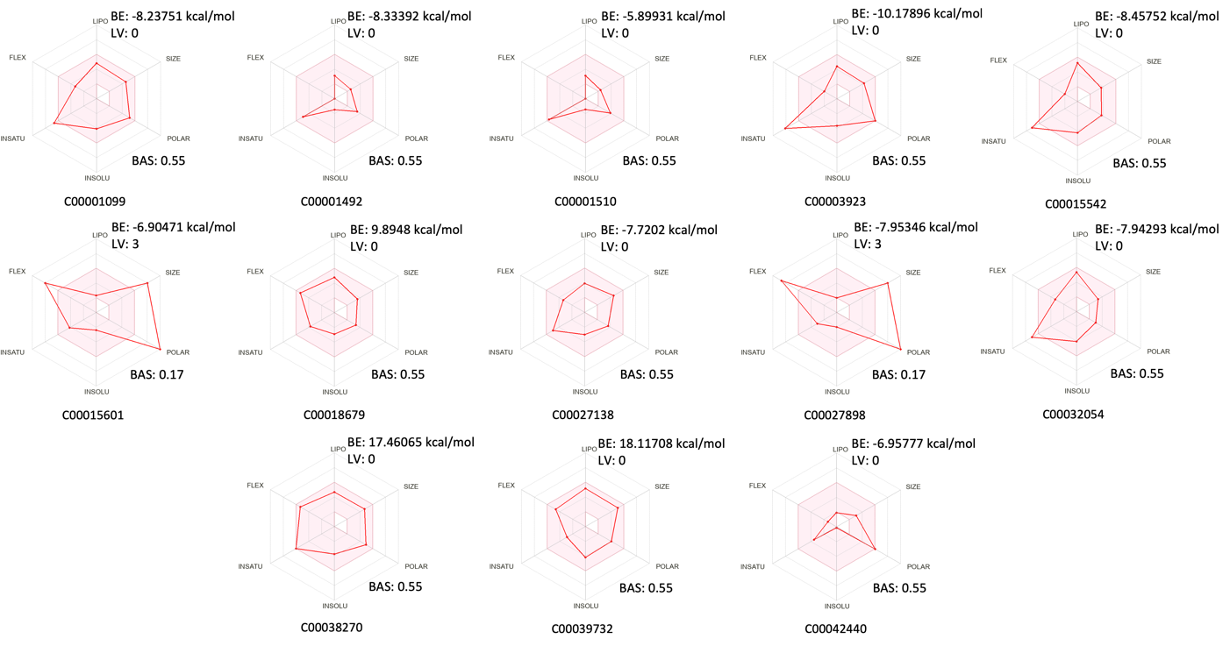
Figure S3. Bioavailability radar of secondary metabolites in cluster 2.

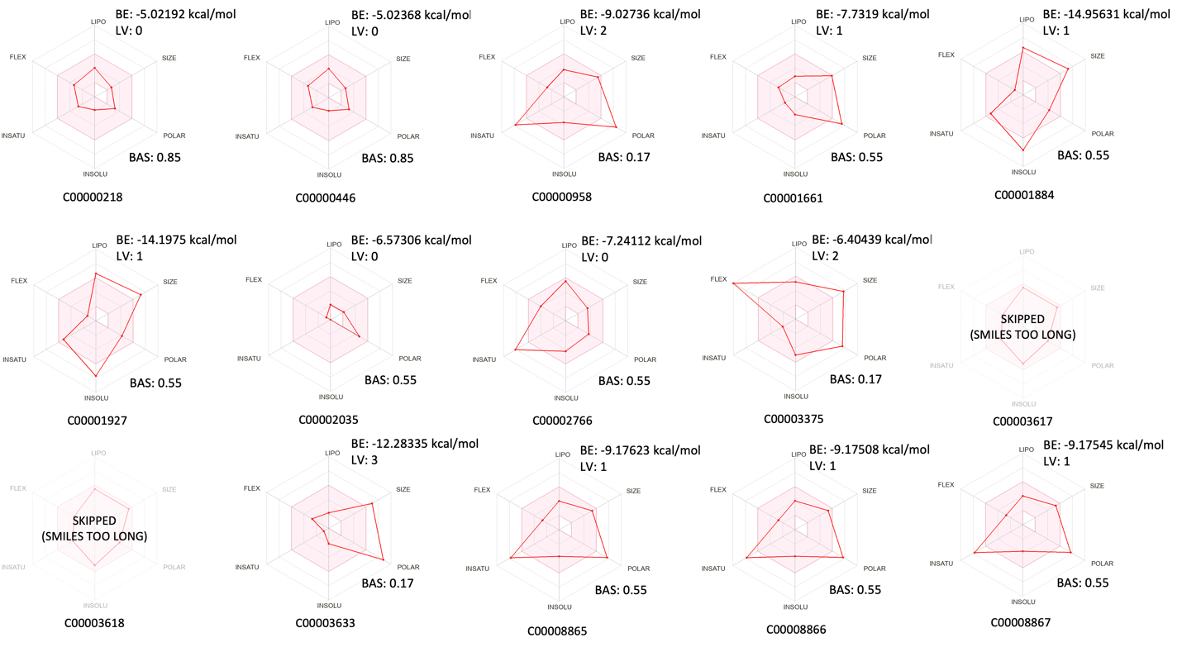
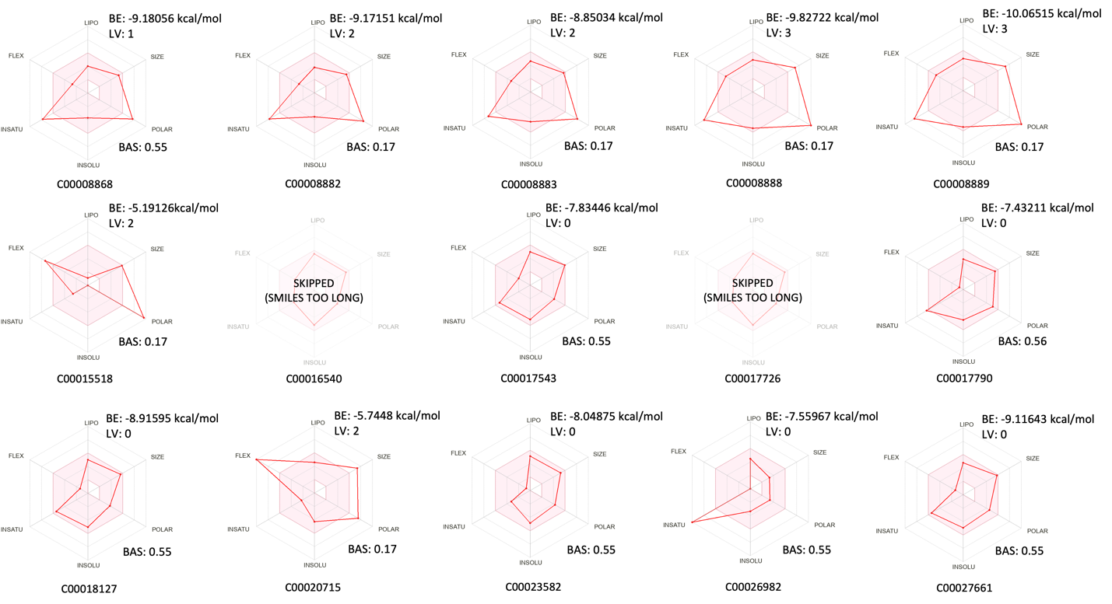
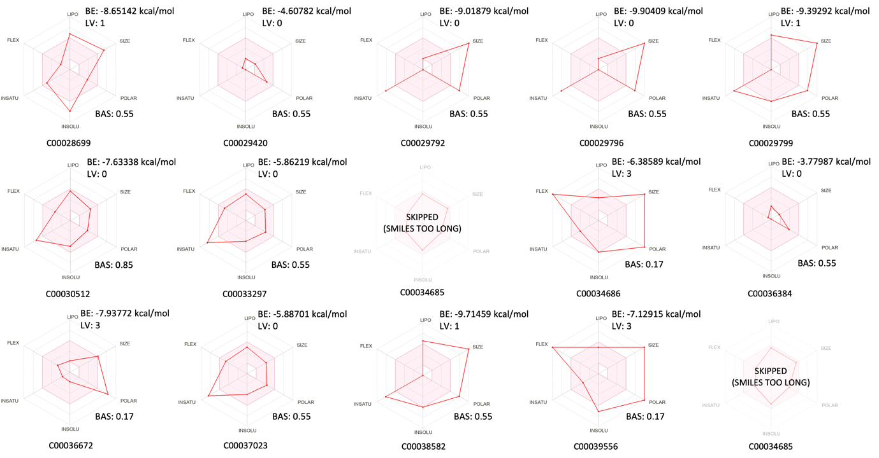
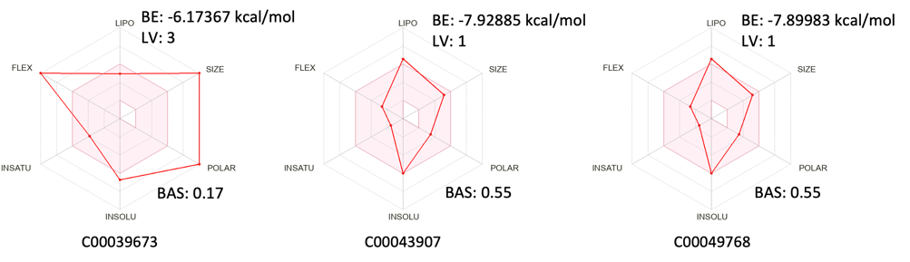
Figure S4. Bioavailability radar of secondary metabolites in cluster 4.

TABLE SII
Bioactivity properties of investigated compounds.
CID | Name | Description | Bioactivity | Reference
Cluster 1
C00001835 | Cephaeline | An inductor of histone H3 acetylation | Shown anti-cancer properties in all mucoepidermoid carcinoma cell lines tested by regulating tumor cells viability, migration, proliferation, and disrupting the ability of cancer cells to generate tumorspheres. | [1]
C00001849 | Emetine | Compound belongs to the class of organic compounds known as emetine alkaloids. | Inhibitory action on protein biosynthesis in HeLa cells, potential antiviral agent against HIV, anti-malarial, anti-cancer, and anti-hypertension. | [2], [3], [4], [5], [6], [7]
C00032469 | Uzarigenin | A carnolide that can be isolated from plants such as Pergularia tomentosa and the root of Calotropis gigantea | Traditionally treat diarrhea. | [8]
C00051992 | 9-O-Demethylcephaeline | A derivative of cephaeline | Same as Cephaeline, shown anti-cancer properties in all mucoepidermoid carcinoma cell lines. | [1]
C00003318 | Linifolin A | A natural product found in plants such as Helenium donianum and Helenium aromaticum | Induce apoptosis in various cancer cell lines, significant anti-inflammatory properties | [9], [10]
C00027245 | 10-O-Demethylcephaeline; (-)-10-Demethylcephaeline | Also known as (-)-10-Demethylcephaeline, is a phytochemical compound with the chemical formula C27H36N2O4 | Exhibited potent cytotoxic activity against human lung carcinoma (A549) and breast adenocarcinoma (MCF-7). | [11]
C00003211 | Angustibalin | A phytochemical compound, also known as helenalin acetate, found in Balduina angustifolia | Antitumor agents as a new cytotoxic sesquiterpene lactone from Balduina angustifolia (Pursh.) Robins. | [12]
C00044486 | 7'-O-Demethylisocephaeline; (-)-7'-O-Demethylisocephaeline | A sesquiterpene lactone found in plants such as Alangium lamarckii, Alangium longiflorum, Cephaelis acuminata, Psychotria ipecacuanha, Psychotria klugii | Alkaloids derived from Psychotria klugii have demonstrated potent antimalarial and antileishmanial activities in vitro. | [13]
C00038322 | 7'-O-Demethylcephaeline
C00021120 | Balduilin | A sesquiterpene lactone found in plants such as Balduina angustifolia, and Balduina uniflora | Sesquiterpene lactones have been found to possess a variety of biological activities, making them as therapeutic candidates including anticancer, anti-inflammatory, antimicrobial, antiparasitic, antiviral, antioxidant, and moderate antinociceptive properties. | [14], [15]
C00021118 | Bigelovin | A sesquiterpene lactone isolated from Inula helianthus aquatica, Helenium scorzoneraefolia, Dittrichia graveolens (L.) GREUTER | Suppresses tumor growth through inducing apoptosis and autophagy, Anti-angiogenesis and immunomodulatory activities of an anti-tumor, | [16], [17]
C00003218 | Aromaticin | A sesquiterpene lactone isolated from Helenium amarum, Heleium aromaticum found in the aerial parts of the plant Inula hupehensis | Potential as Anti-inflammatory agents | [18]
C00027384 | Isocephaeline | Isocephaeline is a natural compound belongs to Terpenoid tetrahydroisoquinoline alkaloids | Inhibits hypoxia-inducible factor-1 activation in breast tumor cells | [19]
C00021143 | Aromatin | A natural product isolated from Blumea aromatica | Blumea aromatica is a traditional Chinese medicine used for treating various diseases such as rheumatoid arthritis, eczema, and pruritus | [20]
C00010979 | Cantharidin | A colorless fatty substance of the terpenoid class, which is secreted by many species of blister beetles. | Inhibits the growth of pancreatic cancer cells through G2/M cell-cycle arrest and apoptosis, with a much lighter toxicity effect against normal pancreatic duct cells. | [21]
C00051813 | Dihydro-beta-carboline | A natural compound belongs to alkaloid | Found therapeutic effect for most of non-human diseases such as inhibitory effect on both Penicillium digitatum and Botrytis cinerea, protective effect against hydrogen peroxide and paraquat oxidative agents in yeast cells. | [22], [23]
Cluster 2
C00001492 | Caffeine; Caffein | Caffeine is a stimulant, which means it increases activity in your brain and nervous system. | Moderate caffeine intake (the human equivalent of 500 mg caffeine or 5 cups of coffee per day) can protect against or treat Alzheimer's disease in a mouse model, chance of antidepressants in major depressive disorder and improve cognitive performance. | [24], [25]
C00027138 | Colchamine; Demecolcine | A plant-derived alkaloid | Demecolcine has been used experimentally to improve the results of cancer radiotherapy. | [26]
C00042440 | Cytidine | A pyrimidine nucleoside in which cytosine is attached to ribofuranose via a beta-N(1)-glycosidic bond. | Treating bipolar disorders, . | [27], [28]
C00001510 | Theophylline | A methylxanthine derivative | Used for treating respiratory diseases such as asthma and chronic obstructive pulmonary disease (COPD), including anti-inflammatory and immunomodulatory | [29], [30], [31]
Cluster 4
C00027661 | 11-Hydroxyvittatine | A compound suggested as the main precursor for montanine and haemanthamine biosynthesis. | Montanine-type alkaloids are predominantly present in plants in low concentrations, but some of them display promising biological properties, especially in vitro anti-inflammatory activity. | [32], [33]
C00018127 | (+)-Staurosporine; Staurosporine; AM-2282; Antibiotic 230; Antibiotic AM 2282; CGP 39360; Staurosporin; Staurosporine | An indolocarbazole alkaloid and an organic heterooctacyclic compound. | Induces apoptosis in pancreatic carcinoma cells, affects single and collective cell migration in breast carcinoma cells, antifungal and antiangiogenic properties | [34], [35], [36]
C00023582 | Paxilline | A mycotoxin from the fungus Penicillium paxillin. | Found to be a cytoprotection, sensitizing glioma cells to apoptosis-inducing therapies, mitigating heavy metal toxicity. | [37], [38], [39]
C00017543 | TAN 999 | An indolocarbazole alkaloids isolated from Nocardiopsis dassonvillei | Facilitate the spreading or activation of the Mm 1 cell line, which is a type of macrophage cell line derived from mice. | [40]
C00002035 | 1-Deoxymannojirimycin;  (-)-Deoxymannojirimycin;  1-Deoxymannojirimycin | A natural compound belongs to Iminosugars | Induces cellular endoplasmic reticulum stress and caspase-12 pathway apoptosis in human hepatocarcinoma cells, offering potential for anti-cancer therapy. Iminosugar-based enzyme inhibition has significant potential for drug development in several areas including anticancer, antiviral (HIV, Hepatitis B), cystic fibrosis, lysosomal storage disorders (Fabry and Gaucher disease) and metabolic control disorders (type-2 diabetes mellitus). | [41], [42], [43], [44], [45]
C00000446 | (+)-Epijasmonic acid;  7-iso-Jasmonic acid | A plant growth regulator and a member of jasmonates and a plant metabolite | Extracts from plants rich in jasmonic compounds show a broad spectrum of activity, i.e., anti-cancer, anti-inflammatory and cosmetic. | [46]
C00000218 | (-)-Jasmonic acid;  Jasmonic acid;  trans-Jasmonic acid;  3-Oxo-2-(2Z-pentenyl)cyclotentylacetic acid | A member of jasmonates isolated from the fungus Lasiodiplodia theobromae | Extracts from plants rich in jasmonic compounds show a broad spectrum of activity, i.e., anti-cancer, anti-inflammatory and cosmetic. | [46]

References
[1] L. C. Silva et al., “Cephaeline is an inductor of histone H3 acetylation and inhibitor of mucoepidermoid carcinoma cancer stem cells,” J Oral Pathology Medicine, vol. 51, no. 6, pp. 553–562, Jul. 2022, doi: 10.1111/jop.13252.
[2] A. P. Grollman, “Inhibitors of Protein Biosynthesis,” Journal of Biological Chemistry, vol. 243, no. 15, pp. 4089–4094, Aug. 1968, doi: 10.1016/S0021-9258(18)93283-7.
[3] A. Valadão et al., “Natural Plant Alkaloid (Emetine) Inhibits HIV-1 Replication by Interfering with Reverse Transcriptase Activity,” Molecules, vol. 20, no. 6, pp. 11474–11489, Jun. 2015, doi: 10.3390/molecules200611474.
[4] W. Wong et al., “Cryo-EM structure of the Plasmodium falciparum 80S ribosome bound to the anti-protozoan drug emetine,” eLife, vol. 3, p. e03080, Jun. 2014, doi: 10.7554/eLife.03080.
[5] J. Son and S. Y. Lee, “Emetine exerts anticancer effects in U2OS human osteosarcoma cells via activation of p38 and inhibition of ERK, JNK, and β‐catenin signaling pathways,” J Biochem & Molecular Tox, vol. 35, no. 10, p. e22868, Oct. 2021, doi: 10.1002/jbt.22868.
[6] M. A. H. Siddique et al., “Identification of Emetine as a Therapeutic Agent for Pulmonary Arterial Hypertension: Novel Effects of an Old Drug,” ATVB, vol. 39, no. 11, pp. 2367–2385, Nov. 2019, doi: 10.1161/ATVBAHA.119.313309.
[7] A. Marino, “Electrocardiographic and Behavioral Effects of Emetine,” Science, vol. 133, no. 3450, pp. 385–386, Feb. 1961, doi: 10.1126/science.133.3450.385.
[8] S. Schmiedl et al., “Cardiovascular effects, pharmacokinetics and cross-reactivity in digitalis glycoside immunoassays of an antidiarrheal uzara root extract,” CP, vol. 50, no. 10, pp. 729–740, Oct. 2012, doi: 10.5414/CP201712.
[9] H. Yan et al., “Grifolin induces apoptosis and promotes cell cycle arrest in the A2780 human ovarian cancer cell line via inactivation of the ERK1/2 and Akt pathways,” Oncology Letters, vol. 13, no. 6, pp. 4806–4812, Jun. 2017, doi: 10.3892/ol.2017.6092.
[10] H. Pan et al., “Repeated systemic administration of the nutraceutical alpha-linolenic acid exerts neuroprotective efficacy, an antidepressant effect and improves cognitive performance when given after soman exposure,” NeuroToxicology, vol. 51, pp. 38–50, Dec. 2015, doi: 10.1016/j.neuro.2015.09.006.
[11] N. Sakurai et al., “Cytotoxic Alangium alkaloids from Alangium longiflorum,” Phytochemistry, vol. 67, no. 9, pp. 894–897, May 2006, doi: 10.1016/j.phytochem.2006.01.009.
[12] K.-H. Lee, D. C. Anuforo, E.-S. Huang, and C. Piantadosi, “Antitumor Agents I: Angustibalin, a New Cytotoxic Sesquiterpene Lactone from Balduina angustifolia (Pursh.) Robins,” Journal of Pharmaceutical Sciences, vol. 61, no. 4, pp. 626–628, Apr. 1972, doi: 10.1002/jps.2600610431.
[13] I. Muhammad et al., “Antiparasitic Alkaloids from Psychotria klugii,” J. Nat. Prod., vol. 66, no. 7, pp. 962–967, Jul. 2003, doi: 10.1021/np030086k.
[14] Werner. Herz, A. Romo. De Vivar, J. Romo, and N. Viswanathan, “Constituents of Helenium Species. XIII. The Structure of Helenalin and Mexicanin A,” J. Am. Chem. Soc., vol. 85, no. 1, pp. 19–26, Jan. 1963, doi: 10.1021/ja00884a004.
[15] M. Shoaib et al., “Sesquiterpene lactone! a promising antioxidant, anticancer and moderate antinociceptive agent from Artemisia macrocephala jacquem,” BMC Complement Altern Med, vol. 17, no. 1, p. 27, Dec. 2017, doi: 10.1186/s12906-016-1517-y.
[16] B. Wang, T.-Y. Zhou, C.-H. Nie, D.-L. Wan, and S.-S. Zheng, “Bigelovin, a sesquiterpene lactone, suppresses tumor growth through inducing apoptosis and autophagy via the inhibition of mTOR pathway regulated by ROS generation in liver cancer,” Biochemical and Biophysical Research Communications, vol. 499, no. 2, pp. 156–163, May 2018, doi: 10.1016/j.bbrc.2018.03.091.
[17] G. G. L. Yue et al., “Anti-angiogenesis and immunomodulatory activities of an anti-tumor sesquiterpene bigelovin isolated from Inula helianthus-aquatica,” European Journal of Medicinal Chemistry, vol. 59, pp. 243–252, Jan. 2013, doi: 10.1016/j.ejmech.2012.11.029.
[18] J.-J. Qin et al., “Pseudoguaianolides and Guaianolides from Inula hupehensis as Potential Anti-inflammatory Agents,” J. Nat. Prod., vol. 74, no. 9, pp. 1881–1887, Sep. 2011, doi: 10.1021/np200319x.
[19] Y.-D. Zhou et al., “Terpenoid Tetrahydroisoquinoline Alkaloids Emetine, Klugine, and Isocephaeline Inhibit the Activation of Hypoxia-Inducible Factor-1 in Breast Tumor Cells,” J. Nat. Prod., vol. 68, no. 6, pp. 947–950, Jun. 2005, doi: 10.1021/np050029m.
[20] Z. Song et al., “Aromatin D-J: Seven previously undescribed labdane diterpenoids isolated from Blumea aromatica,” Phytochemistry, vol. 184, p. 112659, Apr. 2021, doi: 10.1016/j.phytochem.2021.112659.
[21] W. Li et al., “Cantharidin, a potent and selective PP2A inhibitor, induces an oxidative stress‐independent growth inhibition of pancreatic cancer cells through G2/M cell‐cycle arrest and apoptosis,” Cancer Science, vol. 101, no. 5, pp. 1226–1233, May 2010, doi: 10.1111/j.1349-7006.2010.01523.x.
[22] G. M. Olmedo, L. Cerioni, M. M. González, F. M. Cabrerizo, V. A. Rapisarda, and S. I. Volentini, “Antifungal activity of β-carbolines on Penicillium digitatum and Botrytis cinerea,” Food Microbiology, vol. 62, pp. 9–14, Apr. 2017, doi: 10.1016/j.fm.2016.09.011.
[23] D. J. Moura, M. F. Richter, J. M. Boeira, J. A. Pegas Henriques, and J. Saffi, “Antioxidant properties of -carboline alkaloids are related to their antimutagenic and antigenotoxic activities,” Mutagenesis, vol. 22, no. 4, pp. 293–302, Jul. 2007, doi: 10.1093/mutage/gem016.
[24] M. Rivera-Oliver and M. Díaz-Ríos, “Using caffeine and other adenosine receptor antagonists and agonists as therapeutic tools against neurodegenerative diseases: A review,” Life Sciences, vol. 101, no. 1–2, pp. 1–9, Apr. 2014, doi: 10.1016/j.lfs.2014.01.083.
[25] G. N. Venkata Charan Tej, K. Neogi, S. S. Verma, S. Chandra Gupta, and P. K. Nayak, “Caffeine-enhanced anti-tumor immune response through decreased expression of PD1 on infiltrated cytotoxic T lymphocytes,” European Journal of Pharmacology, vol. 859, p. 172538, Sep. 2019, doi: 10.1016/j.ejphar.2019.172538.
[26] T. Nomura and J. E. Plager, “Action of demecolcine (colcemid) in the murine sarcoma 180 tumor,” Cancer Treat Rep, vol. 65, no. 3–4, pp. 283–290, 1981.
[27] S. J. Yoon, I. K. Lyoo, C. Haws, T.-S. Kim, B. M. Cohen, and P. F. Renshaw, “Decreased Glutamate/Glutamine Levels May Mediate Cytidine’s Efficacy in Treating Bipolar Depression: A Longitudinal Proton Magnetic Resonance Spectroscopy Study,” Neuropsychopharmacol, vol. 34, no. 7, pp. 1810–1818, Jun. 2009, doi: 10.1038/npp.2009.2.
[28] K. Niu, P. Bai, J. Zhang, X. Feng, and F. Qiu, “Cytidine Alleviates Dyslipidemia and Modulates the Gut Microbiota Composition in ob/ob Mice,” Nutrients, vol. 15, no. 5, p. 1147, Feb. 2023, doi: 10.3390/nu15051147.
[29] G. Devereux et al., “Low-dose oral theophylline combined with inhaled corticosteroids for people with chronic obstructive pulmonary disease and high risk of exacerbations: a RCT,” Health Technol Assess, vol. 23, no. 37, pp. 1–146, Jul. 2019, doi: 10.3310/hta23370.
[30] X. Sun et al., “Theophylline and dexamethasone in combination reduce inflammation and prevent the decrease in HDAC2 expression seen in monocytes exposed to cigarette smoke extract,” Exp Ther Med, Mar. 2020, doi: 10.3892/etm.2020.8584.
[31] A. Frymoyer, K. P. Van Meurs, D. R. Drover, J. Klawitter, U. Christians, and V. Y. Chock, “Theophylline dosing and pharmacokinetics for renal protection in neonates with hypoxic–ischemic encephalopathy undergoing therapeutic hypothermia,” Pediatr Res, vol. 88, no. 6, pp. 871–877, Dec. 2020, doi: 10.1038/s41390-020-01140-8.
[32] D. Koutová et al., “Chemical and Biological Aspects of Montanine-Type Alkaloids Isolated from Plants of the Amaryllidaceae Family,” Molecules, vol. 25, no. 10, p. 2337, May 2020, doi: 10.3390/molecules25102337.
[33] G. Zhan et al., “Structurally diverse alkaloids with nine frameworks from Zephyranthes candida and their acetylcholinesterase inhibitory and anti-inflammatory activities,” Phytochemistry, vol. 207, p. 113564, Mar. 2023, doi: 10.1016/j.phytochem.2022.113564.
[34] M. Malsy, D. Bitzinger, B. Graf, and A. Bundscherer, “Staurosporine induces apoptosis in pancreatic carcinoma cells PaTu 8988t and Panc-1 via the intrinsic signaling pathway,” Eur J Med Res, vol. 24, no. 1, p. 5, Dec. 2019, doi: 10.1186/s40001-019-0365-x.
[35] F. A. H. Meyer, D. Kraus, A. Glassmann, N. Veit, J. Winter, and R. Probstmeier, “The Presence of Yin-Yang Effects in the Migration Pattern of Staurosporine-Treated Single versus Collective Breast Carcinoma Cells,” IJMS, vol. 22, no. 21, p. 11961, Nov. 2021, doi: 10.3390/ijms222111961.
[36] M. Mojicevic et al., “Streptomyces sp. BV410 isolate from chamomile rhizosphere soil efficiently produces staurosporine with antifungal and antiangiogenic properties,” MicrobiologyOpen, vol. 9, no. 3, p. e986, Mar. 2020, doi: 10.1002/mbo3.986.
[37] B. Kulawiak and A. Szewczyk, “Glutamate-induced cell death in HT22 mouse hippocampal cells is attenuated by paxilline, a BK channel inhibitor,” Mitochondrion, vol. 12, no. 1, pp. 169–172, Jan. 2012, doi: 10.1016/j.mito.2011.12.001.
[38] Y. J. Kang et al., “Paxilline enhances TRAIL-mediated apoptosis of glioma cells via modulation of c-FLIP, survivin and DR5,” Exp Mol Med, vol. 43, no. 1, p. 24, 2011, doi: 10.3858/emm.2011.43.1.003.
[39] E. A. Belyaeva and T. V. Sokolova, “Mitigating effect of paxilline against injury produced by Cd2+ in rat pheochromocytoma PC12 and ascites hepatoma AS-30D cells,” Ecotoxicology and Environmental Safety, vol. 196, p. 110519, Jun. 2020, doi: 10.1016/j.ecoenv.2020.110519.
[40] S. Tanida, M. Takizawa, T. Takahashi, S. Tsubotani, and S. Harada, “TAN-999 and TAN-1030A, new indolocarbazole alkaloids with macrophage-activating properties.,” J. Antibiot., vol. 42, no. 11, pp. 1619–1630, 1989, doi: 10.7164/antibiotics.42.1619.
[41] Y. Lu, Y.-Y. Xu, K.-Y. Fan, and Z.-H. Shen, “1-Deoxymannojirimycin, the α1,2-mannosidase inhibitor, induced cellular endoplasmic reticulum stress in human hepatocarcinoma cell 7721,” Biochemical and Biophysical Research Communications, vol. 344, no. 1, pp. 221–225, May 2006, doi: 10.1016/j.bbrc.2006.03.111.
[42] V. J. Lad, V. R. Shende, and A. K. Gupta, “Effect of catanospermine, 1-deoxynojirimycin or 1-deoxymannojirimycin on biological and functional activities of Japanese encephalitis virus in porcine stable kidney cells,” Microbiol Res (Pavia), vol. 4, no. 1, p. 3, Apr. 2013, doi: 10.4081/mr.2013.e3.
[43] C. A. Jakob, P. Burda, J. Roth, and M. Aebi, “Degradation of Misfolded Endoplasmic Reticulum Glycoproteins in Saccharomyces cerevisiae Is Determined by a Specific Oligosaccharide Structure,” The Journal of Cell Biology, vol. 142, no. 5, pp. 1223–1233, Sep. 1998, doi: 10.1083/jcb.142.5.1223.
[44] G. W. J. Fleet et al., “Inhibition of HIV replication by amino‐sugar derivatives,” FEBS Letters, vol. 237, no. 1–2, pp. 128–132, Sep. 1988, doi: 10.1016/0014-5793(88)80185-6.
[45] A. Esposito et al., “Synthesis and Therapeutic Applications of Iminosugars in Cystic Fibrosis,” IJMS, vol. 21, no. 9, p. 3353, May 2020, doi: 10.3390/ijms21093353.
[46] I. Jarocka-Karpowicz and A. Markowska, “Therapeutic Potential of Jasmonic Acid and Its Derivatives,” IJMS, vol. 22, no. 16, p. 8437, Aug. 2021, doi: 10.3390/ijms22168437.

