Ultra-Lightweight and Reinforced ZnO/Cellulose Hierarchical Aerogel for Thermal Insulation
Tingli Wang, Juanjuan Sun, Fang Zhang, Jialing Tan, Chaoxia Wang*
College of Textile Science and Engineering, Jiangnan University, Wuxi 214122, China
*Corresponding author.
E-mail addresses: wangchaoxia@sohu.com

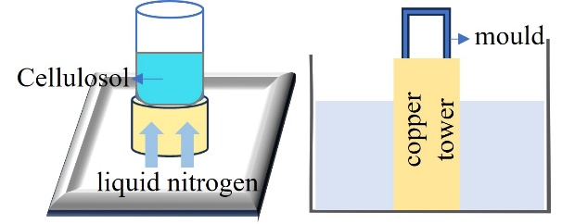
Fig. S1 The directional freezing device

Tab.S1 Element distribution on ZnO/CA-3 aerogel surface and cross-section
Scanning position | Element | Weight % | Atomic %
Surface | C | 43.2 | 55.2
Surface | O | 43.5 | 41.7
Surface | Zn | 13.3 | 3.1
Cross-section | C | 30.6 | 36.7
Cross-section | O | 48.3 | 43.6
Cross-section | Zn | 2.6 | 0.6

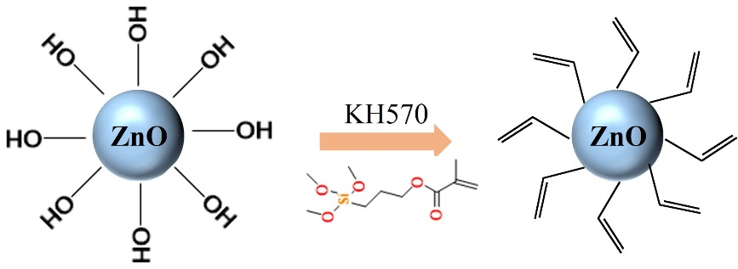
Fig. S2 The mechanism of KH570 graft-modified ZnO nanoparticles
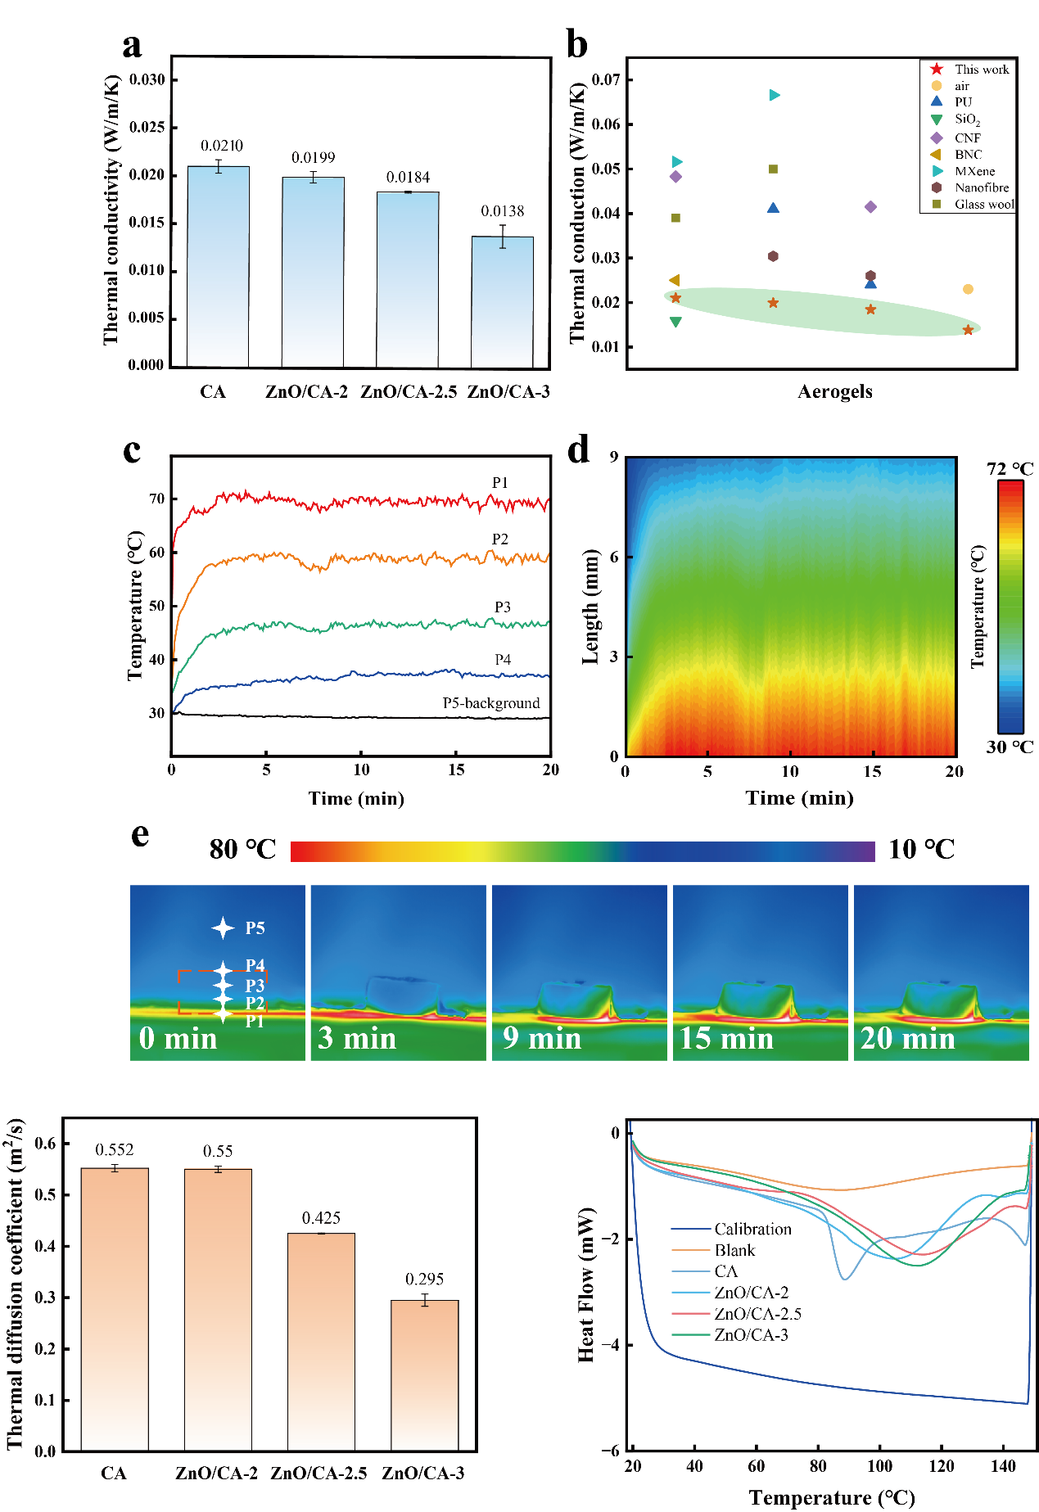
Fig. S3 Heat flow curves for the blank sample, the calibration sample and ZnO/CA aerogel
The specific heat capacity (c_{p}) of textiles was evaluated in the temperature range (20.0 ℃-150.0 ℃) using a Q200 differential scanning calorimeter. Isothermal-heating-isothermal process (Equilibrate 20.0 ℃, isothermal for 10.0 min, ramp 15.0 ℃/min to 150.0 ℃ and isothermal for 10 min). The specific heat capacity (c_{p}) can be calculated directly from equation (5):
(5)
$${cp}^{sp}={cp}^{cal}·\frac{\left(Pspecimen run-Pblank run\right)m^{cal}}{\left(Pcalibration run-Pblank run\right)m^{sp}}$$
Where c_{p} and m were the specific heat capacity (J/g⁻¹·℃⁻¹) and mass (g) of the aerogel, respectively. P signified the heat flow. The superscripts used in the equation are defined as follows: sp and cal，representing the sample being analyzed and the standard (calibration) sample, respectively.
Fig. S4 The thermal diffusivity coefficient of ZnO/CA aerogel
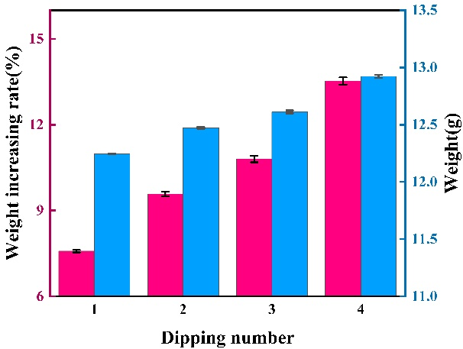
Fig. S5 The relationship between the number of impregnations of cotton fabrics and the weight gain rate and fabric weight
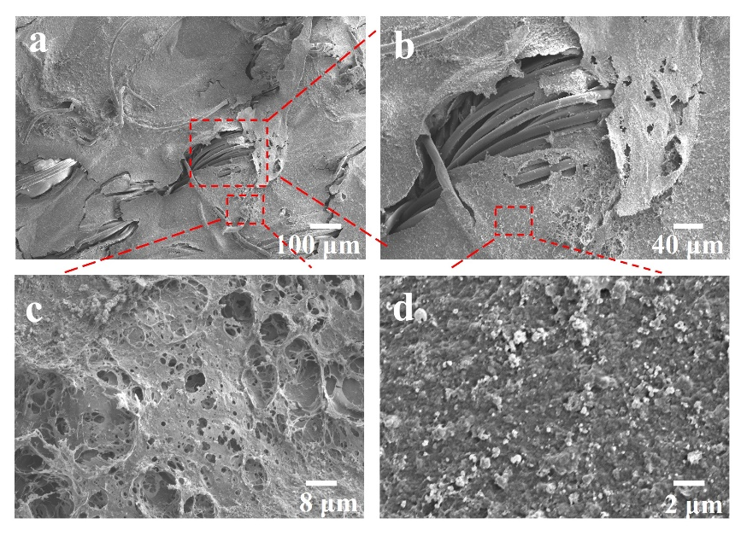
Fig. S6 The surface morphology of CZo aerogel-coated fabrics.
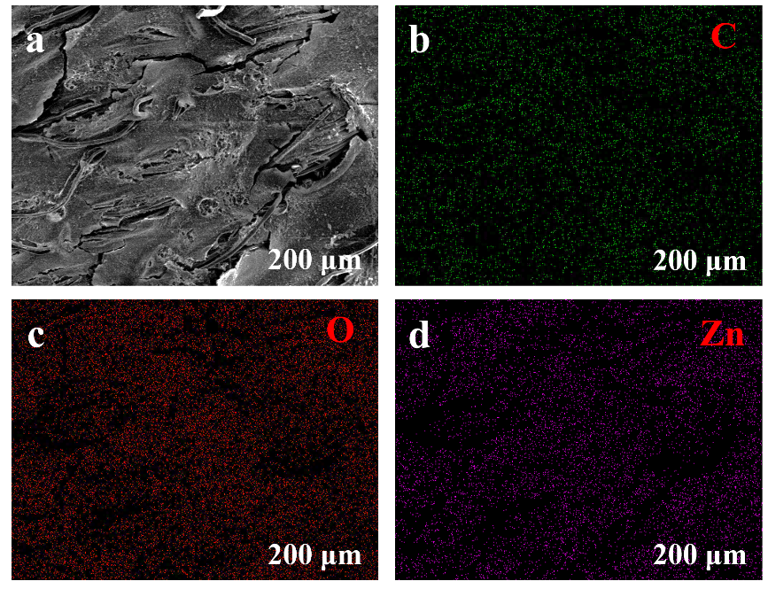
Fig.S7 Elemental mapping of CZo aerogel-coated fabrics
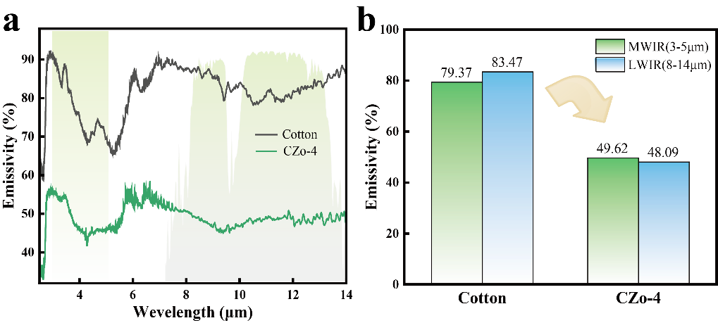
Fig.S8 a The emissivity of CZo-4 and cotton under the infrared bands and b the atmospheric window
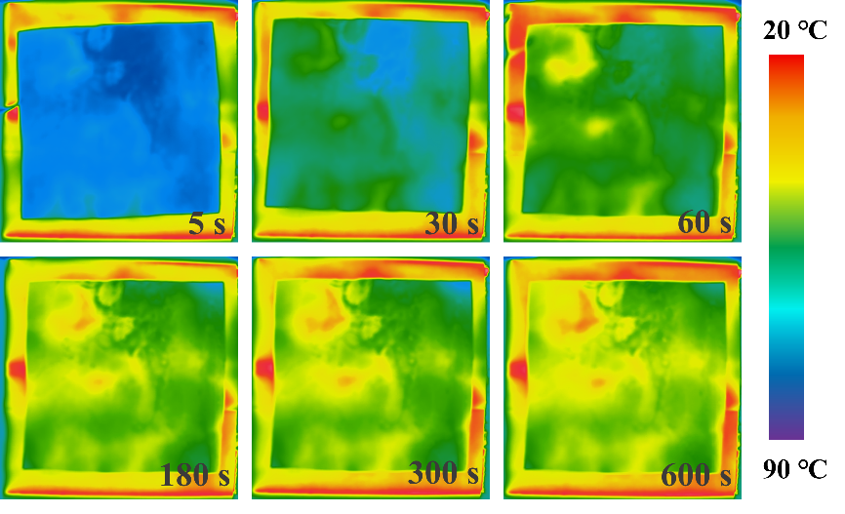
Fig. S9 Infrared thermal images of CZo-4 aerogel-coated fabrics

