Supplementary Materials for

Systematic identification of cancer-type specific drugs based on essential genes and validations in lung adenocarcinoma
Xiang Lian et al.

Corresponding author: fbguoy@whu.edu.cn
or zhenshun_cheng@126.com

The PDF file includes:

Supplementary Materials and Methods

Figs. S1 to S7

Tables S1 to S7

Methods:
Molecular docking section:
Molecular docking can study the interaction mechanism between receptors and ligands, helping researchers quickly select compounds or targets with research potential. In this study, we started with the molecular docking of drugs and proteins (Fig. 1E). Considering the large number of essential genes in lung cancer cell lines, we selected the genes with the top e values and studied their drug-binding mechanisms using molecular docking. For this study, we selected two protein crystal files from the RCSB database (https://www.rcsb.org/): 4zyo (SCD) and 7sj3 (CDK4). In addition, we obtained the structure file of the drug through the Pubchem database (https://pubchem.ncbi.nlm.nih.gov/).
Statistical analysis of molecular docking:
Statistical analysis of molecular docking data was performed using Autodock Vina [43] and Pymol [The PyMOL Molecular Graphics System, Version 2.3 Schrodinger, LLC.], Discovery Studio 2019 Client (19.1.0.18287), and TBtools [44].
Molecular dynamic simulation section:
We further investigated the interactions between the three drugs and the three corresponding protein structures in the body fluid using molecular dynamics simulation (MD simulation) to verify whether the drugs can bind to the corresponding proteins (Fig. 1E). MD simulation is a computational method used to explore the movement of small molecules in time and space under specific conditions, providing an opportunity to study the dynamic behavior of small molecules in proteins and the structural stability of proteins. Here, we set the conditions of MD to a neutral sodium chloride solution (0.145 mol/L), constant pressure (101 kPa), constant temperature (310 K), a simulation duration of 50 ns, and the TIP3P water model [45], it is important to note that accuracy is improved considering the interaction of drugs with water molecules.
We first balanced all pre-treated states and then performed 50 ns MD simulations of each of the three drugs with three proteins, with conformation calculations performed every 10 ps. Root mean square deviation (RMSD) is an indicator that describes whether conformational changes occur and whether small molecules can move stably within the protein system in MD simulation. Radius of gyration (Rg) values reflect the volume and structure of protein macromolecules. The higher the Rg value in the same system, the greater the expansion in the MD process; Solvent accessible surface area (SASA) is a key index to describe protein solubility and hydrophobicity, and the hydrophobicity of amino acid residues is a key physical factor affecting protein folding. The formulas for RMSD, Rg, and SASA values are given by formulas (1), (2), and (3).
$RMSD=\sqrt{\frac{1}{N}\sum_{i=1}^{N}{{(R_{t}−R_{ref})}^{2}} }$ (1)
$Rg=\sqrt{\frac{\sum_{i=1}^{N}{m_{i}}{\left(C_{i}−R_{cm}\right)}^{2}}{\sum_{i=1}^{N}{m_{i}}} }$ (2)
${ASA}_{i}=4πr_{i}^{2}$ (3)
In the above equations, $R_{t}−R_{ref}$ represents the positional offset, specifically the position of the t-th atom in a given frame subtracted by the position of the ref-th atom in the reference conformation. N is the number of atoms, $m_{i}$ is the mass of the i-th atom, $C_{i}$ is the coordinates of the i-th atom, $R_{cm}$ is the center of mass coordinates of the drug, ${ASA}_{i}$ is the accessible surface area of the i-th atom, and $r_{i}$ is the effective radius of the i-th atom.
We obtained RMSD/cluster index data from MD simulations to fully describe the effects of the three drugs on protein conformational changes during the simulation. The RMSD/clustering index not only visually reflects the fluctuations, variations, and potential conformational shifts of protein structure during MD simulation, but also shows the number of different conformational clusters formed during the simulation. The top half of the RMSD/Cluster Index plot (fig. S6) represents RMSD and the bottom half represents clustering. An interpretation of the RMSD/cluster index plot can be found in Ref. [46], where the number and size of clusters can be used to explain the number of stable protein conformations during constant RMSD fluctuations. The RMSD/cluster index (fig. S6) shows that during the 50 ns simulation, after binding the three drugs at their original ligand binding sites the protein conformations can remain stable (fig. S6A, S6C, and S6E). These results suggest that the three drugs are able to bind to their original ligand-binding sites.
To validate the above results from the perspective of drug conformational changes, we used a protein number density map similar to a three-dimensional fluorescence spectrum, which researchers can use to optimize the drug structure using the information provided by the protein number density map. Here, regions of preferential interactions between the drug and the protein are shown. According to the protein quantity density (fig. S6), all three drugs exhibited a relatively dense aggregation binding effect at their corresponding binding sites, indicating that the 3D structure of the three drugs may not have changed (fig. S6B, S6D, and S6F) and the drug efficacy is more likely to be stable. These results suggest that the three drugs can bind to their original ligand-binding sites.
Statistical analysis of MD simulations:
MD simulations were performed using the Gromacs program suite [47]. Built-in programs in Gromacs were used to extract data from MD simulation results, including RMSD (root mean square deviation), Rg (radius of turn), total energy, and SASA (solvent usable surface area). Origin was used for data visualization.

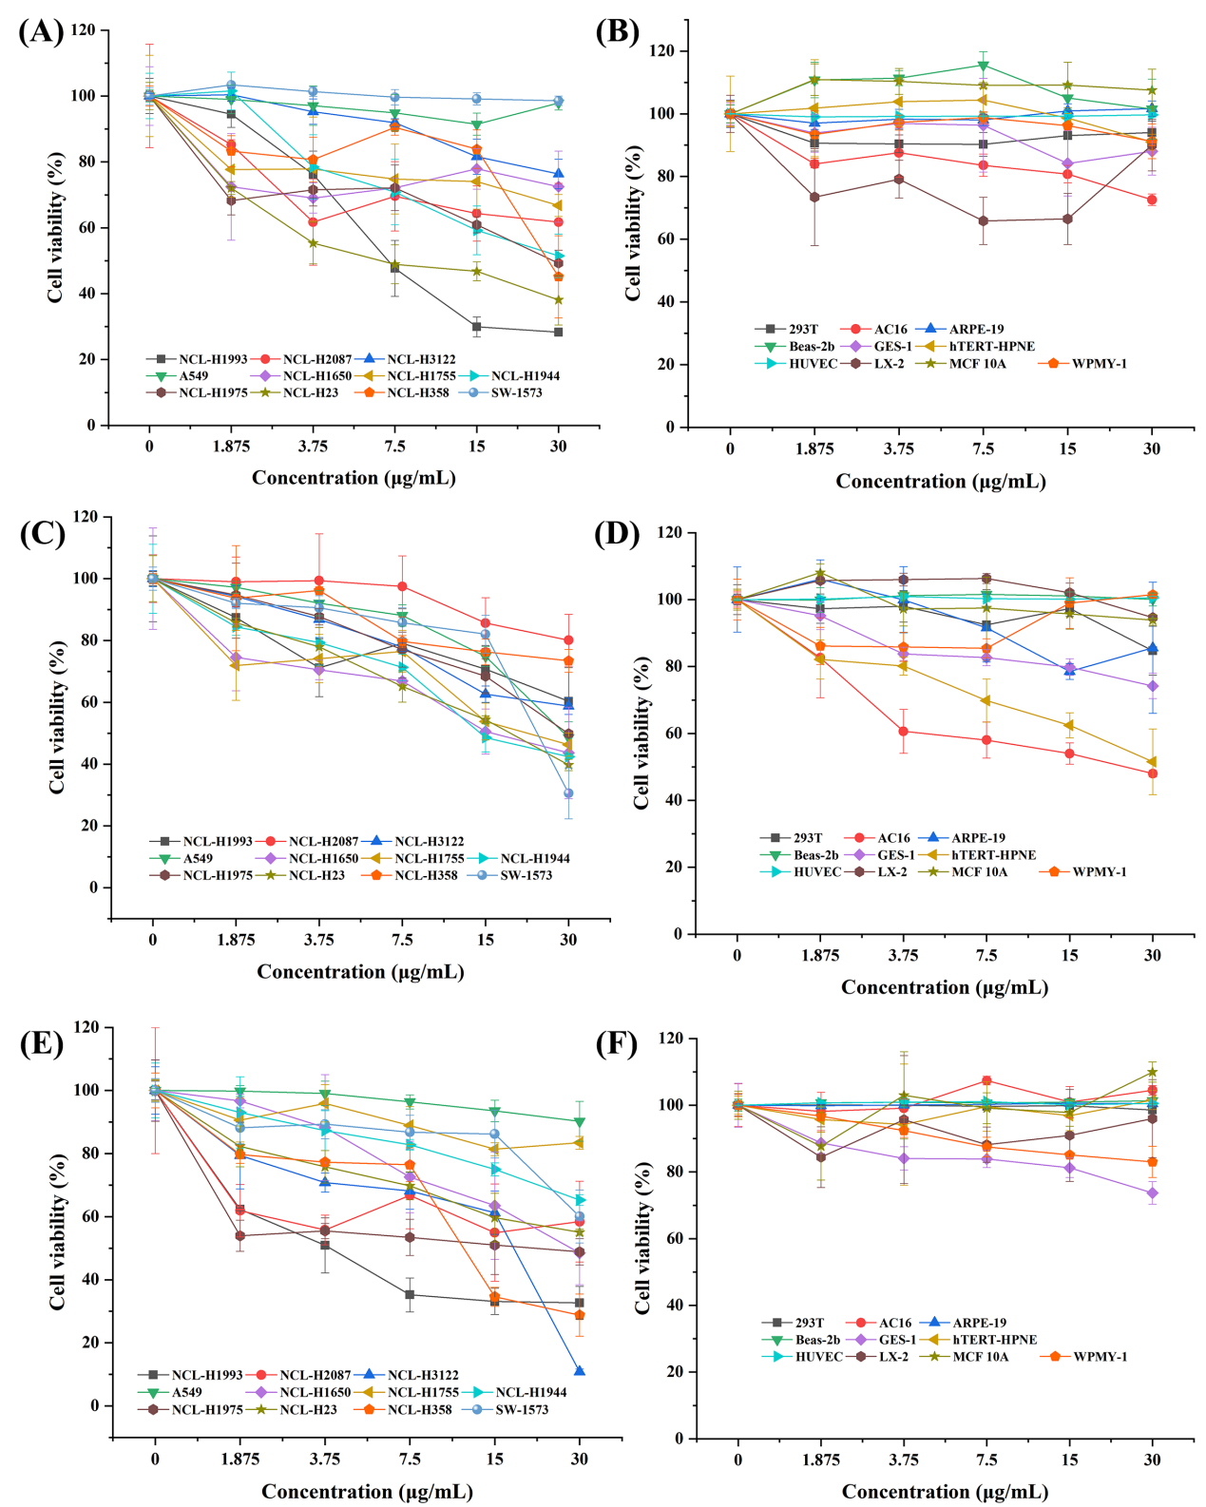
Supplementary Figure 1. (A, B) Cell viability of apremilast in 11 lung cancer cell lines and 10 normal cell lines, respectively. (C, D) Cell viability of rosiglitazone in 11 lung cancer cell lines and 10 normal cell lines, respectively. (E, F) Cell viability of hydrochlorothiazide in 11 lung cancer cell lines and 10 normal cell lines, respectively.

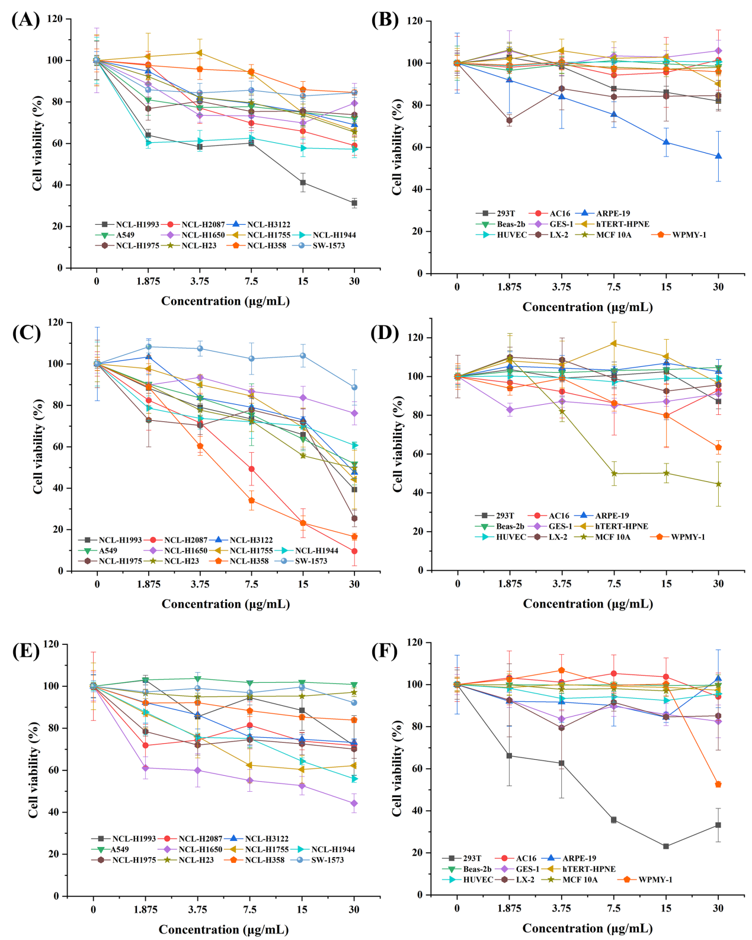
Supplementary Figure 2. (A, B) Cell viability of dexamethasone in 11 lung cancer cell lines and 10 normal cell lines, respectively. (C, D) Cell viability of progesterone in 11 lung cancer cell lines and 10 normal cell lines, respectively. (E, F) Cell viability of ibuprofen in 11 lung cancer cell lines and 10 normal cell lines, respectively.

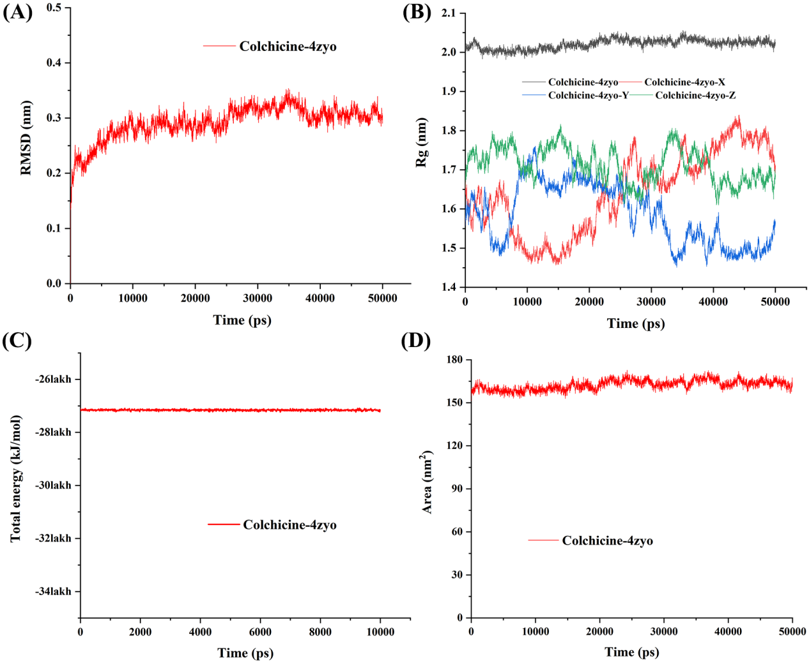
Supplementary Figure 3. MD simulation results of colchicine and SCD system. (A) RMSD; (B) Rg; (C) Total energy; (D) SASA.
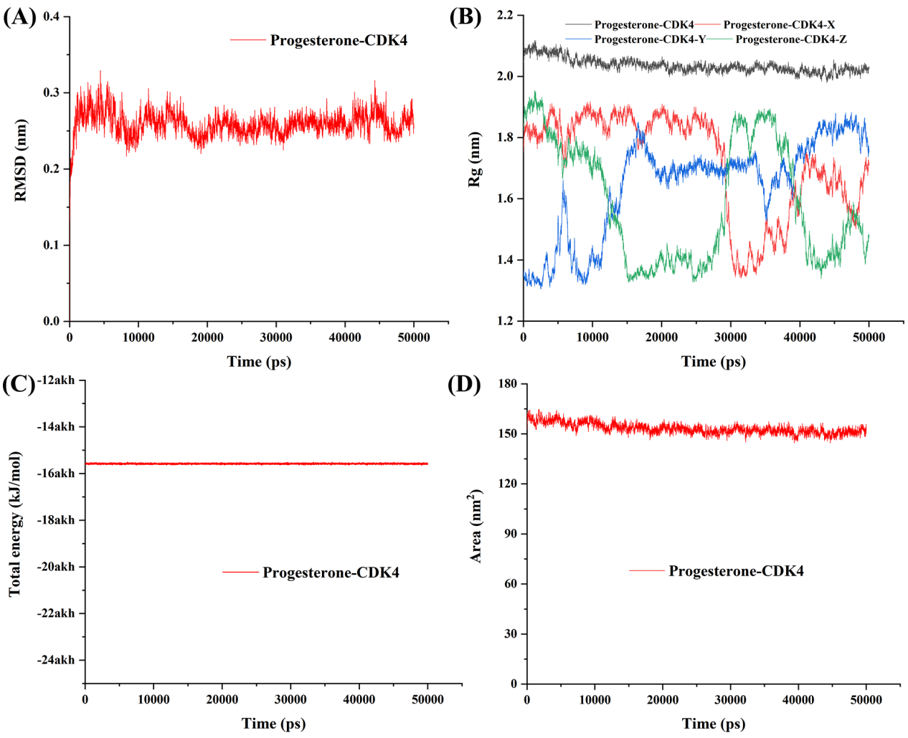
Supplementary Figure 4. MD simulation results of progesterone and CDK4 system. (A) RMSD; (B) Rg; (C) Total energy; (D) SASA.
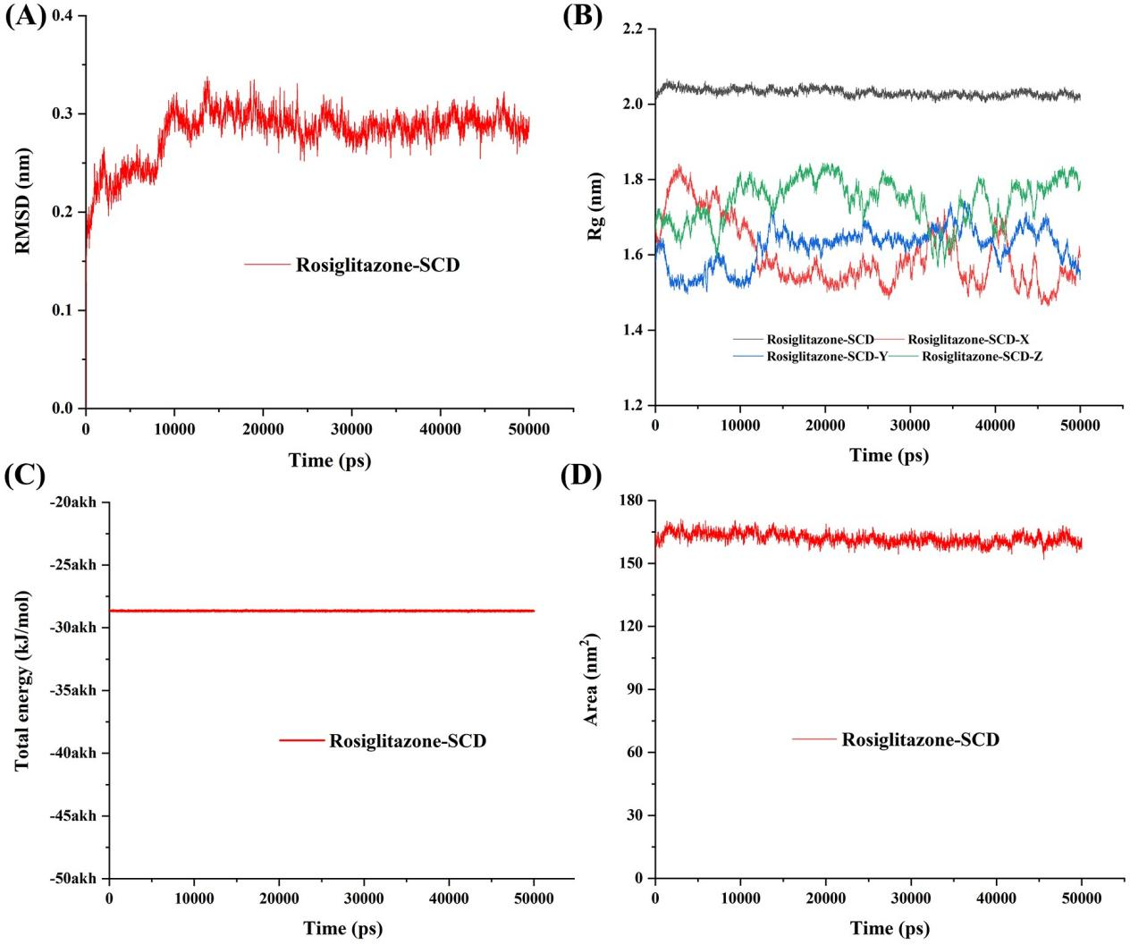
Supplementary Figure 5. MD simulation results of rosiglitazone and SCD system. (A) RMSD; (B) Rg; (C) Total energy; (D) SASA.
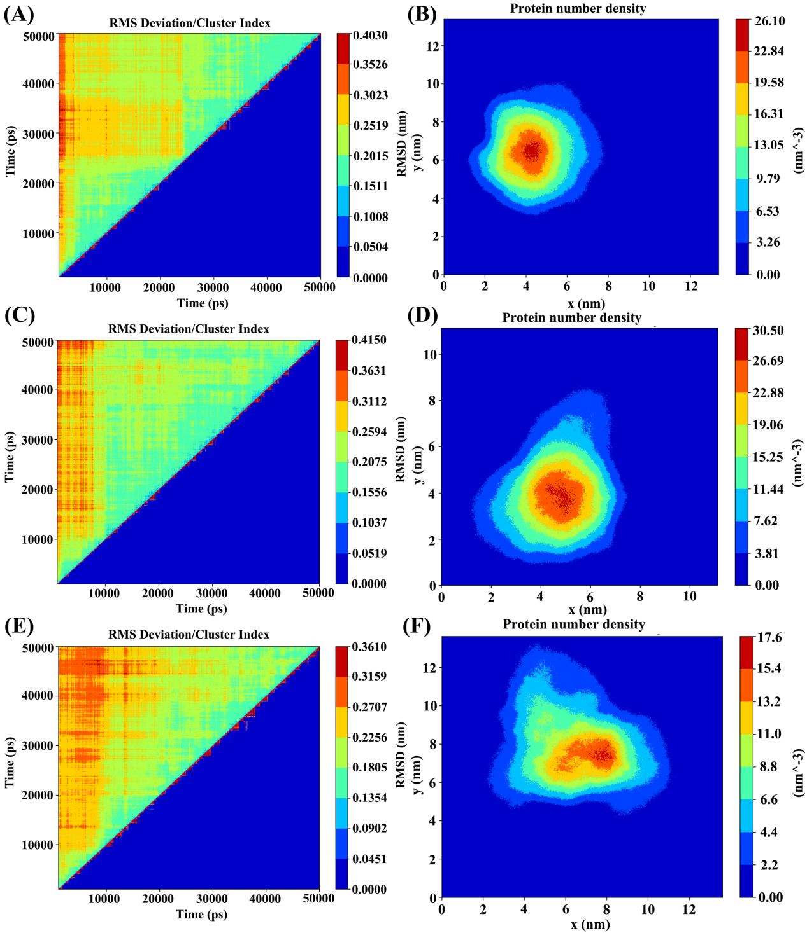
Supplementary Figure 6. RMSD/clustering index and protein number density for three complex systems. (A) RMSD/clustering index of colchicine-SCD site; (B) Protein number density of colchicine-SCD site; (C) RMSD/clustering index of the progesterone-CDK4 site; (D) Protein number density at colchicine-CDK4; (E) RMSD/clustering index of the rosiglitazone-SCD site; (F) Protein number density at the rosiglitazone-SCD site. The red lines in the clusters indicate the size and number of clusters, and the high-density areas indicate the likelihood that the drug will bind to those specific areas.
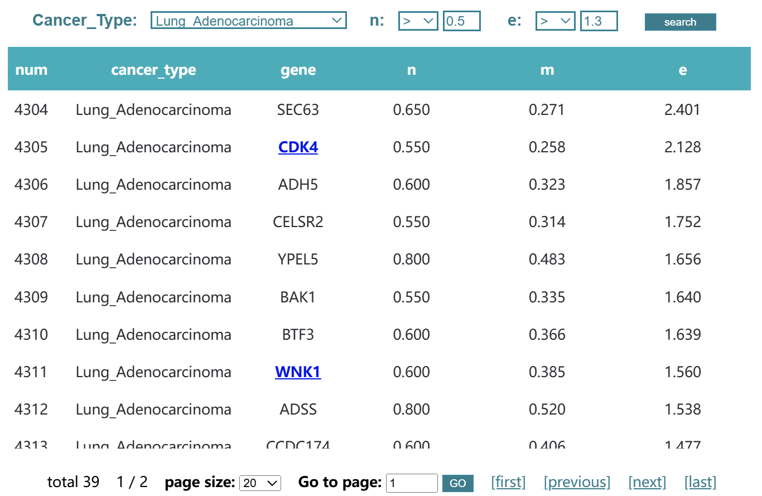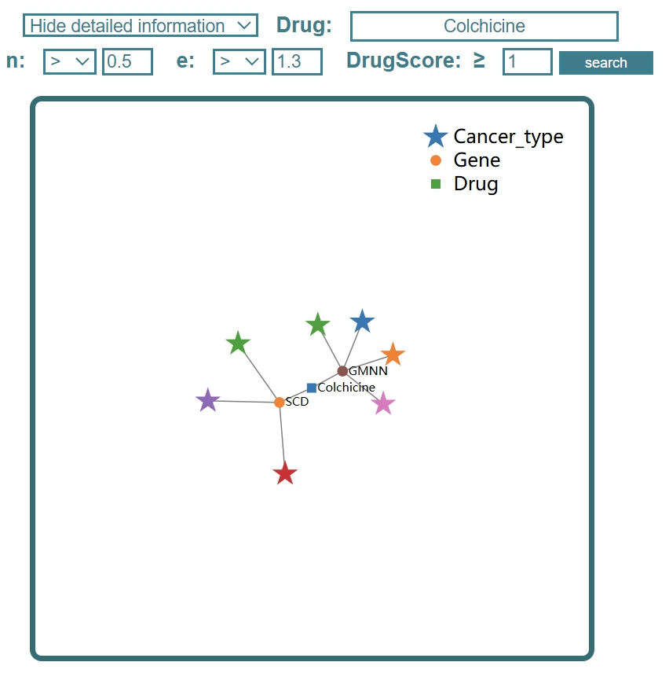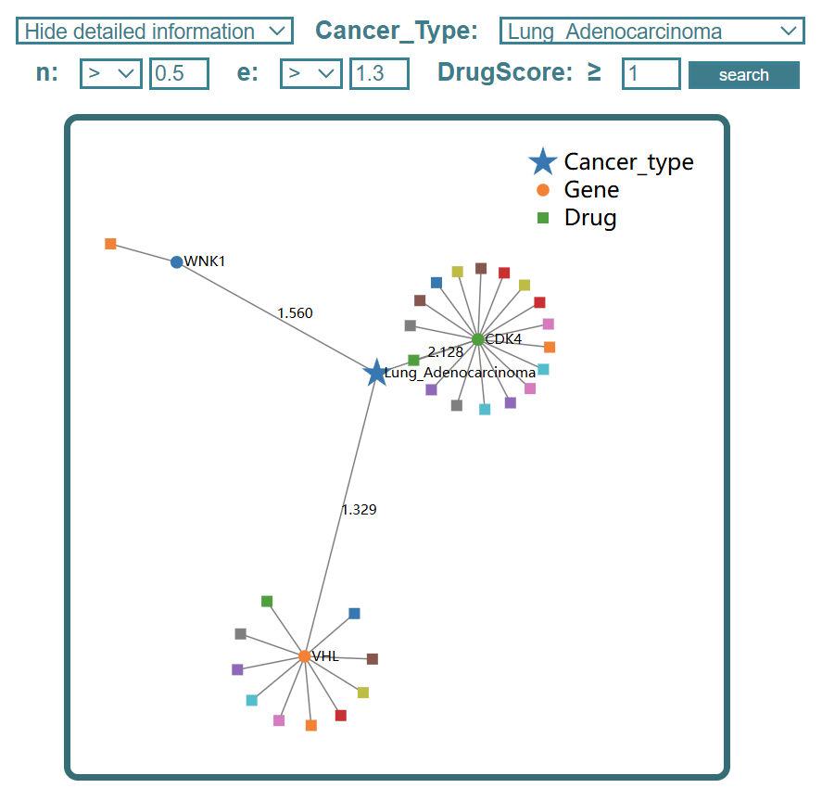
(B)
(A)
(C)
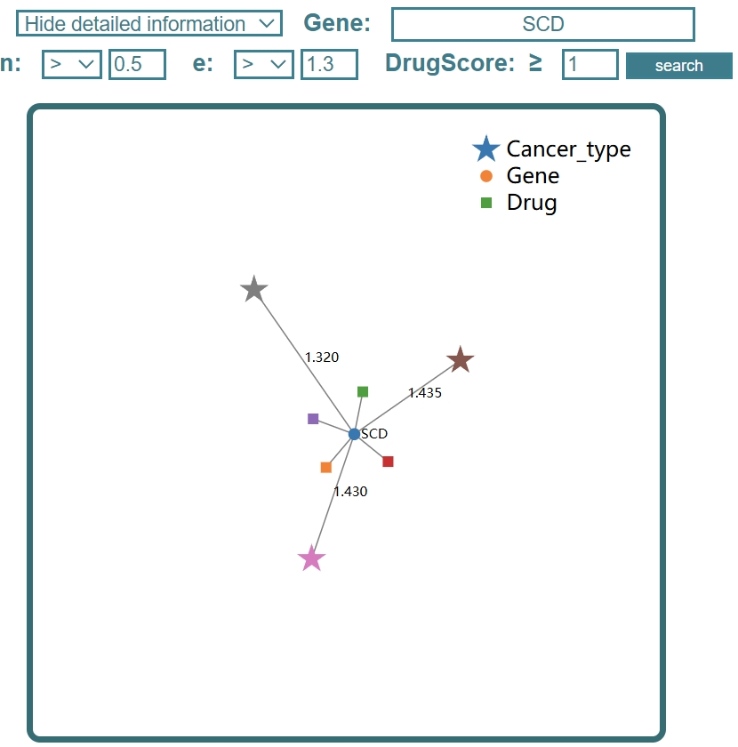
(D)
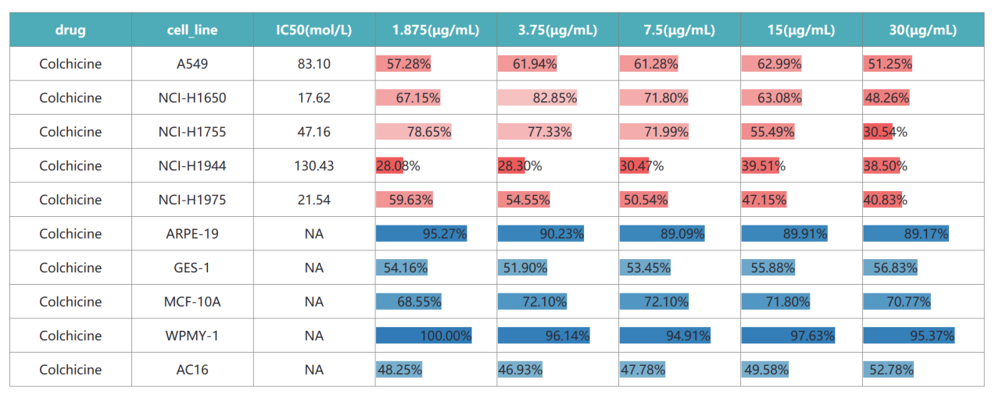
(E)
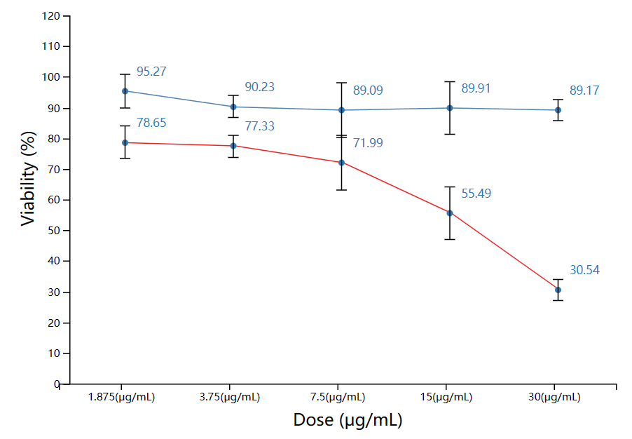
(F)
Supplementary Figure 7. (A) “Target” module in EGKG, an example of searching for recommended target genes by cancer type. Click on the link to view information on the drug corresponding to the gene. If there is no link, it means that the target has no matching drugs in our data collection. (B, C, D) The corresponding knowledge graph (Drug module) based on drug, cancer type, and gene respectively (E) Experiment results interface in EGKG. The table in the figure showcases the inhibition effects of drugs on cancer cell lines, with the red bar graph indicating the degree of inhibition. The darker the shade of red, the better the inhibitory effect of the drug on the cancer cell lines. The blue bar graph represents the cytotoxic effects of the drugs on normal cell lines, with darker blue shades indicating lesser harm to normal cells. (F) Experiment results interface in EGKG. The line graph in the figure depicts the trend of drug effects on cell lines at different concentrations.

Supplementary Table 1. Gene-drug records in EGKG for each annotation source (redundant records are included). The table shows the number of initial records and the number of processed records after filtering.
Source | Source provider | #initial records | #processed records
CancerCommons | DGIdb | 109 | 51
DTC | DGIdb | 23879 | 3364
JAX-CKB | DGIdb | 1962 | 786
NCI | DGIdb | 6231 | 794
GuideToPharmacology | DGIdb | 14081 | 1169
ChemblInteractions | DGIdb | 7610 | 861
PharmGKB | DGIdb | 5078 | 1044
MyCancerGenome | DGIdb | 865 | 259
TEND | DGIdb | 2243 | 316
TdgClinicalTrial | DGIdb | 5063 | 703
CIViC | DGIdb | 959 | 333
TALC | DGIdb | 624 | 170
MyCancerGenomeClinicalTrial | DGIdb | 377 | 106
DoCM | DGIdb | 76 | 31
ClearityFoundationClinicalTrial | DGIdb | 281 | 74
ClearityFoundationBiomarkers | DGIdb | 163 | 82
FDA | DGIdb | 427 | 189
OncoKB | DGIdb | 150 | 72
COSMIC | DGIdb | 37 | 17
TTD | TTD | 44431 | 13643
#initial records: those downloaded directly from the dataset containing gene-drug records.
#processed records: After filtering, the gene-drug records were used in EGKG.

Supplementary Table 2. In each of the 19 cancer types, the number of our identified drugs and their corresponding targets and the number of total targets applied to the cancer type.
Serial number | Cancer-type | Drug (number) | Target (number) | Target (total)
1 | B cell non hodgkin`s lymphoma | 106 | 26 | 318
2 | Breast carcinoma | 40 | 6 | 40
3 | Colorectal carcinoma | 68 | 6 | 37
4 | Endometrial carcinoma | 82 | 6 | 185
5 | Esophageal adenocarcinoma | 156 | 19 | 133
6 | Esophageal squamous cell carcinoma | 49 | 9 | 167
7 | Ewing`s sarcoma | 103 | 16 | 374
8 | Gastric carcinoma | 168 | 9 | 103
9 | Glioblastoma | 48 | 3 | 84
10 | Head and neck carcinoma | 74 | 8 | 199
11 | Low grade glioma | 131 | 13 | 300
12 | Lung adenocarcinoma | 33 | 5 | 39
13 | Neuroblastoma | 75 | 12 | 221
14 | Non-Small cell lung carcinoma | 113 | 8 | 120
15 | Oral cavity carcinoma | 27 | 5 | 180
16 | Ovarian carcinoma | 54 | 6 | 86
17 | Pancreatic carcinoma | 144 | 11 | 114
18 | Plasma cell myeloma | 198 | 25 | 309
19 | Squamous cell lung carcinoma | 76 | 7 | 152

Supplementary Table 3. Clinical indication of top 32 identified drugs in lung adenocarcinoma from TTD.
Drug | Rank | Known Indications | Repositioning of the Cancer | Target Gene | e score
Alpelisib | 1 | Breast cancer ^{[1]} | lung Adenocarcinoma | CDK4 | 2.13
Dexamethasone | 2 | Rheumatoid arthritis ^{[2]} | lung Adenocarcinoma | CDK4 | 2.13
Progesterone | 3 | Premature labour ^{[3]} | lung Adenocarcinoma | CDK4 | 2.13
Palbociclib | 4 | Breast cancer ^{[4]} | lung Adenocarcinoma | CDK4 | 2.13
Ribociclib Succinate | 5 | Breast cancer ^{[5]} | lung Adenocarcinoma | CDK4 | 2.13
Abemaciclib | 6 | Breast cancer ^{[5]} | lung Adenocarcinoma | CDK4 | 2.13
Apremilast | 7 | Psoriasis vulgaris ^{[6]} | lung Adenocarcinoma | CDK4 | 2.13
chembl:CHEMBL3894860/Trilaciclib | 8 | Small-cell lung cancer ^{[7]} | lung Adenocarcinoma | CDK4 | 2.13
Nicotine | 9 | Nicotine dependence ^{[8]} | lung Adenocarcinoma | CDK4 | 2.13
Imidazo pyridine derivative 3 | 10 | Unclear | lung Adenocarcinoma | CDK4 | 2.13
Indole-based analog 13 | 11 | Unclear | lung Adenocarcinoma | CDK4 | 2.13
Oxazolyl methylthiothiazole derivative 1 | 12 | Unclear | lung Adenocarcinoma | CDK4 | 2.13
Palbociclib/ribociclib analog 1 | 13 | Unclear | lung Adenocarcinoma | CDK4 | 2.13
PMID26161698-Compound-17 | 14 | Unclear | lung Adenocarcinoma | CDK4 | 2.13
Pyrrolo[2,3-d]pyrimidine derivative 10 | 15 | Unclear | lung Adenocarcinoma | CDK4 | 2.13
Pyrrolo[2,3-d]pyrimidine derivative 9 | 16 | Unclear | lung Adenocarcinoma | CDK4 | 2.13
Hydrochlorothiazide | 17 | Hypertension ^{[9]} | lung Adenocarcinoma | WNK1 | 1.56
Everolimus | 18 | Renal cell carcinoma ^{[10]} | lung Adenocarcinoma | VHL | 1.33
Temsirolimus | 19 | Renal cell carcinoma ^{[11]} | lung Adenocarcinoma | VHL | 1.33
chembl:CHEMBL521686/Olaparib | 20 | Ovarian cancer ^{[12]} | lung Adenocarcinoma | VHL | 1.33
Regorafenib | 21 | Metastatic colorectal cancer ^{[13]} | lung Adenocarcinoma | VHL | 1.33
Trametinib | 22 | Melanoma ^{[14]} | lung Adenocarcinoma | VHL | 1.33
Sunitinib | 23 | Gastrointestinal cancer ^{[15]} | lung Adenocarcinoma | VHL | 1.33
Ruxolitinib | 24 | Pancreatic cancer ^{[16]} | lung Adenocarcinoma | VHL | 1.33
Nicotine | 25 | Nicotine dependence ^{[8]} | lung Adenocarcinoma | VHL | 1.33
Ibuprofen | 26 | Pain ^{[18]} | lung Adenocarcinoma | VHL | 1.33
Pyrrolidine carboxamide derivative 1 | 27 | Unclear | lung Adenocarcinoma | VHL | 1.33
Colchicine | 28 | Acute gouty arthritis ^{[18]} | lung Adenocarcinoma | SCD | 1.32
Rosiglitazone | 29 | Type 2 diabetes ^{[19]} | lung Adenocarcinoma | SCD | 1.32
Clofibrate | 30 | Dysbetalipoproteinemia ^{[20]} | lung Adenocarcinoma | SCD | 1.32
Isoxyl | 31 | Bacterial infection ^{[21]} | lung Adenocarcinoma | SCD | 1.32
Atorvastatin | 32 | Cardiovascular disease ^{[22]} | lung Adenocarcinoma | SCAP | 1.30
Simvastatin | 33 | Hypercholesterolaemia ^{[23]} | lung Adenocarcinoma | SCAP | 1.30

Literature:
[1] Drugs@FDA. U.S. Food and Drug Administration. U.S. Department of Health Human Services. 2019.
[2] URL: http://www.guidetopharmacology.org Nucleic Acids Res. 2015 Oct 12. pii: gkv1037. The IUPHAR/BPS Guide to PHARMACOLOGY in 2016: towards curated quantitative interactions between 1300 protein targets and 6000 ligands. (Ligand id: 3447).
[3] URL: http://www.guidetopharmacology.org Nucleic Acids Res. 2015 Oct 12. pii: gkv1037. The IUPHAR/BPS Guide to PHARMACOLOGY in 2016: towards curated quantitative interactions between 1300 protein targets and 6000 ligands. (Ligand id: 2377).
[4] Drugs@FDA. U.S. Food and Drug Administration. U.S. Department of Health Human Services. 2017.
[5] 2017 FDA drug approvals.Nat Rev Drug Discov. 2018 Feb;17(2):81-85.
[6] URL: http://www.guidetopharmacology.org Nucleic Acids Res. 2015 Oct 12. pii: gkv1037. The IUPHAR/BPS Guide to PHARMACOLOGY in 2016: towards curated quantitative interactions between 1300 protein targets and 6000 ligands. (Ligand id: 7372).
[7] Drugs@FDA. U.S. Food and Drug Administration. U.S. Department of Health Human Services. 2021.
[8] URL: http://www.guidetopharmacology.org Nucleic Acids Res. 2015 Oct 12. pii: gkv1037. The IUPHAR/BPS Guide to PHARMACOLOGY in 2016: towards curated quantitative interactions between 1300 protein targets and 6000 ligands. (Ligand id: 2585).
[9] URL: http://www.guidetopharmacology.org Nucleic Acids Res. 2015 Oct 12. pii: gkv1037. The IUPHAR/BPS Guide to PHARMACOLOGY in 2016: towards curated quantitative interactions between 1300 protein targets and 6000 ligands. (Ligand id: 4836).
[10] URL: http://www.guidetopharmacology.org Nucleic Acids Res. 2015 Oct 12. pii: gkv1037. The IUPHAR/BPS Guide to PHARMACOLOGY in 2016: towards curated quantitative interactions between 1300 protein targets and 6000 ligands. (Ligand id: 5889).
[11] URL: http://www.guidetopharmacology.org Nucleic Acids Res. 2015 Oct 12. pii: gkv1037. The IUPHAR/BPS Guide to PHARMACOLOGY in 2016: towards curated quantitative interactions between 1300 protein targets and 6000 ligands. (Ligand id: 5892).
[12] URL: http://www.guidetopharmacology.org Nucleic Acids Res. 2015 Oct 12. pii: gkv1037. The IUPHAR/BPS Guide to PHARMACOLOGY in 2016: towards curated quantitative interactions between 1300 protein targets and 6000 ligands. (Ligand id: 7519).
[13] URL: http://www.guidetopharmacology.org Nucleic Acids Res. 2015 Oct 12. pii: gkv1037. The IUPHAR/BPS Guide to PHARMACOLOGY in 2016: towards curated quantitative interactions between 1300 protein targets and 6000 ligands. (Ligand id: 5891).
[14] URL: http://www.guidetopharmacology.org Nucleic Acids Res. 2015 Oct 12. pii: gkv1037. The IUPHAR/BPS Guide to PHARMACOLOGY in 2016: towards curated quantitative interactions between 1300 protein targets and 6000 ligands. (Ligand id: 6495).
[15] URL: http://www.guidetopharmacology.org Nucleic Acids Res. 2015 Oct 12. pii: gkv1037. The IUPHAR/BPS Guide to PHARMACOLOGY in 2016: towards curated quantitative interactions between 1300 protein targets and 6000 ligands. (Ligand id: 5713).
[16] URL: http://www.guidetopharmacology.org Nucleic Acids Res. 2015 Oct 12. pii: gkv1037. The IUPHAR/BPS Guide to PHARMACOLOGY in 2016: towards curated quantitative interactions between 1300 protein targets and 6000 ligands. (Ligand id: 5688).
[17] URL: http://www.guidetopharmacology.org Nucleic Acids Res. 2015 Oct 12. pii: gkv1037. The IUPHAR/BPS Guide to PHARMACOLOGY in 2016: towards curated quantitative interactions between 1300 protein targets and 6000 ligands. (Ligand id: 2713).
[18] URL: http://www.guidetopharmacology.org Nucleic Acids Res. 2015 Oct 12. pii: gkv1037. The IUPHAR/BPS Guide to PHARMACOLOGY in 2016: towards curated quantitative interactions between 1300 protein targets and 6000 ligands. (Ligand id: 7526).
[19] Drugs@FDA. U.S. Food and Drug Administration. U.S. Department of Health&Human Services.
[20] URL: http://www.guidetopharmacology.org Nucleic Acids Res. 2015 Oct 12. pii: gkv1037. The IUPHAR/BPS Guide to PHARMACOLOGY in 2016: towards curated quantitative interactions between 1300 protein targets and 6000 ligands. (Ligand id: 2667).
[21] Has nature already identified all useful antibacterial targets Curr Opin Microbiol. 2008 Oct;11(5):387-92.
[22] Drugs@FDA. U.S. Food and Drug Administration. U.S. Department of Health & Human Services. 2015.
[23] URL: http://www.guidetopharmacology.org Nucleic Acids Res. 2015 Oct 12. pii: gkv1037. The IUPHAR/BPS Guide to PHARMACOLOGY in 2016: towards curated quantitative interactions between 1300 protein targets and 6000 ligands. (Ligand id: 2955).

Supplementary Table 4. The essentiality of the seven drug targets in lung adenocarcinoma cell lines [22].
 | Dexamethasone | Progesterone | Apremilast | Hydrochlorothiazide | Ibuprofen | Colchicine | Rosiglitazone
Cell-Line Name/Gene | CDK4 | CDK4 | CDK4 | WNK1 | VHL | SCD | SCD
A549 | 0 | 0 | 0 | 1 | 0 | 1 | 1
NCI-H1650 | 0 | 0 | 0 | 1 | 0 | 0 | 0
NCI-H1755 | 0 | 0 | 0 | 0 | 1 | 1 | 1
NCI-H1944 | 1 | 1 | 1 | 1 | 1 | 1 | 1
NCI-H1975 | 1 | 1 | 1 | 1 | 1 | 1 | 1
NCI-H1993 | 1 | 1 | 1 | 1 | 1 | 0 | 0
NCI-H2087 | 1 | 1 | 1 | 1 | 1 | 1 | 1
NCI-H23 | 1 | 1 | 1 | 0 | 0 | 1 | 1
NCI-H3122 | 1 | 1 | 1 | 0 | 1 | 1 | 1
NCI-H358 | 1 | 1 | 1 | 0 | 0 | 1 | 1
SW1573 | 0 | 0 | 0 | 1 | 0 | 1 | 1
SUM | 7 | 7 | 7 | 7 | 6 | 9 | 9

Supplementary Table 5. Clinical trial records of the top 32 repurposable drug candidates for lung adenocarcinoma.
Drug | Cancer clinical trial title
Alpelisib | Phase Ib study of alpelisib with cisplatin in patients with HPV+ solid tumor malignancies
Dexamethasone | Low dose versus standard dose dexamethasone for reduction of swelling in patients with primary or metastatic brain tumors
Progesterone | Cytoprotective effect and clinical outcome of perioperative proesterone in brain tumors
Palbociclib | A trial of SHR-1802 in patients with failure of standard treatment for advanced malignant tumors
Ribociclib Succinate | Early-phase study to assess inhibitor ribociclib in patients with recurrent glioblastoma or anaplastic glioma
Abemaciclib | Abemaciclib (LY2835219) in patients with recurrent primary brain tumors
Apremilast | Apremilast pregnancy exposure registry
chembl:CHEMBL3894860/Trilaciclib | Trilaciclib combined with chemotherapy for perioperative treatment of osteosarcoma
Nicotine | Thrive breast cancer app study
Hydrochlorothiazide | Hydrochlorothiazide and risk of skin cancer
Everolimus | Everolimus in patients with advanced solid malignancies with TSC1, TSC2, NF1, NF2, or STK11 mutations
Temsirolimus | Phosphatidylinositol 3 kinase and mammalian target of rapamycin (PI3K-mTOR) in advanced cancer patients
chembl:CHEMBL521686/Olaparib | Neoadjuvant chemotherapy with PISOXO for locally-invaded-gastric cancer (LIGC)
Regorafenib | A study of continued treatment with regorafenib in participants with solid tumors who have participated in other Bayer studies
Trametinib | Open-label study to investigate the safety, PK, and pharmacodynamics of GSK1120212 in subjects with solid tumors or lymphoma
Sunitinib | Use of individual pharmacokinetically (PK)-guided sunitinib dosing: a feasibility study in patients with advanced solid tumors
Ruxolitinib | INCB018424 in patients with advanced hematologic malignancies
Ibuprofen | Analgesia regimens following trans-sphenoidal surgery for pituitary tumors
Colchicine | Pilot trial of colchicine in urothelial cancer and other solid tumors
Rosiglitazone | Rosiglitazone in treating patients with pituitary tumors
Clofibrate | Coronary drug project mortality surveillance
Atorvastatin | A pilot trial of atorvastatin in tumor protein 53 (p53) -mutant and p53 wild-type malignancies
Simvastatin | The effect of high dose simvastatine on multiple myeloma

Supplementary Table 6. The average survival rate, T-test value, variance and standard deviation of 11 lung cancer cell lines and 10 normal cell lines were treated by the drugs.
 | Colchicine | Apremilast | Dexamethasone | Progesterone | Rosiglitazone | Ibuprofen | Hydrochlorothiazide | Progesterone+Rosiglitazone
Average  (cancer cell lines) (StDev) | 39.78% (9%) | 62.37% (23%) | 67.52% (15%) | 46.36% (24%) | 52.15% (15%) | 74.86% (18%) | 52.92% (23%) | 31.23% (12%)
Average  (normal cell lines) (StDev) | 71.66% (24%) | 93.73% (10%) | 91.29% (15%) | 87.78% (19%) | 83.46% (20%) | 84.30% (23%) | 96.95% (11%) | 94.31% (8%)
P value | 0.00066 | 0.00074 | 0.0017 | 0.00033 | 0.00055 | 0.30 | 2.67E-05 | 1.26E-11

Supplementary Table 7. IC50 values for seven drugs in eleven lung cancer cell lines.
log₁₀(IC50[μM]) | Apremilast | Dexamethasone | Progesterone | Rosiglitazone | Colchicine | Ibuprofen | Hydrochlorothiazide
A549 | 2.03 | 2.24 | 1.86 | 1.61 | 1.92 | 3.51 | 2.70
NCI-H1650 | / | 2.28 | 2.43 | 1.63 | 1.25 | 1.99 | 1.63
NCI-H1755 | 2.19 | 1.80 | 1.93 | 1.82 | 1.67 | 1.70 | 2.13
NCI-H1944 | 1.64 | 2.37 | 2.21 | 1.61 | 2.12 | 2.04 | 1.80
NCI-H1975 | 1.81 | 2.51 | 1.69 | 1.66 | 1.33 | 2.85 | 1.91
NCI-H1993 | 1.19 | 1.39 | 1.86 | 1.94 | 1.55 | 2.39 | 1.16
NCI-H2087 | 1.70 | 1.49 | 1.37 | 2.29 | 0.89 | 3.08 | 1.95
NCI-H23 | 1.16 | 2.14 | 1.76 | 1.51 | 0.22 | / | 1.56
NCI-H3122 | 1.64 | 1.66 | 1.95 | 1.77 | / | 1.90 | 1.68
NCI-H358 | 1.79 | 2.15 | 1.25 | 2.51 | 1.62 | 2.61 | 1.56
SW1573 | 2.76 | 3.26 | 2.43 | 1.78 | / | 3.00 | 2.12
Average | 1.79 | 2.12 | 1.89 | 1.83 | 1.40 | 2.51 | 1.84

