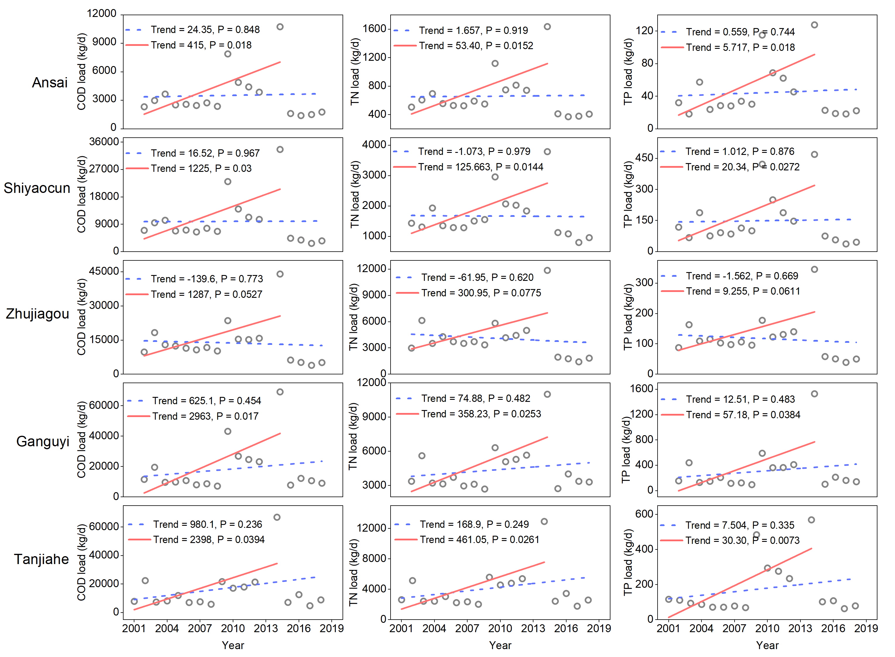
Fig. S1. Annual average loads of COD, TN, and TP at ﬁve stations. Black dots represented the annual average value (kg/d), red lines indicated linear tendency and significance from 2001–2014, and blue lines indicated linear tendency and significance from 2001–2018.

