SUPPLEMENTARY INFORMATION

DEHYDRATION OF CLOUDY-DIESEL USING HYDROGEL OF POLY(ACRYLAMIDE-CO-SODIUM POLYACRYLATE) GRAFTED ONTO CELLULOSE

Isadora Dias Perez^{a*}, Bianca Ramos Estevamª, João B.P. Soares^{b}, Melissa Gurgel Adeodato Vieiraª, Leonardo Vasconcelos Fregolenteª.
ª Department of Process and Product Design - School of Chemical Engineering, University of Campinas (UNICAMP), 13083-852 Campinas-SP, Brazil.
^{b} Department of Chemical and Materials Engineering, University of Alberta, T6G 1H9, Edmonton, Alberta, Canada
*Corresponding author e-mail: dpisadora@gmail.com

The distillation curve of the Canadian diesel used in the experiments was identified by the HT-SimDis analysis and is presented in Fig. S1. The Initial boiling point was determined at 98 ºC. At this temperature, the oil begins to produce vapors and forms a mixture with air that can ignite in the presence of a flame. The final boiling point was identified as 414 ºC. The oil used falls within the expected range for diesel (100-400 °C), making it an appropriate material for studying treatment with hydrogels.

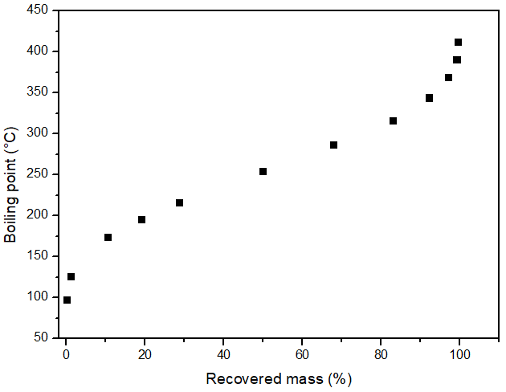
Fig. S1. Distillation curves of automotive diesel obtained from HT-SimDis simulated distillation.
Table S1 presents the analysis of variance (ANOVA) of the 2³ full factorial design used to investigate the synthesis condition of the cellulose-grafted hydrogel. The mathematical models are statistically significant since the F values calculated are higher than the tabulated F values and R² values are close to 1. Thus, the responses can be predicted by Eq. S1 and S2, regarding the maximum swelling degree (W_{max}) and final water content in diesel, respectively.

W_{max} = 89.05 + 3.81*CT – 1.01*CP + 38.61*IS + 1.69*CT*CP + 7.13*CT*IS -5.45*CP*IS | (S1)
Final water concentration = 261.73 – 71.87*CT – 12.93*CP – 59.11*IS – 0.27*CT*CP + 26.75*CT*IS + 12.75*CT*IS | S(2)

Where: CT is the cellulose type, CP is the cellulose percentage and IS is the initiation system, all of them in coded variables.

Table S1: ANOVA of the of the full factorial design (2³ + duplicates) used to evaluate the cellulose-grafted hydrogel synthesis method.
Response | Source | SS | DF | MS | Fitting parameters
 |  |  |  |  | R² | F_{calc} | F_{tab}
Swelling degree | Regression | 25,690.07 | 7 | 3,670.01 | 0.9627 | 29.53 | 3.50
Swelling degree | Residue | 994,21 | 8 | 124.28 | 0.9627 | 29.53 | 3.50
Swelling degree | Total | 26,684.28 | 15 |  | 0.9627 | 29.53 | 3.50
Final water content in diesel | Regression | 156,134.90 | 7 | 22,304.99 | 0.9772 | 49.07 | 3.50
Final water content in diesel | Residue | 3,636.60 | 8 | 454.58 | 0.9772 | 49.07 | 3.50
Final water content in diesel | Total | 159,771.50 | 15 |  | 0.9772 | 49.07 | 3.50
Footnote: SS: sum of square; DF: degree of freedom; MS: mean square; R²: coefficient of determination; F_{calc}=MS_{Regression}/MS_{residue} and F_{tab}: F tabulated value corresponding to the Fisher-Snedecor distribution.

