Supplementary Materials

Heavy metals stabilization in lead zinc mine tailings by using Mechanical activation, Mechano-chemical and microwave oven activation: Tailing waste utilization in building materials

Karim Nawaz^{a,b}, , Guangwei Yu^{a,b}, Muhammad Noman^{a,b} Fang Jintao^{a,b}, Wisal Ahmed^{a,b},

Institute of urban environment Chinese academy of science, China.

* Corresponding author
E-mail address: gwyu@iue.ac.cn (Guangwei Yu)

Figure S1: EDS Energy Dispersive Spectroscopy
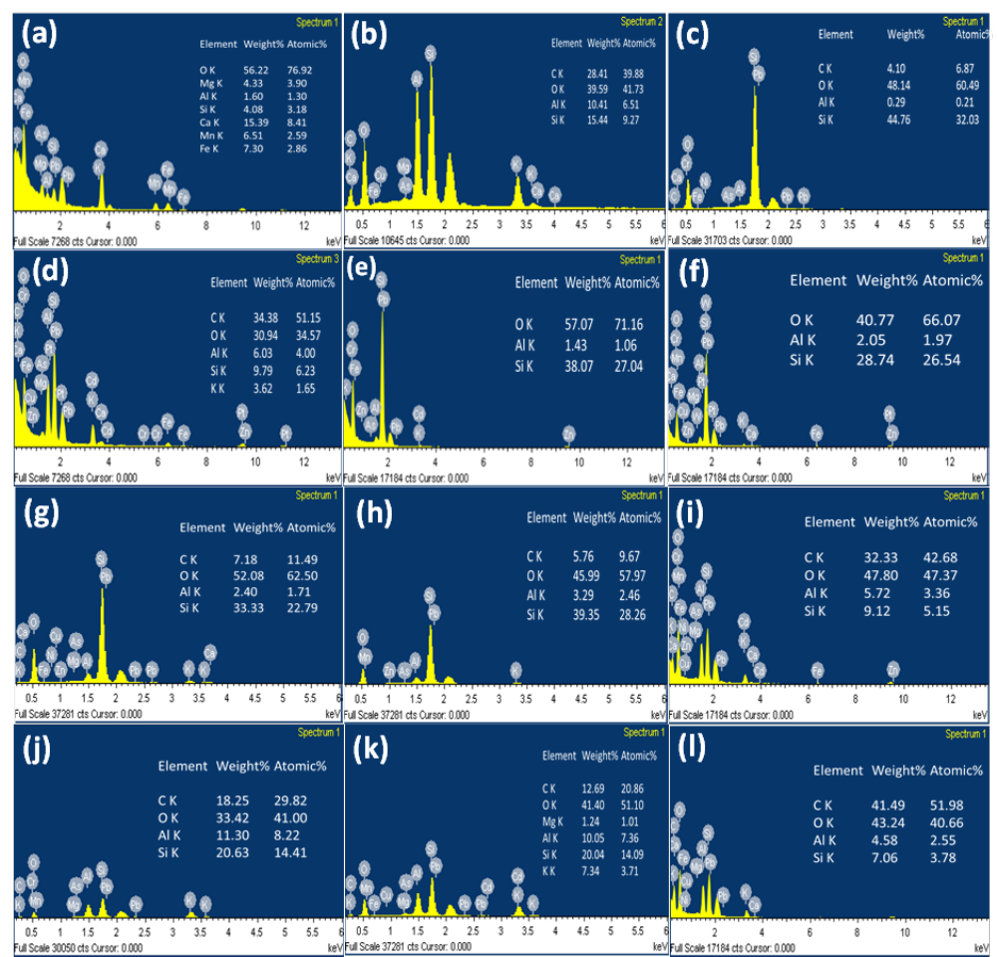
Figure S1: EDS results of performed SEM images
Figures (a, b, and c) show the mapping analysis of raw LZTs in the powders and concrete samples after the curing time of 7 days and 28 days, respectively. The presence of 56% oxygen confirms that LZTs are in the form of oxides, and they react in the presence of water to perform a hydration reaction. 20% of LZTs were replaced with cement in concrete materials. As per our XRF and XRD results LZTs are mainly composed of silicates, and calcite EDS confirm their presence and evidence of forming C-S-H gel and improved Cementous properties. Also, Figures b and c show that many mobile elements were stabilized as LZTs reacted as cement substitutes, evidenced by the XRD and SEM results.
Figures (d, e, and f) prove the mapping analysis of activated LZT powders after Microwave oven activation, Mechano-chemical activation, and Mechanical activation of LZT powders. It can be seen from the images that the activation percentage of Si increased from 4.08% to 9.79, 38.07 and 28.74%.
Figure (g, h, and i) gives the EDS spectrum of concrete samples based on activated LZTs by Microwave oven activation, Mechano-chemical activation, and Mechanical activation (T40, GO 0.03% and 200R respectively) after 7 days of curing. As per XRF results, cement is rich in silicates and Cao and shows a strong hydration reaction in water. When activated LZTs are added to cement, a hydration reaction results and forms the stabilized structure. The mobility of elements can be seen in raw LZTs and activated LZTs. Mostly, the stabilization of mobile and toxic elements was reduced due to activation, and this stabilization was further improved due to strong hydration reactions and concrete formation.
Figure (j, k, and l) gives the quantitative analysis of SEM images via EDS analysis of Microwave oven active, Mechano-chemical activation, and Mechanical activated LZTs based concrete materials after a curing time of 28 days. Peaks evidence that the formation of a more stabilized structure presented in 28 days of cured concrete compared to 7 days of curing shows that as curing times increase, more hydration reaction occurs as C-S-H gel formation increases. Hence, it proves the maximum compression strength after 28 days of curing. The presence of more carbonates in mechanically activated LZTs is responsible for their maximum compression strength.
Text S1: BET results
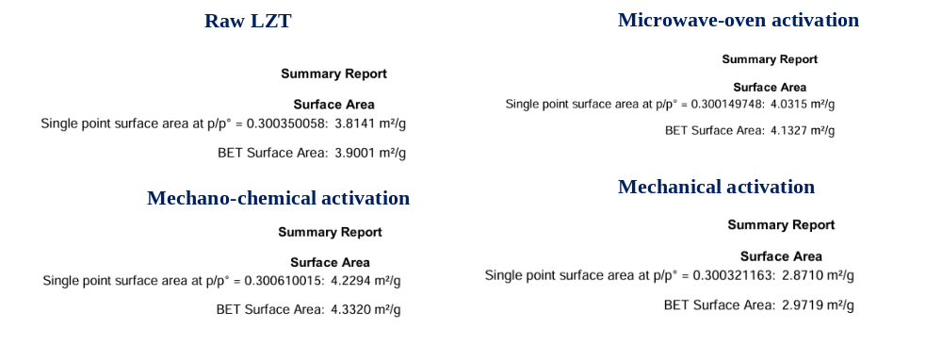
As per BET results Activated LZTs, especially those processed via Microwave or mechano-chemical activation, are highly suitable for incorporation into construction materials. These processes enhance their reactivity, maintain or increase surface area, and immobilize heavy metals, ensuring performance and environmental safety. Ball milling for 1h often leads to agglomeration due to van der Waals forces, resulting in a decrease in surface area and can add value by creating structural defects that improve mechanical integration in concrete or cement [1]. Moreover, BCR and TCLP results shows that mechanical activation improves the heavy metals stabilization along with improved compression strength.
Raw LZTs (Surface Area: 3.9001 m²/g)
Raw LZTs have less developed pore structure and surface area which isn’t suitable for utilization in construction because of potential health and environmental risks. Weak binding interactions shows the leaching and mobility of heavy metals as it’s been proved in BCR and TCLP results. Thus, raw LZTs are highly toxic without activation methods.
Microwave Activation (Surface Area: 4.1327 m²/g)
The increased surface area (compared to mechanically activated LZTs) and the thermal-induced chemical changes (e.g., phase transformations) enhance the pozzolanic reactivity of LZTs. Microwave-induced cracking and porosity also improve compatibility with cementitious matrices. It can be used as a supplementary cementitious material (SCM) in concrete, replacing a portion of ordinary Portland cement (OPC).
Mechano-Chemical Activation (Surface Area: 4.3320 m²/g)
Mechanical activation increases the surface area of LZTs and modifications introduced by GO during activation significantly enhance the reactivity of LZTs. The formation of functional groups and the stabilization of heavy metals improve the safety of these tailings for reuse in construction, while also boosting the compressive strength and durability of construction materials.
Mechanical Activation (Surface Area: 2.9719 m²/g)
Mechanical activation introduces defects and amorphization, which can improve chemical reactivity despite the lower surface area. Can act as a filler material to improve the mechanical strength and density of concrete or cement. It also enhances the binding of tailings with other construction materials through defect-induced reactivity. While mechanical activation reduces surface area, the structural defects can still contribute to improved bonding in construction materials. Compression strength of mechanical activated is always higher than other activation methods because it improves the activity of tailings and stabilizes the mobility of elements in it and also improve the compactness of concrete specimen. Pre crushing and grinding helps in formation of stabilized structure.

Reference
1. Zhang Y, Yang D, Gu X, et al (2022) Application of Iron Tailings-Based Composite Supplementary Cementitious Materials (SCMs) in Green Concrete. Materials 15:
.https://doi.org/10.3390/ma15113866

