PARASITOLOGY RESEARCH

Development of a Molecular Assay for the Determination of
Eimeria tenella Oocyst Viability

Kruth PS^{1,2}, Whale J¹, Léveillé AN^{1,3}, Brisbin J⁴, Barta JR^{1,5}

¹Department of Pathobiology, Ontario Veterinary College, University of Guelph, Guelph, Ontario, Canada
²ORCID: 0000-0002-3994-8080
³ORCID: 0000-0002-5506-3792
⁴Ceva Animal Health Inc., Guelph, Ontario, Canada
⁵ORCID: 0000-0001-6896-2271

JRB is corresponding author: jbarta@uoguelph.ca

Supplementary File 2

Comparison of Technical Replicate Runs for qPCR Standard Curve Analysis
Summary of qPCR reaction plates run to establish technical performance of primers. Threshold was set to the higher of the automatically set thresholds from both qPCR runs for each target. T_{m} was calculated using uMelt online software (Dwight et al., 2011), with a correction factor of -1.3 applied, with the predicted T_{m} range set to the uMelt predicted T_{m} ± 1ºC. Technical repeats were set up separately and run on separate qPCR plates. Slope, R², y-intercept, reaction efficiency, and the standard error of the regression (SER) were determined using Design and Analysis Software Version 2.6.0 (Applied BiosystemsTM).

Target | Threshold | T_{m} (ºC) | Predicted T_{m} range |  | Slope | R² | Y-intercept | Efficiency | Difference in efficiency | SER
Target | Threshold | T_{m} (ºC) | Low | High
Luc1 | 0.451 | 78.7 | 77.7 | 79.7 | -3.310 | 0.998 | 36.947 | 100.5% | 1.031 | 0.026
 |  |  |  |  | -3.286 | 0.999 | 36.428 | 101.5% | 1.031 | 0.017
S1 | 0.261 | 80.7 | 79.7 | 81.7 | -3.238 | 0.995 | 36.026 | 103.6% | 1.163 | 0.056
 |  |  |  |  | -3.264 | 0.999 | 35.909 | 102.5% | 1.163 | 0.024
V-2879 | 0.382 | 76.7 | 75.7 | 77.7 | -3.312 | 0.998 | 37.385 | 100.4% | 1.446 | 0.030
 |  |  |  |  | -3.347 | 0.999 | 37.345 | 99.0% | 1.446 | 0.025
V-3985 | 0.165 | 81.7 | 80.7 | 82.7 | -3.338 | 0.998 | 35.401 | 99.3% | 2.933 | 0.027
 |  |  |  |  | -3.269 | 0.999 | 34.838 | 102.3% | 2.933 | 0.024
V-8585_2 | 0.308 | 82.7 | 81.7 | 83.7 | -3.361 | 0.999 | 36.096 | 98.4% | 2.407 | 0.024
 |  |  |  |  | -3.303 | 0.999 | 35.598 | 100.8% | 2.407 | 0.024
V-9639 | 0.225 | 82.7 | 81.7 | 83.7 | -3.336 | 0.999 | 36.308 | 99.4% | 0.269 | 0.023
 |  |  |  |  | -3.330 | 0.999 | 36.041 | 99.7% | 0.269 | 0.024

Quantitative PCR Standard Curves
Horizontal dashed lines indicate the highest quantification cycle (C_{q}) values generated from 10-fold plasmid dilution series that fell within the linear portion of the standard curve (i.e., C_{q} values associated with approximate limit of quantification).

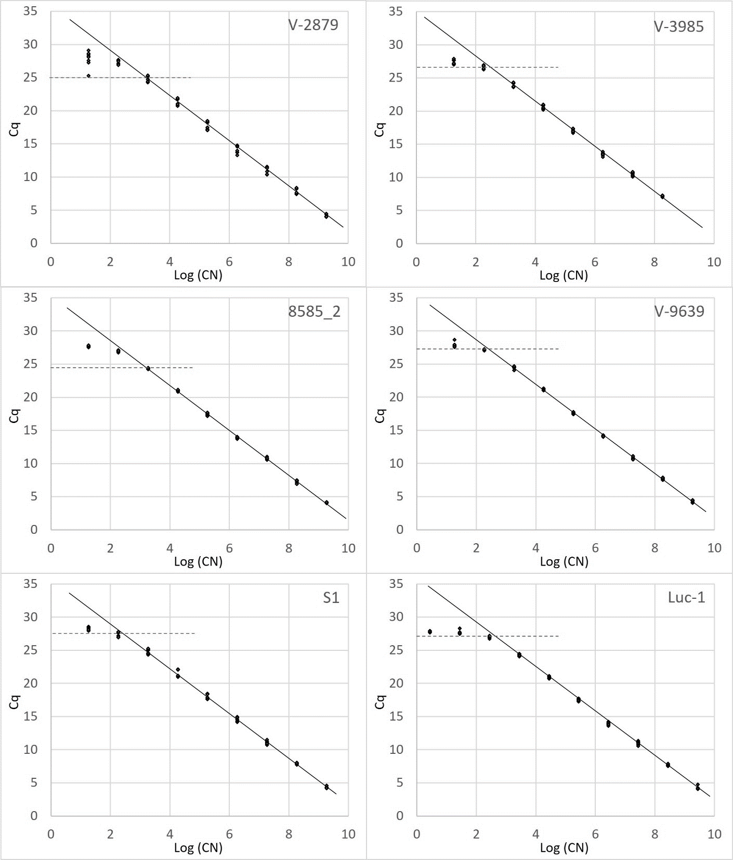

qPCR Primer Tendencies for Secondary Structure Formation
Assessing the tendencies for formation of primer dimers, primer secondary structures, and amplicon secondary structures. No primer hairpin structures or forward/ reverse primer dimers with ΔG below -3.5 were detected; self-primer dimers with ΔG (kcal/mol) below -3.5 are reported. Amplicon structures with T_{m}s ≥ 50ºC or ΔG below -9 kcal/mol are reported below. Where more than one secondary structure was predicted within a single amplicon: “# of structures: T_{m}s = Lower end of range – higher end of range; ΔG (kcal/mol) = higher end of range – lower end of range.

