Adjunctive phage therapy improves antibiotic treatment of Ventilator-Associated-Pneumonia with Pseudomonas aeruginosa
Chantal Weissfuss¹, Jingjing Li¹, Ulrike Behrendt¹, Karen Hoffmann¹, Magdalena Bürkle¹, Gopinath Krishnamoorthy¹, Imke H. E. Korf², Christine Rohde³, Baptiste Gaborieau^{4,5,6}, Laurent Debarbieux⁴, Jean-Damien Ricard^{5,6}, Martin Witzenrath^{1,7}, Matthias Felten^{1,*} and Geraldine Nouailles^{1,*}

¹ Charité - Universitätsmedizin Berlin, Corporate Member of Freie Universität Berlin and Humboldt-Universität zu Berlin, Department of Infectious Diseases, Respiratory Medicine and Critical Care, Berlin, Germany.
² Pharmaceutical Biotechnology, Fraunhofer Institute for Toxicology and Experimental Medicine, Braunschweig, Germany.
³ Leibniz Institute DSMZ-German Collection of Microorganisms and Cell Cultures, Braunschweig, Germany.
⁴ Institut Pasteur, Université Paris Cité, CNRS UMR6047, Department of Microbiology, Bacteriophage Bacteria Host Laboratory, Paris, France
⁵ Université Paris-Cité, Inserm, UMR 1137, Infection Antimicrobials Modelling Evolution, Paris, France.
⁶ APHP, Hôpital Louis Mourier, DMU ESPRIT, Service de Médecine Intensive Réanimation, Colombes, France.
⁷ German Center for Lung Research (DZL), Berlin, Germany
* Equally contributed to this work.

Correspondence: chantal.weissfuss@charite.de (C.W.), geraldine.nouailles@charite.de (G.N.)

Supplementary Table S1. Clinical disease score for murine VAP model.
Symptom | Score
Fur  Shiny  Dishelved | 0  1
Eyes  Bright  Tearing | 0  1
Behaviour  Curious, awaken  Less active (cage-side observation)  Less reactive to external stimulus | 0  1  2
Breathing  Steady, consistent  Hyper- /hypoventilation  Labored | 0  1  2
Temperature p. i.  > 35 °C  ≤ 35 °C  ≤ 30 °C | 0  1  2
Body weight change p. i.  <5 %  >5 % ≤ 10 %  >10 % ≤ 20 % | 0  1  2
Total clinical score
p. i., post infection.

Supplementary Table S2. Summary of statistics from the bacterial load at 4 hpi from cyclic stretch experiments with the Flexcell® FX-5000™ Tension System. Data were determined by two-way ANOVA with Tukey´s multiple comparisons test; n = 3 with duplicates per sample per day. Combination ++++ (Meropenem 5 µg/mL, Phages MOI 0.5); Combination +++ (Meropenem 0.5 µg/mL, Phages MOI 0.5); Combination ++ (Meropenem 0.05 µg/mL, Phages MOI 0.05); Combination + (Meropenem 0.005 µg/mL, Phages MOI 0.005).
Tukey's multiple comparisons test | Summary | Adjusted P Value
4 hpi:Control vs. 4 hpi:Mero 5 µg/mL | ** | 0,0014
4 hpi:Control vs. 4 hpi:Mero 0.5 µg/mL | ns | 0,5055
4 hpi:Control vs. 4 hpi:Phages MOI 0.5 | **** | <0,0001
4 hpi:Control vs. 4 hpi:Phages MOI 0.005 | * | 0,0279
4 hpi:Control vs. 4 hpi:Combination ++++ | **** | <0,0001
4 hpi:Control vs. 4 hpi:Combination +++ | **** | <0,0001
4 hpi:Control vs. 4 hpi:Combination ++ | **** | <0,0001
4 hpi:Control vs. 4 hpi:Combination + | ** | 0,0091
4 hpi:Mero 5 µg/mL vs. 4 hpi:Mero 0.5 µg/mL | ns | 0,7914
4 hpi:Mero 5 µg/mL vs. 4 hpi:Phages MOI 0.5 | * | 0,0202
4 hpi:Mero 5 µg/mL vs. 4 hpi:Phages MOI 0.005 | ns | >0,9999
4 hpi:Mero 5 µg/mL vs. 4 hpi:Combination ++++ | ** | 0,0021
4 hpi:Mero 5 µg/mL vs. 4 hpi:Combination +++ | ** | 0,0021
4 hpi:Mero 5 µg/mL vs. 4 hpi:Combination ++ | ns | 0,8422
4 hpi:Mero 5 µg/mL vs. 4 hpi:Combination + | ns | >0,9999
4 hpi:Mero 0.5 µg/mL vs. 4 hpi:Phages MOI 0.5 | **** | <0,0001
4 hpi:Mero 0.5 µg/mL vs. 4 hpi:Phages MOI 0.005 | ns | 0,98
4 hpi:Mero 0.5 µg/mL vs. 4 hpi:Combination ++++ | **** | <0,0001
4 hpi:Mero 0.5 µg/mL vs. 4 hpi:Combination +++ | **** | <0,0001
4 hpi:Mero 0.5 µg/mL vs. 4 hpi:Combination ++ | * | 0,0169
4 hpi:Mero 0.5 µg/mL vs. 4 hpi:Combination + | ns | 0,979
4 hpi:Phages MOI 0.5 vs. 4 hpi:Phages MOI 0.005 | * | 0,0257
4 hpi:Phages MOI 0.5 vs. 4 hpi:Combination ++++ | ns | >0,9999
4 hpi:Phages MOI 0.5 vs. 4 hpi:Combination +++ | ns | >0,9999
4 hpi:Phages MOI 0.5 vs. 4 hpi:Combination ++ | ns | 0,8268
4 hpi:Phages MOI 0.5 vs. 4 hpi:Combination + | ** | 0,0042
4 hpi:Phages MOI 0.005 vs. 4 hpi:Combination ++++ | ** | 0,0035
4 hpi:Phages MOI 0.005 vs. 4 hpi:Combination +++ | ** | 0,0035
4 hpi:Phages MOI 0.005 vs. 4 hpi:Combination ++ | ns | 0,774
4 hpi:Phages MOI 0.005 vs. 4 hpi:Combination + | ns | >0,9999
4 hpi:Combination ++++ vs. 4 hpi:Combination +++ | ns | >0,9999
4 hpi:Combination ++++ vs. 4 hpi:Combination ++ | ns | 0,3247
4 hpi:Combination ++++ vs. 4 hpi:Combination + | *** | 0,0004
4 hpi:Combination +++ vs. 4 hpi:Combination ++ | ns | 0,3247
4 hpi:Combination +++ vs. 4 hpi:Combination + | *** | 0,0004
4 hpi:Combination ++ vs. 4 hpi:Combination + | ns | 0,4923

Supplementary Table S3. Summary of statistics from the bacterial load at 8 hpi from cyclic stretch experiments with the Flexcell® FX-5000™ Tension System. Data were determined by two-way ANOVA with Tukey´s multiple comparisons test; n = 3 with duplicates per sample per day. Combination ++++ (Meropenem 5 µg/mL, Phages MOI 0.5); Combination +++ (Meropenem 0.5 µg/mL, Phages MOI 0.5); Combination ++ (Meropenem 0.05 µg/mL, Phages MOI 0.05); Combination + (Meropenem 0.005 µg/mL, Phages MOI 0.005).
Tukey's multiple comparisons test | Summary | Adjusted P Value
8 hpi:Control vs. 8 hpi:Mero 5 µg/mL | **** | <0,0001
8 hpi:Control vs. 8 hpi:Mero 0.5 µg/mL | **** | <0,0001
8 hpi:Control vs. 8 hpi:Phages MOI 0.5 | **** | <0,0001
8 hpi:Control vs. 8 hpi:Phages MOI 0.005 | **** | <0,0001
8 hpi:Control vs. 8 hpi:Combination ++++ | **** | <0,0001
8 hpi:Control vs. 8 hpi:Combination +++ | **** | <0,0001
8 hpi:Control vs. 8 hpi:Combination ++ | **** | <0,0001
8 hpi:Control vs. 8 hpi:Combination + | **** | <0,0001
8 hpi:Mero 5 µg/mL vs. 8 hpi:Mero 0.5 µg/mL | ns | 0,9301
8 hpi:Mero 5 µg/mL vs. 8 hpi:Phages MOI 0.5 | ns | >0,9999
8 hpi:Mero 5 µg/mL vs. 8 hpi:Phages MOI 0.005 | ns | >0,9999
8 hpi:Mero 5 µg/mL vs. 8 hpi:Combination ++++ | ns | 0,0655
8 hpi:Mero 5 µg/mL vs. 8 hpi:Combination +++ | ns | 0,0655
8 hpi:Mero 5 µg/mL vs. 8 hpi:Combination ++ | ns | 0,405
8 hpi:Mero 5 µg/mL vs. 8 hpi:Combination + | ns | >0,9999
8 hpi:Mero 0.5 µg/mL vs. 8 hpi:Phages MOI 0.5 | ns | 0,9985
8 hpi:Mero 0.5 µg/mL vs. 8 hpi:Phages MOI 0.005 | ns | 0,9718
8 hpi:Mero 0.5 µg/mL vs. 8 hpi:Combination ++++ | *** | 0,0004
8 hpi:Mero 0.5 µg/mL vs. 8 hpi:Combination +++ | *** | 0,0004
8 hpi:Mero 0.5 µg/mL vs. 8 hpi:Combination ++ | ** | 0,0059
8 hpi:Mero 0.5 µg/mL vs. 8 hpi:Combination + | ns | 0,6616
8 hpi:Phages MOI 0.5 vs. 8 hpi:Phages MOI 0.005 | ns | >0,9999
8 hpi:Phages MOI 0.5 vs. 8 hpi:Combination ++++ | * | 0,0142
8 hpi:Phages MOI 0.5 vs. 8 hpi:Combination +++ | * | 0,0142
8 hpi:Phages MOI 0.5 vs. 8 hpi:Combination ++ | ns | 0,1358
8 hpi:Phages MOI 0.5 vs. 8 hpi:Combination + | ns | 0,9995
8 hpi:Phages MOI 0.005 vs. 8 hpi:Combination ++++ | * | 0,0412
8 hpi:Phages MOI 0.005 vs. 8 hpi:Combination +++ | * | 0,0412
8 hpi:Phages MOI 0.005 vs. 8 hpi:Combination ++ | ns | 0,2983
8 hpi:Phages MOI 0.005 vs. 8 hpi:Combination + | ns | >0,9999
8 hpi:Combination ++++ vs. 8 hpi:Combination +++ | ns | >0,9999
8 hpi:Combination ++++ vs. 8 hpi:Combination ++ | ns | >0,9999
8 hpi:Combination ++++ vs. 8 hpi:Combination + | ns | 0,2095
8 hpi:Combination +++ vs. 8 hpi:Combination ++ | ns | >0,9999
8 hpi:Combination +++ vs. 8 hpi:Combination + | ns | 0,2095
8 hpi:Combination ++ vs. 8 hpi:Combination + | ns | 0,7518

Supplementary Table S4. Summary of statistics from the bacterial load at 4 hpi vs. 8 hpi from cyclic stretch experiments with the Flexcell® FX-5000™ Tension System. Data were determined by two-way ANOVA with Tukey´s multiple comparisons test; n = 3 with duplicates per sample per day. Combination ++++ (Meropenem 5 µg/mL, Phages MOI 0.5); Combination +++ (Meropenem 0.5 µg/mL, Phages MOI 0.5); Combination ++ (Meropenem 0.05 µg/mL, Phages MOI 0.05); Combination + (Meropenem 0.005 µg/mL, Phages MOI 0.005).
Tukey's multiple comparisons test | Summary | Adjusted P Value
4 hpi:Control vs. 8 hpi:Control | ** | 0,0066
4 hpi:Mero 5 µg/mL vs. 8 hpi:Mero 5 µg/mL | ns | 0,9978
4 hpi:Mero 0.5 µg/mL vs. 8 hpi:Mero 0.5 µg/mL | ns | 0,9775
4 hpi:Phages MOI 0.5 vs. 8 hpi:Phages MOI 0.5 | ns | 0,1076
4 hpi:Phages MOI 0.005 vs. 8 hpi:Phages MOI 0.005 | ns | 0,9969
4 hpi:Combination ++++ vs. 8 hpi:Combination ++++ | ns | >0,9999
4 hpi:Combination +++ vs. 8 hpi:Combination +++ | ns | >0,9999
4 hpi:Combination ++ vs. 8 hpi:Combination ++ | ns | 0,8766
4 hpi:Combination + vs. 8 hpi:Combination + | ns | 0,6538

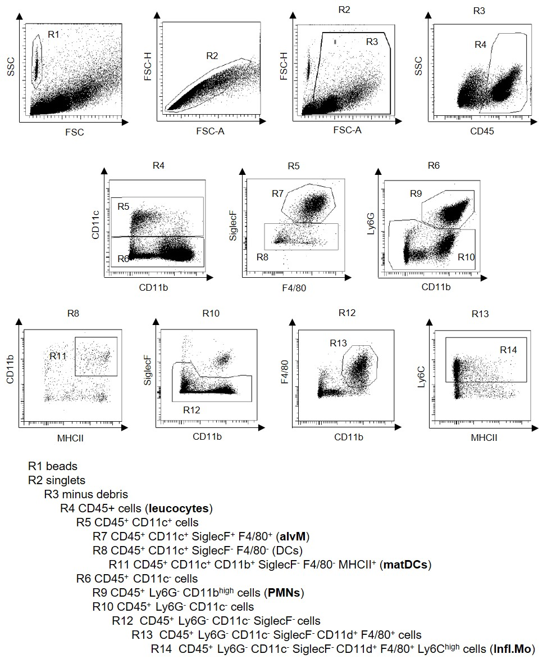
Figure S1: Exemplary flow cytometric gating strategy for the analysis of innate immune cells. Representative dot plots illustrating the gating strategy of innate immune cells in BALC and lungs. alvM, Alveolar Macrophages; BALC, Bronchoalveolar lavage cells; Infl.Mo, Inflammatory Monocytes; matDCs, mature Dendritic Cells; PMNs, Polymorphonuclear Neutrophils.

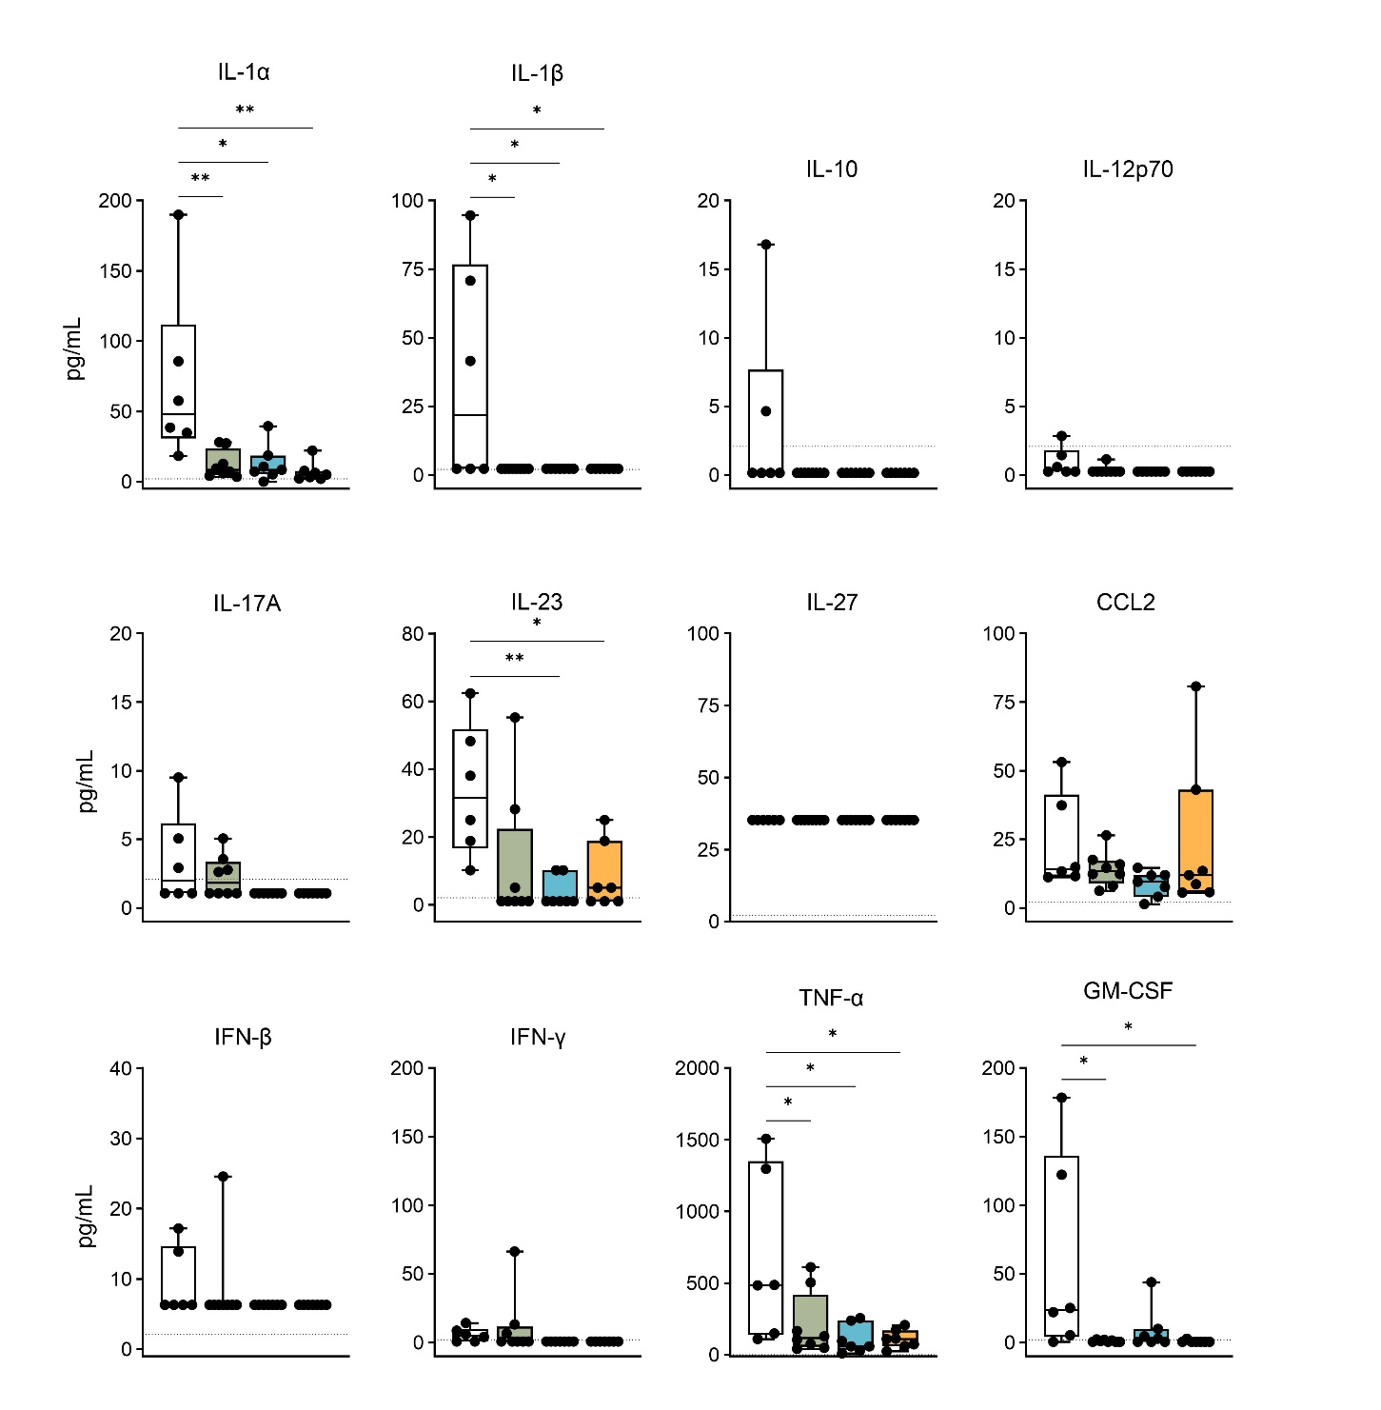
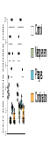
Figure S2: Inflammatory cytokines in BALF of VAP mice. Level of pro-inflammatory cytokines (pg/mL) in BALF of VAP mice analyzed at 24 hpi. Results are shown as box plots depicting median, quartiles, and range, as determined by ordinary one-way ANOVA with Tukey´s multiple comparisons test: *p < 0.05; **p < 0.01; n = 6 – 8 mice per group. Dotted lines represent the detection limit, respectively. BALF, bronchoalveolar lavage fluid; IL, interleukin; CCL2, chemokine (C-C motif) ligand 2; GM-CSF, Granulocyte-macrophage- colony stimulating factor.
Control
Meropenem
Phages
Combination

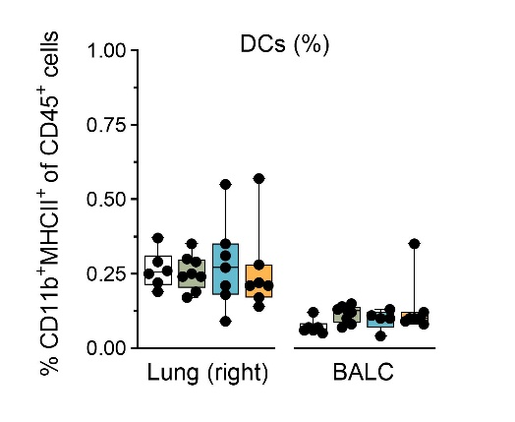
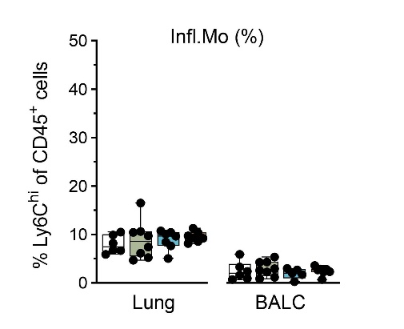
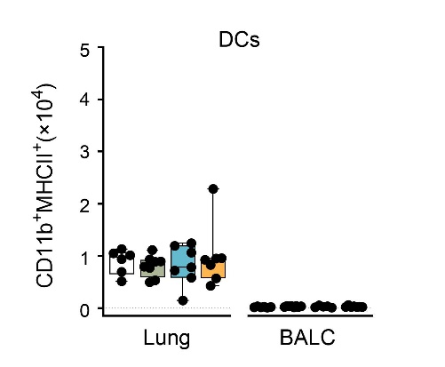
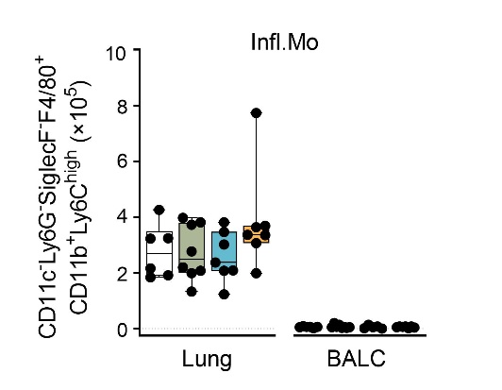
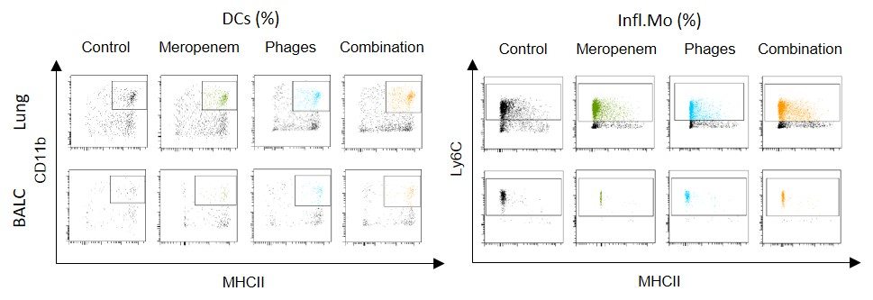
Figure S3: Phage treatment of Pseudomonas-induced VAP mice had no impact on innate immune cells in BAL and lungs. Bar graphs depicting (a) the percentage, (b) total cell numbers or (c) representative dot plots of mature dendritic cells (DCs) and inflammatory monocytes (Infl.Mo) in BALC and half lungs (left) of VAP mice analyzed at 24 hpi by flow cytometry. Results are shown as box plots depicting median, quartiles, and range, as determined by 2-way ANOVA with Tukey’s multiple comparisons test; n = 6 – 8 mice per group. For full gating strategy and cell type identifying markers see Supplementary Figure S1. BALC, bronchoalveolar lavage cells.
Control
Meropenem
Phages
Combination
a
b
c

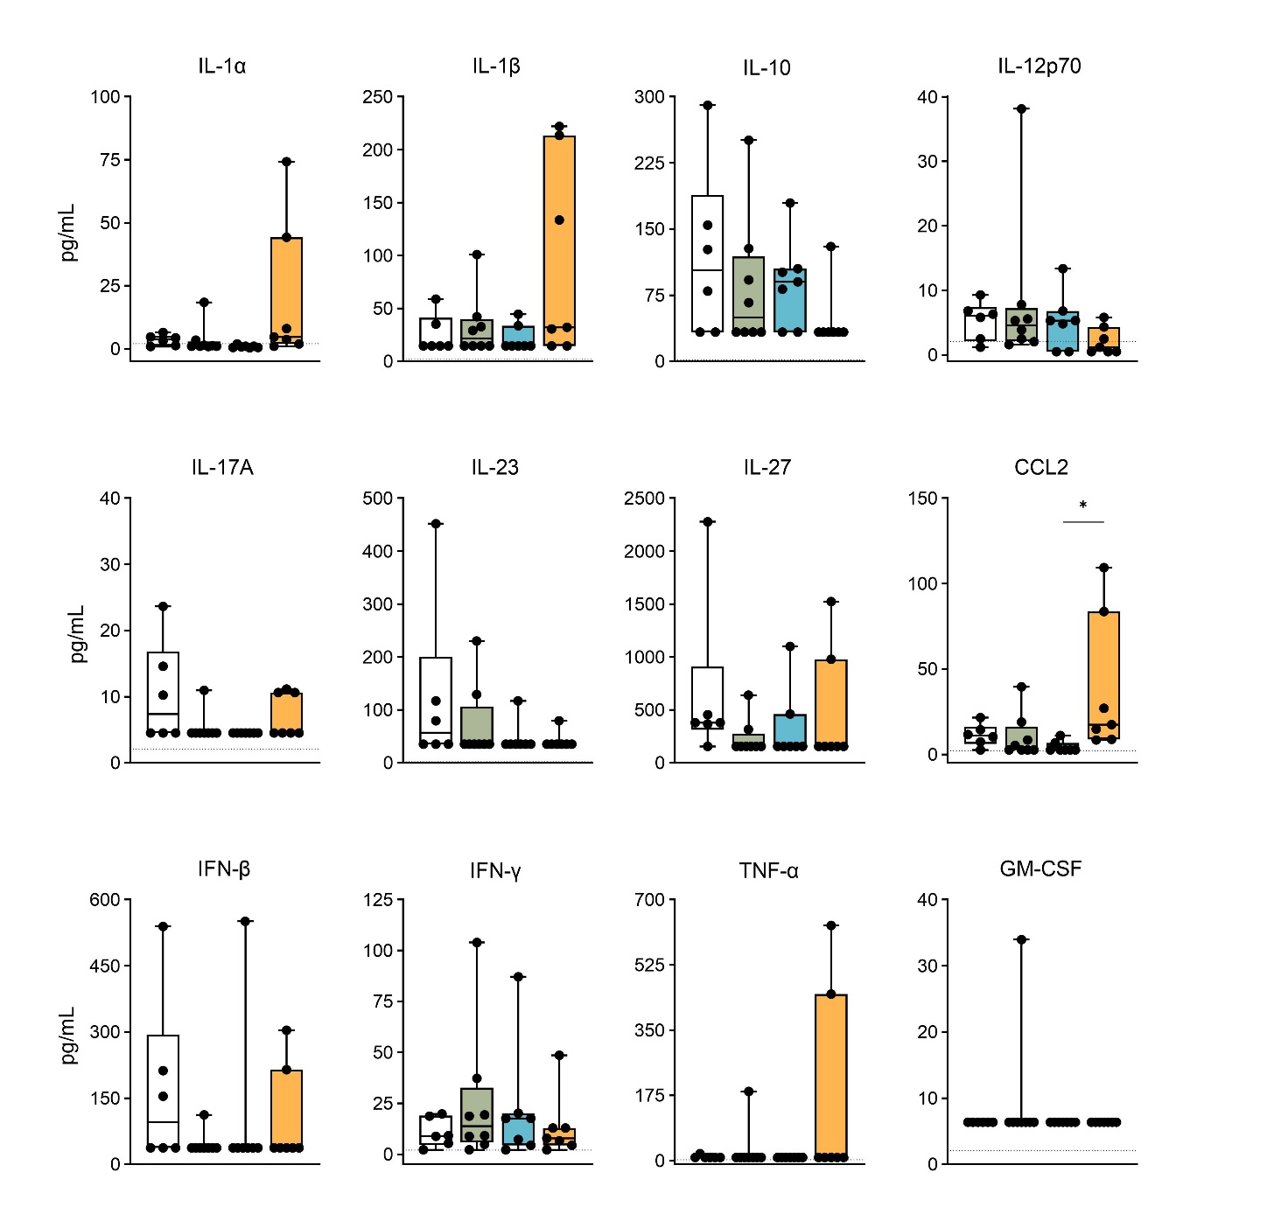
Figure S4: Inflammatory cytokines in plasma of VAP mice. Level of pro-inflammatory cytokines (pg/mL) in plasma of VAP mice analyzed at 24 hpi. Results are shown as box plots depicting median, quartiles, and range, as determined by ordinary one-way ANOVA with Tukey´s multiple comparisons test; n = 6 – 8 mice per group. Dotted lines represent the detection limit, respectively. CCL2, chemokine (C-C motif) ligand 2; IL, interleukin; GM-CSF, Granulocyte-macrophage- colony stimulating factor.
Control
Meropenem
Phages
Combination

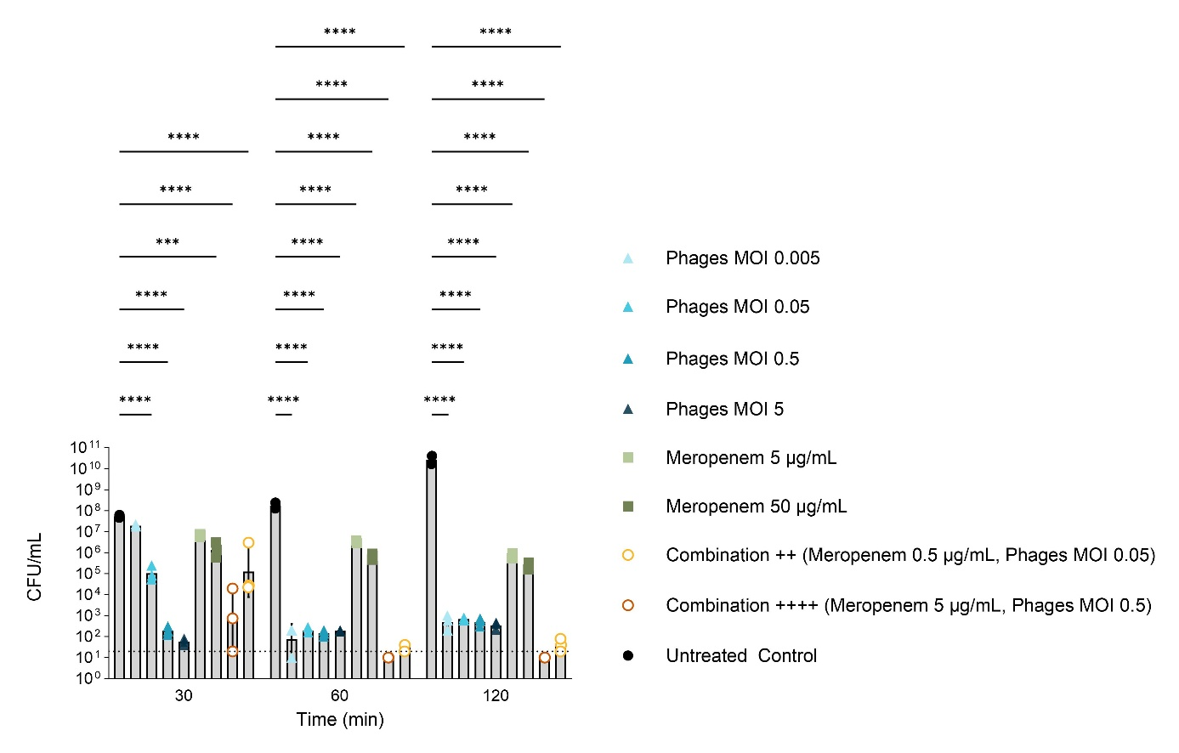
Figure S5: Direct comparison of the bacterial clearance in the Infection assay with different antibacterials. For the infection assay PAO1 were cultured in absence (control) or presence of meropenem, the Pseudomonas-specific phage cocktail, or the combination of both in different concentrations as indicated. Results are shown as means ± SD of bacterial load at different time points, as determined by two-way ANOVA with Dunett´s multiple comparisons test: : *p < 0,05, **p < 0,01, ***p < 0,001, ****p < 0,0001; n = 3. Dotted line reflects detection limit. MOI, multiplicity of infection.

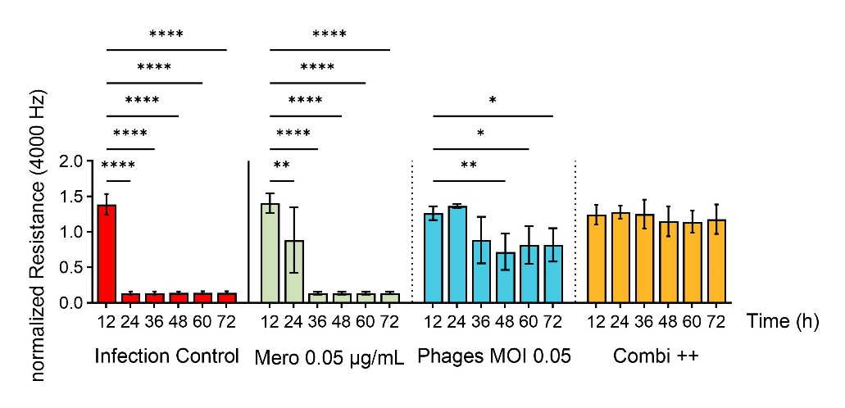
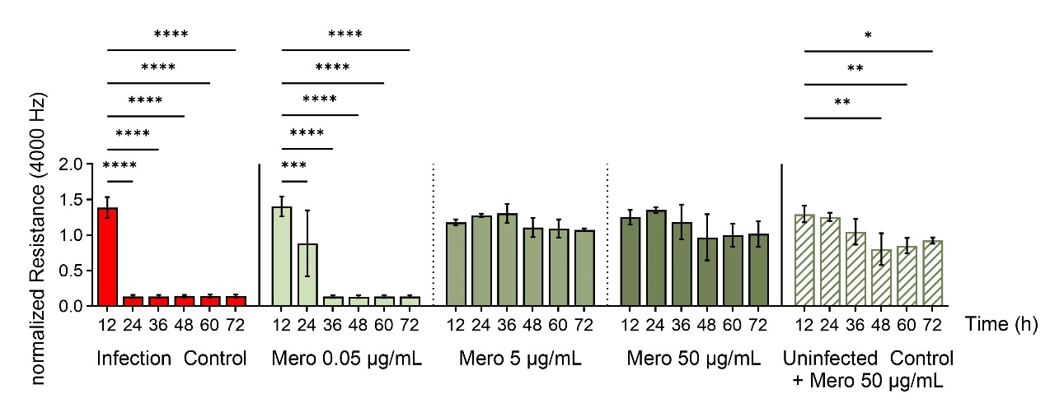
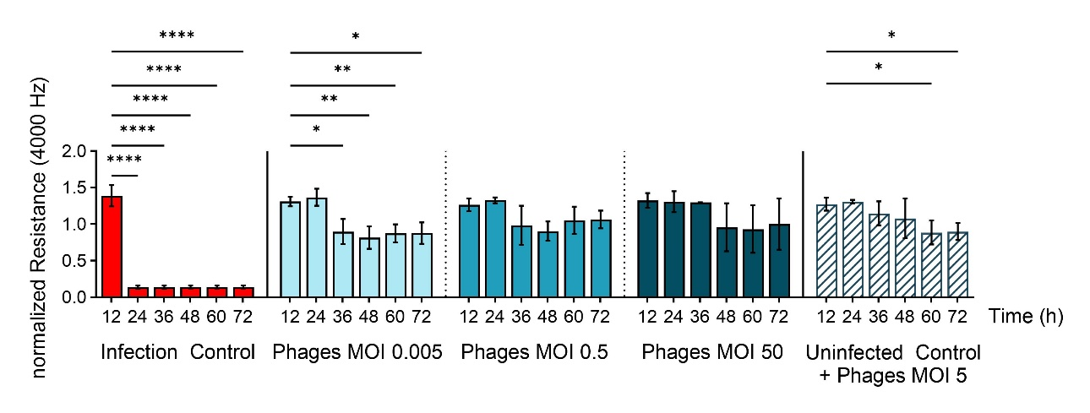
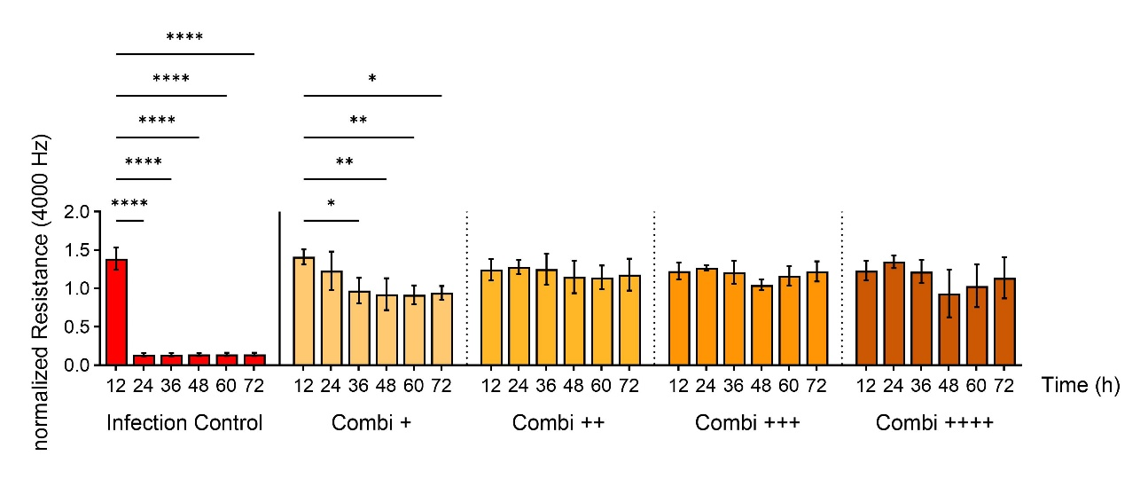
Figure S6: Loss of epithelial cell integrity in a dose dependent-manner by meropenem treatment of P. aeruginosa-infection in vitro. HPAEpiC monolayers in ECIS TM array wells were washed with antibiotic-free medium followed by infection with PAO1 (MOI 1) and treatment with (a) meropenem (Mero), (b) the Pseudomonas-specific phage cocktail (Phages), or (c) the combination of both (Combi +: Mero 0.005 µg/mL, Phages MOI 0.005; Combi ++: Mero 0.05 µg/mL, Phages MOI 0.05; Combi +++: Mero 0.5 µg/mL, Phages MOI 0.5; Combi ++++: Mero 5 µg/mL, Phages MOI 0.5) for 72 h. Cell toxicity controls were assessed by treating HPAEpiC with high dose of Meropenem (50 µg/mL) or Phages (MOI 5) without infection. (d) Direct comparison of ECIS experiments with combination and single therapy. Results are shown as means ± SD of normalized resistance (4000 Hz) at different time points, as determined by two-way ANOVA with Tukey´s multiple comparisons test: : *p < 0,05, **p < 0,01, ***p < 0,001, ****p < 0,0001; n = 3. Infection control (PAO1 MOI 1) same dataset in each figure. ECIS, electric cell-substrate impedance sensing; HPAEpiC, human primary alveolar epithelial cells.
d
c
b
a

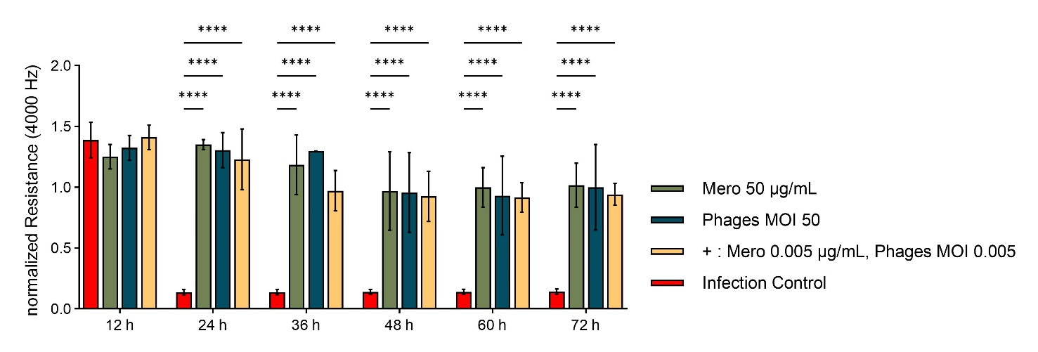
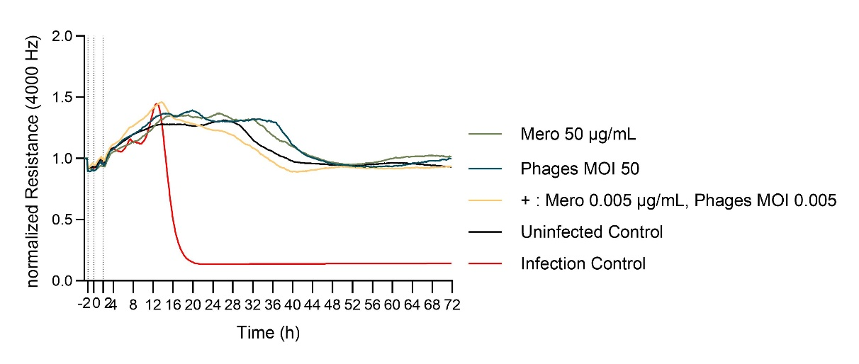
Figure S7: Adjunctive phage therapy against Pseudomonas-infection in vitro as successful as high-dose monotherapy. HPAEpiC monolayers in ECISTM array wells were washed with antibiotic-free medium followed by infection with PAO1 (MOI 1) and treatment with (a) meropenem (Mero), the Pseudomonas-specific phage cocktail (Phages), or the combination of both (Combi +: Mero 0.005 µg/mL, Phages MOI 0.005) for 72 h. (b) Direct comparison of ECIS experiments with combination and single therapy. Results are shown as means ± SD of normalized resistance (4000 Hz) at different time points, as determined by two-way ANOVA with Tukey´s multiple comparisons test: : *p < 0,05, **p < 0,01, ***p < 0,001, ****p < 0,0001; n = 3. Infection control (PAO1 MOI 1) same dataset in each figure. Uninfected Control are only HPAEpiC. ECIS, electric cell-substrate impedance sensing; HPAEpiC, human primary alveolar epithelial cells.
a
b

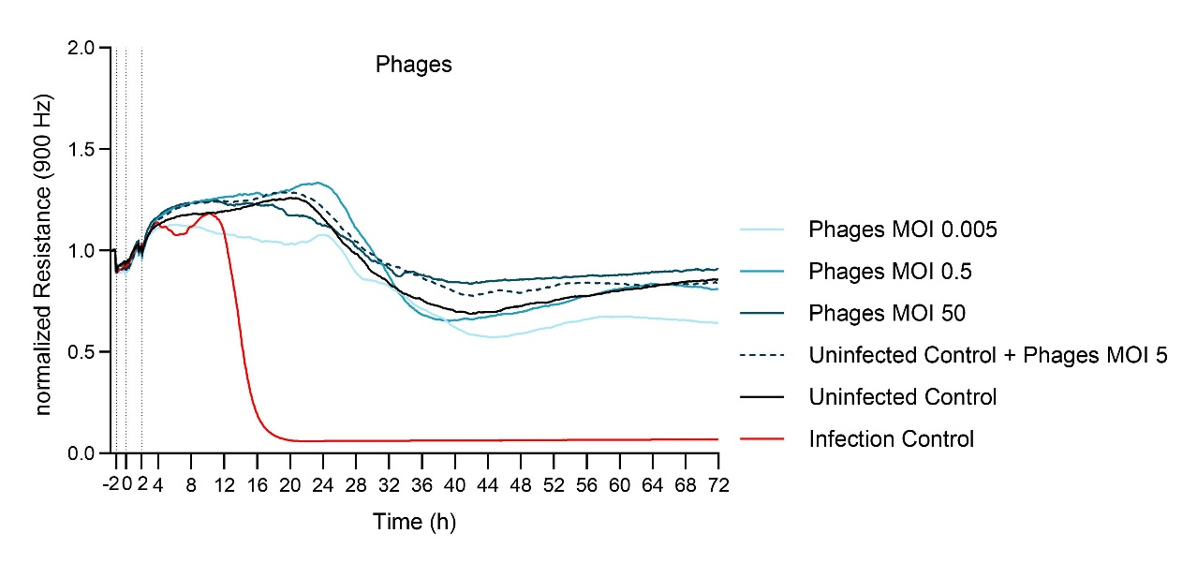
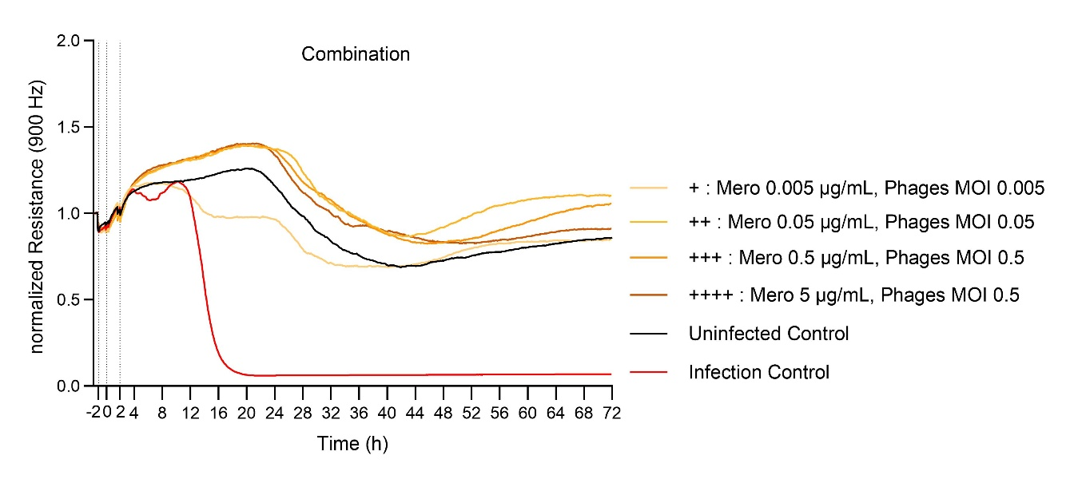
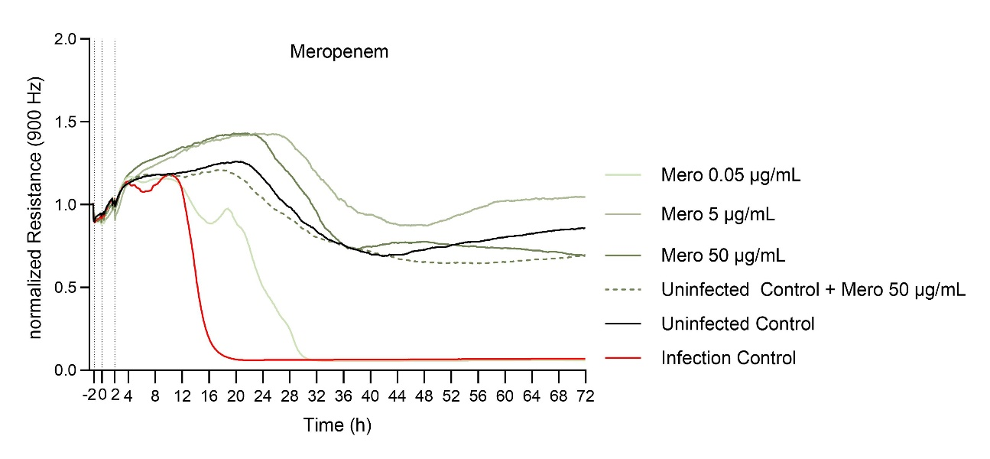
Figure S8: Improved lung epithelial cell integrity by phage treatment of bacterial infection in vitro. Measuring the transepithelial electric resistance (TEER) of epithelial cell monolayers by using ECISTM system upon infection with PAO1 (MOI 1) and subsequent treatment with (a) meropenem (Mero), (b) the Pseudomonas-specific phage cocktail (Phages), or (c) a combination of both in indicated concentrations for 72 h. (d) Direct comparison of adjunctive phage therapy and single therapy. Means of normalized resistance (900 Hz) versus time curves are shown; each isolate was run in 3 independent experiments while each condition where run in triplicates (96W10idf). Dotted line indicates the starting time of starving (-2 h), infection (0 h) and treatment (2 h). Uninfected Control and Infection Control (PAO1 MOI 1) same dataset in each figure. Uninfected Control are only HPAEpiC. ECIS, electric cell-substrate impedance sensing; HPAEpiC, human primary alveolar epithelial cells.
c
b
a

