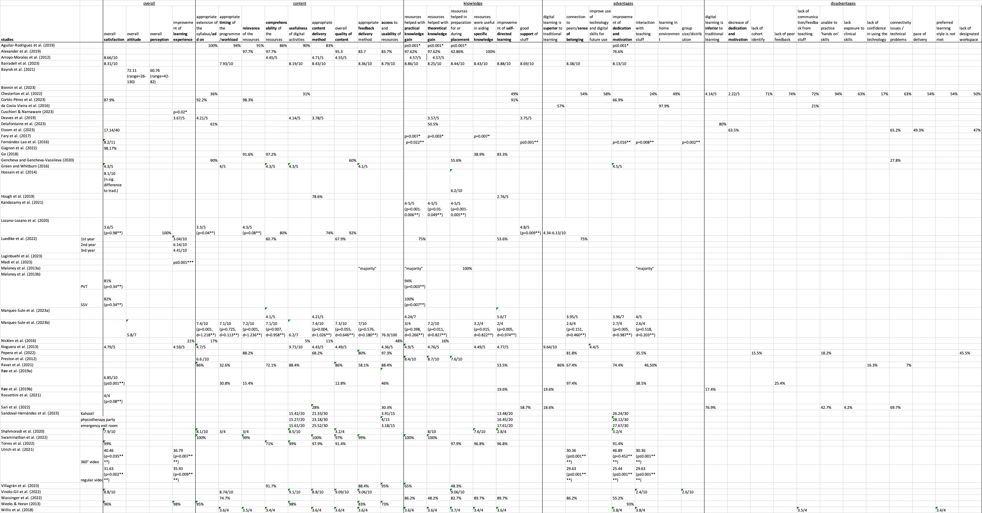

table II: summary of quantitative outcomes of students' satisfaction, attitude and perception (* improvement / difference baseline vs. after learning with digital content; ** difference compared to traditional learning in favor for the digital learning group; *** decrease / difference baseline vs. after learning with digital content; **** difference compared to traditional learning in favor for the traditional learning group)

