SUPPORTING MATERIAL

Supplementary Video 1
A series of volumes derived from 3D Variability analysis show a range of flexible motion in one of the two receptor protomers. Models were built into the conformational extremes and used to create a series of interpolated molecular motions which fit were into the experimental density. In the asymmetric extreme, 3 Vh-Ins molecules are apparent in the complex, including one in a combined S1/S2 position. As the receptor moves toward the symmetric state, L1 and CR move away from their position near combined site and separate density for both site-1- and site-2-bound Vh-Ins becomes apparent.

FIGURE S1

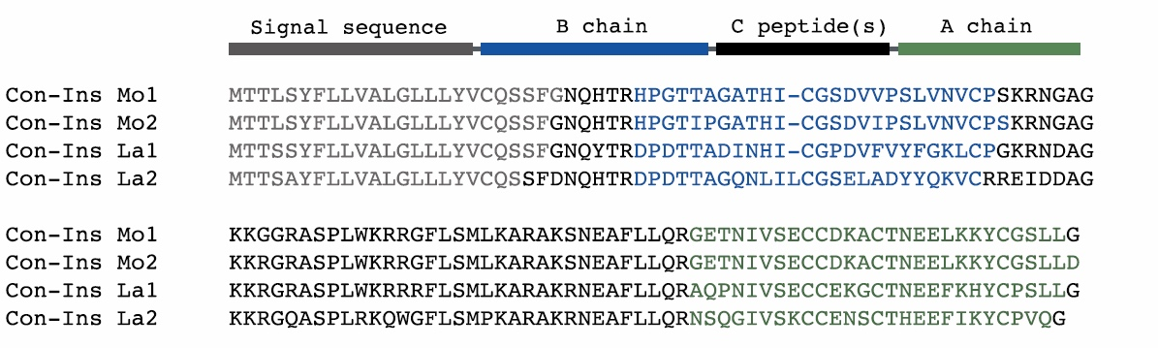

Fig. S1. Precursor sequence alignment of venom insulins identified here showing the canonical arrangement of preproinsulins with N-terminal signal sequences (gray) followed by the B chain (blue), C-peptide region (black) and A chain (green). The signal sequence, C-peptide, and additional black-colored residues are predicted to be cleaved during post-translational processing.

FIGURE S2

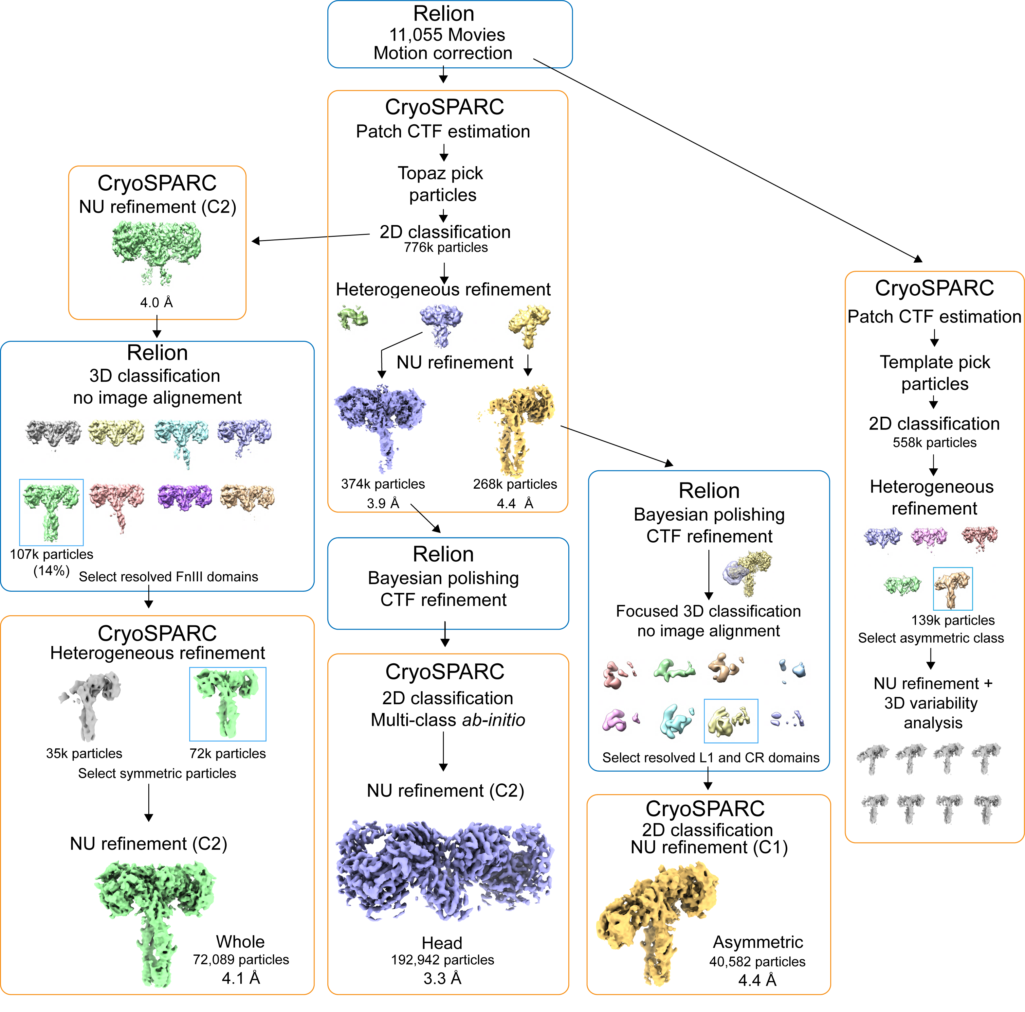

Fig. S2 | Data processing workflow used for the reconstructions of the Vh-Ins-HSLQ-receptor complexes. Initial patch motion correction was done in Relion. All subsequent data processing, with the exception of Bayesian polishing, CTF refinement, and alignment-free 3D classification (in Relion), was done in CryoSPARC. 3D variability analysis of the asymmetric class was performed in a separate workflow. Indicated resolutions were determined by an independent half-map FSC threshold of 0.143.
FIGURE S3

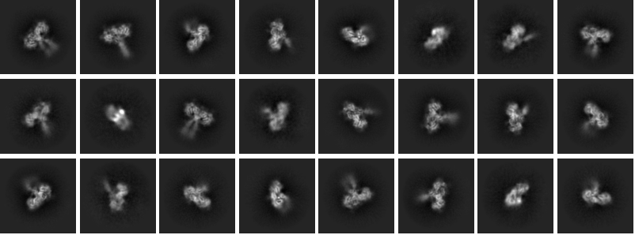

Fig S3. Representative 2D class averages of Vh-Ins-HSLQ-receptor particles used for the final C2 reconstruction.

FIGURE S4

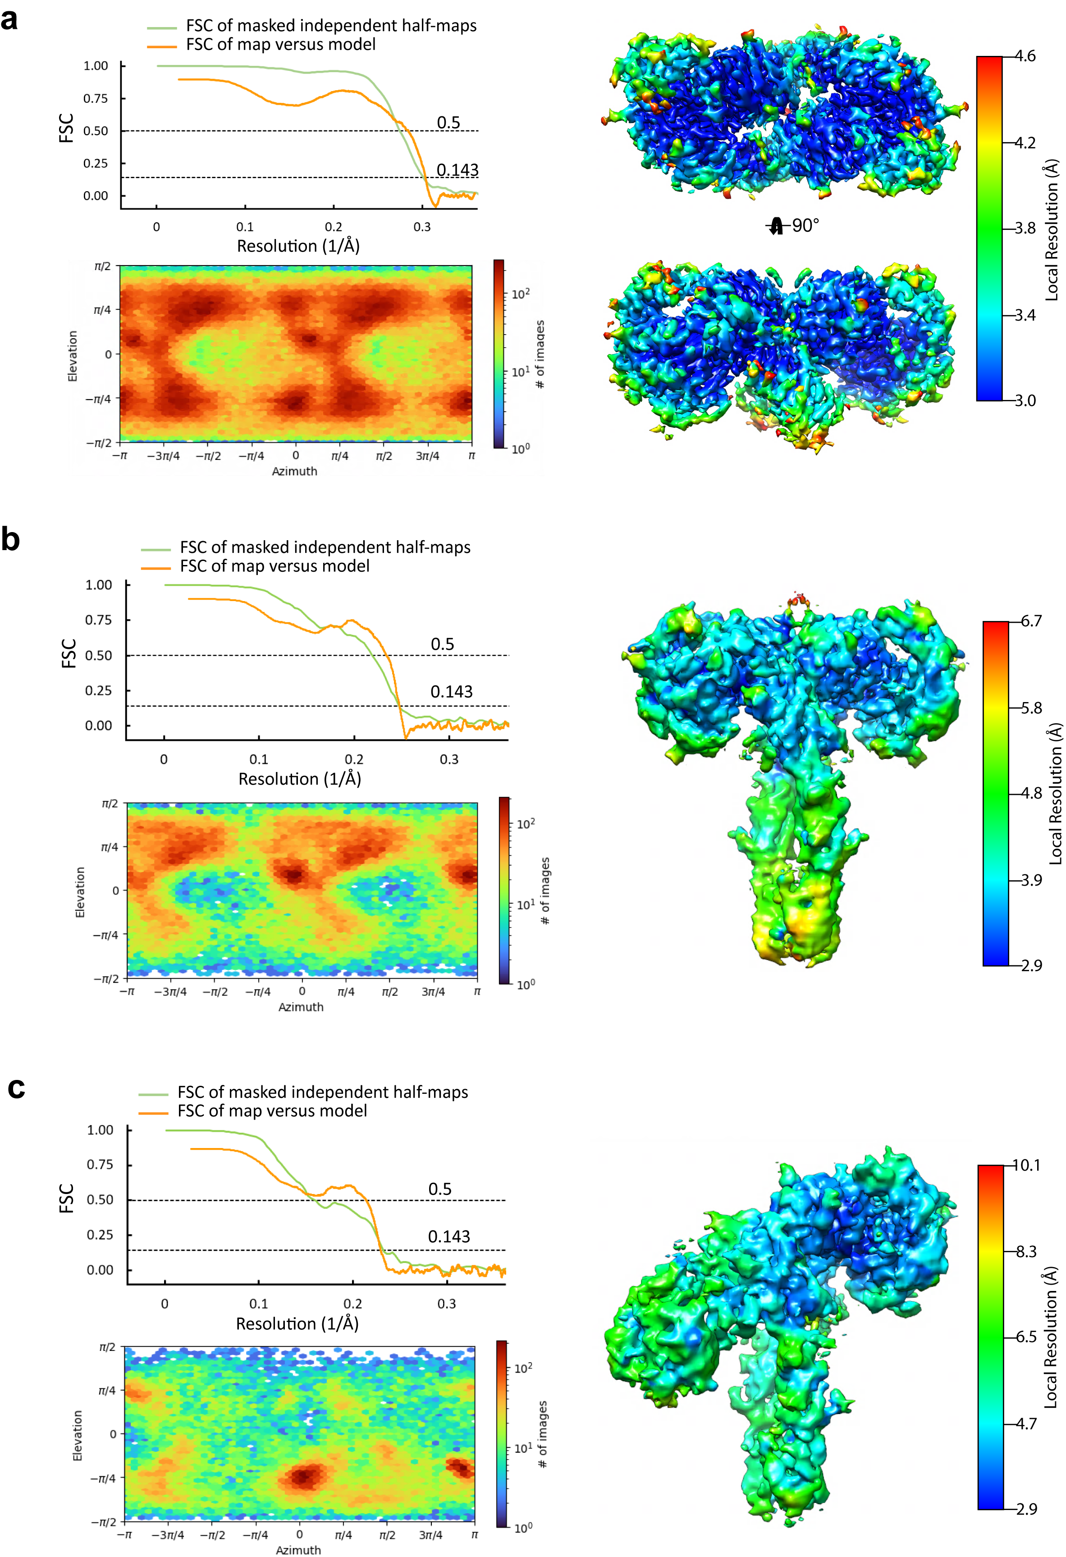

Fig. S4 | Map quality of the cryo-EM reconstructions. a-c, Half-map and map-to-model Fourier shell correlation plots, particle orientation distribution, and local resolution for the “head”, “whole”, and “asymmetric” reconstructions respectively.

FIGURE S5

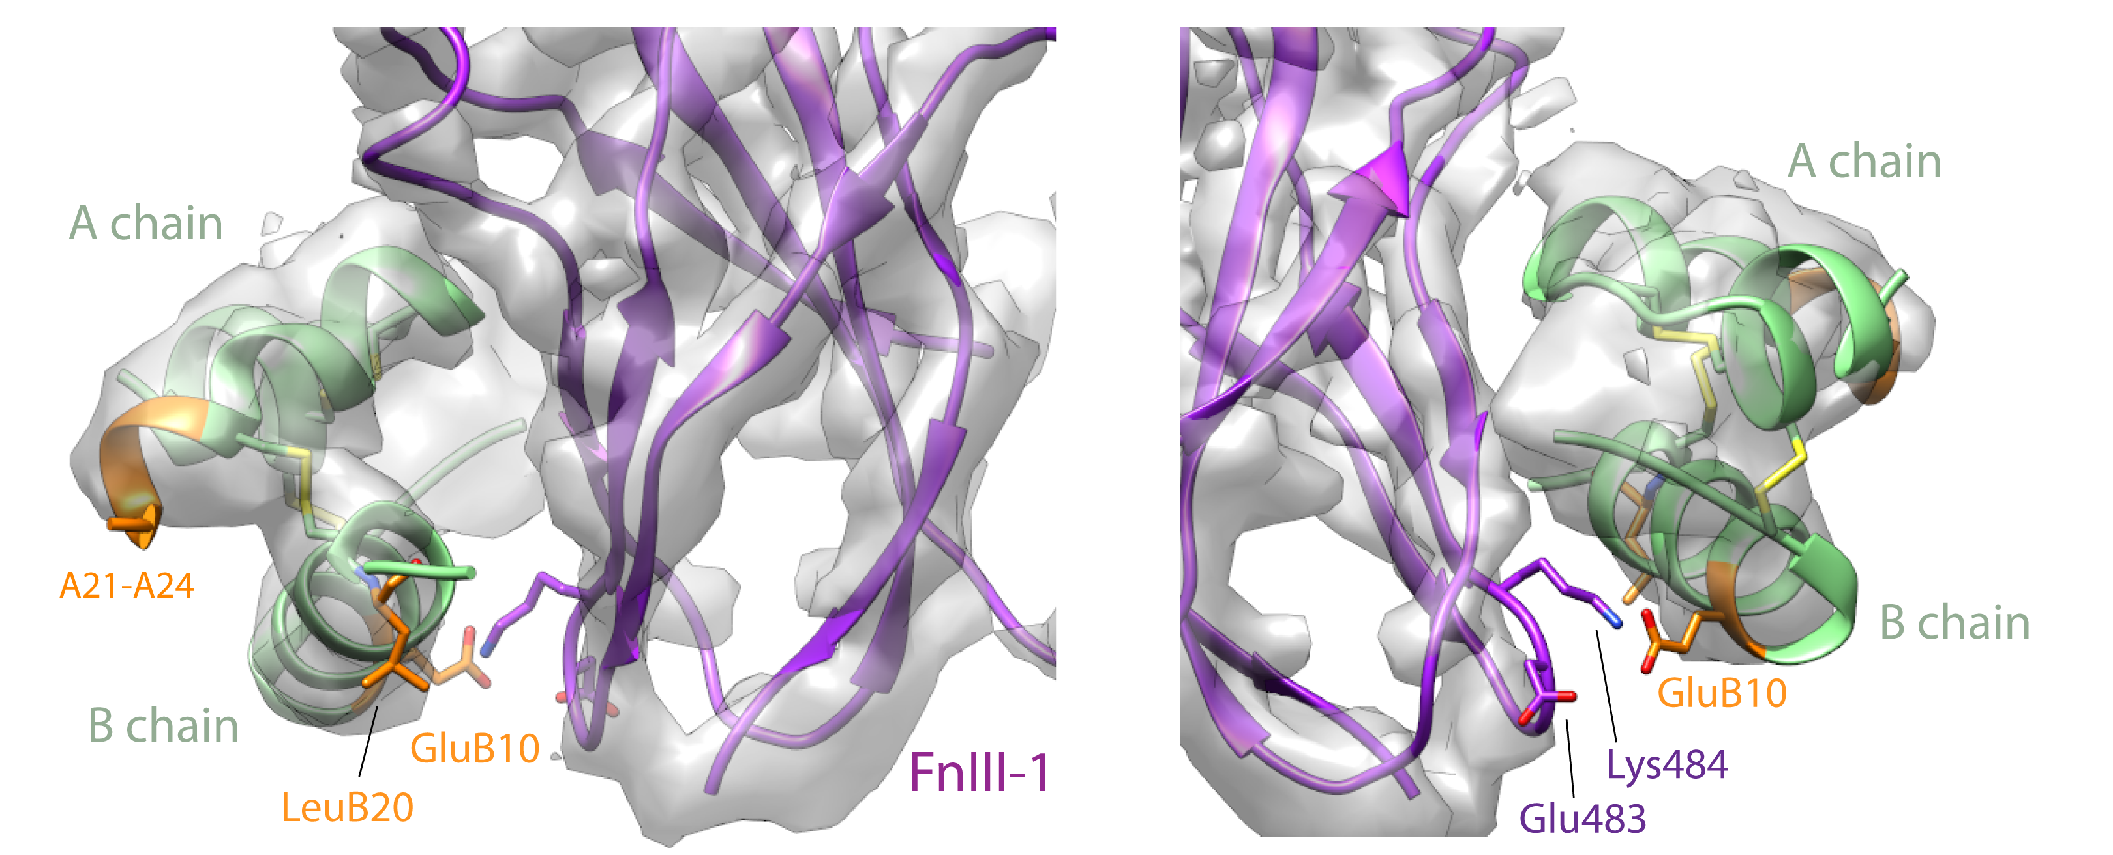

Fig. S5 | Vh-Ins-HSLQ at site 2. Density is shown around Vh-Ins-HSLQ. Vh-Ins-HSLQ green, with Vh-Ins mutated residues relative to native human insulin shown in orange. Receptor FnIII-1 domain, purple. The only Vh-specific residue that approaches receptor at site 2 is GluB10 which has poor density. Nearby receptor side chains lack density but are shown explicitly for illustrative purposes.

FIGURE S6

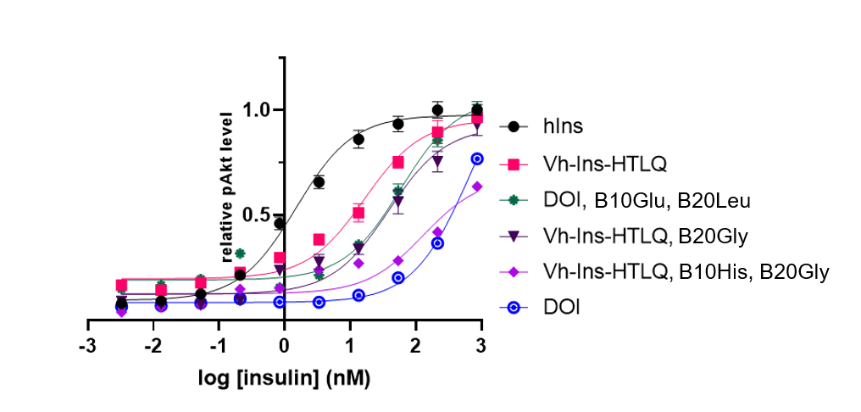

Fig. S6 | AKT phosphorylation activity of Vh-Ins-HTLQ and related analogs. Two substitutions on the B chain, GluB10 and LeuB20, were found to increase the relative activity of Vh-Ins-HTLQ. These substitutions were subsequently included in later stages of design of Vh-Ins molecules.

FIGURE S7

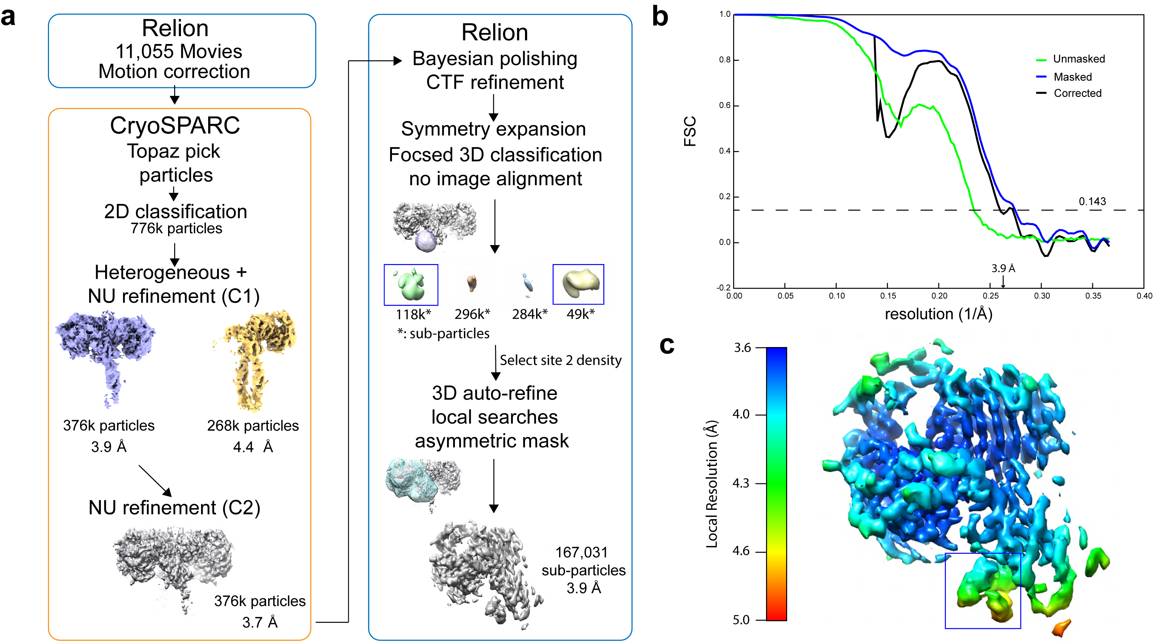

Fig. S7 | Focused refinement of Vh-Ins-HSLQ bound at site 2. a, Data processing workflow. Symmetry expansion (C2) and 3D classification were used to enrich for sub-particles with site 2 occupancy, giving a final map with 3.9 Å resolution. b, Half-map Fourier shell correlation plot for the site-2-focused reconstruction. c, Local map resolution. Density for site-2 Vh-Ins-HSLQ is boxed.

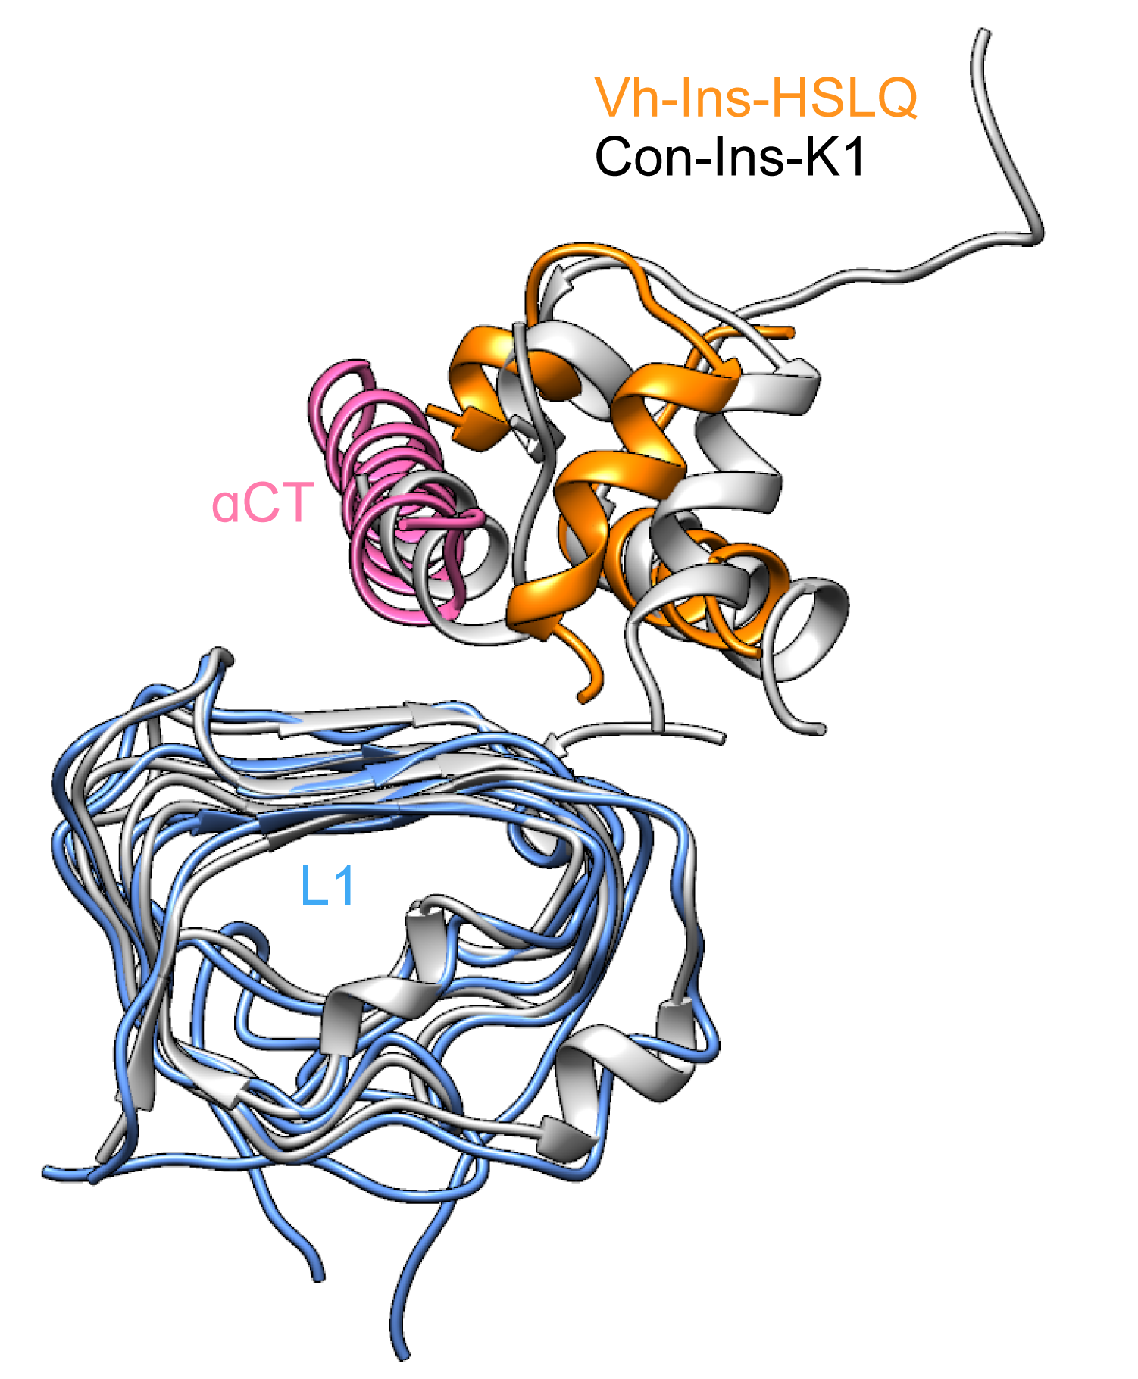
Figure S8. Comparison of the molecular-dynamics-predicted model of Con-Ins-K1 binding to IR (white) and the EM model of Vh-Ins-HSLQ following alignment to the L1 domain. Both αCT and Con-Ins-K1 are displaced relative to Vh-Ins-HSLQ and EM-derived structures of human insulin in complex with IR at site 1.

Table S1. EC₅₀ of insulin analogs in stimulating AKT phosphorylation (pSer 473) in NIH T3T fibroblasts after 30-minute incubation.

Insulin analog | EC₅₀ (nM) | 95% CI | Insulin analog | EC₅₀ (nM) | 95% CI
Vh-Ins-GSLLD | 0.846 | 0.5503 to 1.306 | Vh-Ins-HAIQ | 12.30 | 8.606 to 17.52
Vh-Ins-PSLL | 0.861 | 0.6200 to 1.195 | Vh-Ins-HAVQ | 13.43 | 8.847 to 20.28
Vh-Ins-HSLQ | 1.217 | 0.8092 to 1.825 | Vh-Ins-HTLQ | 16.43 | 8.415 to 31.26
Human insulin | 1.499 | 1.034 to 2.181 | Vh-Ins-PVR | 17.61 | 13.33 to 23.22
Vh-Ins-GSLL | 1.787 | 0.9057 to 3.537 | Vh-Ins-HVLQ | 30.16 | 19.03 to 47.52
Vh-Ins-ASLLGL | 1.929 | 1.548 to 2.402 | Vh-Ins-HTLQ, B20G | 38.85 | 14.09 to 102.3
Vh-Ins-HALQ | 1.971 | 1.477 to 2.629 | Vh-Ins-HTLA | 41.22 | 22.74 to 73.95
Vh-Ins-HAFQ | 2.106 | 1.505 to 2.940 | Vh-Ins-ATLQ | 46.30 | 24.53 to 87.51
Vh-Ins-PALQ | 2.150 | 1.598 to 2.891 | DOI, B10E, 20L | 58.86 | 29.47 to 119.0
Vh-Ins-HALR | 2.518 | 1.840 to 3.439 | Vh-Ins-HTLQ, B10H, 20G | 130.1 | 4.155 to 3075
Vh-Ins-HALK | 2.679 | 1.898 to 3.771 | Vh-Ins-HTAQ | 144.3 | 111.7 to 187.2
Vh-Ins-HALE | 2.697 | 1.799 to 4.027 | Vh-Ins-HFLQ | 159.6 | 122.4 to 209.2
Vh-Ins-EALQ | 3.282 | 2.166 to 4.981 | Vh-Ins-HKLQ | 196.0 | 138.5 to 280.5
Vh-Ins-NALQ | 3.450 | 2.518 to 4.717 | Vh-Ins-HELQ | 197.7 | 123.0 to 326.4
Vh-Ins-HGLQ | 3.632 | 2.445 to 5.397 | Vh-Ins-HLLQ | 288.6 | 229.6 to 366.7
Vh-Ins-HALN | 4.279 | 3.086 to 5.930 | DOI | 662.0 | 426.9 to 1117
Vh-Ins-KALQ | 8.272 | 6.722 to 10.17

Table S2. Competition binding assays using full-length, detergent-solubilized, immunocaptured receptors.

Insulin receptor
Competitor ligand | IC₅₀ (M) | 95% C.I. (M)
human insulin | 5.5x10⁻¹⁰ | 3.8x10⁻¹⁰ – 8.0x10⁻¹⁰
Vh-Ins-HALQ | 7.0x10⁻¹⁰ | 3.6x10⁻¹⁰ – 1.4x10⁻⁹
IGF-1 receptor
Competitor ligand | IC₅₀ (M) | 95% C.I. (M)
human insulin | 3.5x10⁻⁹ | 2.3x10⁻⁹ – 5.3x10⁻⁹
Vh-Ins-HALQ | 4.7x10⁻⁹ | 2.3x10⁻⁹ – 9.6x10⁻⁹
hIGF-1 | 4.2x10⁻¹⁰ | 3.8x10⁻¹⁰ – 4.7x10⁻¹⁰

Table S3 Isothermal titration calorimetry of insulin analogs against IR485 plus αCT. Mini-Ins, a minimized insulin based on a venom peptide from Conus geographus, was described previously⁴.

Isothermal titration of insulin analogs
against IR485 with IR αCT
Insulin analog
Vh-Ins-HALQ
DOI
Mini-Ins
hIns
0.347 ± 0.047
8.32 ± 0.19
2.00 ± 0.22
0.035 ± 0.005

K_{d} (μM)

