1. General Information:
1.1 Chemical and Protein Materials
Insulin was purchased from Life Technologies unless otherwise specified. Peptides were synthesized via Fmoc solid phase peptide synthesis. N,N-Diisopropylethylamine (DIEA), triisopropylsilane, L-ascorbic acid, acetic acid (AcOH), iodine, piperidine, methanol (MeOH), urea and dichloromethane (DCM) were purchased from Sigma-Aldrich and used directly. Fmoc-protected amino acids and 1-[Bis(dimethylamino)methylene]-1H-1,2,3-triazolo[4,5-b]pyridinium 3-oxid hexafluorophosphate (HATU) were purchased from Chem-Impex Int’l. Inc. Boc-Ser[Fmoc-Thr(tBu)] was purchased from AAPPTec. 2-Chlorotrityl chloride resin was purchased from ChemPep. ChemMatrix® Rink amide resin was purchased from Biotage. Dimethylformamide (DMF), trifluoroacetic acid (TFA), acetonitrile (ACN) and ethyl ether were purchased from Fisher Scientific and used as supplied.
1.2 HPLC and LC/MS
All crude peptides were purified with a water/acetonitrile gradient in 0.1% TFA on an Agilent 1260 HPLC system. Fractions collected from HPLC were analyzed by LC/MS on a XBridge C18 5-μm (50 × 2.1 mm) column at 0.4 mL.min⁻¹ with a water/acetonitrile gradient in 0.1% formic acid on an Agilent 6120 Quadrupole LC/MS system. Fractions containing targeted product (based on LC/MS) were collected and lyophilized.
1.3 General RP-HPLC conditions
Method A: Individual chains were purified by a Preparative C18 (2) Column (Luna®, 5 μm, 250 x 21.2 mm) with a linear gradient from 20% aqueous ACN (0.1% TFA) to 50% aqueous ACN (0.1% TFA) over 40 min at a flow rate of 5 mL.min⁻¹ for A chains and from 30% aqueous ACN (0.1% TFA) to 60% aqueous ACN (0.1% TFA) over 40 min at a flow rate of 5 mL.min⁻¹ for B chains.
Method B: All of A‐B dimers were purified by a Preparative C18 (2) Column (Luna®, 5 μm, 250 x 21.2 mm) with a linear gradient from 25% aqueous ACN (0.1% TFA) to 50% aqueous ACN (0.1% TFA) over 40 min at a flow rate of 5 mL.min⁻¹.
Method C: All final products were purified by a Phenomenex semi-preparative C18 Column (5 μm, 250 x 10 mm) with a linear gradient from 20% aqueous ACN (0.1% TFA) to 50% aqueous ACN (0.1% TFA) over 35 min at a flow rate of 3 mL.min⁻¹.
2. Peptide Synthesis
Peptides were synthesized via Fmoc solid phase peptide synthesis on peptide synthesizer (Alstra; Biotage, Inc). Automated peptide synthesis was carried out in a 10 mL reactor vial with the following protocols (for 0.1 mmol scale). For Fmoc deprotection: (i) 4.5 mL of 20% piperidine in DMF; (ii) mix 2 × 3 min (new solvent delivered for each mixing cycle). For amino acid coupling: (i) 1.25 mL of 0.4 M Fmoc-protected amino acid in DMF; (ii) 1.225 mL of 0.4 M HATU; (iii) 1.0 mL of 1.0 M DIPEA in DMF; and (iv) mix for 10 min at 70 ºC (for cysteine and histidine coupling: mix for 10 min at 50 ºC; for arginine coupling: mix for 10 min at 50 ºC and coupling twice). For DMF washing (performed between deprotection and coupling steps): (i) 4.5 mL of DMF; (ii) mix 45 s. Upon completion of the peptide chain, resins were washed with DCM and dried (using vacuum) for 30 min. Peptide was then cleaved from the resin by exposure to cleavage cocktail for 2 h, which was prepared with 12.5 mL TFA, 330 μL water, 330 μL TIS. The peptide was precipitated with ethyl ether at 4 ºC, followed by HPLC purification and lyophilization.
General synthetic strategy for insulin analogs
2.1 General procedure for A-chain
The synthesis of A-chain with amide c-terminal was conducted on H-Rink-Amide-ChemMatrix resin using peptide synthesizer through a standard Fmoc/HATU/DIEA method, While Using 2-chlorotrityl chloride resin for C-terminal acid. The resulting resin-bound A chain was treated with 6.0 mL TFA solution containing 2.5% TIS, 2.5% H₂O at rt, with gently shaking for 2.0 hours. The resin was removed by filtration, and the filtrate was precipitated by addition of cold ether (40 mL). The precipitate was collected by centrifugation, then washed with cold ether (40 mL x 3), and vacuum dried for purification. A-chain was obtained after HPLC purification and lyophilization.
2.2 General procedure for B chain
B-chain syntheses was conducted on 2-chlorotrityl chloride resin using standard Fmoc/HATU/DIEA method. The first amino acid was synthesized manually. Cleavage was conducted by treating the resin with 6.0 mL TFA solution that contained 2.5% TIS, 2.5% H₂O and 15 equivalents of DTDP at rt, with shaking for 2.5 hours. The resin was removed by filtration, and the filtrate was precipitated with cold ether (45 mL). The precipitates were collected by centrifugation, and then washed with cold ether (45 mL x 3). Crude B chain was dissolved 0.05% TFA containing aqueous acetonitrile (ACN/H₂O: 50/50 vol/vol, 40 mL) and purified using a preparative C18 column.
2.3 General procedure for preparation of analogs by two-step method
A chain (25 mg) and B chain (25 mg) were mixed in 6 M urea, 0.2 M NH₄HCO₃ buffer (pH 7.5, 4.5 mL). The mixture was left at rt for 20 min. The resulting solution was purified using a preparative C18 column with a linear gradient from 25% aqueous ACN (0.1% TFA) to 50% aqueous ACN (0.1% TFA) over 45 min at a flow rate of 5 mL/min. A-B dimer was eluted at around 30 min.

The lyophilized powder A-B dimer was dissolved in water:AcOH (2:1). It was treated with a freshly prepared solution of iodine in methanol (10 mg/mL). The resulting solution was gently agitated at rt for 20 min before the addition of 1 M ascorbic acid (~0.1 mL) until the iodine color (purple) disappeared. The crude was purified by C18 preparative column HPLC with a linear gradient from 20% aqueous ACN (0.1% TFA) to 50% aqueous ACN (0.1% TFA) over 45 min at a flow rate of 5 mL/min.

3. Insulin analogs and their sequences:

3.1 Venom-DOI hybrids with various elongated sequences from cone snail insulins：
3.2 Venom-DOI analogs with alanine substitutions：
3.3 Mutations on A21:
3.4 Mutations on A22:

3.5 Mutations on A23:

3.6 Mutations on A24:

3.7 Vh-Ins-HTLQ and related analogs:

Table S1. LC-MS characterization of the synthetic peptides
Peptide name | M.W.
Peptide name | Calculated | observed
Vh-Ins-HTLQ, B10H, 20G | 5229.0 | 5229.3
Vh-Ins-HTLQ, B20G | 5221.0 | 5221.3
Vh-Ins-HTLQ | 5277.1 | 5277.1
Vh-Ins-ASLLGL | 5353.2 | 5353.6
Vh-Ins-GSLL | 5168.9 | 5168.4
Vh-Ins-GSLLD | 5284.0 | 5284.2
Vh-Ins-PVQ | 5122.9 | 5123.3
Vh-Ins-PSLL | 5209.0 | 5208.9
Vh-Ins-HTLA | 5220.0 | 5220.2
Vh-Ins-HTAQ | 5235.0 | 5235.2
Vh-Ins-HALQ | 5248.0 | 5247.4
Vh-Ins-ATLQ | 5211.0 | 5211.0
Vh-Ins-NALQ | 5225.0 | 5225.3
Vh-Ins-PALQ | 5208.0 | 5208.4
Vh-Ins-EALQ | 5240.0 | 5240.3
Vh-Ins-KALQ | 5239.0 | 5239.3
Vh-Ins-HALE | 5249.0 | 5248.9
Vh-Ins-HALK | 5248.1 | 5248.3
Vh-Ins-HALN | 5234.0 | 5234.4
Vh-Ins-HALR | 5276.1 | 5276.8
Vh-Ins-HGLQ | 5234.0 | 5234.3
Vh-Ins-HSLQ | 5264.0 | 5264.4
Vh-Ins-HELQ | 5306.1 | 5306.2
Vh-Ins-HKLQ | 5305.1 | 5305.9
Vh-Ins-HLLQ | 5290.1 | 5290.2
Vh-Ins-HFLQ | 5324.1 | 5324.3
Vh-Ins-HVLQ | 5276.1 | 5276.4
Vh-Ins-HAFQ | 5282.0 | 5282.4
Vh-Ins-HAIQ | 5248.0 | 5248.4
Vh-Ins-HAVQ | 5234.0 | 5234.2
Vh-Ins-HALE | 5249.0 | 5248.9
Vh-Ins-HALK | 5248.1 | 5248.3
Vh-Ins-HALN | 5234.0 | 5234.4
Vh-Ins-HALR | 5276.1 | 5276.8

4. LC chromatogram and MS spectrum for each peptide.
LC and MS for Vh-Ins-HTLQ, B10H, B20G
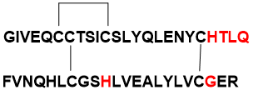
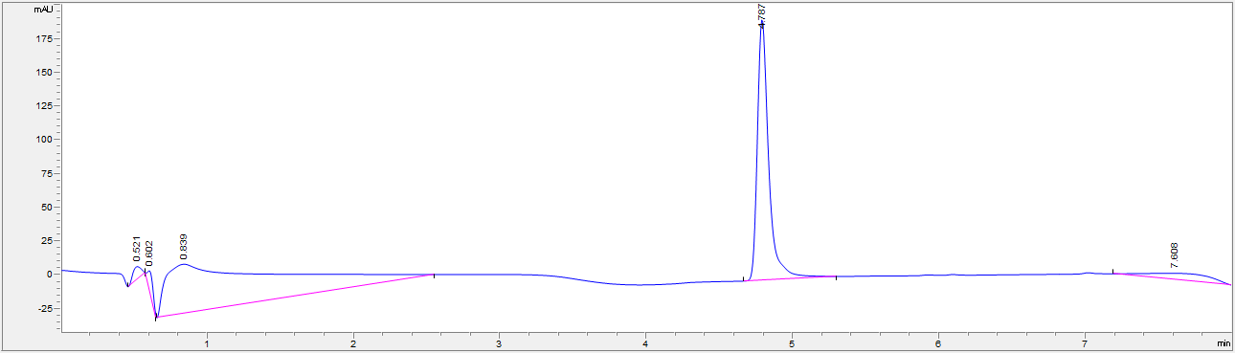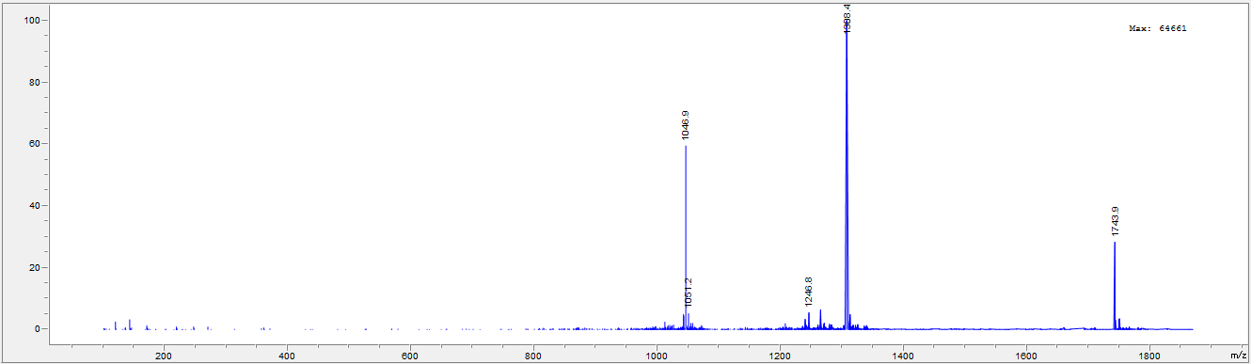

LC and MS for Vh-Ins-HTLQ, B20G
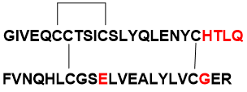
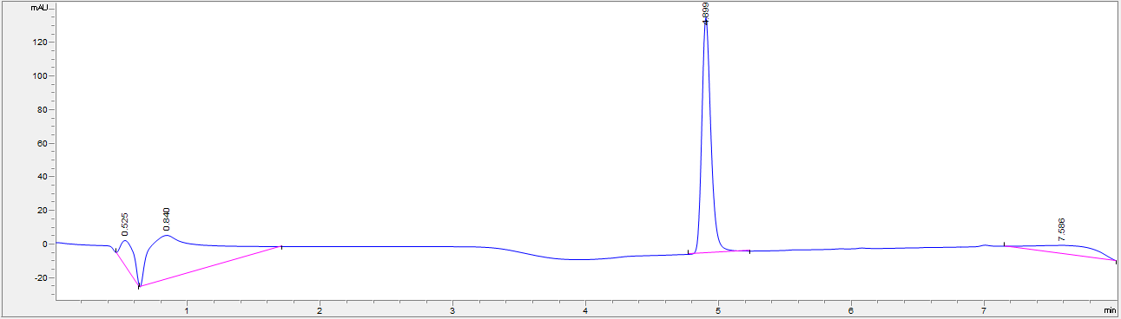
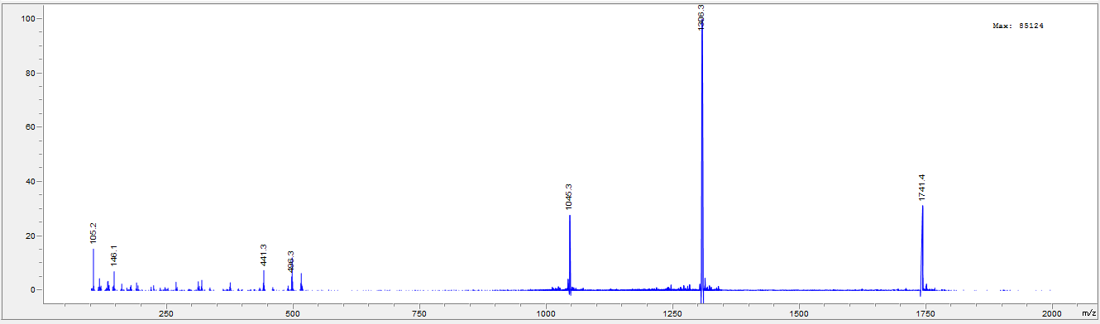

LC and MS for Vh-Ins-HTLQ
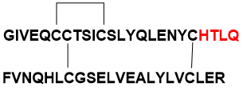
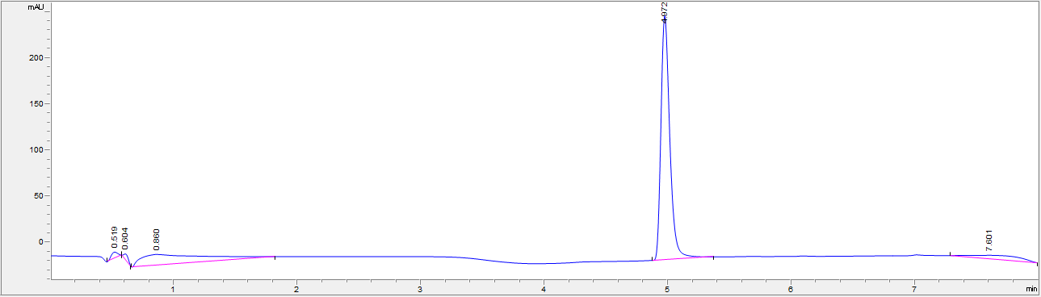
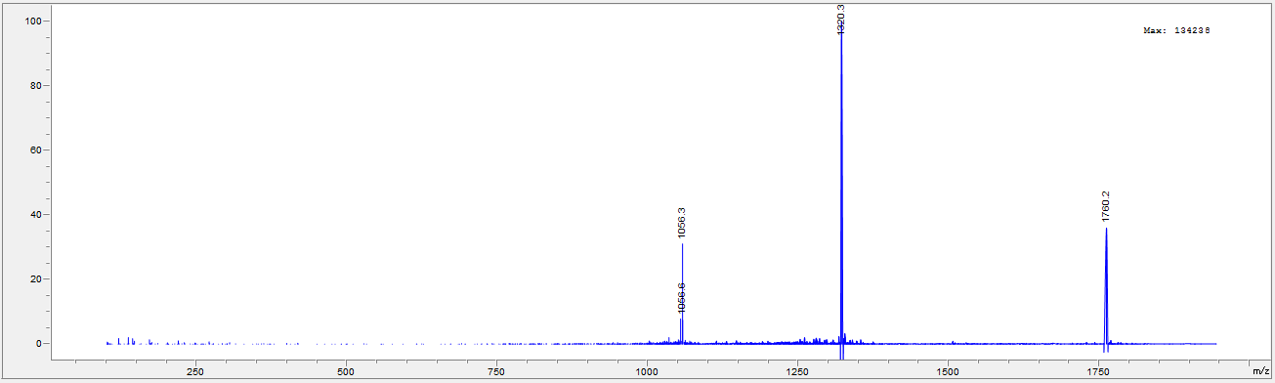

LC and MS for Vh-Ins-GSLLD
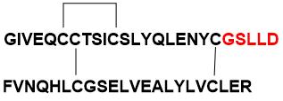
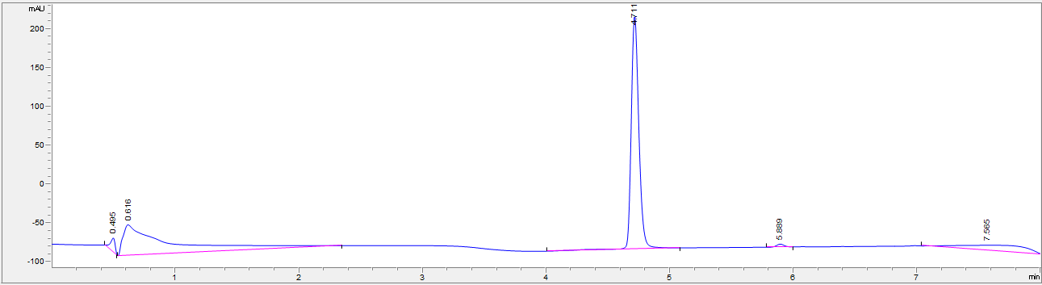
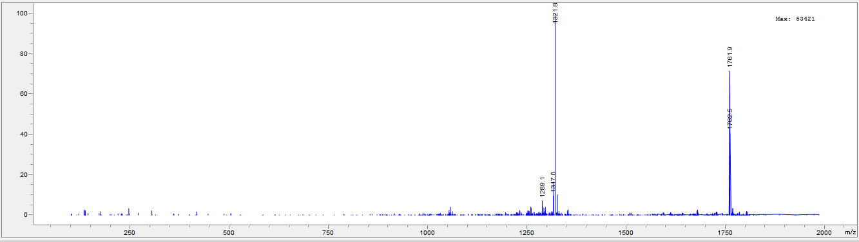

LC and MS for Vh-Ins-PSLL
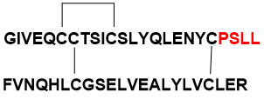
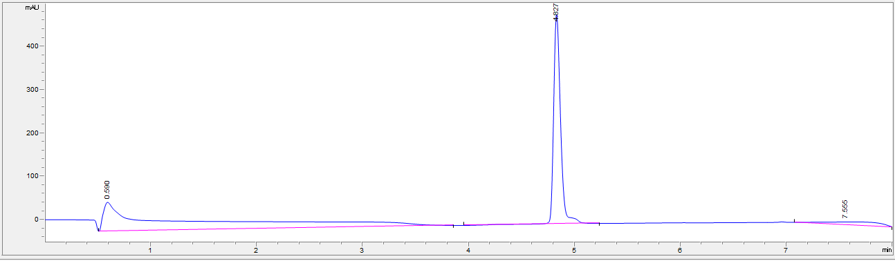
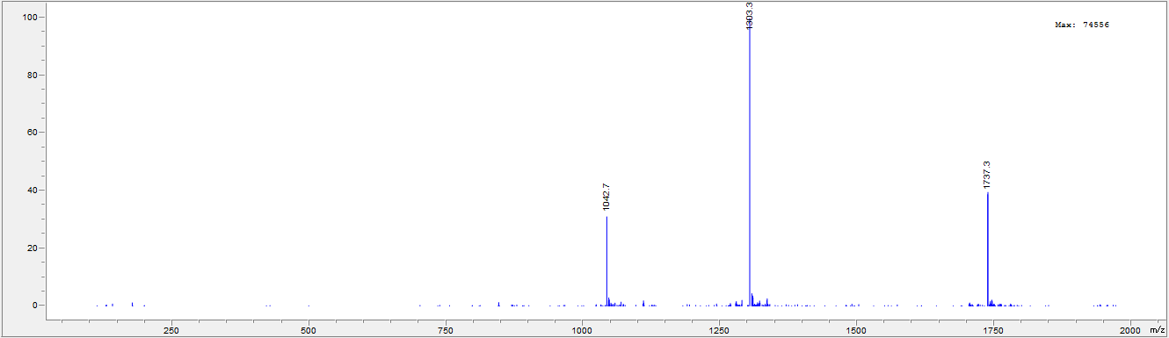

LC and MS for Vh-Ins-GSLL
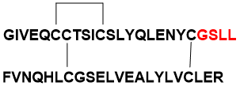
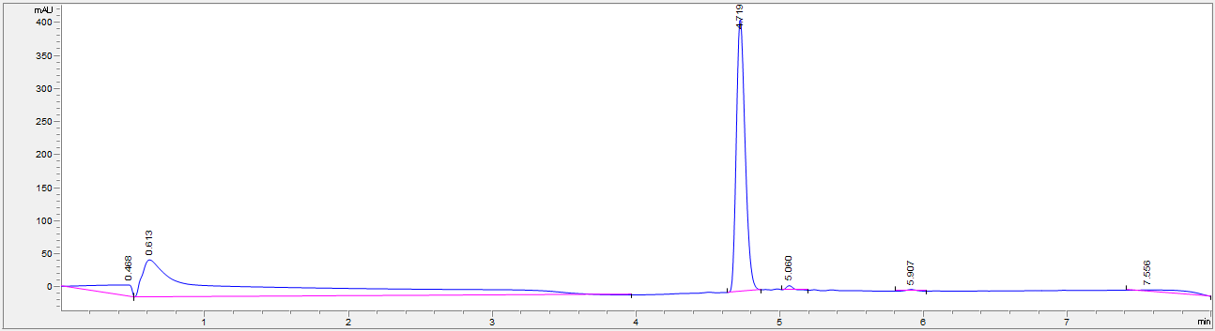
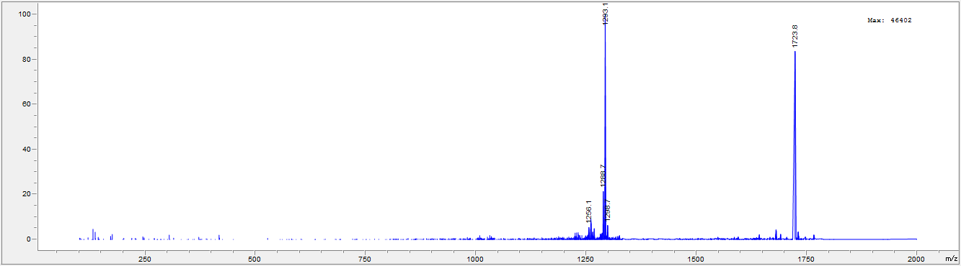

LC and MS for Vh-Ins-ASLLGL
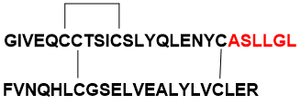
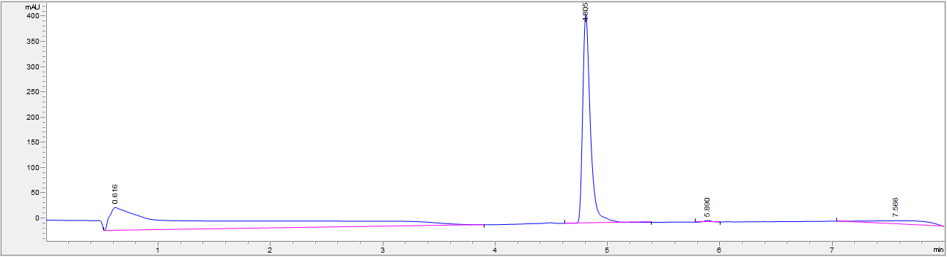
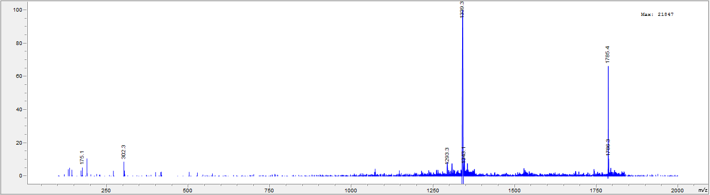
LC and MS for Vh-Ins-PVQ
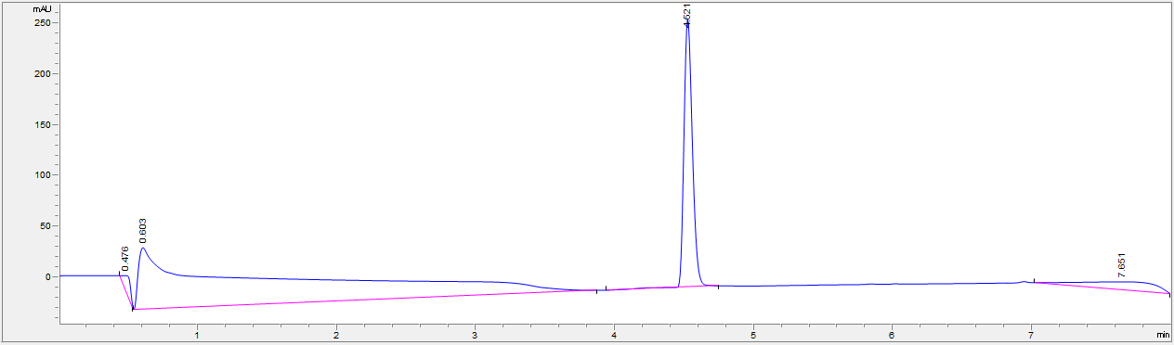

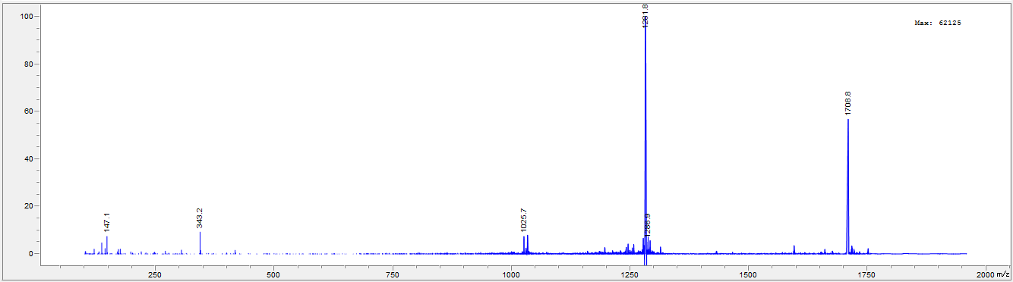

LC and MS for Vh-Ins-HTLA
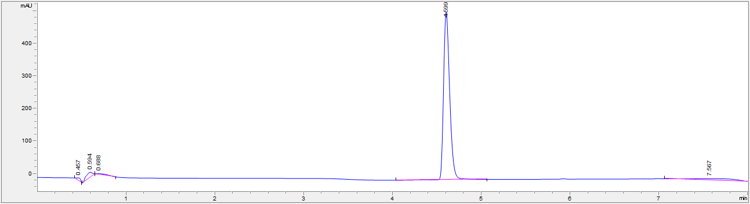
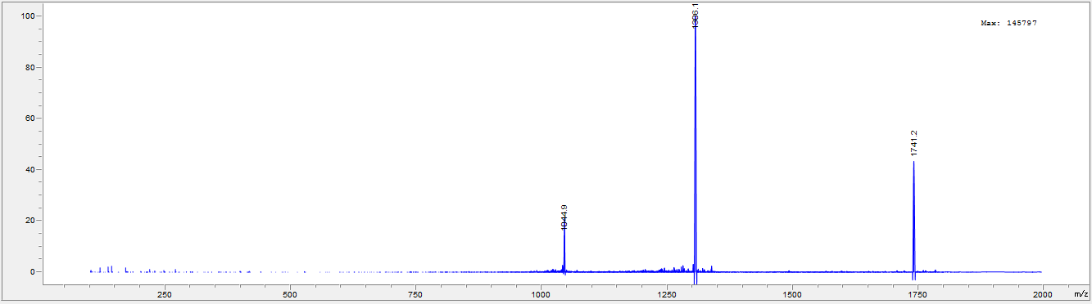
LC and MS for Vy-Ins-HTAQ

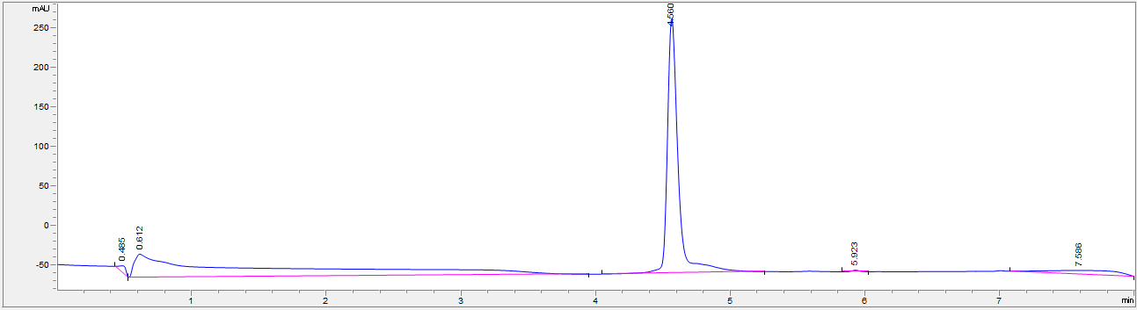
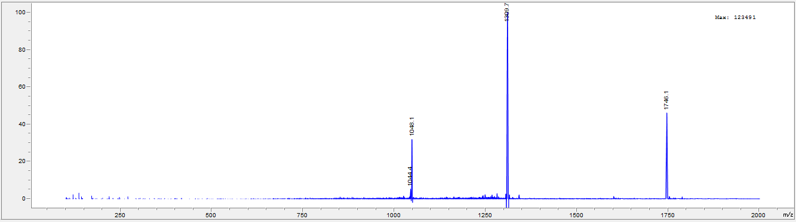

LC and MS for Vh-Ins-HALQ
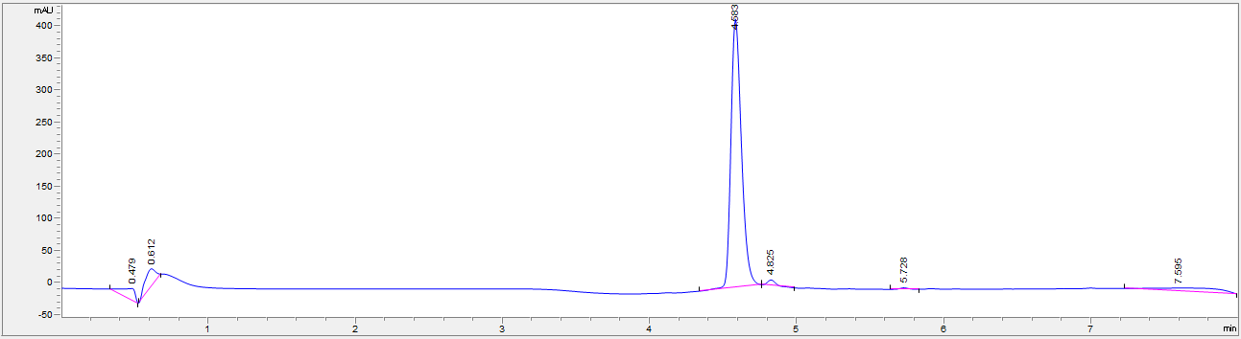
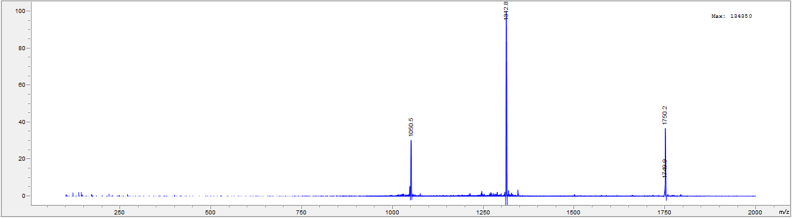
LC and MS for Vh-Ins-ATLQ
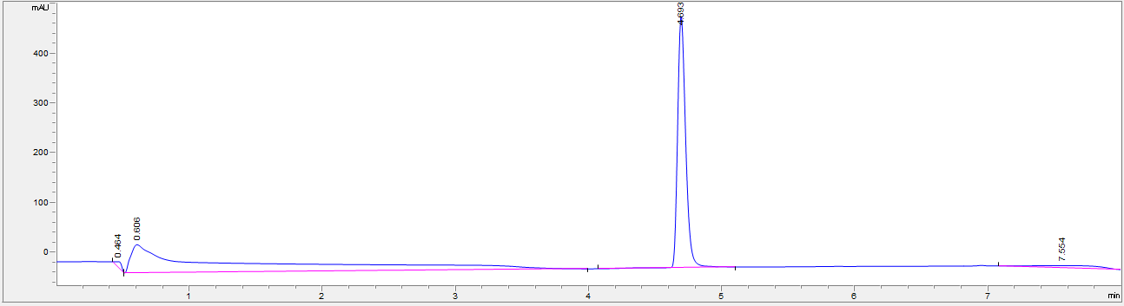
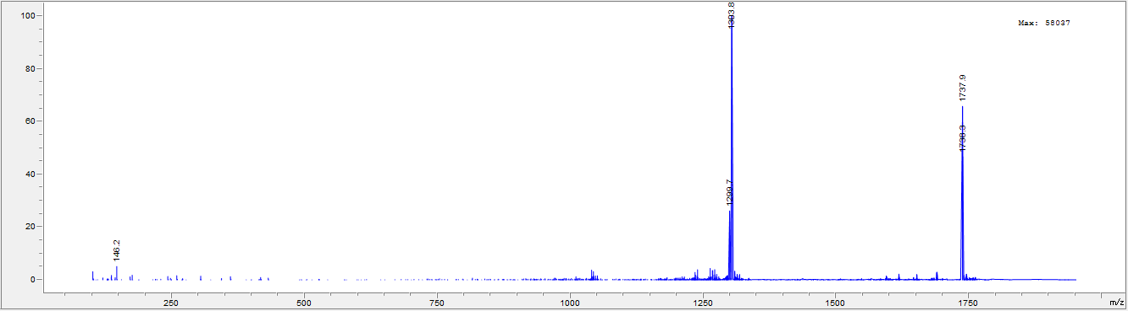

LC and MS for Vh-Ins-HALE
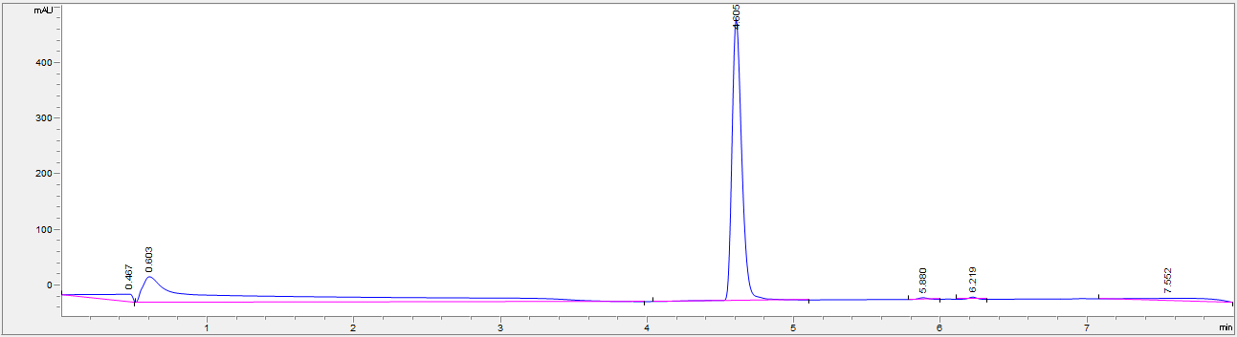
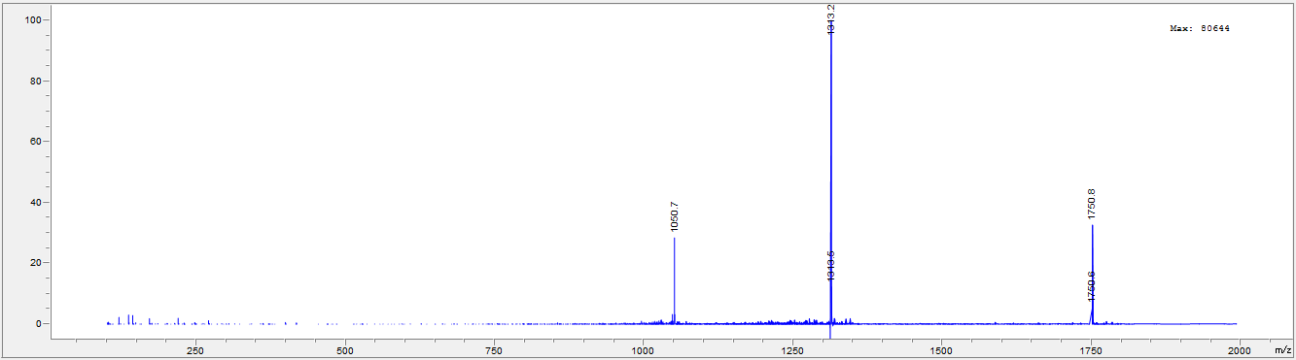

LC and MS for Vh-Ins-HALK
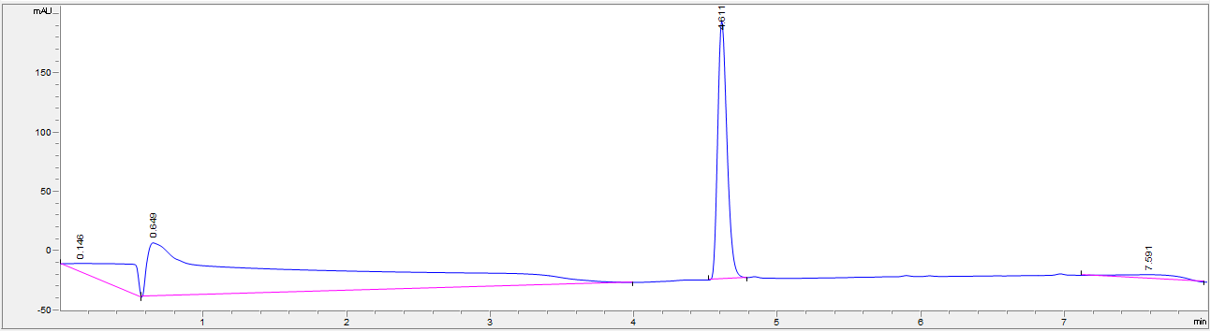
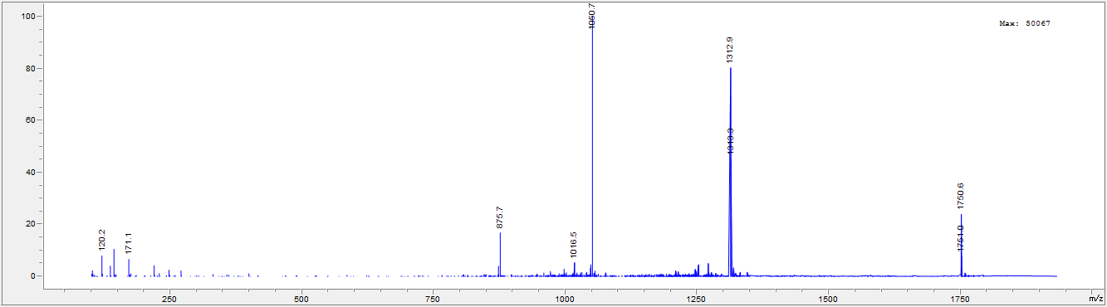

LC and MS for Vh-Ins-HALN
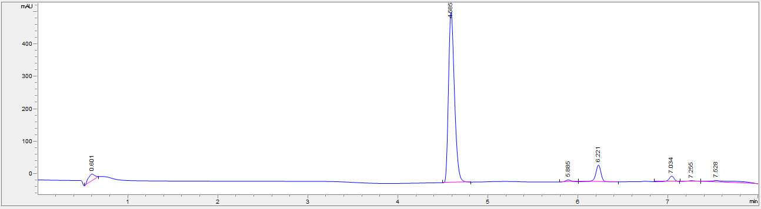
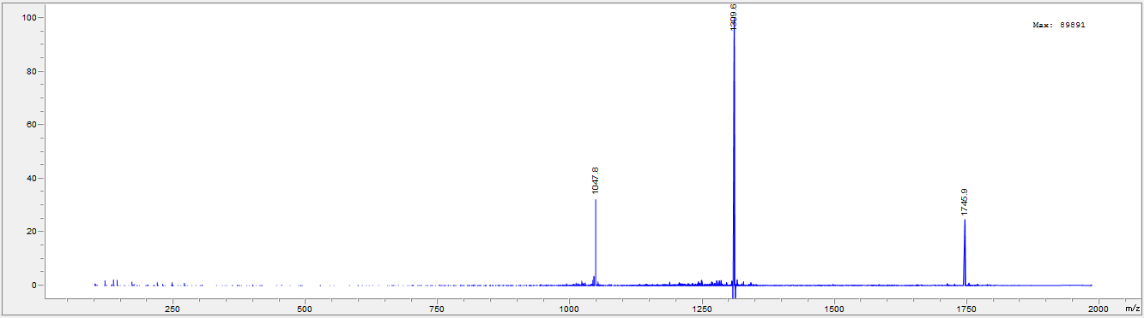

LC and MS for Vh-Ins-HALR
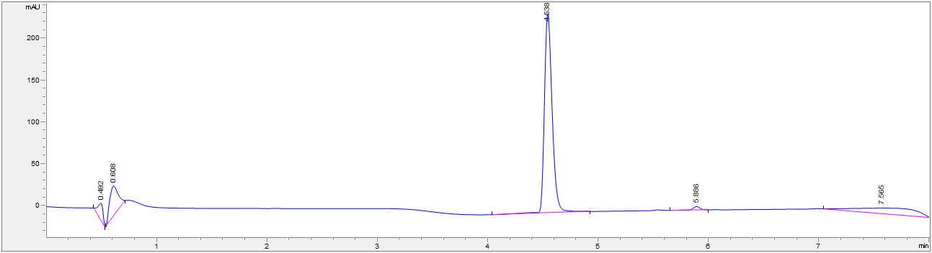
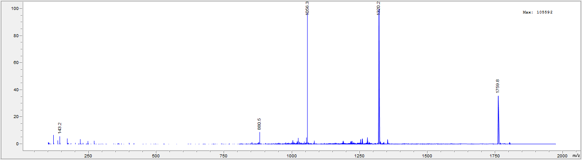

LC and MS for Vh-Ins-HAFQ
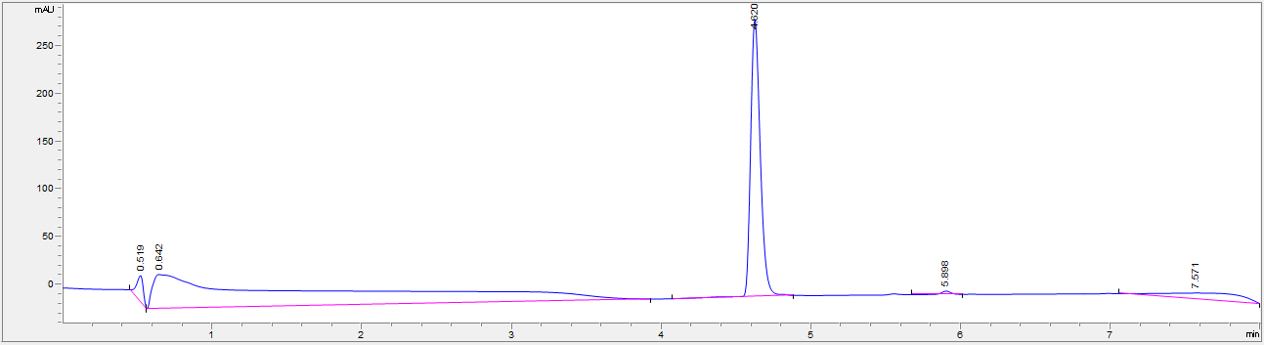
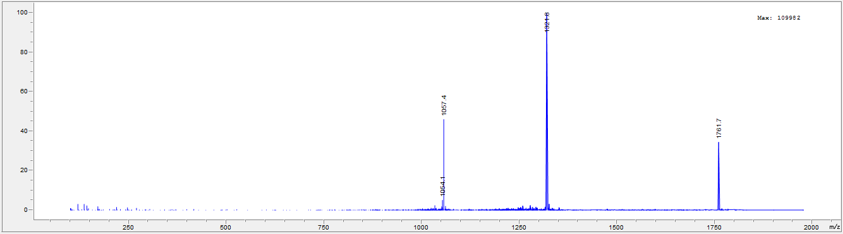
LC and MS for Vh-Ins-HAIQ
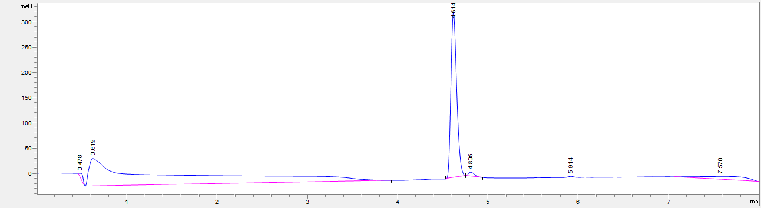
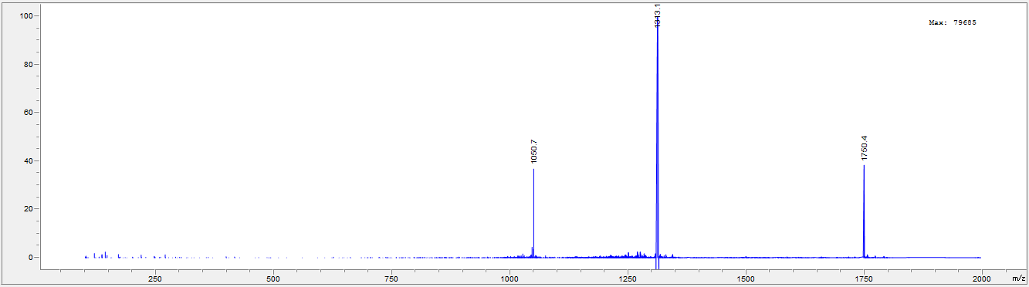

LC and MS for Vh-Ins-HAVQ
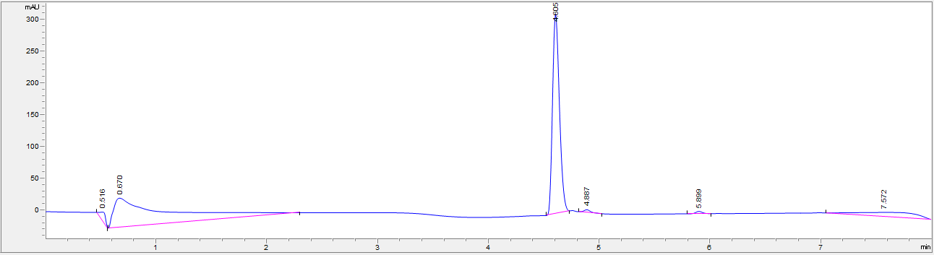
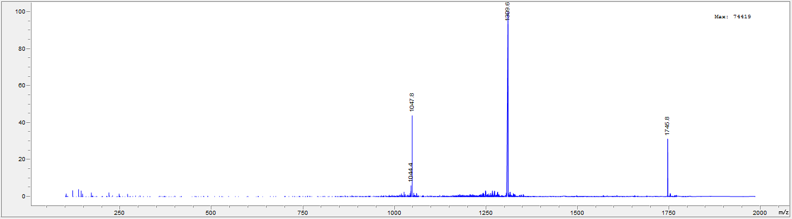

LC and MS for Vh-Ins-HGLQ
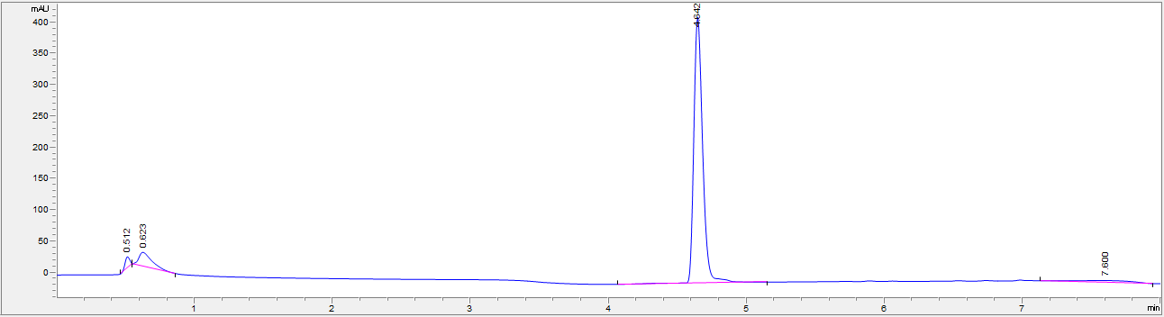
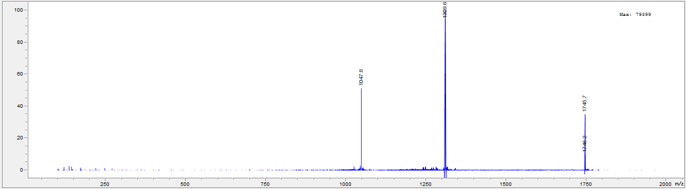

LC and MS for Vh-Ins-HSLQ
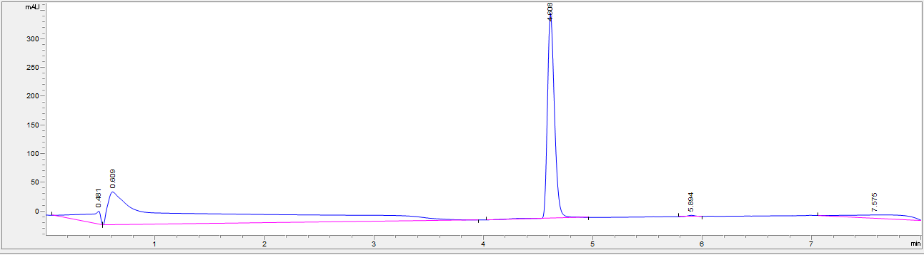
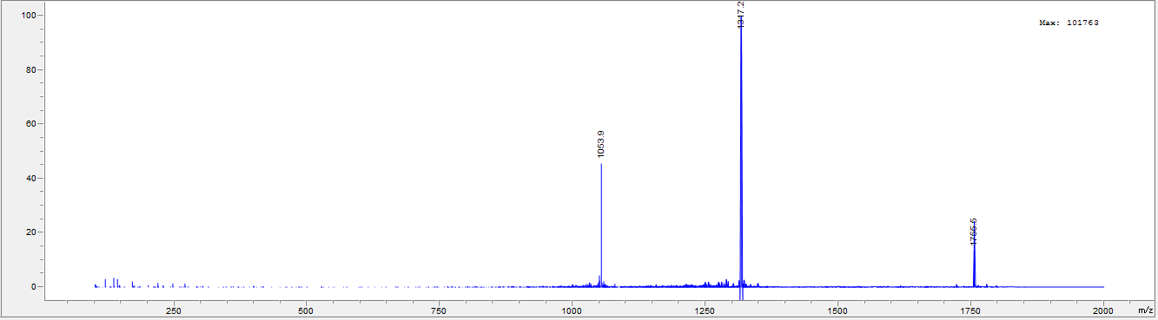

LC and MS for Vh-Ins-HELQ
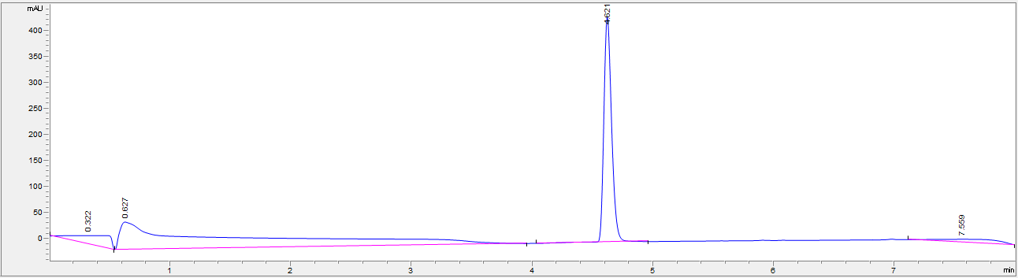
MS for HELQ, E, L
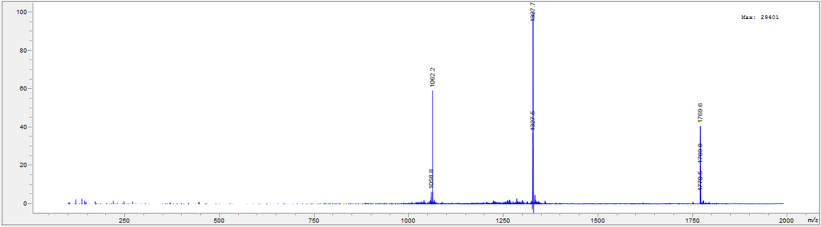

LC and MS for Vh-Ins-HKLQ
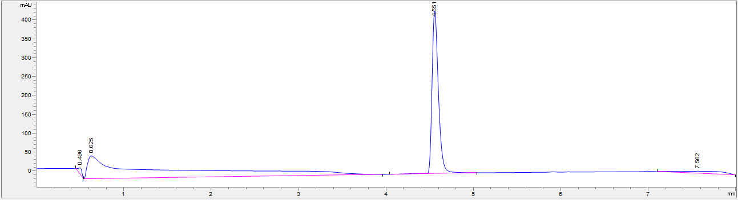
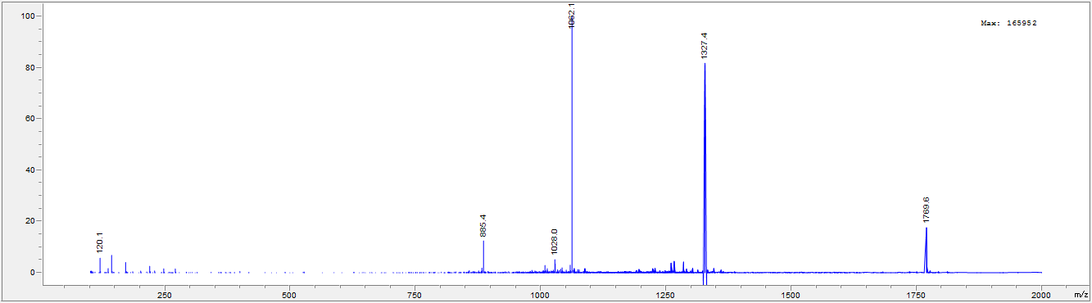
LC and MS for Vh-Ins-HLLQ, E, L
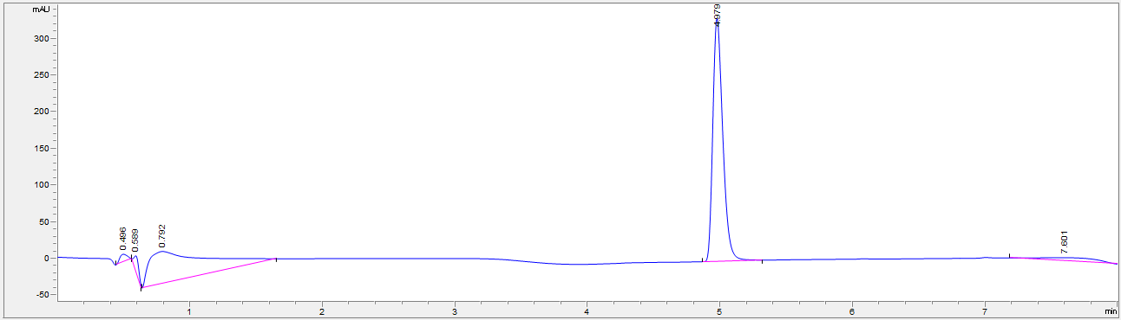
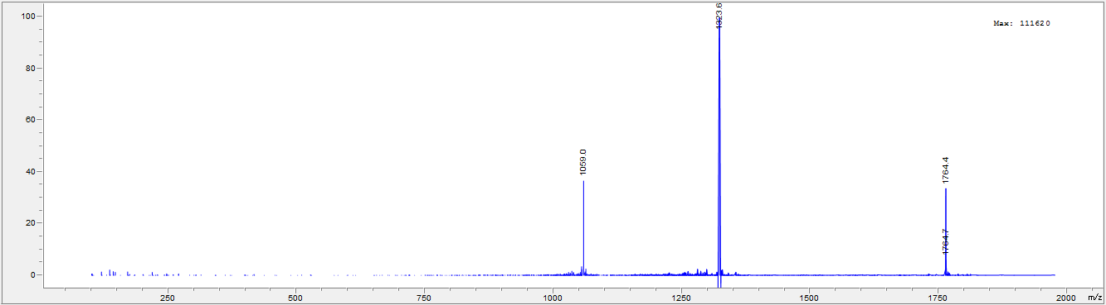

LC and MS for Vh-Ins-HFLQ
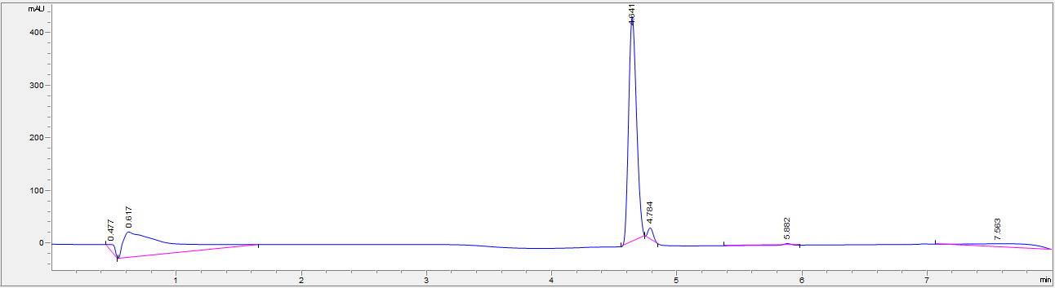
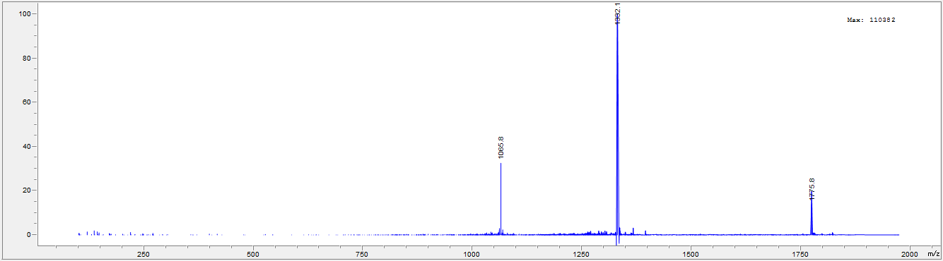
LC and MS for Vh-Ins-HVLQ
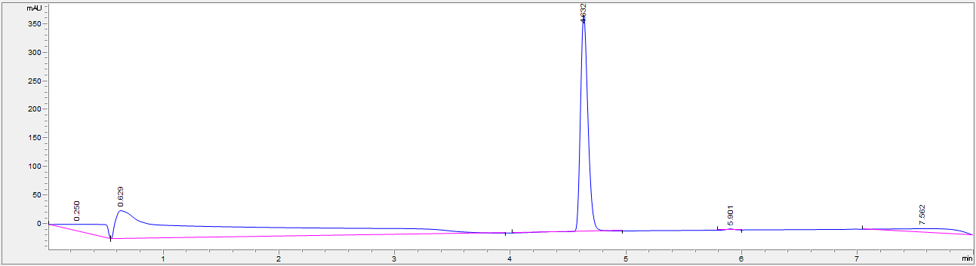
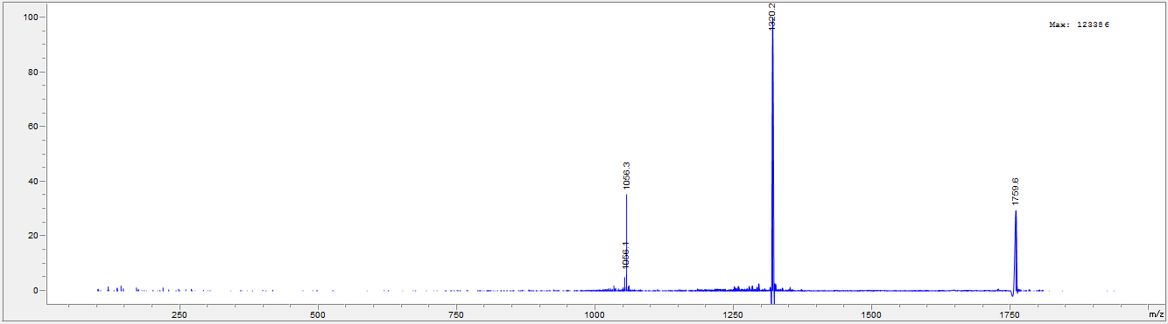

LC and MS for Vh-Ins-NALQ
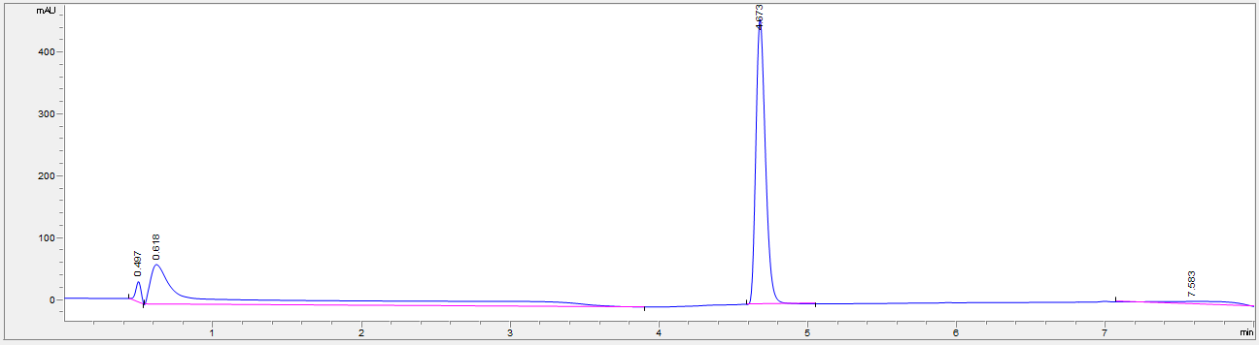
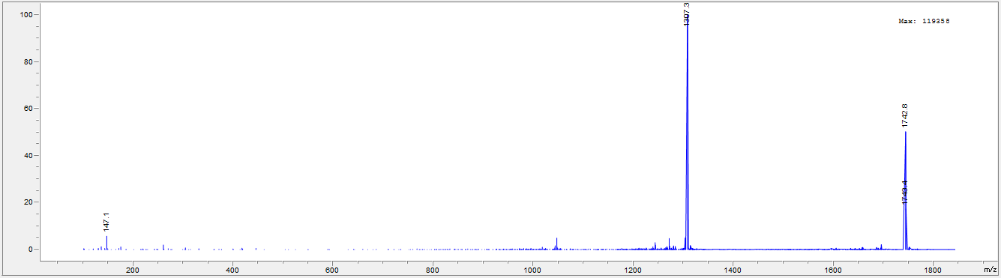
LC and MS for Vh-Ins-PALQ
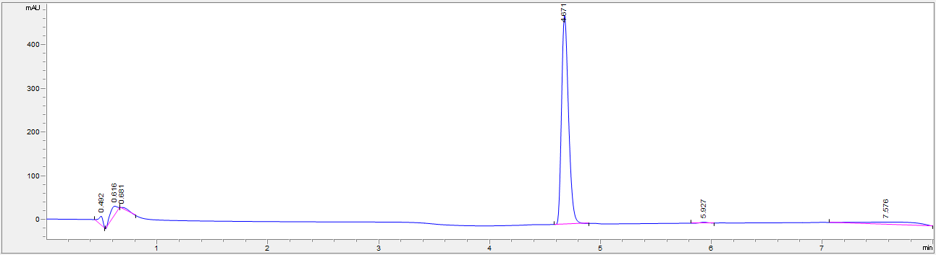
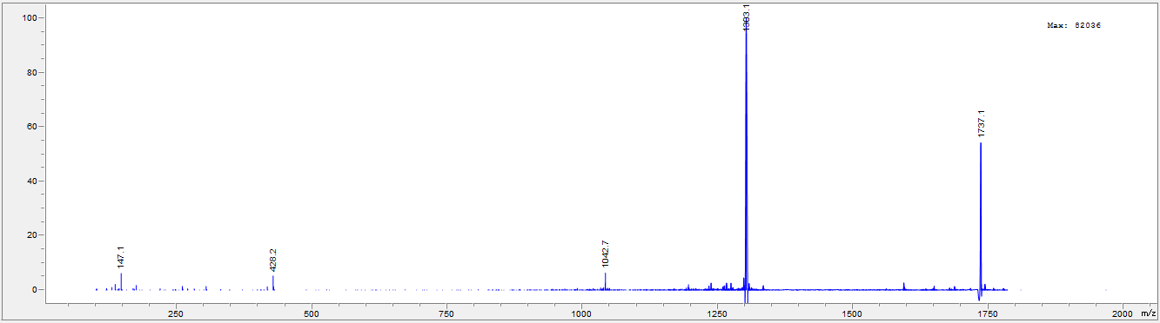

LC and MS for Vh-Ins-EALQ
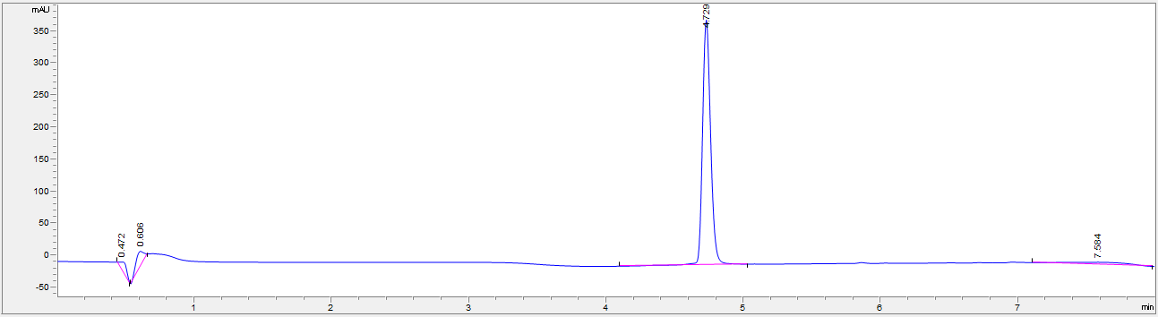
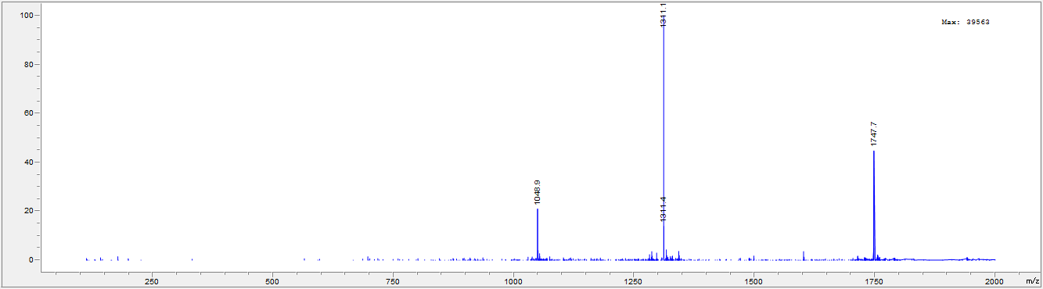

LC and MS for Vh-Ins-KALQ
