Supplementary Materials
Table S1: Difference in AIC values from the most supported model for all model structures tested during model selection
Model Formula | Warning | Delta AIC
SunPosition*Zone+(SunPosition+Zone|ID) | NA | 0.0
River+Zone*SunPosition+(SunPosition+Zone|ID) | NA | 0.2
Year+Zone*SunPosition+(SunPosition+Zone|ID) | Failed to converge | 1.9
SunPosition*Zone+(SunPosition+Zone|ID)+ (1|Fjord) | Singular fit | 2.0
Fjord+Zone*SunPosition+(SunPosition+Zone|ID) | NA | 2.0
SunPosition*Zone+(SunPosition+Zone|ID)+ (1|Year) | Singular fit | 2.0
SunPosition+Zone+(SunPosition+Zone|ID) | NA | 17.0
DistToEstuary*SunPosition+(SunPosition+DistToEstuary|ID) | NA | 97.8
SunPosition(Param.)*Zone+(SunPosition(Param.)+Zone|ID) | Singular fit | 116.9
SunPosition(Param.)+Zone+(SunPosition(Param.)+Zone|ID) | NA | 147.1
SunPosition*Zone+(SunPosition|ID) | NA | 524.3
Zone+SunPosition+(Zone|ID) | NA | 565.3
SunPosition*Zone+(1|ID) | NA | 1022.0
Zone+(Zone|ID) | NA | 1059.3
SunPosition+Zone+(1|ID) | NA | 1081.0
SunPosition*DistToEstuary+(1|ID) | NA | 1250.4
SunPosition+DistToEstuary+(1|ID) | Failed to converge | 1266.3
Zone+SunPosition(Param.)+(1|ID) | Unable to evaluate scaled gradient | 1276.0
Zone+DayOfYear+(1|ID) | NA | 1524.5
Zone+(1|ID) | NA | 1525.7
Zone*Year+(1|ID) | NA | 1526.6
Zone+Year+(1|ID) | NA | 1527.6
SunPosition+Fjord+(1|ID) | NA | 1552.5
SunPosition+(1|ID) | NA | 1552.8
DistToEstuary+(1|ID) | NA | 1637.5
DayOfYear+(1|ID) | NA | 1672.1
SunPosition(Param.)+(1|ID) | NA | 1687.3
1+(1|ID) | NA | 1835.0
Fjord+(1|ID) | NA | 1835.3
Year+(1|ID) | NA | 1837.0

Parameterization of the Position of the Sun with Respect to the Horizon
Sun position data was parameterized such that it varied through dusk and dawn but was flat when it was fully light or fully dark. As we expect that salmon react to light level and not sun position as such, this parameterization was tested in model selection.
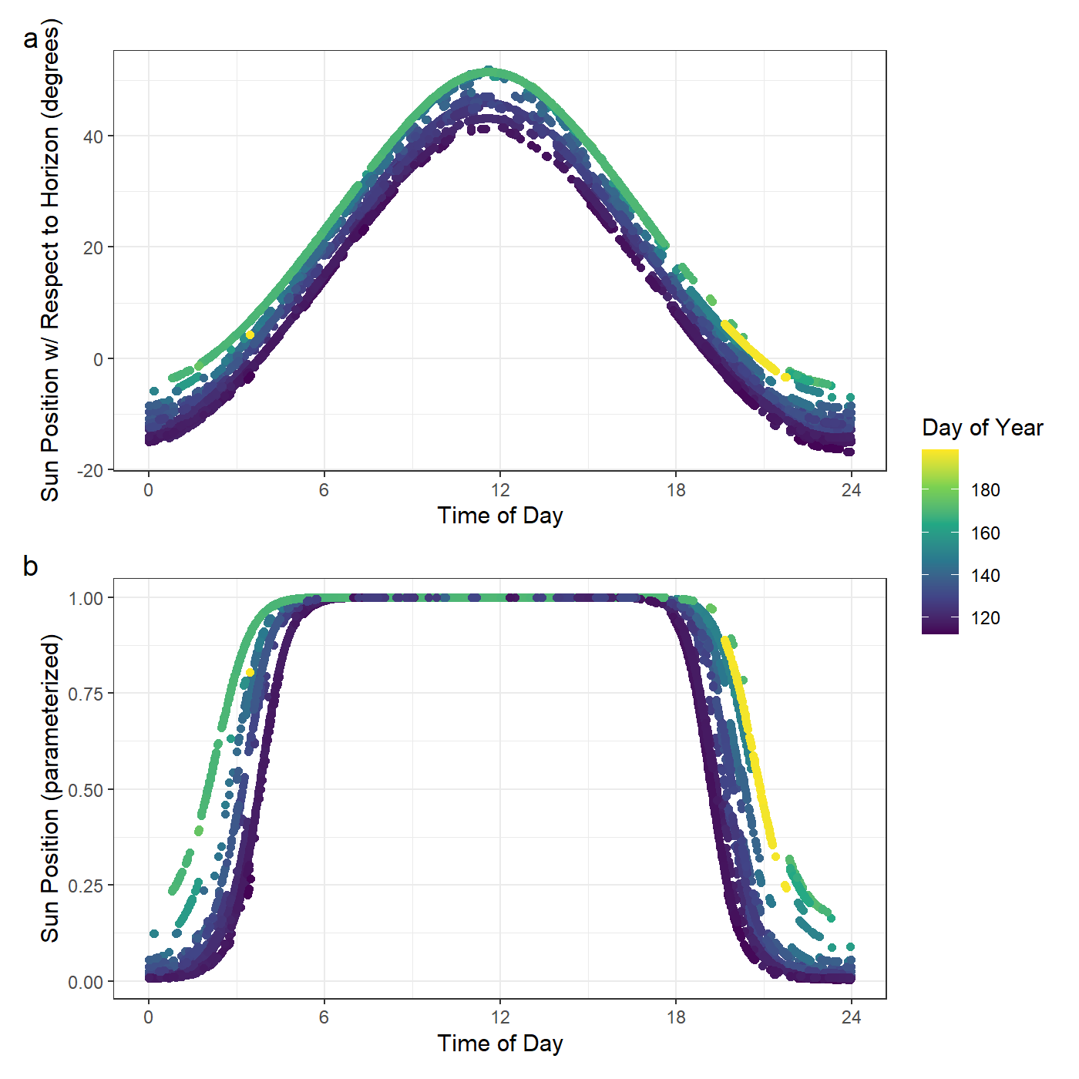
Figure S1: The relationship between the time of day in hours vs (a) the position of the sun with respect to the horizon and (b) the parameterized values of the position of the sun for each recording of depth after quality control.

Salinity in the fjord
CTD measurements were taken at several fixed stations throughout both fjords during the smolt migration using a SAIV CTD profiler Model SD204 (https://saiv.no/sd204-ctd-profiler).
In Hardanger, these measurements were taken on the 13th of May and the 15th-16th of May in 2018 and 2019, respectively. In Nordfjord, these measurements were taken on the 10th-11th of May and the 21st of May in 2018 and 2019, respectively. In order to produce the figures in Figure S2, these measurements were interpolated as a function of the distance of each measurement from the innermost river mouth using the function interp in the R package akima.
Crosbie et al. (2019) showed 80% reduction in the number of sea-lice copepodites at salinities below 20 ppt compared to full-strength seawater, while Bricknell et al. (2006) showed a 66% reduction in attachment rate at 19 ppt compared to full-strength seawater and that copepodids effectively failed to attach to salmon at 12 ppt. These breakpoints, 20 and 12 ppt are shown by red and orange lines respectively in Figure S2.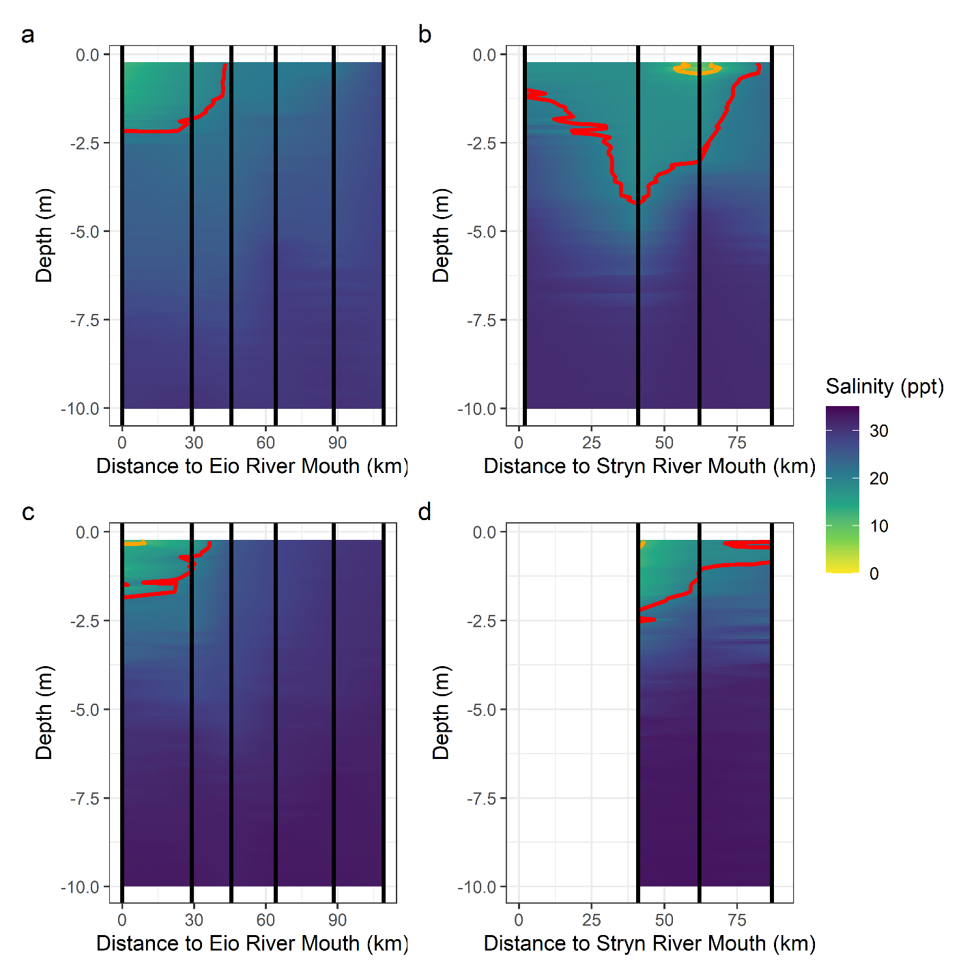
Figure S2: Interpolated salinity through each fjord in each year based on CTD measurements in the month of May, where a) shows Hardanger 2018, b) is Nordfjord 2018, c) is Hardanger 2019, and d) is Nordfjord 2019. The orange and red contour lines show 12 and 20 salinity, respectively. The vertical black lines show the distances at which the CTD measurements were taken for each plot.
Unfortunately, these CTD measurements have too low spatiotemporal resolution to be used directly in the depth use model. However, if we subset our data to only detections that occur within two days and five kilometers of a CTD measurement we are left with 289 detections across 26 individuals. Assuming that the closest CTD measurement to those detections is a good proxy for the temperature and salinity experienced at the time of detection, no post-smolts were observed at salinities greater than 20 ppt when any part of the water column was below 20 ppt (Figure S3). In this subset, only 22 of the 289 detections occurred at location-times where such low salinity water was available. However, in our pilot project in 2017 where 53 smolts were tagged with depth tags in the Stryn river system, there were an additional 399 detections with depth data occurring near in time and space to CTD measurements. Of these, 296 occurred when low salinity water was available and none of these crossed the 20 ppt threshold. These data were not included in this study as the tags used in 2017 recorded depth to the nearest 0.51 meters, rather than the 0.2 meters used in later years. This rendered these datasets difficult to compare statistically as the difference due to the unit of measurement was larger than any of the observed effects on depth use.
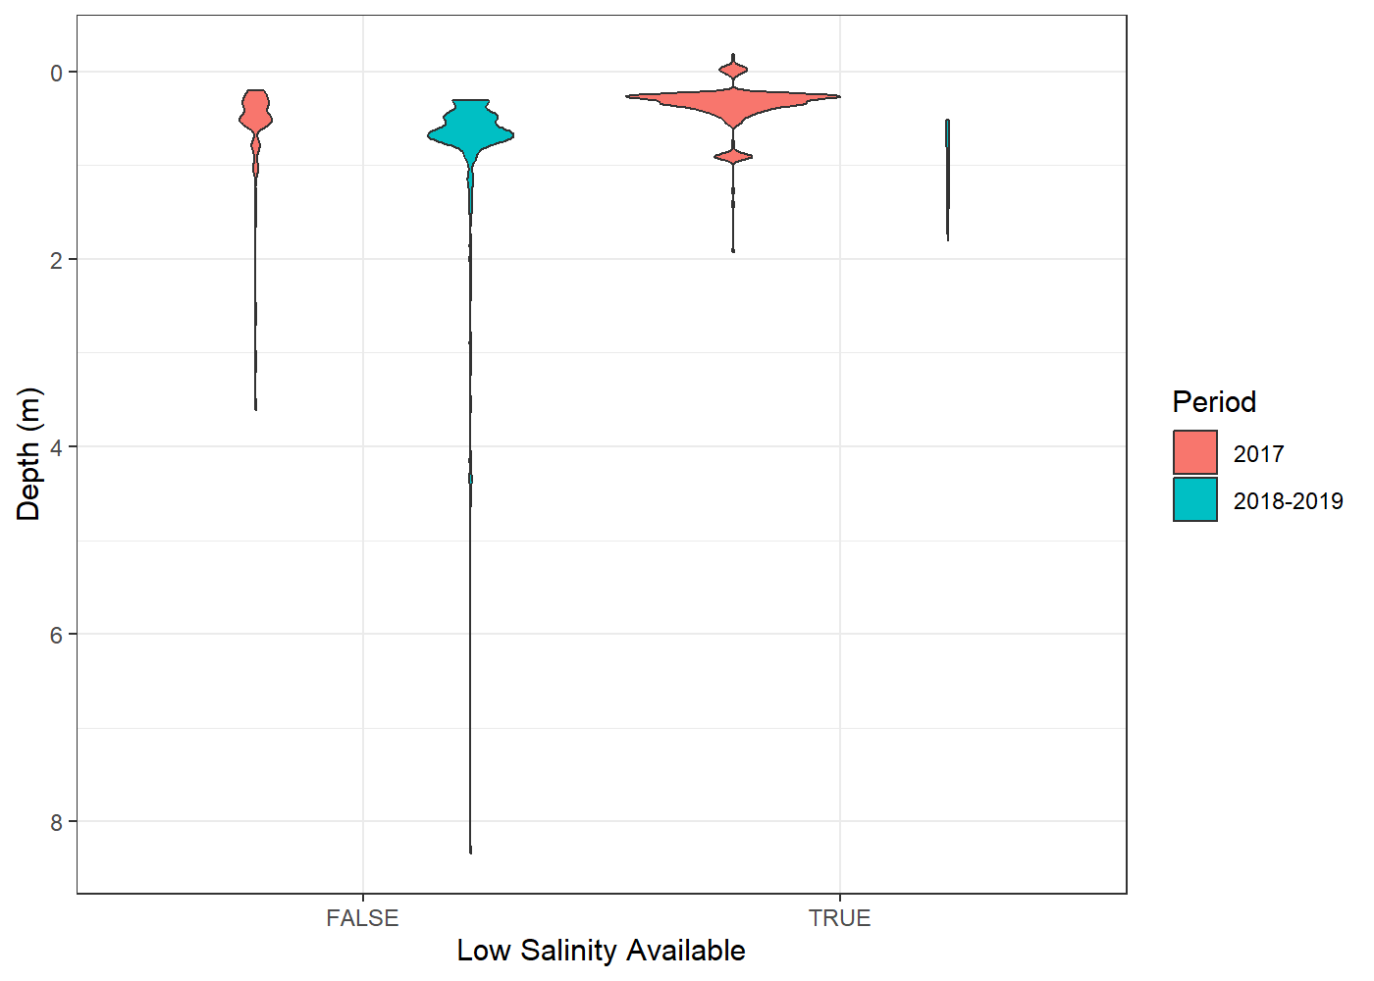
Figure S3: Violin plots showing observed depths of smolts when low salinity water was or was not available, defined as some part of the water column having salinity lower than 20 ppt. In red are detections from Stryn 2017, which had to be removed from the analysis as the tags used reported depth in 0.51 m increments as opposed to 0.2 m increments, while in red are all detections from other river years. The area of each violin plot is scaled according to how many data points are in it.
This result indicates that when low salinity water is available to migrating smolts, the variance in depth use will be smaller. Regardless, finer scale modelling of salinity will be necessary to assess where and when smolt can utilize low salinity water and whether smolts actively seek out low salinity water in their migration.

References
Bricknell, I. R., Dalesman, S. J., O’Shea, B., Pert, C. C., & Mordue Luntz, A. J. (2006). Effect of environmental salinity on sea lice Lepeophtheirus salmonis settlement success. Diseases of Aquatic Organisms, 71, 201–212. https://doi.org/10.3354/dao071201
Crosbie, T., Wright, D., Oppedal, F., Johnsen, I., Samsing, F., & Dempster, T. (2019). Effects of step salinity gradients on salmon lice larvae behaviour and dispersal. Aquaculture Environment Interactions, 11, 181–190. https://doi.org/10.3354/aei00303

