SUPPLEMENTARY MATERIAL
FIGURES AND TABLES

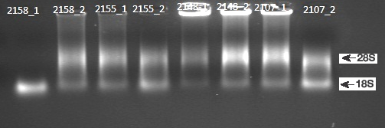
Figure S1. Ethidium bromide-stained denaturing agarose gel of total RNA content from the testis of vervet monkeys fed on escalating doses of (-)-cathinone. The animal groups are represented with 2107_1 and 2107_2, 2158_1 and 2158_2, 2155_1 and 2155_2, 2148_1 and 2148_2 with low, medium and high doses of (-)- cathinone and controls, respectively; n = 8.

Table S1. Comparisons between samples based on “cycle threshold” (CT). √ means samples with low CT, X means samples with high CT. Note that most samples expressing 17β- HSD showed high CT compared to those of 3β- HSD indicating that mRNA expression of 17β- HSD was more suppressed by (-)-cathinone than was that of 3β- HSD.

Sample | 3B HSD | 17BHSD
2158_1 | 40  X | 40  X
2158_2 | 27  √ | 40  X
2155_1 | 40  X | 40  X
2155_2 | 28  √ | 40  X
2148_1 | 26  √ | 36  X
2148_2 | 25  √ | 32  √
2107_1 | 27  √ | 31  √
2107_2 | 30  √ | 32  √

