Supplementary Fig SF1: Comparison of the reduction in TD among parents and hybrids, correlation matrix of TD and insect damage, and microscopic image of cotton leaf disc with trichomes

Supplementary Fig SF2: Comparison of pollen size among the F₁ and their respective parents

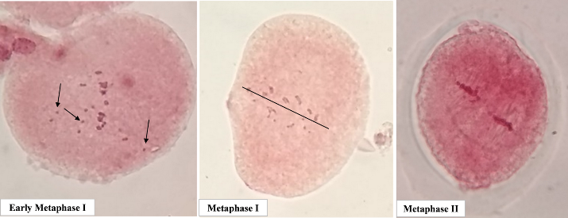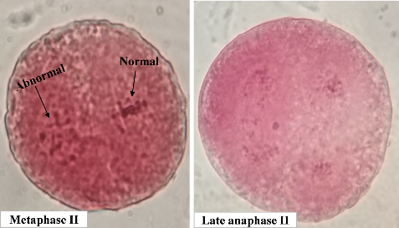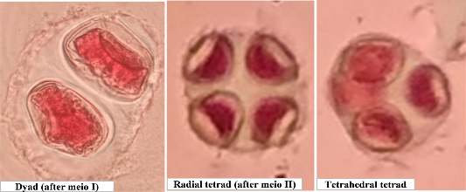
Supplementary Fig SF3: Different stages of meiosis and different types of cytokinesis in interspecific hybrids (here, arrows at early metaphase indicate univalents)

Supplementary Table information:
Supplementary Table ST1: Information of SSR primers used for hybridity confirmation
SSR Marker | Chromosome | Genome
BNL 1679 | 12 | A
NAU 0922 | 05 | A
BNL 0946 | 20 | D
NAU 1222 | 07 | A
BNL 2921 | 01 | A
CIR 0183 | 12 | A
BNL 2652 | 13 | A
BNL 3888 | 11 | A
Data source: https://www.cottongen.org/
Supplementary Table ST2: Information of primer used in viral DNA amplification
Primer | Sequence | Nucleotides
A | 5'-TAATATTACCKGWKGVCCSC-3' | 20
B | 5'-TGGACYTTRCAWGGBCCTTCACA-3' | 23
†(Where, K=G or T, R=A or G, S=C or G, W=A or T, Y=C or T, B=C, G or T, and V=A, C or G).
Supplementary Table ST3: Stock and final concentration of different components used in PCR
Components | Stock concentration | Volume (µl) | Final concentration
PCR buffer | 5X | 4.0 | 1X
MgCl₂ | 25mM | 1.5 | 1.5mM
dNTP’s | 1mM | 3.0 | 200µM
Primer forward | 5µm | 2.0 | 0.5µM
Primer reverse | 5µm | 2.0 | 0.5µM
Taq polymerase | 5U/µl | 0.2 | 1 unit
DNA template | 20ng/µl | 3.0 | 60ng
Autoclaved water |  | 4.3
Total |  | 20

Supplementary Table ST4: PCR amplification profile:
Step | Temperature (°C) | Time (min) | No. of cycles
Initial denaturation | 94 | 6 | 1
Denaturation | 94 | 1 | 35
Annealing | 52-57 | 1 | 35
Elongation | 72 | 1 | 35
Final extension | 72 | 7 | 1
Hold | 4 | ∞ | -

