Supporting Information

Supplementary figures
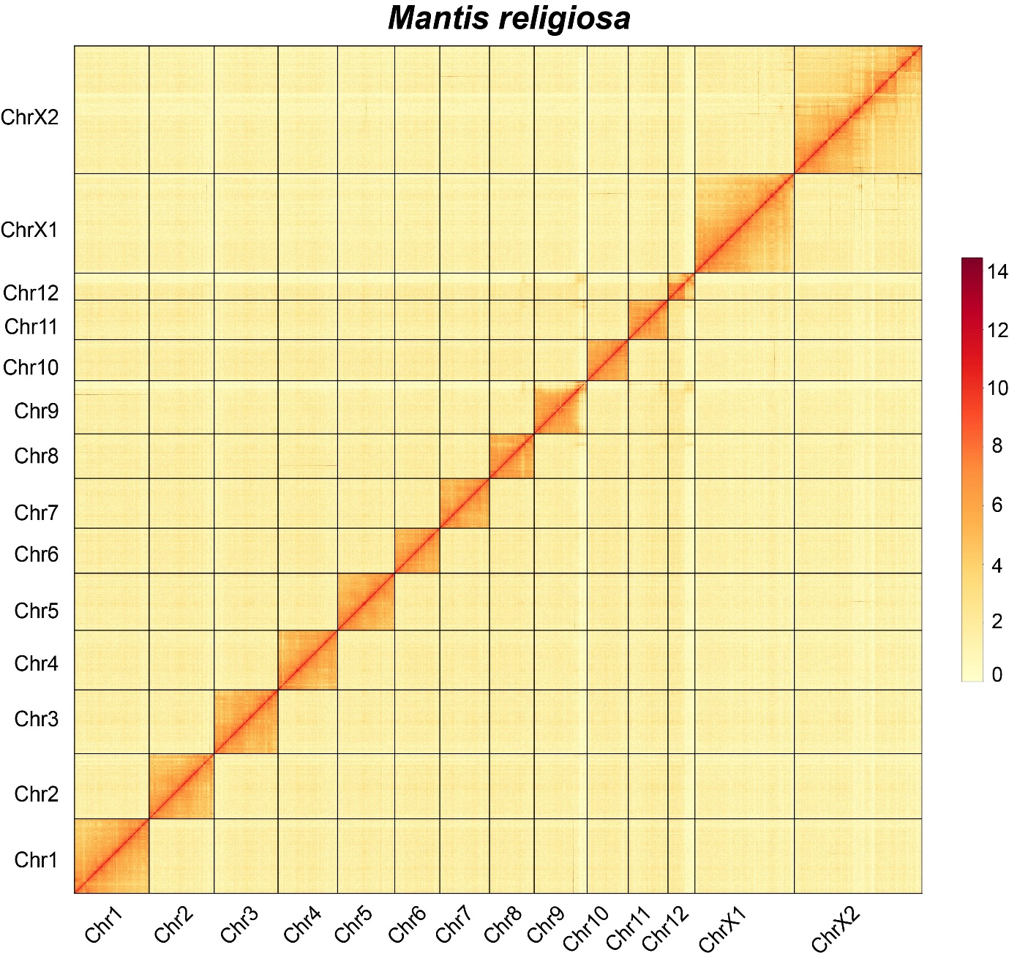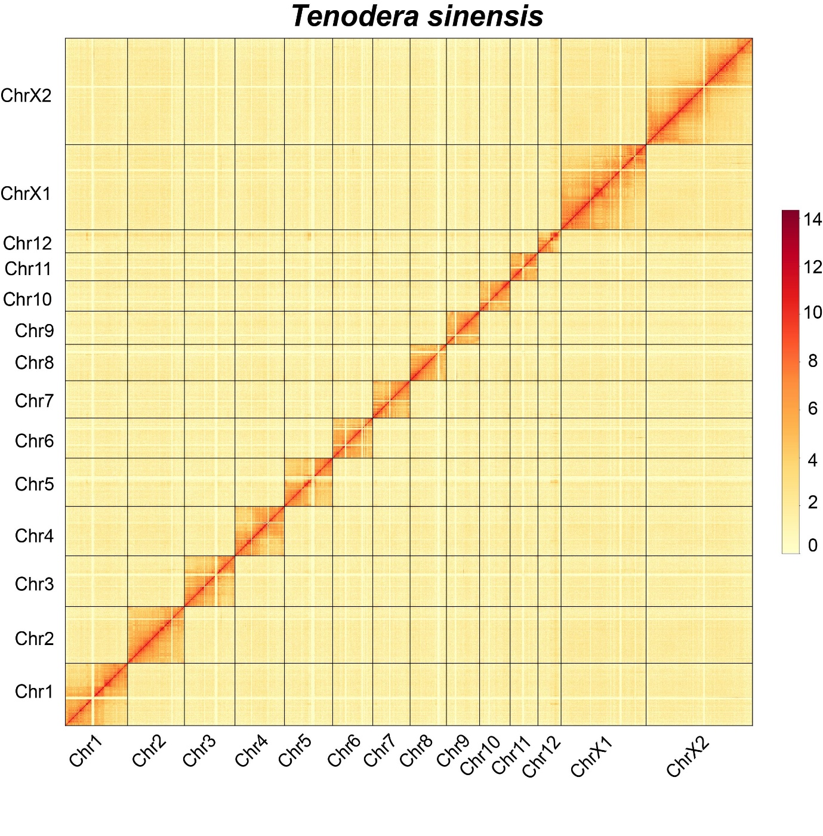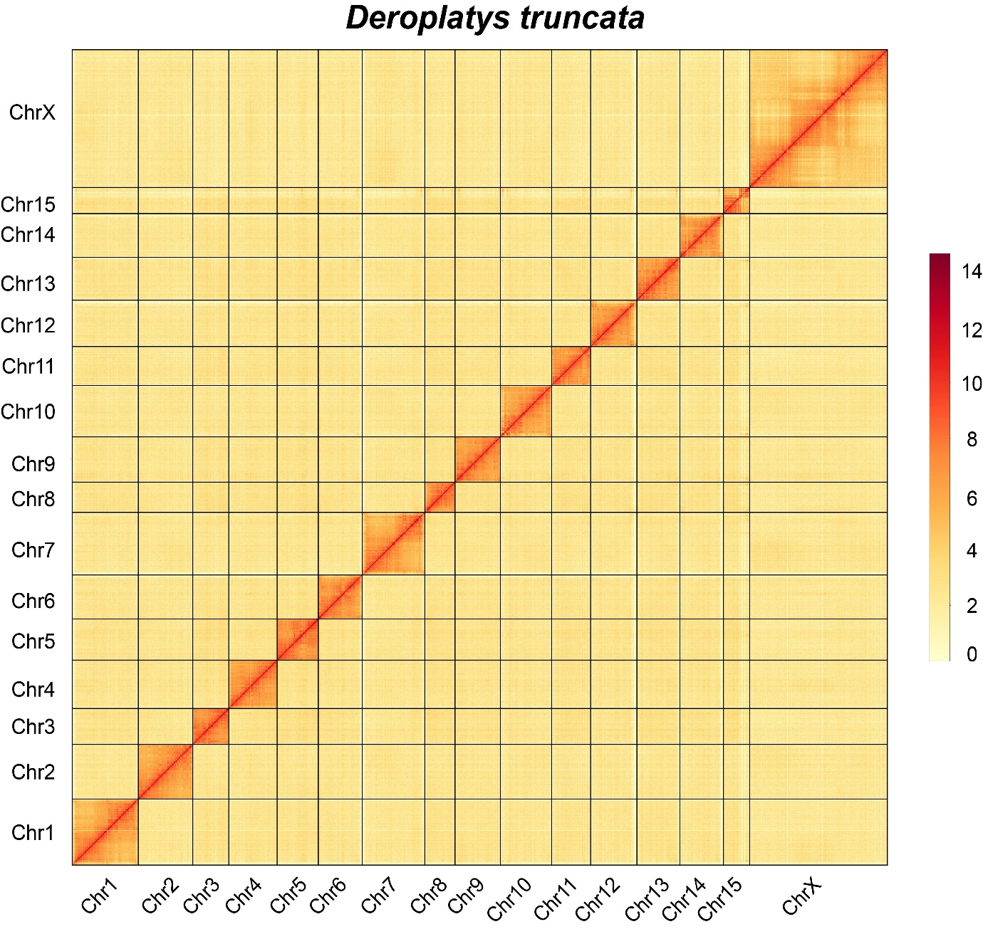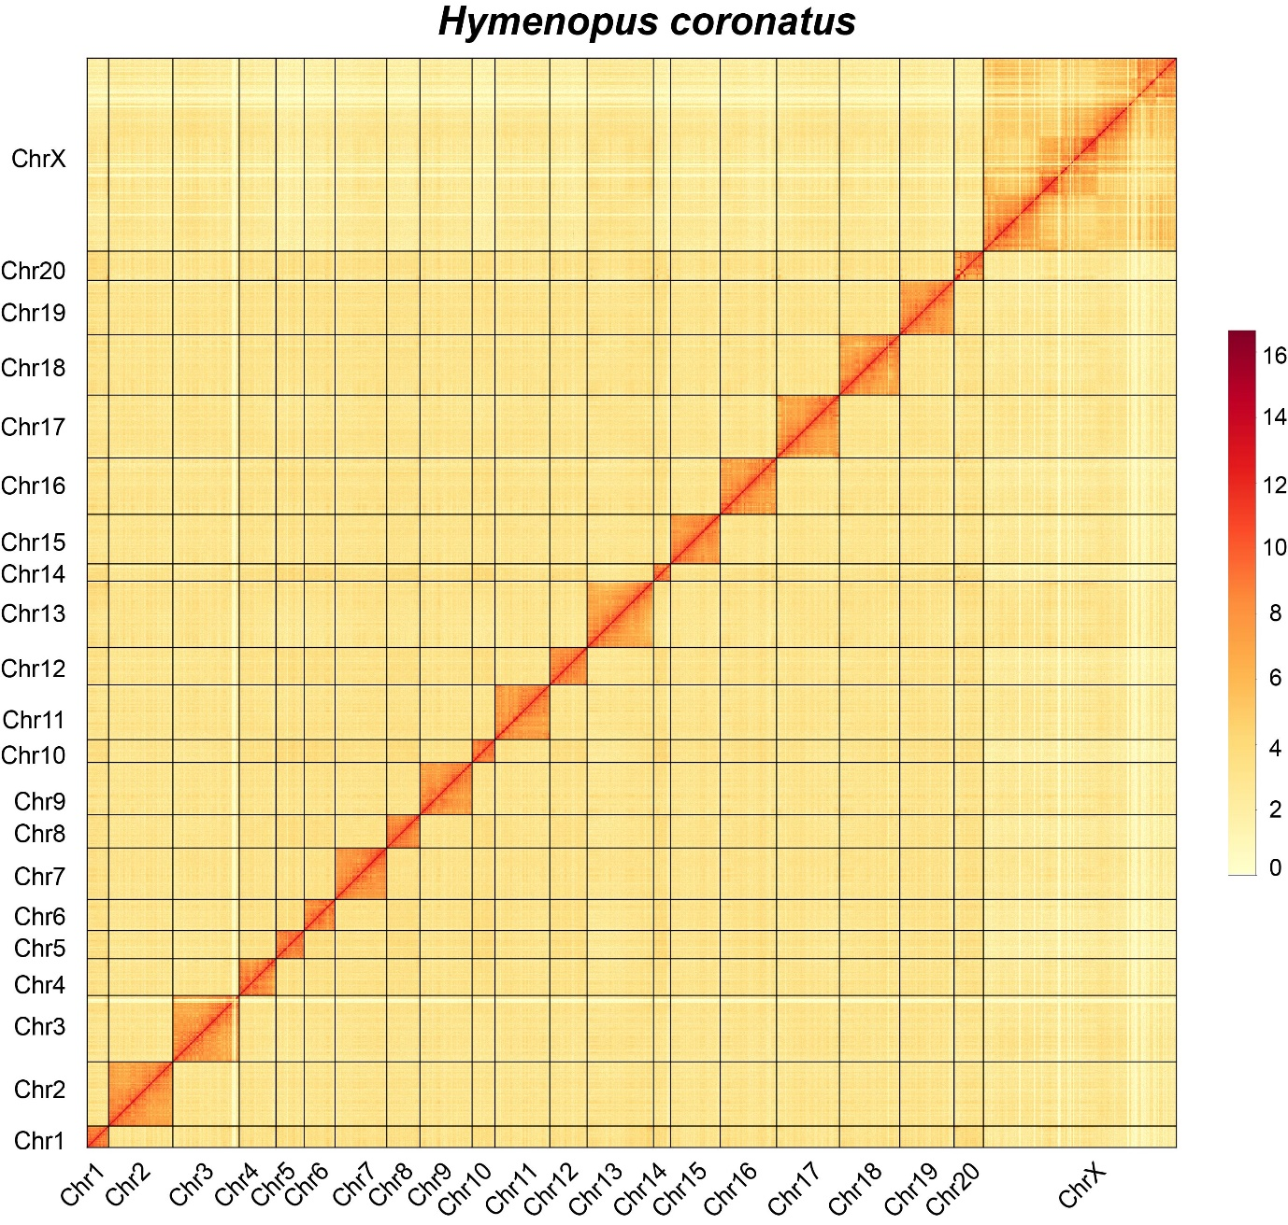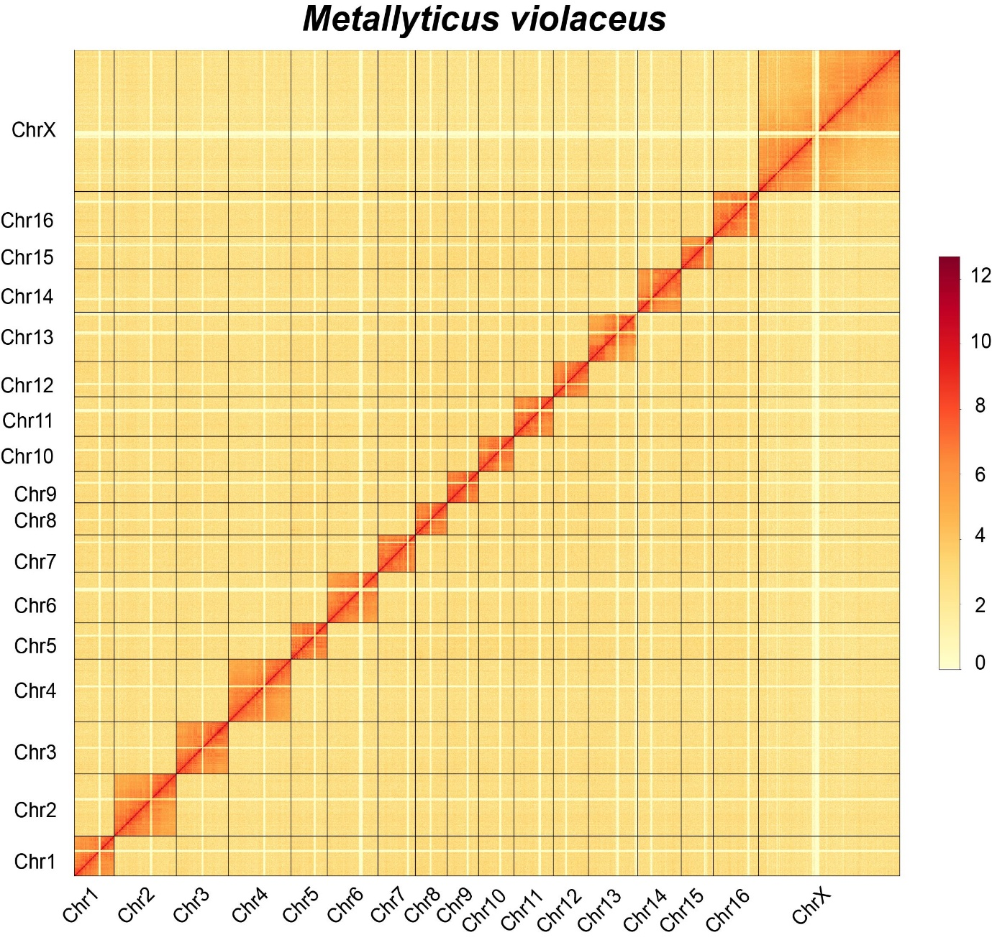
Figure S1. Hi-C heatmap of genome assembly for M. religiosa, T. sinensis, D. truncata, H. coronatus, and M. violaceus. The resolution (window size) is 1000-Kb, and color represents log₂(Links number). Links number is the number of Hi-C links falling between the two analyzed genomic windows.

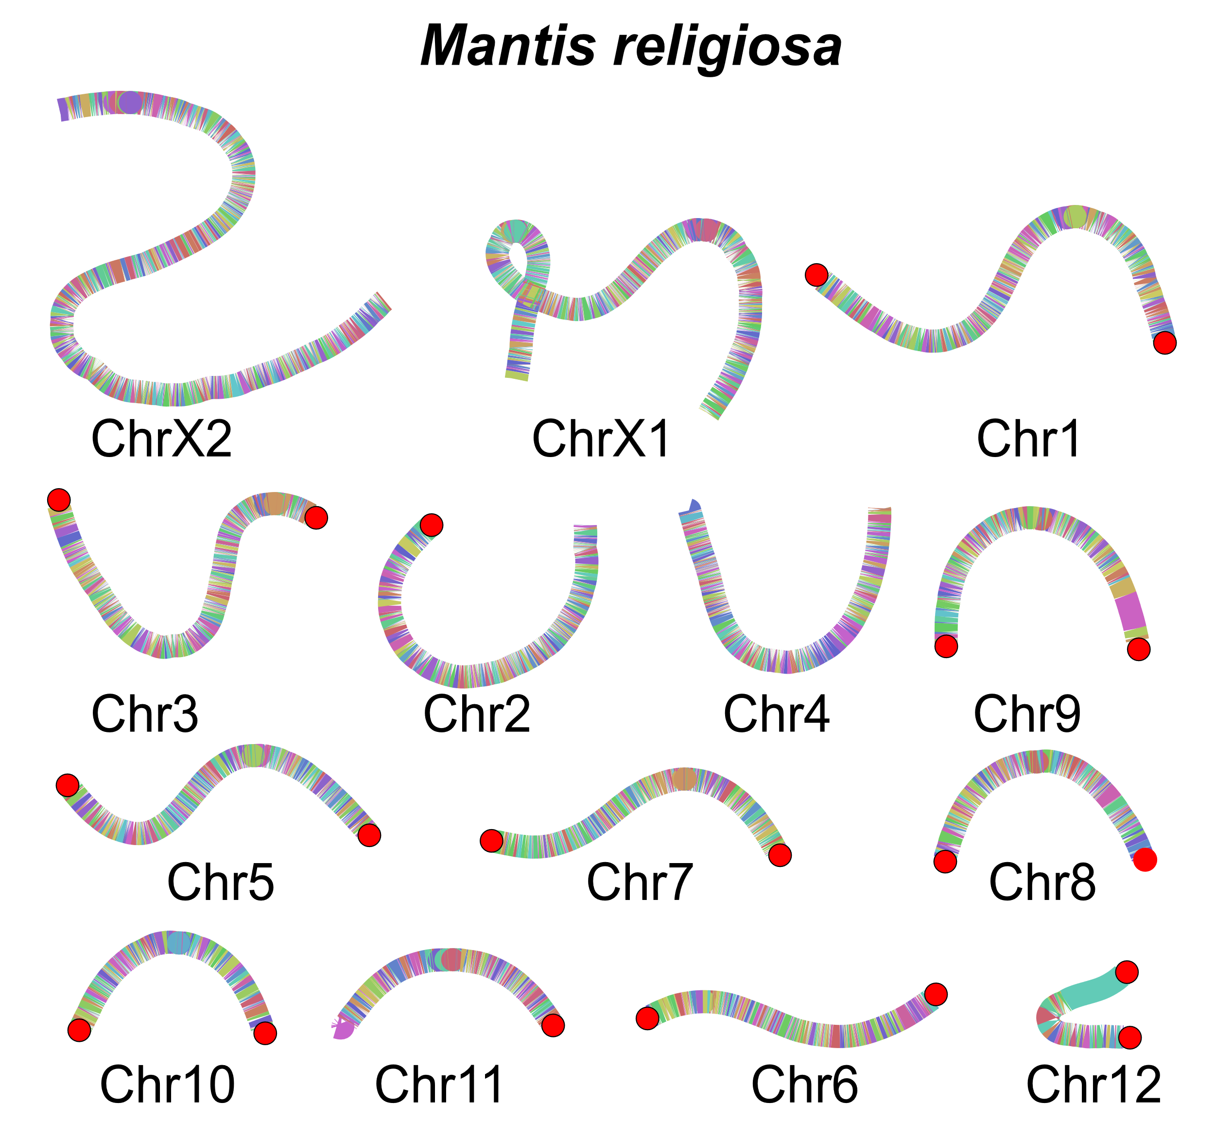
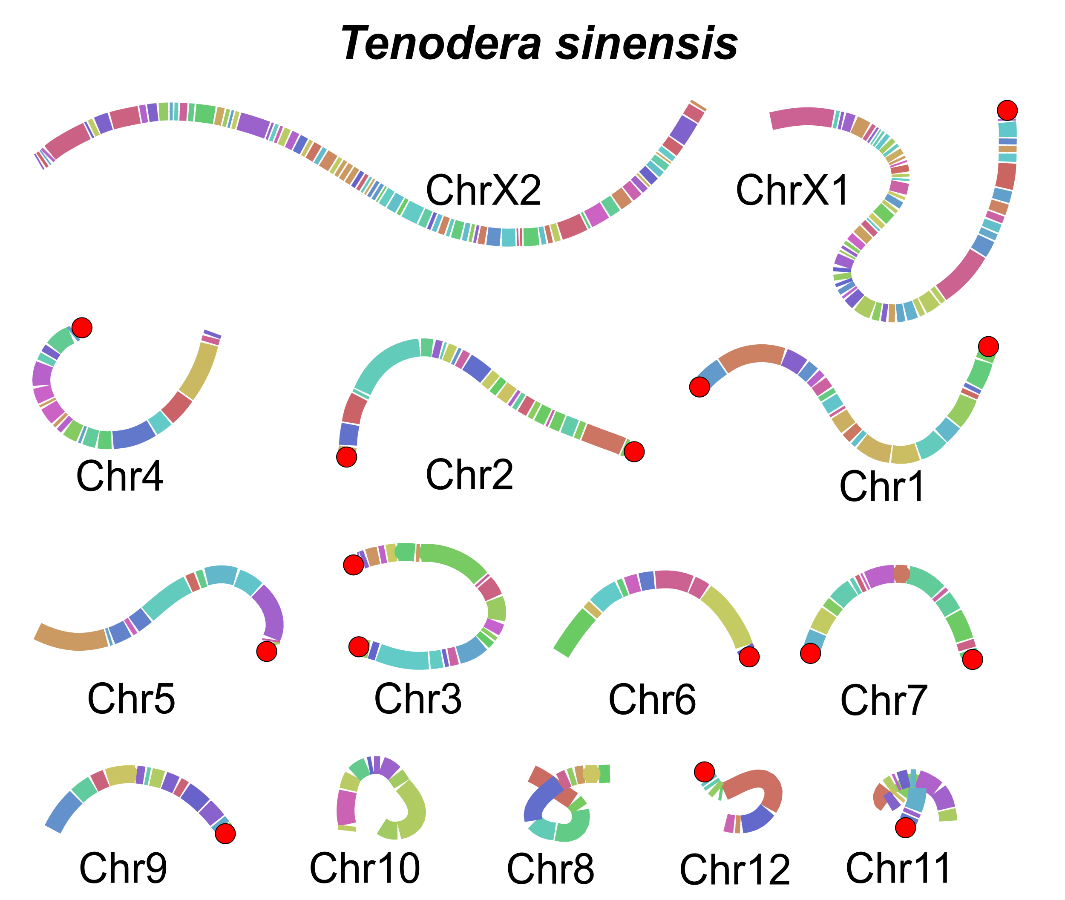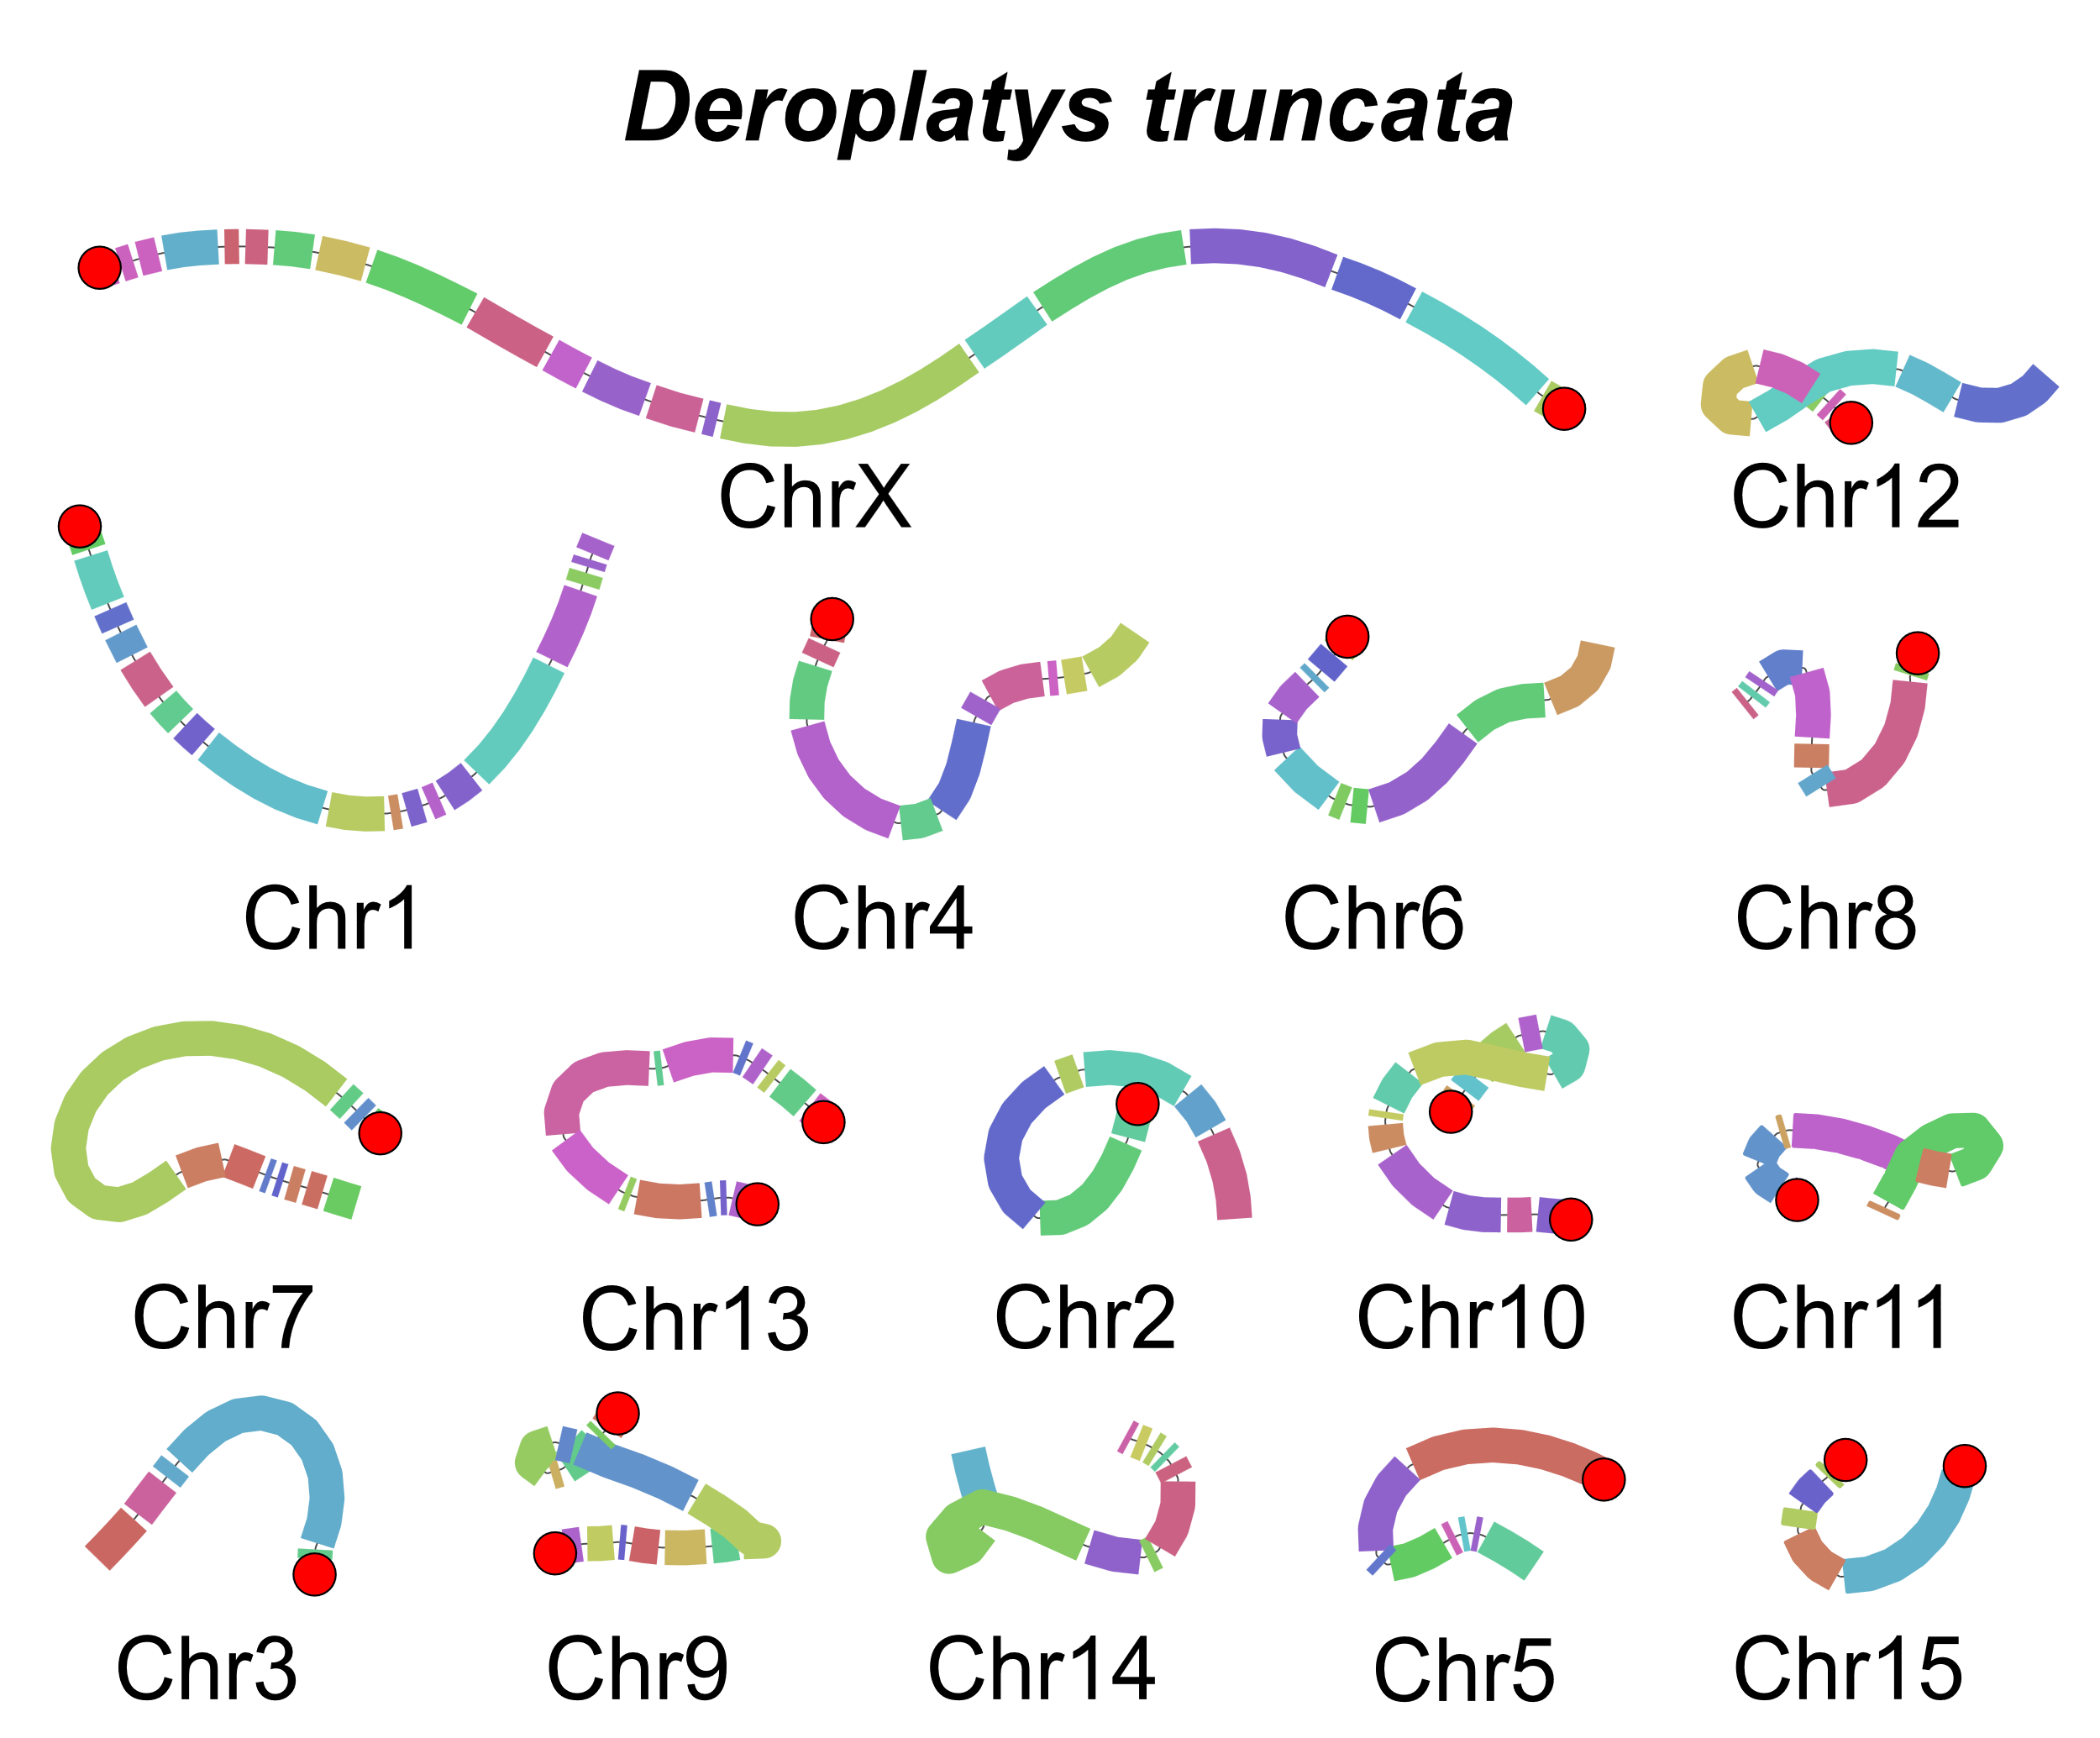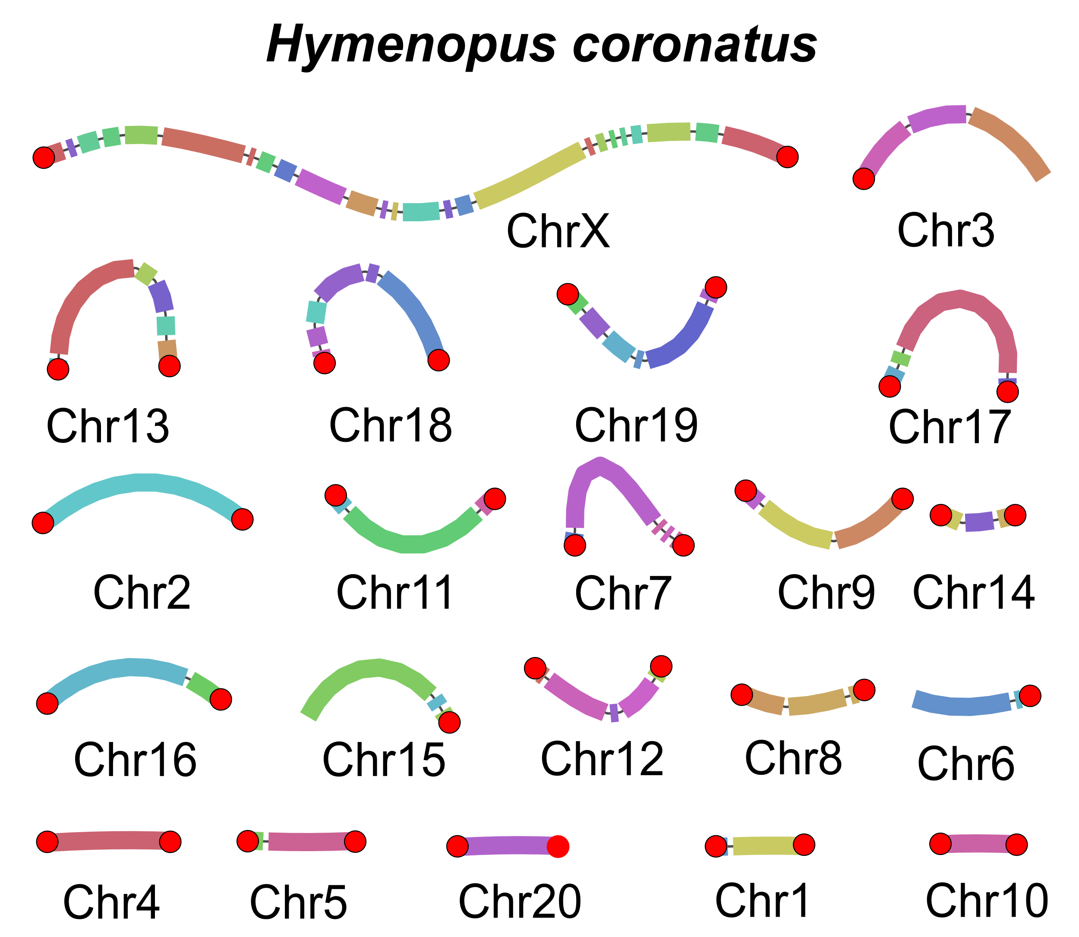
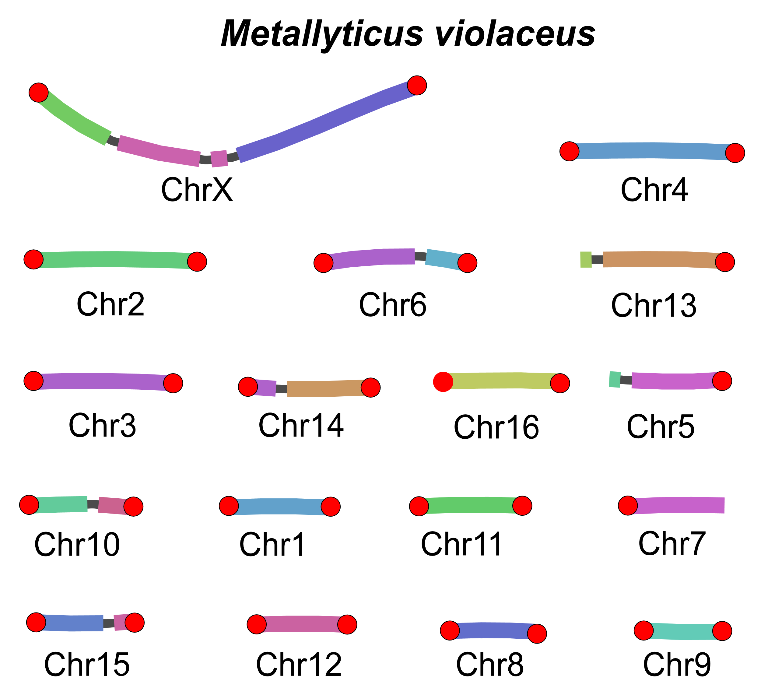 Figure S2. Bandage view of scaffolding results for M. religiosa, T. sinensis, D. truncata, H. coronatus, and M. violaceus. Each rectangle represents for a contig. The chromosome ends assembled with telomere-specific tandem repeats (unit: TTAGG) were highlighted with red circle.

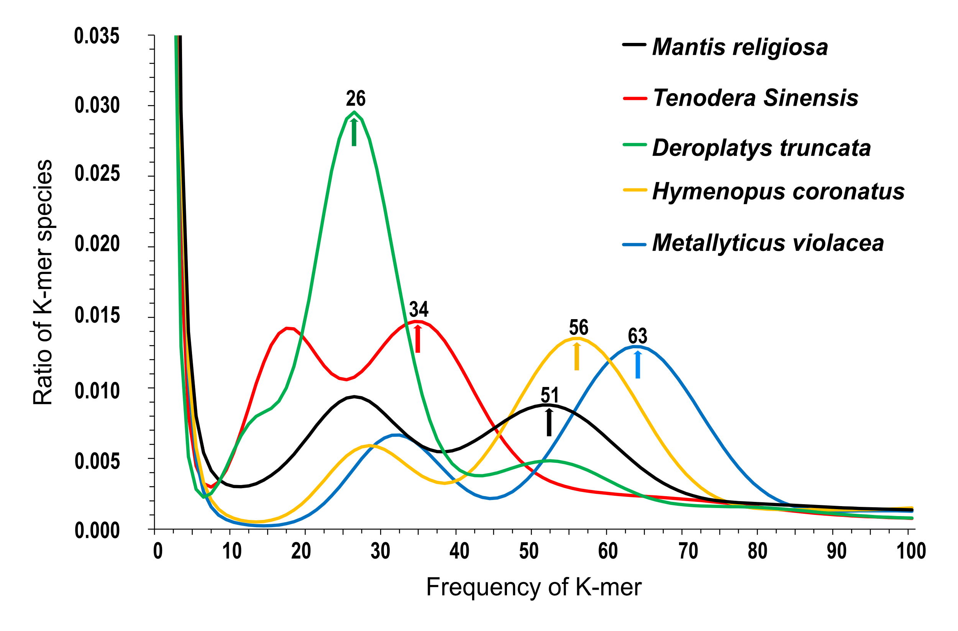
Figure S3. Distribution of K-mer (K-size 17) frequencies in sequencing data for M. religiosa, T. sinensis, D. truncata, H. coronatus, and M. violaceus. For each mantis, the left peak reflects the heterozygous regions, while the right peak reflects the homozygous regions, which were marked by arrow.

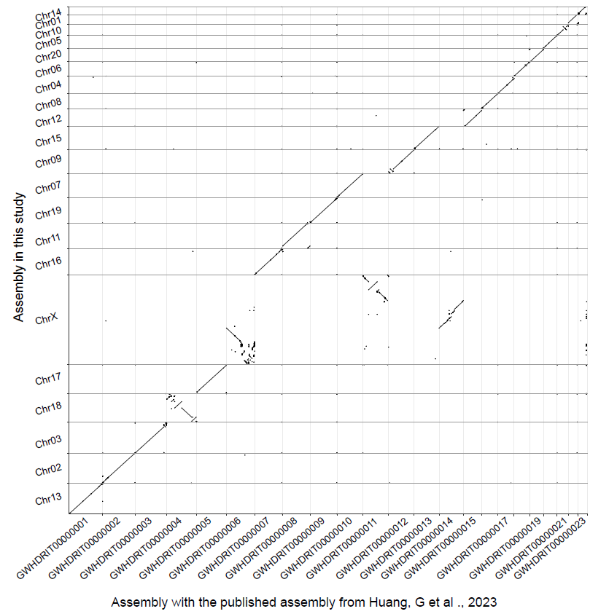
Fig. S4. Syntenic comparison of our H. coronatus assembly with the published assembly from Huang, G et al., 2023. The whole genome alignment is performed by minimap2 with “-x asm10” parameter.
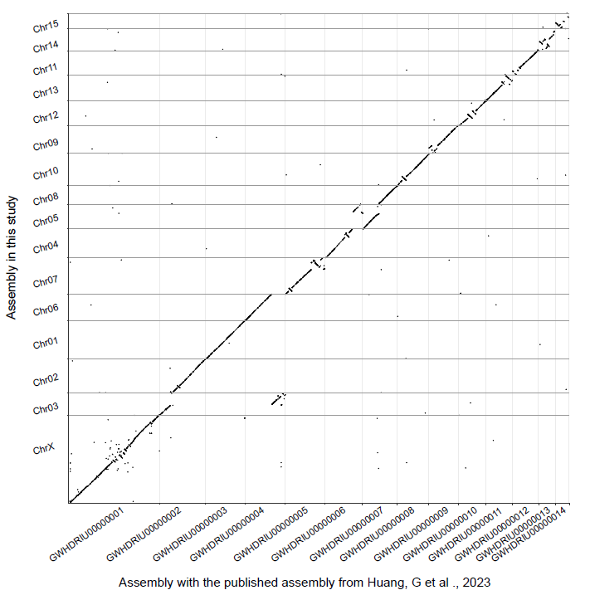
Fig. S5. Syntenic comparison of our D. truncata assembly with the published assembly of D. lobata from Huang, G et al., 2023. The whole genome alignment is performed by minimap2 with “-x asm10” parameter.
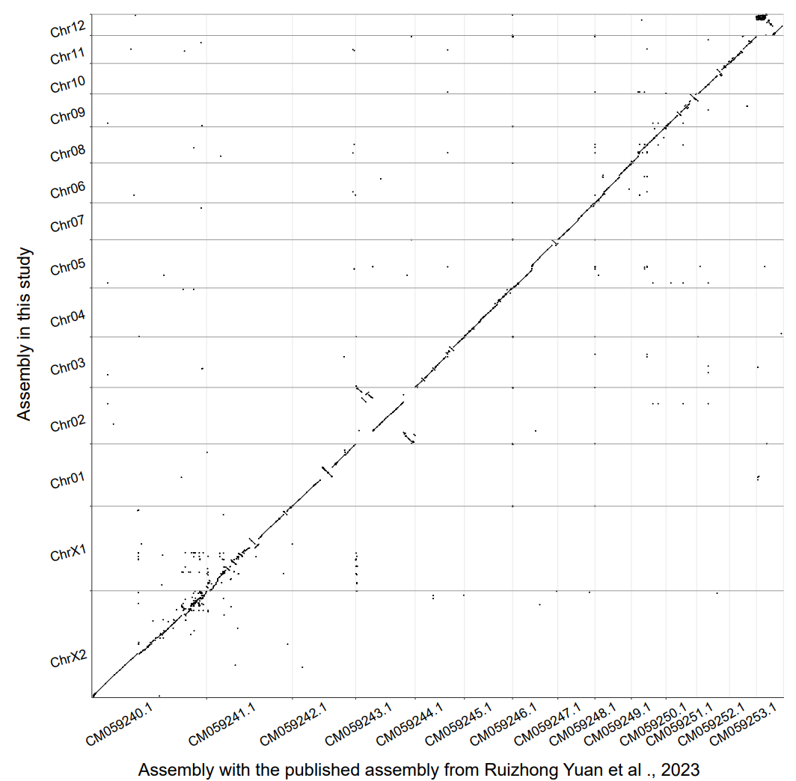
Fig. S6. Syntenic comparison of our T. sinensis assembly with the published assembly from Ruizhong Yuan et al., 2023. The whole genome alignment is performed by minimap2 with “-x asm10”parameter.

Figure S7. The relationship between genome size and TE size (ratio) of 5 Mantodea species.

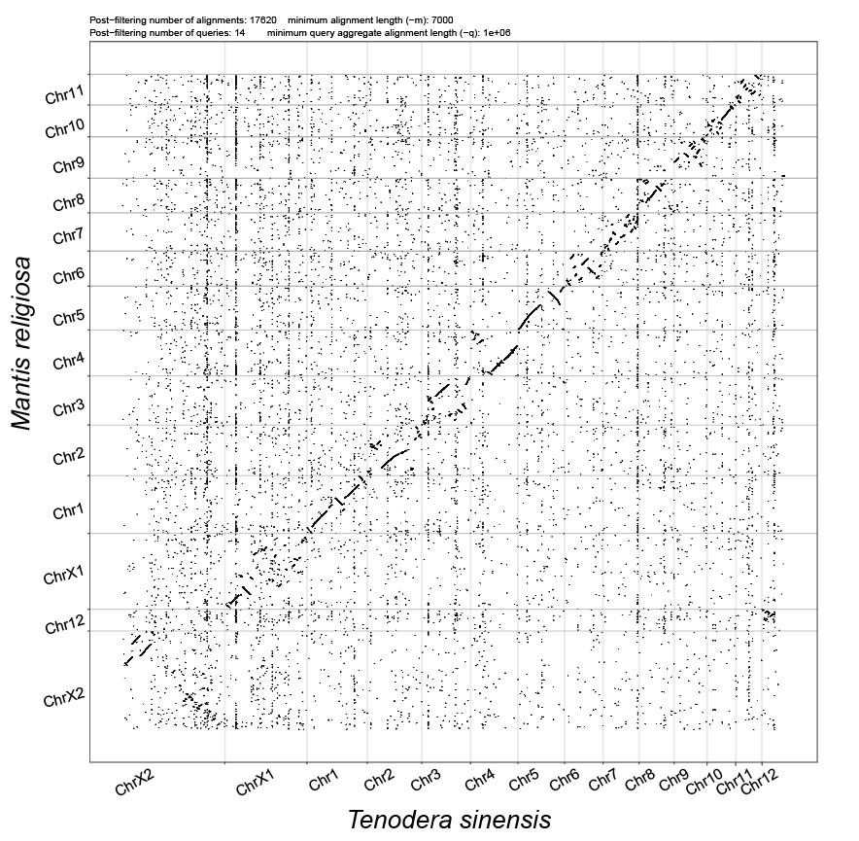
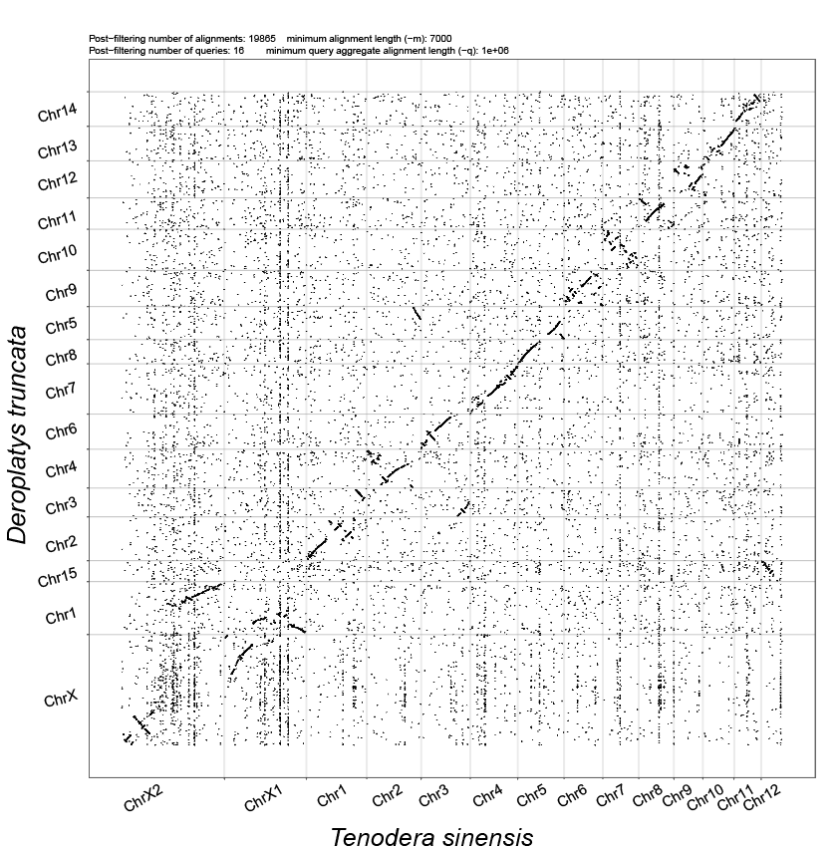
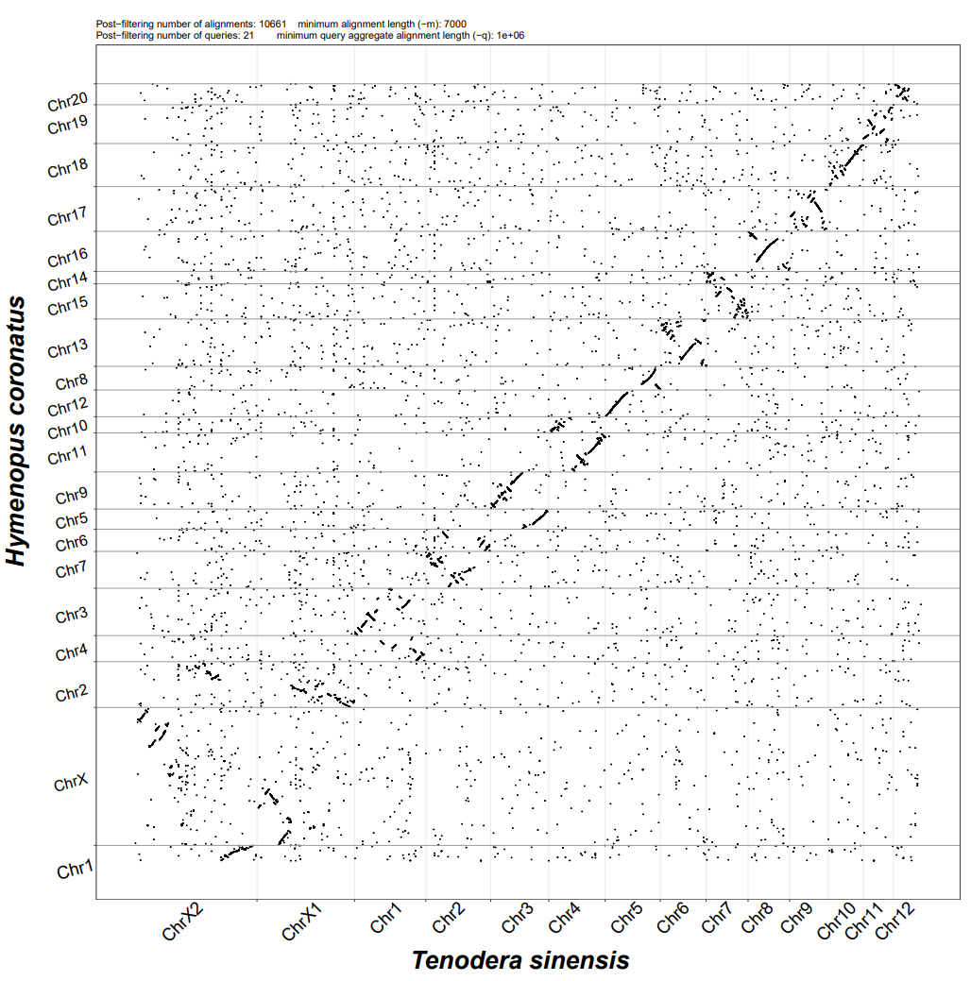
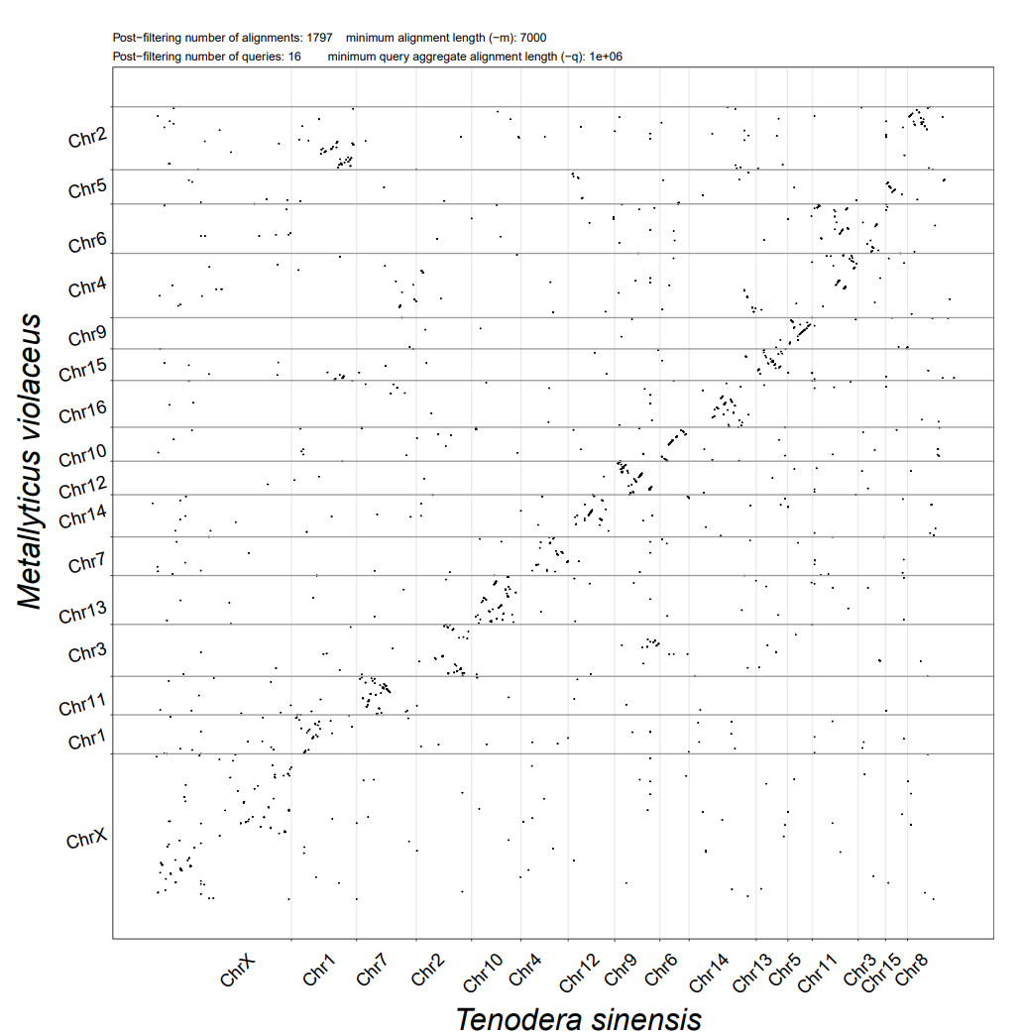 Fig. S8. Syntenic comparison of T. sinensis with the other 4 mantises. The whole genome alignment is performed by minimap2 with “-x asm10” parameter.

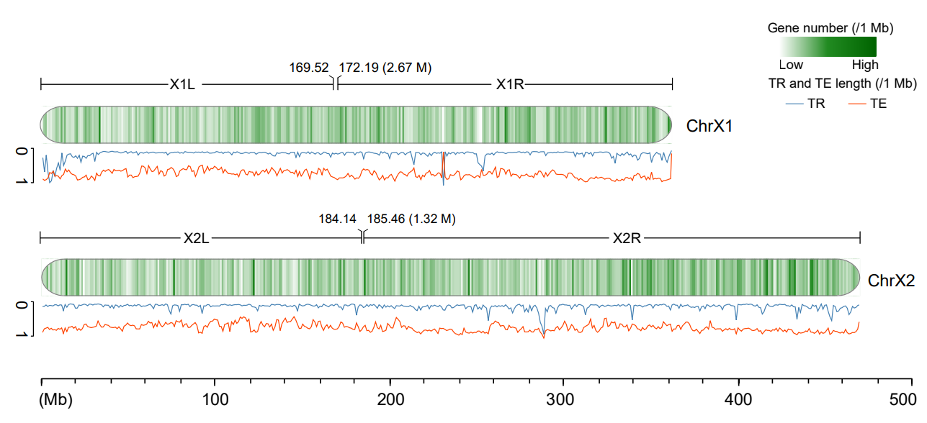

Figure S9. The interval range for the translocation site on the X1 and X2 chromosomes of M. religiosa. Distributions of TF (tandem repeat) and TE (transposable element) were shown.

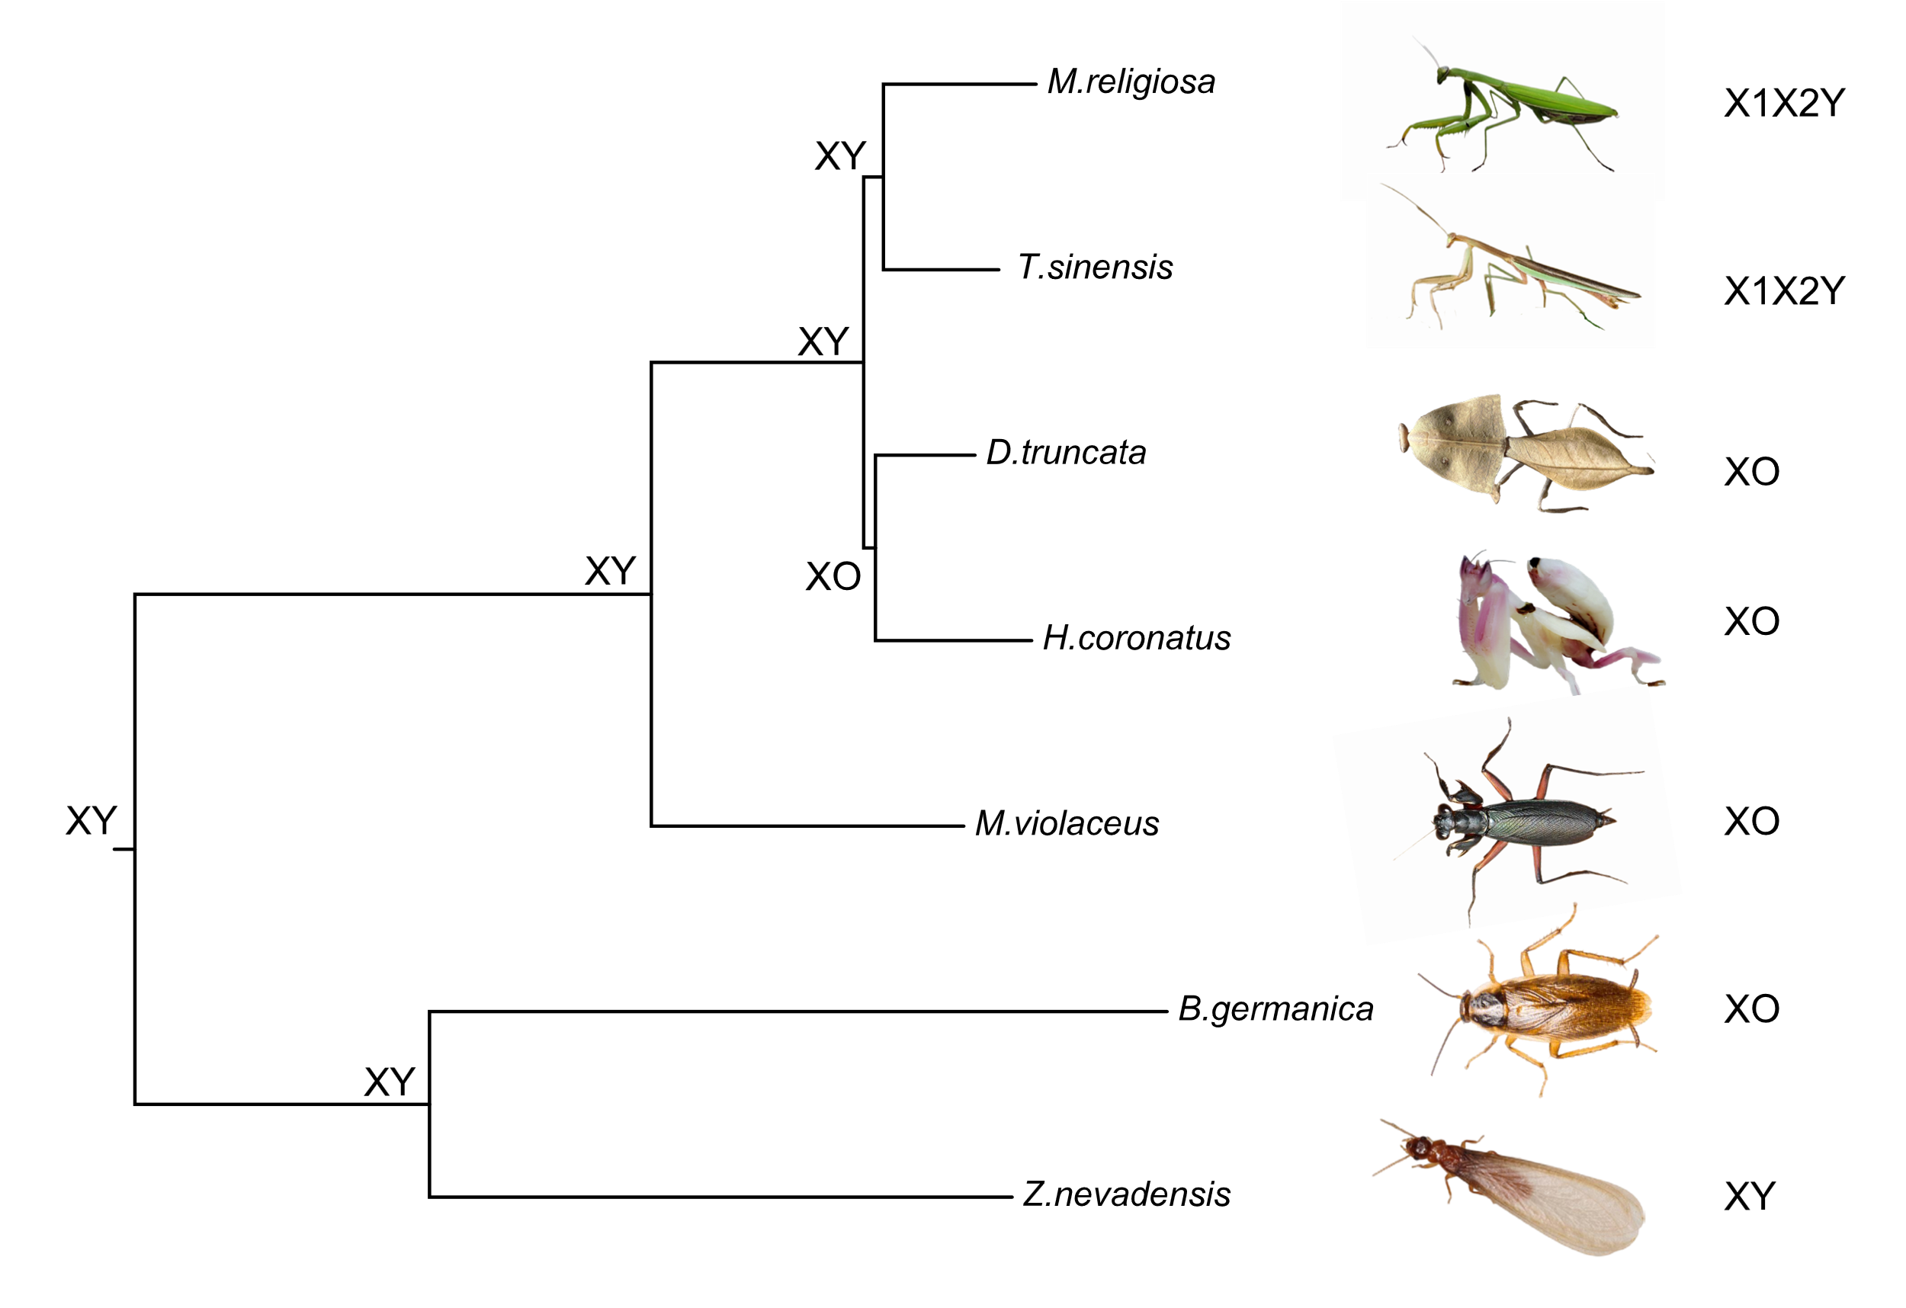
Figure S10. Sex determination system of Mantodea (mantises) and Blattodea (cockroaches and termites). The plot was draw refer to “evobir.shinyapps.io/PolyneopteraDB/”.

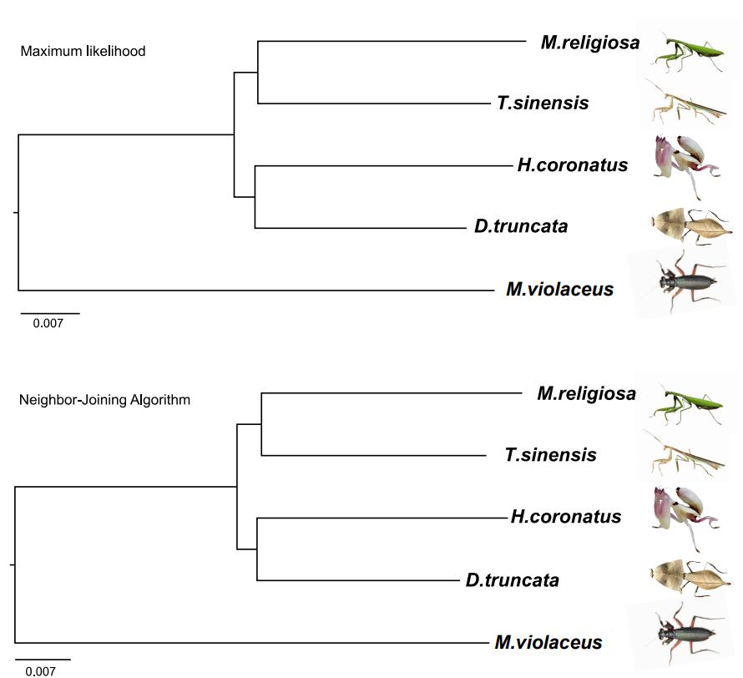
Figure S11. Phylogeny tree for 5 mantis species. The phylogenetic tree was built based on 6,988 single-copy orthologs, with both neighbor joining and maximum likelihood methods. The two phylogeny results are largely consistent.

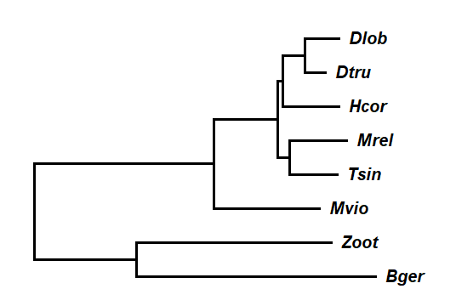
Figure S12. Phylogeny tree for 8 Dictyoptera species. The phylogenetic tree was built based on 2201 single-copy orthologs, with maximum likelihood methods. Dlob: D.lobata, Dtru: D. truncate, Hcor: H. coronatus, Mrel: M. religiosa,Tsin: T. sinensis, Mvio: M. violaceus ,Zoot: Z. nevadensis, Bger: B. germanica

Supplementary tables

Table S1. Background information of the sequenced mantis species.
Species name | Family / Sub-family | Chromosome number | source
Mantis religiosa | Mantidae / Mantinae | 2n = 28 | China: Guangzhou
Tenodera sinensis | Mantidae / Mantinae | 2n = 28 | China: Guangzhou
Deroplatys truncata | Mantidae / Deroplatyinae | 2n = 32 | Malaysia: Cameron
Hymenopus coronatus | Hymenopoidea / Hymenopodidae | 2n = 42 | China: Xishuangbanna
Metallyticus violaceus | Metallyticidae / Metallyticidae | 2n = 34 | Malaysia: Kuala Lumpur
Note: The chromosome number of D. truncata, H. coronatus, and M. violaceus were determined by genome assembly. No karyotype information was available for these 3 mantis species.

Table S2. Statistics of genome sequencing data.
 | Genomic Hifi (CCS) |  | Genomic HiC |  | Illumina RNAseq PE150
 | reads | bases | reads | bases | reads | bases
Mantis religiosa | 10,736,312 | 179,683,809,522 | 847,343,050 | 127,101,457,500 | 618,200,522 | 92,730,078,300
Tenodera sinensis | 4,901,197 | 97,511,748,151 | 749,492,290 | 112,423,843,500 | 487,921,752 | 73,188,262,800
Deroplatys truncata | 7,744,738 | 112,906,676,547 | 1,023,722,878 | 153,558,431,700 | 624,484,224 | 93,672,633,600
Hymenopus coronatus | 10,167,730 | 177,528,078,708 | 1,214,765,322 | 182,214,798,300 | 630,950,136 | 94,642,520,400
Metallyticus violaceus | 9,250,962 | 147,014,941,985 | 1,225,352,740 | 183,802,911,000 | - | -

Table S3. Statistics of Hi-C data mapping to contigs.
HiC pro results | Mantis religiosa |  | Tenodera sinensis |  | Deroplatys truncata |  | Hymenopus coronatus |  | Metallyticus violaceus
HiC pro results | Reads number | Reads % | Reads number | Reads % | Reads number | Reads % | Reads number | Reads % | Reads number | Reads %
Total pairs processed | 423,671,525 | 100.0% | 374,746,145 | 100.0% | 511,861,439 | 100.0% | 607,382,661 | 100.0% | 612,676,370 | 100.0%
Unmapped pairs | 20,914,316 | 4.9% | 31,898,335 | 8.5% | 5,258,539 | 1.0% | 8,315,587 | 1.4% | 26,580,086 | 4.3%
Low qual pairs | 157,153,623 | 37.1% | 148,457,384 | 39.6% | 201,124,421 | 39.3% | 213,630,868 | 35.2% | 141,182,216 | 23.0%
Pairs with singleton | 80,162,675 | 18.9% | 123,773,101 | 33.0% | 44,326,963 | 8.7% | 73,893,690 | 12.2% | 85,201,198 | 13.9%
Unique paired alignments | 165,440,911 | 39.0% | 70,617,325 | 18.8% | 261,151,516 | 51.0% | 311,542,516 | 51.3% | 359,712,870 | 58.7%
Valid interaction pairs | 85,602,445 | 20.2% | 56,106,670 | 15.0% | 228,045,907 | 44.6% | 273,688,263 | 45.1% | 129,362,070 | 21.1%
Dangling end pairs | 73,543,590 | 17.4% | 9,246,952 | 2.5% | 28,174,610 | 5.5% | 27,962,589 | 4.6% | 205,423,801 | 33.5%
Religation pairs | 3,169,697 | 0.7% | 860,676 | 0.2% | 1,493,478 | 0.3% | 4,059,892 | 0.7% | 16,514,464 | 2.7%
Self Cycle pairs | 141,033 | 0.0% | 60,031 | 0.0% | 418,528 | 0.1% | 455,795 | 0.1% | 3,822,912 | 0.6%
Filtered pairs | 2,978,737 | 0.7% | 4,328,894 | 1.2% | 3,016,583 | 0.6% | 5,365,973 | 0.9% | 4,562,422 | 0.7%
Dumped pairs | 5,409 | 0.0% | 14,102 | 0.0% | 2,410 | 0.0% | 10,004 | 0.0% | 27,201 | 0.0%
valid interaction | 85,602,445 | 20.2% | 56,106,670 | 15.0% | 228,045,907 | 44.6% | 273,688,263 | 45.1% | 129,362,070 | 21.1%
valid interaction rmdup | 71,796,880 | 16.9% | 43,658,431 | 11.7% | 181,375,815 | 35.4% | 202,919,881 | 33.4% | 34,648,667 | 5.7%
Note: The statistics numbers were obtained from Hi-C pro result files: *.mpairstat, *.mRSstat, and * allValidPairs.mergestat. The “valid interaction rmdup” represents non-redundant and valid Hi-C read pairs, which were used by EndHiC for scaffolding.

Table S4. Statistics of genome assembly.
Species | Total contig size （bp) | Contig N50 size （bp) | Contig N90 size （bp) | Total scaffold size （bp) | Scaffold N50 size （bp) | Scaffold N90 size （bp) | % anchored to chromosomes | BUSCO results with insecta odb10
Mantis religiosa | 3,675,712,721 | 1,407,320 | 339,785 | 3,680,002,721 | 210,326,877 | 3,517,080 | 85.39% | C:98.7% [S:94.1%, D:4.6%]
Tenodera sinensis | 2,687,116,722 | 13,794,865 | 2,923,070 | 2,687,426,722 | 190,002,057 | 104,358,734 | 95.63% | C:99.3% [S:95.6%, D:3.7%]
Deroplatys truncata | 4,290,634,545 | 44,541,363 | 9,432,610 | 4,290,792,545 | 248,405,437 | 184,535,799 | 97.47% | C:98.6% [S:96.6%, D:2.0%]
Hymenopus coronatus | 3,127,524,514 | 71,519,735 | 15,255,482 | 3,127,590,514 | 159,059,693 | 82,661,183 | 98.27% | C:99.0% [S:97.7%, D:1.3%]
Metallyticus violaceus | 2,322,120,794 | 109,157,195 | 61,664,404 | 2,322,129,794 | 125,733,329 | 88,780,966 | 98.51% | C:98.9% [S:97.4%, D:1.5%]
Note: % anchored to chromosomes represents for percent of contig sequences assembled into chromosome-level scaffolds. In the BUSCO results, C means complete gene, S means single copy gene, while D means duplicated gene. S and D are both complete genes.

Table S5. Statistics of tandem repeats annotation.
Species | Total scaffold size (bp) | Total TR size (bp) | TR rate % | TR N50 size (bp)
M. religiosa | 3,680,002,721 | 396,842,330 | 10.8% | 3,188
T. sinensis | 2,687,426,722 | 403,304,947 | 15.0% | 30,747
D. truncata | 4,290,792,545 | 471,243,565 | 11.0% | 35,332
H. coronatus | 3,127,590,514 | 238,530,960 | 7.6% | 6,018
M. violaceus | 2,322,129,794 | 186,949,249 | 8.1% | 2,372,101
Note: TR represents for “tandem repeat”.

Table S6. Statistics of TE content in various classes.
TE class | Mantis religiosa |  | Tenodera sinensis |  | Deroplatys truncata |  | Hymenopus coronatus |  | Metallyticus violaceus
TE class | Length (bp) | Percent | Length (bp) | Percent | Length (bp) | Percent | Length (bp) | Percent | Length (bp) | Percent
SINEs | 88,675,710 | 2.41% | 41,364,524 | 1.51% | 34,634,604 | 0.81% | 79,926,835 | 2.56% | 68,180,146 | 2.94%
Penelope | 179,087,096 | 4.87% | 46,171,123 | 1.69% | 40,398,887 | 0.94% | 56,917,120 | 1.82% | 65,477,245 | 2.82%
LINEs | 579,512,280 | 15.77% | 321,787,695 | 11.75% | 369,853,954 | 8.62% | 299,105,729 | 9.56% | 226,842,133 | 9.77%
LTR elements | 191,759,399 | 5.22% | 92,024,175 | 3.36% | 106,555,013 | 2.48% | 64,704,975 | 2.07% | 22,924,553 | 0.99%
DNA transposons | 775,059,780 | 21.09% | 521,921,270 | 19.06% | 1,039,790,255 | 24.23% | 1,023,083,723 | 32.71% | 516,358,740 | 22.24%
hobo-Activator | 80,830,494 | 2.20% | 120,355,965 | 4.39% | 72,581,984 | 1.69% | 53,762,543 | 1.72% | 62,477,753 | 2.69%
Tc1-IS630-Pogo | 487,487,116 | 13.26% | 307,146,368 | 11.22% | 743,125,454 | 17.32% | 904,769,393 | 28.93% | 391,997,649 | 16.88%
PiggyBac | 25,568,568 | 0.70% | 14,271,115 | 0.52% | 13,683,942 | 0.32% | 6,242,598 | 0.20% | 9,228,673 | 0.40%
Tourist/Harbinger | 3,509,956 | 0.10% | 6,656,014 | 0.24% | 10,579,236 | 0.25% | 4,453,869 | 0.14% | 2,199,720 | 0.09%
Other (Mirage, P-element, Transib) | 46,791,717 | 1.27% | 5,008,403 | 0.18% | 6,326,642 | 0.15% | 3,570,992 | 0.11% | 993,579 | 0.04%
Rolling-circles | 29,521,374 | 0.80% | 105,886,680 | 3.87% | 324,281,627 | 7.56% | 139,155,718 | 4.45% | 5,674,177 | 0.24%
Total interspersed repeats | 2,458,966,257 | 66.90% | 1,591,021,662 | 58.09% | 2,589,727,245 | 60.36% | 1,981,438,372 | 63.35% | 1,343,923,274 | 57.87%

Table S7. Statistics of RNAseq mapping and assembly.
Species | Samples | Total RNAseq reads number | HiSAT2 mapping rate % | StringTie mRNA number | StringTie exon number
Mantis religiosa | Sample_1 | 88,785,004 | 91.45% | 242,954 | 614,681
Mantis religiosa | Sample_2 | 86,154,304 | 91.46% | 242,954 | 614,681
Mantis religiosa | Sample_3 | 82,340,876 | 92.14% | 242,954 | 614,681
Mantis religiosa | Sample_4 | 87,545,542 | 92.31% | 242,954 | 614,681
Mantis religiosa | Sample_5 | 64,013,662 | 88.66% | 242,954 | 614,681
Mantis religiosa | Sample_6 | 79,818,902 | 88.58% | 242,954 | 614,681
Mantis religiosa | Sample_7 | 119,602,504 | 89.11% | 242,954 | 614,681
Tenodera sinensis | Sample_1 | 67,885,312 | 94.91% | 24,901 | 180,176
Tenodera sinensis | Sample_2 | 74,463,660 | 94.68% | 24,901 | 180,176
Tenodera sinensis | Sample_3 | 69,051,400 | 94.34% | 24,901 | 180,176
Tenodera sinensis | Sample_4 | 73,588,644 | 93.78% | 24,901 | 180,176
Tenodera sinensis | Sample_5 | 70,815,820 | 94.53% | 24,901 | 180,176
Tenodera sinensis | Sample_6 | 65,008,126 | 93.26% | 24,901 | 180,176
Tenodera sinensis | Sample_7 | 67,108,790 | 93.57% | 24,901 | 180,176
Deroplatys truncata | Sample_1 | 96,379,192 | 97.48% | 22,917 | 562,724
Deroplatys truncata | Sample_2 | 76,125,082 | 97.21% | 22,917 | 562,724
Deroplatys truncata | Sample_3 | 108,158,576 | 96.86% | 22,917 | 562,724
Deroplatys truncata | Sample_4 | 86,689,652 | 97.34% | 22,917 | 562,724
Deroplatys truncata | Sample_5 | 83,429,828 | 97.33% | 22,917 | 562,724
Deroplatys truncata | Sample_6 | 80,351,926 | 97.16% | 22,917 | 562,724
Deroplatys truncata | Sample_7 | 93,349,968 | 97.03% | 22,917 | 562,724
Hymenopus coronatus | Sample_1 | 121,597,780 | 96.88% | 115,759 | 400,507
Hymenopus coronatus | Sample_2 | 81,361,518 | 96.95% | 115,759 | 400,507
Hymenopus coronatus | Sample_3 | 99,558,770 | 97.35% | 115,759 | 400,507
Hymenopus coronatus | Sample_4 | 79,018,200 | 96.95% | 115,759 | 400,507
Hymenopus coronatus | Sample_5 | 85,621,424 | 97.14% | 115,759 | 400,507
Hymenopus coronatus | Sample_6 | 78,941,540 | 96.95% | 115,759 | 400,507
Hymenopus coronatus | Sample_7 | 84,850,904 | 97.04% | 115,759 | 400,507
Note: The StringTie mRNA coordinates were converted into hints gff format, and used as the hints data in augustus gene prediction.

Table S8. Public genome data information.
Species Name | Ploidy | Sequencing technology | Genome Size (bp) | Contig N50 size | Assemly level / Scaffold N50 size | Data Address | Data version
Zootermopsis nevadensis | 2n = 52 | Illumina HiSeq | 485,009,472 | 22.8 Kb | Scaffold level, 751.1 Kb | NCBI | ZooNev1.0
Blattella germanica | 2n = 24 | Illumina | 2,037297555 | 12.1 Kb | Scaffold level, 1.1 Mb | NCBI | Bger_1.1
Deroplatys lobata | 2n = 28 | nanopore 59.86 | 3,962,954,272 | 6.11 Mb | chromosome level, 285.05 Mb | CNCB | Dlob_genome_v1.0

