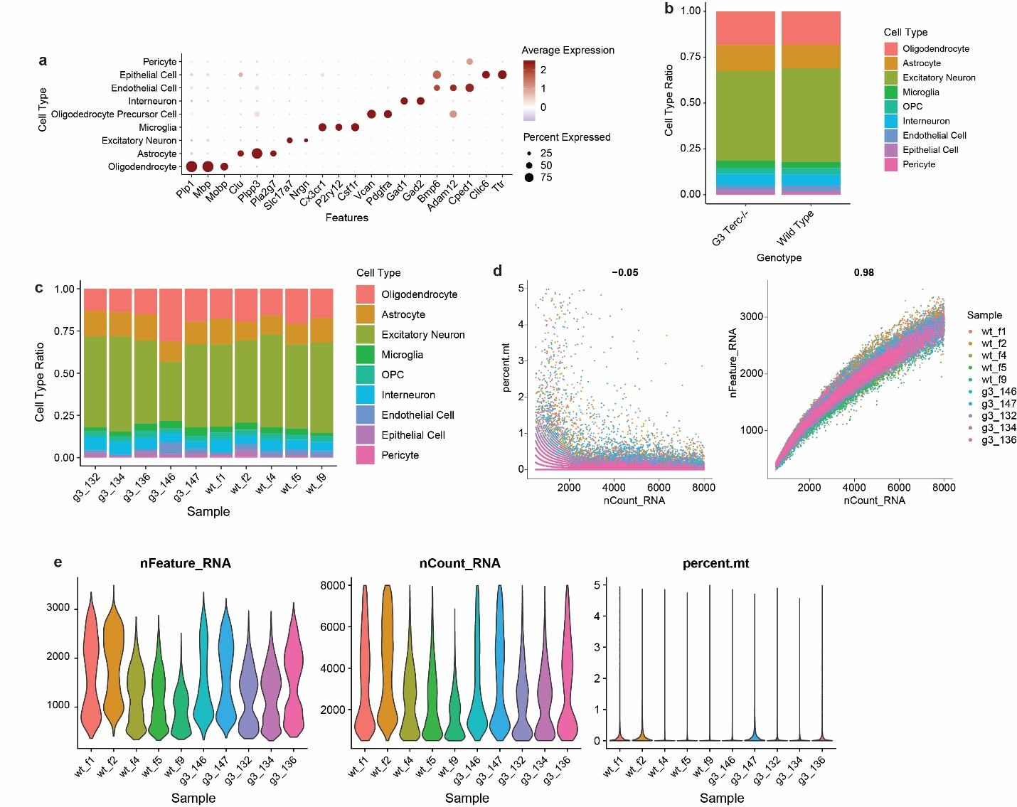
Supp Fig. 1 | Quality control assessment of single-nuclei RNA-Seq in the G3 Terc^{-/-} cohort. a. Dot plot showing expression levels of canonical cell markers in each identified cell types. b. Proportion of each cell type within WT and G3 Terc^{-/-} genotypes. c. Proportion of each cell type within individual samples. d. Correlation between UMI counts and percentage of mitochondrial genes (left) or total gene counts (right) per nuclei for each individual sample. e. Violin plots showing the number of unique features (left); the number of total RNA count (middle), and the percentage of mitochondrial genes (right) detected in the each sample.
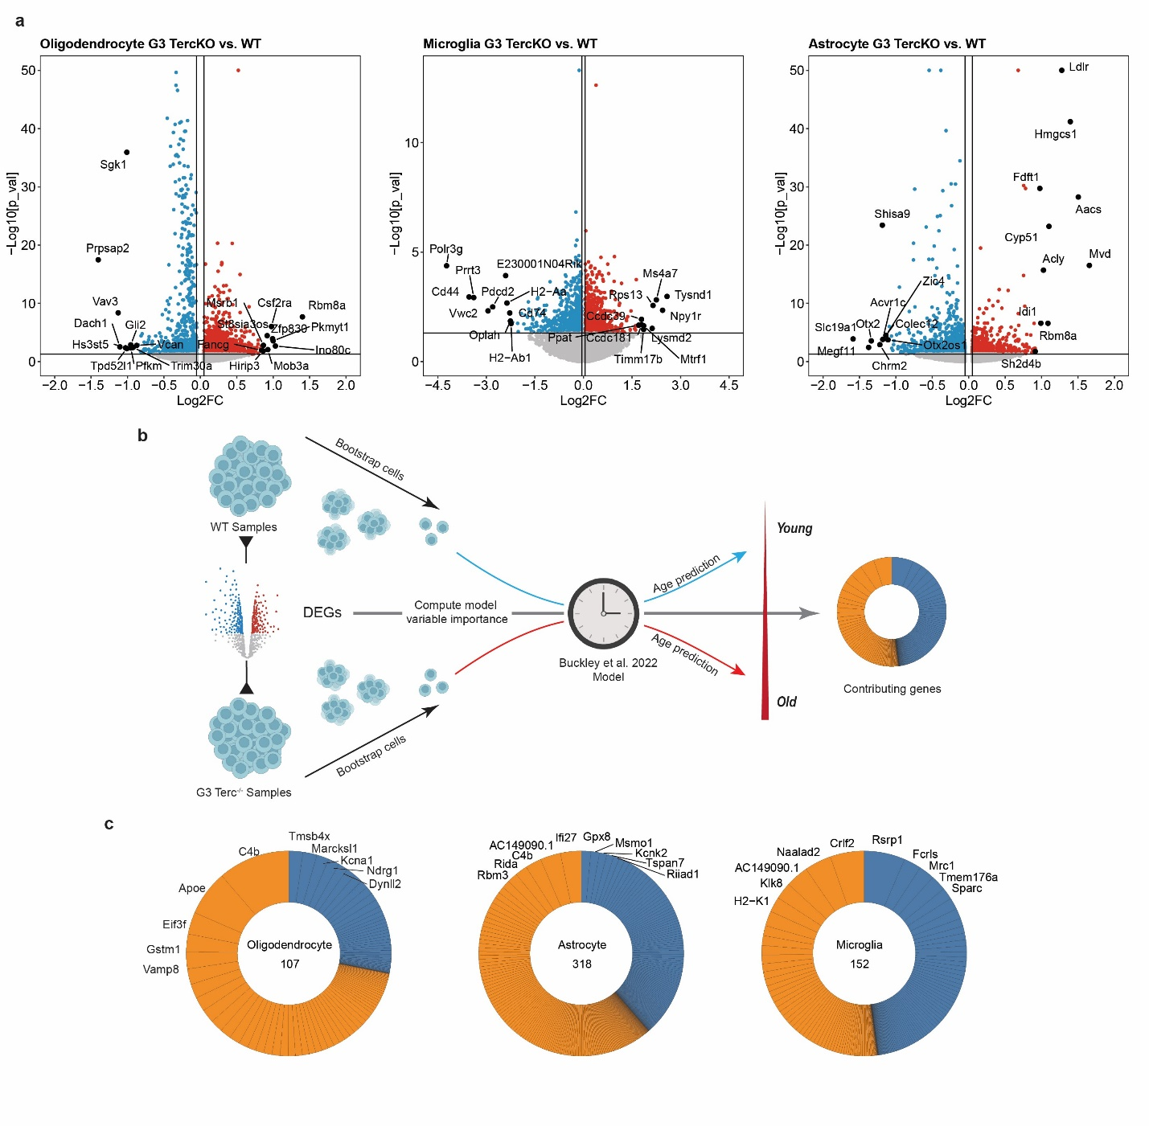
Supp Fig. 2 | Transcriptome-based age prediction of astrocyte, oligodendrocyte, and microglia. a. Volcano plot of significant DEGs in oligodendrocytes, microglia, and astrocytes. Red and blue dots represent genes with a log2FC > 0.05 or < -0.05, respectively. Top differential genes are labeled. b. Schematic showing the application of aging-predicting model on G3 Terc-/- snRNA data. c. Donut plots showing the weight of genes contributing to the prediction of chronological age in oligodendrocytes, astrocytes, and microglia. The orange segments represent positive correlation to predicted age, and the blue segments represent negative correlation.

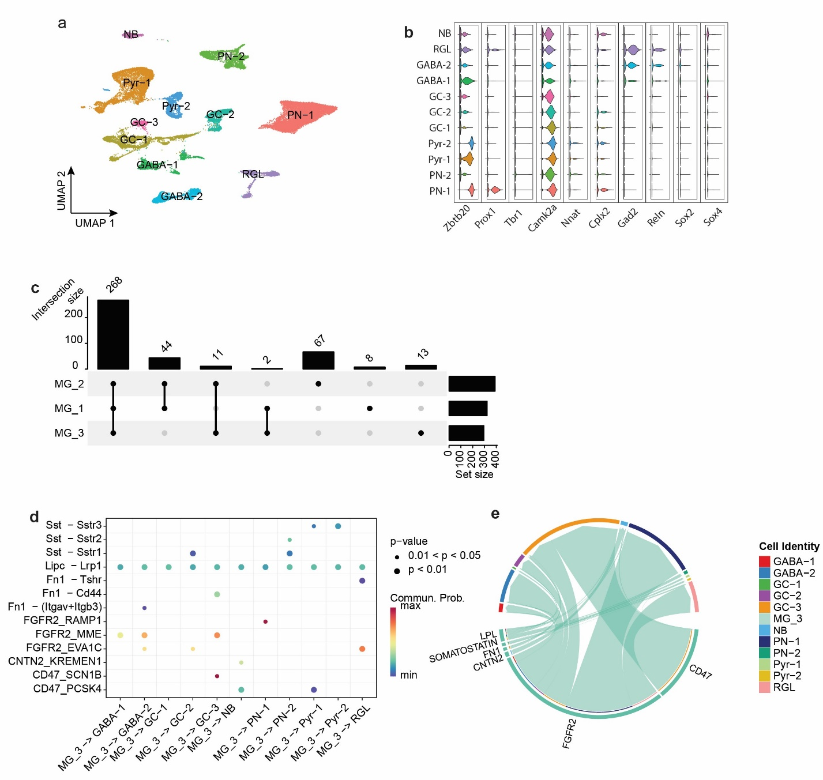
Supp Fig. 3 | Telomere shortening disrupts microglia-neuron intercellular communication. a. UMAP plots showing 11 neuronal subtypes identified in the mouse hippocampus. (GABA: GABAergic neurons; GC: granule cells; NB: neuroblast; PN: projection neuron; Pyr: pyramidal neuron; RGL: radial glial-like cell) b. Violin plots showing the expression levels of the key markers for the neuronal subtypes. c. Upset plot depicting the relationships of the microglia-subcluster-specific microglia-neuron interactions predicted by CellChat. d. Bubble plot showing the interactions between senescent microglia subpopulation (MG3) and various neuronal subtypes. e. Chord diagram showing MG_3-specific signaling pathway predicted by CellChat. The lengths of the segmented outer circle reflect the expression level of ligand proteins in the MG-3 (bottom) and of receptor proteins in the targeted cells (top), showing strong expressions of FGFR2 expression in MG-3 targeting projection neurons and granule cells (GABA: GABAergic neurons; GC: granule cells; NB: neuroblast; PN: projection neuron; Pyr: pyramidal neuron; RGL: radial glial-like cell).

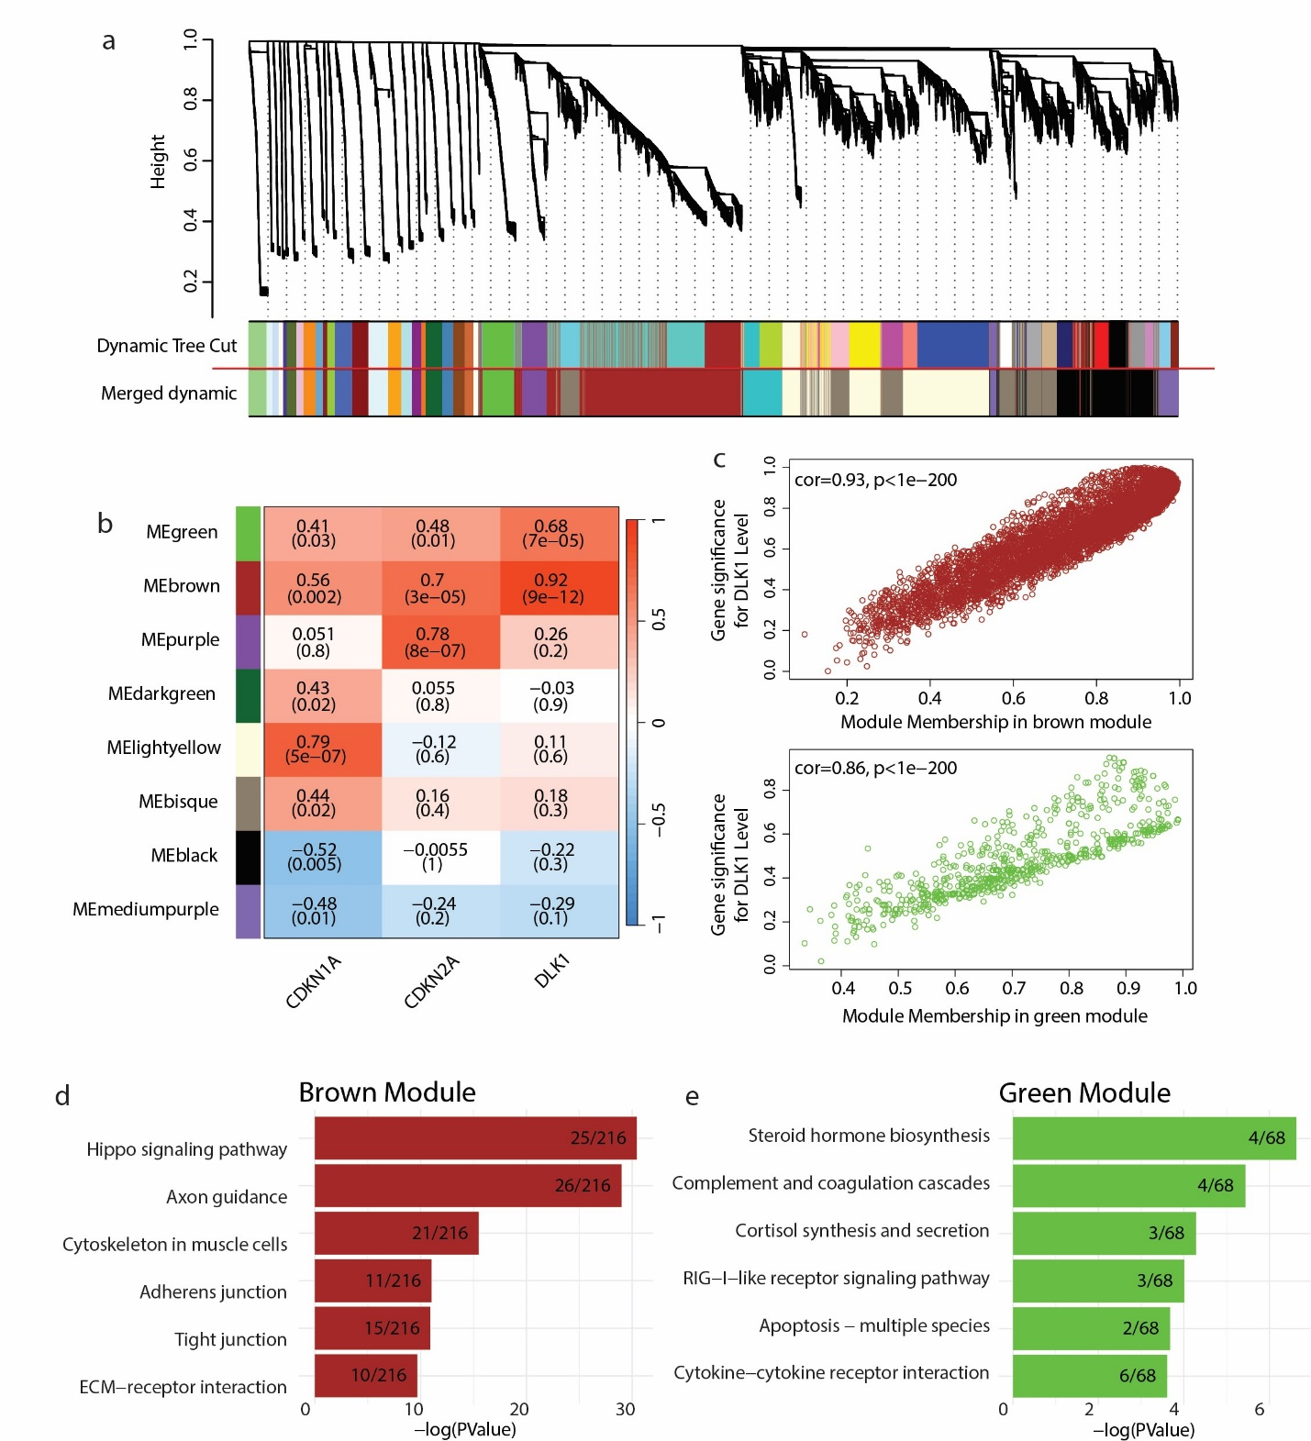
Supp Fig. 4 | Gene networks associated with microglial senescence and DLK1 upregulation. a. Gene dendrogram showing all the gene modules identified in the iPSC-derived microglia transcriptome data. Merged dynamic was generated using a height threshold of 0.5. b. Heatmap showing the WGCNA modules significantly (p <= 0.05) correlated with p21, p16, or DLK1. c. Scatterplot of gene significance for DLK1 expression level versus module membership in the brown module (top) and the green module (bottom). e. Top six KEGG (Kyoto Encyclopedia of Genes and Genomes) pathways predicted from the top 500 genes (ranked by module membership) in the brown (d) and green module (e).

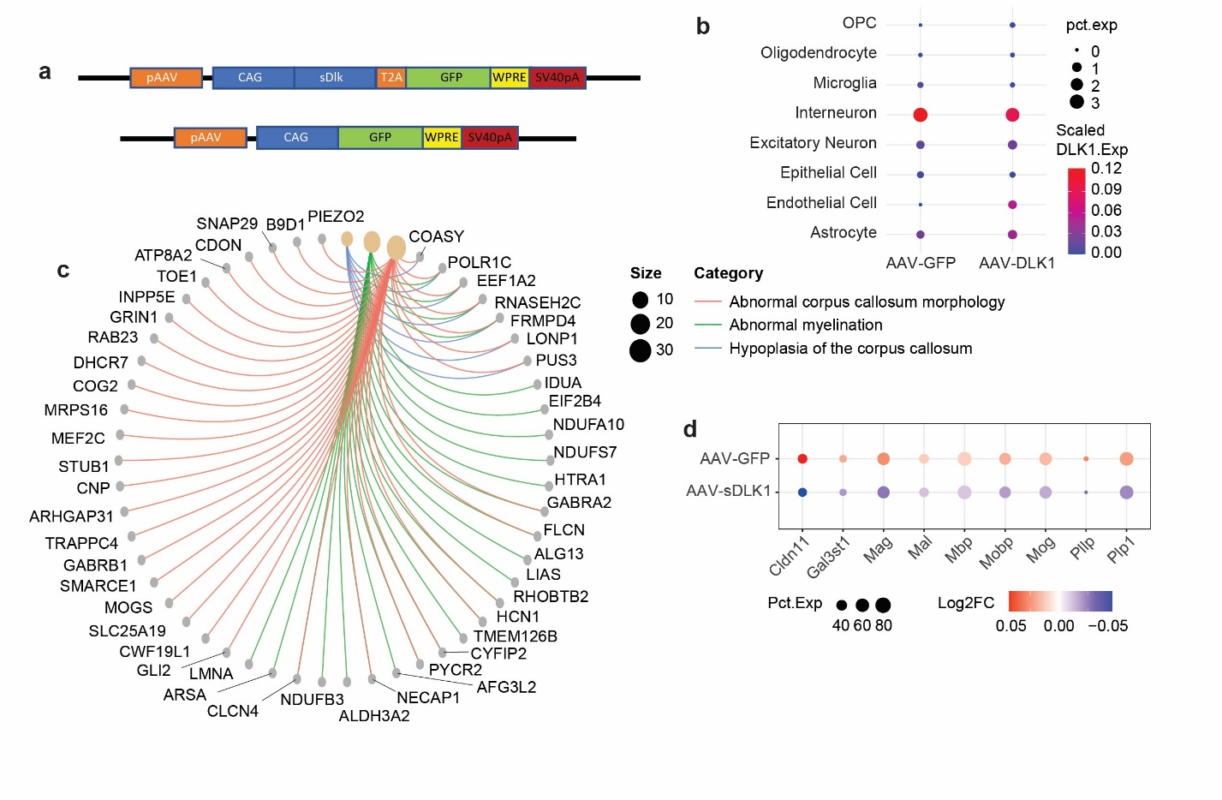Supp Fig. 5| Elevated sDLK1 expression disrupts transcriptions of myelination genes. a. sDLK-AVV (top) and GFP-AAV control (bottom) vectors. b. Dot plot showing the expression level of DLK1 in difference cell types in the hippocampus tissue. The size of each dot represents the percentage of cells with detected DLK1 mRNA. c. Cnet plot showing the genes linked to myelination pathways and myelin-related diseases among the top 500 differentially expressed genes in oligodendrocytes. d. Dot plot showing the change of expression levels of myelination proteins in oligodendrocytes caused by the increase of sDLK1.
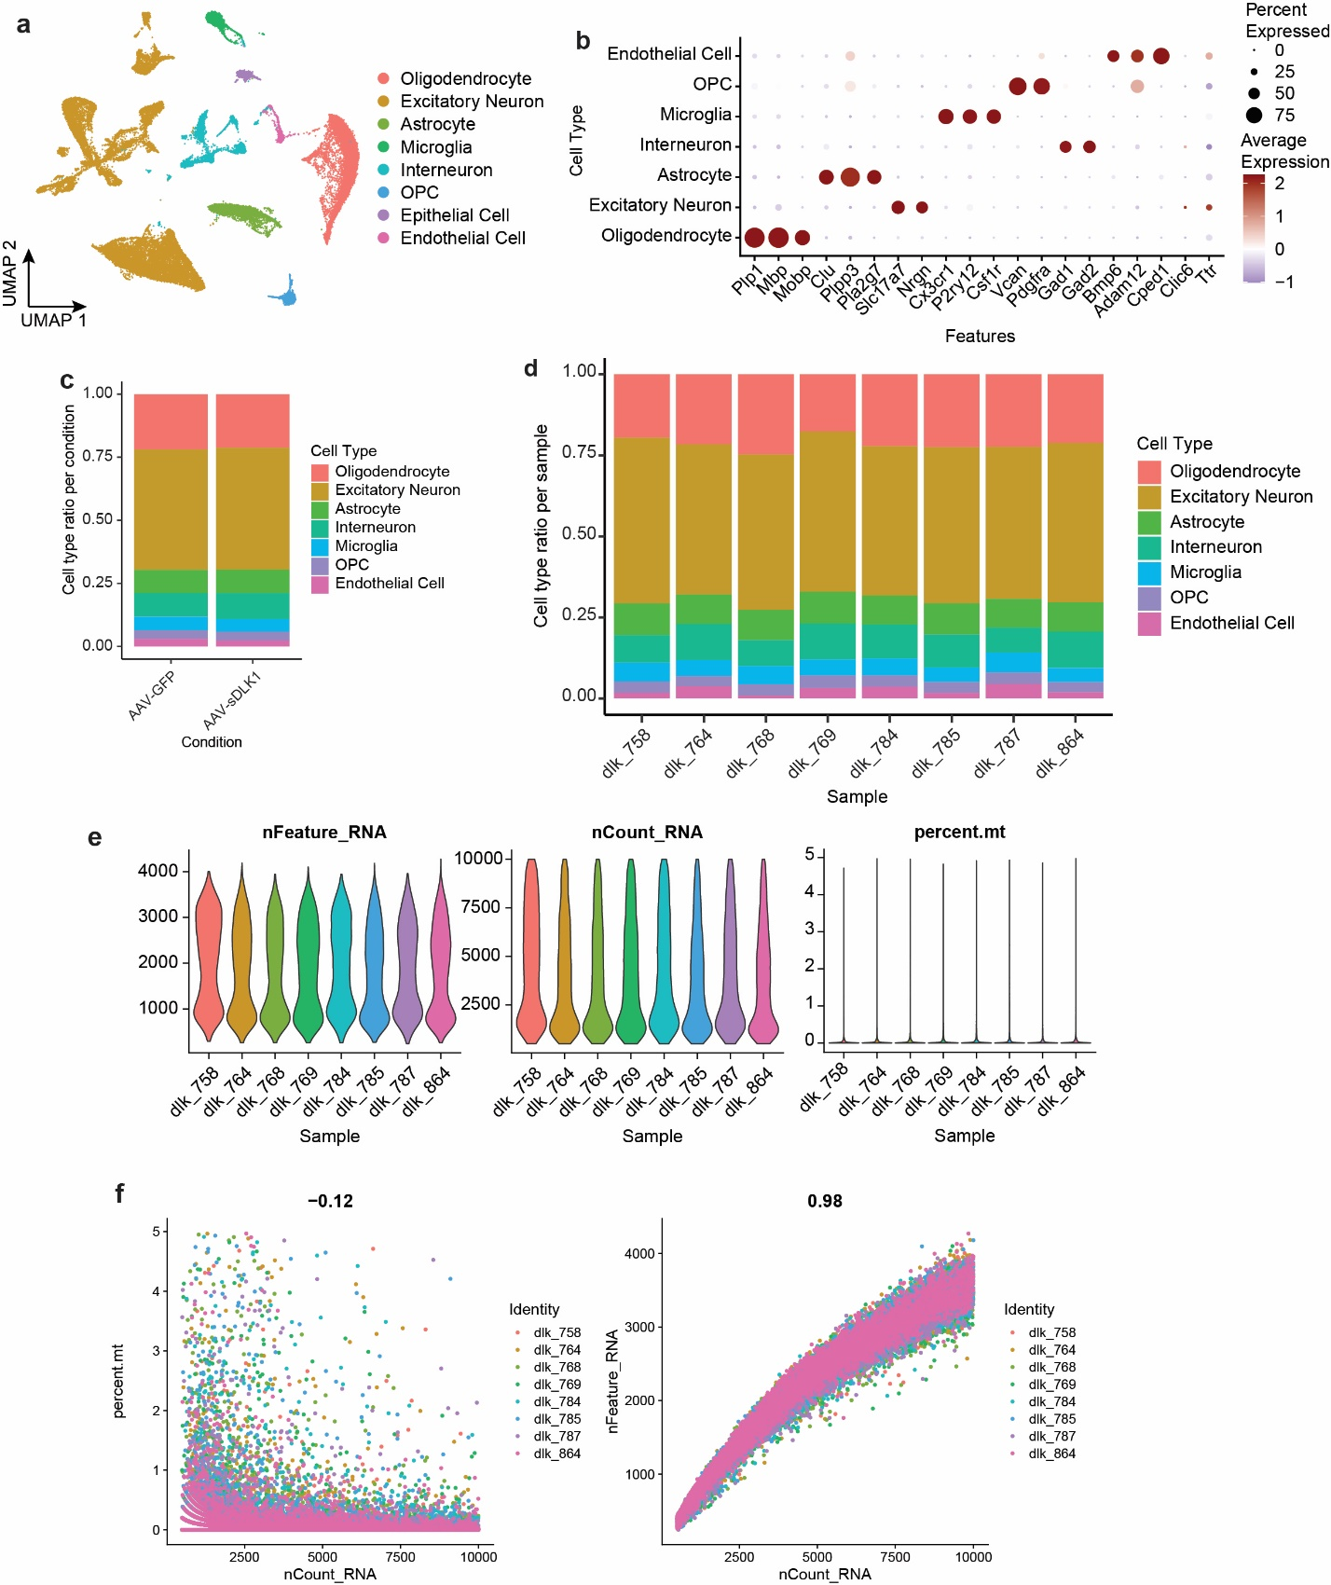
Supp Fig. 6 | Quality control assessment of single-nuclei RNA-Seq in the AAV-sDLK1 cohort. a. UMAP plots showing eight major cell types identified in the mouse hippocampus. b. Dot plot showing expression levels of canonical cell markers in each identified cell types. c. Proportion of each cell type within animals injected with AAV-GFP and AAV-sDLK1. d. Proportion of each cell type within individual samples. e. Violin plots showing the number of unique features (left); the number of total RNA count (middle), and the percentage of mitochondrial genes (right) detected in the each identified cell types. f. Correlation between UMI counts and percentage of mitochondrial genes (left) or total gene counts (right) per nuclei for each individual sample.
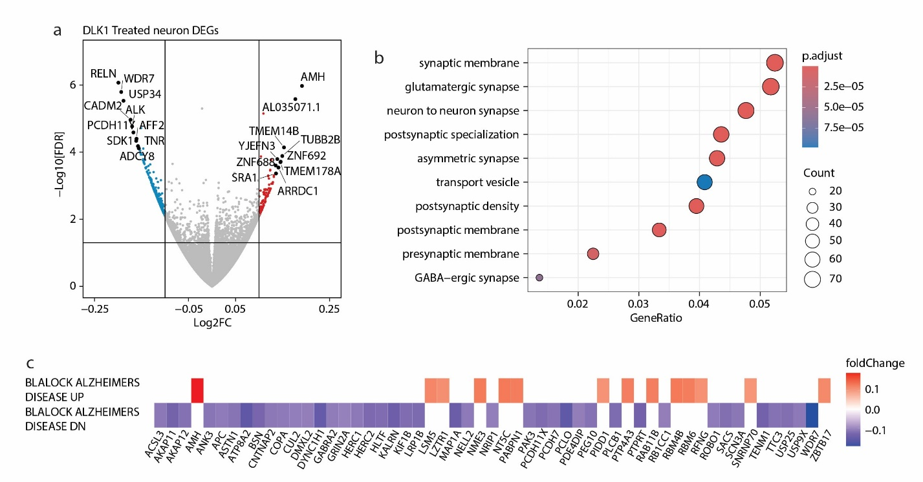
Supp Fig. 7 | Soluble DLK1 alters the transcriptions of synaptic proteins in the iPSC-derived neurons. a. Volcano plot of significant DEGs in iPSC-derived neurons treated with soluble DLK1. Red and grey dots represent genes with a log2FC > 0.1 or < -0.1, respectively. Top 10 differential genes are labeled. b. Dot plot of the top 10 GO Cellular Component ontologies inferred by the upregulated overlapping DEGs in sDLK1-treated neurons. c. Heatmap showing the fold-change of the genes upregulated (top) and downregulated (bottom) in the brains from patients with Alzheimer’s disease. All gene expressions are significantly changed (p-value <= 0.05) in the sDLK1-treated neurons.

