Long-term mortality rate in older ICU patients compared to the general population --

Supplementary online-only material

eFigure S1. Flow chart describing selection of the study population.
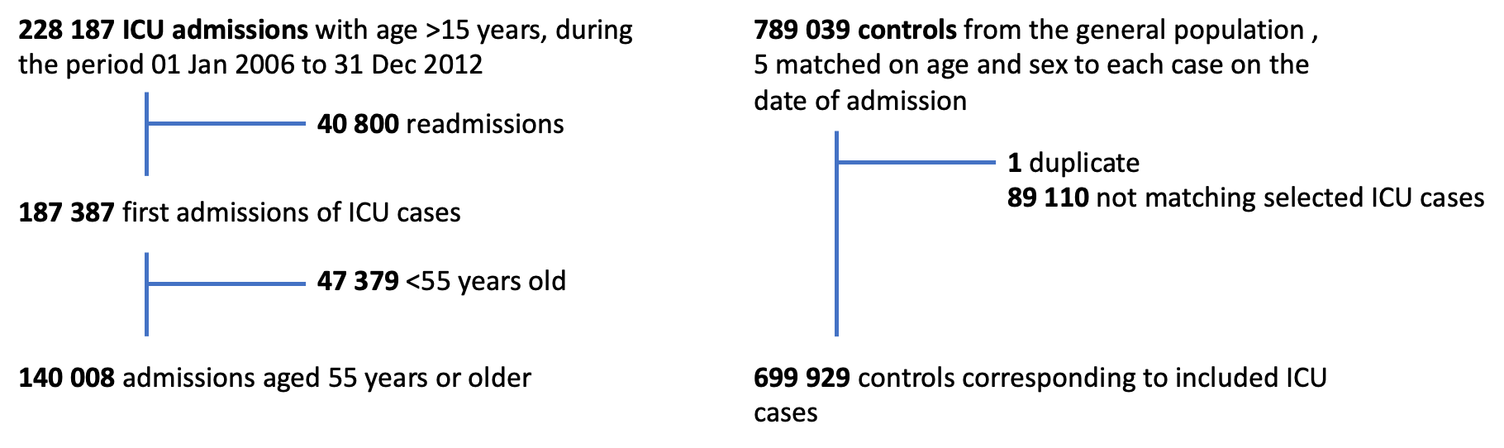

eTable S1. Categorisation of admission diagnoses based on APACHE and SAPS3 as registered in the Swedish Intensive Care Register (SIR). Registration of SAPS3 was introduced in 2009 and therefore only available from the later part of the study period.
Area | APACHE - Reason for admission | SAPS3 - Reason for admission | Categorisation of reason for ICU admission in the study
Cardiovascular | Cardiac arrest | Cardiac arrest | Circulatory (excl. septic shock)
Cardiovascular | Acute myocardial infarction |  | Circulatory (excl. septic shock)
Cardiovascular |  | Anaphylactic shock | Circulatory (excl. septic shock)
Cardiovascular | Other cardiovascular disease | Other cardiovascular | Circulatory (excl. septic shock)
Cardiovascular |  | Mixed/undefined shock | Circulatory (excl. septic shock)
Cardiovascular |  | Hypovolemic/haemorrhagic shock | Circulatory (excl. septic shock)
Cardiovascular |  | Hypovolemic/non-haemorrhagic shock | Circulatory (excl. septic shock)
Cardiovascular | Cardiogenic shock | Cardiogenic shock | Circulatory (excl. septic shock)
Cardiovascular | Cardiac failure |  | Circulatory (excl. septic shock)
Cardiovascular |  | Anaphylactic shock | Circulatory (excl. septic shock)
Cardiovascular |  | Chest pain | Circulatory (excl. septic shock)
Cardiovascular | Hypertension | Hypertensive crisis | Circulatory (excl. septic shock)
Cardiovascular | Arrhythmia | Arrhythmia | Circulatory (excl. septic shock)
Cardiovascular |  | Cardiovascular failure without shock | Circulatory (excl. septic shock)
Cardiovascular |  | Septic shock | Septic shock
Hepatic |  | Hepatic failure | Hepatic
Hepatic | Cholecystitis/cholangitis |  | Hepatic
Hepatic |  | Other hepatic reason | Hepatic
Gastrointestinal |  | Acute abdomen | Gastrointestinal
Gastrointestinal |  | Gastrointestinal bleeding | Gastrointestinal
Gastrointestinal |  | Pancreatitis | Gastrointestinal
Gastrointestinal | Gastrointestinal obstruction |  | Gastrointestinal
Gastrointestinal | Gastrointestinal perforation/rupture |  | Gastrointestinal
Gastrointestinal | Gastrointestinal inflammatory disease |  | Gastrointestinal
Gastrointestinal | Other gastrointestinal disease | Other gastrointestinal reason | Gastrointestinal
Cardiovascular |  | Septic shock | Septic shock
Respiratory | Chronic obstructive pulmonary disease | Acute pulmonary failure on chronic pulmonary failure | Respiratory, acute-on-chronic
Respiratory |  | Acute pulmonary failure, ARDS | Respiratory, other
Respiratory | Aspiration pneumonia |  | Respiratory, other
Respiratory | Bacterial/viral pneumonia |  | Respiratory, other
Respiratory | Pulmonary infection |  | Respiratory, other
Respiratory | Parasitic pneumonia |  | Respiratory, other
Respiratory | Pulmonary oedema (non-cardiogenic) |  | Respiratory, other
Respiratory | Respiratory arrest |  | Respiratory, other
Respiratory | Respiratory neoplasm |  | Respiratory, other
Respiratory | Asthma |  | Respiratory, other
Respiratory | Pulmonary embolism |  | Respiratory, other
Respiratory | Mechanical airway obstruction |  | Respiratory, other
Respiratory | Other respiratory disease | Other respiratory reason | Respiratory, other
Trauma |  | Trauma | Trauma
Trauma | Multiple trauma (excl. head injury) |  | Trauma
Trauma | Burn |  | Trauma
Neurological |  | Focal neurological deficit | Neurological
Neurological |  | Intracranial expansion | Neurological
Neurological | Head trauma (with/without multiple trauma) |  | Neurological
Neurological | Subdural/epidural hematoma |  | Neurological
Neurological | Intracerebral bleeding |  | Neurological
Neurological |  | Epileptic seizures | Neurological
Neurological |  | Reduced consciousness | Neurological
Neurological | Subarachnoid hemorrhage |  | Neurological
Neurological | Other neurological disease |  | Neurological
Renal |  | Renal failure | Renal
Renal |  | Postrenal kidney failure | Renal
Renal |  | Prerenal kidney failure | Renal
Renal | Other renal disease | Other renal reason | Renal
Haematological |  | Bleeding, DIC | Haematological
Haematological |  | Severe haemolysis | Haematological
Haematological |  | Other haematological reason | Haematological
Metabolic |  | Hypo/hyperthermia | Metabolic
Metabolic |  | Hypo/hyperglycemia | Metabolic
Metabolic |  | Acid-base or electrolyte disorder | Metabolic
Metabolic |  | Other metabolic reason | Metabolic

eFigure S2. Directional acyclic graphs (DAG) describing the assumed associations between age (Panel A) and severity of specific comorbidity (Panel B) with the outcome all-cause death.

Panel A:
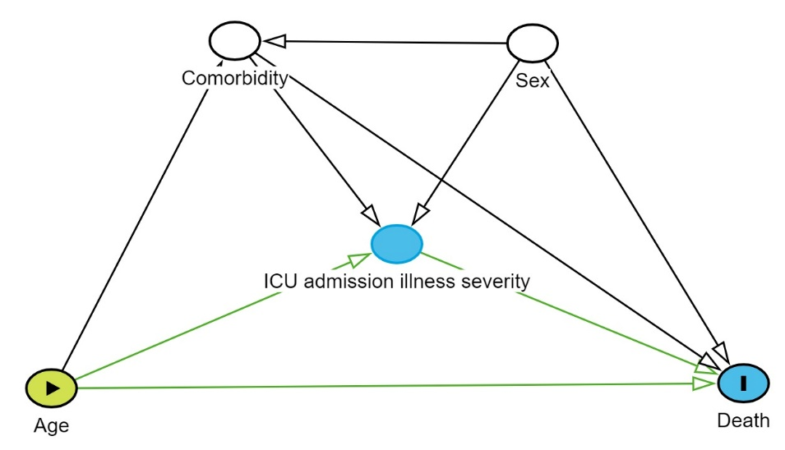

Panel B:

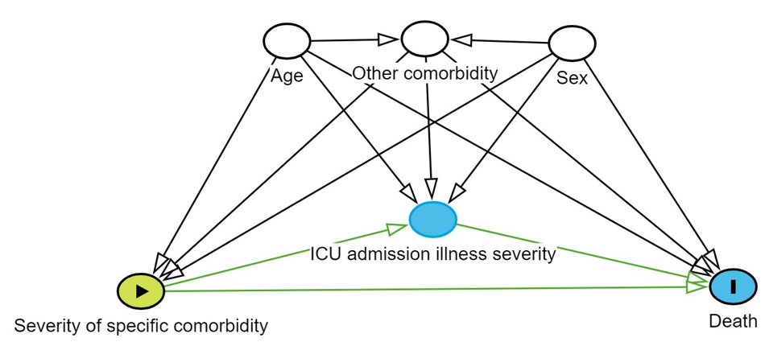

eTable S2. Baseline characteristics of 140 008 ICU patients, comparing baseline characteristics stratified by age.
 | Age categories
 | <60 years  (N=15 713) | 60-69 years  (N=45 764) | 70-79 years  (N=46 607) | 80-89 years  (N=28 936) | ≥90 years  (N=2988)
Age (years), median (interquartile range) | 57 (56-58) | 65 (62-67) | 75 (72-77) | 83 (81-86) | 91 (90-93)
Sex, % (n)
Female | 36% (5649) | 36% (16 442) | 40% (18 835) | 49% (14 139) | 60% (1794)
ICU type, % (n)
Thoracic | 16% (2458) | 17% (7954) | 18% (8226) | 8% (2235) | 1% (22)
General | 84% (13 255) | 83% (37 810) | 82% (38 381) | 92% (26 701) | 99% (2966)
Burn | 0% (0) | 0% (0) | 0% (0) | 0% (0) | 0% (0)
Reason for ICU admissionª, % (n)
Circulatory (excl. septic shock) | 9% (1468) | 12% (5290) | 14% (6433) | 16% (4638) | 16% (478)
Septic shock | 2% (298) | 3% (1223) | 3% (1345) | 3% (906) | 3% (75)
Gastrointestinal | 7% (1029) | 8% (3474) | 8% (3761) | 10% (2969) | 11% (340)
Neurological | 13% (2014) | 13% (5776) | 11% (5251) | 11% (3171) | 11% (326)
Renal | 4% (555) | 5% (2308) | 6% (2962) | 7% (2067) | 7% (204)
Respiratory, acute-on-chronic | 2% (332) | 3% (1353) | 4% (1734) | 3% (966) | 3% (75)
Respiratory, other | 15% (2424) | 16% (7251) | 16% (7308) | 18% (5182) | 19% (559)
Haematological | 2% (259) | 2% (915) | 2% (958) | 2% (598) | 2% (56)
Metabolic | 6% (916) | 6% (2955) | 6% (2979) | 7% (2017) | 7% (198)
Trauma | 4% (570) | 3% (1436) | 2% (1085) | 3% (869) | 6% (176)
Missing | 61% (9567) | 59% (26 855) | 58% (27 132) | 54% (15 491) | 52% (1548)
SAPS3 score, median (interquartile range) | 47 (39-58) | 53 (44-64) | 59 (50-70) | 64 (55-73) | 62 (55-71)
Type of comorbidity present at baseline
Alcohol abuse | 11% (1652) | 7% (3005) | 2% (1086) | 1% (182) | 0% (1)
Blood loss anemia | 1% (104) | 1% (393) | 1% (541) | 2% (452) | 2% (60)
Bone/muscle disease | 8% (1257) | 10% (4638) | 14% (6540) | 16% (4740) | 15% (461)
Cardiac arrhythmias | 6% (955) | 10% (4562) | 18% (8244) | 25% (7315) | 29% (853)
Cerebrovascular disease | 4% (652) | 6% (2932) | 10% (4554) | 13% (3632) | 13% (395)
Chronic pulmonary disease | 6% (982) | 9% (4318) | 13% (5890) | 12% (3590) | 9% (263)
Coagulopathy | 0% (49) | 0% (202) | 0% (231) | 1% (170) | 1% (19)
Congestive heart failure | 5% (820) | 8% (3742) | 14% (6451) | 20% (5814) | 25% (734)
Depression | 5% (735) | 3% (1570) | 3% (1376) | 3% (848) | 3% (81)
Diabetes | 10% (1553) | 13% (6084) | 15% (7150) | 14% (3937) | 11% (315)
Drug abuse | 4% (578) | 2% (1110) | 1% (616) | 1% (182) | 0% (6)
Fluid balance disorder | 3% (410) | 3% (1385) | 3% (1574) | 4% (1233) | 5% (152)
Hematological disease | 2% (236) | 2% (810) | 2% (730) | 1% (387) | 1% (36)
Hematological malignancy | 1% (216) | 2% (841) | 2% (807) | 1% (390) | 1% (25)
Hepatic disease | 6% (869) | 3% (1516) | 1% (635) | 1% (207) | 0% (10)
Hypertension | 15% (2434) | 22% (10 241) | 30% (14 070) | 33% (9567) | 32% (959)
Immunodeficiency | 0% (37) | 0% (98) | 0% (49) | 0% (18) | 0% (1)
Infectious disease | 14% (2250) | 17% (7758) | 21% (9976) | 29% (8367) | 35% (1056)
Injury | 10% (1532) | 10% (4446) | 12% (5360) | 18% (5068) | 26% (773)
Ischemic heart disease | 10% (1573) | 15% (6723) | 21% (9985) | 25% (7097) | 24% (723)
Malnutrition | 0% (75) | 0% (228) | 1% (247) | 1% (204) | 1% (29)
Neurological disease | 9% (1475) | 11% (4812) | 12% (5562) | 15% (4220) | 15% (451)
Obesity | 2% (310) | 2% (828) | 1% (511) | 1% (145) | 0% (0)
Other anemias | 4% (673) | 5% (2413) | 7% (3226) | 10% (2849) | 12% (360)
Other endocrine disease | 3% (453) | 3% (1573) | 5% (2219) | 6% (1791) | 7% (210)
Peripheral vascular disease | 5% (799) | 7% (3127) | 9% (4007) | 8% (2445) | 7% (213)
Poisoning | 3% (439) | 2% (732) | 1% (586) | 1% (409) | 1% (42)
Psychoses | 2% (309) | 1% (603) | 1% (347) | 1% (146) | 0% (7)
Pulmonary circulation disorders | 1% (170) | 2% (716) | 2% (1033) | 2% (693) | 2% (66)
Renal disease | 4% (652) | 5% (2246) | 6% (2971) | 7% (2026) | 6% (193)
Rheumatic/autoimmune disease | 2% (311) | 3% (1293) | 4% (1900) | 5% (1483) | 4% (107)
Transplantation-related disorder | 1% (164) | 1% (397) | 0% (145) | 0% (14) | 0% (0)
Tumour metastatic | 2% (333) | 2% (1070) | 2% (812) | 1% (301) | 1% (21)
Tumour non-metastatic | 8% (1183) | 10% (4412) | 11% (4961) | 10% (2855) | 8% (232)
Valvular disease | 4% (635) | 5% (2363) | 8% (3689) | 8% (2306) | 5% (135)
ª Admission diagnoses registered in the Swedish Intensive Care register are based on the APACHE score for the early part of the study period, and the SAPS3 score that is available from the year 2009 onwards. Se supplementary eTable S1 for harmonisation of admission diagnoses. Note that one patient can have multiple admission diagnoses registered.

eFigure S3. Subgroup analysis excluding ICU admissions from thoracic intensive care. Landmark analysis of survival probability after admission to intensive care. Survival described by Kaplan-Meier curves is compared to age- and sex-matched individuals from the general population, and separately for different age groups. Hazard ratios with 95% confidence intervals (CI) have been estimated in Cox proportional hazards models adjusted for age, sex and comorbidity.
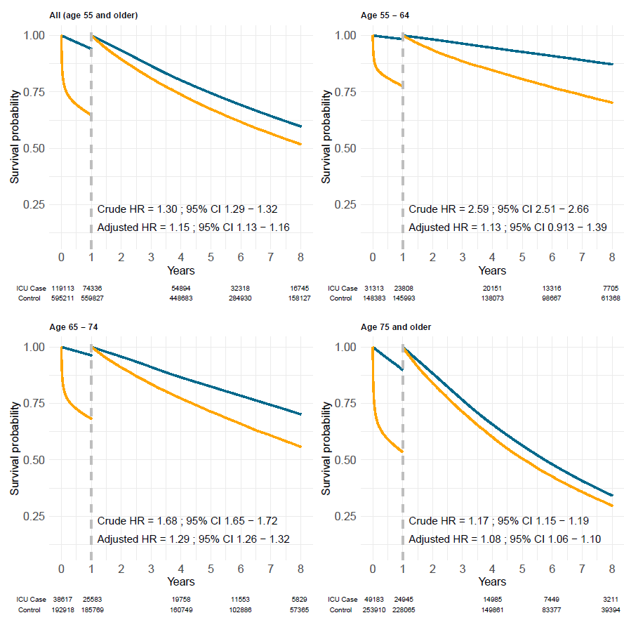

eFigure S4. Landmark analysis of survival probability after admission to intensive care, stratified by the reason for ICU admission and restricted to 2009-2012 when SAPS3 scoring is available in the Swedish intensive care register. Survival described by Kaplan-Meier curves is compared to age- and sex-matched individuals from the general population. Hazard ratios with 95% confidence intervals (CI) have been estimated in Cox proportional hazards models adjusted for sex, age, and comorbidity.

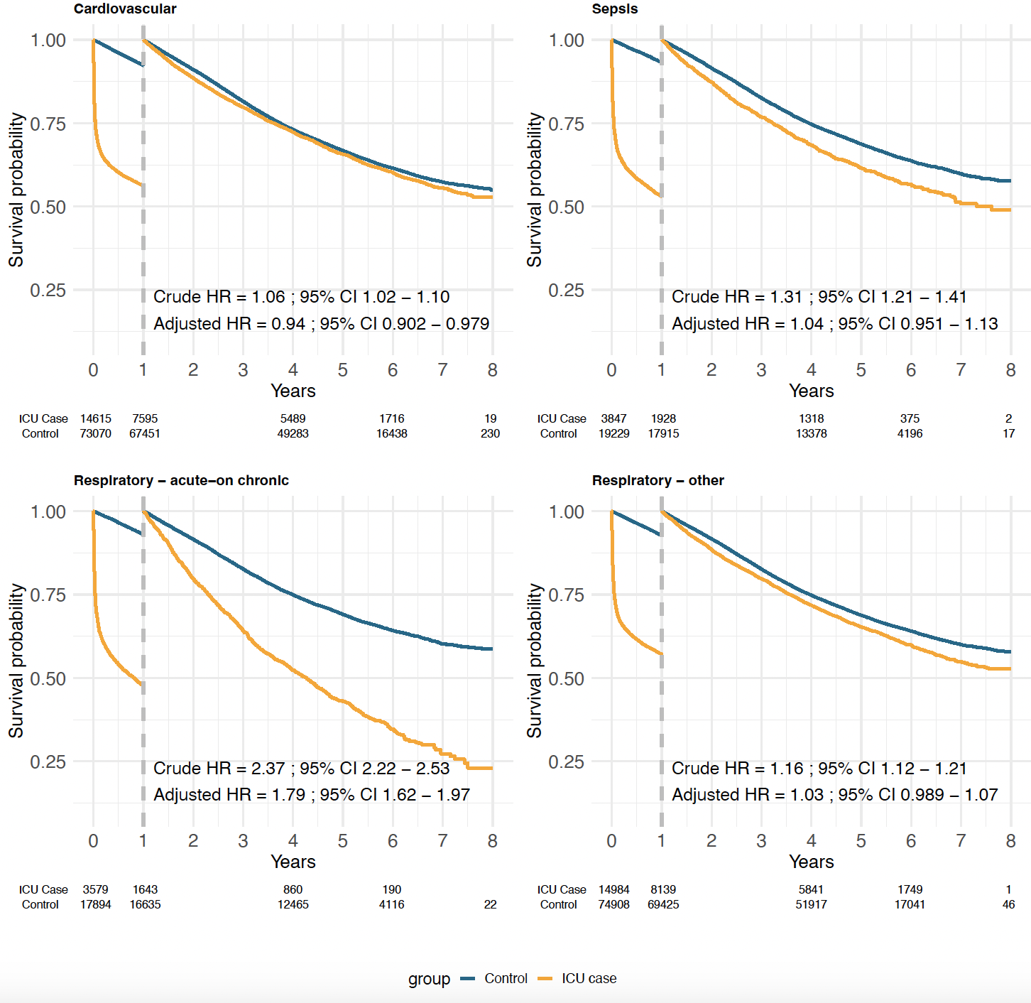
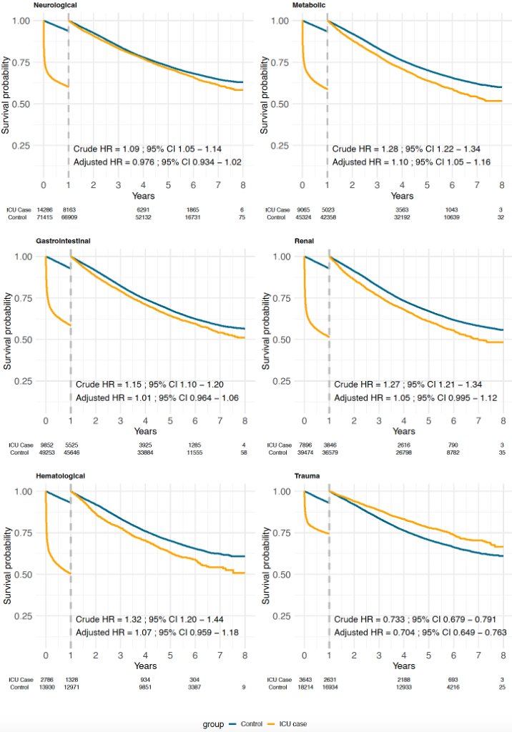

eTable S3. Comparison of survival probability during the first year after ICU admission. Patients admitted to the ICU are compared to individuals from the general population, matched on age and sex. Cox proportional hazards regression with results presented as hazard ratios (HR) with 95% confidence intervals (CI). Unadjusted analyses as well as analyses adjusted for age, sex, and comorbidity are presented.
 |  | Unadjusted analyses |  |  | Adjusted analyses
Admission diagnosis ICU | Group | Total number of ICU patients | Total number of deaths | HR (95% CI) | Total number of ICU patients | Total number of deaths | HR (95% CI)
Any | ICU Case | 140 008 | 45 879 | 7.2 (7.1 to 7.3) | 140 001 | 45 874 | 5.8 (5.6 to 5.9)
 | Controls | 699 929 | 40 436 | Reference | 699 927 | 40 435 | Reference
Circulatory (excl. septic shock) | ICU Case | 14 615 | 7 020 | 9.2 (8.9 to 9.6) | 14 606 | 7 013 | 8 (7.7 to 8.3)
 | Controls | 73 070 | 5 619 | Reference | 73 063 | 5 618 | Reference
Septic shock | ICU Case | 3 847 | 1 919 | 10.9 (10.1 to 11.7) | 3 815 | 1 899 | 8 (7.2 to 8.7)
 | Controls | 19 229 | 1 314 | Reference | 19 197 | 1 310 | Reference
Gastrointestinal | ICU Case | 9 852 | 4 327 | 8.4 (8 to 8.8) | 9 824 | 4 316 | 6.8 (6.5 to 7.2)
 | Controls | 49 253 | 3 607 | Reference | 49 234 | 3 605 | Reference
Nervous system | ICU Case | 14 286 | 6 123 | 9.5 (9.2 to 9.9) | 14 281 | 6 121 | 8.5 (8.1 to 8.8)
 | Controls | 71 415 | 4 506 | Reference | 71 373 | 4 497 | Reference
Renal | ICU Case | 7 896 | 4 050 | 10.7 (10.2 to 11.2) | 7 874 | 4 040 | 8.2 (7.8 to 8.8)
 | Controls | 39 474 | 2 895 | Reference | 39 455 | 2 891 | Reference
Respiratory, acute-on-chronic | ICU Case | 3 579 | 1 936 | 11.9 (11.1 to 12.8) | 3 559 | 1 924 | 8.2 (7.1 to 9.3)
 | Controls | 17 894 | 1 259 | Reference | 17 817 | 1 247 | Reference
Respiratory, other | ICU Case | 14 984 | 6 845 | 8.9 (8.6 to 9.3) | 14 975 | 6 837 | 7.5 (7.2 to 7.8)
 | Controls | 74 908 | 5 483 | Reference | 74 896 | 5 480 | Reference
Hematology | ICU Case | 2 786 | 1 458 | 11.6 (10.7 to 12.6) | 2 746 | 1 433 | 8.1 (6.8 to 9.8)
 | Controls | 13 930 | 959 | Reference | 13 892 | 955 | Reference
Metabolic | ICU Case | 9 065 | 4 042 | 9.6 (9.2 to 10.1) | 9 056 | 4 039 | 7.6 (7.1 to 8.1)
 | Controls | 45 324 | 2 966 | Reference | 45 294 | 2 961 | Reference
Trauma | ICU Case | 3 643 | 1 012 | 4.8 (4.5 to 5.2) | 3 636 | 1 008 | 4.6 (4.3 to 5)
 | Controls | 18 214 | 1 280 | Reference | 18 138 | 1 260 | Reference
eTable S4. Survival probability for ICU patients that survived the first year after ICU admission. Patients admitted to the ICU are compared to individuals from the general population, matched on age and sex. Cox proportional hazards regression with results presented as hazard ratios (HR) with 95% confidence intervals (CI). Unadjusted analyses as well as analyses adjusted for age, sex, and comorbidity are presented.
 |  | Unadjusted analyses |  |  | Adjusted analyses
Admission diagnosis ICU | Group | Total number of ICU patients | Total number of deaths | HR (95% CI) | Total number of ICU patients | Total number of deaths | HR (95% CI)
Any | ICU Case | 94 129 | 38 248 | 1.14 (1.13 to 1.15) | 94 127 | 38 246 | 1.03 (1.02 to 1.04)
 | Controls | 659 493 | 250 377 | Reference | 659 492 | 250 376 | Reference
Circulatory (excl. septic shock) | ICU Case | 7 595 | 2 854 | 1.06 (1.02 to 1.1) | 7 593 | 2 852 | 0.94 (0.9 to 0.98)
 | Controls | 67 451 | 24 595 | Reference | 67 445 | 24 592 | Reference
Septic shock | ICU Case | 1 928 | 790 | 1.31 (1.21 to 1.41) | 1 916 | 781 | 1.04 (0.95 to 1.13)
 | Controls | 17 915 | 6 106 | Reference | 17 887 | 6 092 | Reference
Gastrointestinal | ICU Case | 5 525 | 2 146 | 1.15 (1.1 to 1.2) | 5 508 | 2 137 | 1.01 (0.96 to 1.06)
 | Controls | 45 646 | 16 168 | Reference | 45 629 | 16 157 | Reference
Nervous system | ICU Case | 8 163 | 2 594 | 1.09 (1.05 to 1.14) | 8 160 | 2 594 | 0.98 (0.93 to 1.02)
 | Controls | 66 909 | 19 941 | Reference | 66 876 | 19 920 | Reference
Renal | ICU Case | 3 846 | 1 626 | 1.27 (1.21 to 1.34) | 3 834 | 1 621 | 1.05 (1 to 1.12)
 | Controls | 36 579 | 13 146 | Reference | 36 564 | 13 139 | Reference
Respiratory, acute-on-chronic | ICU Case | 1 643 | 1 010 | 2.37 (2.22 to 2.53) | 1 635 | 1 004 | 1.79 (1.62 to 1.97)
 | Controls | 16 635 | 5 612 | Reference | 16 570 | 5 566 | Reference
Respiratory, other | ICU Case | 8 139 | 3 080 | 1.16 (1.12 to 1.21) | 8 138 | 3 079 | 1.03 (0.99 to 1.07)
 | Controls | 69 425 | 23 653 | Reference | 69 416 | 23 646 | Reference
Hematology | ICU Case | 1 328 | 529 | 1.32 (1.2 to 1.44) | 1 313 | 520 | 1.07 (0.96 to 1.18)
 | Controls | 12 971 | 4 228 | Reference | 12 937 | 4 208 | Reference
Metabolic | ICU Case | 5 023 | 1 957 | 1.28 (1.22 to 1.34) | 5 017 | 1 955 | 1.10 (1.05 to 1.16)
 | Controls | 42 358 | 13 742 | Reference | 42 333 | 13 730 | Reference
Trauma | ICU Case | 2 631 | 641 | 0.73 (0.68 to 0.79) | 2 628 | 640 | 0.70 (0.65 to 0.76)
 | Controls | 16 934 | 5 373 | Reference | 16 878 | 5 336 | Reference

eFigure S5. Landmark survival analysis described by Kaplan-Meier curves (left panel), stratified for recency of a previous hospital admission with hypertension as the main discharge diagnosis. Hazard ratios with 95% confidence intervals (right two panels) have been estimated from Cox proportional hazards models separately for each time period, comparing an unadjusted analysis with an analysis adjusted for sex, age, and other comorbidities.
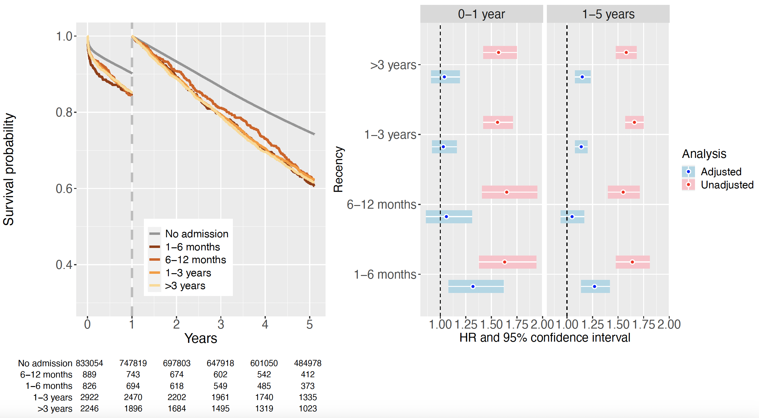

eFigure S6a. Landmark survival analysis described by Kaplan-Meier curves (left panel), stratified for recency of a previous hospital admission with ischemic heart disease as the main discharge diagnosis. Hazard ratios with 95% confidence intervals (right two panels) have been estimated from Cox proportional hazards models separately for each time period, comparing an unadjusted analysis with an analysis adjusted for sex, age, and other comorbidities.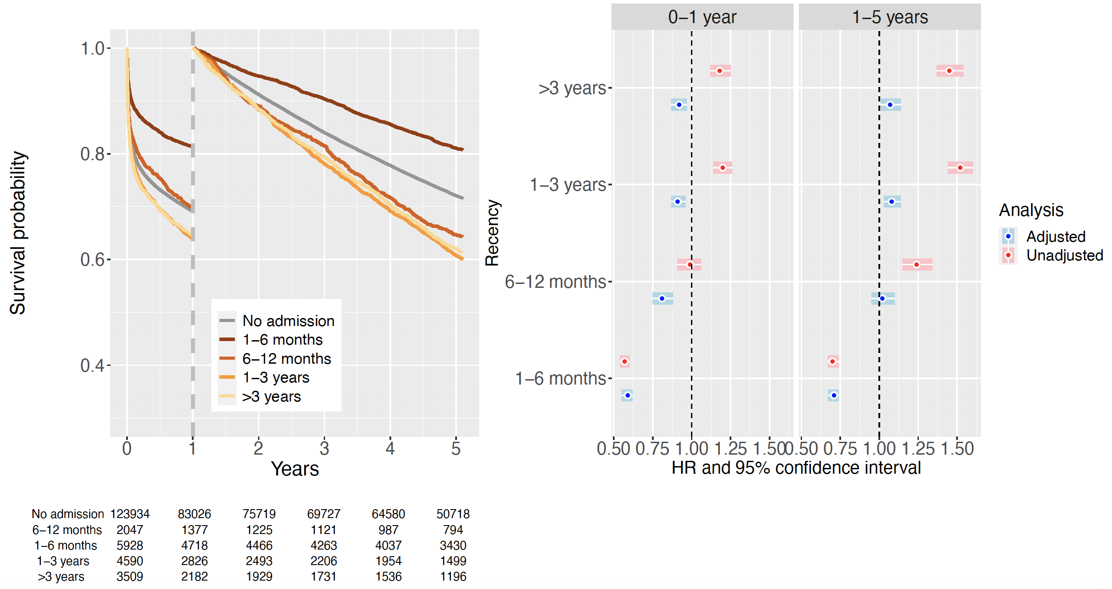

eFigure S6b. Subgroup analysis restricted to admissions to general ICUs (excluding thoracic ICUs). Landmark survival analysis described by Kaplan-Meier curves (left panel), stratified for recency of a previous hospital admission with ischemic heart disease as the main discharge diagnosis. Hazard ratios (HR) with 95% confidence intervals (CI) (right two panels) have been estimated from Cox proportional hazards models separately for each time period, comparing an unadjusted analysis with an analysis adjusted for sex, age, and other comorbidities.
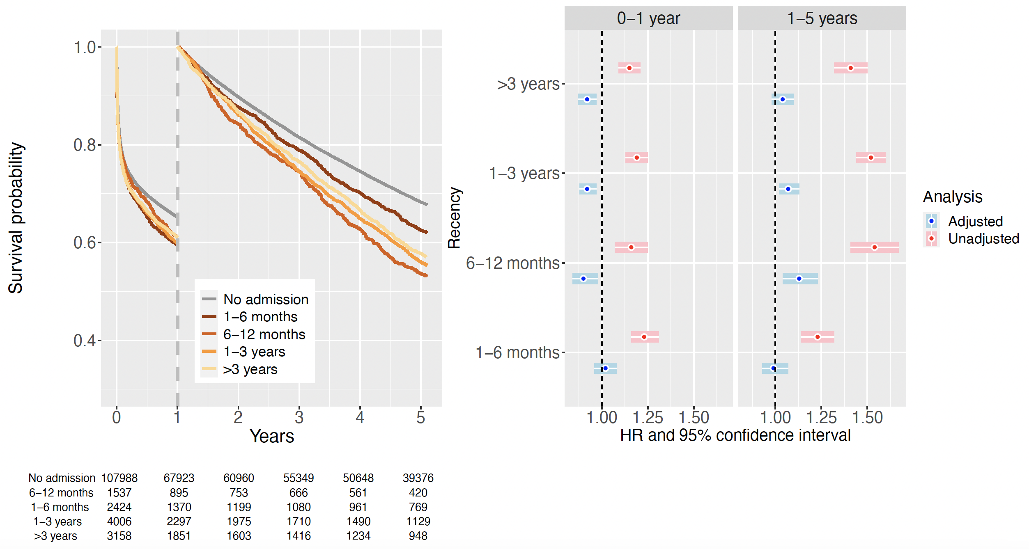
eFigure S7. Landmark survival analysis described by Kaplan-Meier curves (left panel), stratified for recency of a previous hospital admission with arrythmia as the main discharge diagnosis. Hazard ratios with 95% confidence intervals (right two panels) have been estimated from Cox proportional hazards models separately for each time period, comparing an unadjusted analysis with an analysis adjusted for sex, age, and other comorbidities.
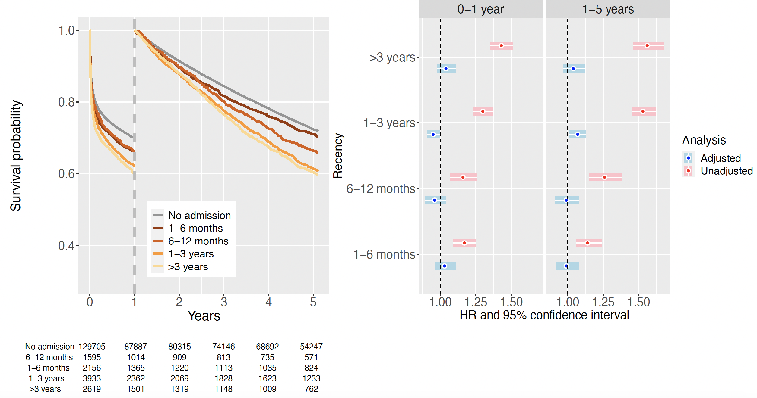

eFigure S8. Landmark survival analysis described by Kaplan-Meier curves (left panel), stratified for recency of a previous hospital admission with heart failure as the main discharge diagnosis. Hazard ratios with 95% confidence intervals (right two panels) have been estimated from Cox proportional hazards models separately for each time period, comparing an unadjusted analysis with an analysis adjusted for sex, age, and other comorbidities.
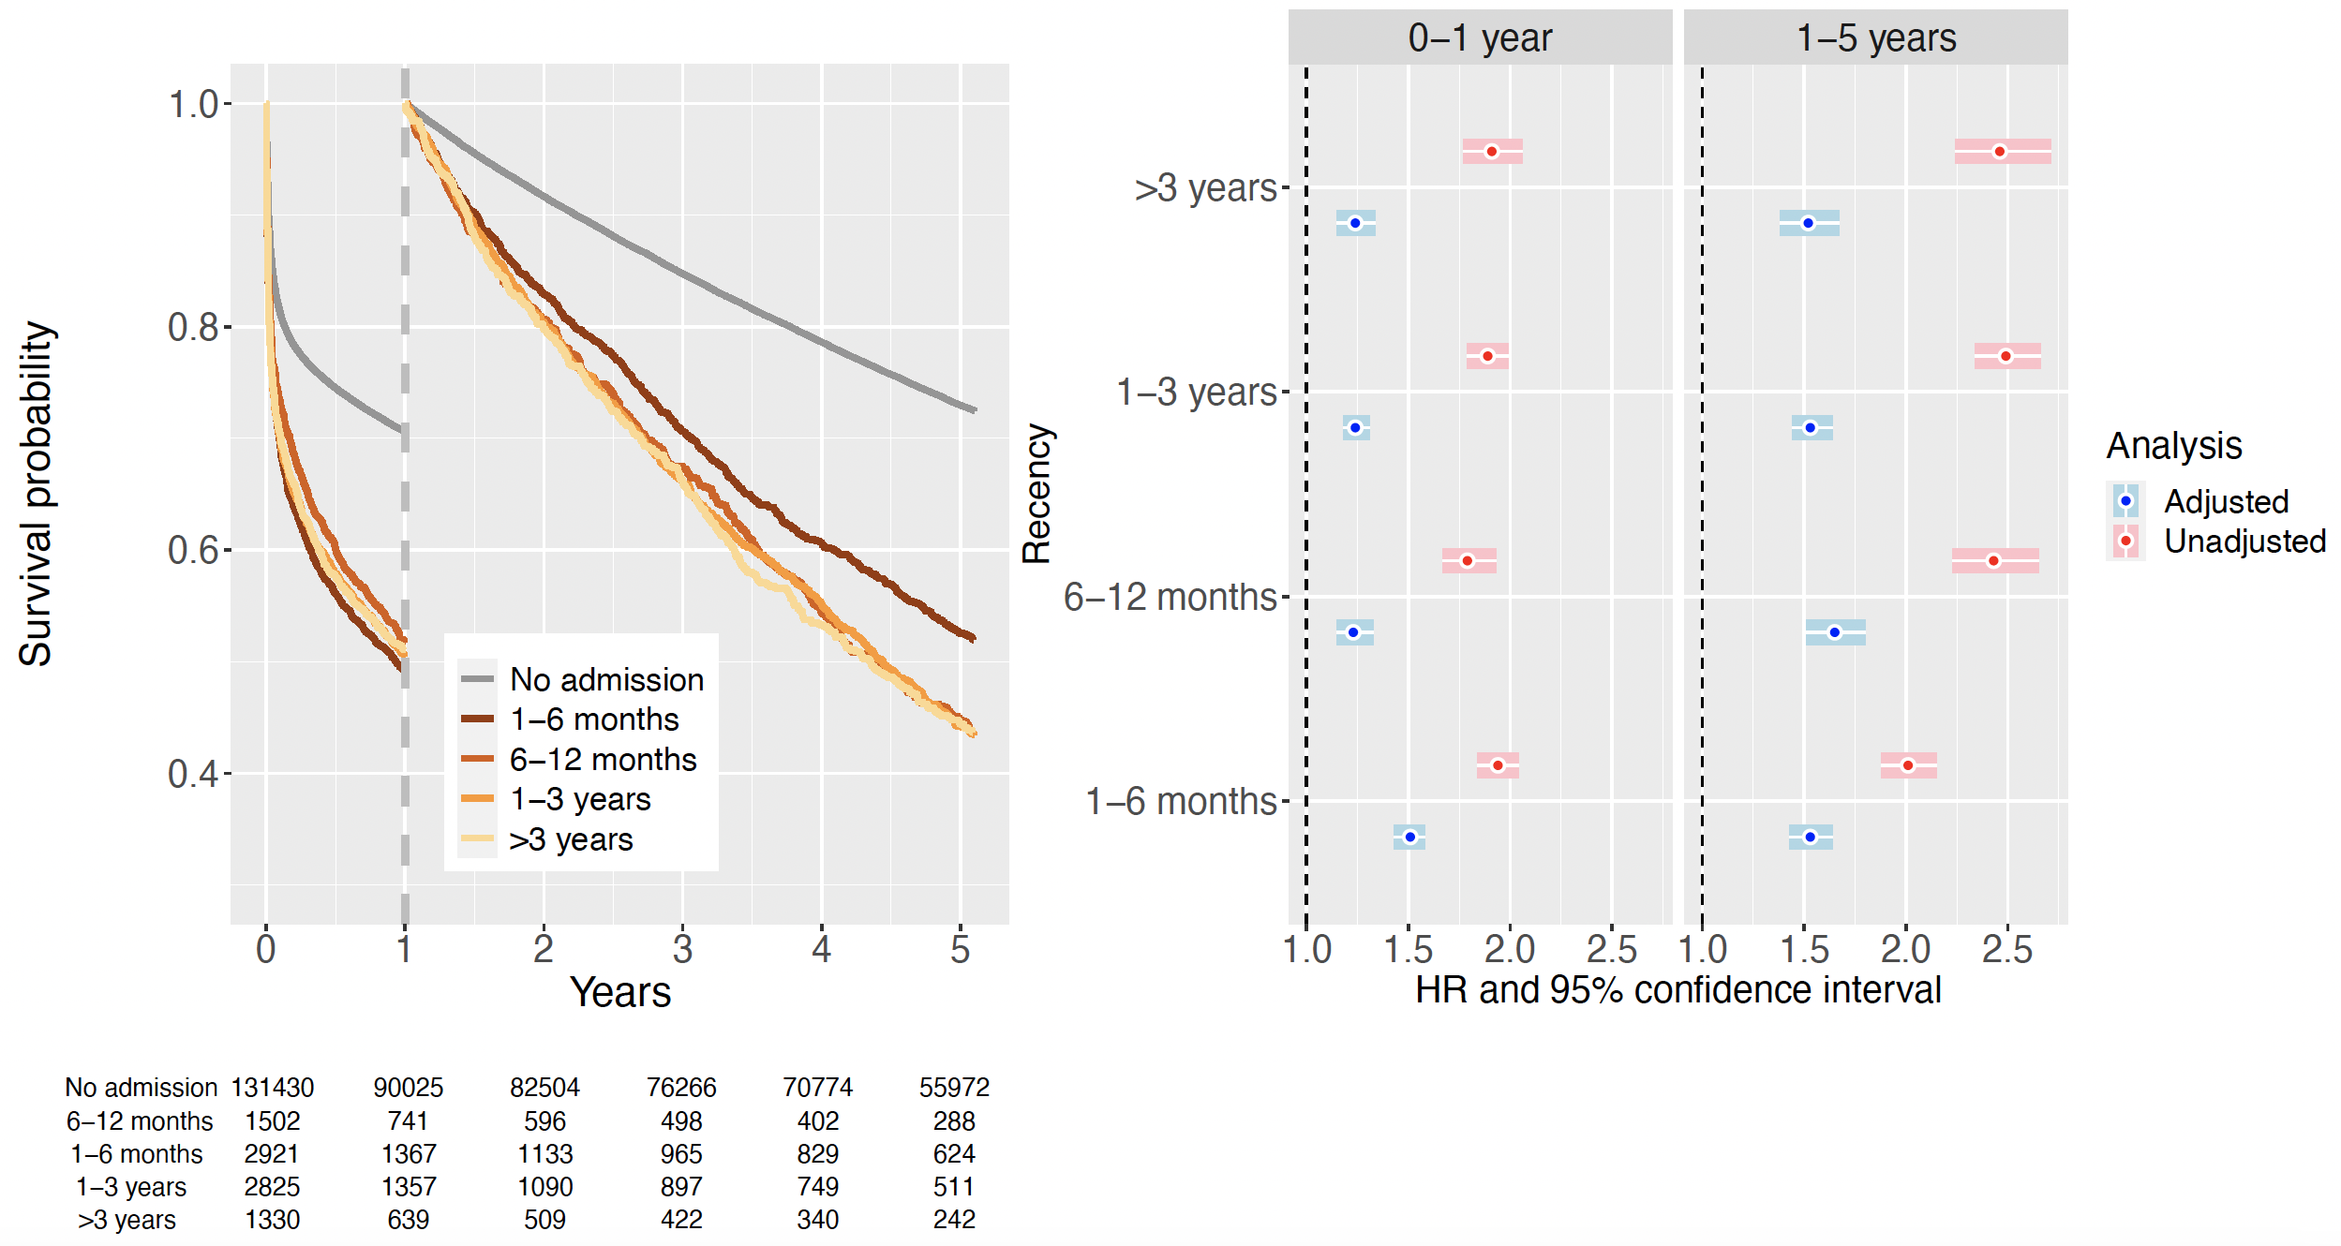
eFigure S9. Subgroup analysis restricted to ICU admissions with a SAPS3 reason for admission classified as circulatory (excl. septic shock). Landmark survival analysis described by Kaplan-Meier curves (left panel), stratified for recency of a previous hospital admission with heart failure as the main discharge diagnosis. Hazard ratios (HR) with 95% confidence intervals (CI) (right two panels) have been estimated from Cox proportional hazards models separately for each time period, comparing an unadjusted analysis with an analysis adjusted for sex, age, and other comorbidities.
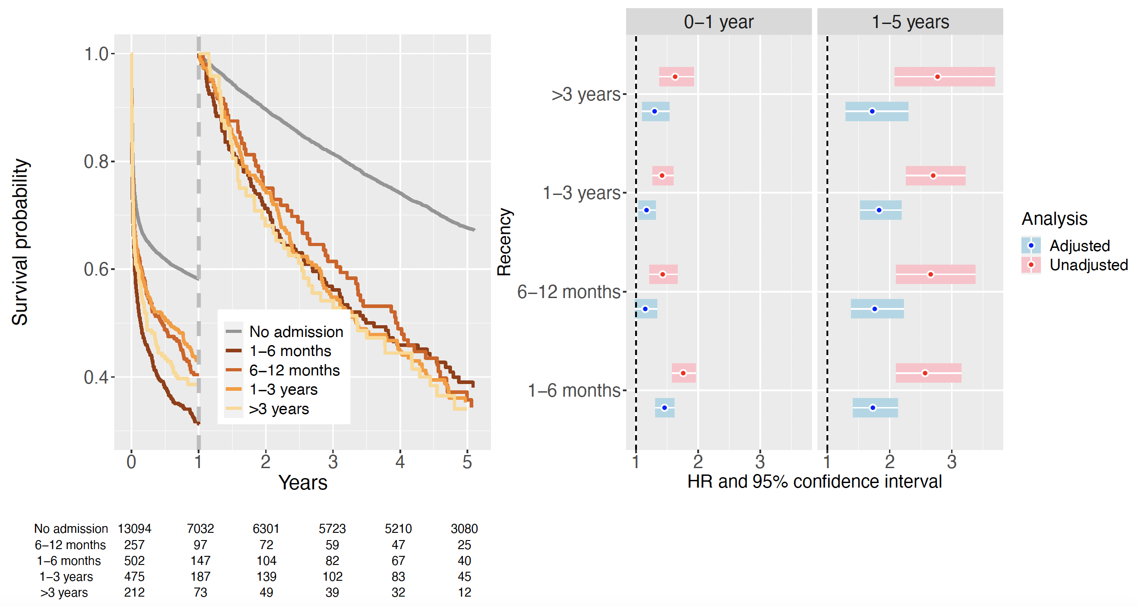
eFigure S10. Landmark survival analysis described by Kaplan-Meier curves (left panel), stratified for recency of a previous hospital admission with chronic pulmonary disease as the main discharge diagnosis. Hazard ratios with 95% confidence intervals (right two panels) have been estimated from Cox proportional hazards models separately for each time period, comparing an unadjusted analysis with an analysis adjusted for sex, age, and other comorbidities.
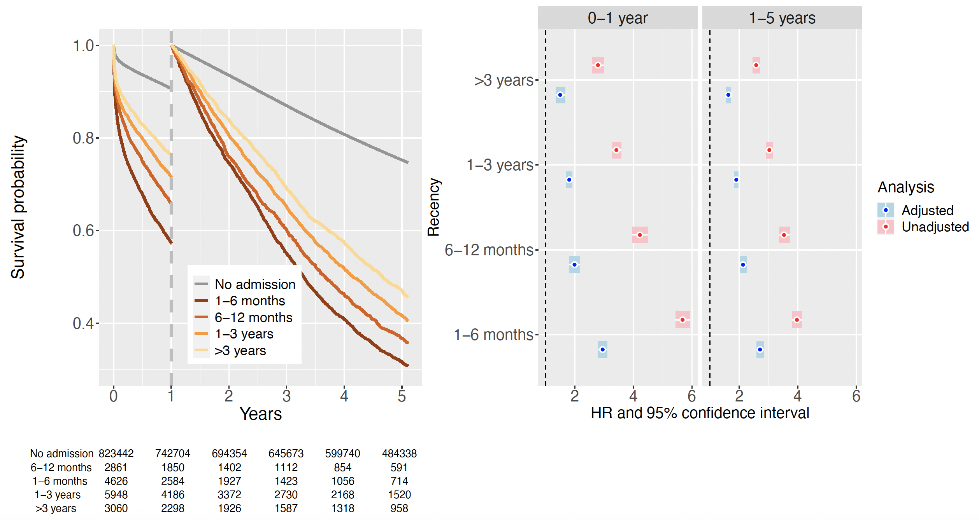
eFigure S11. Subgroup analysis restricted to ICU admissions with a SAPS3 reason for admission classified as circulatory (excl. septic shock). Landmark survival analysis described by Kaplan-Meier curves (left panel), stratified for recency of a previous hospital admission with chronic pulmonary disease as the main discharge diagnosis. Hazard ratios (HR) with 95% confidence intervals (CI) (right two panels) have been estimated from Cox proportional hazards models separately for each time period, comparing an unadjusted analysis with an analysis adjusted for sex, age, and other comorbidities.
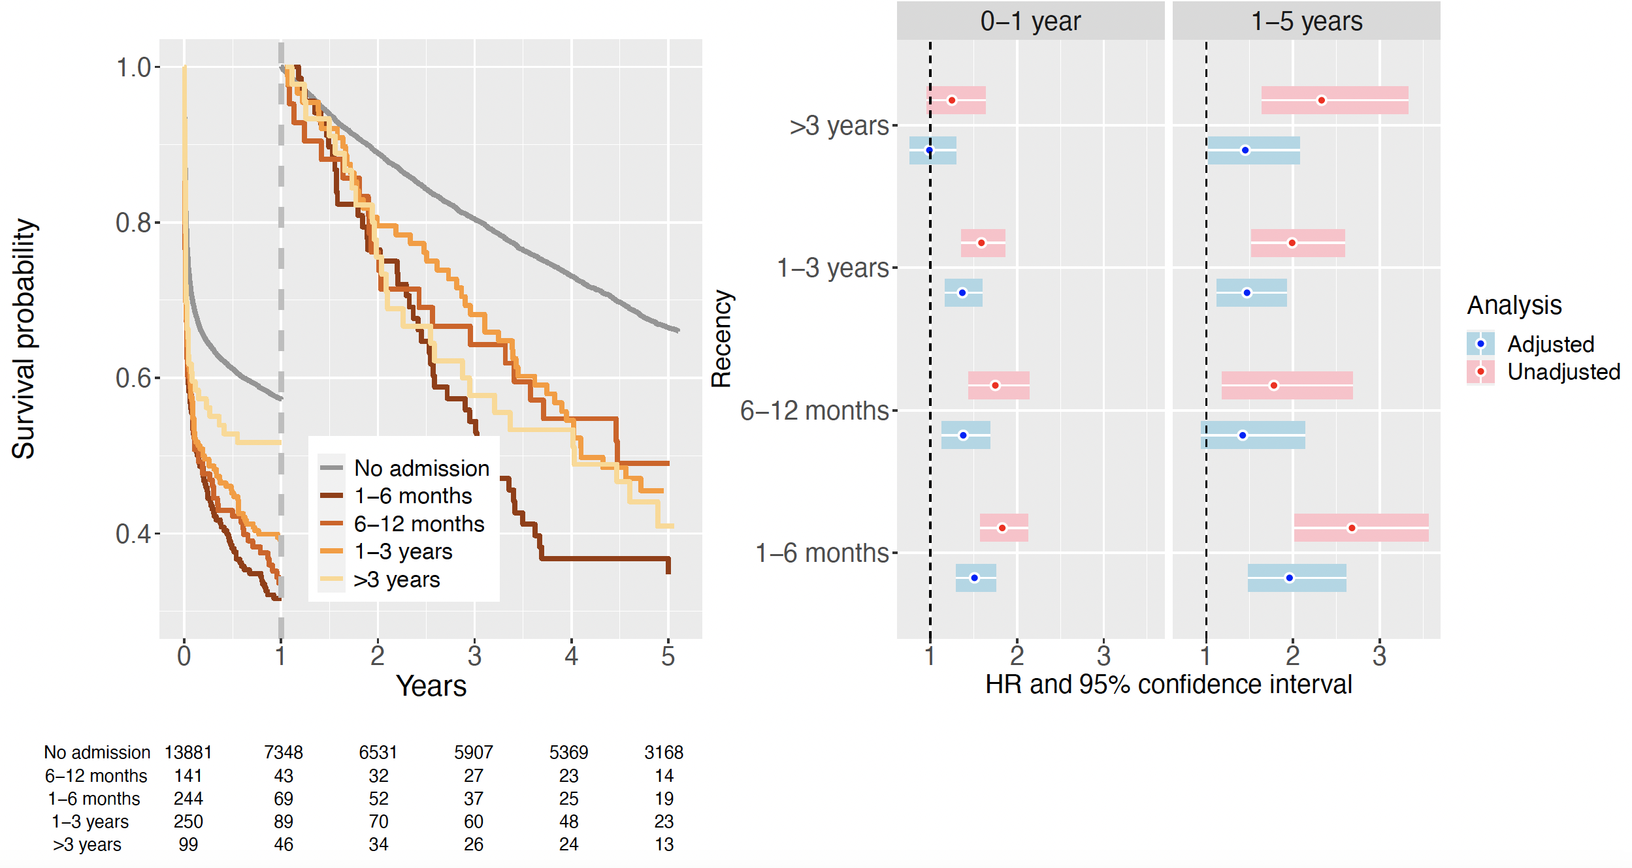
eFigure S12. Subgroup analysis restricted to ICU admissions with a SAPS3 reason for admission classified as respiratory, other. Landmark survival analysis described by Kaplan-Meier curves (left panel), stratified for recency of a previous hospital admission with chronic pulmonary disease as the main discharge diagnosis. Hazard ratios (HR) with 95% confidence intervals (CI) (right two panels) have been estimated from Cox proportional hazards models separately for each time period, comparing an unadjusted analysis with an analysis adjusted for sex, age, and other comorbidities.
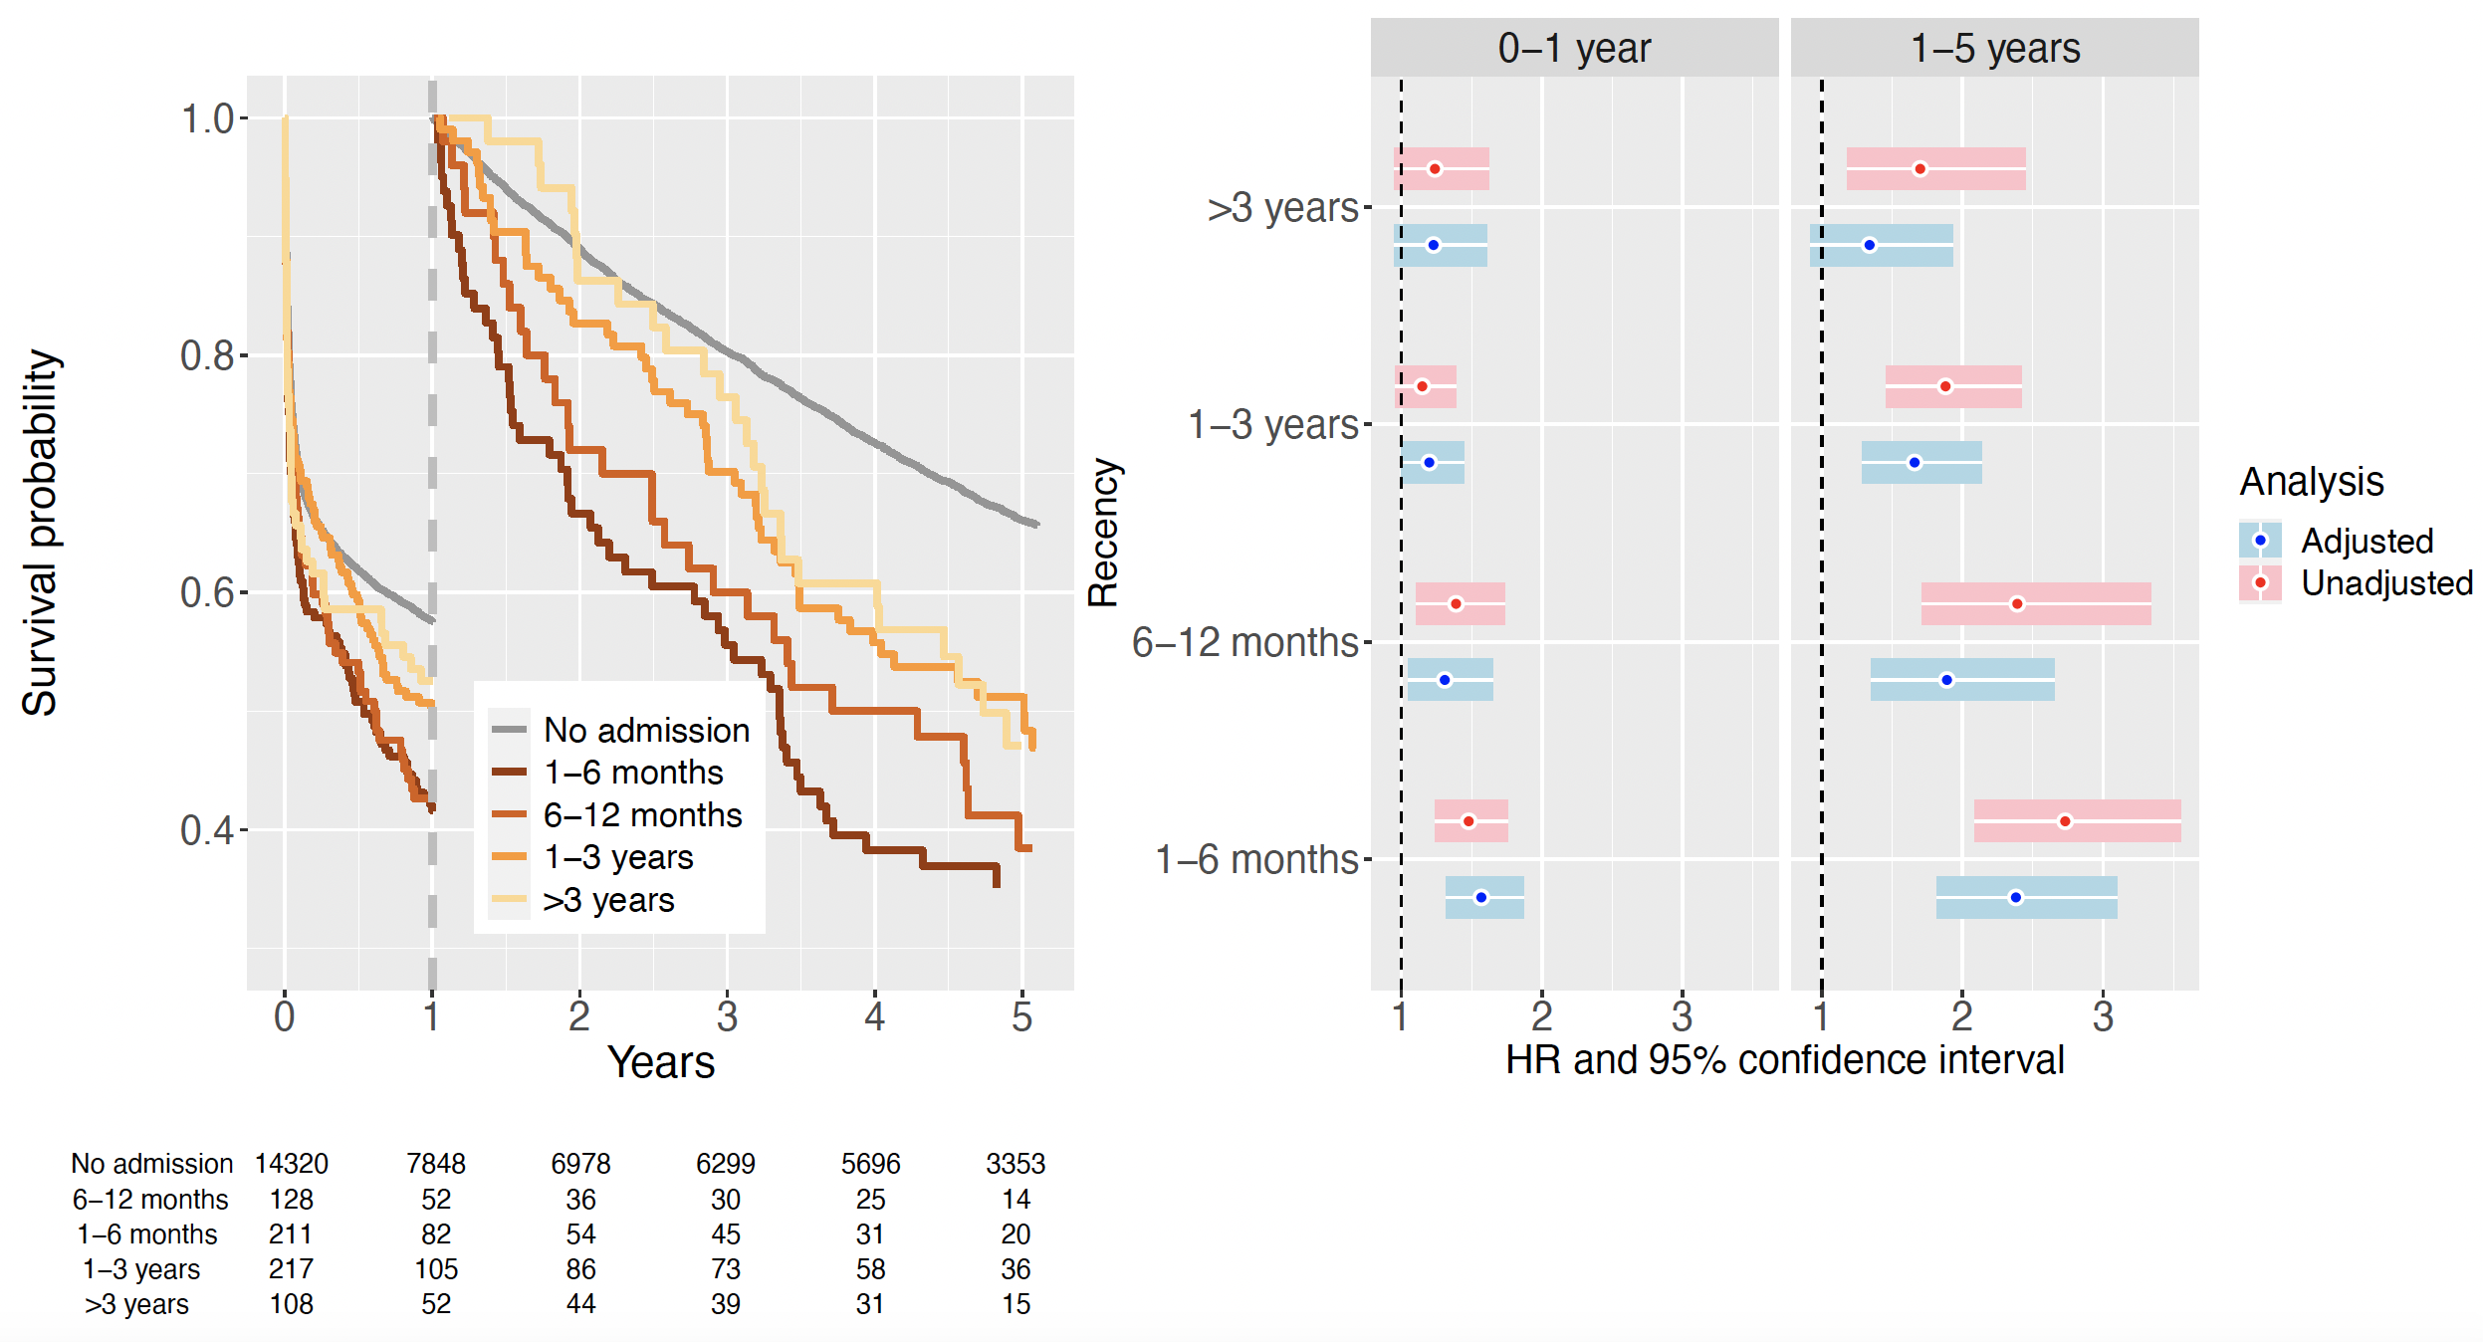

eTable S5. Association between recency of single comorbidity, based on hospital admission with a main diagnosis from that category, and survival probability in 140 008 patients ≥55 years old and admitted to an ICU. Hazard ratio (HR) and 95% confidence interval (CI) estimated from Cox proportional hazards regression, unadjusted and adjusted for age, sex, and other comorbidity.
Main diagnosis category and recency of previous hospital admission used as a measure of comorbidity | Period of follow-up
 | 0-1 year |  |  |  | 1-5 years
 | Unadjusted |  | Adjusted |  | Unadjusted |  | Adjusted
 | HR | (95% CI) | HR | (95% CI) | HR | (95% CI) | HR | (95% CI)
Previous hospital admission for infectious disease
1-6 months | 1.76 | (1.69 to 1.83) | 1.29 | (1.24 to 1.34) | 2.25 | (2.13 to 2.37) | 1.50 | (1.42 to 1.59)
6-12 months | 1.54 | (1.46 to 1.62) | 1.14 | (1.08 to 1.2) | 2.18 | (2.05 to 2.32) | 1.51 | (1.42 to 1.61)
1-3 years | 1.46 | (1.41 to 1.52) | 1.09 | (1.05 to 1.13) | 2.03 | (1.95 to 2.12) | 1.41 | (1.35 to 1.48)
>3 years | 1.33 | (1.26 to 1.39) | 1.06 | (1.01 to 1.11) | 1.78 | (1.69 to 1.89) | 1.36 | (1.28 to 1.43)
No previous admission | Reference |  | Reference |  | Reference |  | Reference
Previous hospital admission for hypertension
1-6 months | 1.19 | (0.97 to 1.45) | 1.05 | (0.86 to 1.28) | 1.49 | (1.19 to 1.88) | 1.18 | (0.94 to 1.49)
6-12 months | 0.95 | (0.75 to 1.2) | 0.87 | (0.69 to 1.1) | 1.36 | (1.08 to 1.73) | 1.10 | (0.87 to 1.39)
1-3 years | 1.11 | (0.98 to 1.26) | 0.93 | (0.82 to 1.05) | 1.48 | (1.29 to 1.69) | 1.16 | (1.01 to 1.33)
>3 years | 1.11 | (0.96 to 1.28) | 0.97 | (0.84 to 1.12) | 1.22 | (1.03 to 1.43) | 1.02 | (0.86 to 1.2)
No previous admission | Reference |  | Reference |  | Reference |  | Reference
Previous hospital admission for ischemic heart disease
1-6 months | 1.23 | (1.16 to 1.31) | 1.02 | (0.96 to 1.08) | 1.23 | (1.14 to 1.32) | 0.99 | (0.93 to 1.07)
6-12 months | 1.16 | (1.07 to 1.25) | 0.90 | (0.84 to 0.98) | 1.54 | (1.41 to 1.67) | 1.13 | (1.04 to 1.23)
1-3 years | 1.19 | (1.13 to 1.25) | 0.92 | (0.88 to 0.97) | 1.52 | (1.44 to 1.6) | 1.07 | (1.02 to 1.13)
>3 years | 1.15 | (1.09 to 1.21) | 0.92 | (0.87 to 0.97) | 1.41 | (1.32 to 1.5) | 1.04 | (0.98 to 1.1)
No previous admission | Reference |  | Reference |  | Reference |  | Reference
Previous hospital admission for ischemic heart disease. Analysis excluding admissions to thoracic ICUs
1-6 months | 1.23 | (1.16 to 1.31) | 1.02 | (0.96 to 1.08) | 1.23 | (1.14 to 1.32) | 0.99 | (0.93 to 1.07)
6-12 months | 1.16 | (1.07 to 1.25) | 0.9 | (0.84 to 0.98) | 1.54 | (1.41 to 1.67) | 1.13 | (1.04 to 1.23)
1-3 years | 1.19 | (1.13 to 1.25) | 0.92 | (0.88 to 0.97) | 1.52 | (1.44 to 1.6) | 1.07 | (1.02 to 1.13)
>3 years | 1.15 | (1.09 to 1.21) | 0.92 | (0.87 to 0.97) | 1.41 | (1.32 to 1.5) | 1.04 | (0.98 to 1.1)
No previous admission | Reference |  | Reference |  | Reference |  | Reference
Previous hospital admission for arrythmia
1-6 months | 1.17 | (1.09 to 1.25) | 1.03 | (0.96 to 1.11) | 1.14 | (1.06 to 1.24) | 0.99 | (0.92 to 1.08)
6-12 months | 1.16 | (1.07 to 1.26) | 0.96 | (0.89 to 1.04) | 1.26 | (1.15 to 1.38) | 0.99 | (0.91 to 1.08)
1-3 years | 1.30 | (1.23 to 1.37) | 0.95 | (0.91 to 1) | 1.53 | (1.45 to 1.62) | 1.07 | (1.01 to 1.13)
>3 years | 1.43 | (1.35 to 1.51) | 1.04 | (0.98 to 1.11) | 1.56 | (1.46 to 1.68) | 1.04 | (0.97 to 1.12)
No previous admission | Reference |  | Reference |  | Reference |  | Reference
Previous hospital admission for heart failure
1-6 months | 2.08 | (1.98 to 2.19) | 1.51 | (1.43 to 1.59) | 2.57 | (2.38 to 2.78) | 1.61 | (1.49 to 1.73)
6-12 months | 1.78 | (1.66 to 1.92) | 1.23 | (1.14 to 1.32) | 2.66 | (2.41 to 2.92) | 1.60 | (1.46 to 1.76)
1-3 years | 1.74 | (1.65 to 1.84) | 1.22 | (1.15 to 1.28) | 2.44 | (2.28 to 2.61) | 1.49 | (1.4 to 1.6)
>3 years | 1.76 | (1.63 to 1.9) | 1.22 | (1.13 to 1.32) | 2.45 | (2.22 to 2.7) | 1.51 | (1.37 to 1.66)
No previous admission | Reference |  | Reference |  | Reference |  | Reference
Previous hospital admission for heart failure. Analysis restricted to subgroup with cardiovascular reason for ICU admission
1-6 months | 1.76 | (1.58 to 1.96) | 1.46 | (1.31 to 1.62) | 2.57 | (2.1 to 3.15) | 1.73 | (1.41 to 2.13)
6-12 months | 1.43 | (1.22 to 1.67) | 1.15 | (0.98 to 1.34) | 2.66 | (2.1 to 3.38) | 1.76 | (1.38 to 2.23)
1-3 years | 1.42 | (1.27 to 1.6) | 1.17 | (1.04 to 1.32) | 2.70 | (2.26 to 3.22) | 1.83 | (1.53 to 2.19)
>3 years | 1.63 | (1.38 to 1.93) | 1.30 | (1.1 to 1.54) | 2.77 | (2.08 to 3.69) | 1.72 | (1.29 to 2.3)
No previous admission | Reference |  | Reference |  | Reference |  | Reference
Previous hospital admission for heart failure. Analysis restricted to subgroup with respiratory (other than acute-on-chronic) reason for ICU admission
1-6 months | 1.97 | (1.72 to 2.25) | 1.54 | (1.35 to 1.77) | 2.35 | (1.82 to 3.05) | 1.53 | (1.18 to 1.98)
6-12 months | 1.58 | (1.29 to 1.93) | 1.19 | (0.97 to 1.45) | 2.76 | (2.05 to 3.74) | 1.72 | (1.27 to 2.33)
1-3 years | 1.44 | (1.25 to 1.66) | 1.08 | (0.93 to 1.24) | 2.46 | (2.00 to 3.01) | 1.44 | (1.17 to 1.77)
>3 years | 1.67 | (1.37 to 2.04) | 1.27 | (1.04 to 1.55) | 2.99 | (2.20 to 4.05) | 1.95 | (1.44 to 2.65)
No previous admission | Reference |  | Reference |  | Reference |  | Reference
Previous hospital admission for chronic pulmonary disease
1-6 months | 1.84 | (1.74 to 1.93) | 1.59 | (1.51 to 1.68) | 3.11 | (2.90 to 3.34) | 2.64 | (2.46 to 2.83)
6-12 months | 1.68 | (1.55 to 1.81) | 1.39 | (1.28 to 1.5) | 2.71 | (2.45 to 2.98) | 2.12 | (1.92 to 2.34)
1-3 years | 1.54 | (1.45 to 1.63) | 1.33 | (1.25 to 1.41) | 2.27 | (2.11 to 2.43) | 1.82 | (1.69 to 1.95)
>3 years | 1.42 | (1.3 to 1.56) | 1.22 | (1.12 to 1.34) | 2.03 | (1.83 to 2.26) | 1.58 | (1.42 to 1.76)
No previous admission | Reference |  | Reference |  | Reference |  | Reference
Previous hospital admission for chronic pulmonary disease. Analysis restricted to subgroup with cardiovascular reason for ICU admission
1-6 months | 1.82 | (1.57 to 2.12) | 1.61 | (1.39 to 1.88) | 2.67 | (2.01 to 3.54) | 1.91 | (1.43 to 2.54)
6-12 months | 1.75 | (1.43 to 2.13) | 1.62 | (1.32 to 1.98) | 1.78 | (1.18 to 2.68) | 1.41 | (0.93 to 2.13)
1-3 years | 1.58 | (1.35 to 1.85) | 1.36 | (1.16 to 1.59) | 1.98 | (1.51 to 2.59) | 1.43 | (1.09 to 1.88)
>3 years | 1.25 | (0.95 to 1.63) | 1.06 | (0.81 to 1.39) | 2.32 | (1.63 to 3.31) | 1.41 | (0.99 to 2.01)
No previous admission | Reference |  | Reference |  | Reference |  | Reference
Previous hospital admission for chronic pulmonary disease. Analysis restricted to subgroup with respiratory (other than acute-on-chronic) reason for ICU admission
1-6 months | 1.48 | (1.24 to 1.76) | 1.22 | (1.03 to 1.46) | 2.72 | (2.09 to 3.55) | 2.21 | (1.69 to 2.88)
6-12 months | 1.39 | (1.11 to 1.74) | 1.17 | (0.93 to 1.47) | 2.39 | (1.71 to 3.34) | 1.86 | (1.33 to 2.6)
1-3 years | 1.15 | (0.96 to 1.39) | 1.03 | (0.85 to 1.24) | 1.88 | (1.46 to 2.42) | 1.56 | (1.21 to 2.01)
>3 years | 1.24 | (0.95 to 1.62) | 1.07 | (0.82 to 1.39) | 1.70 | (1.18 to 2.45) | 1.33 | (0.92 to 1.92)
No previous admission | Reference |  | Reference |  | Reference |  | Reference

eTable S6. Comparison of characteristics between ICU patients with and without SAPS3 score registered. SAPS3 score only available from the year 2009 in the Swedish Intensive Care register.
 | N | SAPS3 available  (N=43 685) | SAPS3 missing  (N=34 368)
Age (years), median (interquartile range) | 78 053 | 72 (65 - 80) | 70 (64 - 78)
Age (years), % (n) | 78 053
<60 |  | 10% (4366) | 11% (3949)
60-69 |  | 32% (13 856) | 35% (12 045)
70-79 |  | 33% (14 405) | 34% (11 616)
80-89 |  | 23% (9921) | 18% (6155)
≥90 |  | 3% (1137) | 2% (603)
Sex | 78 053
Female |  | 43% (18 699) | 38% (13 158)
Calendar year | 78 053
2009 |  | 13% (5628) | 36% (12 321)
2010 |  | 24% (10 568) | 26% (9013)
2011 |  | 28% (12 282) | 23% (7872)
2012 |  | 35% (15 207) | 15% (5162)
ICU type | 78 053
Thoracic |  | 0% (81) | 34% (11 789)
General |  | 100% (43 604) | 66% (22 579)
ICU length of stay | 78 053
<1 day |  | 20% (8754) | 18% (6236)
1-2 days |  | 51% (22 469) | 61% (21 121)
3-6 days |  | 18% (7764) | 14% (4699)
7-13 days |  | 7% (2843) | 4% (1458)
≥14 days |  | 4% (1855) | 2% (854)
Type of comorbidity
Hypertension | 78 053 | 31% (13 572) | 29% (10 075)
Ischemic heart disease | 78 053 | 16% (6994) | 20% (6805)
Infectious disease | 78 053 | 24% (10 499) | 18% (6124)
Cardiac arrhythmias | 78 053 | 17% (7399) | 15% (5287)
Diabetes | 78 053 | 15% (6607) | 13% (4513)
Bone/muscle disease | 78 053 | 15% (6343) | 12% (4254)
Congestive heart failure | 78 053 | 13% (5749) | 11% (3901)
Injury | 78 053 | 13% (5861) | 11% (3707)
Neurological disease | 78 053 | 14% (6006) | 11% (3686)
Valvular disease | 78 053 | 3% (1360) | 11% (3663)
Tumour non-metastatic | 78 053 | 11% (4592) | 9% (3252)
Chronic pulmonary disease | 78 053 | 13% (5605) | 9% (3086)
Cerebrovascular disease | 78 053 | 9% (4103) | 8% (2621)
Peripheral vascular disease | 78 053 | 7% (3271) | 7% (2415)
Other anemias | 78 053 | 8% (3620) | 6% (2073)
Renal disease | 78 053 | 7% (3010) | 5% (1742)
Other endocrine disease | 78 053 | 5% (2360) | 4% (1520)
Alcohol abuse | 78 053 | 5% (2091) | 4% (1267)
Rheumatic/autoimmune disease | 78 053 | 4% (1853) | 3% (1170)
Depression | 78 053 | 4% (1622) | 3% (1054)
Fluid balance disorder | 78 053 | 5% (2042) | 3% (1031)
Drug abuse | 78 053 | 2% (825) | 2% (742)
Hepatic disease | 78 053 | 3% (1129) | 2% (694)
Tumour metastatic | 78 053 | 2% (954) | 2% (637)
Pulmonary circulation disorders | 78 053 | 2% (1004) | 2% (598)
Hematological disease | 78 053 | 2% (850) | 1% (474)
Hematological malignancy | 78 053 | 2% (909) | 1% (462)
Obesity | 78 053 | 2% (771) | 1% (462)
Poisoning | 78 053 | 1% (607) | 1% (435)
Blood loss anemia | 78 053 | 1% (530) | 1% (320)
Psychoses | 78 053 | 1% (545) | 1% (288)
Malnutrition | 78 053 | 1% (283) | 1% (182)
Coagulopathy | 78 053 | 1% (226) | 1% (176)
Immunodeficiency | 78 053 | 0% (74) | 0% (44)
Transplantation-related disorder | 78 053 | 1% (228) | 0% (166)

eFigure S13. Survival probability of ICU patients with and without SAPS3 score registered. SAPS3 score is only available from the year 2009 in the Swedish Intensive Care register. The analysis is therefore restricted to ICU admissions during the years 2009-2013.
