e-Figure1 A: The ASDR of cervical cancer attributable to smoking at different SDI quintile from 1990 to 2019.
B: The ASDR of cervical cancer attributable to unsafe sex at different SDI quintile from 1990 to 2019.
DALY: disability-adjusted life-year; ASDR: age-standardized DALY rate; SDI: sociodemographic index.

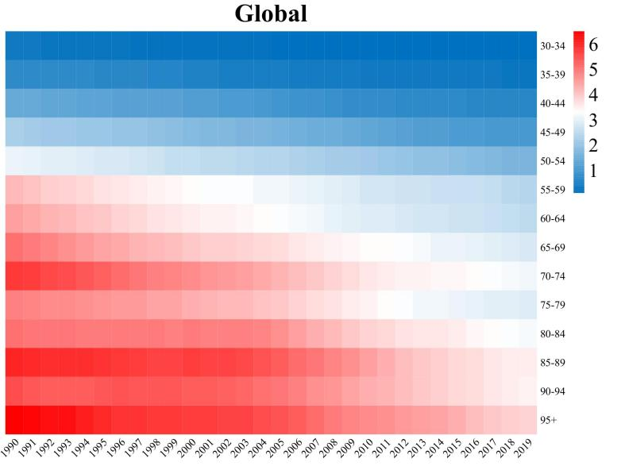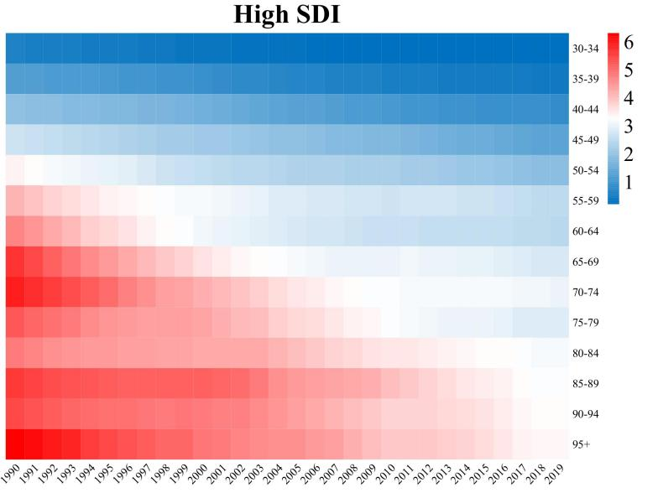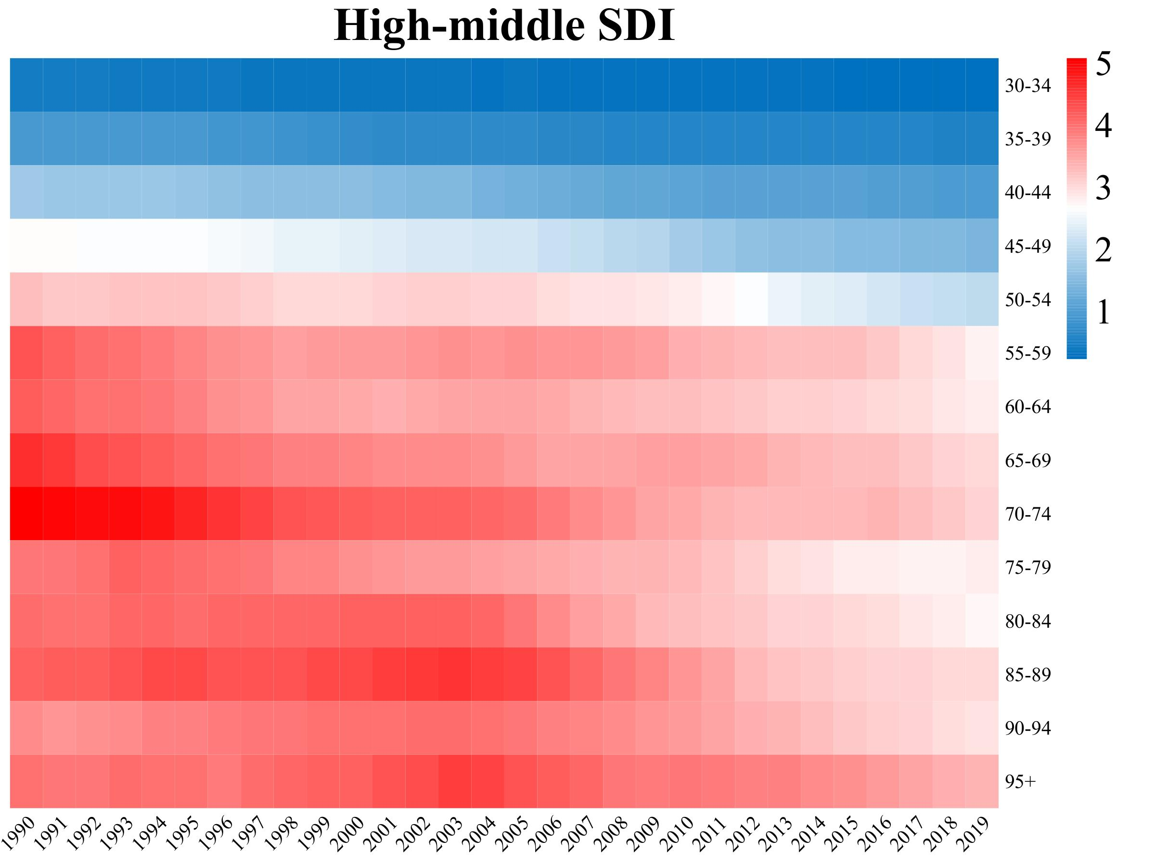

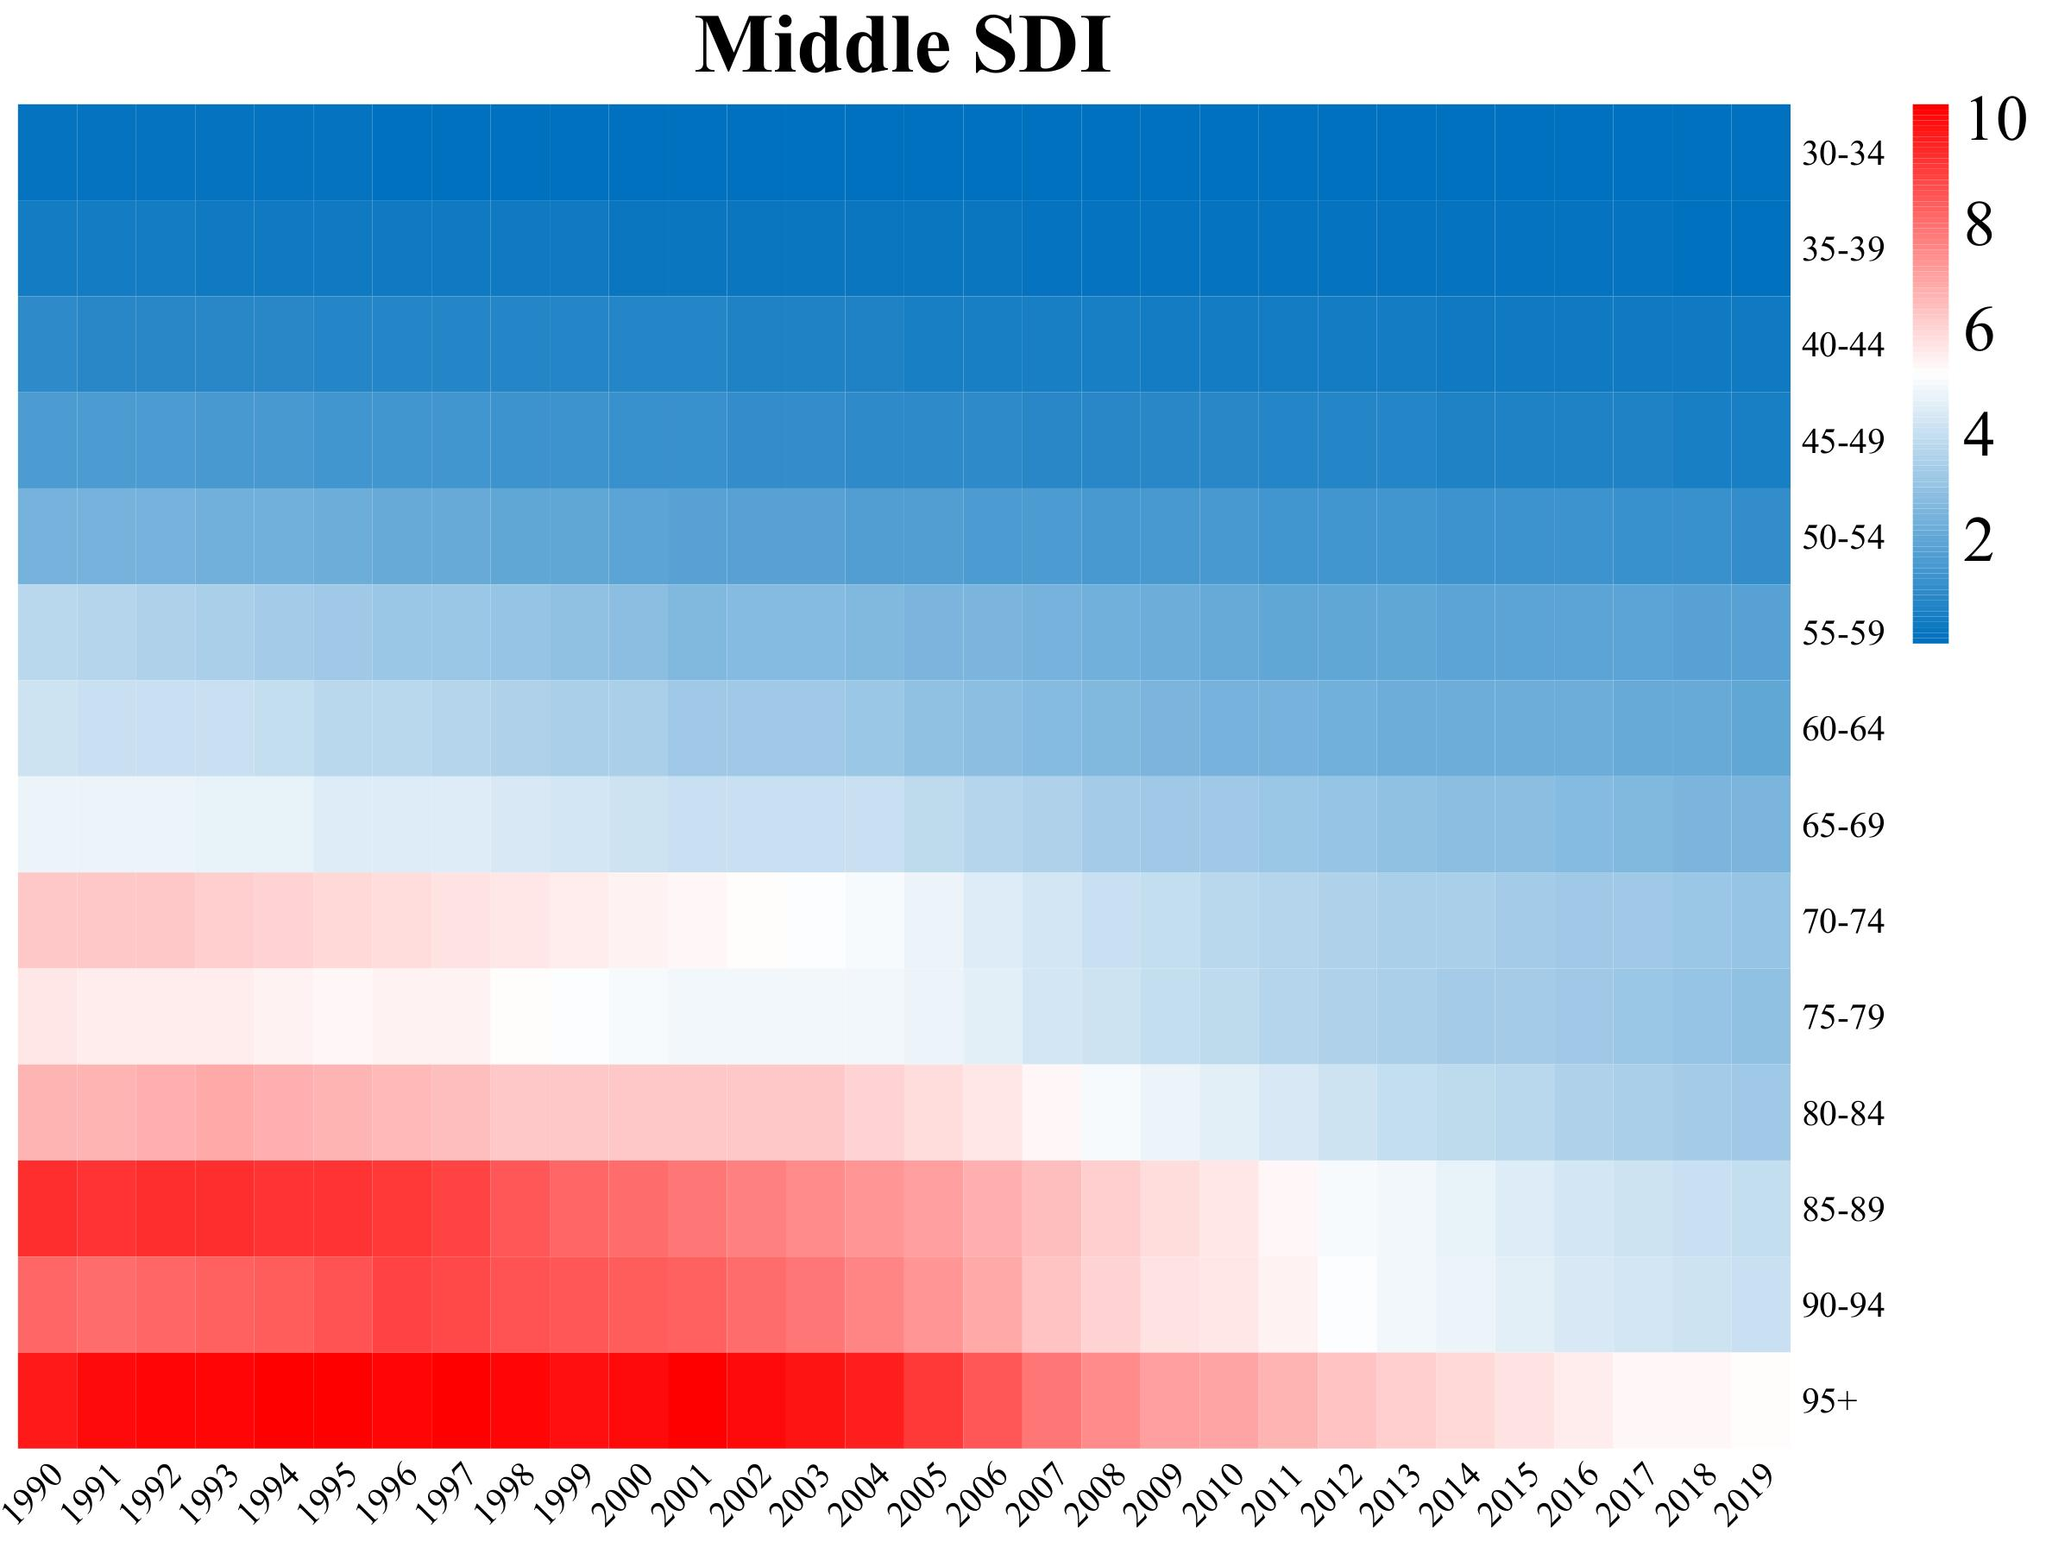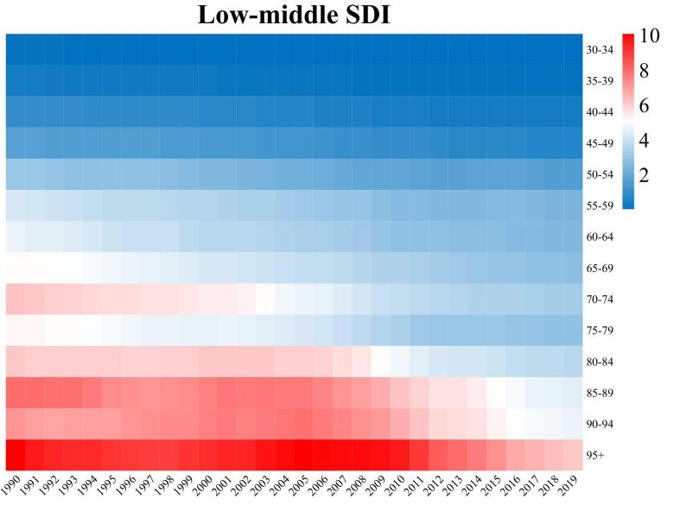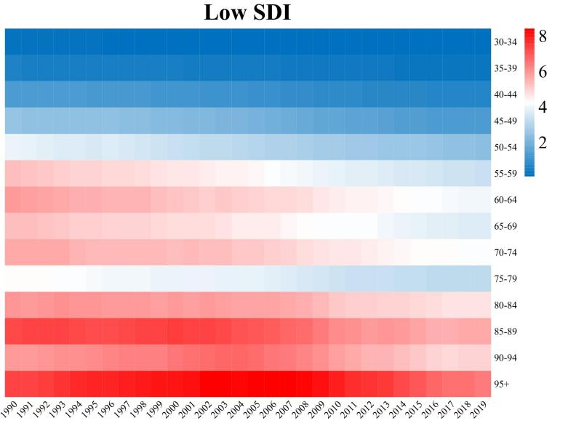

Figure 2: Age-specific mortality rates for cervical cancer attributable to smoking by SDI, 1990-2019.

Figure 5: The relationship between the ASDR (per 100000) of cervical cancer attributable to smoking, unsafe sex and SDI from 1990 to 2019 in 21 regions classified by GBD.
Each colored line represents the time trend of the designated area. Each point represents a specific year for that region. The dotted line represents the result of quintile regression; from top down to next are the results of P₉₅, P₇₅, P₅₀, P₂₅ and P₅.
DALY: disability-adjusted life-year; ASDR: age-standardized DALY rate

