Additional Information

A Simple Self-Adjuvanting Biomimetic Nanovaccine Self-Assembled with the Conjugate of Phospholipids and Nucleotides Can Induce Strong Cancer Immunotherapeutic Effect

Dan Liu ¹, Jiale Liu¹, Bing Ma¹, Bo Deng¹, Haiyan Xu² Xigang Leng¹ Deling Kong ^{1, 3}
and Lanxia Liu^{1, *}

- The Tianjin Key Laboratory of Biomaterials, Institute of Biomedical Engineering, Peking Union Medical College & Chinese Academy of Medical Sciences, Tianjin 300192, China
- Institute of Basic Medical Sciences, Chinese Academy of Medical Sciences, School of Basic Medicine, Peking Union Medical College, Beijing100730, China
- College of Life Science, Nankai University, Tianjin 300071, China.

*Corresponding author
Lanxia Liu
Institute of Biomedical Engineering, Peking Union Medical College & Chinese Academy of Medical Sciences, Tianjin 300192, China.
Phone & Fax: +86 (22) 8789-1191
E-mail: liulanxiabme@163.com

Additional Figures and Tables
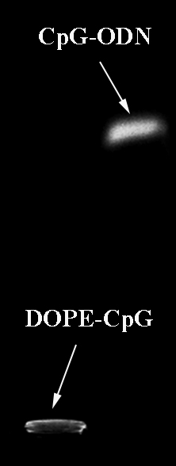
Figure S1. The typical agarose gel electrophoresis images of DOPE-CpG.

Table S1. Characterization of different formation
Nanoparticles | Diameter(nm) | Polydispersity | Zeta potential(mV)
SNCs | 138.20±0.90 | 0.20±0.01 | -23.40±1.24
NaVs | 192.40±0.66 | 0.14±0.02 | -31.20±2.43

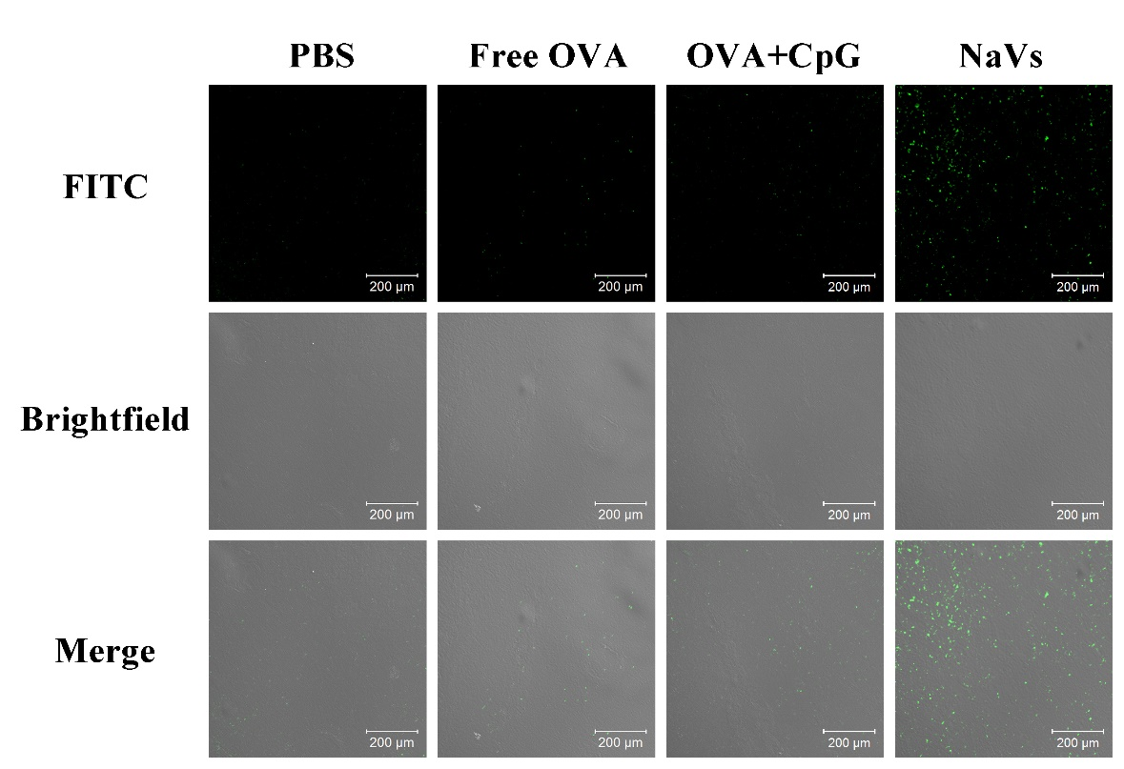
Figure S2. Detection of apoptosis by TUNEL assay in tumor tissues obtained from different experimental groups. The figure shows representative results of one of at least three independent experiments. Cells undergoing apoptosis were positively stained with TUNEL reagent and are shown in green
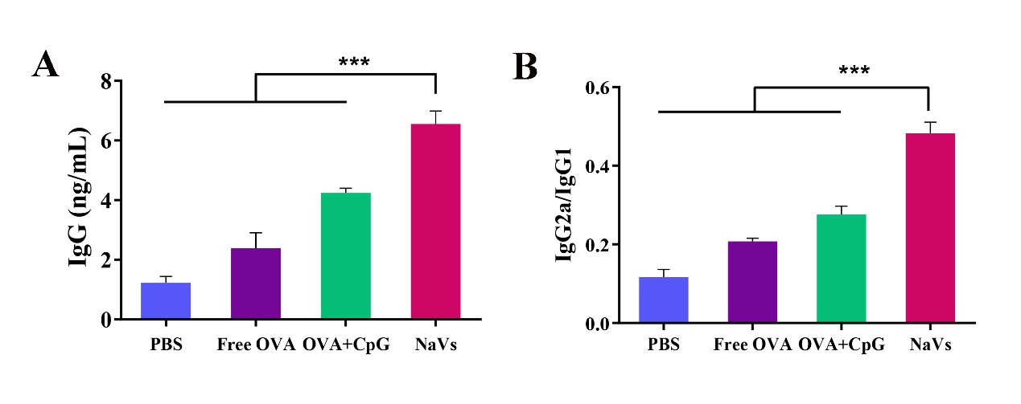
Figure S3. OVA-specific IgG antibody responses in mice immunized with PBS, Free OVA, OVA+CpG, or NaVs, respectively. (A) Total IgG serum levels and (B) the IgG2a/IgG1 ratio in tumor-bearing mice.

