Investigation of novel brightener acid blue 1 on copper electroplating coating
Mingjie Li ^{b, 1}, Xin Li ^{b, 1}, Yaqiang Li ^{a,} *, Xuesong Peng ^{b}, Jie Jiang ^{b}, Fan Meng ^{b}, Jinqiu Zhang ^{b}, Peixia Yang ^{b}, Ruopeng Li ^{b,} *, Maozhong An ^{b,} *
ª College of Chemistry, Institute of Molecular Engineering Plus, Fuzhou University, Fuzhou, Fujian 350116, P. R. China.
^{b} School of Chemistry and Chemical Engineering, Harbin Institute of Technology, Harbin 150001, China.
* Corresponding authors
1 These authors contributed equally to this work and should be considered co-first authors.
E-mail: liyaqiang@fzu.edu.cn

1 Phase structure of copper substrate
Figure S1 shows the X-ray diffraction pattern of copper substrate used for molecular dynamics simulation. The diffraction peaks of copper crystal appear at 43.3°, 50.4° and 74.1°, respectively, which corresponds (111), (200) and (220).
Figure S1 Atomic numbering of Acid Blue 1 (AB1)

The atomic numbering of AB1 and atomic types are shown in figure S2 (a). The charge distribution is shown in figure S2 (b). It can be seen that the charge for O31, O34 and O35 is -0.665e, -0.664e and -0.666e, respectively, demonstrating that negatively charged Oxygen atoms can attract positively charged Cu²⁺ due to electrostatic attraction.

2. Theoretical calculation
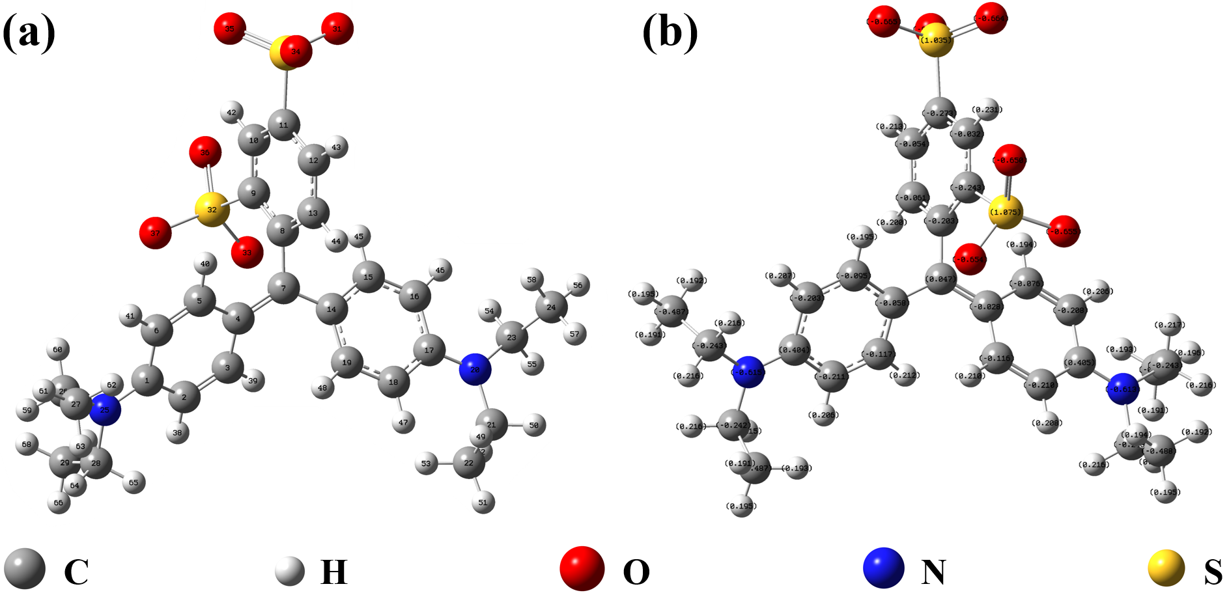
Figure S2 Atomic numbering of Acid Blue 1 (AB1)

The criterion based on atoms in molecules (AIM) theory is shown in table S1 ^{[1-3]}. The electron density (ρ_{BCP}) and Laplacian of electron density (▽²ρ_{BCP}) at bond critical point are regarded as indicator to evaluate the bond properties.
Table S1 Judging criterion of bond critical points of AIM theory
Judging criterion | Bond type
ρ_{BCP} > 0.2 a.u. | Covalent bond
ρ_{BCP} < 0.1 a.u. | Ionic bond
▽²ρ_{BCP} < 0 | Covalent bond
▽²ρ_{BCP} > 0 | Ionic bond

In interaction region indicator (IRI) method, sign(λ₂) ρ function can be mapped as isosurfaces to show the interaction regions. ρ is the electron density and the sign(λ₂) shows the second largest eigenvalue of Hessian of ρ. As a result, the high value of sign(λ₂) ρ represents strong interaction and the low value of sign(λ₂) ρ indicates the week interaction. In 3D AB1-Cu²⁺ complex figure, blue region represents strong attraction interaction like covalent interaction and ionic interaction, while red region indicates strong repulsion interaction. Green region illustrates weak interaction like Van der Waals interaction. In 2D AB1-Cu²⁺ complex figure, the red region indicates strong interaction while dark blue represents weak interaction ^{[4]}.

3. Surface morphology of copper coating
Figure S3, figure S4 and figure S5 show the influence of AB1 concentration and current density on the surface morphology. At low current density (3A/dm²), the copper surface appears parallel lines and ravines without AB1. After the introduction of AB1 (50 mg/L), the parallel lines and ravines phenomena are weakened and surface morphology is improved. When AB1 concentration is within 100 to 150 mg/L, the surface morphology become flat and compact. With AB1 concentration further increased to 200 and 250 mg/L, the copper coating is full of bumps and the surface becomes uneven. As a result, 100-150 mg/L AB1 is beneficial to the formation of flat copper coating at 3 A/dm².
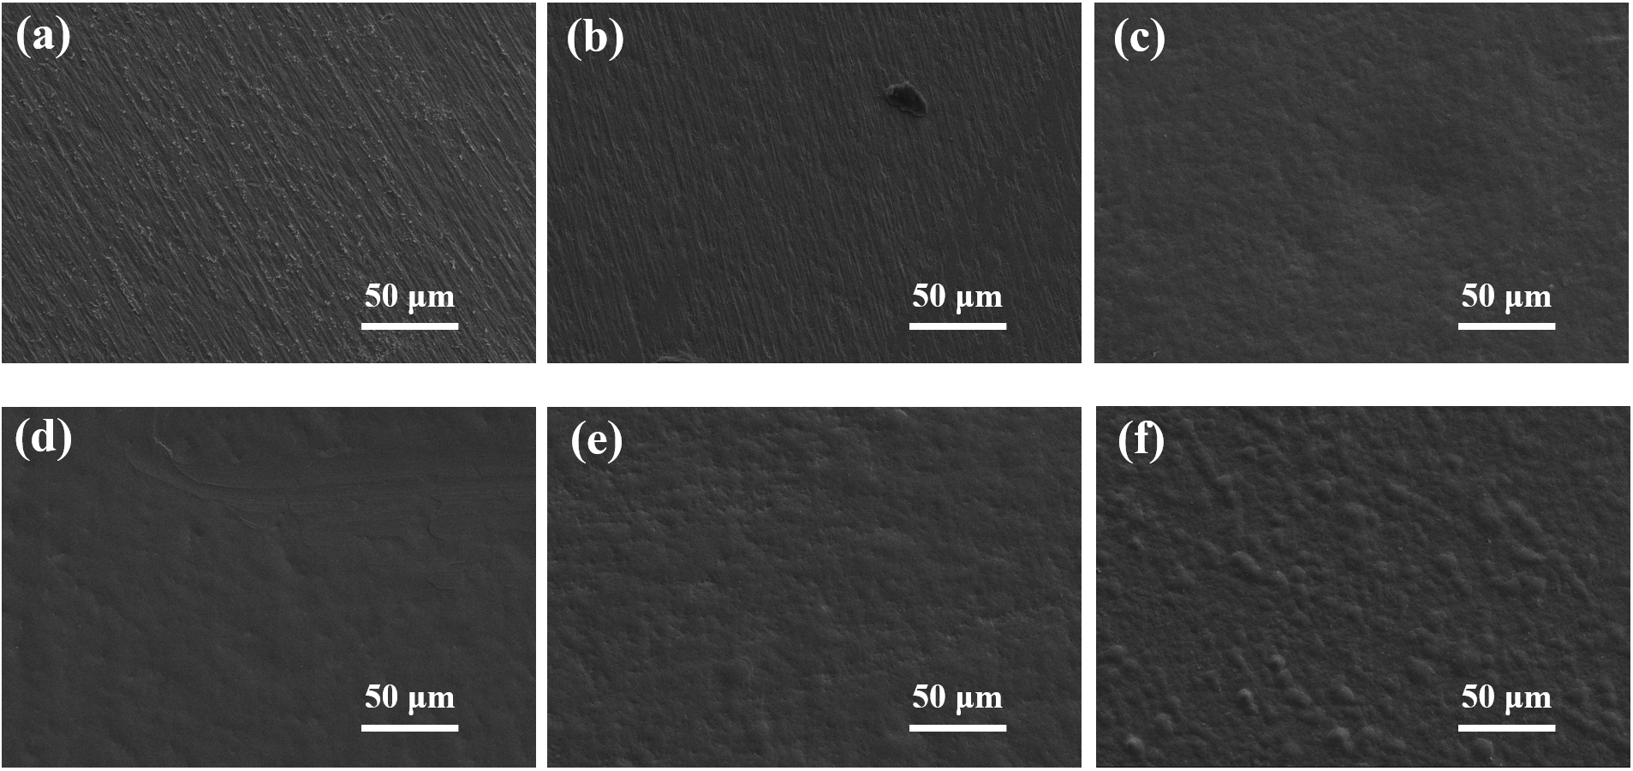
Figure S3 SEM images of copper coating electrodeposited at 3A/dm² for 5 min with different AB1 concentration. (a) 0 mg/L, (b) 50 mg/L, (c) 100 mg/L, (d) 150 mg/L, (e) 200 mg/L and (f) 250 mg/L.

When current density is 5 A/dm², the surface compactness is better than that obtained at 3 A/dm². Similarly, the copper surface is uneven without AB1. The uneven surface phenomena are obviously weakened with AB1 concentration rising from 50 mg/L to 100 mg/L. When AB1 concentration is 150 mg/L, the copper surface is compact and flat without any bumps. However, small bumps appear with 200 mg/L to 250 mg/L AB1 concentration. Thus, 150 mg/L was the optimum value.
When current density is 8 A/dm², copper surface is full of spherical particles without AB1. After introduction of AB1 (50 mg/L to 150 mg/L), the surface morphology is improved to some extent. However, there are still some spherical particles on copper coating. With AB1 concentration rising to above 200 mg/L, the compactness of copper coating decreases. As a result, flat and compact copper can be obtained with 100 mg/L to 150 mg/L AB1 at 5 A/dm² and 150 mg/L is optimum value for all the current density (3, 5, 8 A/dm²).
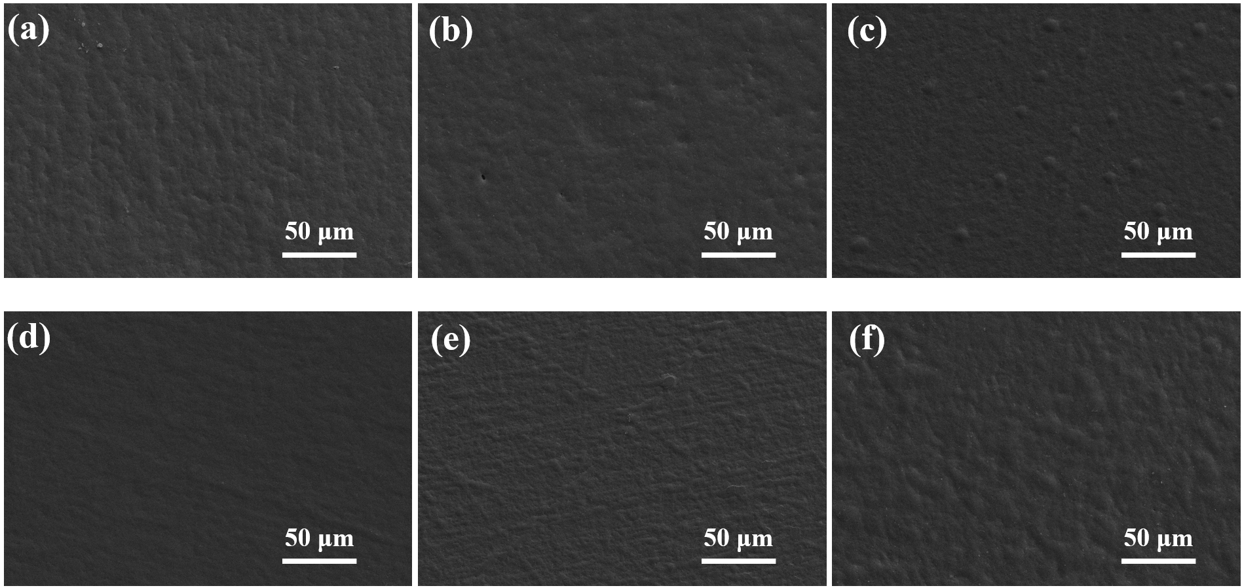
Figure S4 SEM images of copper coating electrodeposited at 5A/dm² for 5 min with different AB1 concentration. (a) 0 mg/L, (b) 50 mg/L, (c) 100 mg/L, (d) 150 mg/L, (e) 200 mg/L and (f) 250 mg/L.

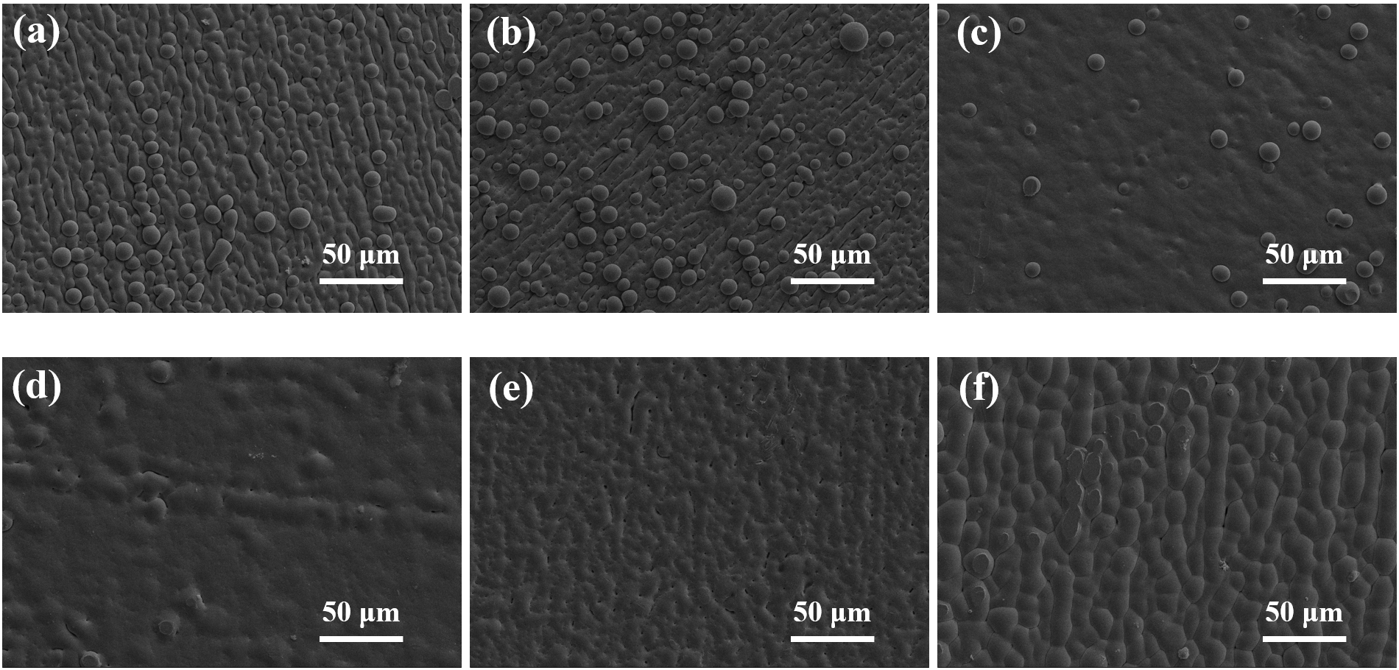
Figure S5 SEM images of copper coating electrodeposited at 8A/dm² for 5 min with different AB1 concentration. (a) 0 mg/L, (b) 50 mg/L, (c) 100 mg/L, (d) 150 mg/L, (e) 200 mg/L and (f) 250 mg/L.

AFM was used to study the influence of AB1 concentration on copper surface roughness at 5 A/dm², as shown in figure S6. It can be seen that the surface roughness is obviously improved after the introduction of proper AB1 (50 mg/L to 150 mg/L). With AB1 concentration rising to above 200 mg/L, the surface becomes uneven.
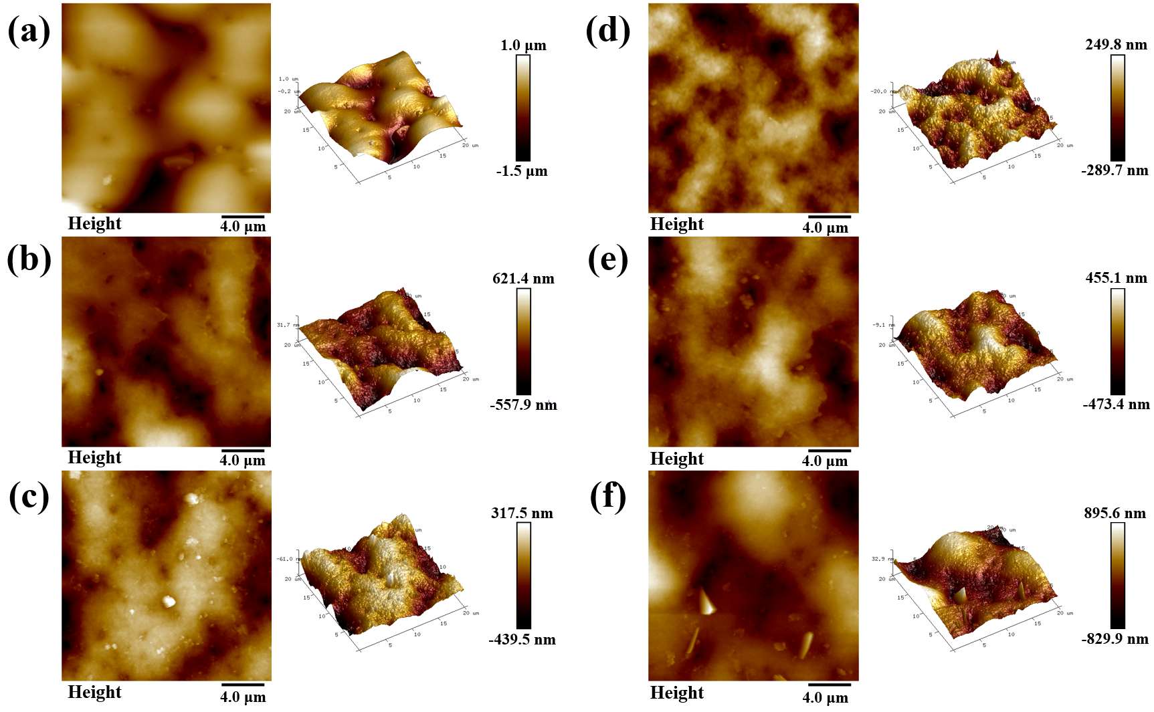
Figure S6 AFM images of copper coating electrodeposited from electroplating bath containing different AB1 concentration: (a) 0 mg/L, (b) 50 mg/L, (c) 100 mg/L, (d) 150 mg/L, (e) 200 mg/L, (f) 250 mg/L. The current density is 5 A/dm².

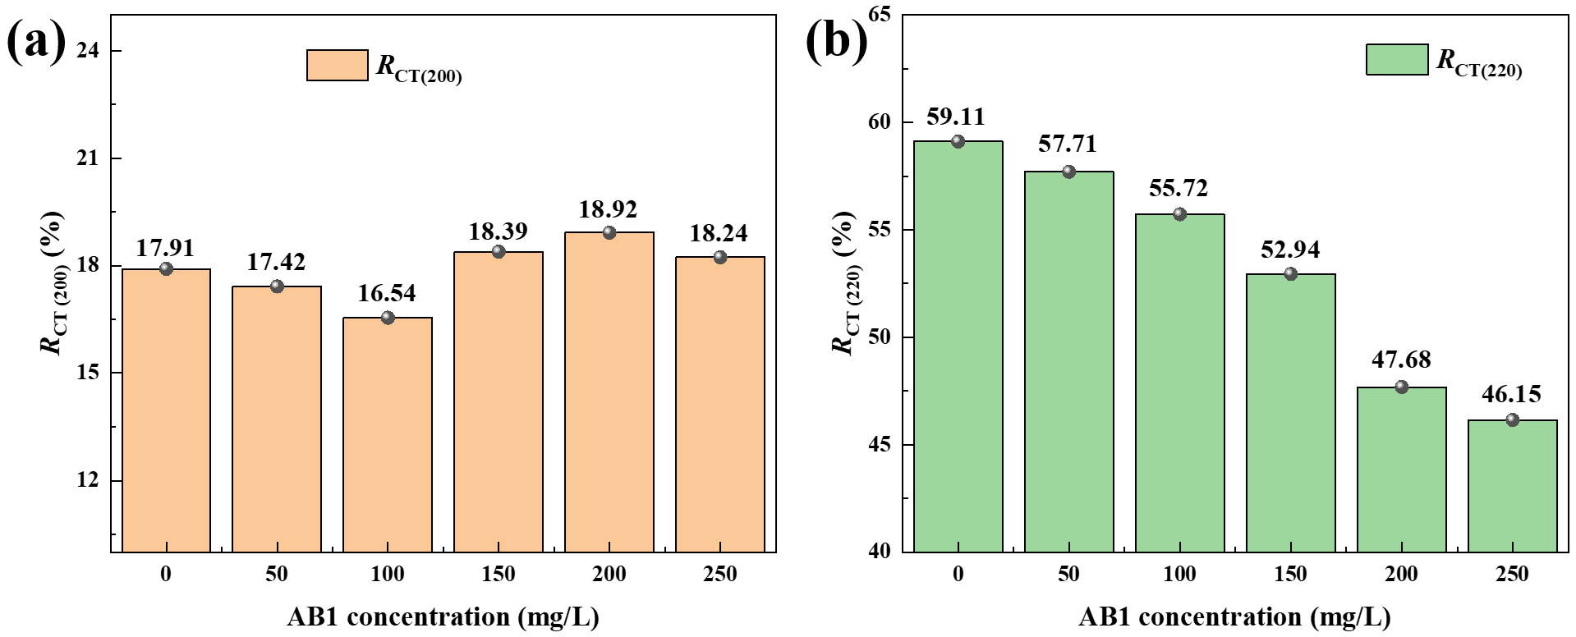
Figure S7 Histograms of calculated texture coefficient for (a) Cu (200) and (b) Cu (220) from XRD pattern.

Figure S7 shows the calculated texture coefficient for Cu (200) and Cu (220). It can be seen from figure S7 (a) that R_{CT(200)} stayed basically unchanged (about 18%) regardless of AB1 concentration. As for R_{CT(220)} decreases from 59.11% to 46.15% with AB1 concentration rising from 0 mg/L to 250 mg/L, indicating that AB1 can suppress the formation of Cu (220) crystal plane.

Reference
[1] Lane J. R., Contreras-Garcia J., Piquemal J. P. et al. Are Bond Critical Points Really Critical for Hydrogen Bonding? [J]. Journal of Chemical Theory and Computation, 2013, 9 (8): 3263-6266.
[2] Zhao J., Khalizov A., Zhang R. Y., et al. Hydrogen-Bonding Interaction in Molecular Complexes and Clusters of Aerosol Nucleation Precursors [J]. Journal of Physical Chemistry A, 2009, 113 (4): 680-689.
[3] Quantum-mechanical study of thermodynamic and bonding properties of MgF₂ [J]. Journal of Physical Chemistry A, 1998, 102 (9): 1595-1601.
[4] Lu, T.; Chen, Q. Interaction Region Indicator (IRI): A Simple Real Space Function Clearly Revealing Both Chemical Bonds and Weak Interactions. Chem. Methods 2021, 1 (5), 231−239.

